**AR MUSE Unity Toolkit Test Guide**

In this test, you are going to use Unity Editor to generate some AR-ready models, and then deploy them to a remote server in a few steps by using AR MUSE Unity Toolkit. In the end, you can use a mobile phone with AR MUSE Viewer App to have a look at what you have created.

**STEP 1. Edit Model in Unity Editor with QR code Reference**

1. Open **“Asset - Scene - CoordsScene”**

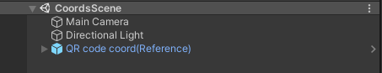

1. Find **“Assets - Test - Models for Test”** Drag one model into the scene and make customizations as you like it (Position, Rotation, Scale)

*Optional: If you are familiar with Unity, the* ***“X Bot”*** *model comes with an animation clip, that means you can animate it by adding the Animator component*

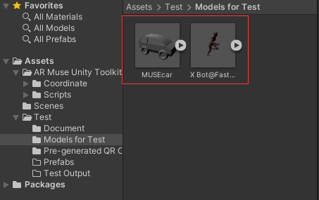

1. Select your model and make a new prefab by dragging it to **“Assets – Test - Prefabs”**, then select **“Original Prefab”** to save your customized model as a prefab

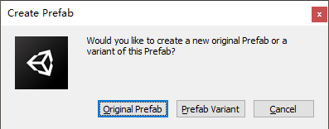

**STEP 2. Pack Asset**

1. Select **“MUSE”** on the top menu bar, go to **“MUSE - AR Toolkit - Asset Bundle Packer”**

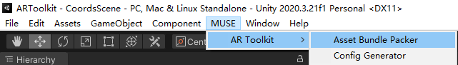

1. Drag your prefab to **“Configure”**

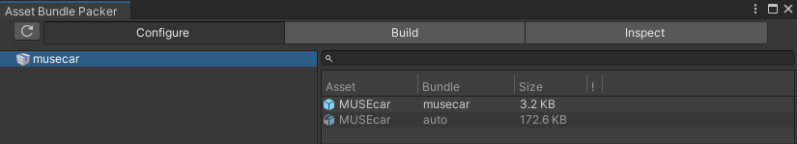

1. Select **“Build”,** and choose **“Build Target”** as **“Android”,** and we have set the output path for you

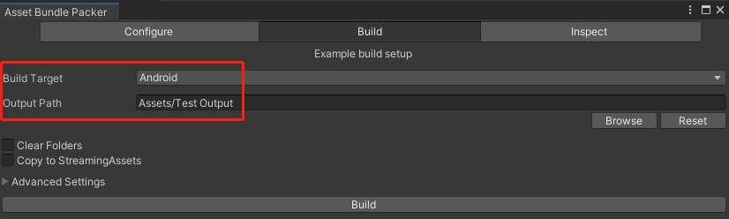

1. Click **“Build”** button to pack your assets

**STEP 3. Generate XML Config File**

1. Select **“MUSE”** on the top menu bar, go to **“MUSE - AR Toolkit - Config Generator”**
2. Select **“Museum Info”** to edit your AR museum/exhibition Info

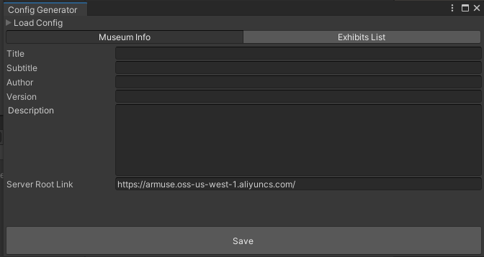

1. Check if **“Server Root Link”** equals **“https://armuse.oss-us-west-1.aliyuncs.com/”**, if not paste it into text field
2. Select **“Exhibits List”** to add new Exhibits info, you can add multiple exhibits into this list

*Make sure you have input* ***ALL*** *the information*

*Make sure the* ***“Filename”*** *of each exhibit is the same as the packed asset name and ends with “.ab”. For example: car.ab*

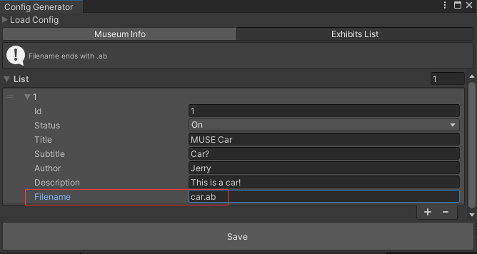

1. Click **“Save”** button to save your config file

**STEP 4. Upload To Server and Generate QR code**

Let us do this for you :)

**STEP 5. See it on Viewer App**

1. Scan the Museum Entry Code
2. Scan the Exhibit Code and see your uploaded models

*Optional: You can interact with any buttons you see on the screen, feel free to play with Viewer App. We will be happy if you find some bugs or problems ;)*