CIS 288 — Cloud Computing | Community College of Philadelphia
Lab 02 — Cloud Account Setup: AWS | Azure | Google Cloud
Summer 2026 | Due: Sunday May 24, 2026 by 11:59 PM | 10 Points

Full Name: | John Emmanuel Gonzales
GitHub Username: | jgonz1881
CCP Email: | ▶ jgonz188@student.ccp.edu
Date Completed:

Why This Lab Matters
Before you can do anything hands-on in this course, you need active accounts on all three cloud platforms — AWS, Azure, and Google Cloud (the Three Landlords). This lab walks you through setting up each one, verifying access, and documenting your work.
Estimated time: 45–60 minutes total | Complete before Week 3 class.

💳 Important Note on Credit Cards (Updated for 2026): Both AWS and Azure require a credit or debit card when signing up — even on free plans. This is identity verification only. You will NOT be charged as long as you use your credits responsibly. AWS will charge a temporary $1 hold that is immediately refunded. Note: AWS changed its free tier model in July 2025. New accounts no longer get the old '750 hours/month for 12 months' model — instead you receive $100 in credits valid for 6 months. GCP requires NO credit card (your $50 education coupon covers everything).

Part 1 — AWS: Amazon Web Services
console.aws.amazon.com | $100 in credits for new accounts | Credit card required (identity verification only)

What You Get | Details (New Accounts Created After July 2025)
$100 in AWS Credits | Automatically applied to your account on signup. Covers EC2, S3, RDS, Lambda, and most services.
Credit Validity | 6 months from account creation date. Use them or lose them.
Always Free Services | Lambda (1M requests/month), DynamoDB (25GB), CloudWatch, and 30+ other services — free forever within limits.
Credit Card Required? | Yes — for identity verification only. AWS charges a $1 temporary hold that is immediately refunded. You will not be billed while credits remain.
⚠ Changed from 2025 | Before July 15, 2025, new accounts received '750 EC2 hours/month free for 12 months.' That model no longer exists for new accounts. New accounts now receive $100 in credits instead.

Step-by-Step: Create Your AWS Account
- Go to aws.amazon.com and click Create a Free Account.
- Enter your email address and choose a password.
- Enter your name and choose Personal account type.
- Enter a credit or debit card — required for identity verification. You will NOT be charged while your $100 credit balance remains.
- Verify your phone number via text message.
- Choose the Basic Support plan (free).
- Sign in to the AWS Management Console at console.aws.amazon.com.
- Confirm your account name appears in the top-right corner.
- Important: Always set the region to us-east-1 (N. Virginia) for all labs unless told otherwise.

✅ Confirm your $100 credit: Go to Billing Dashboard → Credits to confirm your $100 promotional credit is applied. Set up a billing alert while you're there — Billing → Budgets → Create Budget → set $5 threshold so you get an email if anything unexpected happens.

AWS Screenshots — Attach Below
Screenshot | Your Filename
AWS Console home page — logged in (your account name visible top-right) | 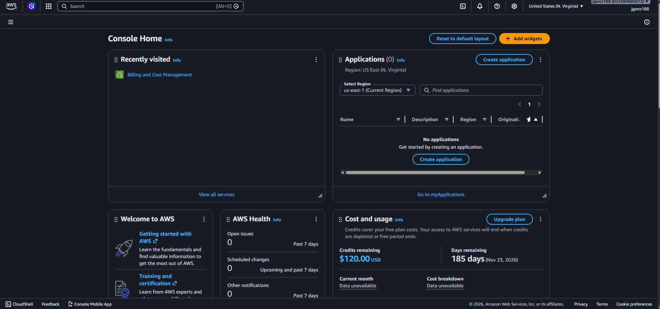
Billing → Credits page showing $100 promotional credit applied | 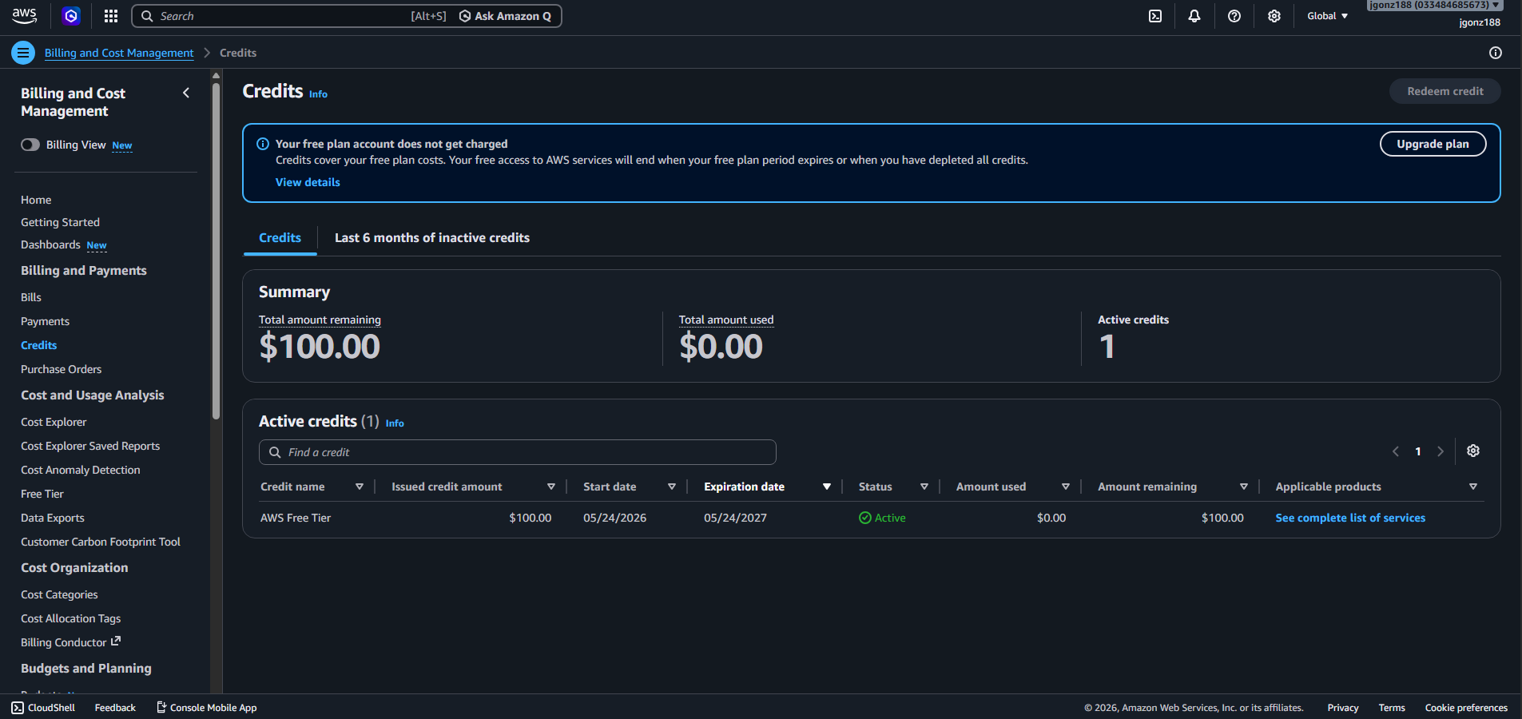

Part 2 — Microsoft Azure
portal.azure.com | $100 credit valid for 30 days | Credit card required (identity verification only)

What You Get | Details
$100 Free Credit | Valid for 30 days from account creation. Covers most Azure services.
Free Services (12 months) | 25+ services free for 12 months including VMs (750 hrs/month), Blob Storage (5GB), SQL Database.
Always Free Services | 55+ services always free — including Azure Functions, Cosmos DB (400 RU/s), App Service (10 apps).
Credit Card Required? | Yes — for identity verification only. You will NOT be charged during your free period. After credits expire, Azure will ask before billing you.

Step-by-Step: Create Your Azure Account
- Go to azure.microsoft.com/free and click Start free.
- Sign in with a Microsoft account (personal Outlook or Hotmail works fine — or create one free).
- Fill in your profile information.
- Enter a credit or debit card — required for identity verification. You will NOT be charged during your free period.
- Complete phone verification.
- Click Go to Azure Portal — you will land at portal.azure.com.
- Confirm your $100 credit: Go to Subscriptions → Azure subscription 1 → Overview to see your credit balance.

Azure Screenshots — Attach Below
Screenshot | Your Filename
Azure Portal home page — logged in (your name visible top-right) | 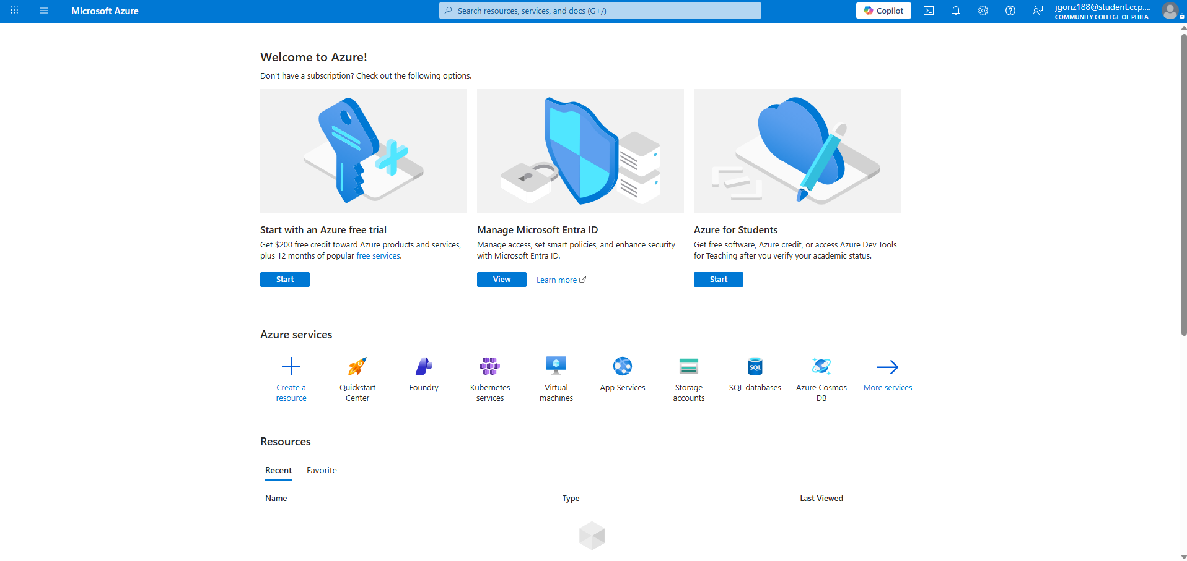
Subscriptions → Azure subscription 1 showing $100 credit balance | 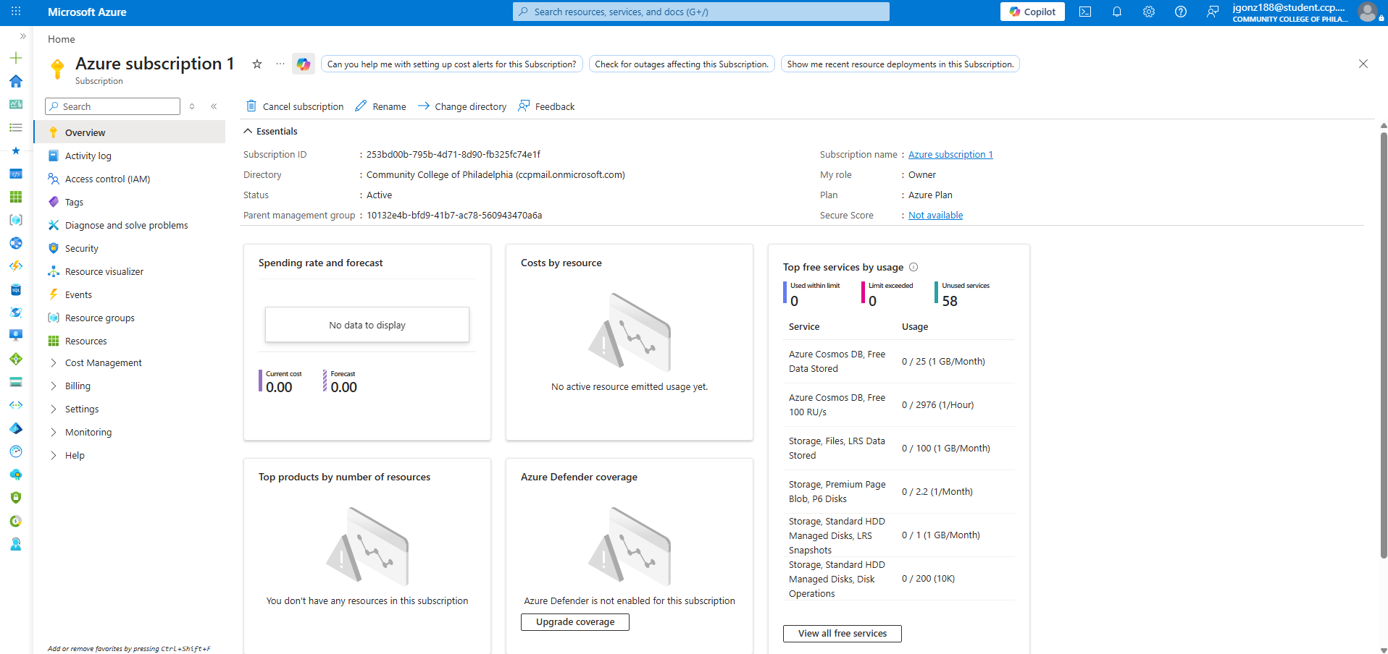

Part 3 — Google Cloud Platform (GCP)
console.cloud.google.com | $50 CCP Education Credit | No credit card required for coupon redemption

🎟 Your GCP coupon has been pre-approved by Professor Chang through Google Cloud Education Grants — at no cost to you and no credit card required for the coupon itself. GCP does require a card to create the account, but your $50 education credit covers all charges for this course.

Step 1: Request Your $50 CCP Coupon Code
- Click this link: https://gcp.secure.force.com/GCPEDU?cid=n4gFp5Psw4Pl2WKpAdA3MAcx2%2FKarlEJvrG9JDR%2BAZt4KuYCEtEXCIDQgtxRWmkj/
- Enter your First Name, Last Name, and your @student.ccp.edu email address — personal Gmail will not work here.
- Click Submit. Check your @student.ccp.edu inbox for a confirmation email from Google.
- Save your coupon code — you will redeem it in Step 2.

📌 One coupon per student email address. Do not click Submit more than once. Redeem by: June 25, 2026. Valid through: February 25, 2027.

Step 2: Create Your GCP Account and Redeem Coupon
- Go to console.cloud.google.com and sign in with your Google account (Gmail is fine here).
- Complete account setup. A credit card may be required by Google to create the account.
- Go to Navigation Menu (☰) → Billing → Credits → Redeem a coupon.
- Paste your coupon code. Confirm your $50 CCP Education Credit appears.
- Create a new project called CIS288-YourLastName (e.g., CIS288-Chang). Always work inside this project for all labs.

GCP Screenshots — Attach Below
Screenshot | Your Filename
GCP Console home — logged in showing your project name (CIS288-YourName) | 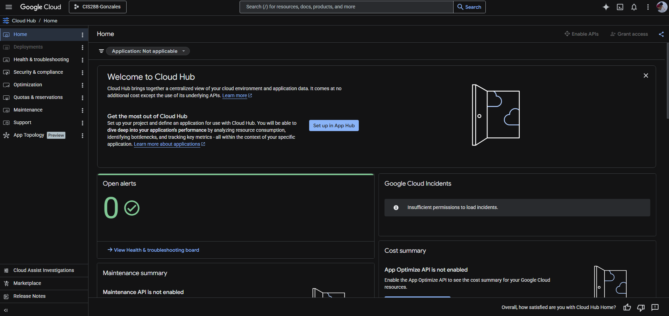
Billing page showing your $50 CCP promotional credit applied | 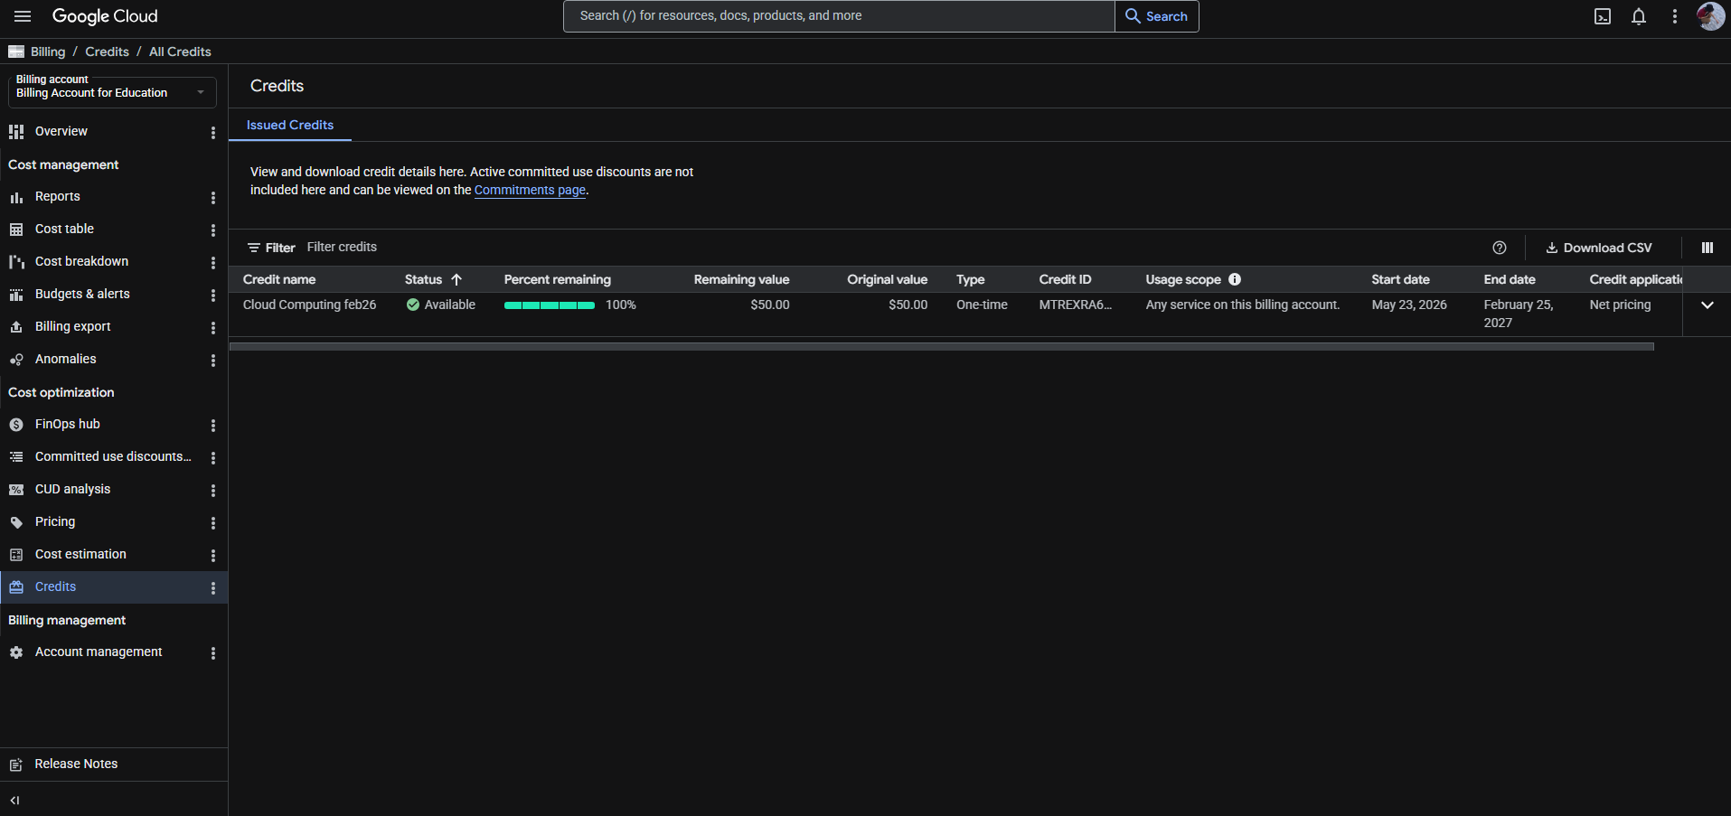
Confirmation email from Google with coupon code (blur the actual code) | 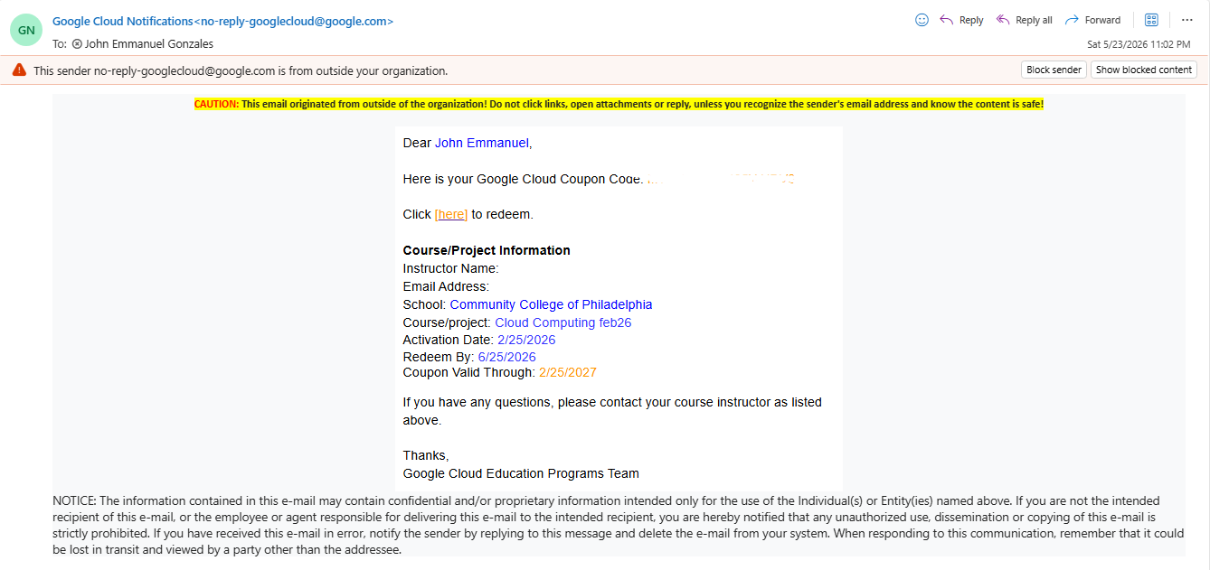

Part 4 — Verify All Three Consoles
Before submitting, confirm you can log into all three consoles. Fill in the table below:

Platform | Console URL | Logged In? | Credit / Status
AWS | console.aws.amazon.com | Yes / No | $100 Credits Active
Azure | portal.azure.com | Yes / No | $100 Credit Active
GCP | console.cloud.google.com | Yes / No | $50 Education Credit

Part 5 — Submit to GitHub Classroom
This lab is submitted to your GitHub Classroom repo — not Canvas. No terminal needed.

- Save this file as: CIS288_Lab02_YourName.docx (e.g., CIS288_Lab02_JohnSmith.docx)
- Make sure all your screenshot image files are saved on your computer.
- Go to your GitHub Classroom Lab 02 repo in your browser (check your email for the assignment link from Lab 00).
- Click Add file → Upload files.
- Drag and drop your .docx and all screenshot images into the upload area.
- Scroll down and type a commit message: lab02 complete - Your Name
- Click Commit changes.
- Go to your repo on github.com and confirm all your files are visible.

Grading Rubric — 10 Points Total
Criterion | Points | Your Score | Notes
AWS account created — console screenshot attached | 2 pts
Azure account created — console screenshot attached | 2 pts
GCP coupon redeemed — billing credit screenshot attached | 3 pts
All 3 consoles verified in Part 4 table | 1 pt
Uploaded to GitHub Classroom (file + screenshots) | 2 pts
TOTAL | 10 pts

Troubleshooting
Problem | Fix
AWS requires a credit card | This is normal and expected. AWS uses your card for identity verification only. You will NOT be charged as long as you stay within your $100 credit balance. This changed from the old 12-month free tier model in July 2025.
Azure requires a credit card | Same as AWS — required for identity verification only. Your $100 Azure credit covers all charges. You will not be billed unless you manually upgrade to a paid plan after credits expire.
GCP coupon email never arrived | Check your spam folder. Make sure you used your @student.ccp.edu email address — personal Gmail will not work for the coupon request.
GCP coupon already used | Each student gets one coupon per email. If you used a different email by mistake, contact Professor Chang at schang@ccp.edu.
Azure portal shows no credit | Go to Subscriptions > Azure subscription 1 > Overview to see your credit balance.
Cannot find GitHub repo | Make sure you completed Lab 00 first. Go to github.com and find your Lab 02 repo — the link is in your assignment acceptance email.

Lab 02 complete — you now have accounts with all Three Cloud Landlords. Keep your login credentials safe. You will use all three accounts throughout this semester.

