**SQL Server Management Studio Guide**

**NoHo Database Connection Instructions**

**Step 1:**

Contact IT and have them install the latest version of Miscrosoft SQL Server Management Studio to your machine.

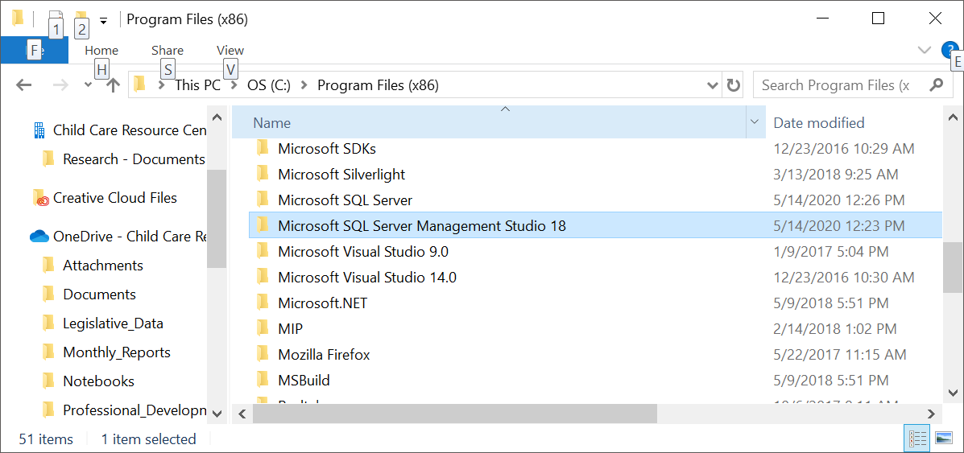

**Step 2:**

IT will give you access to a group in the AD with access to server name **shqrsrch01**

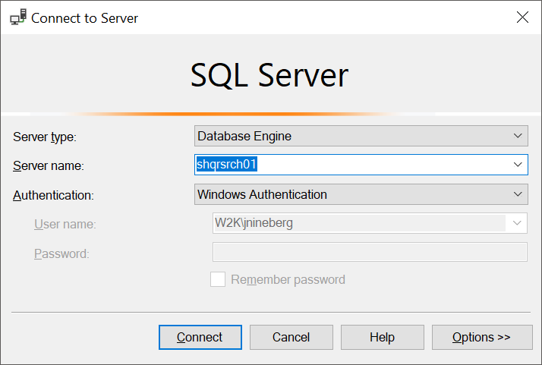

**Step 3:**

Connect to the **shqrsrch01** database and follow the path – Server Objects\Linked Servers\SDRSQL1\Catalogs

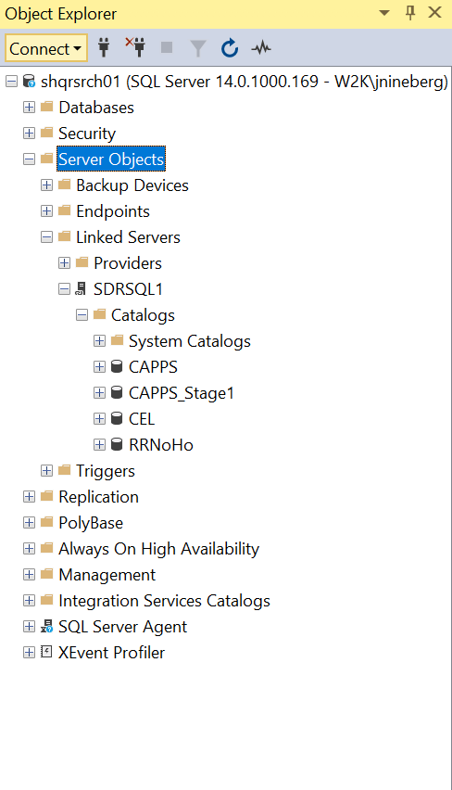

**Step 4:**

Open up a table and start exploring the data.

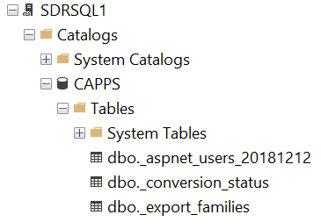

**Step 5:**

Left-click on the “New Query” button to open up a blank SQL script.

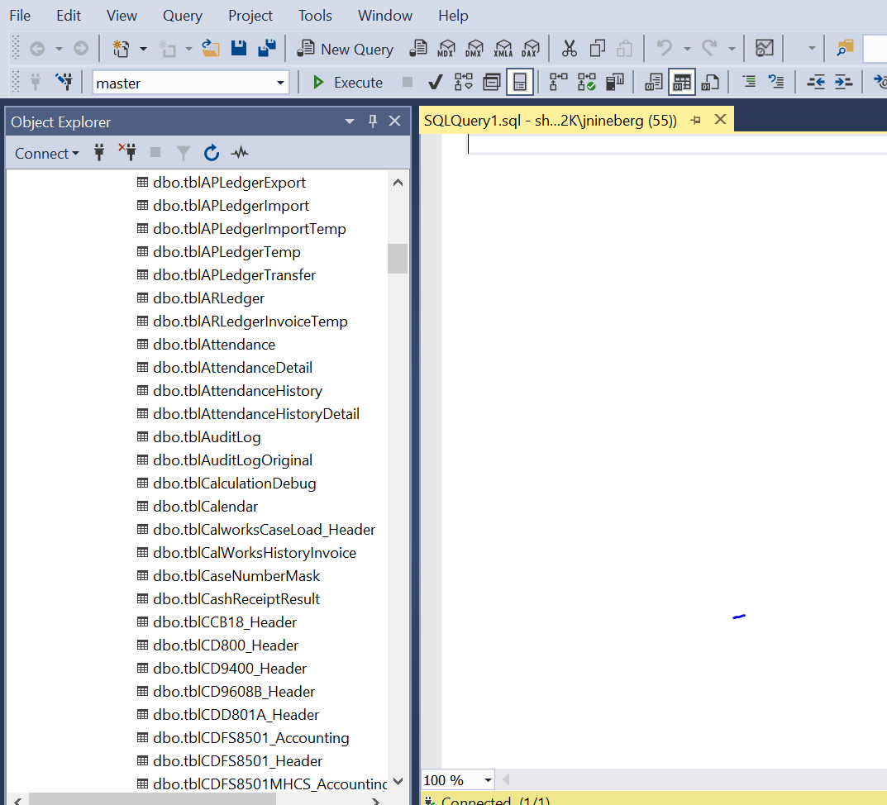

**Step 6:**

Write a SQL script and have fun exploring all of the data that NoHo has to offer.

**SQL Basics – Getting Started**

In the query window type the following script:

SELECT * FROM [SDRSQL1].[CAPPS].[dbo].[tblChild]

The returned results should look something like this:

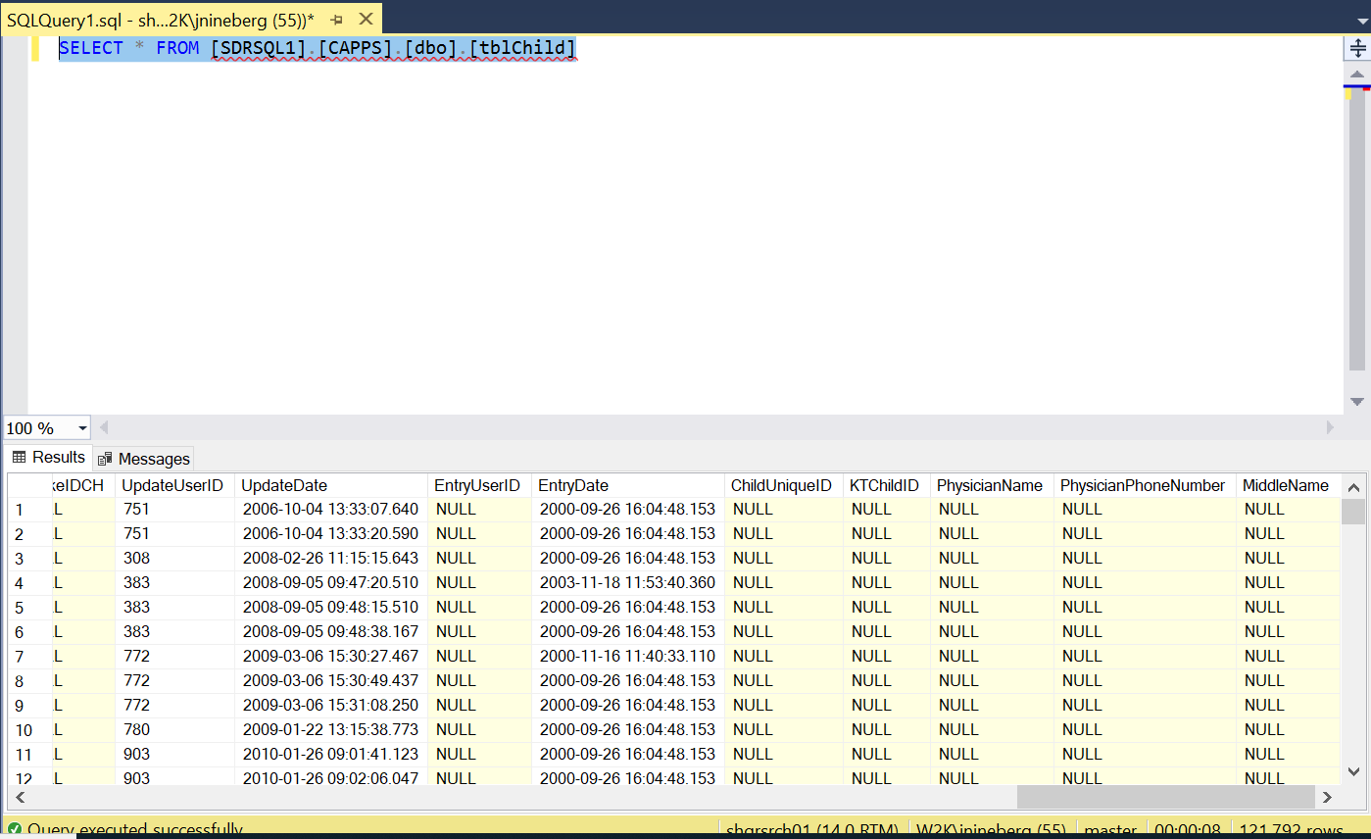

At this point, you, as the user, have the power to extract and load data based on your desired SQL script.

**Extracting Data into Tabular Format**

The easiest way to get your results into a tabular format is to create an Excel file beforehand in preparation to copy the data. Once your Excel file has been created left-click on any cell in the results grid and then press Ctrl + A. Next, Right-click and select “Copy with Headers”. Your SQL results are now pasted in Excel ready for post-hoc analyses.

**Exploring the CCRC NoHo Databases**

Understanding the design foundation of the NoHo Databases that CCRC operates and maintains is critical for Research staff to comprehend when extracting data.

***There are four databases:***

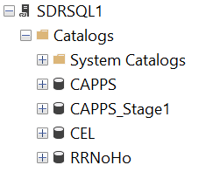

**CAPPS:**

CAPPS contains CDE Subsidy data

**CAPPS_Stage1:**

CAPPS_Stage1 contains Stage 1 data

**CEL:**

CEL contains Waitlist data

**RRNoHo:**

RRNoHo contains Provider data

***Important Data Fields:***

When performing SQL queries it is imperative that the user understand that ChildID, FamilyID, and ProviderID (all iterations) are the primary keys to be used when joining data. CCRC, as an agency, promotes data collection using these fields as the primary connectors.