Software Design Document

**The Price Check Program**

Document Version 1.0

Printing Date

<https://1drv.ms/w/s!Ag58mauhRXtbh2yFxjomcgv-Ko34>

Derick Ho, Computer Science IV, 2018

Angel Ross, Computer Science IV, 2018

Dan Chin, Computer Science IV, 2018

# Change History

|  |  |  |  |
| --- | --- | --- | --- |
| **Version** | **Primary Author(s)** | **Description of Version** | **Date Completed** |
| 1.0 | Angel Ross  Dan Chin  Derick Ho | Drafting and Finalizing |  |

Table of Contents

Change History i

1. Project Description 3

1.1. Project 3

1.2. Description 3

2. Overview 4

2.1. Purpose 4

2.2. Scope 4

2.3. Requirements 4

2.3.1 Estimates 4

2.3.2 Traceability Matrix 5

3. System Architecture 7

4. Data Dictionary 8

Data Dictionary 8

5. User Interface Design 10

5.1. User Interface Design Overview 10

5.2. User Interface Navigation Flow 17

5.3. Use Cases / User Function Description 19

6. Extra Design Features / Outstanding Issues 22

7. References 22

8. Glossary 22

Appendices 23

Appendix A – Group Log 23

Index 24

Table 1 Estimate of modules 6

Table 2 traceability matrix 7

Table 3 Data Dictionary 10

# Project Description

## Project

**The Price Check Program**

## Description

The Price Check Program is an online service for comparing prices of supermarket goods. The PCP is developed by a group of students from the College of Computer Studies. The program aims to provide users a convenient way to save time and money. This is achieved by providing customers an insight on the various price comparison applied on their personal grocery list.

# Overview

## Purpose

Brief description of the focus of this module of the overall project and its intended audience.

The document provides the system architecture design of PCP. The purpose, scope and requirements are also specified in this document.

This document is intended to act as a guide for the developers as a reference in the creation of modules.

## Scope

The first release of the system would only cover two supermarkets. Furthermore, the system will only show the total amount of expenses for each supermarket and the number of items not available in the particular supermarket.

## Requirements

Your mileage may vary -- we typically break down the requirements to provide a ballpark estimate.

### 2.3.1 Estimates

Table 1 Estimate of modules

|  |  |  |
| --- | --- | --- |
| **#** | **Description** | **Hrs. Est.** |
| 1 | Home Page and Functions | 8 |
|  | List (of Products) Page and Functions | 8 |
|  | Price Total Comparison Page and Functions | 8 |
|  | Login/Sign Up Page and Functions | 4 |
|  | User Account Page and Functions | 4 |
|  | Administrator Home Page | 4 |
|  | Administrator Messages/Feedback Management Page | 2 |
|  | Administrator Supermarket Management Page | 4 |
|  | Administrator User Management Page | 2 |
|  | Administrator Products Management Page | 4 |
|  | About Pages | 2 |
|  | **TOTAL**: | 50 |

### 2.3.2 Traceability Matrix

Table 2 traceability matrix

|  |  |
| --- | --- |
| **SRS Requirement** | **SDD Module** |
| PCP-UR 1 | 5.1.0 |
| PCP-UR 2 | 5.1.1 |
| PCP-UR 3 | 5.1.1 |
| PCP-UR 4 | 5.1.1 |
| PCP-UR 5 | 5.1.2 |
| PCP-UR 6 | 5.1.4 |
| PCP-UR 7 | 5.1.4 |
| PCP-UR 8 | 5.1.1 |
| PCP-UR 9 | 5.1.5 |
| PCP-UR 10 | 5.1.5 |
| PCP-UR 11 | 5.1.5 |
| PCP-UR 12 | 5.1.7 |
| PCP-UR 13 | 5.1.10 |
| PCP-UR 14 | 5.1.10 |
| PCP-UR 15 | 5.1.8 |
| PCP-UR 16 | 5.1.9 |
| PCP-UR 17 | 5.1.10 |
| PCP-UR 18 | 5.1.10 |

# System Architecture

Describe/include a figure of the overall system architecture (and where this module fits in)

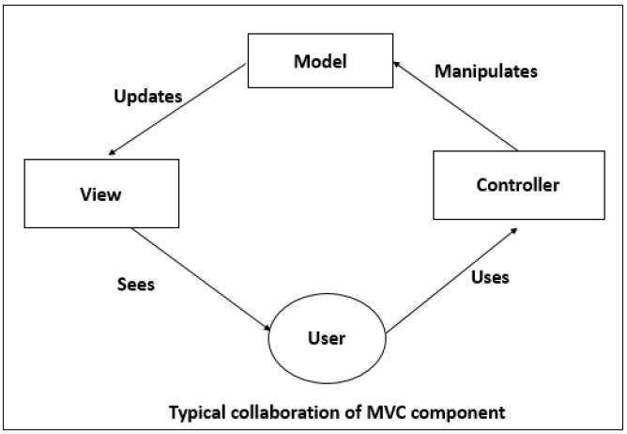

Figure 1 MVC System Architecture

The usage of the PCP website cycles through the MVC system architecture. For example, When the user searches for a product, that activates the controller to manipulate the model depending on the user’s search query. The Model then updates the view of the user in which the webpage would automatically display the search results. For each action the user makes, a single cycle through the MVC system architecture occurs.

# Data Dictionary

Brief description of each element in this module or a link to an actual data dictionary

(template of a database table description)

## Data Dictionary

Table 3 Data Dictionary

|  |  |  |  |  |  |  |  |  |  |  |
| --- | --- | --- | --- | --- | --- | --- | --- | --- | --- | --- |
| **TABLE NAME** | **ATTRIBUTE NAME** | **CONTENTS** | **TYPES** | **FORMAT** | **RANGE** | **REQUIRED** | **PK/FK** | **VALID VALUES** | **DEFAULT VALUE** | **REFERENCE TABLE** |
| USER | userID | Primary key of a user | INT | ### | 0-999 | Y | PK | NA | NA |  |
|  | userName | Username for a user | VARCHAR | X(15) | NA | Y | NA | NA | NA |  |
|  | userPassword | User’s password | VARCHAR | X(1000) | NA | Y | NA | NA | NA |  |
|  | lastName | Last name of a user | VARCHAR | X(20) | NA | Y | NA | NA | NA |  |
|  | firstName | First name of a user | VARCHAR | X(40) | NA | Y | NA | NA | NA |  |
|  | userType | Type of user | VARCHAR | X | NA | Y | NA | ‘A’,’R’,’G’ | ‘G’ |  |
| SUPERMARKET | supermarketID | Primary key for a supermarket | INT | ### | 0-999 | Y | PK | NA | NA |  |
|  | supermarketName | Name of a supermarket | VARCHAR | X(30) | NA | Y | NA | NA | NA |  |
|  | supermarketAddress | Address of a supermarket | VARCHAR | X(50) | NA | Y | NA | NA | NA |  |
| PRODUCT | productID | Primary key for a product | INT | #### | 0-9999 | Y | PK | NA | NA |  |
|  | productName | Name of a product | VARCHAR | X(30) | NA | Y | NA | NA | NA |  |
|  | productPrice | Price of a product | FLOAT | #####.## | 0-99999.99 | Y | NA | NA | NA |  |
|  | productAvailability | Availability of a product | BOOLEAN | True/False | NA | Y | NA | ‘True’, ‘False’ | NA |  |
|  | supermarketID | Supermarket ID where product is available | INT | ### | 0-999 | Y | FK | NA | NA | SUPERMARKET |
| FEEDBACK | feedbackID | Primary key for a feedback | INT | #### | 0-9999 | Y | PK | NA | NA |  |
|  | userID | Primary key for user | INT | #### | 0-9999 | Y | FK | NA | NA | USER |
|  | productName | Name of product | VARCHAR | X(30) | NA | Y | NA | NA | NA |  |
|  | productID | productid of product being reported | INT | ### | 0-999 | Y | FK | NA | NA | PRODUCT |
|  | feedbackType | Type of report being made | CHAR | X(5) | NA | Y | NA | NA | NA |  |

# User Interface Design

## User Interface Design Overview

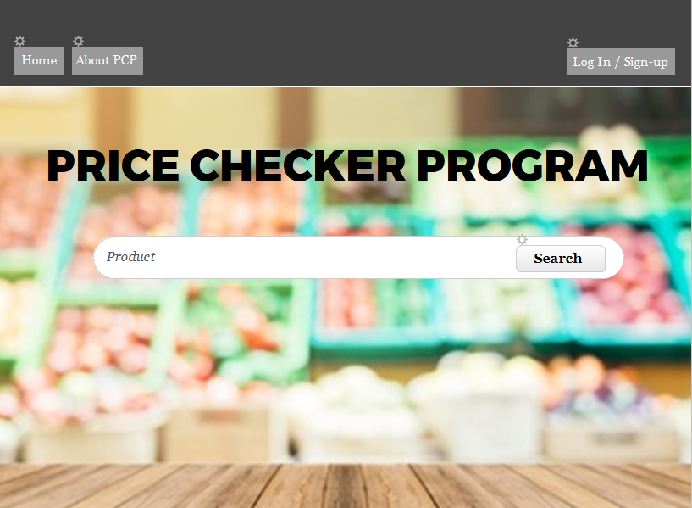

Figure 2 Home Page

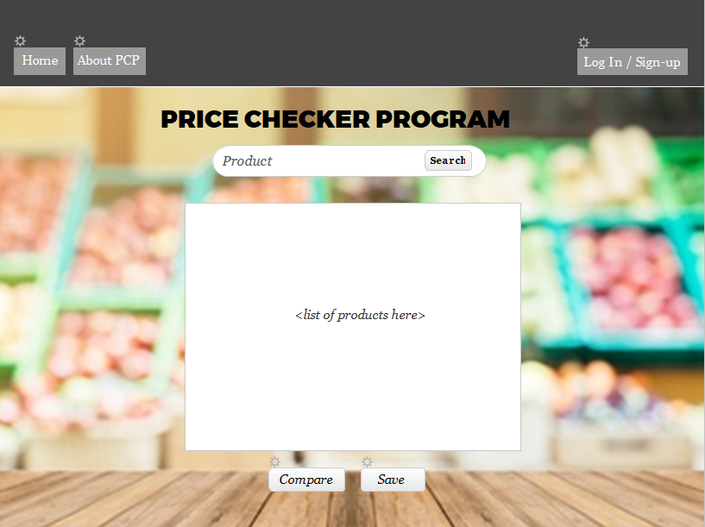

Figure 3 List Page

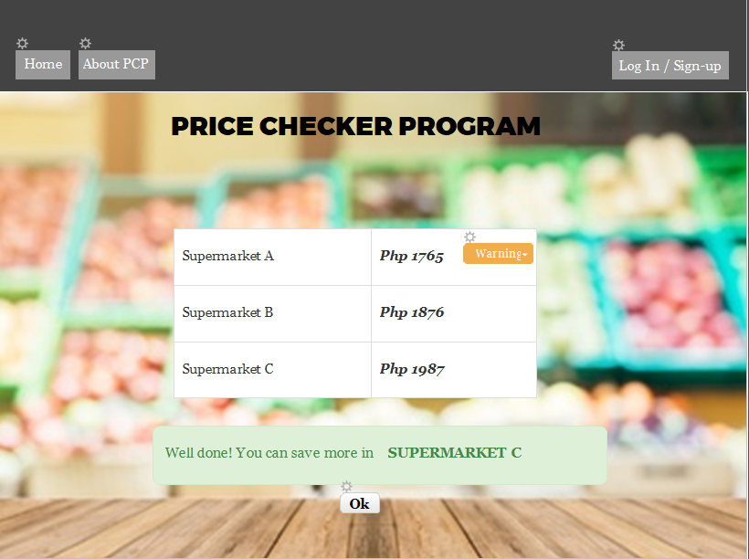

Figure 4 Comparison Page

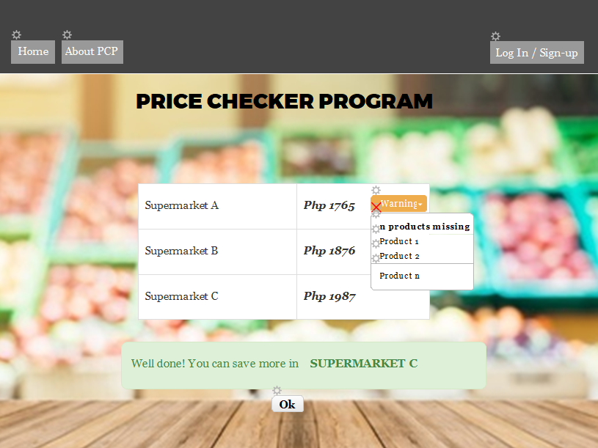

Figure 5 Product missing box

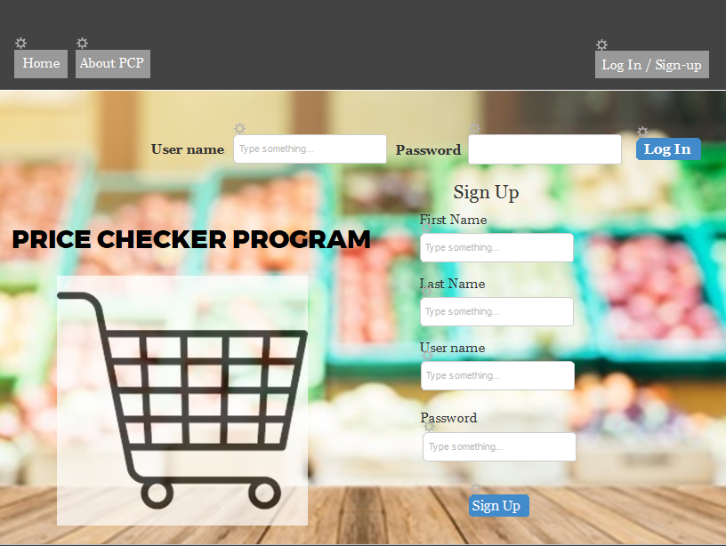

Figure 6 Log-in/Sign-up Page

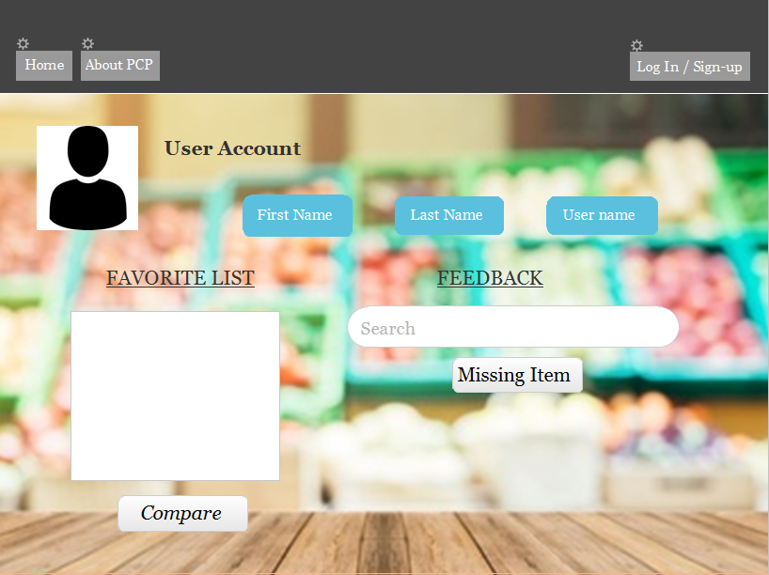

Figure 7 User account page

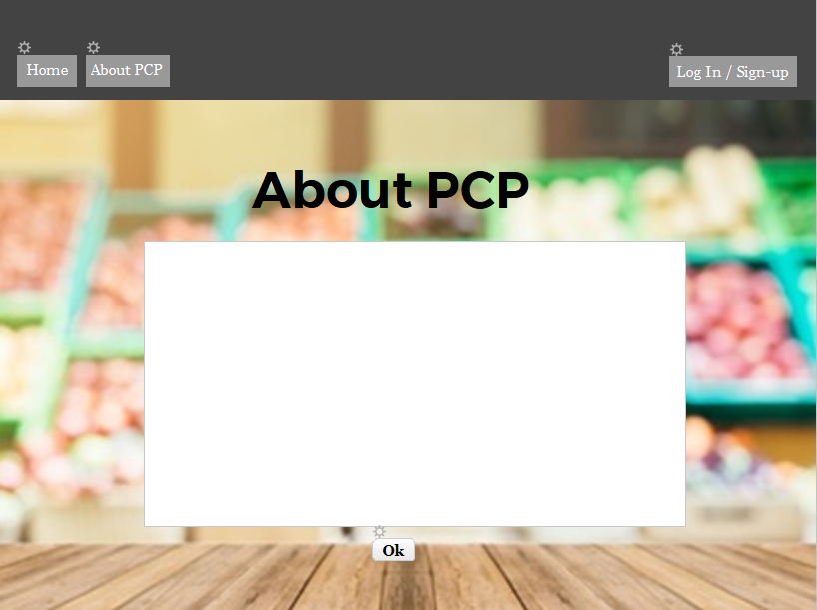

Figure 8 about pcp page

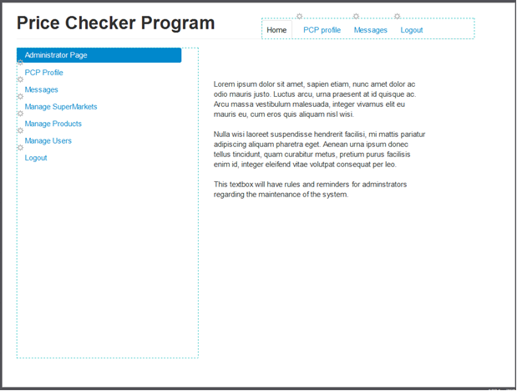

Figure 9 administrator page

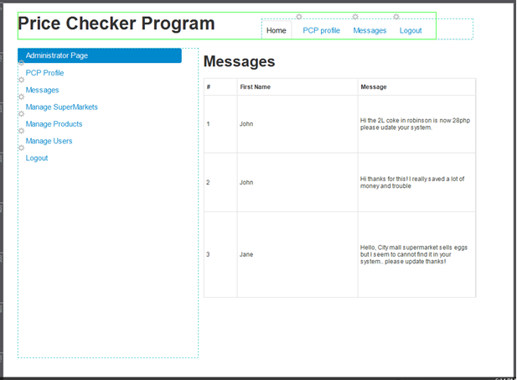

Figure 10 Messages page

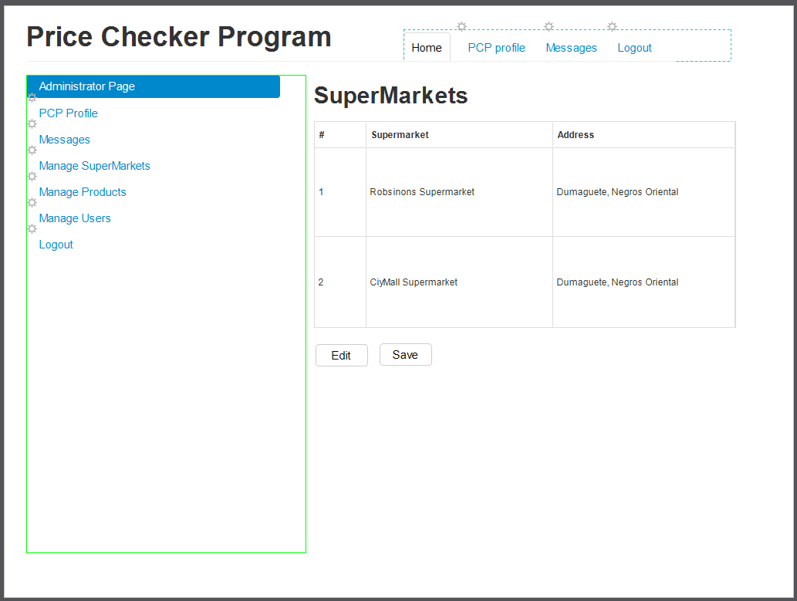

Figure 11 Manage supermarkets page

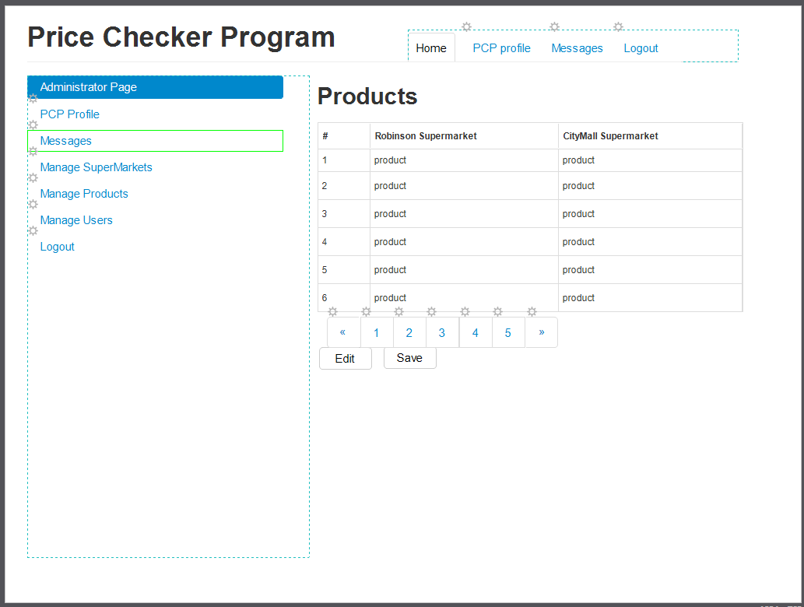

Figure 12 manage products page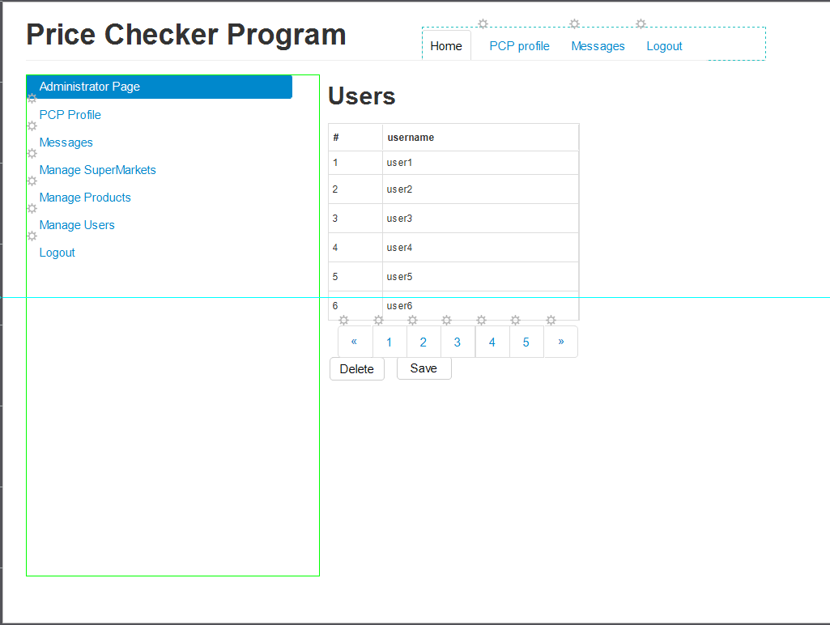

Figure 13 manage users page

## User Interface Navigation Flow

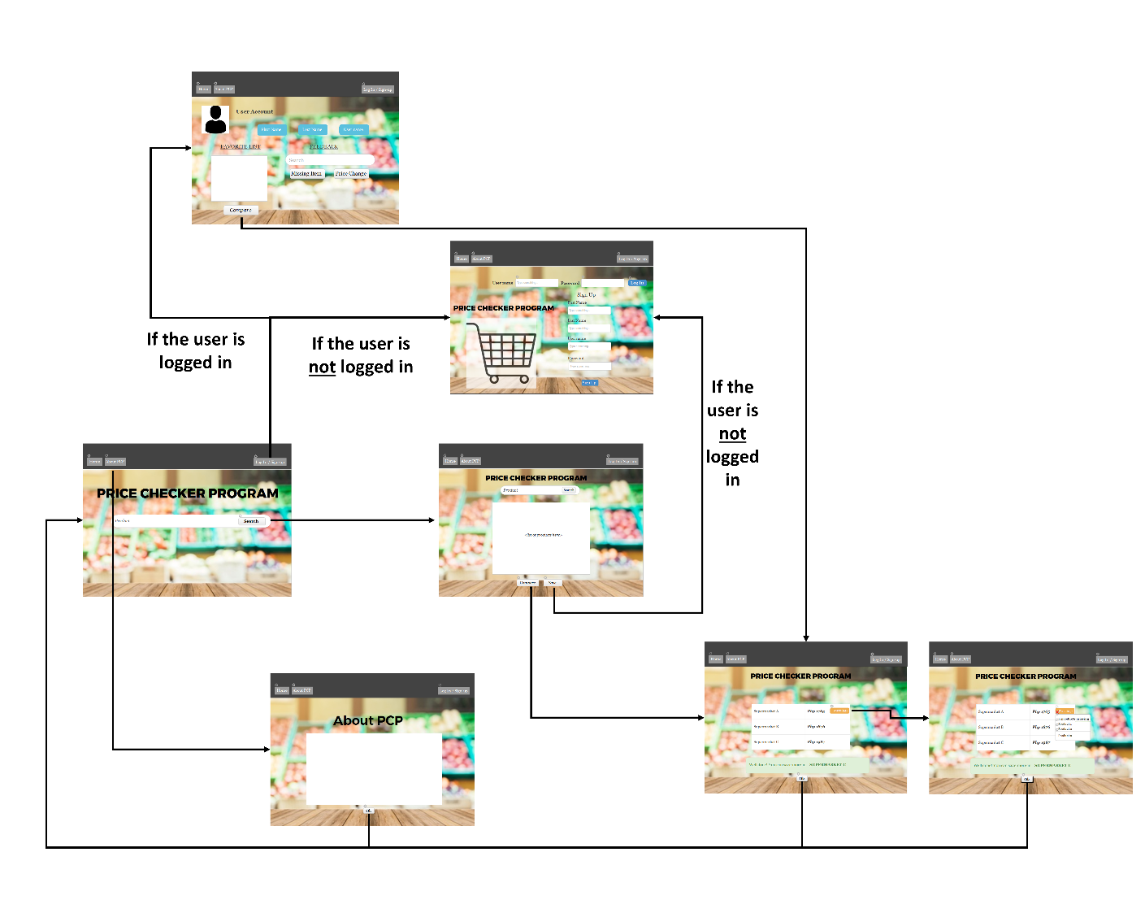

Figure 14 Navigation Flow for Users and Registered Users

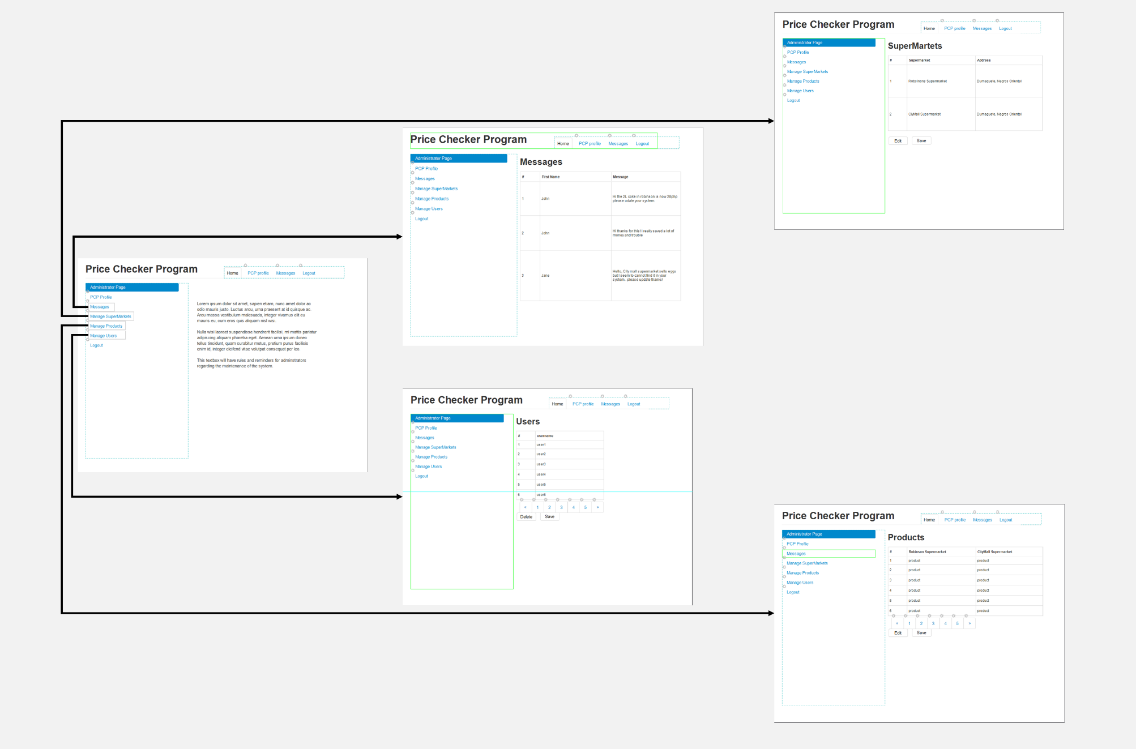

Figure 15 Navigation Flow for Administrators

## Use Cases / User Function Description

Describe screen usage / function using use cases, or on a per function basis

Home Page – The landing or the initial page that the user will see when visiting the website. In this page, the user may click the search box where he/she may search for a product. If a user will click the search button, the user will be sent to the list page.

* + Search Box – The user may type product names.
  + Search Button – The user may click to begin the search of a product.

List Page – The list of searched products will be shown in this page. After the user completes his/her search they may click the compare button to view the price comparisons between supermarkets available.

* + Search Box – The user may type product names to be searched.
  + Search Button – The user may click the button to search the product specified in the search box.
  + List Box – This box will contain the list of products searched by the user. Here, the user may delete items from the list.
  + Compare – This button allows the user to see the comparison of prices from the different supermarkets

Comparison Page – Shown in this page is the price comparison between the different supermarkets. A pop-up message showing which supermarket will help the user save more will appear below the price comparison table. A warning label will also appear if there is any product missing in a certain supermarket.

* + Warning label – The user can click the warning label to see the missing products in that certain supermarket
  + Comparison table – this table contains the different supermarkets and its corresponding total amount of the list of products the user has put into his/her list box
  + Ok button – When the user clicks the OK button, it will directly go back to the home page

Product Missing Message Box – The user can click the warning label to know which products are missing in that certain supermarket.

* + Comparison table – this table contains the different supermarkets and its corresponding total amount of the list of products the user has put into his/her list box
  + Warning label – when the user clicks this label, the products that are missing in that certain supermarket will be shown
  + Ok button – When the user clicks the OK button, it will directly go back to the home page

Log-in/Sign-up Page – The user can log-in to his/her account using his/her username and password. If the user has not signed-up yet then the user can also sign-up in this page by inputting his/her first name, last name, username and password.

* + User name box – if the user is already registered then he/she can type his/her username in this box
  + Password box – the user will input his/her password in this box
  + Log in button – after the user hast typed in his/her username and password, this log in button will be clicked and will then lead to the user account page
  + First name, last name, username, password box – if one wishes to be a registered user then he/she will input his details in these boxes
  + Sign up page – when the user is done inputting the details needed, the user will click this button and he/she is now a registered user and can already access the use account page

User Account Page – If the user has been already registered, the user may save their searched list of products and may be viewed in their account page. Here the user my click the compare button to do a quick comparison using their saved list to find the best price comparison between supermarkets. In the account page, the user may also provide feedback on missing items.

* + First name, last name and user name box – these boxes show the information details of the user
  + Compare button – when the user clicks this button, products in his/her favorite list will be compared and will go to the comparison page
  + Search box for feedback – this box will allow the user to search/ type in a product that he/she wishes to give a feedback
  + Missing item button – this button will allow the user to report that there is a product missing

About PCP Page – The about page basically shows what the Price Checker Program is about.

* + About PCP box – Text written in this box will tell the user exactly what PCP is
  + Ok button – When the user clicks the OK button, it will directly go back to the home page

Navigation Bar/ Header for guests/ registered users – This contain the Home, About PCP and Log in/Sign up tabs

* + Home tab – this will allow the user to go back directly to the home page
  + About PCP – when the user clicks this tab, then it will go the About PCP page
  + Log in/Sign up tab – this tab will go to the log in/ sign up page and will allow the user to log in if he/she is already a registered user or sign up if he/she has not already signed up

Administrator page – This page contains the PCP profile, Messages, Manage supermarkets, Manage products, Manage uses and Log out button.

* + About PCP – when the user clicks this tab, then it will go the About PCP page
  + Log in/Sign up tab – this tab will go to the log in/ sign up page and will allow the user to log in if he/she is already a registered user or sign up if he/she has not already signed up

Messages page – this page will show the feedback messages from the registered users

* + Messages box – this box will allow the admin to view the different feedback messages from the users; this a table showing the Name of the user and its corresponding feedback message

Manage supermarket page – This page will contain the list of supermarkets and the admin will be able to manage this list

* + Supermarket table – this table will show the list of different supermarkets with its corresponding addresses
  + Edit button – this button will allow the admin to edit the list of supermarkets
  + Save button – after the edits has been made, this button will allow the changes/edits made by the admin to be saved

Manage products page – This page will contain the list of products from the different supermarkets and the admin can do edits and save the changes

* + Products table – this table will show the list of different products in the different supermarkets
  + Edit button – this button will allow the admin to edit the list of products
  + Save button – after the edits has been made, this button will allow the changes/edits of products made by the admin to be saved

Manage users page – This page will contain the list of users that registered to the PCP system

* + List of users – the registered users will be seen from this list
  + Delete button – this button will allow the admin to delete a registered user from the list
  + Save button – when the admin has already deleted that specific user he/she wishes to delete then by clicking this button, the changes to the list of user will be saved

Navigation Bar/ Header for Admin – This contain the home page, PCP profile, messages, manage supermarket and user and products, and log out tab

* + Home tab – this page will show the admin home page
  + PCP profile tab –
  + Messages tab – this tab will go to the messages page
  + Manage supermarkets tab – will direct to the manage supermarkets page
  + Manage products tab – will direct to the manage products page
  + Manage users tab – will direct to the manage users page
  + Log out button – by clicking this button, the admin will log out from the admin system

# Extra Design Features / Outstanding Issues

Does not fit anywhere else above, but should be mentioned -- goes here

# References

Justinmind prototyper – used to design the user interfaces

Microsoft PowerPoint – used for designing user interface's navigation flow

# Glossary

* Supermarkets - places where customers can buy various goods.
* Groceries – products such as canned goods, frozen goods, spices, vegetables, snacks, and drinks.
* PCP – The Price Check Program
* SMS - Short Message Service; texts
* XAMPP – a free and open source cross-platform web server solution stack package consisting mainly of the Apache HTTP Server, MariaDB database, and interpreters for scripts written in the PHP and Perl programming languages.
* PHP – PHP: Hypertext Preprocessor; a language designed for web development.
* SQL – Structured Query Language; a language for managing data held in a database.
* ERD – Entity Relationship Diagram; a diagram that shows the relationship from one database table to another.
* 3NF – third normal form of an ERD.
* Data Dictionary – a “guide” on what the types of values are kept inside a database.

# Appendices

## Appendix A – Group Log

| **Date and Time** | **Activity** | **Member’s Name** | **Attendance and Contribution** | **Signature** |
| --- | --- | --- | --- | --- |
| **11/07/2018** |  | **Angel Ross** |  |  |
| **11/07/2018** |  | **Derick Ho** |  |  |
| **11/07/2018** |  | **Dan Chin** |  |  |

# Index