Table of Contents

Mean Length Estimation Using CPUE and Size Frequency Data
June 2026 · Seattle, WA

1. Introduction
This document describes the processing of Japanese longline size frequency and CPUE data to compute size composition of the catch based on both nominal and model-derived CPUE. The model-based CPUE is derived from a GAM (generalized additive model).

2. Data Input and Cleaning
As a first step, files are read in and labelled consistently.
knitr::opts_chunk$set(
echo = TRUE,
message = FALSE,
warning = FALSE
)
suppressPackageStartupMessages({
library(tidyverse)
library(janitor)
library(here)
})
library(tidyverse)
library(janitor)
library(here)
size_file_candidates <- c(
Sys.getenv("JP_SIZE_FILE", unset = NA_character_),
here("doc", "JP_Size_Age4plus.csv"),
here("scratch", "JP_Size_Age4plus.csv"),
here("JP_Size_Age4plus.csv"),
"JP_Size_Age4plus.csv"
)
size_file <- size_file_candidates[!is.na(size_file_candidates) & file.exists(size_file_candidates)][1]
model_file_candidates <- c(
Sys.getenv("JP_MODEL_EST_FILE", unset = NA_character_),
here("doc", "MeanPredictGAM2022_YMLL.csv"),
here("scratch", "MeanPredictGAM2022_YMLL.csv"),
here("MeanPredictGAM2022_YMLL.csv"),
"MeanPredictGAM2022_YMLL.csv"
)
model_file <- model_file_candidates[!is.na(model_file_candidates) & file.exists(model_file_candidates)][1]
if (is.na(size_file)) {
stop(
"Could not find JP_Size_Age4plus.csv. Set JP_SIZE_FILE or copy data to ",
here("doc", "JP_Size_Age4plus.csv"),
call. = FALSE
)
}
if (is.na(model_file)) {
stop(
"Could not find MeanPredictGAM2022_YMLL.csv. Set JP_MODEL_EST_FILE or copy data to ",
here("doc", "MeanPredictGAM2022_YMLL.csv"),
call. = FALSE
)
}
df1 <- read_csv(size_file, show_col_types = FALSE) |> clean_names()
names(df1) <- c("year", "month", "lat5", "lon5", "length", "freq", "prec", "hooks")
df2 <- read_csv(model_file, show_col_types = FALSE) |>
clean_names() |>
rename(value = mean_pred1)
latest_data_year <- min(max(df1$year, na.rm = TRUE), max(df2$year, na.rm = TRUE))
assessment_length_freq <- read_csv(here("csv_2026", "length_freq.csv"), show_col_types = FALSE)
latest_assessment_year <- max(assessment_length_freq$Year, na.rm = TRUE)
The Japanese size data currently loaded from /Users/jim/_mymods/CCSBT/sbt_2026/OMMP16/doc/JP_Size_Age4plus.csv run through 2025. The GAM CPUE data currently loaded from /Users/jim/_mymods/CCSBT/sbt_2026/OMMP16/doc/MeanPredictGAM2022_YMLL.csv run through 2025, so the joined GAM-weighted estimates run through 2025. The assessment length-frequency data loaded from /Users/jim/_mymods/CCSBT/sbt_2026/OMMP16/csv_2026/length_freq.csv run through 2025.

2.1 Spatial Adjustments and Filtering
The data is filtered to include only records after 1968, and the spatial coordinates are adjusted by shifting the latitude and longitude by -2.5 and +2.5 degrees, respectively:
df1 <- df1 |>
filter(year > 1968) |>
mutate(lat5 = lat5 - 2.5, lon5 = lon5 + 2.5)
df2 <- df2 |>
filter(year > 1968) |>
mutate(jap_cpue = value)

2.2 Normalized Length Frequencies by Cell
Each record is normalized to yield proportions at length within each spatial-temporal cell:
df1.1 <- df1 |>
group_by(year, month, lat5, lon5, length) |>
mutate(lft = sum(freq)) |>
ungroup() |>
group_by(year, month, lat5, lon5) |>
mutate(lfnorm = sum(freq), prop = lft / lfnorm)
propl=freqll​freql

2.3 Merge with CPUE Data
dfj <- df1.1 |> inner_join(df2, by = join_by(year, month, lat5, lon5))

3. Size composition from CPUE-weighted Frequencies
We compute length-frequency estimates weighted by (for eacy $i$ year-month-area grid):
- Nominal CPUE:
ui=i​catchi∑hooks
(by year, month, and 5x5 degree spatial block)
- Model-based CPUE: from the GAM model output we have the predicted CPUE by year, month, 5x5 cell to get ${\text{CPUE}}_{i}$. See jap_cpue code in previous section.
Then for each length bin:
lflnom=i​ui⋅propil,
lflgam=i​CPUEi⋅propil
And annual proportions:
plnom=lflnoml​lflnom, plgam=lflgaml​lflgam
Mean lengths (for a given year; index dropped for clarity):
Lnom=l​l⋅plnom, Lgam=l​l⋅plgam
As a diagnostic to compare with the GAM CPUE, we can also compute mean lengths from the assessment model’s length frequency data. This is done by summing the product of length and proportion for each year. Comparing these values shows that the mean lengths from the GAM CPUE data and the nominal CCSBT data are similar, but not identical. The GAM CPUE is a model-based estimate that may differ from the nominal CPUE due to smoothing and other adjustments in the GAM (Figure 1). Importantly, the fact that the GAM and the nominal composition data differ more substantially from the catch-at-length data from the CCSBT assessment model. This suggests that the GAM CPUE catch composition data should be used to align most appropriately with the Japanese-based CPUE data.
mnlen_cpue <- dfj %>%
group_by(year, month, lat5, lon5) |>
mutate(u = sum(freq) / mean(hooks)) |>
ungroup() |>
group_by(year, length) |>
mutate(
# lf_catch = sum(freq),
lf_u_nom = sum(u * prop),
lf_u_gam = sum(jap_cpue * prop)
) |>
ungroup() |>
group_by(year) |>
mutate(
# p_catch = lf_catch/sum(lf_catch),
p_u_nom = lf_u_nom / sum(lf_u_nom),
p_u_gam = lf_u_gam / sum(lf_u_gam)
) |>
summarise(
# mean_len_catch = sum(length*p_catch),
mean_len_u_nom = sum(length * p_u_nom),
mean_len_u_gam = sum(length * p_u_gam)
) |>
pivot_longer(cols = 2:3, names_to = "type", values_to = "Length")
# assessment_length_freq |>
# filter(Year > 1968, Fishery == 1)
mnlen_LL1 <- assessment_length_freq |>
filter(Year > 1968, Fishery == 1) |>
pivot_longer(cols = 4:113, names_to = "len", values_to = "proportion") |>
filter(proportion > 0) |>
mutate(year = Year, len = as.numeric(len)) |>
group_by(year) |>
summarise(type = "Model", Length = sum(len * proportion))
rbind(mnlen_cpue, mnlen_LL1) |>
ggplot(aes(x = year, y = Length, color = type)) +
geom_point() +
geom_line() +
ggthemes::theme_few()
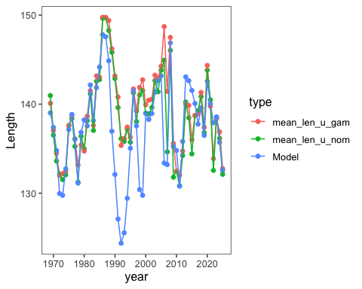
Figure 1: Mean lengths of SBT by year from the CCSBT data and the GAM CPUE data.

3.1 Length Frequency by GAM CPUE
To compute and optionally visualize full length frequency distributions weighted by GAM-predicted CPUE:
Length-frequency proportions by year are computed as:
propl,yeargam=i​CPUEi⋅propill​i​CPUEi⋅propil
📌 Notes
- floor(length / 2) * 2 groups lengths 40 and 41 into bin 40, 42 and 43 into 42, etc.
  - The prop_gam is the proportion at each 2-cm bin within each year:
propb,yeargam=freqbgamb​freqbgam
• Use length_bin for plotting or comparison to model outputs.

3.2 Format to bring into the assessment as a new set of length-composition data
We write as matrix with rows are years and columns length bins. For comparisons, we show the length frequency (in proportions) for the GAM CPUE data (Figure 2) and the assessment model input data (Figure 3).
# str(lf_gam)
lf_gam_wide <- lf_gam %>%
select(year, length_bin, prop_gam) %>%
pivot_wider(
names_from = length_bin,
values_from = prop_gam,
values_fill = 0
)
# lf_gam_wide
#sdf <- pivot_longer(df,names_to="age",values_to="sel",cols=2:(nages+1)) %>% filter(Year>=styr) %>% mutate(age=as.numeric(age)) #+ arrange(age,yr)
#names(lf_gam)
#write_csv(lf_gam_wide, "lf_gam_out.csv")
#write_csv(assessment_length_freq, "lf_assessment.csv")
flen=80;llen=190
library(ggridges)
p1 <- ggplot(lf_gam,aes(x=length_bin,y=as.factor(year),height = prop_gam)) + geom_density_ridges(stat = "identity",scale = 4, alpha = .7,
fill="salmon",color="black") + ggthemes::theme_few() +
ylab("Year") + xlab("Length (2-cm bin)") +
scale_x_continuous(limits=c(flen,llen),breaks=seq(flen,llen,6)) +
scale_y_discrete(limits=rev(levels(as.factor(lf_gam$year))))
p1
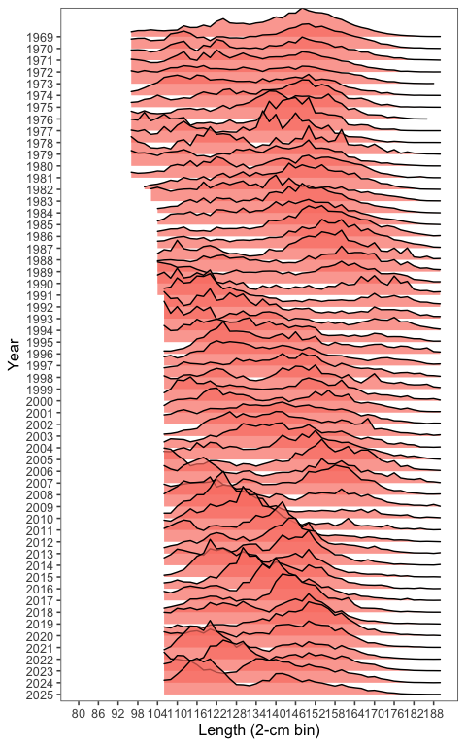
Figure 2: Length frequency matrix from GAM CPUE data.
lf_ass <- assessment_length_freq |>
filter(Year > 1968, Fishery == 1) |>
pivot_longer(cols = 4:113, names_to = "length_bin", values_to = "proportion")
p2 <- ggplot(lf_ass,aes(x=as.numeric(length_bin),y=as.factor(Year),height = proportion)) + geom_density_ridges(stat = "identity",scale = 4, alpha = .7,
fill="salmon",color="black") + ggthemes::theme_few() +
ylab("Year") + xlab("Length (2-cm bin)") +
scale_x_continuous(limits=c(flen,llen),breaks=seq(flen,llen,6)) +
scale_y_discrete(limits=rev(levels(as.factor(lf_ass$Year))))
p2
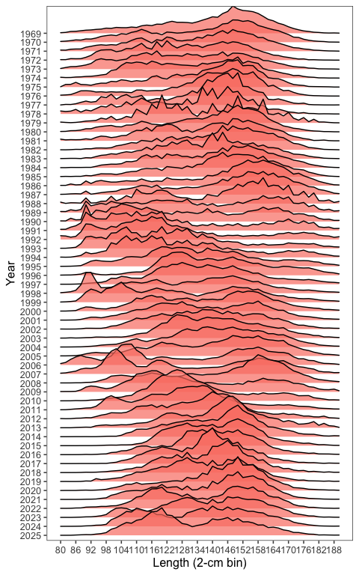
Figure 3: Length frequency matrix from the assessment model input.

4. Summary
This workflow merges catch-at-length observations with spatially resolved GAM model predictions to compute trends in average catch size. The final product includes both mean lengths and full length-frequency distributions weighted by GAM CPUE.

