##### New_DOE_Logo_Color_042808



**Intellectual Property Management Plan**

**February 28, 2011**

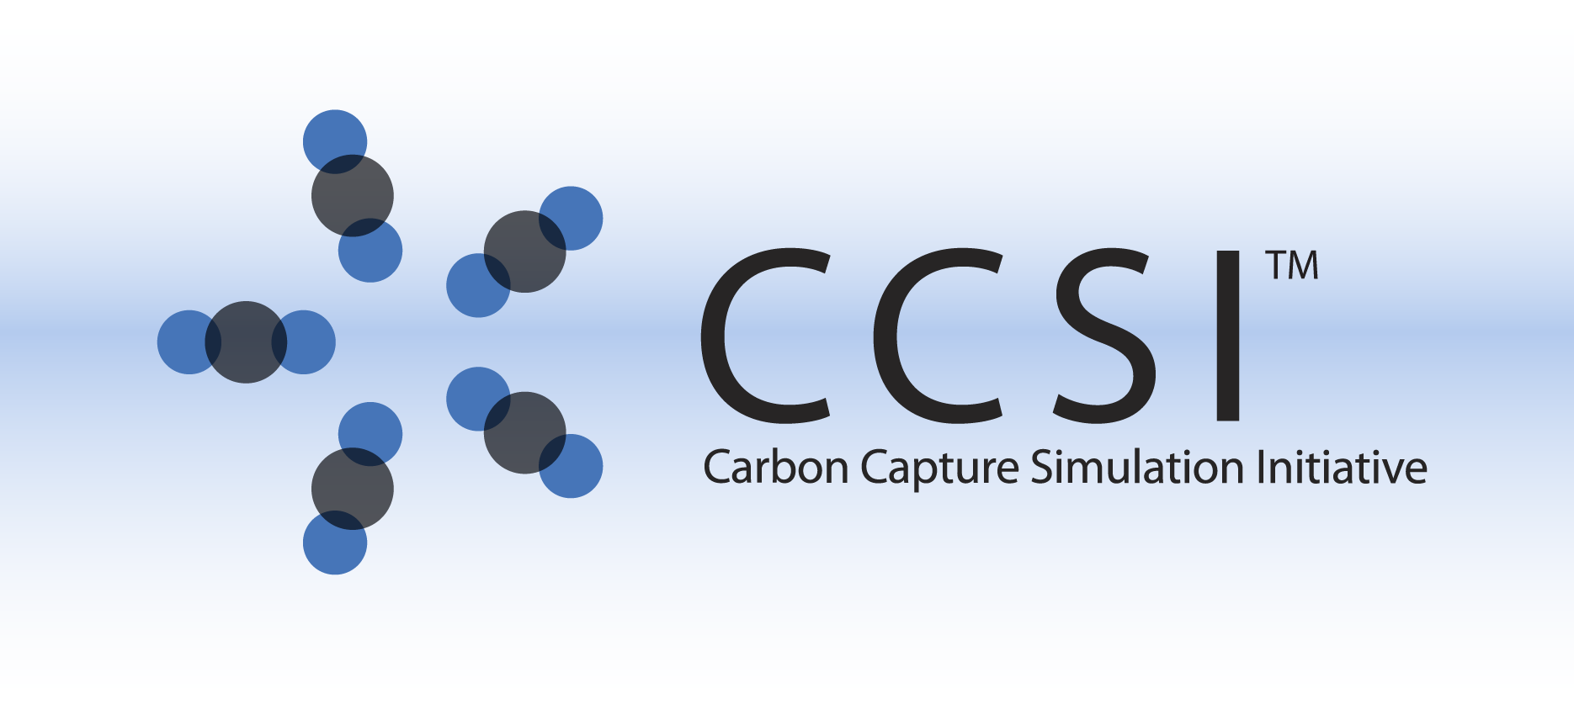

MFIX SIMULATIONS FOR C2U

INSTALLATION GUIDE

Version 2014.7.10

July 10, 2014

**This material was produced under the DOE Carbon Capture Simulation Initiative (CCSI), and copyright is held by the software owners: ORISE, LANS, LLNS, LBL, PNNL, CMU, WVU, et al. The software owners and/or the U.S. Government retain ownership of all rights in the CCSI software and the copyright and patents subsisting therein. Any distribution or dissemination is governed under the terms and conditions of the CCSI Test and Evaluation License, CCSI Master Non-Disclosure Agreement, and the CCSI Intellectual Property Management Plan. No rights are granted except as expressly recited in one of the aforementioned agreements.**

Table of Contents

[1. Installation 1-1](#_Toc363743243)

[1.1. Prerequisites 1-1](#_Toc363743244)

[1.2. Third Party Software 1-1](#_Toc363743245)

[1.3. Product Installation 1-1](#_Toc363743246)

[AX Cold Flow 1-1](#_Toc363743247)

[2. simulations 2-2](#_Toc363743248)

[3. references 3-2](#_Toc363743249)

# Installation

CCSI C2U simulations are custom MFIX simulations. For that reason, the general installation procedure in this user manual follows that of MFIX [1]. In this session, only the AX cold flow specific installation procedure will be covered in details, leaving the general MFIX steps referring to the MFIX manual. For more details about AX cold flow, please refer to the User Manual [2].

## Prerequisites

The hardware and software prerequisites follow exactly that of MFIX [1].

## Third Party Software

Open-source, multi-platform data analysis and visualization application ParaView is recommended for the MFIX simulation post-processing purpose. Users can download ParaView software online from <http://www.paraview.org/>.

Users can choose other similar visualization tools (for example, *Visit*) for the post-processing need.

## Product Installation

This session will only describe the steps to build CFD models for AX cold flow. It is assumed that users have downloaded official MFIX source files of 2013-2 release (<https://mfix.netl.doe.gov/download/mfix/mfix-archives/mfix_2013-2.tar.gz>), set environment variables and alias, and built mfix.exe on their chosen platform under $InstallDir/mfix/model. Users can build either a serial version or a parallel version of mfix.exe following instructions in [1].

Source code files for C2U simulations and this Installation Guide file are all available on this site: <https://www.acceleratecarboncapture.org/product/1mwcfd>.

## C2U Cold Flow

Create a directory for CCSI AX cold flow, for example, in LINUX, $HOME/CCSI/AXColdFlow. Obtain 32D\_kinetics.tar.gz from the above CCSI site, and unzip the file in this directory to get the following files:

calc\_mu\_s.f

drag\_gs.f

mfix.dat

species.inc

usr0.f

usr\_init\_namelist.f

usr\_mod.f

usrnlst.inc

usr\_rates.f

Note that the custom files are for 32D reaction flow simulations, and it has no impact on cold flow simulation. Since the PNNL CFD team was responsible of CFD simulations for all C2U simulations which include cold flow, hot but non-reacting flow, and 32D reaction flow, one set of mfix.exe is chosen by the team for consistency. An official mfix.exe built without any custom files is expected to yield the same simulation results for non-reacting flows.

In the AX cold flow directory (e.g., $HOME/CCSI/AXColdFlow), type “sh $InstallDir/model/make\_mfix” and follow instructions on [1] to build the model. The build process will compile object files and generate a custom mfix.exe in directory $InstallDir/mfix/model. Upon successful compilation, mfix.exe is also copied to $HOME/CCSI/AXColdFlow.

# simulations

The model input file mfix.dat for the AX cold flow is included in the zip file. Users can choose to run serial or parallel version of the CFD simulation. For more details, please refer to [1] for general MFIX simulations and [2] for AX cold flow specific topics.

# references

[1] MFIX – Multiphase Flow with Interphase eXchanges, Version MFIX-2012-1, January 2012. Download available <https://mfix.netl.doe.gov/>

[2] CCSI MFIX Simulations for AX Cold Flow USER MANUAL, version 0.1, PNNL, August 9, 2013.