





CCSI 2MPZ

User Manual

Version 2.0.0

March 2018

Copyright (c) 2012 - 2018

**Copyright Notice**

2MPZ was produced under the DOE Carbon Capture Simulation Initiative (CCSI), and is copyright (c) 2012 - 2018 by the software owners: Oak Ridge Institute for Science and Education (ORISE), Los Alamos National Security, LLC., Lawrence Livermore National Security, LLC., The Regents of the University of California, through Lawrence Berkeley National Laboratory, Battelle Memorial Institute, Pacific Northwest Division through Pacific Northwest National Laboratory, Carnegie Mellon University, West Virginia University, Boston University, the Trustees of Princeton University, The University of Texas at Austin, URS Energy & Construction, Inc., et al.. All rights reserved.

NOTICE. This Software was developed under funding from the U.S. Department of Energy and the U.S. Government consequently retains certain rights. As such, the U.S. Government has been granted for itself and others acting on its behalf a paid-up, nonexclusive, irrevocable, worldwide license in the Software to reproduce, distribute copies to the public, prepare derivative works, and perform publicly and display publicly, and to permit other to do so.

**License Agreement**

2MPZ Copyright (c) 2012 - 2018, by the software owners: Oak Ridge Institute for Science and Education (ORISE), Los Alamos National Security, LLC., Lawrence Livermore National Security, LLC., The Regents of the University of California, through Lawrence Berkeley National Laboratory, Battelle Memorial Institute, Pacific Northwest Division through Pacific Northwest National Laboratory, Carnegie Mellon University, West Virginia University, Boston University, the Trustees of Princeton University, The University of Texas at Austin, URS Energy & Construction, Inc., et al. All rights reserved.

Redistribution and use in source and binary forms, with or without modification, are permitted provided that the following conditions are met:

1. Redistributions of source code must retain the above copyright notice, this list of conditions and the following disclaimer.
2. Redistributions in binary form must reproduce the above copyright notice, this list of conditions and the following disclaimer in the documentation and/or other materials provided with the distribution.
3. Neither the name of the Carbon Capture Simulation Initiative, U.S. Dept. of Energy, the National Energy Technology Laboratory, Oak Ridge Institute for Science and Education (ORISE), Los Alamos National Security, LLC., Lawrence Livermore National Security, LLC., the University of California, Lawrence Berkeley National Laboratory, Battelle Memorial Institute, Pacific Northwest National Laboratory, Carnegie Mellon University, West Virginia University, Boston University, the Trustees of Princeton University, the University of Texas at Austin, URS Energy & Construction, Inc., nor the names of its contributors may be used to endorse or promote products derived from this software without specific prior written permission.

THIS SOFTWARE IS PROVIDED BY THE COPYRIGHT HOLDERS AND CONTRIBUTORS "AS IS" AND ANY EXPRESS OR IMPLIED WARRANTIES, INCLUDING, BUT NOT LIMITED TO, THE IMPLIED WARRANTIES OF MERCHANTABILITY AND FITNESS FOR A PARTICULAR PURPOSE ARE DISCLAIMED. IN NO EVENT SHALL THE COPYRIGHT OWNER OR CONTRIBUTORS BE LIABLE FOR ANY DIRECT, INDIRECT, INCIDENTAL, SPECIAL, EXEMPLARY, OR CONSEQUENTIAL DAMAGES (INCLUDING, BUT NOT LIMITED TO, PROCUREMENT OF SUBSTITUTE GOODS OR SERVICES; LOSS OF USE, DATA, OR PROFITS; OR BUSINESS INTERRUPTION) HOWEVER CAUSED AND ON ANY THEORY OF LIABILITY, WHETHER IN CONTRACT, STRICT LIABILITY, OR TORT (INCLUDING NEGLIGENCE OR OTHERWISE) ARISING IN ANY WAY OUT OF THE USE OF THIS SOFTWARE, EVEN IF ADVISED OF THE POSSIBILITY OF SUCH DAMAGE.

You are under no obligation whatsoever to provide any bug fixes, patches, or upgrades to the features, functionality or performance of the source code ("Enhancements") to anyone; however, if you choose to make your Enhancements available either publicly, or directly to Lawrence Berkeley National Laboratory, without imposing a separate written license agreement for such Enhancements, then you hereby grant the following license: a non-exclusive, royalty-free perpetual license to install, use, modify, prepare derivative works, incorporate into other computer software, distribute, and sublicense such enhancements or derivative works thereof, in binary and source code form. This material was produced under the DOE Carbon Capture Simulation

Table of Contents

2MPZ 1

1.0 Abstract 1

2.0 Reporting Issues 2

3.0 Version Log 2

2-MPZ Model 3

1.0 Introduction 3

1.1 Predicting CO2 Solubility 3

1.2 Features List 5

2.0 Tutorial 6

2.1 Absorber Simulation 6

2.2 Stripper Simulation 13

3.0 Usage Information 19

3.1 Environment/Prerequisites 19

3.2 Support 19

3.3 Restrictions 19

3.4 Next Steps 19

4.0 Debugging 20

4.1 How to Debug 20

4.2 Known Issues 21

4.3 Reporting Issues 21

5.0 Model History 22

5.1 Thermodynamic Model 22

5.2 Kinetic Model 25

6.0 References 31

List of Figures

Figure 1: CO2 solubility in 8 m 2MPZ. 5

Figure 2: A simple absorber. 6

Figure 3: Excerpt of stream results. 11

Figure 4: Design specification REMOVAL results. 12

Figure 5: Packed column rating results. 12

Figure 6: Stripper simulation flowsheet. 13

Figure 7: Excerpt of stream results. 17

Figure 8: The design specification results. 17

Figure 9: Excerpt from packed column rating results. 18

Figure 10: Thermodynamic heat of absorption of 8 m 2MPZ calculated from Equation 1. 23

Figure 11: Calorimetric heat of absorption of 8 m 2MPZ calculated from Equation 2. 23

Figure 12: The absolute differences between the two heat of absorption calculations, which agree well until a loading of 0.25 mol CO2/mol alkalinity, where the zwitterion becomes significant. 24

Figure 13: WWC process flow diagram for Aspen Plus. 25

Figure 14: Boundary layer discretization. The x-axis is fraction through the boundary layer with the gas-liquid interface at left and the bulk liquid at right. 26

Figure 15: Brønsted plot showing the reaction rate constant (kAm-b) versus the pKa of a base for an amine catalyzed by a base, kAm-base. 27

Figure 16: 8 m 2MPZ kinetic fit. There is a linear bias with temperature. Filled points represent absorption, open points desorption. Dashed lines delineate the target range ±20%. 29

Figure 17: 8 m 2MPZ kinetic fit. Model flux ratioed to experimental flux shows no clear trend with loading. Filled points represent absorption, open points desorption. The dashed lines delineate the target range ±20%. 30

List of Tables

Table 1: Excerpt of 2MPZ VLE Results 4

Table 2: Boundary Layer Discretization 9

Table 3: Variables for the LOADINGS Calculator 15

Table 4: The Thunder Moon Chemistry Block 22

Table 5: Reaction Set for 2MPZ with Forward Reactions above the Rule 28

Table 6: Diffusivity Parameter Values 28

To obtain support for the products within this package, please send an e-mail to   
[ccsi-support@acceleratecarboncapture.org](mailto:ccsi-support@acceleratecarboncapture.org).

2MPZ

1. Abstract

2MPZ Aspen Plus Process Model: This is an Aspen Plus absorption/stripping model for CO2 capture from natural gas or coal-fired power plants using the solvent 8 molal 2-methylpiperazine (2MPZ). This model can be used for techno-economic assessments, pilot plant data reconciliation, and process design. The solvent has greater oxidative stability than MEA, is thermally stable up to 151°C, has a greater viscosity-normalized capacity (0.89 mol CO2/kg solvent vs 0.62 mol CO2/kg solvent), and has 37% faster mass transfer than 7 molal MEA. The solvent suffers from higher cost than MEA, five-times higher viscosity, and solid precipitation at very low CO2 loading. The model was constructed using sequential regression of bench-scale experimental thermodynamic and mass transfer data. The thermodynamics are modeled using the asymmetric eNRTL model to fit CO2 solubility data. A custom flowsheet simulates the wetted-wall column used for mass-transfer data collection. The diffusion of amine and kinetic rate constants were regressed to match the experimental CO2 flux data. Activity-based kinetics were used to account for the high non-ideality of the system.

1. Reporting Issues

To report an issue, please send an e-mail to [ccsi-support@acceleratecarboncapture.org](mailto:ccsi-support@acceleratecarboncapture.org).

1. Version Log

| Product | Version Number | Release Date | Description |
| --- | --- | --- | --- |
| 2MPZ CO2 Capture Simulation | 2.0.0 | 3/31/2018 | Initial Open Source release |
| 2MPZ CO2 Capture Simulation | 2014.10.0 | 10/31/2014 | 2014 October IAB Release – The Aspen Plus® model is now built in V8.4. |
| 2MPZ CO2 Capture Simulation | 2013.10.0 | 10/10/2013 | Initial release. |

2-MPZ Model

**Management Plan**

**February 28, 2011**

1. Introduction

This document describes a 2-methylpiperazine (2MPZ) CO2 capture system process simulation. The amine scrubbing system is divided into separate absorber and stripper simulations. The model consists of the “ThunderMoon.bkp” file with supporting subroutines “full.dll” and “2mpzloc.opt.” This manual was written using Aspen Plus® V7.3.

* 1. Predicting CO2 Solubility

Knowing the solubility of CO2 enables the user to select a loading range, as well as a stripper temperature and pressure. In this five minute example, a property analysis block is used to generate a series of isotherms for a fixed amine concentration and variable loading.

1. Open the “ThunderMoon.bkp” file, press “F8” to open the Data Browser, and then under “Setup” change the “Run type” to “Property Analysis.”
2. In the left pane, navigate to “Properties” → “Analysis.” Click “New” to create a new analysis block. Enter its “ID” as “82MPZVLE” and then select the “type” as “generic.” Change the “system basis” to “Mass” and then set “H2O” to “1000 kg/sec.”
3. On the “Variable” tab, change “Temperature” to “Vapor Fraction” and then set “Vapor Fraction” to “1e-05.” Create three variables: (1) Temperature, (2) Mole Flow 2MPZ, and (3) Mole Flow CO2. Select these variables and then click “Range/List” at the bottom of the window to define them.
   1. Temperature is a list: 293.15, 313.15, 333.15, 353.15, 373.15
   2. Mole Flow 2MPZ is a list: 8
   3. Mole Flow CO2 is a range: Lower=0, Upper=8, Points=20
4. On the “Tabulate” tab, select “PPCO2-KP” for the partial pressure of CO2 in kilopascals.
5. Run the simulation. A pop-up window displays, “Table generation completed with warnings. Results are present. Display Run-Status results form?” Click “Cancel.”
6. To view the results, navigate to “Properties” → “Analysis” → “82MPZVLE” → “Results.” Some of the results are shown in Table 19. Using additional graphing software, the user can plot results as shown in Figure 47.

Table 1: Excerpt of 2MPZ VLE Results

| Temp  K | Mole Flow 2MPZ kmol/sec | Mole Flow CO2 kmol/sec | Vapor PPMX CO2 kPa |
| --- | --- | --- | --- |
| 293.15 | 8 | 0 | 0 |
| 293.15 | 8 | 0.4 | 0.000101 |
| 293.15 | 8 | 0.8 | 0.000312 |
| 293.15 | 8 | 1.2 | 0.000629 |
| 293.15 | 8 | 1.6 | 0.001112 |
| 293.15 | 8 | 2 | 0.001886 |
| 293.15 | 8 | 2.4 | 0.003193 |
| 293.15 | 8 | 2.8 | 0.005527 |
| 293.15 | 8 | 3.2 | 0.009976 |
| 293.15 | 8 | 3.6 | 0.019235 |
| 293.15 | 8 | 4 | 0.040809 |
| 293.15 | 8 | 4.4 | 0.097194 |
| 293.15 | 8 | 4.8 | 0.249722 |
| 293.15 | 8 | 5.2 | 0.607471 |
| 293.15 | 8 | 5.6 | 1.256137 |
| 293.15 | 8 | 6 | 2.213122 |
| 293.15 | 8 | 6.4 | 3.523392 |
| 293.15 | 8 | 6.8 | 5.433286 |
| 293.15 | 8 | 7.2 | 8.835594 |
| 293.15 | 8 | 7.6 | 18.2461 |
| 293.15 | 8 | 8 | 188.3118 |

Figure 1: CO2 solubility in 8 m 2MPZ.

Using Property Analysis blocks, the user can explore many other properties of the solvent, such as vapor pressure or viscosity.

* 1. Features List

This product is a thermodynamic and kinetic model of 2MPZ for amine scrubbing; therefore, it represents the CO2 solubility, speciation, amine vapor pressure, heat capacity, pKa, heat of absorption, density, and viscosity for 2MPZ. While the model can extrapolate over a range of amine concentration, loading, and temperature, it is based on data collected primarily at 8 m 2MPZ with loadings ranging from 0 to 0.4 mol CO2/mol alkalinity.

1. Tutorial

This tutorial assumes basic knowledge of Aspen Plus software. Consult the Aspen Plus documentation, “Getting Started Building and Running a Process Model,” for additional information.

* 1. Absorber Simulation

Description

This example describes how to simulate a rate-based absorber. It includes tips on converging simulations, using design specifications to meet process criteria, and determining the proper discretization to be used for rate-based calculations.

Examples

*Setup*

1. Build the flowsheet of Figure 48, using an ABSBR1 RadFrac column. In the “Model Library” pane at the bottom of the window, navigate to “Columns” → “RadFrac” → “ABSBR1.” (If the model library is not visible, press “F10.”) Place the block on the flowsheet and name it “ABSORBER.” If a prompt to name the flowsheet does not display, right-click the block and then select “Rename Block.”

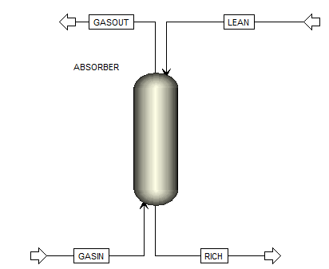

Figure 2: A simple absorber.

1. Select “Material STREAMS” in the model library. Create GASIN by clicking the arrow on the left of the block (the feed) and then clicking elsewhere. Create RICH by clicking the arrow at the bottom (the bottoms). Create GASOUT by clicking the arrow at the top (the vapor distillate). Lastly, create LEAN by clicking the now blue arrow on the left (the feed).
2. Double-click “GASIN” to configure it as follows:
   1. Temperature: 40 C
   2. Pressure: 1 atm
   3. Total flow: 5 kmol/sec
   4. Composition: Mole-Frac
      1. H2O: 7.3
      2. CO2: 12
      3. N2: 80.7

**Note:** Aspen normalizes the mole fractions to one.

1. Select “LEAN” from the left pane and configure it as follows:
   1. Temperature: 40 C
   2. Pressure: 1 atm
   3. Total flow: 20 kmol/sec
   4. Composition: Mole-Frac
      1. H2O: 55.556
      2. CO2: 4.32
      3. 2MPZ: 8
2. In the left pane, navigate to “Blocks” → “ABSORBER” and then configure its “Setup” as follows:
   1. On the “Configuration” tab:
      1. Calculation type: Rate-Based
      2. Number of stages: 30
      3. Condenser: none
      4. Reboiler: none
   2. On the “Streams” tab:
      1. GASIN On-Stage 30
      2. LEAN On-Stage 1
   3. On the “Pressure” tab, set the “Top stage pressure” to “1 atm.”
3. Configure the absorber Reactions with two sections:
   1. One starts on stage 1 and ends on stage 3 with Reaction ID ZERO.
   2. The other starts on stage 4 and ends on stage 30 with Reaction ID ZERO.

**Note:** This reaction set is used to ease convergence of the simulation. It is the 2MPZ reaction set with all activation energies and reaction pre-exponentials set to “0.”

1. Create a new pack rating section 1. Configure its “Specifications” as follows:
   1. Starting stage: 1
   2. Ending stage: 30
   3. Type: MELLAPAK
   4. Vendor: SULZER
   5. Material: STANDARD
   6. Dimension: 250X
   7. Section diameter: 8 meter
   8. Section packed height: 15 meter

**Note:** As the column is packed, the number of stages does not represent trays. It is purely a computational construct. The more stages, the more finely discretized the column. However, this results in more computation time. As a very rough approximation, one stage for every half meter of packing is recommended. Use more stages for greater temperature and mass transfer gradients.

* 1. Navigate to “Rate-based” from the left pane (“Pack Rating” → “1” → “Rate-based”). Configure it as follows:
     1. Select the “Rate-based calculations” check box.
     2. Flow model: Countercurrent
     3. Film resistance:
        1. Liquid phase: Discrxn
        2. Vapor phase: Film
  2. On the “Holdups” tab, set the “Holdup Method Correlation” to “Percent-Data” and then set the “Liquid Phase” to “Correlation with % of free volume set to 5.”
  3. On the “Design” tab, select the “Design mode” check box to calculate column diameter with Base Stage as 30.
  4. On the “Optional” tab, set the “Additional discretization points” to the “32” shown in Table 20.

Table 2: Boundary Layer Discretization

| Point | Liquid Film |  |  | Point | Liquid Film |
| --- | --- | --- | --- | --- | --- |
| 1 | 6.40E-05 |  |  | 17 | 0.0106 |
| 2 | 7.68E-05 |  |  | 18 | 0.0127 |
| 3 | 0.000159 |  |  | 19 | 0.0152 |
| 4 | 0.000229 |  |  | 20 | 0.0182 |
| 5 | 0.00033 |  |  | 21 | 0.0219 |
| 6 | 0.000476 |  |  | 22 | 0.0263 |
| 7 | 0.000571 |  |  | 23 | 0.0315 |
| 8 | 0.0007 |  |  | 24 | 0.0378 |
| 9 | 0.000986 |  |  | 25 | 0.0454 |
| 10 | 0.00118 |  |  | 26 | 0.059 |
| 11 | 0.00142 |  |  | 27 | 0.0826 |
| 12 | 0.00187 |  |  | 28 | 0.124 |
| 13 | 0.0027 |  |  | 29 | 0.198 |
| 14 | 0.00389 |  |  | 30 | 0.317 |
| 15 | 0.0056 |  |  | 31 | 0.507 |
| 16 | 0.00806 |  |  | 32 | 0.862 |

1. Under “Flowsheeting,” navigate to “Options” → “Calculator” and then create a new Calculator named “C-RM.” This block calculates the fraction of CO2 captured.
   1. On the “Define” tab, create three variables:

|  |  |  |
| --- | --- | --- |
| Variable Name | Information Flow | Definition |
| REMOVE | Export | Parameter Parameter no. = 2 |
| CO2IN | Import | Mole-Flow Stream = GASIN; Substream = MIXED; Component = CO2 Units=kmol/sec |
| CO2OUT | Import | Mole-Flow Stream = GASOUT; Substream = MIXED; Component = CO2 Units=kmol/sec |

* 1. On the “Calculate” tab, type “F REMOVE=(CO2IN-CO2OUT)/CO2IN.”

**Note:** Between “F” and “REMOVE” there are five spaces.

1. Create a Design Spec named “REMOVAL.”
   1. On the “Define” tab, create a variable “REMOVE” and assign it to parameter 2.
   2. On the “Spec” tab:
      1. Spec: REMOVE
      2. Target: 0.90
      3. Tolerance: 0.000001
   3. On the “Vary” tab:
      1. Type: Stream-Var
      2. Stream: LEAN
      3. Variable: MOLE-FLOW
      4. Lower: 5
      5. Upper: 300

*Running the Simulation*

1. Deactivate the design spec by right-clicking the design spec and then selecting “Deactivate.”
2. Run the simulation, which provides Aspen a good initial guess.
3. Change the absorber “Reactions” to “R-1” from ZERO for stages one to three. Run the simulation.
4. Change the absorber “Reactions” to “R-1” from ZERO for the remaining stages. Run the simulation.
5. Increase the “section packed height” under the pack rating to “12 m,” and then run the simulation.
6. Review the C-RM calculator block results (“Flowsheeting Options” → “Calculator” →   
   “C-RM” → “Results” on the “Define Variable” tab) to determine if the fractional CO2 removal is approximately 0.51.
   1. Increase the LEAN stream total flow in 10 kmol/sec increments until the percent removal is within 0.10 of 0.90. Be sure to run the simulation after each increment.
7. Once approximately 90% removal has been achieved, activate the Design Spec REMOVAL by right-clicking “Design Spec” → “Removal” and then selecting “Activate.” Run the simulation.
8. The converged absorber should now be removing 90% of the incoming CO2. Results should be similar to those shown in Figures 49–51 below. View the results by selecting   
   “Results Summary” → “Streams, Flowsheeting Options” → “Design Spec” → “Removal” → “Results, and Blocks” → “ABSORBER” → “Pack Rating” → “1” → “Results.”

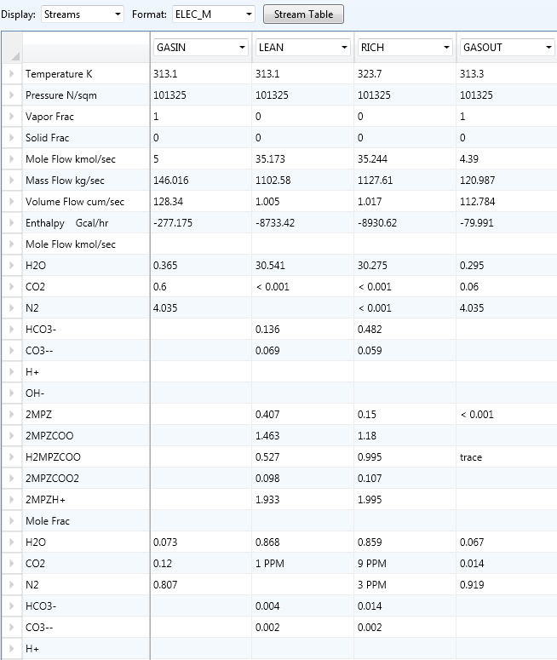

Figure 3: Excerpt of stream results.

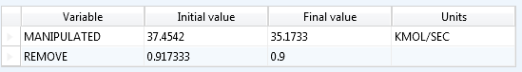

Figure 4: Design specification REMOVAL results.

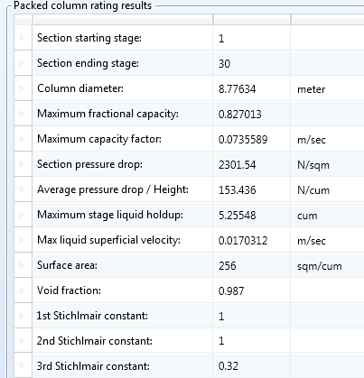

Figure 5: Packed column rating results.

* 1. Stripper Simulation

Description

This example is a guide to simulating a simple stripper and a heat exchanger.

Examples

*Setup*

1. Open the “ThunderMoon.bkp” file.
2. Construct the flowsheet shown in Figure 52. From “Columns” in the “Model Library,” select “RadFrac” → “STRIP1” for the stripper. From “Heat Exchangers,” select “Heater” for   
   “CX-COLD,” “CX-HOT,” and “HX-TRIM.” From “Pressure Changers,” select “pump” for “LEANPUMP.” Create the streams using “Material STREAMS.”

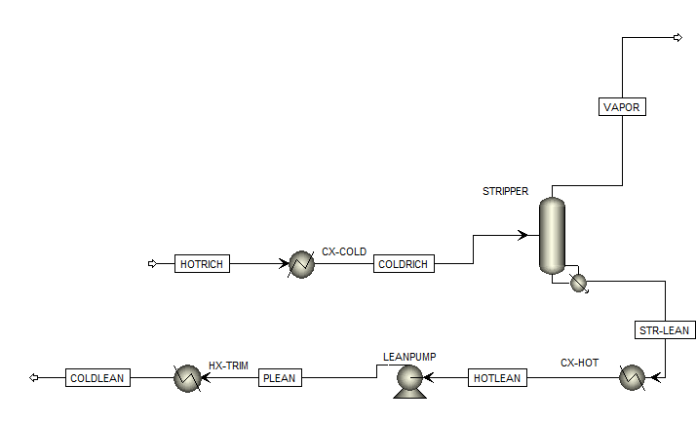

Figure 6: Stripper simulation flowsheet.

1. Set “HOTRICH” to the values from the absorber example.
   1. Temperature: 323.7 K
   2. Pressure: 11 bar
   3. Total flow: 35.244 kmol/sec
   4. Composition: Mole-Frac
      1. H2O 55.556
      2. CO2 5.29
      3. 2MPZ 8

**Note:** The pressure is set as if coming from a pump. This pump is neglected for simplicity.

1. Set “CX-COLD”:
   1. Pressure: 0 N/sqm
   2. Temperature: 85 C
   3. Valid phases: Liquid-Only

**Note:** Pressure drop is neglected.

1. Configure the “STRIPPER Setup” as follows:
   1. On the “Configuration” tab:
      1. Calculation type: Rate-Based
      2. Number of stages: 15
      3. Condenser: None
      4. Reboiler: Kettle
      5. Reboiler duty: 225 MW
   2. On the “Streams” tab, set “COLDRICH” to “stage 1 as liquid.”
   3. On the “Pressure” tab, set the “top stage pressure” to “3 bar.”
2. Set reactions in the stripper to stages 1–15 using “Chemistry ID REDUCED.”
3. Create a new Pack Rating for the stripper and configure it as follows:
   1. Under “Setup,” stages 1–14 use “MELLAPAK,” “SULZER,” “STANDARD,” “250X” with a “diameter” of “5 m,” and a “section packed height” of “2 m.”
   2. Under “Rate-Based,” select the “Rate-based calculations” check box with “Film Resistance” set to “Film for liquid and vapor phases.” On the “Design” tab, select the “Design mode” check box to calculate column diameter and then set the “base stage” to “14.”
4. Configure “CX-HOT”:
   1. Temperature: 50 C
   2. Pressure: 0 N/sqm
5. Configure “LEANPUMP”:
   1. Discharge pressure: 250 kPa
6. Configure “HX-TRIM”:
   1. Temperature: 40 C
   2. Pressure: 0 N/sqm

**Note:** This flowsheet takes the rich stream from the previous absorber tutorial, passes it through a cross-exchanger, and then to the stripper. CX-COLD and CX-HOT are used to simulate the cross exchanger. HX-TRIM is the trim cooler to lower the lean solvent down to 40°C prior to entering the absorber.

1. Create a LOADINGS calculator.
   1. Define the variables as shown in Table 21.
   2. The Fortran code is

F LLDG=(LCO2+LCO3+LHCO3+L2MPZCOO+2*L2MPZC2+LH2MPZC)/

F (2*(L2MPZ+L2MPZH+L2MPZCOO+L2MPZC2+LH2MPZC))

F RLDG=(RCO2+RCO3+RHCO3+R2MPZCOO+2*R2MPZC2+RH2MPZC)/

F (2*(R2MPZ+R2MPZH+R2MPZCOO+R2MPZC2+RH2MPZC))

Table 3: Variables for the LOADINGS Calculator

| Variable Name | Information Flow | Definition |
| --- | --- | --- |
| RLDG | Export | Parameter Parameter no. = 3 |
| LLDG | Export | Parameter Parameter no. = 4 |
| LCO2 | Import | Mole-Frac Stream = STR-LEAN; Substream = MIXED; Component = CO2 |
| L2MPZ | Import | Mole-Frac Stream = STR-LEAN; Substream = MIXED; Component = 2MPZ |
| L2MPZH | Import | Mole-Frac Stream = STR-LEAN Substream = MIXED; Component = 2MPZH+ |
| L2MPZCOO | Import | Mole-Frac Stream = STR-LEAN; Substream = MIXED; Component = 2MPZCOO |
| L2MPZC2 | Import | Mole-Frac Stream = STR-LEAN; Substream = MIXED; Component = 2MPZCOO2 |
| LH2MPZC | Import | Mole-Frac Stream = STR-LEAN; Substream = MIXED;  Component = H2MPZCOO |
| LHCO3 | Import | Mole-Frac Stream = STR-LEAN; Substream = MIXED; Component = HCO3- |
| LCO3 | Import | Mole-Frac Stream = STR-LEAN; Substream = MIXED; Component = CO3-- |
| R2MPZ | Import | Mole-Frac Stream = HOTRICH; Substream = MIXED; Component = 2MPZ |
| R2MPZH | Import | Mole-Frac Stream = HOTRICH; Substream = MIXED; Component = 2MPZH+ |
| R2MPZCOO | Import | Mole-Frac Stream = HOTRICH; Substream = MIXED; Component = 2MPZCOO |
| R2MPZC2 | Import | Mole-Frac Stream = HOTRICH; Substream = MIXED; Component = 2MPZCOO2 |
| RH2MPZC | Import | Mole-Frac Stream = HOTRICH; Substream = MIXED; Component = H2MPZCOO |
| RHCO3 | Import | Mole-Frac Stream = HOTRICH; Substream = MIXED; Component = HCO3- |
| RCO3 | Import | Mole-Frac Stream = HOTRICH; Substream = MIXED; Component = CO3-- |

1. Create a Design Spec named “SETLEAN.”
   1. Define “LLDG” as “Parameter 4.”
   2. “Spec LLDG” to “0.27 with a tolerance of 0.001.”
   3. On the “Vary” tab under “Manipulated variable limits,” Lower: 0 and Upper: 5.5E8 Watts. Under “Manipulated variable” set the following:
      1. Type: Block-Var
      2. Block: STRIPPER
      3. Variable: QN
2. Create a Design Spec named “SETTEMP.”
   1. Define “TEMP” as “Stream-Var Stream=STR-LEAN Substream=MIXED Variable=TEMP Units=K.”
   2. “Spec TEMP” to “423.15 K with a tolerance of 0.01.”
   3. On the “Vary” tab, set the “Manipulated variable limits” to “300000 to 1500000N/sqm.” Under “Manipulated variable” set the following:
      1. Type: Block-Var
      2. Block: STRIPPER
      3. Variable: STAGE-PRES
      4. ID1: 1

*Running the Simulation*

1. Deactivate both design specs.
2. Run the simulation.
3. Review the lean loading (LLDG) in the LOADINGS calculator block by navigating to the “Define Variable” tab of “Results.” Decrease the stripper reboiler duty in 25 MW increments until the lean loading is close to the desired value of 0.27. Run the simulation after each decrement.
4. Activate the SETLEAN design spec and then run the simulation.
5. Activate the SETTEMP design spec and then run the simulation.
6. Create a heat stream from CX-HOT to CX-COLD named “Q-XC.” To clear the temperature specification of CX-COLD, double-click the block, right-click “temperature” under “flash specifications,” and then select “Clear.”
7. Run the simulation. Results similar to those in Figures 53–55 should be displayed. To view these results, navigate to “Results Summary” → “Streams, Flowsheeting Options” →   
   “Design Spec” → “SETLEAN” → “Results, Flowsheeting Options” → “Design Spec” → “SETTEMP” → “Results, and Blocks” → “STRIPPER” → “Pack Rating” → “1” → “Results.”

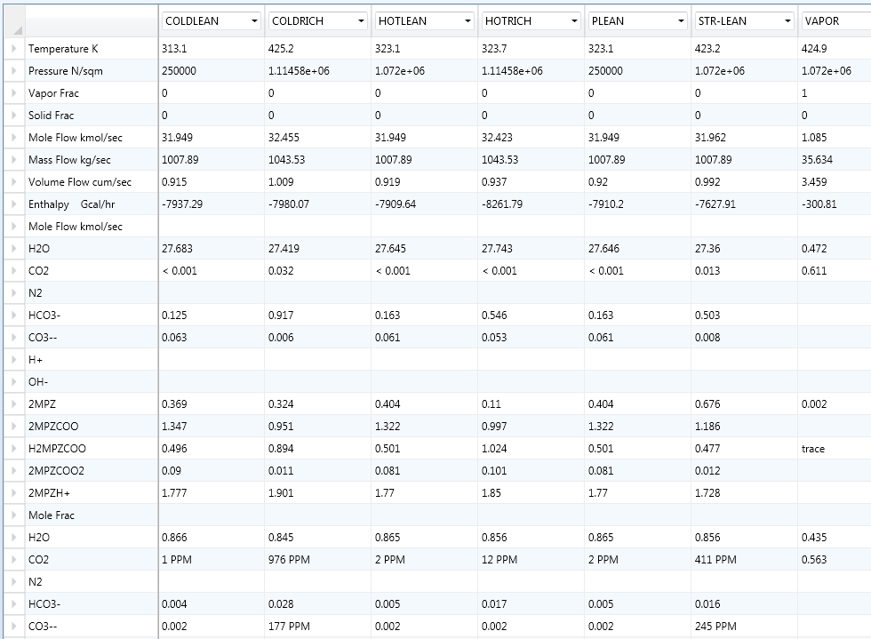

Figure 7: Excerpt of stream results.

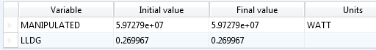

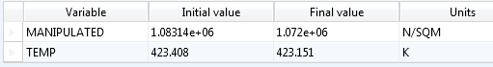

Figure 8: The design specification results.

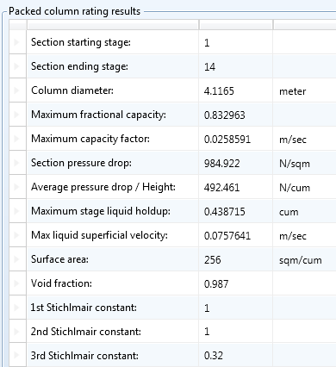

Figure 9: Excerpt from packed column rating results.

1. Usage Information
   1. Environment/Prerequisites

This product requires Aspen Plus V7.3 or newer with an Aspen Rate-Based Distillation license. As such, the supported environments are limited to:

* Windows® XP SP3
* Windows Vista® Business SP2
* Windows Vista Ultimate SP2
* Windows 7 Ultimate (32- and 64-Bit)
* Windows 7 Professional (32- and 64-Bit)
  1. Support

Support can be obtained by email to [ccsi-support@acceleratecarboncapture.org](mailto:ccsi-support@acceleratecarboncapture.org)

* 1. Restrictions

The model is centered at an amine concentration of 8 m. Extrapolating far from this concentration should be done with care.

* 1. Next Steps

The next release will include a heat exchanger model that predicts area as a function of pressure drop and solvent viscosity and a model for kla in the absorber and stripper as a function of viscosity.

1. Debugging

The model is running correctly if it is converging for the above tutorials with similar results. If it is not, see the next section, “How to Debug.”

* 1. How to Debug

Always run the simulation with the control panel visible. It is the only output available during computation, and it notifies the user whether or not the simulation will converge. This enables the user to avoid wasting time on fruitless computation. Furthermore, it alerts the user to any problems encountered during computation.

*Subroutine Errors*

If the following error message displays:

*** SEVERE ERROR

COULD NOT RESOLVE USER OR IN-LINE FORTRAN SUBROUTINE(S):

the simulation will not run. The possible causes and solutions are:

1. The “.bkp” file and the “.dll” and “.opt” files are not located in the same directory. Move all the files into the same directory to resolve this.
2. The linker is not specified in the run settings. Set the linker to “2mpzloc.opt.”

*Simulation Problems*

* If warnings are displayed regarding unusual liquid molefrac profile or unusual component production profile, follow the suggested instructions in the error message.
* If a warning is displayed stating that the water liquid viscosity model MULH2O is violated due to the temperature being lower than the minimum temperature limit, something is not specified correctly. Review the inputs and re-run.
* Ignore flooding errors (TPSAR MESSAGE: XXX.XX% FLOOD IN COLUMN EXCEEDS 80%) unless it displays in the final step.

*Aiding Convergence*

* Only reinitialize when absolutely necessary.
* Make small changes in a converged model.
* Converge an initial, simple case before enabling reactions and design specifications. It is recommended that only small changes are made; therefore, only turn on one of these at a time.
* Before enabling the design specification, the variable should be close to the desired value.
  1. Known Issues
* Flash errors can occur if the solvent goes above 0.5 mol CO2/mol alk.
* Multiple warnings display regarding property data while processing input specifications that follow this pattern, “PARAMETER XXX DATA SET 1 FOR COMPONENT 2MPZ HAS BEEN ENTERED MORE THAN ONCE. THE LAST ENTRY WILL BE USED.”, where XXX is the parameter name.
* In running the tutorials, warnings display that the mole fractions are normalized to unity.
* Warnings display that IONRDL is missing for 2MPZCOO, 2MPZCOO2, and 2MPZH+.
* Using design mode to calculate column diameter for the absorber can lead to inconsistent results. With the absorber tutorial, the model may converge with a diameter of 4.58 m.
  1. Reporting Issues

To report an issue, please send an e-mail to [ccsi-support@acceleratecarboncapture.org](mailto:ccsi-support@acceleratecarboncapture.org).

1. Model History

This section details the creation of Thunder Moon, including the data used in the regressions.

* 1. Thermodynamic Model

Thunder Moon is based on previous work using the electrolyte NRTL model (Chen, 2011). The model is focused on the operating conditions for capture from a coal-fired power plant, meaning a loading range from 0.27 to 0.37 mol CO2/mol alkalinity. The thermodynamic framework was modified slightly in that the default chemistry used had proton and hydroxide ions removed to enhance convergence. The equilibrium chemistry is shown in Table 22.

Table 4: The Thunder Moon Chemistry Block

|  |
| --- |
| Model Chemistry |
| 2 2MPZ + CO2 ↔ 2MPZCOO‒ + 2MPZH+ |
| 2 2MPZCOO‒ + CO2 ↔ 2MPZCOO2 + H2MPZCOO |
| 2MPZCOO‒ + CO2 + H2O ↔ HCO3‒ + H2MPZCOO |
| 2MPZ + H2MPZCOO ↔ 2MPZH+ + 2MPZCOO‒ |
| 2MPZCOO‒ + HCO3‒ ↔ CO3‒‒ + H2MPZCOO‒ |

Changing the chemistry reaction set did not significantly affect the thermodynamic model; therefore, all fits are the same as in (Chen, 2011). In the process of verifying all fits, a discrepancy between the calorimetric and thermodynamic methods for calculating heat of absorption was uncovered.

|  |  |  |
| --- | --- | --- |
|  |  | (1) |
|  |  | (2) |

where *Q* is the net-duty of the flash block, and  is the molar flow rate of gaseous CO2. The heat of absorption is calculated by sending a loaded solvent stream and a gaseous CO2 stream to a flash block for a bubble point calculation.

The latter method using Equation 1 is shown in Figure 56; while the former using Equation 2 is shown in Figure 57. (The process model uses the calorimetric heat of absorption.) The disagreement between the two methods occurs above a loading of 0.25, as shown in Figure 58. It is suspected that the deviation above a loading of 0.25 mol CO2/mol alkalinity is due to the zwitterion becoming a significant species.

Figure 10: Thermodynamic heat of absorption of 8 m 2MPZ calculated from Equation 1.

Figure 11: Calorimetric heat of absorption of 8 m 2MPZ calculated from Equation 2.

Figure 12: The absolute differences between the two heat of absorption calculations, which agree well until a loading of 0.25 mol CO2/mol alkalinity, where the zwitterion becomes significant.

In conclusion, the thermodynamic model represents amine volatility, CO2 solubility, pKa, speciation, density, and viscosity data (Chen, 2011).

* 1. Kinetic Model

The kinetics were regressed using a wetted wall column (WWC) Aspen Plus simulation to adjust reaction rate constants, activation energies, and diffusion parameters to match experimental flux values within 20% (Plaza, 2011; Rochelle et al., 2012). Activity-based kinetics are used as in (Chen, 2011). The process flow diagram is shown in Figure 59.

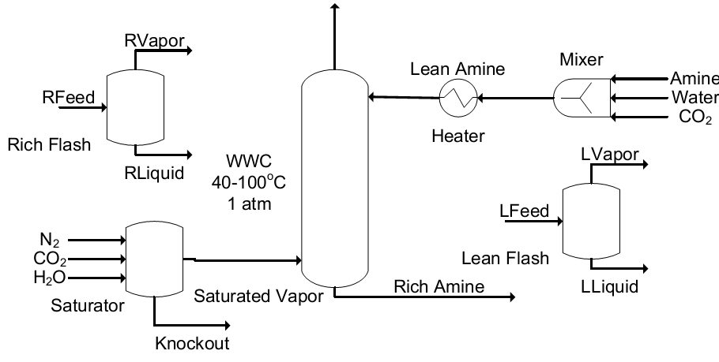

Figure 13: WWC process flow diagram for Aspen Plus.

The solvent is fed as three separate streams of amine, water, and CO2. When mixed, the solvent heats up due to heat of mixing and speciation; therefore, a heater is used to return it to the desired temperature for isothermal operation. The entire WWC is operated isothermally to mimic laboratory conditions. The gas is fed to a flash vessel, which saturates it with water. The gas and solvent are contacted in the WWC, which has the same height as the real life apparatus (9.1 cm) but a diameter that is 100x larger (0.44 cm x100). The rich and lean flash vessels flash the rich and lean amine streams after the heater to calculate the equilibrium partial pressure of CO2.

Aspen Plus discretizes the boundary layer to perform its mass transfer calculation for the reactions. The previous discretization used 50—the maximum number of points possible—which means it requires the most computation time (Chen, 2011). Based on prior studies (Kucka et al., 2003) and looking at previous modeling work (Plaza, 2011), the number of discretization points was reduced without any loss of accuracy. The old and new discretizations are compared in Figure 60.

Figure 14: Boundary layer discretization. The x-axis is fraction through the boundary layer with the gas-liquid interface at left and the bulk liquid at right.

The complete reaction set used is shown in Table 23. The forward and reverse kinetic reactions are represented separately in Aspen Plususing a powerlaw form shown in Equation 3.

|  |  |  |
| --- | --- | --- |
|  |  | (3) |

The forward reaction rates are calculated, and then the reverse rates are back-calculated using the reaction equilibrium constant. The bicarbonate-forming reaction was fixed using values from literature (Ko & Li, 2000), while the dicarbamate-forming reaction was ratioed to the carbamate-forming reaction by assuming the Brønsted plot of PZ holds (kcarbamate = 0.88kdicarbamate). This plot is shown in Figure 61. Thus, only the carbamate-forming reaction was regressed.

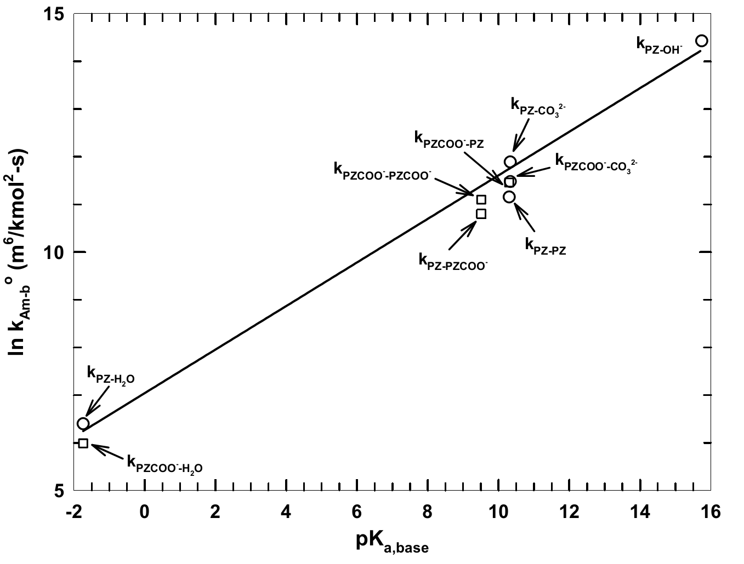

Figure 15: Brønsted plot showing the reaction rate constant (kAm-b) versus the pKa of a  
base for an amine catalyzed by a base, kAm-base.

To calculate ko and EA, two points were chosen at different loadings: one where the bicarbonate reaction is insignificant and a second, higher one where the bicarbonate is significant. At each of these points, the 40°C and 60°C fluxes were examined. Using a fixed set of kinetic parameters, the loading was adjusted to ensure that at zero driving force there is zero flux. This adjustment was made until the ratio of predicted flux to actual flux for the absorption and desorption points were within 1% of each other, or until the loading had been adjusted up to 10% of the operational loading range. Therefore, the maximum loading adjustment was ±0.01 mol CO2/mol alk.

Once this loading adjustment was completed, a design specification was used to match the flux exactly by varying the ko of one reaction. This is tested at two different temperatures to produce a coherent set of ko and EA ­for all reactions. The diffusivity parameters of Equation 4 were also adjusted. The diffusivity adjustments were made to fit the higher temperature data points primarily.

|  |  |  |
| --- | --- | --- |
|  |  | (4) |

With all parameters fixed, the WWC flux cases were all simulated. The power-law parameters, the loading, and the diffusivity parameters were adjusted. The flux cases were again simulated and this process was repeated until a satisfactory fit emerged.

Using a very small reaction set, most of the data were matched within 20%. There were nine predicted fluxes not within 20% of the experimental fluxes. The kinetic fit is displayed in Figures 62 and 63. As seen in Figure 62, the predictions worsen at higher temperatures as experimental error is expected to increase and as the mechanism shifts to diffusion-dominated. In addition to increasing scatter with increasing temperature, there is a linear systematic bias. Efforts to correct for this bias by changing the reference temperature for diffusivity were unsuccessful. Figure 63 shows no systematic trend with loading and the scatter with temperature remains approximately constant.

Table 23 shows the power-law parameters, and Table 24 shows diffusivity parameters. While the dependence of diffusivity on viscosity is reasonable, its dependence on temperature is probably indicative not of a physical effect, but of the diffusivity being distorted to fit temperature dependence effects.

Table 5: Reaction Set for 2MPZ with Forward Reactions above the Rule

|  |  |  |
| --- | --- | --- |
| Reaction | ko (kmol/s-m3) | EA (kJ/mol) |
| 2MPZCOO- + H2O + CO2 🡪 H2MPZCOO + HCO3- | 2.62E6 | 98.0 |
| 2 2MPZ + CO2 🡪 2MPZH+ + 2MPZCOO- | 1.45E10 | 21.9 |
| 2 2MPZCOO- + CO2 🡪 2MPZ(COO-)2 + H2MPZCOO | 1.28E10 | 21.9 |
| H2MPZCOO + HCO3- 🡪 2MPZCOO- + H2O + CO2 | 3.67E5 | 174 |
| 2MPZH+ + 2MPZCOO 🡪 2 2MPZ + CO2 | 3.96E4 | 97.8 |
| 2MPZ(COO-)2 + H2MPZCOO 🡪 2 2MPZCOO- + CO2 | 2.71E8 | 129 |

Table 6: Diffusivity Parameter Values

|  |  |
| --- | --- |
| Diffusivity Parameter | 8 m 2MPZ value |
| Do | 4.4E-11 m2/s |
| α | -1.50 |
| β | -11.5 |
| Tref | 373.15 K |

**Figure 16: 8 m 2MPZ kinetic fit. There is a linear bias with temperature. Filled points represent absorption, open points desorption. Dashed lines delineate the target range ±20%.**

Figure 17: 8 m 2MPZ kinetic **fit. Model flux ratioed to experimental flux shows no clear trend with loading. Filled points represent absorption, open points desorption.  
The dashed lines delineate the target range ±20%.**

1. References

Chen, X., “Carbon Dioxide Thermodynamics, Kinetics, and Mass Transfer in Aqueous Piperazine Derivatives and Other Amines,” The University of Texas at Austin, PhD Dissertation, 2011.

Frailie, P., Plaza, J., Van Wagener, D., and Rochelle, G.T., “Modeling Piperazine Thermodynamics,” *Energy Procedia*, 4, 35–42, 2011.

Freeman, S.A., “Thermal Degradation and Oxidation of Aqueous Piperazine for Carbon Dioxide Capture,” The University of Texas at Austin, PhD Dissertation, 2011.

Hilliard, M.D., “A Predictive Thermodynamic Model for an Aqueous Blend of Potassium Carbonate, Piperazine, and Monoethanolamine for Carbon Dioxide,” The University of Texas at Austin, PhD Dissertation, 2008.

Ko, J., and Li, M., “Kinetics of Absorption of Carbon Dioxide into Solutions of   
N-Methyldiethanolamine + Water,” *Chem Eng Sci*., 55:4139–4147, 2008.

Plaza, J.M., “Modeling of Carbon Dioxide Absorption using Aqueous Monoethanolamine, Piperazine and Promoted Potassium Carbonate,” The University of Texas at Austin, PhD Dissertation, 2011.

Rochelle, G.T., Xi, C., Li, L., Namjoshi, O., Xu, Q., Nguyen, T., Frailie, P., Van Wagener, D.,   
Plaza, J.M., Wang, C., Chen, E., Ziaii, S., Dunia, R., Cohen, S., Closmann, F., Freeman, S., Voice, A., Ashouripashaki, M., Fulk, S., and Rafique, H.A., “CO2 Capture by Aqueous Absorption, First Quarterly Progress Report 2011.” Luminant Carbon Management Program, The University of Texas at Austin, 2011.

Rochelle, G.T., Li, L., Nguyen, T., Li, H., Du, Y., Frailie, P., Chen, E., Sachde, D., Wang, C.,   
Madan, T., Sherman, B., Walters, M., Ziaii, S., Cohen, S., Namjoshi, O., Voice, A., Fulk, S., Nielsen, P., Fine, N., and Ashouripashaki, M., “CO2 Capture by Aqueous Absorption, Second Quarterly Progress Report 2012,” Luminant Carbon Management Program, The University of Texas at Austin, 2012.

Rochelle, G.T., Li, L., Du, Y., Frailie, P., Chen, E., Sachde, D., Lin, Y., Wang, C., Madan, T., Sherman, B., Walters, M., Namjoshi, O., Voice, A., Fulk, S., Nielsen, P., and Fine, N., “CO2 Capture by Aqueous Absorption, Fourth Quarterly Progress Report 2012,” Luminant Carbon Management Program, The University of Texas at Austin, 2013.

Weiland, R.H., Dingman, J.C., Cronin, D.B., Browning, G.J., “Density and Viscosity of Some Partially Carbonated Aqueous Alkanolamine Solutions and Their Blends,” *J. Chem. Eng. Data*, *9568*(1985), 378–382, 1998.

Xu, Q., “Thermodynamics of CO2 Loaded Aqueous Amines,” University of Texas at Austin, PhD Dissertation, 2011.