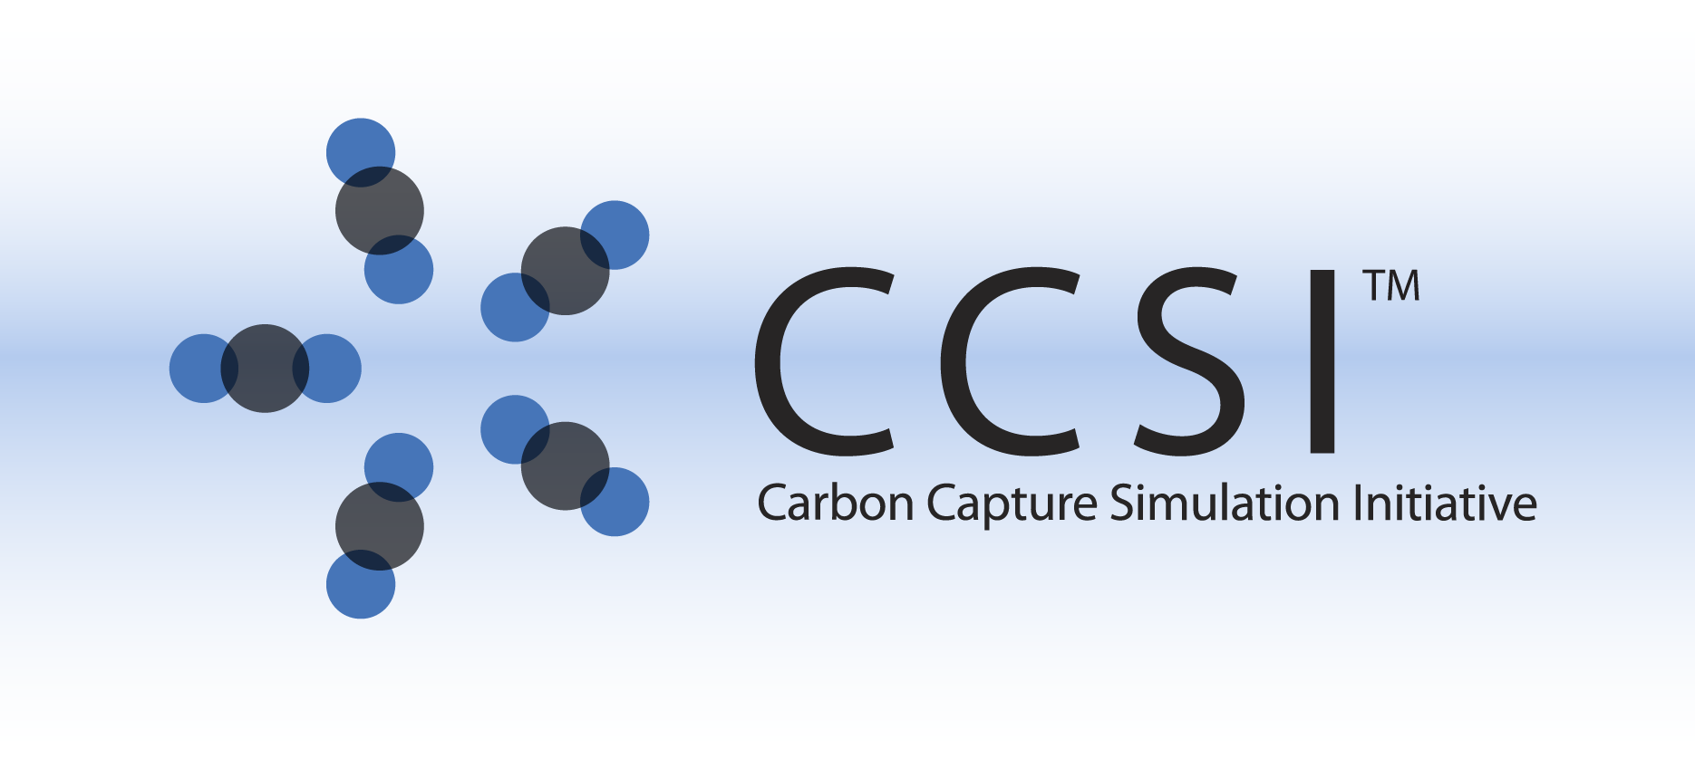

**A Validation Hierarchy for CFD Models of**

**Solvent-based Carbon Capture Systems**

Prepared by

Xin Sun, Zhijie Xu, Canhai Lai, Wenxiao Pan, Chao Wang, Pacific Northwest National Laboratory

Janine Carney, Rajesh Singh, National Energy Technology Laboratory

James Gattiker, Peter Marcy, Los Alamos National Laboratory

Sankaran Sundaresan, Ali Ozel, Princeton University

Prepared for

U.S. Department of Energy

National Energy Technology Laboratory

July 31, 2015





Revision Log

|  |  |  |  |
| --- | --- | --- | --- |
| **Revision** | **Date** | **Revised By:** | **Description** |
| 0 | 7/24/15 | Xin Sun | Original draft |
| 1 | 8/10 | Janine Carney, Rajesh Singh, Zhijie Xu, Canhai Lai, Wenxiao Pan, James Gattiker | First consolidated draft |
| 2 | 8/14 | Chao Wang | 2nd revision with formatting and proof reading |
| 3 | 8/17 | Xin Sun | Proof reading |
| 4 | 8/19 | Canhai Lai, Janine Carney, Rajesh Singh, Xin Sun | Final proof reading |

Disclaimer

This report was prepared as an account of work sponsored by an agency of the United States Government. Neither the United States Government nor any agency thereof, nor any of their employees, makes any warranty, express or implied, or assumes any legal liability or responsibility for the accuracy, completeness, or usefulness of any information, apparatus, product, or process disclosed, or represents that its use would not infringe privately owned rights. Reference herein to any specific commercial product, process, or service by trade name, trademark, manufacturer, or otherwise does not necessarily constitute or imply its endorsement, recommendation, or favoring by the United States Government or any agency thereof. The views and opinions of authors expressed herein do not necessarily state or reflect those of the United States Government or any agency thereof.

Table of Contents

1. Introduction 1-1

2. Overview of Verification and Validation 2-2

3. Objectives and Expected Outcomes 3-3

4. Overview of Validation Hierarchy 4-4

5. Description and Discussion of the Validation Hierarchy 5-5

5.1 Unit problem 1 – Prediction and validation of wetted interfacial area 5-5

5.2 Unit problem 2 – Prediction and validation of effective mass transfer coefficient 5-7

5.3 Geometric upscaling 5-9

5.4 Coupled simulations of bench-scale capture system 5-9

5.5 Coupled predictions on available laboratory scale demonstration 5-11

5.6 Predictive confidence on conceptual designs 5-11

6. Overview of Uncertainty Quantification 6-13

7. Available and Planned Experimental Cases 7-14

7.1 Unit Problems 7-14

7.2 Intermediate bench scale experiments 7-16

7.3 Laboratory scale absorption column 7-17

7.4 Pilot scale systems 7-17

7.5 Industrial scale systems 7-17

8. Linkages and Connections to Process Models 8-19

9. Limitations and Gaps 9-22

10. Conclusions 10-24

List of Figures

Figure 1 Solvent-based capture system and the associated unit problems with experimental validation 4-4

Figure 2 Validation Hierarchy for solvent-based capture system 5-5

Figure 3 Comparison of the VOF predicted rivulet width (B) with experiments for 10cS general purpose silicon oil. Width of the rivulet is measured at 60 mm from inlet. Inset shows the comparison of the shape of the interface at We=1.02. 7-15

Nomenclature

**Acronyms**

BSS-ANOVA Bayesian Smoothing Spline ANalysis Of VAriance

CCSI Carbon Capture Simulation Initiative

CFD Computational Fluid Dynamics

DoE Department of Energy

E-E Eulerian-Eulerian

GE General Electric

GPM/SA Gaussian Process Models for Simulation Analysis

LHS Latin Hypercube Sampling

LIF Light Induced Fluorescence

MEA Monoethanolamine

MFIX Multiphase Flow with Interphase eXchanges

NCCC National Carbon Capture Center

NETL National Energy Technology Laboratory

PNNL Pacific Northwest National Laboratory

UQ Uncertainty Quantification

VOF Volume of Fluid

WWC Wetted Wall Column

XCT X-ray Computed Tomography

# Introduction

Currently, the most commonly used technology for low concentration CO2 capture is absorption with chemical solvents. Even though solvent-based carbon capture has been successfully demonstrated in small-scale carbon capture applications, it may experience significant difficulties in processing large volumes of CO2 as needed by post-combustion carbon capture of coal-based power plants. The challenges mainly stem from the time and cost associated with the process of technology scale-up. Traditionally, the time required for moving a new concept from the research lab to industrial deployment takes anywhere from 20 to 30 years with many incremental experimental demonstration projects to gain experience and confidence during the scale up process.

The Carbon Capture Simulation Initiative (CCSI), which is developing a suite of advanced modeling and simulation tools for solvent-based capture, seeks to reduce this scale up time by hierarchically calibrating and validating the physically-based mathematically models for solvent capture at different scales and thereby providing the confidence bound for at-scale capture predictions.

This document serves as a roadmap for CCSI validation and uncertainty quantification (UQ) activities associated with solvent-based capture. The primary purpose is to identify and quantify the computational fluid dynamics (CFD) simulation errors in relation to experimental data and to provide an assessment of the uncertainties for at-scale predictions. The proposed validation and UQ efforts are supported by experimental data from a variety of sources including National Energy Technology Laboratory (NETL) and Pacific Northwest National Laboratory (PNNL) facilities, NETL-supported industrial experiments at external locations (Department of Energy (DoE) NETL Industrial Challenge Problems) as well as available literature data.

The plan for the integrated validation and UQ activities for the CCSI CFD modeling and simulations outlined herein is based on the expertise and experience of the CCSI team members as well as on the state-of-the-art knowledge of basic concepts, principles and procedures [1-5].

# Overview of Verification and Validation

The CCSI CFD development work is focused on the specific multi-physics of the carbon capture systems of interest to CCSI and the capabilities of the models and codes. This work needs to be supported by a quantitative assessment of the confidence in their predictions. The contributing elements in the development of CCSI CFD models and simulations with predictive capabilities are verification, validation, and uncertainty quantification.

**Verification** addresses the correctness and functionality of the computations. It denotes the process of establishing the precision of the numerical solution compared to an accurate solution. The verification process may be divided into two areas: code verification and numerical solution verification. The CCSI CFD researchers are developing their models and codes in an open-source multiphase flow computer code Multiphase Flow with Interphase eXchanges (MFIX) and OpenFOAM as well as commercial software Ansys Fluent®. These codes have been developed by employing appropriate software engineering practices and have been subjected to mature software verification in numerous implementations.

Therefore, the general-purpose software being used in this effort (MFIX, OpenFOAM and Ansys Fluent®) are assumed to be fully verified, that is, they are considered to be accurate computational representations of the original mathematical models. As a result, no attempt to re-verify them will be made.

**Model validation** is the process of determining the degree to which a CFD model is an accurate representation of the real system, from the perspective of the intended uses of the model [1], in this case, the solvent-based carbon capture. The execution of this process generally requires experimentally measured data to compare with the simulation results. A hierarchical validation process will be followed in this work. Accordingly, simulations with simple physics and simple geometry will be validated first, followed by simulations with coupled physics and more complex geometries representing the actual absorption column.

The plan is to utilize both available literature data and the wetted wall column (WWC) experimental capability to obtain small scale separate effect experimental data for unit problem calibration. In addition, absorber column-scale experimental data from a variety of sources including NETL facilities, NETL-supported industrial experiments at external locations, and literature data will be used to assist in validation of column-scale absorber simulations.

# Objectives and Expected Outcomes

The objective of this validation hierarchy is to determine the accuracy of the CFD models for a solvent-based carbon capture system and to quantify the predictive confidence of the CFD modeling results for capture efficiency and equipment performance.

As will be discussed in the following sections, the proposed approach is to hierarchically calibrate and validate the CFD models ranging from bench scale to demonstration scale carbon capture systems with input knowledge from lower length scale simulation results and experimental data. At the lowest tier, smaller scale models and models with simple and uncoupled physics/chemistry will be calibrated. To help accomplish this task, separate effect experiments will be conducted to investigate the accuracy of the various components and parameters in the CFD models. It is worth noting that the validation approach outlined here is specific to the CCSI program in the context of solvent-based capture, and it is not intended to be ubiquitously applicable to all other complex coupled physical systems/phenomena.

The outcome of this validation process will be an estimated confidence range on system performance metrics for the developed CFD models and codes when applied to the carbon capture technologies of interest to the CCSI program. This estimation will be based on the confidence level gained in the various decoupled unit problems as well as the upscaling procedure outlined in this document. By considering smaller unit problems which isolate particular aspects of the multi-physics of the full scale system, the contributions of different aspects of the model to the predictive errors may be evaluated, such as, the effects of coupling different physics or the geometric upscaling of the coupled physics.

# Overview of Validation Hierarchy

Solvent-based carbon capture devices are complex engineering systems involving multi-phase and multi-scale phenomena as well as state-of-the-art industrial technology. Figure **1** schematically illustrates an absorber column with packing structures to promote better flow distributions and to provide a high gas-liquid interfacial area. In addition to interfacial area, mass transfer coefficient, reaction rate constants and solvent’s equilibrium constants all contribute to the overall capture efficiency and capacity on the device scale.

To validate computational predictions of this complex engineering system, a hierarchical method [1, 2] is proposed. The purpose of this effort is to calibrate model parameters and to evaluate the predictive confidence range of the CFD models at different scales. Figure **1** schematically illustrates the proposed physical problems that will be separately predicted and calibrated with corresponding separate effect experiments.

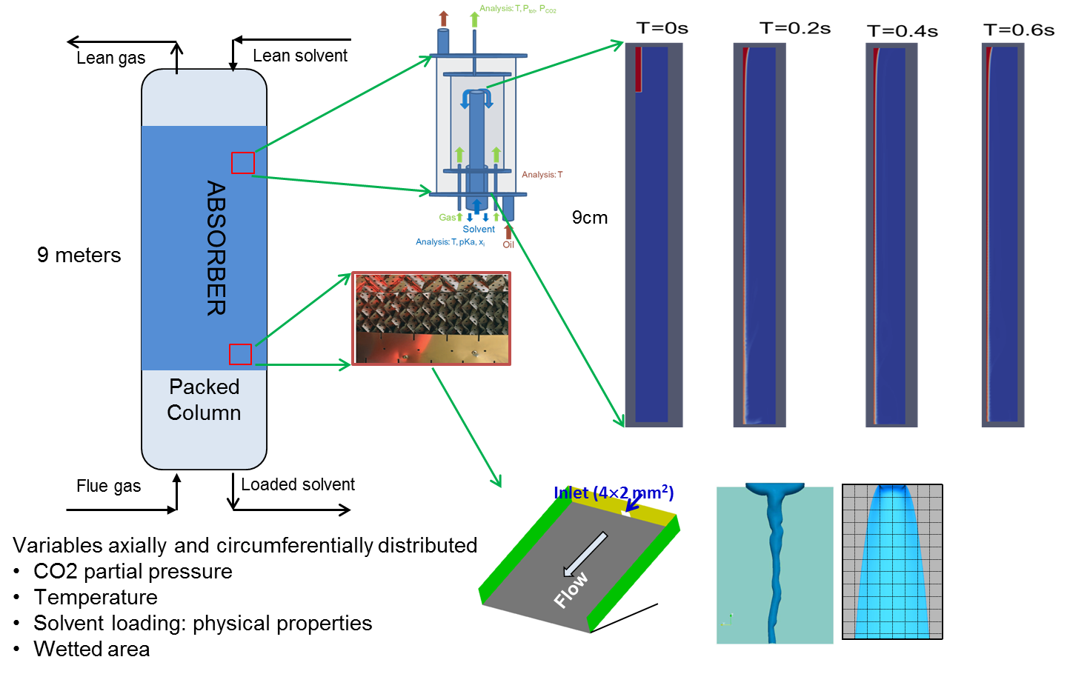

Figure 1 Solvent-based capture system and the associated unit problems with experimental validation

# Description and Discussion of the Validation Hierarchy

The complex solvent-based carbon capture system is then divided into several validation tiers. The lowest tier is made of small scale systems and unit problems with progressively increasing complexity as shown in Figure **2**.

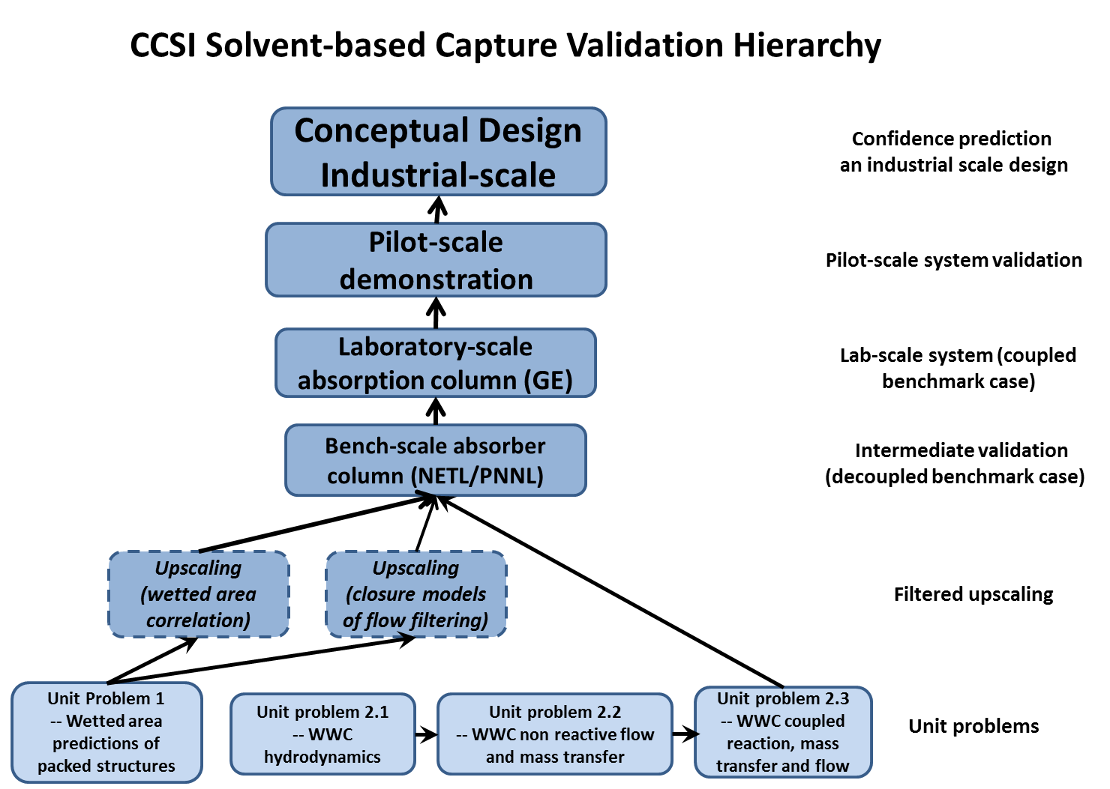

Figure 2 Validation Hierarchy for solvent-based capture system

The aim of the unit problems is to break the complex multi-physics found in a solvent-based reactor into simpler single physics unit problems as described below.

## Unit problem 1 – Prediction and validation of wetted interfacial area

Since the full-length absorption columns usually contain packing structures with different designs to manage the solvent flows in achieving the desired reaction areas (interfacial area), researchers in the past have sought to develop the correlations on wetted area and reaction absorption through simple laboratory experiments. For example, simple hydrodynamic experiments could yield data on pressure drop as well as liquid holdup at various combinations of flow rates. These could be analyzed to deduce correlations that are useful for coarse device-scale models. By first coating the packing elements with a soluble material and then having gas-liquid flow through a column containing these packing elements, the efficacy of liquid-solid mass transfer is assessed. It does not however afford explicit separation of the mass transfer coefficient and wetted area. Similarly by studying absorption of a gas into a liquid, the efficacy of gas-liquid mass transfer is assessed. Again, it is not possible to separately identify the mass transfer coefficient and interfacial area. The biggest challenges in the experimental approach are the limited range of the physical properties of the fluids that can be examined and therefore the predictive capabilities of the correlations. Mechanism-based predictive simulations on the other hand offer a greater flexibility with respect to physical properties. However, experimental data are very useful and needed to validate such models.

Absorption columns usually contain packings of different designs to manage the solvent flow and afford intimate contact between the liquid solvent and the gas phase. Accordingly, the first unit problem in the first level of the CCSI validation hierarchy seeks to model and simulate the flow details at the level of the individual packing elements, and to predict wetted and interfacial areas. Our analyses to date as well as literature studies [6-9] have shown that the volume-of-fluid (VOF) simulation is a promising method to tackle this unit problem. VOF simulations reveal spatial variation of gas and liquid phase volume fractions as well as velocities. The area of the solid surface wetted by the liquid as well as the gas-liquid interfacial area (both typically being expressed on "per unit volume of the column" basis) can be determined under different flow conditions those can arise in the absorption column. In principle, one can perform many such simulations and formulate correlations for computationally generated quantities. As VOF simulations require very fine spatial and temporal resolutions, one can only simulate flows over the length scale of a few packing elements in an affordable manner.

A key challenge in this unit problem is the idealization of the actual packing into representative geometries that is convenient, meaningful and computationally affordable. Often there is no unique geometry idealization and so it may be necessary to examine different equally viable geometry idealizations. Consider, for example, packing elements that take the form of spheres, random packing of spheres allows many different configurations in the representative domain. One typically needs to create many such configurations, simulate flows in all of them and then average the results. The size of the computational campaign can become very large if one has to consider many different configurations. As can be imagined, the more complex the shape of the packing element, the more difficult the geometry idealization will be. Thus, uncertainty in results introduced by geometry idealization needs to be considered.

Given that there are many different options for packing elements, we propose to select a test example involving a simple packing element to demonstrate the approach as a part of CCSI's tool-kit development efforts. Clearly, the choice should also be driven by the available experimental data for validation purpose.

The hydrodynamics through the absorber packing are governed by a number of parameters, including solvent properties, solvent and gas flow rates, geometric characteristics of the packing (e.g., contact angle and design of the corrugated sheet for structured packing), etc… Furthermore, these parameters may not be precisely known, have uncertain values, or exhibit unknown spatial/temporal changes through the column. For example, the solvent viscosity is known to increase significantly with increasing CO2 loading as it flows through the column. In addition, temperature variation can also lead to change in the solvent surface tension and the Marangoni effect may play a role. The contact angle, which is a characteristic of the solid-liquid system in a specific environment, is another parameter that will have a significant effect on the hydrodynamics in these systems. A given solvent shows different wetting behavior (contact angle) with different solids surfaces. In addition, design of the sheet such as texture and corrugation also significantly impact the interfacial area and film thickness and thereby the hydrodynamics through the packing.

As noted earlier the first unit problem in the validation hierarchy involves the prediction of interfacial and wetted area for a representative volume of packing element: structured or randomly packed. The geometries of the packing will be chosen from widely used industrial columns. Note that the ratio of base to height ratio, the crimp angle and corrugation angle define the geometry of the flow channel in a structured packing unit. The systematic and extensive CFD simulations will be conducted and compared with experimental results. The resulted correlations on wetted interfacial areas are inputs required for coarser device-scale Euler-Euler (E-E) simulations as well as process models. Physical properties of the liquids as well as the gas-liquid interfacial surface tension and the contact angle are supplied as inputs to the VOF simulations. Uncertainty in the values of these quantities as well as the geometric assumptions translates as uncertainties in the VOF predictions, and can be quantified through statistical calibration and discrepancy analyses.

## Unit problem 2 – Prediction and validation of effective mass transfer coefficient

The next series of unit problems is designed for the prediction of effective mass transfer coefficient for a specific solvent at a specific CO2 loading and operating temperature. The effective mass transfer coefficient is typically experimentally measured by a WWC test at a designed range of parameter sweep. However, solvent-based CO2 capture within an experimental WWC involves the coupling of the following important physical phenomena: 1) flow hydrodynamics; 2) mass transfer between different phases; 3) reaction kinetics for CO2 adsorption. Hence a series of unit problems for WWC with increasing complexity are designed for model calibration and validation. These specific unit problems are:

*Unit problem 2.1 -- The flow hydrodynamics model*

The focus of this unit problem is the simulation of film flow down the column with various viscosities. Model calibration and validation can be realized by comparison of the steady state film thickness with the theory prediction for various viscosities. After this step, quantitative confidence in the numerical accuracy and code implementation of the open source package for simulating flow hydrodynamics can be established.

*Unit problem 2.2 -- Coupled mass transfer and hydrodynamics simulation for non-reactive fluids*

The focus of this unit problem is the coupling of two fundamental physics, i.e., mass transfer and hydrodynamics between gas and liquid. The gas-liquid pairs of interest include O2/Water and N2O/Monoethanolamine (MEA). In this unit problem, we will first simulate the mass transfer between O2 and water in the wetted column wall with various water injection rates. Model validation can be implemented by comparison of the computed overall mass transfer coefficient for various injection rates with the available literature data [10, 11].

The coupled mass transfer with hydrodynamics model will be further validated and calibrated with controlled WWC experiment in an N2O/MEA system. Here N2O is used as a surrogate for CO2 without the absorption reaction. After this step, confidence on the numerical solution of coupled hydrodynamics and mass transfer model will be established. In addition, the N2O/MEA transport properties can be systematically calibrated in Unit problem 2.2.

*Unit problem 2.3 -- Coupled absorption, mass transfer and hydrodynamics simulation*

This unit problem will be carried out with the same WWC set up, but with the introduction of CO2 in the gas stream. The transport properties of CO2 in MEA system might be inferred from the N2O data calibrated in Unit problem 2.2 based on available literatures [12, 13]. With that, the effects of CO2 mass transfer and chemical absorption with MEA can be separated and investigated independently. After this step, more insights and quantitative ranges will be established for the CO2 absorption rate constants of the MEA solvent system.

For Unit problems 2.2 and 2.3, a series of laboratory scale wetted column wall experiments will be conducted for the purpose of model validation. The general Bayesian calibration/model assessment methodology, i.e., response surface methods such as Gaussian Process Models for Simulation Analysis (GPM/SA) and Bayesian Smoothing Spline ANalysis Of VAriance (BSS-ANOVA) [14, 15], along with Latin hypercube sampling (LHS) are used to calibrate the model parameters. These contemporary Bayesian approaches incorporate the concepts of parameter estimation, estimation of model-data discrepancy, and system predictions incorporating uncertainty from these sources as well as statistical modeling error. The unit problems include mass transfer only and adsorption coupled with mass transfer, with increasing complexity in physics. The model parameters to be calibrated using the Bayesian calibration are identified to be the Henry’s constant, diffusivity in solvent and the reaction rate constants for CO2 in MEA. More specifically, Henry’s constant and diffusivity are transport properties that will be calibrated in Unit problem 2.2 with laboratory scale WWC experiment of N2O/MEA system. The posterior transport properties will be used as the input priori in Unit problem 2.3 and the rate constant of CO2 will be calibrated in Unit problem 2.3 with laboratory scale WWC experiment of CO2/MEA system.

## Geometric upscaling

The second level of the validation hierarchy addresses geometric upscaling in obtaining the accurate constitutive representation of each simulation cell in the device-scale CFD models. This is because it is unrealistic to resolve all the physical details and the length scales in the device scale coupled simulations with today’s computational power, and this complexity would introduce a commensurate fundamental problem in determining the initial conditions of the system for representation in computational models. Instead, the approach is to represent summary statistics of the apparatus, and carefully manage the uncertainty related to the unrepresented complexity.

Generating microscopic constitutive models through simulations is conceptually clear. A fair amount of work of this type has been done for fluid-solid flows and for gas-liquid bubbly flows, and computationally generated closures are available in the literature for these flows. The feasibility of such detailed simulations, using the VOF method, has been demonstrated in the literature and in our studies.

Computationally generated microscopic constitutive relations for gas-liquid flows in packed columns, however, are not yet available. Studies performed by the CCSI team in the past year have shown that both the VOF module in commercial software (Ansys Fluent®) as well as the open-source software (OpenFOAM, which still required a number of improvements) can be used to simulate such flows problems. However, these simulations are computationally expensive and only flows in small domains can realistically be simulated. On the positive side, unlike cold-flow experiments, these simulations allow exploration of a wide range of physical properties.

The validation hierarchy plans to use the E-E formulation in MFIX to simulate the flow and CO2 capture in a solvent-based device scale reactor via porous media sub-models. This formulation requires closure models for certain terms, including interfacial area, effective mass transfer coefficient, and the interfacial interaction (drag). Therefore, the filtered drag model for solvent-gas-solid interactions will also need to be derived for the subsequent device-scale simulations.

## Coupled simulations of bench-scale capture system

For a given solvent, the overall capture performance of the reactor is a complex function of operating pressure and temperature, flow hydrodynamics and reaction kinetics. Understanding the complex hydrodynamics and reaction inside such a multiphase reactive gas-liquid-solid reactor is a challenging task. The benefit of a device-scale CFD model is its ability to probe the impact of various design elements (inlet/outlet configuration) and flow quantities (e.g., viscosity) on local flow behavior within the column. Flow distribution plays an important role in column efficiency and poor wetting, channeling and bypassing are potential issues. For a random packed bed these issues can be exacerbated by inhomogeneity of the packing. For structured packing flow distribution will be influenced by such factors as packing arrangement, corrugation angle and height. Using the device-scale model it may be possible to capture liquid flow distribution patterns and local hot spots which will impact overall flow distribution.

Therefore, in the third level of the validation hierarchy, decoupled laboratory scale bench-level absorber behaviors (with and without reactions or heat transfer) will be compared against predictions from the device scale CFD model for solvent based capture. Typically, such an absorption column is filled with a packing material that offers enhanced interfacial area for gas-liquid contact per unit volume for mass transport, high absorption efficiency while minimizing pressure drop. The accurate design of such columns requires knowing the essential hydrodynamic characteristics of the packing element as well as the reaction kinetics. In this view, interfacial area and reaction kinetics parameters for different solvent loading and temperature are important factors influencing the overall absorption efficiency of the column.

It is envisioned that the CCSI toolkit will utilize open source code MFIX to simulate the flow and CO2 capture in a solvent-based device scale reactor. These E-E simulations will be done via porous media sub-models. As noted earlier, such simulations require closure models for certain terms, including, the interfacial interaction (drag), interfacial area, effective mass transfer coefficient. The overall aim is to use the correlations and closure models developed in the Unit problem 1 for different solvent systems and packings. Until such models are available, however, literature based models have been employed as place holders for concurrent model development [16-21]. The closest available literature in this area concerns trickle bed reactor applications and the corresponding closures are based on phenomenological arguments. Thus, one must consider uncertainty in the results introduced by these closure models. In addition, the role of effective viscosity or pseudo turbulent viscosity should be considered given the complex flow pattern that can be expected in these systems. However, this introduces uncertainty in determining an appropriate value for this quantity.

The ability of MFIX to predict flow behavior may be assessed in a number of ways. A survey of the literature shows that experimental measurements of the overall pressure drop versus gas loading are available [22]. However, a more rigorous assessment of the model would be through comparison with the measured pressure drop profile along the length of the bench-scale column. Since such measurements appear scarce and may not be readily available in the open literature, CCSI plans to leverage the experimental capabilities at NETL and Pacific Northwest National Laboratory (PNNL) to conduct such bench-scale decoupled benchmark experiments for intermediate model validation purpose. In addition to pressure drop, comparisons with liquid hold-up measurements may be conducted. In particular, the ability of MFIX to predict flow distribution, laterally and/or radially, through local measurements of liquid hold-up may be assessed. Data on liquid-holdup profiles is available in the literature although largely for single phase liquid flow through random packed structures through various techniques including liquid collecting methods, X-ray tomography [23, 24], and tracer experiments.

It should be noted that it may not be possible to conduct decoupled experiments to test the performance of upscaled reaction or energy models. Experimental data on CO2 concentration variations along the bench-scale reactor (2.4m high) height are available in the literature [25]. Comparison of MFIX simulation predictions on CO2 distribution profiles at different operating conditions with the literature data may be conducted to validate the MFIX model with respect to mass transfer and reaction kinetics. This step will help calibrate and build confidence regarding the choice of models in the first level and the upscaling (filtering) procedure developed/implemented in the second level. Quantitative assessment regarding the reliability of the model predictions can also be made for each unit problem, which will help in understanding the compounding of errors in the next level.

## Coupled predictions on available laboratory scale demonstration

The fourth level of the hierarchy couples together all the unit problems (flow, reactions, heat transfer) together with the appropriate upscaling relationships for modeling a laboratory scale absorber, such as the General Electric (GE) absorber column in GE Global Research in upstate NY.

Even after performing careful unit-scale experiments and calibrations we should expect to see additional differences at the laboratory-scale experiments, due in part to complexity unrepresented in the models, new physics parameterizations involved, and also perhaps to different operating regimes in some respects than the previous experiments. At this level of the validation hierarchy there is limited opportunity to adjust the calibration of parameters because of the increasing cost and difficulty of running experimental programs. Instead the focus is now on the evaluation of model-experiment discrepancy, given the parameter calibrations previously established. This discrepancy will incorporate (at least) three sources of uncertainty: 1) any parametric uncertainty associated with the interactions from federating the modular calibrations, 2) inherent model mis-specification in functional form and model solving, and 3) the error in model initial and boundary conditions, that is, incomplete specifications of geometry of the laboratory/pilot system and unknowable conditions in the apparatus such as the complete temperature field. How this is addressed depends on the number of system-wide experiments and corresponding simulations that can be performed. At the simplest, a variance representing additional uncertainty can be estimated that expresses the observed differences. If more data is available (several to tens of corresponding points), it may be possible to estimate a structured bias in the expectation not only of additional uncertainty but also of systematic offsets in models predictions. This can be combined with additional expert judgment related to the impact of expected modeling uncertainty and observed indications of model discrepancy.  This shift from estimating parametric uncertainty toward characterizing model-system discrepancy continues while moving up the hierarchy.

## Predictive confidence on conceptual designs

With all the calibrated and known parameter ranges obtained above, the topmost level of the hierarchy is to obtain quantitative confidence on the predictions for the device scale systems for a conceptual design with the given solvent. As of the writing of this validation plan, no agreement with a full scale solvent-based capture system has been reached. Therefore the validation of the device scale models will start with the validation activities in the lower tiers. The device scale simulations will rely on the information gained through the smaller scale validation tiers and the expertise of the CCSI CFD team. In developing the device scale models the validated unit problems and upscaling methods will be employed. In addition the expertise of CCSI team will be used to determine the appropriate baseline operating conditions and parameters for the device scale models. The validation work at the device scale will also provide estimates of the error in the device scale models and the sources of those errors, which will come from the knowledge gained through the lower tier validation studies.

Our work at the device-scale tier will lead to the development of baseline device scale models based on the validation work and our knowledge of the system. The development and use of these baseline models will be coordinated with other elements in the CCSI program to enable the development of reduced order models and for UQ analysis. It is expected that knowledge based calibration of the model parameters will be critical in obtaining better quantitative predictions.

# Overview of Uncertainty Quantification

The UQ process begins with a definition phase in which models are specified and goals and objectives for the uncertainty analysis are developed that will guide the selection of UQ tools needed to obtain information about uncertainty that is needed to support the overall modeling and decision-making framework. Possible sources of uncertainty, including both model uncertainty and data uncertainty, are identified by working closely with subject matter experts using available data and knowledge to narrow down the set of variables of interest. Once the variables of interest have been defined, parametric distributions and/or model forms are developed in the characterization step that capture the available information about uncertainty. Uncertainty may then be propagated either forward or backward through specified models in the system. Various types of analyses may be performed to study the impact of the uncertainties that are present. For example, sensitivity analysis can be conducted to learn about the relative impacts of different input variables and their importance in driving the uncertainty in model outcomes. Finally, the information gained from examining the existing uncertainty can be used to improve the models themselves or to inform the collection of additional data to ultimately reduce the uncertainty present in the system.

# Available and Planned Experimental Cases

Validation of the unit problems will entail a detailed literature search for each of the unit problems shown in Figure **2**, the compilation of the available literature for evaluation by CCSI CFD experts, and some carefully planned experiments for model parameter calibration. The members of the CCSI team are well versed in CFD modeling and multi-phase systems. Based on the available literature data of the unit problems the appropriate models, sub-models and model parameters will be selected for the CCSI carbon capture simulations. We will endeavor to find unit problem validation cases which consider the physics of the unit problems of interest within the operating conditions being considered for the CCSI program. This includes the fluids with representative solvent properties, the reaction mechanisms and the operating temperatures and pressures being considered for the CCSI full scale system.

A typical unit UQ analysis provides information about the uncertainty in model parameters and predictions, and may also provide information about uncertainty in the model itself. A variety of approaches can be used either separately or in combination to achieve various goals and objectives. For example, preliminary investigation of different model candidates and identification of potential sources of variation is an important first step. Characterization of distributional information provides information about uncertainty in inputs. Sensitivity studies can be conducted to identify which parameters are the most important drivers influencing uncertainty in model outputs. More advanced techniques may be used to combine existing knowledge about parameters with simulation runs and additional data to produce parameter estimates and predictions along with quantified uncertainties. When multiple models are present, as in the CCSI Program, uncertainties can be propagated between different levels of a system. For models involving extensive computation, approximate representations of the models referred to as surrogates or reduced order models may be needed, along with an assessment of the uncertainty introduced by the surrogate or reduced order model. The set of tools available for UQ provides a rich collection of approaches for addressing a number of aspects of uncertainty. These tools can be further customized and extended to focus on particular models and questions of interest.

## Unit Problems

The unit problems identified in Figure **2** for the CCSI Solvent CFD validation aim at decoupling the complex multi-physics of the CCSI reactor into simpler single physics units. This includes the wetted area prediction of packed structures (Unit problem 1), hydrodynamics only of WWC (Unit problem 2.1), hydrodynamics with non-reactive mass transfer of WWC (Unit problem 2.2), and coupled hydrodynamics, reaction and mass transfer of WWC (Unit problem 2.3).

Unit problem 1 -- In Year 4, the CCSI team has conducted limited experiments for film flow down an inclined plate for validating and verifying the capabilities of VOF-based simulation in predicting wetted areas for water and highly viscous liquids (10cS and 100cS general purpose silicon oils). The experiment was conducted for rivulet flow over plexiglass, 60° inclined with horizontal. The flow was provided with 20 mm wide rectangular weir at the top of the plate. In order to ensure the correct physical properties, temperature of the fluid was also measured before it passes over the weir. Spreading of the fluids was recorded and measured for a wide range of the flow rates (10-6–10-5 m3/sec). In line with the experiment, CFD simulations with VOF multiphase method were conducted using commercial code Ansys Fluent®. Note that the VOF method has already been used by others in similar type of the problem. The computational model of the domain was discretized with very fine mesh near the plate and in the center of the domain in order to capture correct flow feature. Next, simulations were conducted with variable time step (10-5-10-4 sec) for a sufficient long time so that rivulet achieves pseudo steady state. Eventually, simulations became computationally very expensive. Once rivulet achieved pseudo steady state, the shape and width were measured for further comparison with experiments. More quantitative, variation of the rivulet width with Weber number was compared for each case. The Weber number is another representation of the fluid inertia that has been extensively used in this type of flow. The CFD predicted results matched very well with experiments qualitatively as well as quantitatively, see Figure **3**.

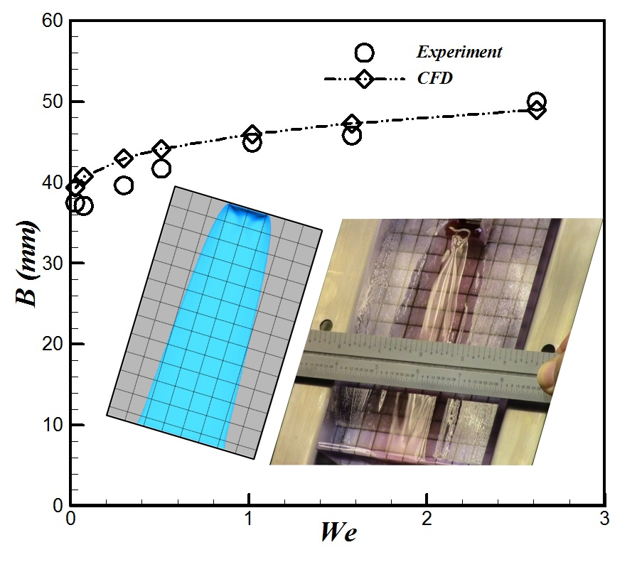

Figure 3 Comparison of the VOF predicted rivulet width (B) with experiments for 10cS general purpose silicon oil. Width of the rivulet is measured at 60 mm from inlet. Inset shows the comparison of the shape of the interface at We=1.02.

Having excellent agreement between CFD and experiment in the elementary problem, VOF simulation can be further utilized for two phase flow investigation in complex geometry with extensive validation. Note that the geometry of the structure packing unit is more complex in which corrugated sheets arranged in a crisscrossing fashion to form a single layer of packing unit. In addition, countercurrent gas–liquid flow through corrugated sheets in the structure packings shows more complicated flow feature. In the proposed work of Unit problem 1, interfacial area will be computed for different packing designs widely used for carbon capture in the industry for validation purpose. Note that interfacial area is a crucial component involving in mass transfer thereby overall efficiency of the column. Without adequate contact of phases (interfacial area), very little reaction will occur which can adversely impact the column efficiency. In this effort, extensive CFD simulations campaign will be conducted for a range of known solvent properties, column design and gas/liquid load to validate the VOF prediction in complex geometry of structure packings.

A number of experimental investigations were conducted for investigating the flow characteristics of the packed columns. The various noninvasive experimental measurement techniques such as X-ray computed tomography (XCT) [26-29], light-induced fluorescence (LIF) [26], etc., were used to visualize and compute the liquid distribution inside various structure packings. The XCT is capable to balance spatial resolution with temporal resolution that enhances its ability for three dimensional flow visualization inside the packing in local level [27]. Because of these features, it has been extensively used for flow visualization and quantifying the liquid holdup as well as gas-liquid interfacial area in different packings design such as Mellapaks 250Y & 500Y [26], Montzs B1-250Y & 250X [27], MellapakPlus 752.Y [30], Ketapack SP12 [31], etc. In the proposed work, validation of Unit problem 1 focuses on uncertainty quantification of CFD prediction with reported experimental studies. We will exploit advantage of the published results to determine the most accurate modeling approach. If further needed, independent experiments using XCT might be designed and conducted for more precise validation and uncertainty quantifications.

Unit problems 2.1-2.3 -- The validation of the Unit problems 2.1-2.3 will need to utilize the wetted wall column type of experimental data together with previously published experimental results for solvents of interests [10-13]. University of Texas Austin and PNNL have both previously designed and built bench top WWC units for solvent screening purposes. It is anticipated that experimental capabilities as such will be instrumented and utilized to conduct separate effect experiments to validate the unit problems depicted in Figure **2**. For example, CCSI Year 5 has performed CFD simulations and WWC experiments with MEA at the PNNL WWC facility with N2O (as non-reactive surrogate for CO2) and CO2 (for reacting cases) for calibrating the transport properties and the reaction rate constants under different temperatures and solvent loadings.

## Intermediate bench scale experiments

Coupled bench scale packed column experiments on solvent-based CO2 capture have been conducted by NETL and PNNL as well as other facilities. However, those experiments are mainly focus on solvent selection and screening and are not intended for model validation and calibration. Through our initial discussion with the NETL experimental team, it is possible that a small packed column reactor at NETL be modified for the model validation purpose. In addition, PNNL also has similar bench-scale packed column available. Our team will work with the project leadership in identifying the most synergistic approach to get the intermediate bench scale validation experiments conducted.

## Laboratory scale absorption column

GE Global Research in Upstate NY has constructed a laboratory scale absorption column (with random packing) with staged ports along the height of the column for process monitoring and data collection. GE has been working with CCSI to acquire the modeling toolsets on uncertainty quantification and process modeling. Through earlier discussions with CCSI, GE has expressed interests in sharing the laboratory scale data for CCSI model validation. At this time, however, no detailed agreement has been reached.

We are also open to partnering with other experimental sources for laboratory scale model validation.

## Pilot scale systems

At this time the most likely experimental pilot scale carbon capture system reside in National Carbon Capture Center (NCCC) since it serves as the main pilot scale demonstration facility for majority of the post-combustion carbon capture technologies developed in the US. However, we have not initiated any detailed discussions with NCCC on data collection needs for device-scale modeling validations.

Should NCCC data (or other data) become available for pilot scale solvent-based carbon capture systems, we will consider the validation of coupled pilot scale problems in a similar manner to the laboratory scale coupled cases. Pilot scale data would allow us to further validate the upscaling methodologies and predicted model discrepancies.

## Industrial scale systems

Using computational tools to virtually develop and progressively validate larger to full scale carbon capture systems with predictive confidence is the main focus of this validation plan. At the time this document is prepared, there does not exist (nor are there any plans for) an industrial scale solvent-based carbon capture system. As such we will most likely not have experimental data available for the validation of our industrial scale reactor models. Should the situation change and a physical system be built, we will work closely with the industry partner or laboratory to obtain data for validation of our larger scale models.

Based on the currently anticipated availability of experimental data, the validation plan for the full scale industrial system will rely on the validation and quantitative confidence gained at the lower tiers of Figure **2**. For our larger laboratory scale to full scale models, we will assume that once the physics coupling of the unit problems and geometric upscaling of our models have been validated at the laboratory scale (and pilot scale if available), the validity of the modeling methodology will hold true for larger to full scale systems.

This assumption relies on thorough validation at the unit scale, upscaling and laboratory scales which will be the main focus of the CCSI validation work. The validation work at the lower tiers will provide us with a confidence range for the full scale system and will allow us to separate out the contributions of geometric upscaling and unit problems coupling to the overall predicted error of the full scale system. This will help to identify areas for improvement in model development and experimental property and parameter measurement which in turn will enhance our ability to understand and manage the uncertainty in the CFD models being developed to model CCSI systems.

As above regarding the extension from bench-scale experiments, there will be little systematic experimental testing available to contribute to parameter calibration as the installations are increasingly focused on considerations of scale. We will instead continue to examine the discrepancy hierarchy between models, lab-, pilot-, and now industrial- scale implementations to understand the important distinctions between the simpler systems and the more complex systems at each level of the development of systems. At the same time, model refinements and small-scale experiments will no doubt continue to be developed to increase relevant understanding of the at-scale systems.

# Linkages and Connections to Process Models

The industrial scale CO2 capture devices are expected to be large, therefore dynamic process models will necessarily have to be simple in order to be able to handle the slow dynamics associated with these devices. These models are expected to be no more complex than one-dimensional in space, tracking the evolution of cross-sectional average liquid holdup, and the velocity, composition and temperature of the gas and liquid phases at various elevations.

As a result, the process models require constitutive models as inputs that can represent the cross-sectional average of the following quantities:

a) The interaction force between the solid and each of the two flowing phases

b) The interaction force between the gas and liquid phases

c) The product of gas-liquid interfacial area per unit volume of the bed and the effective mass transfer coefficient

If local thermal equilibrium is not attained, a model for the heat exchange will also be needed.

At the scale of the packing material, the details of gas-liquid flow determine the local values of interaction forces and mass transfer characteristics. These local quantities are typically correlated in terms of local flow quantities such as local superficial velocities and the physical properties of the fluids and packing material (referred to hereafter as microscopic constitutive models). Such correlations can be generated either experimentally or through a properly designed simulation campaign or a combination of both. As countercurrent-flow packed absorption columns and co-current flow trickle bed reactors have been in use for many decades, researchers have sought to develop such constitutive models by analyzing experimental data gathered from simple test examples. One can find such correlations in the literature; for example, CCSI task 4 is currently using some such models in the device-scale multi-dimensional flow and mass transfer simulations. The question is therefore whether these models are adequate and accurate for the advanced solvents with physical properties (such as viscosities) that differ significantly from those used in the test experiments.

Generating microscopic constitutive models through simulations is conceptually clear. A fair amount of work of this type has been done for fluid-solid flows and for gas-liquid bubbly flows, and computationally generated closures are available in the literature for these flows. The feasibility of such detailed simulations, using the VOF method, has been demonstrated in the literature and in our studies; however, computationally generated microscopic constitutive relations for gas-liquid flows in packed columns are not yet available. Studies performed by the CCSI team in the past year have shown that both the VOF module in commercial software (Ansys Fluent®) as well as the open-source software (OpenFOAM, which required a number of improvements) can be used to simulate such flows problems. However, these simulations are computationally expensive and only flows in small domains can realistically be simulated. On the positive side, unlike cold-flow experiments, these simulations allow exploration of a wide range of physical properties.

Irrespective of whether one approaches the development of constitutive relations experimentally or via simulations, the models are limited to the type of packing material used in the experiments/analysis. (There have been efforts in the literature to integrate the results from various different packing materials into master correlations, with modest success.) While the choice of packing material does not pose any challenge in experiments, it is a challenge in simulation approach. As one can only simulate flows in small regions, one must identify realistic representative packed domains used in the simulations. If one considers randomly packed beds, then one must create many realizations of randomly packed regions, simulate flows in them and obtain a statistical average in them. (This is what one does in fluid-particle flows, for example.) Thus, the principal challenge of VOF simulations of gas-liquid flows in small domains lies in identification of realistic geometries to deploy in the simulations. By and large, the use of VOF simulations in the literature has been focused on developing physical understanding of flows in simple flow geometries. In CCSI, we are studying flows in simple geometries (inclined plane, corrugated plates, disk-packs and sphere packs) to demonstrate the approach to develop constitutive models and also ascertain whether drastic changes in flow behavior arises with advanced solvents in these domains.

Even in these small representative domains, one will expect flow non-uniformities such as partial wetting. Such small-scale flow inhomogeneities can be considered and accounted for in the microscale constitutive models. However, in flows in large devices, there will be both axial and lateral inhomogeneities (which can also have a temporal component). The device-scale process models seek to capture axial variations occurring on a slow time scale, but they are not useful to understand the multi-dimensional spatial and spatiotemporal flows observed in actual devices. For example, the one-dimensional process models will not be able to differential the performances obtained with different non-uniform liquid irrigations at the top. To understand these inhomogeneities, one should perform device scale simulations of two-fluid model (in packed beds). Such device scale simulations can help reveal the following insights:

1) How flow inhomogeneities arise at different operating conditions (below the flooding point) and how they affect the mass transfer characteristics. (In particular, it allows us to ascertain if advanced solvents with very different viscosities encourage emergence of inhomogeneities which adversely affect process performance.)

2) What effective cross-sectional average constitutive models should be used in the process models (by suitable coarse-graining analysis).

While one can, in principle, directly apply the microscale constitutive models developed experimentally or through computations in process models, it would completely ignore the important question as to whether the choice of device design will promote maldistribution to emerge spontaneously (especially because of physical property variation associated with CO2 uptake) or through maldistribution of liquid at the top. Sample simulations already performed by preliminary CCSI solvent research illustrate inhomogeneities revealed by such E-E simulations which will not be captured by one-dimensional process models. Invariably, it is such maldistribution that leads to under-performance of packed devices for gas-liquid contacting. Device scale simulations of the type being pursued by the CCSI CFD team will be useful for the process designers in addressing at least two important questions:

1) Even if we achieve perfect distribution at the boundaries, will inhomogeneity emerge spontaneously and adversely affect contacting? This type of inhomogeneity arises as a result of instabilities associated with the flow, which can be exacerbated by physical property evolution and variation. When this happens, one is forced to divide the device into stages with liquid redistribution after each stage.

2) How close to perfect distribution does one need? Lateral migration of liquid (in the absence of an instability) is generally weak and so, liquid maldistribution tends to persist.

With these considerations, it is clear that device scale models play a very valuable role. In a hierarchical view, process models are essential for overall design and control. Device-scale simulations are useful to understand occurrence of large-scale inhomogeneities and identifying strategies to manage them. Either packing scale simulations or cold flow experiments (preferably a combination of both) are critical to provide inputs needed for the device-scale models. One can initially apply the microscale constitutive models developed from packing scale simulations in process models as a first approximation, while doing the device scale multidimensional flow simulations in parallel to understand complexities.

# Limitations and Gaps

As discussed previously the validation methodology laid out in this proposal can be considered as “validation on a budget”. This validation plan is meant to be specific to the carbon capture systems being considered as part of the CCSI program. As such we have defined a very narrow scope for our validation activities which will allow us to complete the validation in the time frame available and with the funds available to us. This leads to certain limitations and gaps in the methodology which make this validation plan inappropriate for use on more generic multi-physics, multi-scale systems.

The first limitation is the unit problems selected and considered in the validation plan. Very specific unit problems are outlined in our validation plan and are based on the specific CCSI solvent-based carbon capture system designs. Although some of the unit problems may apply to systems outside the CCSI program the overall analysis only applies to the CCSI specific systems and is not applicable to outside systems. Also, the unit problems that we have chosen to consider limit the validation plan to the currently considered CCSI designs. If extreme changes are made in the geometry, sorbent particles design or flow regimes considered we may have to re-evaluate the validation plan.

Another limitation relating to the unit problems will be the availability of high quality experimental data and error estimates. For previously published experimental data for unit problems, we will most likely not have direct access to the experimental data. We will only have access to the published information on the experiments and simulations. This may limit our ability to identify and quantify the experimental errors for those unit problems. We will attempt to use the most complete validation studies available; however, we will most likely not be able to find high quality experimental data for all of the unit problems.

The second limitation is the proposed sequentially coupled approach for the overall validated uncertainty quantification goal. The validation plan presented here aims at first providing quantitative confidence on the CFD simulations for the baseline design. However, this analysis will be augmented by additional uncertainty quantification studies performed in conjunction with the UQ team where uncertain modeling parameters are varied within the bounds that are physically permissible by the problem, hence propagating uncertainties from input parameters to the various metrics for system performance measurements.

A third limitation is the inability to incorporate all parameters and completely specify their associated distributions. In the initial definition phase of the UQ analysis, it is important to narrow down the set of parameters of interest to a modest size that is feasible for subsequent computations. The expensive function evaluations encountered in CFD studies necessitates focusing on a reduced parameter set. This results in a tradeoff between computational effort and the risk of excluding important parameters. The use of statistical experimental design techniques can ameliorate this situation by reducing the number of simulations required to examine high-dimensional parameter spaces. In addition, while expert knowledge can often be used to specify reasonable ranges for parameter studies, initial characterization of parameter distributions is generally approximate.

Another limitation of the validation plan is the gaps, i.e., omissions of the incrementally coupled cases, in the validation hierarchy laid out in this document. These include the consideration of the incremental coupling of the unit problems before upscaling, which would require a large amount of experimental data and numerous validation studies. The lack of data at the intermediate industrial scale (25 MWe, 100 MWe) is also a gap in available data that will most likely not be resolved during the validation process. Insufficient data at other scales may further limit the validation and UQ process.

Due to the gaps and limitations of the validation/UQ studies proposed herein, we will rely heavily on the expertise and past experiences of the CCSI team members, especially those directly involved in Tasks 3 and 4. Their understanding of the problems and insight from past experiences will help to guide the validation work to ensure that we are appropriately considering all of the physical and scaling effects, which will affect the validity and errors associated with the CCSI modeling activities, and that we are minimizing the effects of these gaps and limitations on the validation of the CCSI device scale models.

# Conclusions

A hierarchical validation strategy has been laid out for the CCSI CFD modeling of the full scale solvent-based carbon capture system. The goal of the proposed validation and UQ analysis is to quantify the predictive confidence of the CFD predictions for a specific solvent-based capture system of interest to the CCSI program. We do not intend to lay out a general validation methodology that would be appropriate for other complex multi-physics systems.

The proposed validation and UQ methodology aims to provide quantitative confidence on the CFD simulations of larger to full scale carbon capture systems by coupling of simpler physical systems and upscaling to larger systems. As shown in Figure **2** a multi-tier methodology is proposed which divides the complexities of the full scale system into simpler sub problems. We will start by validating simple unit problems which represent pieces of the multi-physics of the entire carbon capture system. We will rely on previously published literature studies as well as limited number of controlled WWC experiments for the validation and calibration of unit problems. We will next move on to considering the effects of upscaling and coarse graining methodologies which are used to deal with the geometrical challenges associated with simulating a bench scale carbon capture system. Validation of the upscaling will focus on the development of filtered models and their validation with experimental data and fine scale models. Next we will consider decoupled and coupled bench- and laboratory-scale validation cases to investigate the effects of using the filtered models in larger scale systems and the combined effects of upscaling and unit problem coupling on the accuracy of the simulations.

The final tier of Figure **2** is the pilot scale demonstration and conceptually designed full scale carbon capture systems. The overall goal of all of the validation activities is to quantify our confidence in the predictions of the full scale carbon capture simulations. We will use the information gained from the smaller scale validation problems to quantify our confidence in our full scale simulations. Based on the individual tiers of the validation plan we will be able to separate the effects of coupling vs. upscaling vs. model selection on the overall error of the full scale simulations.

We have outlined a validation hierarchy for device-scale CFD predictions of solvent-based CO2 capture system that can be achieved within the timeframe and the funds available to us. As such, there are limitations and gaps associated with the proposed methodology. The gaps include the consideration of the coupling of the unit problems before upscaling, which would require a large amount of experimental data and numerous validation studies. The lack of data at the intermediate and full scale is also a limitation which will most likely not be resolved in time for this validation study. The validation studies which will be done will also be limited by the specific cases considered and the range of model properties and parameters considered which will be limited to those relevant to the CCSI program.

**References**

1. Astronautics, A.I.o.A.A., *AIAA Guide for the Verification and Validation of Computational Fluid Dynamics Simulations*. AIAA G-077-1998. 1998, Renton, VA: American Institute of Aeronautics & Astronautics.

2. Oberkampf, W.L. and C.J. Roy, *Verification and Validation in Scientific Computing*. 2010: Cambridge University Press.

3. Roache, P.J., *Verification and Validation in Computational Science and Engineering*. 1998, Albuquerque, NM: Hermosa Publishers.

4. Roy, C.J. and W.L. Oberkampf, *A comprehensive framework for verification, validation, and uncertainty quantification in scientific computing.* Computer Methods in Applied Mechanics and Engineering, 2011. **200**(25-28): p. 2131-2144.

5. Grace, J.R. and F. Taghipour, *Verification and validation of CFD models and dynamic similarity for fluidized beds.* Powder Technology, 2004. **139**(2): p. 99-110.

6. Gu, F., et al., *CFD simulation of liquid film flow on inclined plates.* Chemical Engineering & Technology, 2004. **27**(10): p. 1099-1104.

7. Raynal, L., C. Boyer, and J.P. Ballaguet, *Liquid holdup and pressure drop determination in structured packing with CFD simulations.* Canadian Journal of Chemical Engineering, 2004. **82**(5): p. 871-879.

8. Raynal, L. and A. Royon-Lebeaud, *A multi-scale approach for CFD calculations of gas-liquid flow within large size column equipped with structured packing.* Chemical Engineering Science, 2007. **62**(24): p. 7196-7204.

9. Shojaee, S., et al., *Prediction of the Effective Area in Structured Packings by Computational Fluid Dynamics.* Industrial & Engineering Chemistry Research, 2011. **50**(18): p. 10833-10842.

10. Hu, J.G., et al., *Numerical simulation of carbon dioxide (CO2) absorption and interfacial mass transfer across vertically wavy falling film.* Chemical Engineering Science, 2014. **116**: p. 243-253.

11. Yoshimura, P.N., T. Nosoko, and T. Nagata, *Enhancement of mass transfer into a falling laminar liquid film by twig-dimensional surface waves - Some experimental observations and modeling.* Chemical Engineering Science, 1996. **51**(8): p. 1231-1240.

12. Li, M.H. and M.D. Lai, *Solubility and Diffusivity of N2o and Co2 in (Monoethanolamine Plus N-Methyldiethanolamine Plus Water) and in (Monoethanolamine Plus 2-Amino-2-Methyl-1-Propanol Plus Water).* Journal of Chemical and Engineering Data, 1995. **40**(2): p. 486-492.

13. Weiland, R.H., et al., *Density and viscosity of some partially carbonated aqueous alkanolamine solutions and their blends.* Journal of Chemical and Engineering Data, 1998. **43**(3): p. 378-382.

14. Higdon, D., et al., *Computer model calibration using high-dimensional output.* Journal of the American Statistical Association, 2008. **103**(482): p. 570-583.

15. Storlie, C.B., et al., *Calibration of Computational Models With Categorical Parameters and Correlated Outputs via Bayesian Smoothing Spline ANOVA.* Journal of the American Statistical Association, 2015. **110**(509): p. 68-82.

16. Al-Dahhan, M.H., et al., *Prediction of pressure drop and liquid holdup in high-pressure trickle-bed reactors.* Industrial & Engineering Chemistry Research, 1998. **37**(3): p. 793-798.

17. Attou, A., C. Boyer, and G. Ferschneider, *Modelling of the hydrodynamics of the cocurrent gas-liquid trickle flow through a trickle-bed reactor.* Chemical Engineering Science, 1999. **54**(6): p. 785-802.

18. Holub, R.A., M.P. Dudukovic, and P.A. Ramachandran, *A Phenomenological Model for Pressure-Drop, Liquid Holdup, and Flow Regime Transition in Gas-Liquid Trickle Flow.* Chemical Engineering Science, 1992. **47**(9-11): p. 2343-2348.

19. Holub, R.A., M.P. Dudukovic, and P.A. Ramachandran, *Pressure-Drop, Liquid Holdup, and Flow Regime Transition in Trickle Flow.* Aiche Journal, 1993. **39**(2): p. 302-321.

20. Iliuta, I., et al., *Gas-liquid interfacial mass transfer in trickle-bed reactors: state-of-the-art correlations.* Chemical Engineering Science, 1999. **54**(23): p. 5633-5645.

21. Saez, A.E. and R.G. Carbonell, *Hydrodynamic Parameters for Gas-Liquid Cocurrent Flow in Packed-Beds.* Aiche Journal, 1985. **31**(1): p. 52-62.

22. Billet, R., *Packed Towers in Processing and Environmental Technology*. 1995, Weinheim: Wiley-VCH.

23. Toye, D., et al., *Local measurements of void fraction and liquid holdup in packed columns using X-ray computed tomography.* Chemical Engineering and Processing, 1998. **37**(6): p. 511-520.

24. Yin, F.H., et al., *Liquid holdup distribution in packed columns: gamma ray tomography and CFD simulation.* Chemical Engineering and Processing, 2002. **41**(5): p. 473-483.

25. deMontigny, D., et al., *Modelling the performance of a CO2 absorber containing structured packing.* Industrial & Engineering Chemistry Research, 2006. **45**(8): p. 2594-2600.

26. Bradtmoller, C., et al., *Influence of Viscosity on Liquid Flow Inside Structured Packings.* Industrial & Engineering Chemistry Research, 2015. **54**(10): p. 2803-2815.

27. Eldridge, R.B., *Advanced Hydraulic and Mass Transfer Models for Distillation Column Optimization and Design* The University of Texas and Oak Ridge National Laboratory

28. Heindel, T.J., *A Review of X-Ray Flow Visualization With Applications to Multiphase Flows.* Journal of Fluids Engineering-Transactions of the Asme, 2011. **133**(7).

29. Schmit, C.E. and R.B. Eldridge, *Investigation of X-ray imaging of vapor-liquid contactors. I. Studies involving stationary objects and a simple flow system.* Chemical Engineering Science, 2004. **59**(6): p. 1255-1266.

30. Janzen, A., et al., *Investigation of liquid flow morphology inside a structured packing using X-ray tomography.* Chemical Engineering Science, 2013. **102**: p. 451-460.

31. Aferka, S., et al., *In situ measurements of the static liquid holdup in Katapak-SP12 (TM) packed column using X-ray tomography.* Chemical Engineering Science, 2007. **62**(21): p. 6076-6080.