##### New_DOE_Logo_Color_042808



**Intellectual Property Management Plan**

**February 28, 2011**

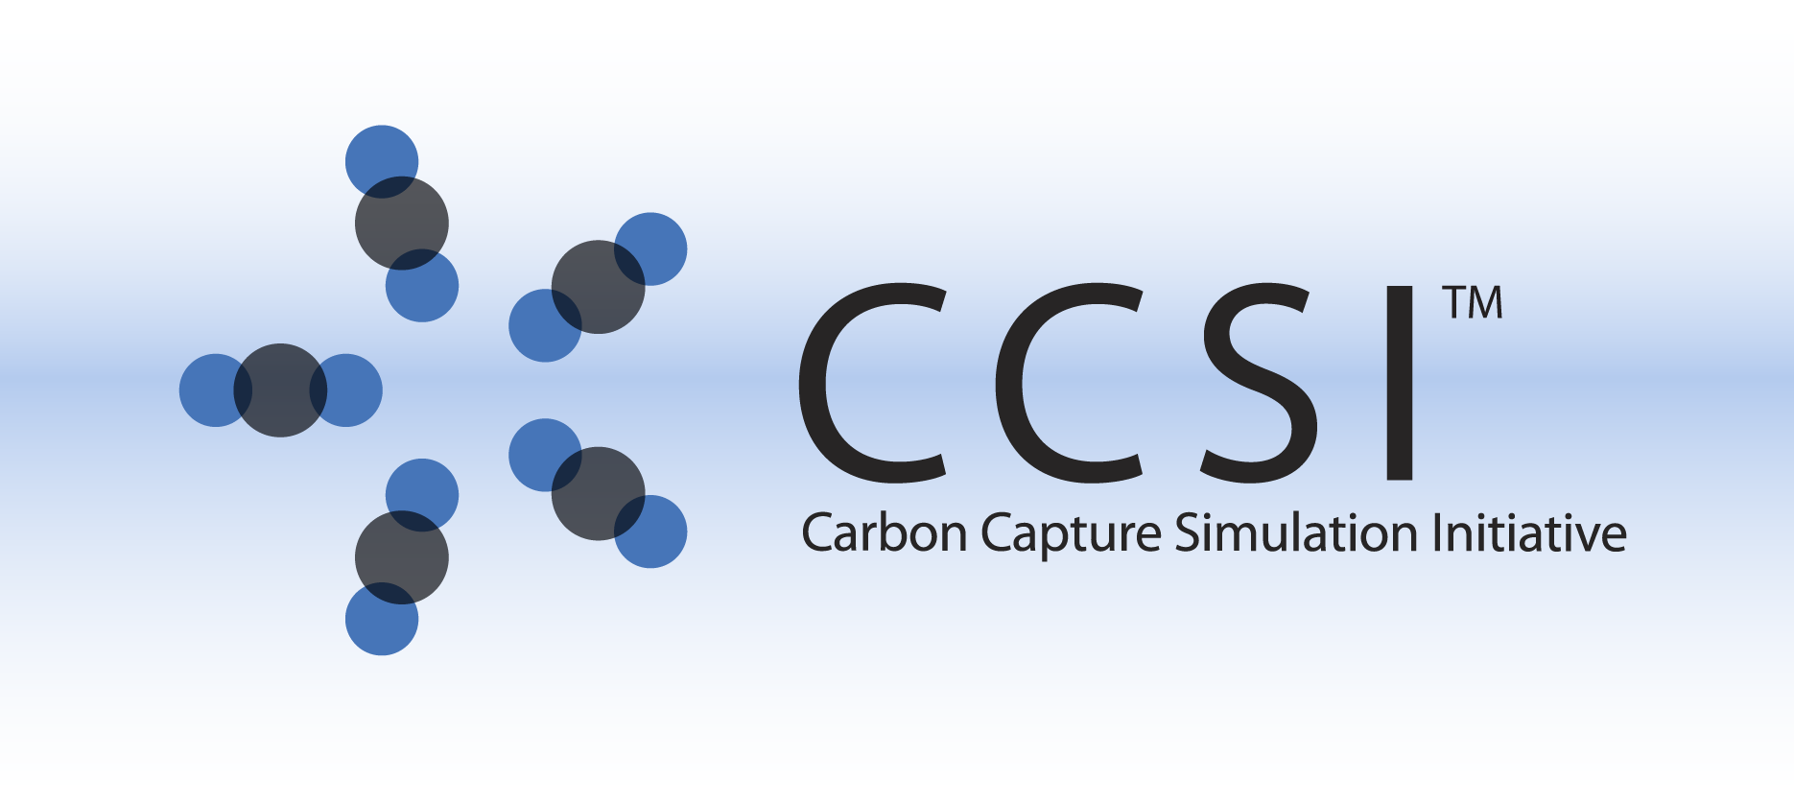

MFIX-DEM ATTRITION MODEL INSTALLATION GUIDE

Version 2013.10.0

August 7, 2013

**This material was produced under the DOE Carbon Capture Simulation Initiative (CCSI), and copyright is held by the software owners: ORISE, LANS, LLNS, LBL, PNNL, CMU, WVU, et al. The software owners and/or the U.S. Government retain ownership of all rights in the CCSI software and the copyright and patents subsisting therein. Any distribution or dissemination is governed under the terms and conditions of the CCSI Test and Evaluation License, CCSI Master Non-Disclosure Agreement, and the CCSI Intellectual Property Management Plan. No rights are granted except as expressly recited in one of the aforementioned agreements.**

Table of Contents

[1. Installation 1-1](#_Toc363641251)

[1.1. Prerequisites 1-1](#_Toc363641252)

[1.2. Third Party Software 1-1](#_Toc363641253)

[1.3. Product Installation 1-1](#_Toc363641254)

[2. Simulations 2-2](#_Toc363641255)

[3. References 3-2](#_Toc363641256)

# Installation

The installation of the CCSI solid sorbent attrition discrete element model (DEM) generally follows the MFIX manual [1]. The present document solely intends to provide an overview on specific procedures required to enable the Attrition-DEM module within MFIX. Please refer to the User Manual [2] for additional details. **It should be noted that the current Attrition-DEM module only works with MFIX-2012-1 version.**

## Prerequisites

Same hardware and software environment specified by MFIX [1] apply.

## Third Party Software

Open-source, multi-platform data analysis and visualization application *ParaView* is recommend for post-processing of the MFIX simulation and can be downloaded from <https://www.paraview.org>. Other similar visualization software (for example, *Tecplot*, *Visit*) can also serve the same purpose.

## Product Installation

It is assumed that user has downloaded the MFIX source files and created the entire MFIX directory structure.

To install the Attrition-DEM module, the user needs to first create a run folder in the MFIX directory ($HOME/mfix), for example, in LINUX system,

$HOME/mfix/attrition

The source code and the simulation input files for the Attrition-DEM model are available on the CCSI repository, and should be downloaded into $HOME/mfix/attrition

Move the following files from $HOME/mfix/attrition to $HOME/mfix/model to replace the original files:

mfix\_l.make

mfix\_l\_not.make

mfix\_u.make

mfix\_u\_not.make

and then copy the desnamelist.inc and calc\_attrition\_des.f files from $HOME/mfix/attrition/des to $HOME/mfix/model/des.

Note this replacement will not affect other MFIX capabilities, but only allow the user to enable/disable the attrition module using the DES\_ATTRITION logical variable.

Follow the MFIX instructions [1] to build the mfix executable in $HOME/mfix/attrition. Remember to choose “[2] Force re-compilation for the question” for “Option to re-compile source files in run directory” during the compilation. Upon successful build, a custom mfix.exe is available in $Home/mfix/attrition.

# simulations

The DEM model input files mfix.dat and particle\_input.dat are included in $Home/mfix/attrition/Example. The present simulation is for the parallel run with *8* processors. Users can choose to run the simulation with different number of processors or in serial by changing the values of NODESI, NODESJ, and NODESK in mfix.dat following [1]. Due to the computationally intensive nature of the DEM model, it is recommended to use the distributed memory parallel (MPI) method. The model will run in serial and shared memory parallel (SMP), however the computations are inefficient and will take a very long time.

Note the logical variable DES\_ATTRITION enables/disables the attrition calculations. If DES\_ATTRITION is set to .FALSE., then the original 2012 MFIX code is obtained (e.g. the DES attrition calculations are skipped over).

# references

[1] MFIX – Multiphase Flow with Interphase eXchanges, Version MFIX-2012-1, January 2012. (readme.pdf distributed within MFIX tarball)

[2] CCSI Solid Sorbent Attrition Model USER MANUAL, version 0.1, August 14, 2013.