



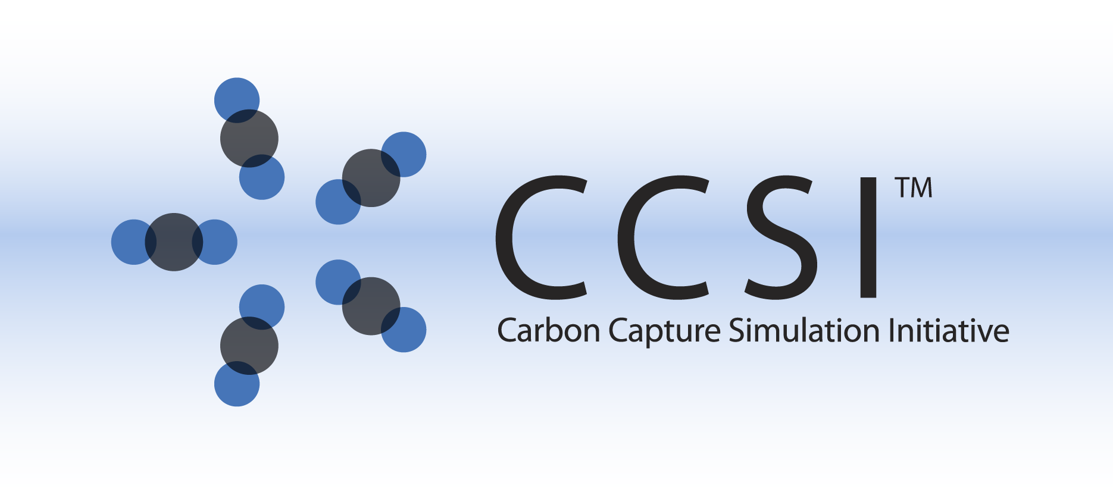

CCSI Integrated Capture Systems Model

(IntCap)

User Manual

Version 2.0.0

March 2018

Copyright (c) 2012 - 2018

**Copyright Notice**

Integrated Capture Systems Model was produced under the DOE Carbon Capture Simulation Initiative (CCSI), and is copyright (c) 2012 - 2018 by the software owners: Oak Ridge Institute for Science and Education (ORISE), Los Alamos National Security, LLC., Lawrence Livermore National Security, LLC., The Regents of the University of California, through Lawrence Berkeley National Laboratory, Battelle Memorial Institute, Pacific Northwest Division through Pacific Northwest National Laboratory, Carnegie Mellon University, West Virginia University, Boston University, the Trustees of Princeton University, The University of Texas at Austin, URS Energy & Construction, Inc., et al.. All rights reserved.

NOTICE. This Software was developed under funding from the U.S. Department of Energy and the U.S. Government consequently retains certain rights. As such, the U.S. Government has been granted for itself and others acting on its behalf a paid-up, nonexclusive, irrevocable, worldwide license in the Software to reproduce, distribute copies to the public, prepare derivative works, and perform publicly and display publicly, and to permit other to do so.

**License Agreement**

Integrated Capture Systems Model Copyright (c) 2012 - 2018, by the software owners: Oak Ridge Institute for Science and Education (ORISE), Los Alamos National Security, LLC., Lawrence Livermore National Security, LLC., The Regents of the University of California, through Lawrence Berkeley National Laboratory, Battelle Memorial Institute, Pacific Northwest Division through Pacific Northwest National Laboratory, Carnegie Mellon University, West Virginia University, Boston University, the Trustees of Princeton University, The University of Texas at Austin, URS Energy & Construction, Inc., et al. All rights reserved.

Redistribution and use in source and binary forms, with or without modification, are permitted provided that the following conditions are met:

1. Redistributions of source code must retain the above copyright notice, this list of conditions and the following disclaimer.
2. Redistributions in binary form must reproduce the above copyright notice, this list of conditions and the following disclaimer in the documentation and/or other materials provided with the distribution.
3. Neither the name of the Carbon Capture Simulation Initiative, U.S. Dept. of Energy, the National Energy Technology Laboratory, Oak Ridge Institute for Science and Education (ORISE), Los Alamos National Security, LLC., Lawrence Livermore National Security, LLC., the University of California, Lawrence Berkeley National Laboratory, Battelle Memorial Institute, Pacific Northwest National Laboratory, Carnegie Mellon University, West Virginia University, Boston University, the Trustees of Princeton University, the University of Texas at Austin, URS Energy & Construction, Inc., nor the names of its contributors may be used to endorse or promote products derived from this software without specific prior written permission.

THIS SOFTWARE IS PROVIDED BY THE COPYRIGHT HOLDERS AND CONTRIBUTORS "AS IS" AND ANY EXPRESS OR IMPLIED WARRANTIES, INCLUDING, BUT NOT LIMITED TO, THE IMPLIED WARRANTIES OF MERCHANTABILITY AND FITNESS FOR A PARTICULAR PURPOSE ARE DISCLAIMED. IN NO EVENT SHALL THE COPYRIGHT OWNER OR CONTRIBUTORS BE LIABLE FOR ANY DIRECT, INDIRECT, INCIDENTAL, SPECIAL, EXEMPLARY, OR CONSEQUENTIAL DAMAGES (INCLUDING, BUT NOT LIMITED TO, PROCUREMENT OF SUBSTITUTE GOODS OR SERVICES; LOSS OF USE, DATA, OR PROFITS; OR BUSINESS INTERRUPTION) HOWEVER CAUSED AND ON ANY THEORY OF LIABILITY, WHETHER IN CONTRACT, STRICT LIABILITY, OR TORT (INCLUDING NEGLIGENCE OR OTHERWISE) ARISING IN ANY WAY OUT OF THE USE OF THIS SOFTWARE, EVEN IF ADVISED OF THE POSSIBILITY OF SUCH DAMAGE.

You are under no obligation whatsoever to provide any bug fixes, patches, or upgrades to the features, functionality or performance of the source code ("Enhancements") to anyone; however, if you choose to make your Enhancements available either publicly, or directly to Lawrence Berkeley National Laboratory, without imposing a separate written license agreement for such Enhancements, then you hereby grant the following license: a non-exclusive, royalty-free perpetual license to install, use, modify, prepare derivative works, incorporate into other computer software, distribute, and sublicense such enhancements or derivative works thereof, in binary and source code form. This material was produced under the DOE Carbon Capture Simulation

Table of Contents

1.0 Reporting Issues 1

2.0 Version Log 1

Integrated Solid Sorbent CO2 Capture System Model 2

1.0 Introduction 2

2.0 Integrated Model Structure 2

2.1 IO Structure 2

2.2 Component List and Physical Properties 3

3.0 ACM Integrated Model Tutorial 4

4.0 Implementation of Integrated Model in gPROMS 6

5.0 Installation Requirements 11

6.0 Reference 12

List of Figures

Figure 1: Gas flowrate to compressors. 4

Figure 2: Percent CO2 removed from the flue gas during step changes. 5

Figure 3: Power requirement of CO2 compressors during step changes. 5

Figure 4: Specification box for MB model. The process flowsheet model “Integrated_process” is highlighted in the “project tree” menu on the left. 6

Figure 5: Click “Play” (the green arrow on the top toolbar) while the “process_MB Model” window is open to open the “Simulate” window. The “Initialisation Procedure” drop-down menu enables the user the option to run the initialization procedure. Select the “Ignore” option. 7

Figure 6: Data selection window for gRMS template. 8

Figure 7: A plot that results from loading template “stage12.gpt.” This plot shows the dynamic power requirements of the stage 1 and stage 2 compressor. Note: The data will be added as the simulation to continue, therefore the generated plot may contain more or less time series data than is shown here. 9

Figure 8: gPROMS simulation power requirement for CO2 compressors during ramped decrease in flue gas. 10

Figure 9: gPROMS simulation inlet flue gas flowrate and percent CO2 removed. 11

To obtain support for the products within this package, please send an e-mail to   
[ccsi-support@acceleratecarboncapture.org](mailto:ccsi-support@acceleratecarboncapture.org).

1. Reporting Issues

To report an issue, please send an e-mail to [ccsi-support@acceleratecarboncapture.org](mailto:ccsi-support@acceleratecarboncapture.org).

1. Version Log

| Product | Version Number | Release Date | Description |
| --- | --- | --- | --- |
| Integrated Solid Sorbent CO2 Capture Process | 2.0.0 | 3/31/2018 | Open Source Release |
| Integrated Solid Sorbent CO2 Capture Process | 2015.10.0 | 10/31/2015 | Initial release. |

Integrated Solid Sorbent CO2 Capture System Model

1. Introduction

This documentation introduces the dynamic integrated solid sorbent CO2 capture and compression process model that utilizes the Moving Bed (MB), Bubbling Fluidized Bed (BFB), and CO2 compression models that have been released as standalone models. This model can be used to predict the power requirements for the CO2 compression while taking into account the transport delay and pressure flow characteristics of the CO2 capture process. This document will give a brief overview of each sub-model that is used in the overall process model. More details of individual model’s assumptions and properties can be found in their corresponding sections in this manual.

1. Integrated Model Structure

There are two versions of the integrated model, one implemented in ACM, and the other is implemented in gPROMS® (Process Systems Enterprise Limited). The ACM integrated model is based on a Framework for Optimization and Quantification of Uncertainty and Sensitivity (FOQUS) optimized   
solid-sorbent steady-state process that is cable of 90% CO2 capture from a 650 MW coal fired plant. The process is assumed to require six trains of a 3-stage absorber, nine trains of 2-stage regenerators, and two trains of CO2 compressors. The model equations for the CO2 compressor are written in the Custom Modeling library. To find the various models that have been developed:

1. In the “All Items” pane of the “Simulation Explorer,” confirm the “Custom Modeling library” is expanded, and then expand the “Models” folder. A list of all models in the current simulation displays.
2. In the list of all developed models, click the desired model.
3. In the “Contents” pane, double-click the “equals” icon for the model.

The gPROMS version of the integrated model uses a two-stage BFB absorber, a 14-stage MB regenerator, and a single CO2 compressor train. **Note:** This model is not based on an optimized steady-state design, however demonstrates the predictive ability of all developed process models in gPROMS.

* 1. IO Structure

The integrated models contains several input and output ports. Each port has associated variables that correspond to the material connection stream variables. In the ACM version, the BFB and MB share the same port types, however those ports are converted when the CO2 stream enters the CO2 compressor train, as many auxiliary models are from the Aspen dynamics library that utilize a different port type. Additionally, the component N2 in the CO2 compressor inlet is removed as the amount of N2 should be negligible and the zero value would cause numerical problems with dynamic integration.

The gPROMS version of the model was developed with different ports for the MB and BFB models, so the project file contains a port convertor “model” that is used each time a stream connects one type of bed to another. Additionally, the CO2 compressor model in gPROMS was developed with the default PML port type (gPROMS model libraries), as many of the auxiliary equipment was modeled with the default PML library models, so the ports change across the beds and CO2 compressor train.

* 1. Component List and Physical Properties

There are three main parts of the integrated simulation, solid sorbent CO2 capture, compression, and drying. The compression section requires accurate properties for CO2 to predict compressor power. The drying section requires accurate vapor-liquid equilibrium calculations for the CO2-TEG-Water system. The MB/BFB needs accurate physical properties for hydrodynamics.

For the BFB and MB sections, two phase flow are modeled, gas and solid. Three components, carbon dioxide (CO2), water (H2O), and nitrogen (N2) are used in gas phase; and three ionic species, bicarbonate (Bic), carbamate (Car), and physisorbed water (H2O) are assumed for the solid phase which exists as the adsorbed state on sorbent. The mechanism of the adsorbate, CO2 and H2O, onto an amine-impregnated mesoporous sorbent is shown in reference (Lee, et al., 2012).

Physical properties of the fluids can be calculated using commercial property packages (Aspen Properties® in ACM and Multiflash® in gPROMS) using cubic equations of state. The sorbent properties should be specified by user, particle diameter, density, heat capacity, and heat conductivity. If the diffusion limited options to calculate the reaction rate is selected, the extra information for average pore diameter, intraparticle void fraction, and tortuosity is necessary.

The CO2 compressor section uses three components, carbon dioxide (CO2), water (H2O), and TEG. The nitrogen component from the solid sorbent section of the model is removed due to numerical issues stemming from the amount of nitrogen in the CO2 compressor train being near zero. The ACM version of the model uses LK-PLOCK for the compression train and the water knock-out drums, while HYSGLYCO is used for the drying section. However, the gPROMS version uses LK-PLOCK for the entire CO2 compression section as HYSGLYCO is not available in Multiflash.

1. ACM Integrated Model Tutorial

Example: Two ramp changes in the inlet flue gas flowrate and shutdown of one solid sorbent train.

1. Open the “ACM/Dynamic/Example_Flowrate/Int.BFB_CO2.acmf” file.
2. Load snapshot “int” results.
3. Run the model.
4. The flue gas ramps occur at 3hrs and 15hrs, and the shutdown of a train occurs at 40hrs. The total simulation time is 65hrs.
5. Observe the custom plot “Power,” “Flowrate,” and “CO2_removed” as shown below (Figure 25 under “Flowsheet Explorer.”



Figure : Gas flowrate to compressors.



Figure : Percent CO2 removed from the flue gas during step changes.



Figure : Power requirement of CO2 compressors during step changes.

1. Implementation of Integrated Model in gPROMS

The gPROMS model is set-up and simulated using the following steps:

1. Open the “gPROMS/Example/Integrated_process v1.0.gpj” file.
2. The integrated model utilizes the built in PML libraries in gPROMS. Navigate to “File” → “Open/Close Libraries.” A window opens with a list of available models. Select the “PML libraries” check box and then click “OK.”
3. In the “project tree” on the left, navigate to “Models” and then double-click “Integrated_process” (see Figure 28).

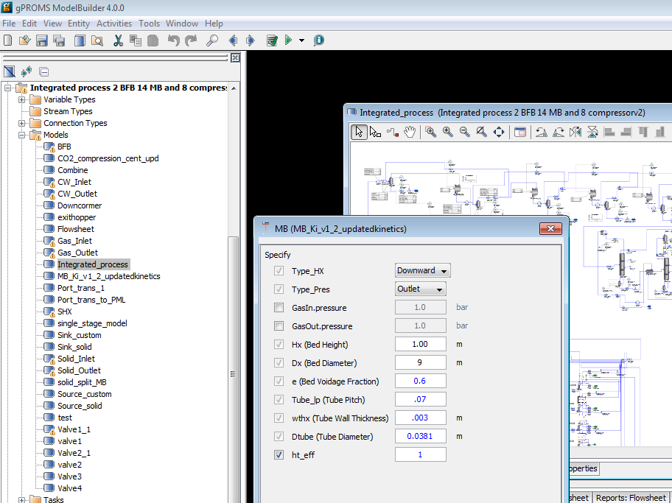

Figure : Specification box for MB model. The process flowsheet model  
“Integrated_process” is highlighted in the “project tree” menu on the left.

**Note:** Specifying the required variables is done by double-clicking each piece of process equipment under the “Topology” tab of the “process_MB” window. These values are set to default values. Like the ACM model, if these variables are changed, it may require an initialization procedure. This can be turned on or off in the next step by selecting “Execute” or “Ignore.”

1. Run the model by clicking “Play” (the green button on the top of the toolbar). The “Simulate” option menu displays. Be sure the check box for “Use steady-state initial conditions” is clear (see Figure 29). The model is setup to automatically select initial conditions. Additionally, be sure to select the “Send results trajectory to gRMS” check box. This sends the results of the simulation to gPROMS data management software, where templates for plotting the results have already been provided. Lastly, ensure that the “Ignore schedule and intrinsic tasks” is left cleared. This runs the schedule already set up (it introduces a disturbance) which can be viewed by opening the “Integrated_process” under the “Processes” folder in the “project tree” and then navigating to the “Schedule” tab. Select the check box to run a steady-state simulation. The disturbance configured is a decrease of inlet flue gas by closing the valve opening.

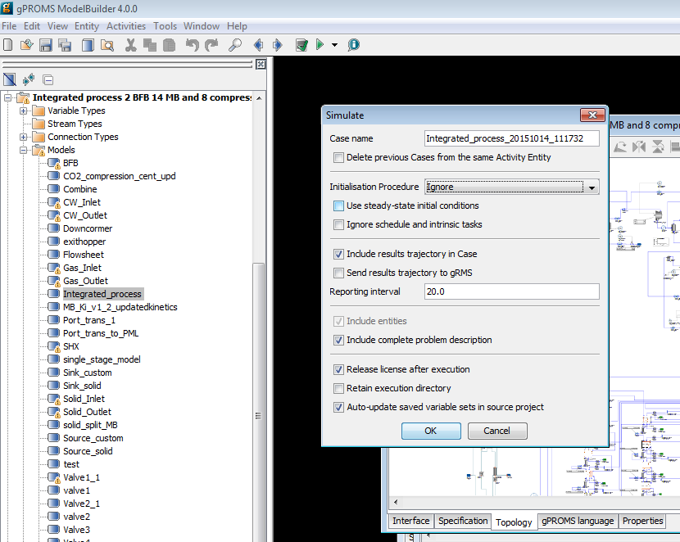

Figure : Click “Play” (the green arrow on the top toolbar) while the “process_MB Model” window is open to open the “Simulate” window. The “Initialisation Procedure” drop-down menu enables the user the option to run the initialization procedure. Select the “Ignore” option.

1. Click “OK” on the “Simulate” options window to begin the simulation.
2. A new results window displays (listed at the bottom of the “project tree”).
3. A ramp change occurs at 1,000s and the simulation time is 20,000s.
4. To view the results, navigate to the “gRMS” window that displayed once the simulation is run. gRMS is a data management program with numerous options and the ability to save a template for the plots, allowing plots to be generated quickly for new simulation results. Six of these templets’ have been provided as “.gpt” files. In the “gRMS” window, navigate to “Graph” → “Open Template” and then select the desired template that has been provided. A window displays asking to specify what results the user would like to plot (see Figure 30). Select the “Integrated_process_xxxxxx_xxxxx” data that is currently being generated. The results will be plotted. Assuming the simulation has not completed running yet, the plots will automatically update as the simulation is solved in gPROMS. Figure 31 shows the resulting plot that results from loading “stage12.gpt.”

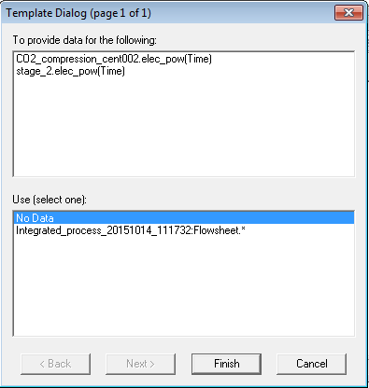

Figure : Data selection window for gRMS template.

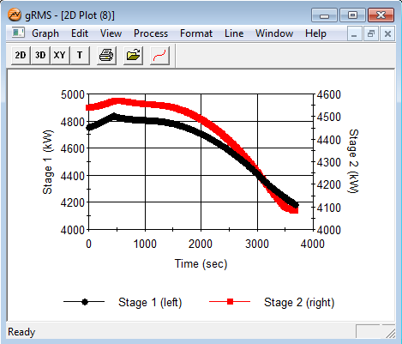

Figure : A plot that results from loading template “stage12.gpt.”  
This plot shows the dynamic power requirements of the stage 1 and stage 2 compressor.  
Note: The data will be added as the simulation to continue,  
therefore the generated plot may contain more or less time series data than is shown here.

**Note:** Results can also be viewed by navigating to the “Trajectories” → “Flowsheet” folder in the results file that is generated at the bottom of the “project tree.” Simply navigate to the desired variable within the flowsheet.

1. The simulation of 20,000 sec will require several hours to complete. When the simulation completes, the results of each template provided are given in Figures 32 and 33.



Figure : gPROMS simulation power requirement for CO2 compressors  
during ramped decrease in flue gas.



Figure : gPROMS simulation inlet flue gas flowrate and percent CO2 removed.

1. Installation Requirements

The minimum suggested hardware requirement is desktop/laptop running Windows® 7 on Intel Core i-5 family 2.8 GHz or faster and 8 GB of RAM. With lower configuration, the simulation speed can be slower. The ACM and gPROMS models have been tested on Aspen V8.4 and gPROMS ModelBuilder 4.0.0, respectively.

1. Reference

A. Lee and D.C. Miller. (2013), “A One-Dimensional (1-D) Three-Region Model for a Bubbling Fluidized-Bed Adsorber”, Industrial & Engineering Chemistry Research, 52 (1), 469-484.

S. Modekurti, D. Bhattacharyya, and S. Zitney (2013), “Dynamic Modeling and Control Studies of a Two-Stage Bubbling Bed Adsorber-Reactor for Solid-Sorbent CO2Capture”, Industrial & Engineering Chemistry Research, 52, 10250-10260.

Aungier, R.H. (2000), “Centrifugal Compressors: A Theory for Aerodynamic Design and Analysis,” ASME Press, NY.

Ilchman, A. (1993), “Non-Identifier-Based High-Gain Adaptive Control,” Springer, NY.

Ilchman, A., and Ryan, E.P. (1994), “Universal -Tracking for Nonlinearly Perturbed Systems in the Presence of Noise,” Automatica, 30, 337-346.

Kohl, A.L., and Nielson, R. (1997), “Gas Purification,” 5th Ed., Gulf Publishing Company, Houston, TX.

Lüdtke, K.H. (2004), “Process Centrifugal Compressors: Basics, Function, Operation, Design, Application,” Springer, Berlin.

Lüdtke, K.H., “Twenty Years of Experience with a Modular Design System for Centrifugal Process Compressors,” Proceeding of the Twenty-First Turbomachinery Syposium.

Mallen, M., and Saville, G. (1977), “Polytropic Processes in the Performance of Prediction of Centrifugal Compressors,” Institute of Mechanical Engineers, Paper No. C183/77.

Span, R., and Wagner, W. (1996), “A New Equation of State for Carbon Dioxide Covering the Fluid Region from the Triple-Point Temperature to 1100 K at Pressures up to 800 MPa,” *Journal of Physical Chemistry Reference Data*, v25, 1509-1596.

Turton, R., Bailie, R.C., Whiting, W.B., Shaeiwitz, J.S., Bhattacharyya, D. (2012), “Analysis, Synthesis and Design of Chemical Processes,” 4th Edition, Prentice Hall, 2012.

U.S. Department of Energy (2010), “Cost and Performance Baseline for Fossil Energy Plants Volume 1: Bituminous Coal and Natural Gas to Electricity,” DOE/NETL-2010/1397.

Weibe, R., and Gaddy, V.L. (1941), “Vapor-Phase Composition of Carbon Dioxide Water Mixtures at Various Temperatures and Pressures to 700 Atmospheres,” *Journal of the American Chemical Society*, v63, 475-477.

Lee, A., Mebane, D.S., Fauth, D.J., and Miller (2011), D.C., “A Model for the Adsorption Kinetics of CO2 on Amine-Impregnated Mesoporous Sorbents in the Presence of Water,ˮ Pittsburgh Coal Conference.