# CCSI Background IP/Copyright Questionnaire and Software Disclosure Form

Date: _7/26/2013_____________________________

CCSI Product: _ACM Membrane model

Product Owner: _Juan Morinelly/David Miller

Your Name: _David Miller

Your Email: _david.miller@netl.doe.gov______________

Does your or your team’s product include, link to or redistribute any code that you or your team did not author[1] as part of the CCSI project? ___NO____________________________

For any included, modified, linked, called or redistributed code contributions, please list, identify whether the component is a separate install or included in the CCSI product, and provide a link to and description of the relevant 3rd party license and copyright information for that contribution (or attach a copy): _______________________

______The model must be used within the Aspen Custom Modeler package from AspenTech. The user must obtain a license for that software from AspenTech directly.

______________________________________________________________________________________

________________________________________________________________________________________________

________________________________________________________________________________________________

________________________________________________________________________________________________

________________________________________________________________________________________________

Does your or your team’s contribution fall under the auspices of any license or copyright claims other than the CCSI Test & Evaluation License and the licenses listed above? If so, please list, describe and provide a link to and description of the license and copyright information for that contribution: _________NO______________________

________________________________________________________________________________________________

________________________________________________________________________________________________

________________________________________________________________________________________________

________________________________________________________________________________________________

________________________________________________________________________________________________

________________________________________________________________________________________________

________________________________________________________________________________________________

________________________________________________________________________________________________

Does your product currently package or otherwise include any license files, EULAs (End User License Agreements) or statements in its distribution or installers. If so, please describe: ___________NO_____________________________________________________________

________________________________________________________________________________________________

________________________________________________________________________________________________

________________________________________________________________________________________________

________________________________________________________________________________________________

________________________________________________________________________________________________

________________________________________________________________________________________________

________________________________________________________________________________________________

Thank you very much for your time in preparing this document.

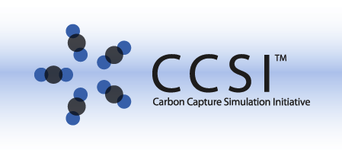

1. Include any entity or individual other than the Software Owner (and its employees) listed above (“SO”); please include guest researchers at the SO (unless you know that they are required to assign copyright to the SO), students who are not employees of the SO, contract employees and subcontractors to the SO, software downloaded from the internet, software provided by a colleague outside the SO, etc.