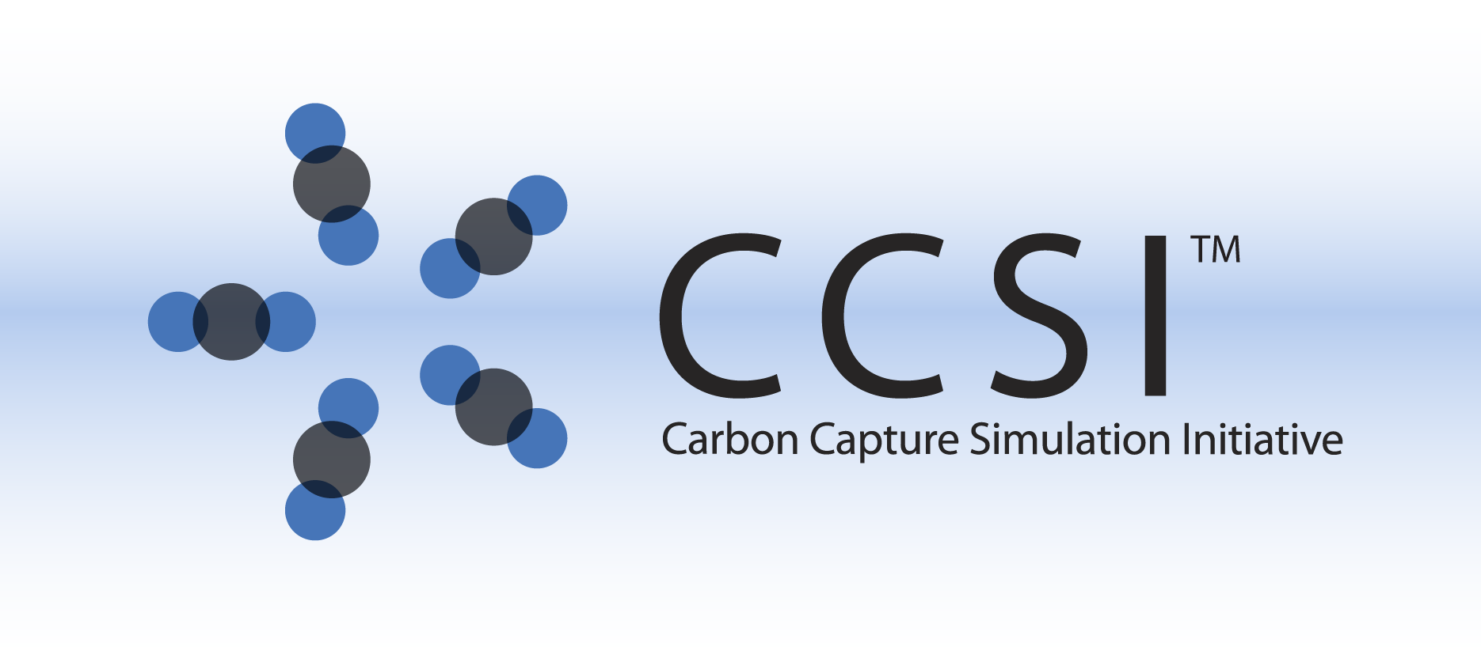

Turbine Science Gateway

Cluster Deployment

Installation Guide

Version 2.0.0

March 31, 2018

Copyright (c) 2012 - 2018

**Copyright Notice**

Turbine Science Gateway was produced under the DOE Carbon Capture Simulation Initiative (CCSI), and is copyright (c) 2012 - 2018 by the software owners: Oak Ridge Institute for Science and Education (ORISE), Los Alamos National Security, LLC., Lawrence Livermore National Security, LLC., The Regents of the University of California, through Lawrence Berkeley National Laboratory, Battelle Memorial Institute, Pacific Northwest Division through Pacific Northwest National Laboratory, Carnegie Mellon University, West Virginia University, Boston University, the Trustees of Princeton University, The University of Texas at Austin, URS Energy & Construction, Inc., et al.. All rights reserved.

NOTICE. This Software was developed under funding from the U.S. Department of Energy and the U.S. Government consequently retains certain rights. As such, the U.S. Government has been granted for itself and others acting on its behalf a paid-up, nonexclusive, irrevocable, worldwide license in the Software to reproduce, distribute copies to the public, prepare derivative works, and perform publicly and display publicly, and to permit other to do so.

**License Agreement**

Turbine Science Gateway Copyright (c) 2012 - 2018, by the software owners: Oak Ridge Institute for Science and Education (ORISE), Los Alamos National Security, LLC., Lawrence Livermore National Security, LLC., The Regents of the University of California, through Lawrence Berkeley National Laboratory, Battelle Memorial Institute, Pacific Northwest Division through Pacific Northwest National Laboratory, Carnegie Mellon University, West Virginia University, Boston University, the Trustees of Princeton University, The University of Texas at Austin, URS Energy & Construction, Inc., et al. All rights reserved.

Redistribution and use in source and binary forms, with or without modification, are permitted provided that the following conditions are met:

1. Redistributions of source code must retain the above copyright notice, this list of conditions and the following disclaimer.
2. Redistributions in binary form must reproduce the above copyright notice, this list of conditions and the following disclaimer in the documentation and/or other materials provided with the distribution.
3. Neither the name of the Carbon Capture Simulation Initiative, U.S. Dept. of Energy, the National Energy Technology Laboratory, Oak Ridge Institute for Science and Education (ORISE), Los Alamos National Security, LLC., Lawrence Livermore National Security, LLC., the University of California, Lawrence Berkeley National Laboratory, Battelle Memorial Institute, Pacific Northwest National Laboratory, Carnegie Mellon University, West Virginia University, Boston University, the Trustees of Princeton University, the University of Texas at Austin, URS Energy & Construction, Inc., nor the names of its contributors may be used to endorse or promote products derived from this software without specific prior written permission.

THIS SOFTWARE IS PROVIDED BY THE COPYRIGHT HOLDERS AND CONTRIBUTORS "AS IS" AND ANY EXPRESS OR IMPLIED WARRANTIES, INCLUDING, BUT NOT LIMITED TO, THE IMPLIED WARRANTIES OF MERCHANTABILITY AND FITNESS FOR A PARTICULAR PURPOSE ARE DISCLAIMED. IN NO EVENT SHALL THE COPYRIGHT OWNER OR CONTRIBUTORS BE LIABLE FOR ANY DIRECT, INDIRECT, INCIDENTAL, SPECIAL, EXEMPLARY, OR CONSEQUENTIAL DAMAGES (INCLUDING, BUT NOT LIMITED TO, PROCUREMENT OF SUBSTITUTE GOODS OR SERVICES; LOSS OF USE, DATA, OR PROFITS; OR BUSINESS INTERRUPTION) HOWEVER CAUSED AND ON ANY THEORY OF LIABILITY, WHETHER IN CONTRACT, STRICT LIABILITY, OR TORT (INCLUDING NEGLIGENCE OR OTHERWISE) ARISING IN ANY WAY OUT OF THE USE OF THIS SOFTWARE, EVEN IF ADVISED OF THE POSSIBILITY OF SUCH DAMAGE.

You are under no obligation whatsoever to provide any bug fixes, patches, or upgrades to the features, functionality or performance of the source code ("Enhancements") to anyone; however, if you choose to make your Enhancements available either publicly, or directly to Lawrence Berkeley National Laboratory, without imposing a separate written license agreement for such Enhancements, then you hereby grant the following license: a non-exclusive, royalty-free perpetual license to install, use, modify, prepare derivative works, incorporate into other computer software, distribute, and sublicense such enhancements or derivative works thereof, in binary and source code form. This material was produced under the DOE Carbon Capture Simulation

1. Introduction 6

2. Prerequisites 6

Operating System 6

Hardware 6

Required Software (see appendices for help) 6

Client Software 6

3. Installation 7

A. Application Settings Dialog 7

B. Feature Selection Dialog 8

C. Application Web Settings Dialog 8

4. Configuration 9

A. Web API 9

IIS Server 9

B. Database 10

C. Administrator Utilities 10

Additional Turbine Accounts 10

5. Clustering FOQUS 11

6. Directory Setup 11

Bin 11

Logs 11

AspenSinterConsumerWindowsServiceLog.txt 11

TurbineCloudWebApp.log 11

WebSite\WebApplication 11

7. Installation Test 11

A. Web API 12

B. Remotely Access the Web API 12

8. Installation Problems 12

A. Failed to Create Database 12

Test if Database exists 12

Database Permissions 12

9. Runtime Problems 13

A. IIS WCF Runtime Problems 13

1) ASP.NET 4.0 not registered 13

2) Server Error in '/Turbine' Application 13

3) ExpressionlessUrl Handler 13

B. AspenConsumer Errors 13

Failed to open Simulation 13

10. Uninstall 14

11. Reporting Installation issues 15

APPENDIX A. Third Party Software Installation (Windows 2008 Server) 15

1) IIS Server 7.5 15

A. Install Roles 15

B. .NET 4 15

C. Register ASP.NET 4 with IIS 16

2) SQL Server ( Express, Standard, etc ) 16

3) AspenTech 17

APPENDIX B. Third Party Software Installation (Windows 7 Professional, Enterprise, Ultimate) 17

1) IIS Server 7.5 17

2) Microsoft® SQL Server® 2008 R2 SP2 - Express Edition 19

APPENDIX C. FOQUS Cluster Configuration 19

# 1. Introduction

The Turbine Science Gateway is a web application and execution environment for running and managing scientific applications and storing and archiving results. Clients interact with the Turbine resource oriented architecture through a RESTful web interface, either directly over HTTP or using the higher-level Python client API. The Python API is designed to be easily scriptable, returning structured JSON output that can be easily consumed by other tools. Turbine is a generic solution that can be extended to process modeling and simulation applications. Currently, AspenTech’s AspenPlus and Aspen Custom Modeler applications are supported.

Turbine can be deployed on a single workstation, or on clusters. The server-side software is Windows-based. A cluster deployment allows for concurrent parallelized application executions, we have scaled to hundreds of concurrent application executions utilizing Amazon Web Services (AWS). Parallelization can dramatically increase application throughput and thus decrease the time to solution.

# 2. Prerequisites

## Operating System

* Windows Server 2008
* Windows 7

## Hardware

* The installation works on 64-bit and 32-bit architectures. The provided 32-bit application works on 64-bit systems utilizing the WOW64 emulator, which is included on all Windows 64 bit versions.

## Required Software (see appendices for help)

* Install all windows updates
* .NET 4
* Web API
  + IIS 7.5
* Database
  + SQL 2008 Server [Express | Standard]
* Redis Server
* http://redis.io/download

## Client Software

* TurbineClient (See TurbineClient installation and user guide )
* FOQUS (Contains TurbineClient, See FOQUS installation and use guide )
* Web Browser

# 3. Installation

* Download and double click on the “TurbineClusterGateway.msi”, you will need to accept the license and then a series of dialog boxes will walk you the installation process.

## A. Application Settings Dialog

* These setting will be utilized to make connections with the database. If this is a “database” installation (see feature dialog 3B) , the installer will create the “SQL_LOGIN/SQL_PASSWORD” if it doesn’t already exist.
* If the database is installed on a different machine provide a FQDN for the SQLServer Hostname.
* Note SQL Server tests passwords for complexity, and installation will fail if it rejects the password.

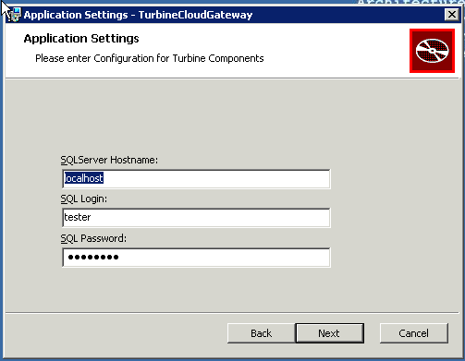

## B. Feature Selection Dialog

* Installing all features results in a fully functional gateway.
* In cluster deployments, only one “master” node will contain the features “Database” and “Web API”.
* Administrator Utilities contains console programs for managing User accounts.

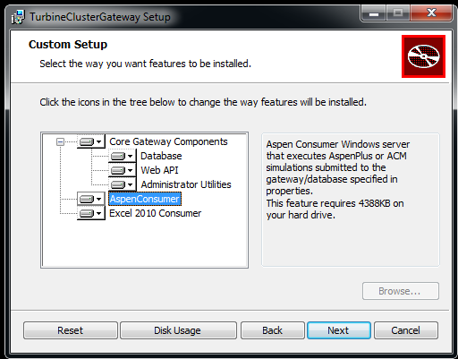

## 

## C. Application Web Settings Dialog

* This dialog appears if one has selected the “Database” feature, and it is used to create an initial Web account.

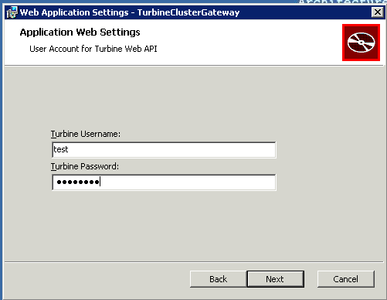

# 4. Configuration

## A. Web API

### IIS Server

#### 1) Server Certificates

##### Without a certificate you CANNOT Connect to Web Site.

1. Open IIS Manager

2. under the machine name (eg. E2AMAZ-....) select "Server Certificates"

3. Create self-signed certficate or import one

##### Bind Site to Server Certificate

1. Open IIS Manager

2. Under Sites, select “Turbine Secure Web Site”

3. Select “Bindings” on right menu

4. Select the binding and click “edit”, in the “Edit Site Binding” pop up menu find the certificate you created in the previous step.

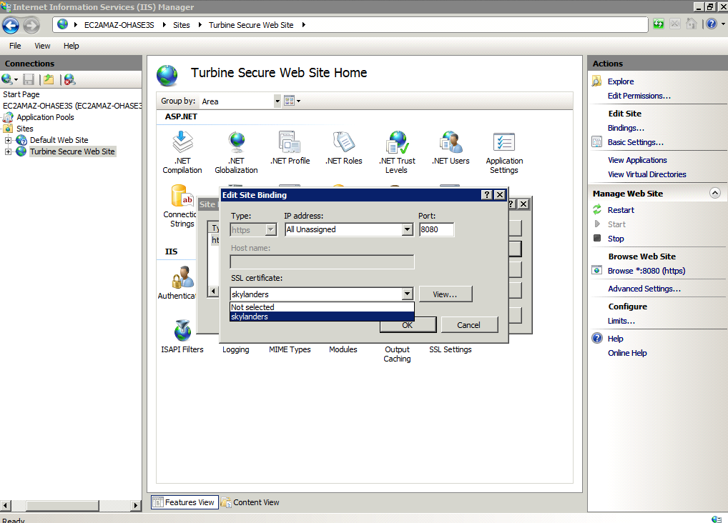

**2) ExpressionlessUrl (Windows 7 Only)**

On Windows 7 HTTP PUT and DELETE are disabled by default, these must be enabled for the Web API to be fully functional (See Section 8.A.3).

## B. Database

By default the installer creates a SQL User and password for accessing the Turbine database tables. During installation you will be queried for an “SQL_LOGIN” and an “SQL_PASSWORD”. These credentials will be used to access the SQLServer Database.

## C. Administrator Utilities

These utilities are executable programs typically located in “Bin” (See Section 5)

### Additional Turbine Accounts

* TurbineAddUser.exe
  + Use this command-line program to create new user accounts
* TurbineChangePassword.exe:
  + Change an existing user’s password

# 5. Clustering FOQUS

Once the Turbine Gateway is installed and configured correctly (sections 3 and 4 respectively), the Web API and the Database are setup. This component is referred to as the “master”. A cluster deployment also requires a Redis Datastore, which must be accessible from the master and all the workers. The master will run a scheduled Task to synchronize its database with the Redis Datastore, and to push submitted job requests and pull job updates. Workers will run a Windows Service that will synchronize the TurbineLite SQLCompact Database with Redis, and pop off submitted job requests and to push job updates. The details for installing all the necessary components are specified in *Appendix C*.

# 6. Directory Setup

[NOTE: on 64 bit architecture the base directory is \Program Files (x86).]

Base Directory “\Program Files\Turbine\Gateway”

## Bin

Contains all DLL, executables, configurations, and PDB (debug) files for console applications and windows services.

**Data**

Contains working directories, files and data generated by consumer processes (Aspen,Excel).

## Logs

Contains the log files for windows services and the web application.

### AspenSinterConsumerWindowsServiceLog.txt

**ExcelSinterConsumerWindowsServiceLog.txt**

### TurbineCloudWebApp.log

## WebSite\WebApplication

Contains all DLL, executables, configurations, and PDB (debug) files for the web application.

# 7. Installation Test

## A. Web API

1. Open Browser on computer

2. Navigate to “<https://localhost:8080/Turbine/session/>”

3. Enter Turbine account username and password

4. If using Internet Explorer, a sessions.json file will be downloaded. The resulting file will contain an empty list. Other browsers will display an empty list.

(NOTE: If this test fails go to 7.A Failed to Create Database)

5. A successful test means the Web API and Database are correctly installed.

## B. Remotely Access the Web API

1. Open Browser on remote computer

2. Navigate to “[https://IPADDRESS:8080/Turbine/session/](https://localhost:8080/Turbine/session/)”

3. Enter Turbine account username and password

4. Should see an empty list

5. If this fails it probably signifies a Windows Firewall issue.

# 8. Installation Problems

## A. Failed to Create Database

### Test if Database exists

1. Open DOS Window

2. sqlcmd -d Turbine -W -Q “SELECT * FROM dbo.Sessions

3. Should see an empty list “[]”, or a list populated with GUIDs.

4. If this failed move do next step

### Database Permissions

You must have write permission to create a database, if this command results in “dbo” then the user you are logged in as has write permission. If it says “guest” you do not.

1. Open DOS Window

2. sqlcmd -d Turbine -S localhost -W -Q “SELECT user_name()”

dbo

**SQL Server Instance**

* The installer utilizes *TCP/IP* connection for SQL Server, it will fail if this protocol is not enabled in the default MYSQLSERVER instance.
* Turbine also uses utilizes *named pipes* to access the SQL Server
* SQL Server Configuration Manager
  + SQL Server Network Configuration
    - Protocols for MSSQLSERVER
      * Enable “Named Pipes” and “TCP/IP” for SQL Server

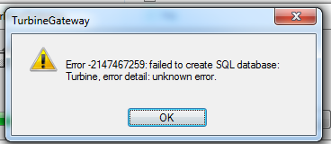

# 

# 

# 9. Runtime Problems

## A. IIS WCF Runtime Problems

### 1) ASP.NET 4.0 not registered

* Navigating to a web resource (eg. see section 6B ) returns a “HTTP/1.1 404 Not Found (StaticHandler can’t find resource).
* Solution is to register ASP.NET 4.0. (See section 4 “Register ASP.NET 4 with IIS”).

### 2) Server Error in '/Turbine' Application

* *A transport-level error has occurred when sending the request to the server. (provider: Shared Memory Provider, error: 0 - The pipe is being closed.)*
  + Enable “Named Pipes” in the SQL Server instance (See 7A under *SQL Server Instance*).

### 3) ExpressionlessUrl Handler

* Performing a HTTP PUT or DELETE and results in a “HTTP/1.1 404 Not Found”.
* Problem on Windows 7
* In the Start search box type “inetmgr”, under IIS select “handler mappings”. Select the “ExtensionlessUrl-Integrated-4.0” handler to edit the managed handler. Next press the “Request Restrictions” button, under the “Verbs” tab change radio button to “All verbs” and press “OK”.

## B. AspenConsumer Errors

### Failed to open Simulation

If the AspenConsumer cannot retrieve a license from the SLM Server, it will not be able to open the simulation. After multiple attempts the job’s state will be moved to error. In order to correct this problem open the “SLM License Profiler” tool. Verify that the license server is correct, then press “Load Information” and next “View Licenses”. Confirm that the information is correct.

[Refer 4.C TurbineClient ]

$ turbine_job_script -bj 77 $CONFIG

Status -1

Reset True

Errors []

Setup 2012-08-12T04:18:11.1000000

Create 2012-08-11T16:09:37.3270000

Messages [u'Failed to open Simulation (1: The remote procedure call failed. (Exception from HRESULT: 0x800706BE)', u'Failed to open Simulation (5: Retrieving the COM class factory for component with CLSID {FDE14671-8E3D-429D-878A-2E97C127D967} failed due to the following error: 80080005 Server execution failed (Exception from HRESULT: 0x80080005 (CO_E_SERVER_EXEC_FAILURE)).', u'Failed to open Simulation (2: The remote procedure call failed. (Exception from HRESULT: 0x800706BE)', u'Failed to open Simulation (3: Retrieving the COM class factory for component with CLSID {FDE14671-8E3D-429D-878A-2E97C127D967} failed due to the following error: 80080005 Server execution failed (Exception from HRESULT: 0x80080005 (CO_E_SERVER_EXEC_FAILURE)).', u'working directory setup finished', u'Failed to open Simulation (4: Retrieving the COM class factory for component with CLSID {FDE14671-8E3D-429D-878A-2E97C127D967} failed due to the following error: 80080005 Server execution failed (Exception from HRESULT: 0x80080005 (CO_E_SERVER_EXEC_FAILURE)).']

Finished 2012-08-12T04:33:58.3270000

Submit 2012-08-11T16:09:49.8570000

Simulation Hybrid_v0.51_rev1.1_UQ_0809

State error

Session 9787fd55-b8e1-4221-a81d-6b1305ccd95d

Initialize False

Consumer 80f44542-829b-4e4c-9727-6c3aa7cd912a

Id 77

# 10. Uninstall

Currently removing all of Turbine is a manual process. You will need to manually delete the web site, and the program file directory. Basic steps for completely removing Turbine:

1. Control Panel
   1. under “Programs”, “uninstall a program” select “TurbineClusterGateway”.
2. IIS Manager
   1. under sites select “Turbine Secure Web Site”, then remove.
   2. under application pools select “TurbineAppPool”, then remove.
   3. restart IIS
3. SQL Server Management Studio
   1. Under “Databases” find the Turbine database and delete.
   2. drop the SQL Login created during installation
   3. restart SQL Server
4. Remove Program Files
   1. 32 bit system delete “\Program Files\Turbine”
   2. 64 bit system delete “\Program Files (x86)\Turbine”

# 11. Reporting Installation issues

ccsi-support@acceleratecarboncapture.org

# APPENDIX A. Third Party Software Installation (Windows 2008 Server)

## 1) IIS Server 7.5

One can install IIS by selecting the Web Server (IIS) role described in the next section.

### A. Install Roles

1. On the taskbar, click **Start**, point to **Administrative Tools**, and then click **Server Manager**.
2. In the **Server Manager** hierarchy pane, expand **Roles**, and then click **Web Server (IIS)**.
3. In the **Web Server (IIS)** pane, scroll to the **Role Services** section, and then click **Add Role Services**.
4. Under Application Development select **ASP.NET** and accept all dependencies, click Next.

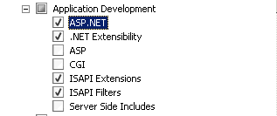

1. On the **Confirm Installation Selections** page, click **Install**.
2. On the **Results** page, click **Close**.
3. Restart IIS Web Server
   1. Open IIS Manager
   2. select the “Turbine Secure Web Site”
   3. select restart

### B. .NET 4

Check if .NET 4 is installed, if not download and install from the Microsoft Download Center. If using “Server Manager” when adding “Web Server” role also make sure to add “ASP.NET”.

### C. Register ASP.NET 4 with IIS

In order for the WCF Web Service to function properly ASP.NET must be registered with IIS. To register ASP.NET with IIS, change directory to the .NET 4 installation and run the registration tool.

32-bit architecture

1. Open DOS Window

2. > cd C:\Windows\Microsoft.NET\Framework\v4.0.30319

3. > aspnet_regiis.exe /i

64-bit architecture

1. Open DOS Window

2. > cd C:\Windows\Microsoft.NET\Framework64\v4.0.30319

3. > aspnet_regiis.exe /i

## 2) SQL Server (Express, Standard, etc )

#### Install SQL Server as the default instance.

Install SQL Server as the 'default' instance. Enter MSSQLServer as the name when installing, it will create a default instance which you can connect to by just specifying 'localhost'.

The SQLExpress installer will name the instance “SQLEXPRESS” , change this to “MSSQLServer” or select default instance.

#### Enable TCP/IP and Named Pipes

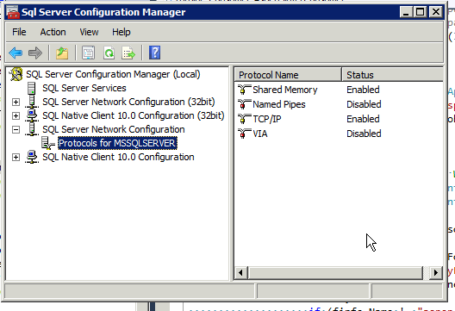

### 

In order for the installer to operate correctly and create the database TCP/IP must be enabled.

### 

## 3) AspenTech

In order to run AspenPlus or ACM simulations one will need to install the Aspen Engineering Suite. Note an Aspen installation is not needed to test the basic functionality of the installation.

# APPENDIX B. Third Party Software Installation (Windows 7 Professional, Enterprise, Ultimate)

## 1) IIS Server 7.5

<http://technet.microsoft.com/en-us/library/cc725762.aspx>

By default, IIS 7.5 is not installed on Windows® 7 Professional, Enterprise, or Windows® 7 Ultimate. You can install IIS by clicking **Turn Windows Features On or Off** under **Programs** in **Control Panel**.

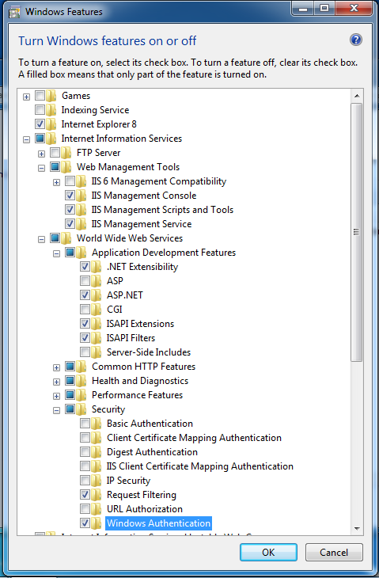

## 2) Microsoft® SQL Server® 2008 R2 SP2 - Express Edition

<http://www.microsoft.com/en-us/download/details.aspx?id=30438>

# APPENDIX C. FOQUS Cluster Configuration

**Install REDIS**

REDIS (http://redis.io/download), is an open source, in-memory data structure store, used as database, cache and message broker. In the Turbine Cluster configuration, REDIS sits between the master and the workers. There is a Windows and Linux version of REDIS. REDIS should be installed at an accessible ip address (REDIS_IPADDR) from the master and the workers. The master queues jobs on REDIS, and the workers pop them off and report the results back.

In the simplest setup REDIS is installed on the master.

**Master Windows Task**

A process must be configured to run on the master to push jobs and pull updates, this is accomplished by registering a Windows Task Scheduler task.

1. FILE “turbine_cluster_task.xml”: Copy and paste

<?xml version="1.0" encoding="UTF-16"?>

<Task version="1.2" xmlns="http://schemas.microsoft.com/windows/2004/02/mit/task">

  <RegistrationInfo>

    <Date>2015-03-15T08:27:44.966</Date>

    <Author>Joshua Boverhof</Author>

  </RegistrationInfo>

  <Triggers>

    <BootTrigger>

      <Repetition>

        <Interval>PT2M</Interval>

        <StopAtDurationEnd>false</StopAtDurationEnd>

      </Repetition>

      <Enabled>true</Enabled>

      <Delay>PT2M</Delay>

    </BootTrigger>

  </Triggers>

  <Settings>

    <MultipleInstancesPolicy>IgnoreNew</MultipleInstancesPolicy>

    <DisallowStartIfOnBatteries>false</DisallowStartIfOnBatteries>

    <StopIfGoingOnBatteries>true</StopIfGoingOnBatteries>

    <AllowHardTerminate>true</AllowHardTerminate>

    <StartWhenAvailable>false</StartWhenAvailable>

    <RunOnlyIfNetworkAvailable>true</RunOnlyIfNetworkAvailable>

    <IdleSettings>

      <StopOnIdleEnd>true</StopOnIdleEnd>

      <RestartOnIdle>false</RestartOnIdle>

    </IdleSettings>

    <AllowStartOnDemand>true</AllowStartOnDemand>

    <Enabled>true</Enabled>

    <Hidden>false</Hidden>

    <RunOnlyIfIdle>false</RunOnlyIfIdle>

    <WakeToRun>false</WakeToRun>

    <ExecutionTimeLimit>PT0S</ExecutionTimeLimit>

    <Priority>4</Priority>

  </Settings>

  <Actions Context="Author">

    <Exec>

      <Command>C:\Program Files (x86)\foqus\foqus\dist\turbine_cluster_script.exe</Command>

      <Arguments>-s "REDIS_IPADDRESS" -u SQL_LOGIN -p SQL_PASSWORD</Arguments>

      <WorkingDirectory>C:\Users\Administrator\Desktop\RedisConnector</WorkingDirectory>

    </Exec>

  </Actions>

</Task>

1. Replace the following

* REDIS_IPADDRESS: IP Address of the REDIS Server
* SQL_LOGIN: SQL Login for accessing Turbine database.
* SQL_PASSWORD: SQL Password

1. Schedule the Task via Task Scheduler: The easiest way to register the task correctly is to run the command in a command window (DOS or PS). Replace “PASSWORD” with Administrator’s password.

SCHTASKS /CREATE /RU Administrator /RP PASSWORD /xml ‘turbine_database_monitor.xml' /TN 'turbine_database_monitor';

**Worker Windows Services**

A worker must run the FOQUS Service to execute workflows, and the Hydro process to poll REDIS periodically. NSSM (<https://nssm.cc/download>) can be used to create a Windows Service to wrap executables.

**FOQUS Windows Service**

To install this service copy and paste the XML below as “foqus-service.xml” into a directory “FOQUS-Service” on the Desktop, then open the Windows Services manager and import it and follow the UI Dialog. Create the directory specified as “workingdirectory”.

<service>

  <id>foqus</id>

  <name>foqus</name>

  <description>This service runs Foqus consumer</description>

  <executable>C:\Program Files (x86)\foqus\foqus\dist\foqus.exe</executable>

  <arguments>--consumer</arguments>

  <logmode>rotate</logmode>

  <workingdirectory>C:\Users\Administrator\Desktop\FOQUS-Service/jobs</workingdirectory>

  <priority>high</priority>

</service>

**Hydro Windows Service**

To install this service

1. Create a Directory “Hydro-Service”

2. Download NSSM and copy the “nssm.exe” executable to the “Turbine-Lite-Service” directory. Create this directory if necessary.

3. Copy and paste the template to file named “turbine-lite-worker.ps1”

# Turbine Cluster Worker: Hydro Redis Service Script

$TARGETDIR="C:\\FOQUS-Service\\"

if(!(Test-Path -Path $TARGETDIR )){

        New-Item -ItemType directory -Path $TARGETDIR

}

CD $TARGETDIR

$file = Get-ChildItem "C:\\Program Files (x86)\\foqus\\foqus\\dist\\turbine_lite_script.exe"

& $file -s localhost

if ($?) { Write-Host "FOQUS Hydro failed to run” }

4. Install as Windows Service by copying the commands below into a command window:

nssm.exe “install TurbineLiteService C:\Windows\System32\WindowsPowerShell\v1.0\powershell.exe .\turbine-hydro-worker.ps1"

nssm.exe "set TurbineLiteService AppDirectory C:\Users\Administrator\Desktop\Turbine-Lite-Service"

nssm.exe “start TurbineLiteService"