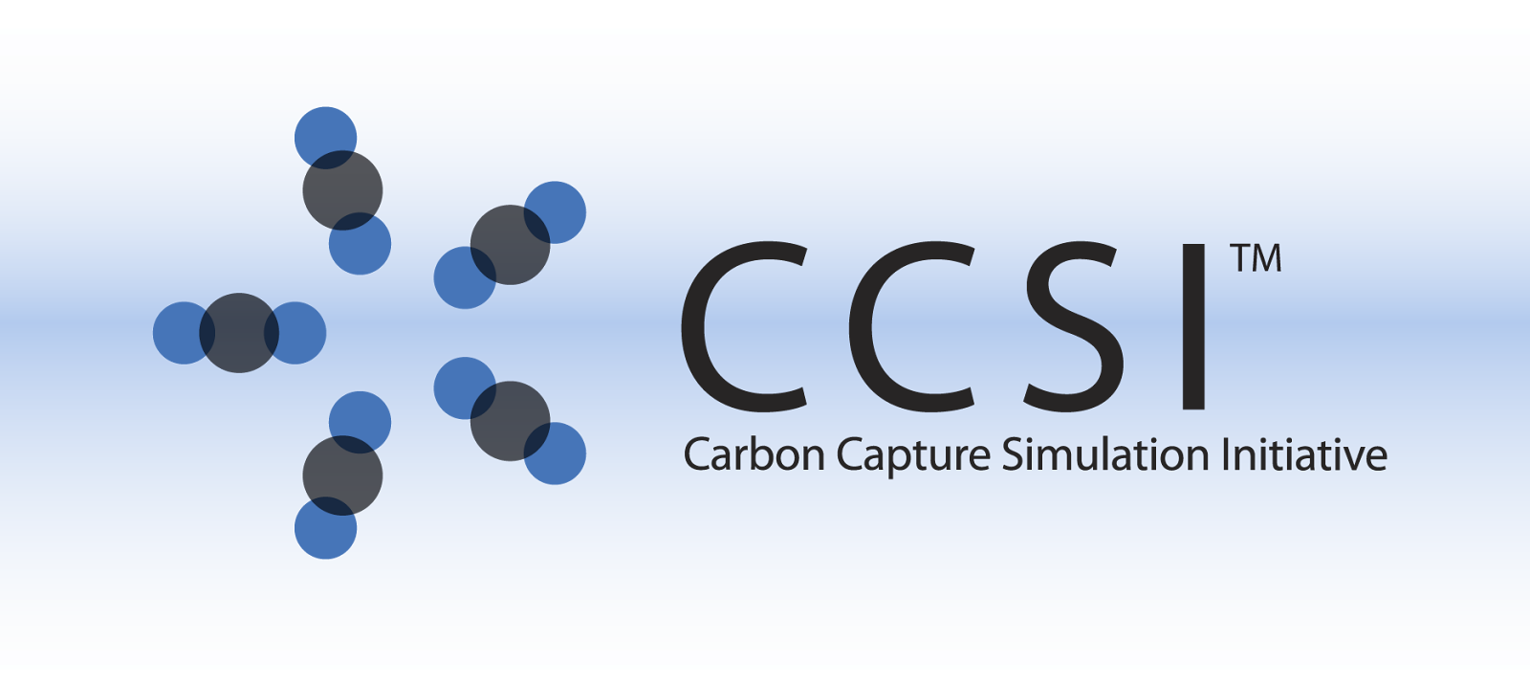

TurbineLite

Installation Guide

Version 2.0.0

March 31, 2018

Copyright (c) 2012 - 2018

**Copyright Notice**

TurbineLite was produced under the DOE Carbon Capture Simulation Initiative (CCSI), and is copyright (c) 2012 - 2018 by the software owners: Oak Ridge Institute for Science and Education (ORISE), Los Alamos National Security, LLC., Lawrence Livermore National Security, LLC., The Regents of the University of California, through Lawrence Berkeley National Laboratory, Battelle Memorial Institute, Pacific Northwest Division through Pacific Northwest National Laboratory, Carnegie Mellon University, West Virginia University, Boston University, the Trustees of Princeton University, The University of Texas at Austin, URS Energy & Construction, Inc., et al.. All rights reserved.

NOTICE. This Software was developed under funding from the U.S. Department of Energy and the U.S. Government consequently retains certain rights. As such, the U.S. Government has been granted for itself and others acting on its behalf a paid-up, nonexclusive, irrevocable, worldwide license in the Software to reproduce, distribute copies to the public, prepare derivative works, and perform publicly and display publicly, and to permit other to do so.

**License Agreement**

TurbineLite Copyright (c) 2012 - 2018, by the software owners: Oak Ridge Institute for Science and Education (ORISE), Los Alamos National Security, LLC., Lawrence Livermore National Security, LLC., The Regents of the University of California, through Lawrence Berkeley National Laboratory, Battelle Memorial Institute, Pacific Northwest Division through Pacific Northwest National Laboratory, Carnegie Mellon University, West Virginia University, Boston University, the Trustees of Princeton University, The University of Texas at Austin, URS Energy & Construction, Inc., et al. All rights reserved.

Redistribution and use in source and binary forms, with or without modification, are permitted provided that the following conditions are met:

1. Redistributions of source code must retain the above copyright notice, this list of conditions and the following disclaimer.
2. Redistributions in binary form must reproduce the above copyright notice, this list of conditions and the following disclaimer in the documentation and/or other materials provided with the distribution.
3. Neither the name of the Carbon Capture Simulation Initiative, U.S. Dept. of Energy, the National Energy Technology Laboratory, Oak Ridge Institute for Science and Education (ORISE), Los Alamos National Security, LLC., Lawrence Livermore National Security, LLC., the University of California, Lawrence Berkeley National Laboratory, Battelle Memorial Institute, Pacific Northwest National Laboratory, Carnegie Mellon University, West Virginia University, Boston University, the Trustees of Princeton University, the University of Texas at Austin, URS Energy & Construction, Inc., nor the names of its contributors may be used to endorse or promote products derived from this software without specific prior written permission.

THIS SOFTWARE IS PROVIDED BY THE COPYRIGHT HOLDERS AND CONTRIBUTORS "AS IS" AND ANY EXPRESS OR IMPLIED WARRANTIES, INCLUDING, BUT NOT LIMITED TO, THE IMPLIED WARRANTIES OF MERCHANTABILITY AND FITNESS FOR A PARTICULAR PURPOSE ARE DISCLAIMED. IN NO EVENT SHALL THE COPYRIGHT OWNER OR CONTRIBUTORS BE LIABLE FOR ANY DIRECT, INDIRECT, INCIDENTAL, SPECIAL, EXEMPLARY, OR CONSEQUENTIAL DAMAGES (INCLUDING, BUT NOT LIMITED TO, PROCUREMENT OF SUBSTITUTE GOODS OR SERVICES; LOSS OF USE, DATA, OR PROFITS; OR BUSINESS INTERRUPTION) HOWEVER CAUSED AND ON ANY THEORY OF LIABILITY, WHETHER IN CONTRACT, STRICT LIABILITY, OR TORT (INCLUDING NEGLIGENCE OR OTHERWISE) ARISING IN ANY WAY OUT OF THE USE OF THIS SOFTWARE, EVEN IF ADVISED OF THE POSSIBILITY OF SUCH DAMAGE.

You are under no obligation whatsoever to provide any bug fixes, patches, or upgrades to the features, functionality or performance of the source code ("Enhancements") to anyone; however, if you choose to make your Enhancements available either publicly, or directly to Lawrence Berkeley National Laboratory, without imposing a separate written license agreement for such Enhancements, then you hereby grant the following license: a non-exclusive, royalty-free perpetual license to install, use, modify, prepare derivative works, incorporate into other computer software, distribute, and sublicense such enhancements or derivative works thereof, in binary and source code form. This material was produced under the DOE Carbon Capture Simulation

**Table of Contents**

1. Introduction

2. Prerequisites

Operating System

Hardware

Required Software

Optional Software

Client Software

3. Installation

4. Configuration

A. Web API

5. Directory Setup

Clients

Logs

AspenSinterConsumerWindowsServiceLog.txt

ExcelSinterConsumerWindowsServiceLog.txt

TurbineWebAPILog.txt

Web

6. Installation Tests

A. Turbine Web API

B. Turbine Aspen ACM

7. Uninstall

8. Reporting Installation issues

# 1. Introduction

The Turbine Science Gateway (TSG) is a web application and execution environment for running and managing scientific applications and storing and archiving results. Clients interact with the Turbine resource oriented architecture through a RESTful web interface, either directly over HTTP or using the higher-level Python client API. The Python API is designed to be easily scriptable, returning structured JSON output that can be easily consumed by other tools. Turbine is a generic solution that can be extended to process modeling and simulation applications. Currently, AspenTech’s AspenPlus and Aspen Custom Modeler applications, Process Systems Enterprise gPROMS, and Microsoft Excel are supported.

TurbineLite is the single workstation release of the TSG, with minimal software dependencies. Note most users will want to install the FOQUS Bundle, this software includes TurbineLite and most of it’s dependencies and is the simplest way to install TurbineLite and FOQUS.

# 2. Prerequisites

## Operating System

* Windows Server 2008
* Windows 7

## Hardware

* The installation works on 64-bit and 32-bit architectures. The provided 32-bit application works on 64-bit systems utilizing the WOW64 emulator, which is included on all Windows 64 bit versions.

## Required Software

* Install all windows updates
* .NET 4
* SimSinter
* Microsoft SQL Compact 4.0
  + Available from the Microsoft Download Center
  + http://www.microsoft.com/en-us/download/details.aspx?id=17876

## Optional Software

* AspenTech Engineering v8.4
  + Process Modeling (Aspen Plus)
* Process Systems Enterprise gPROMS (goRun_xml)
* MS Office Excel 2010
  + Required for the execution of Excel Spreadsheets

## Client Software

* FOQUS ( Contains TurbineClient, See FOQUS installation and use guide )
* TurbineClient ( See TurbineClient installation and user guide )
* Web Browser

# 3. Installation

* Install prerequisites “SQL Compact 4.0”, “AspenTech Engineering v8.4”, “SimSinter”, and “MS Office Excel 2010” (optional).
* Download and double click on the “TurbineLite.msi”, you will need to accept the license and then a series of dialog boxes will walk you the installation process.
* Reboot, all “Turbine” Windows Services should be “started”.

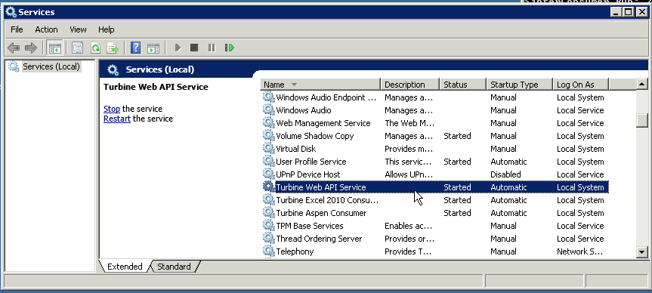

# 4. Configuration

## A. Web API

In order to use the Web API a rule to the firewall to allow through HTTP requests on port 8000.

* netsh http add urlacl url=http://localhost:8000/TurbineLite user=Administrator

# 

# 5. Directory Setup

[NOTE: on 64 bit architecture the base directory is \Program Files (x86).]

Base Directory “\Program Files\Turbine\Lite”

## Clients

Contains all DLL, executables, configurations, and PDB (debug) files for console applications and windows services.

**Data**

Contains working directories, files and data generated by consumer processes (Aspen,Excel) and the database file.

## Logs

Contains the log files for windows services and the web application.

### AspenSinterConsumerWindowsServiceLog.txt

### ExcelSinterConsumerWindowsServiceLog.txt

### TurbineWebAPILog.txt

## Web

Contains all DLL, executables, configurations, and PDB (debug) files for the web application.

# 6. Installation Tests

At this point install FOQUS and follow the FOQUS tutorial. If you experience problems with FOQUS interacting with TurbineLite you should complete the following tasks to diagnose the problem. Section “B” requires FOQUS is installed and has been initialized.

## A. Turbine Web API

1. Navigate to “[https://localhost:8080/TurbineLite/session/](https://localhost:8080/Turbine/session/)”
   1. If using Internet Explorer, a sessions.json file will be downloaded. The resulting file will contain an empty list “[]”.
   2. Firefox will display an empty list “[]”
   3. Powershell you can use the “Invoke-WebRequest”, you will see a “[]” for content

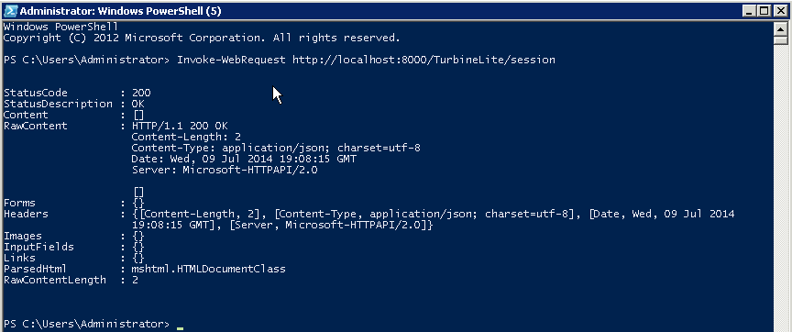

1. A successful test means the Web API and Database are working correctly. If you receive a connection timeout check the Windows Service “Turbine WebAPI Service” status in “services.msc” or use the “sc” tool from a command prompt (DOS). The log contains useful information for diagnosing problems.

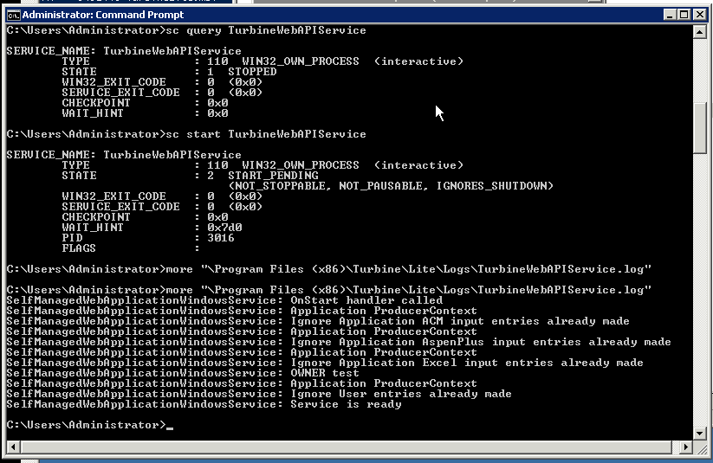

## B. Turbine Aspen ACM

Make sure you have AspenTech process modeling (AspenPlus) v8.4 installed.

1. Check that the Windows Service “Turbine Aspen Consumer” is running. If it is “stopped”, try to “start” it. If the service fails to start something is wrong with your installation.
   1. open “services”, “services.msc” or use the sc tool

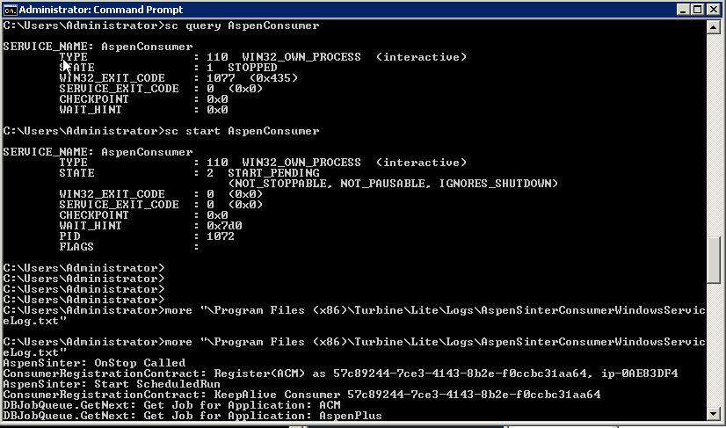

1. Open up the *“Turbine Console”* under the start menu.

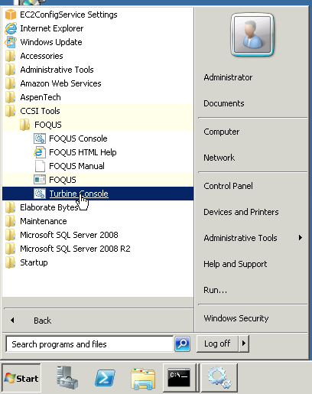

1. Check that FOQUS files are available. In the example script below I am using “Desktop\foqus” as my FOQUS directory, you may have created it with a different path.

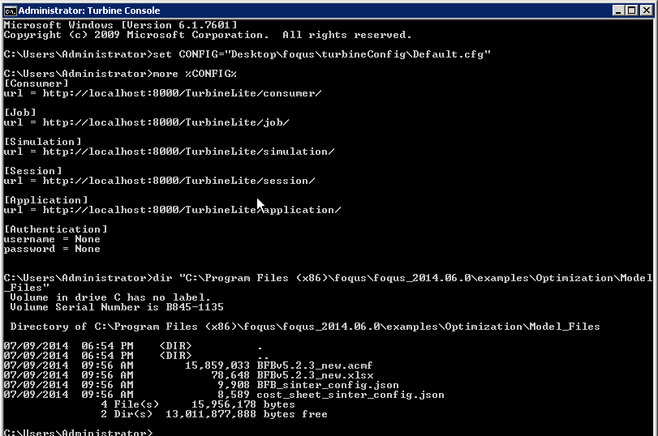

1. Upload a test ACM simulation (Optimization BFB)

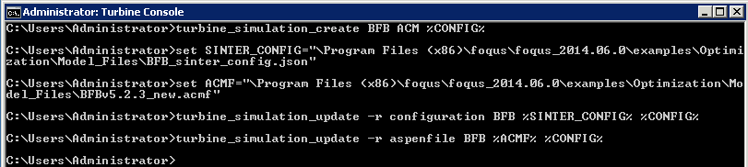

1. Create a “session”, add a job request and submit it to be run

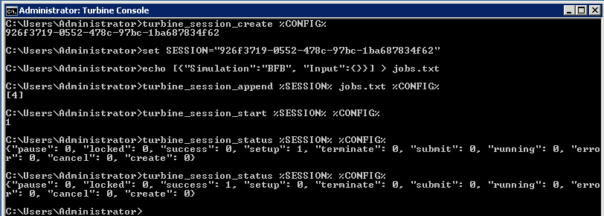

It may take several minutes for the job to move from “submit” to “setup” to “running” to “success”. If the job ends in “error” check the log.

# 7. Uninstall

Control Panel

* 1. under “Programs”, “uninstall a program” select “TurbineLite”.

# 8. Reporting Installation issues

ccsi-support@acceleratecarboncapture.org