Assessment Cover Page

Student Full Name | Matheus Dos Santos Silva
Student Number | 2026438
Module Title | Statistical Techniques for Data Analysis
Assessment Title | CA1
Lecturer/Supervisor | Taufique Ahmed
Assessment Due Date | 2026-10-25
Date of Submission | 2026-11-01
GitHub Repository | CCT-Dublin/CCT_STDA_CA_01_40S

Use of AI Tool
I acknowledge the use of Chat-GPT for the purpose of:
- Translate my writing from Brazilian Portuguese to academic US English ( Jupiter Lab ).
- Improving Python code, I’ve written
- Example of Python code using the [Matplotlib and Seaborn] frameworks
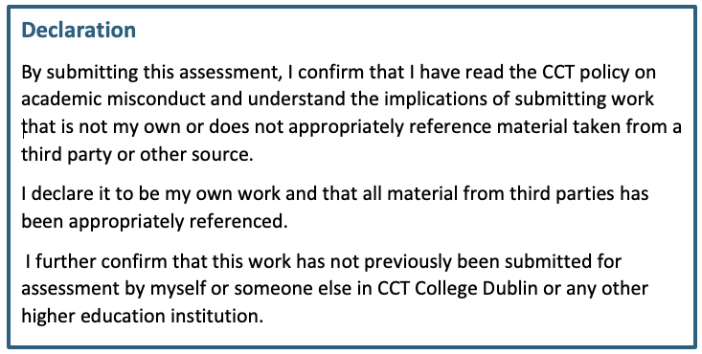

Table of Contents
1. Summarize your dataset clearly, using relevant descriptive statistics and appropriate plots. These should be carefully motivated and justified and clearly presented. You should critically analyse your findings, in addition to including the necessary Python code, output and plots in the report. You are required to plot at least three graphs. [0-35]. 4
2. Use two discrete distributions (Binomial and Poisson) to explain and identify some information about your dataset. You must explain your reasoning and the techniques you have used. Visualize your data and explain what happens with the large samples in these cases. You must work with Python, and your mathematical reasoning must be documented in your report. [0-30]. 4
3. Use Normal distribution to explain/ identify some information about your dataset. [0-20]. 4
4. Explain the importance of the distributions used in point 3 and 4 in your analysis. Justify the choice of the variables and explain if the variables used for the discrete distributions could be used as normal distribution in this case. [0-15]. 4
5. Conclusions. 4
6. References. 4
7. Appendix. 4

1. Summarize your dataset clearly, using relevant descriptive statistics and appropriate plots. These should be carefully motivated and justified and clearly presented. You should critically analyze your findings, in addition to including the necessary Python code, output and plots in the report. You are required to plot at least three graphs. [0-35].

2. Use two discrete distributions (Binomial and Poisson) to explain and identify some information about your dataset. You must explain your reasoning and the techniques you have used. Visualize your data and explain what happens with the large samples in these cases. You must work with Python, and your mathematical reasoning must be documented in your report. [0-30].

3. Use Normal distribution to explain/ identify some information about your dataset. [0-20].

4. Explain the importance of the distributions used in point 3 and 4 in your analysis. Justify the choice of the variables and explain if the variables used for the discrete distributions could be used as normal distribution in this case. [0-15].

5. Conclusions.

6. References.

7. Appendix.

