Assessment Cover Page

Student Full Name | Matheus Dos Santos Silva
Student Number | 2026438
Module Title | Strategic Thinking
Assessment Title | CA1 - Capstone Project Proposal
Lecturer/Supervisor | Taufique Ahmed
Assessment Due Date | 2026-10-25
Date of Submission | 2026-10-25
GitHub Repository | CCT-Dublin/CCT_ST_CA_01_20S
Use of AI Tool
I acknowledge the use of Chat-GPT for the purpose of:
- Translate my writing from Brazilian Portuguese to academic US English ( Jupiter Lab ).
- Improving Python code, I’ve written
- Example of Python code using the [Matplotlib and Seaborn] frameworks

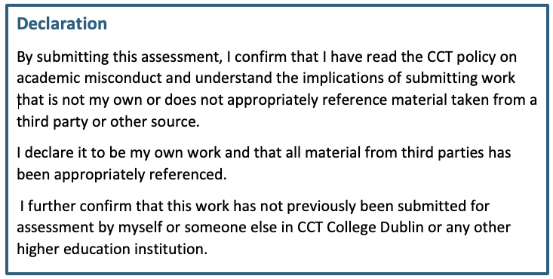

Contents
1. Project Title 4
2. Introduction 4
3. Problem Definition 4
4. Aim and Objectives 5
4.1. General aim: 5
4.2. Specific Objectives: 5
5. Scope 5
6. Methodology 6
7. Data Sources 6
8. Expected Deliverables 7
9. Project Timeline 7
10. Ethical and Legal Considerations 8
11. Conclusions 8
12. References 9
13. Appendix 10
References AI-01 10
References AI-02 11
References AI-03 12
References AI-04 13
References AI-04.01 13
References AI-04.02 16
References AI-05 18
References AI-06 21

1. Project Title
Exploratory Data Analysis and Preparation of the Classification of BitCoin Addresses Associated with Ransomware Using Machine Learning.

2. Introduction
The growth of cryptocurrencies has bought about challenges related to financial security, including their use in ransomware attacks. In this context, blockchain data analysis and machine learning techniques can help investigate patterns associated with potentially illicit transactions.
I am going to utilizes the BitcoinHeist Ransomware Address Dataset to conduct an Exploratory Data Analysis ( EDA ) and prepare the data for subsequent stages of supervised classification.

3. Problem Definition
This project investigates whether the features available in the dataset can help identify differences between addresses classified as white and those associated with ransomware categories.
The dataset contains 2,916,697 records and 10 columns. After transforming the label variable into a binary classification, the classes are represented as follows:
- 0 = White --> Addresses classified as not associated with ransomware in the dataset.
- 1 = Ransomware --> Observations associated with ransomware categories
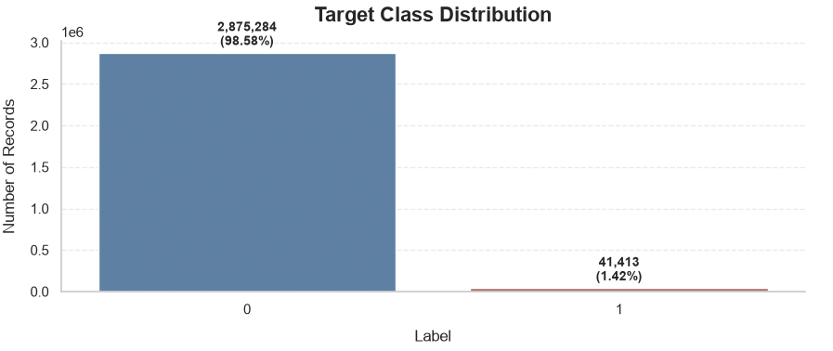Based on the graph above, this class imbalance requires careful consideration because accuracy alone may conceal difficulties in identifying the minority class.

4. Aim and Objectives

4.1. General aim:
To conduct exploratory data analysis and prepare the dataset to investigate patterns associated with Bitcoin addresses classified as related to ransomware.

4.2. Specific Objectives:
- Assess the dataset structure, variable types, missing values, duplicates, and data consistency.
- Explore variable distributions, class imbalance, outliers, and temporal patterns.
- Investigate relationships between numerical variables and repeated Bitcoin address occurrences.
- Evaluate appropriate data preparation, feature selection, and scaling techniques for subsequent classification.
- Define a sampling strategy and a model evaluation plan for the next project stage.

5. Scope
The project covers the exploratory analysis of ten variables:
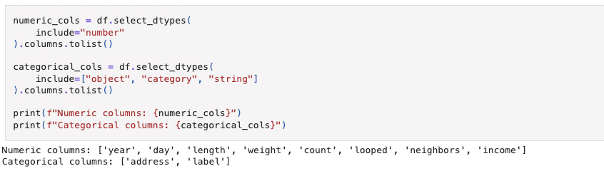
The work includes data quality assessment, statistical visualizations, outlier analysis, correlation analysis, repeated-address investigation, and initial preparation for machine learning.
The project does not constitute a real-time detection system or independently establish criminal activity. The classifications depend on the criteria and information provided by the dataset BitcoinHeist Ransomware Address Dataset. Final model training, model evaluation, and dashboard development remain future stages of the project.

6. Methodology
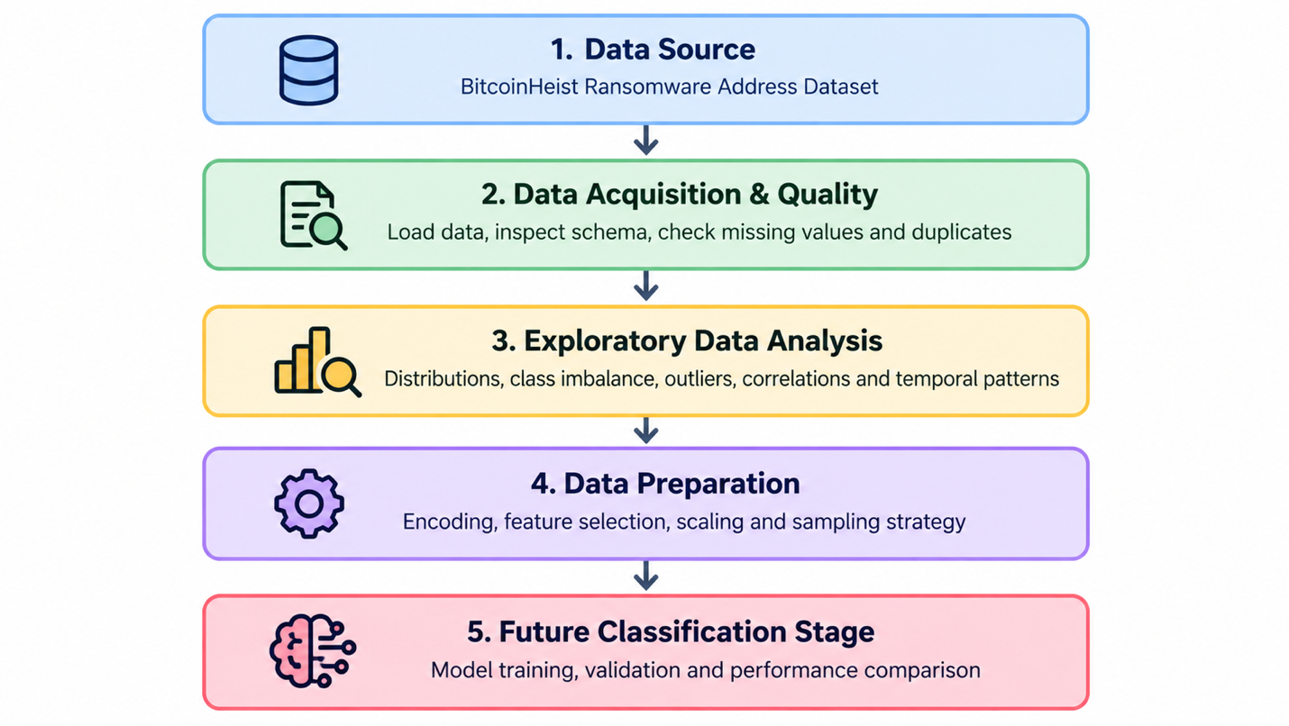

7. Data Sources
You can find the dataset at BitcoinHeist Ransomware Address Dataset — UCI Machine Learning Repository.
The original dataset represents historical Bitcoin Blockchain information from 2011 ~ 2018. The variables include address identifiers, temporal information, transaction structure features, received values, and classifications.
This dataset is licensed under a Creative Commons Attribution 4.0 International (CC BY 4.0) license.

Warning --> The provided labels should be interpreted as dataset classifications rather than independent proof of criminal activity!

8. Expected Deliverables

- A documented Jupyter Lab.
- An exploratory data analysis and data quality report.
- Statistical visualizations and a correlation matrix.
- A dataset prepared for modeling, with documented transformations.
- Supervised classification models and performance comparisons.
- Model evaluation using Precision, F1-score, and a confusion matrix
- An analytical dashboard, if implemented.
- A final academic report presenting the methodology, results, limitations, and conclusions.

9. Project Timeline
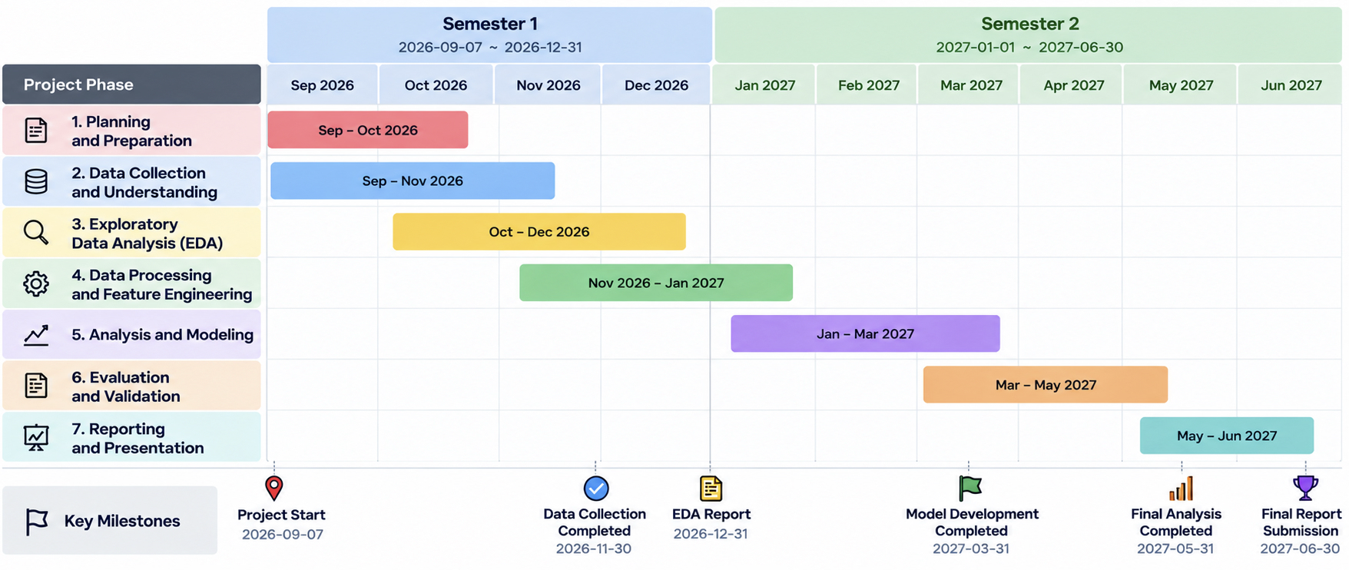

10. Ethical and Legal Considerations
Dataset licensing and reuse: The BitcoinHeist dataset is licensed under the Creative Commons Attribution 4.0 International (CC BY 4.0) licence. This licence permits the sharing and adaptation of the material, provided that appropriate credit is given, a link to the licence is supplied, and any changes made are indicated. The original dataset source will be acknowledged in the project report and relevant documentation. Before publishing or redistributing the dataset or derived materials, the applicable attribution requirements and any additional notices accompanying the dataset will be reviewed.
The project must respect privacy, the terms of use for the dataset, and applicable legislation, Including the General Data Protection Regulations. The results must be interpreted responsibly, taking into account potential biases, labelling limitations, and class imbalance.

11. Conclusions
The exploratory analysis establishes a foundation for investigating patterns associated with Bitcoin addresses classified as related to ransomware. The initial assessement helps clarify the dataset structure, evaluate its quality, and identify key challenges, particularly class imbalance and present of outliers. However, exploratory data analysis alone cannot establish the effectiveness of predictive models. This assessement will depend on future data preparation, training, validation, and model comparison stages.

12. References

Built In (2025) Principal Component Analysis (PCA): A Step-by-Step Explanation. Written by Zakaria Jaadi; updated by Brennan Whitfield. Available at: https://builtin.com/data-science/step-step-explanation-principal-component-analysis (Accessed: 24 October 2026).
Creative Commons (n.d.) Attribution 4.0 International (CC BY 4.0). Available at: https://creativecommons.org/licenses/by/4.0/ (Accessed: 24 October 2026).
GeeksforGeeks (2024) Feature Selection Using Random Forest. Available at: https://www.geeksforgeeks.org/machine-learning/feature-selection-using-random-forest/ (Accessed: 24 October 2026).
GeeksforGeeks (2026) Understanding the Confusion Matrix in Machine Learning. Available at: https://www.geeksforgeeks.org/machine-learning/confusion-matrix-machine-learning/ (Accessed: 24 October 2026).
JMP (n.d.) Interquartile Range (IQR). JMP Statistical Discovery. Available at: https://www.jmp.com/en/statistics-knowledge-portal/exploratory-data-analysis/descriptive-statistics/interquartile-range (Accessed: 24 October 2026).
Kashyap, P. (2024) Understanding Precision, Recall, and F1 Score Metrics. Medium. Available at: https://medium.com/@piyushkashyap045/understanding-precision-recall-and-f1-score-metrics-ea219b908093 (Accessed: 24 October 2026).
Matheus Dos Santos Silva’s Github JupiterLab, (2026) Available at: https://github.com/CCT-Dublin/CCT_ST_CA_01_20S/blob/main/notebooks/CCT_ST_CA_01_20S.ipynb (Accessed: 24 October 2026).
Patel, D., Saxena, A. and Wang, J. ( 2025) ‘A Machine Learning-Based Wrapper Method for Feature Selection’. ScienceDirect. Available at: https://www.sciencedirect.com/org/science/article/pii/S1548392424000107 (Accessed: 24 October 2026).
Punyakeerthi BL (2024) Understanding Feature Scaling in Machine Learning. Medium. Available at: https://medium.com/@punya8147_26846/understanding-feature-scaling-in-machine-learning-fe2ea8933b66 (Accessed: 24 October 2026).

13. Appendix
Reference | Purpose Of Conversation | Evidence
AI-01 | Translation and improvement of academic English | Chat-GPT Chat
AI-02 | Python code development and troubleshooting | Chat-GPT Chat
AI-03 | Exploratory Data Analysis (EDA) and interpretation of results | Chat-GPT Chat
AI-04 | Data visualization using Matplotlib and Seaborn | Chat-GPT Chat
AI-04 | Create a schedule | Chat-GPT Chat
AI-05 | Machine learning concepts and methodology | Chat-GPT Chat
AI-06 | Review of ethical, legal, and referencing requirements | Chat-GPT Chat

References AI-01
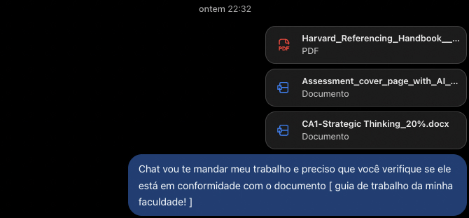
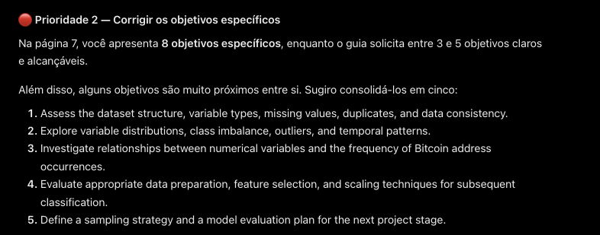

References AI-02
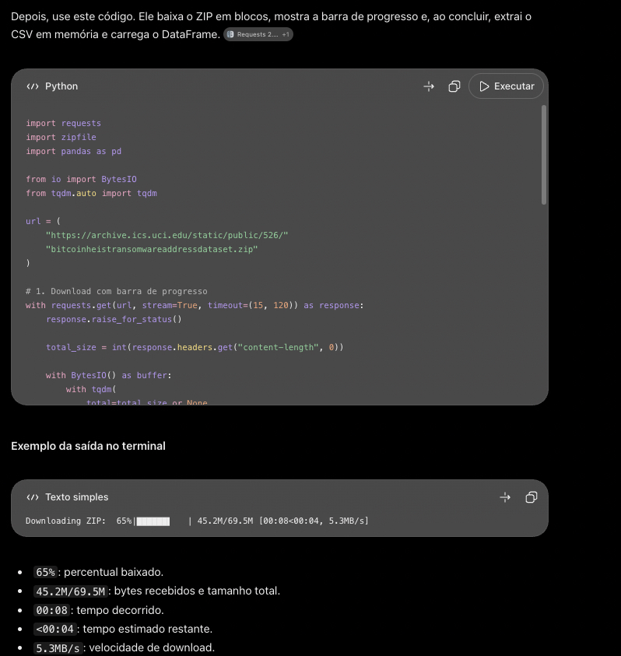
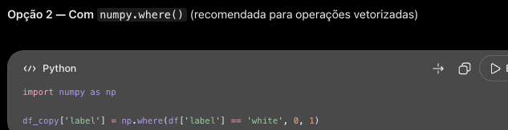

References AI-03

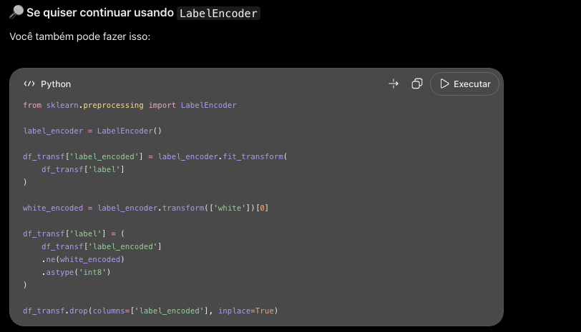
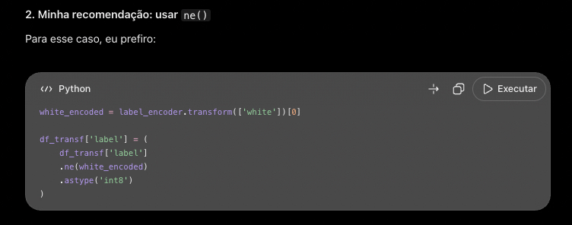

References AI-04

References AI-04.01
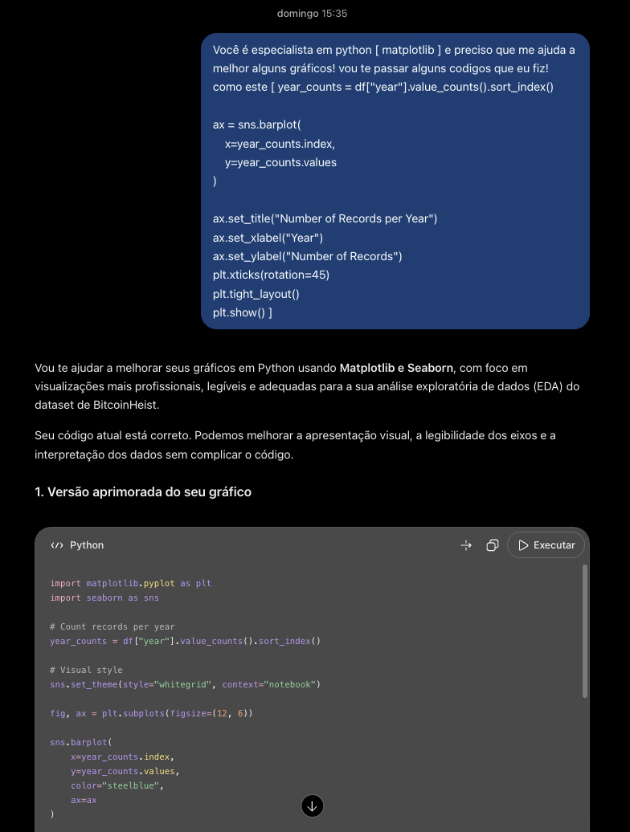
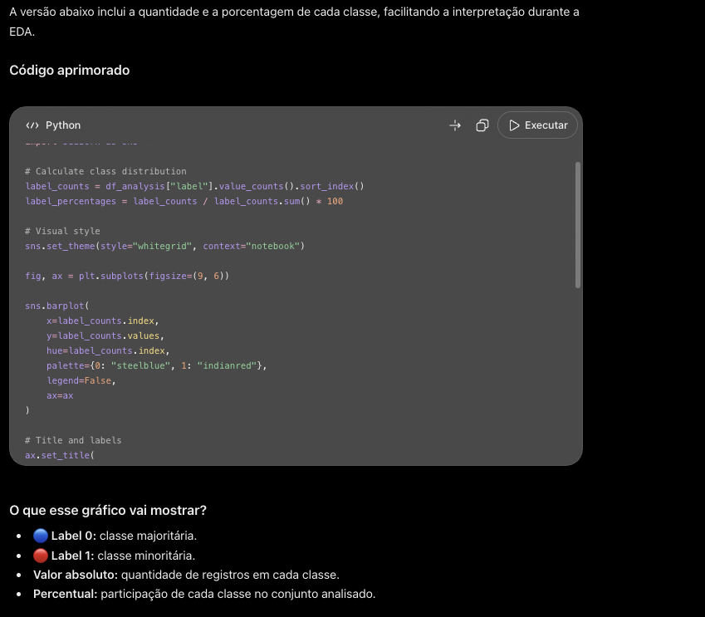
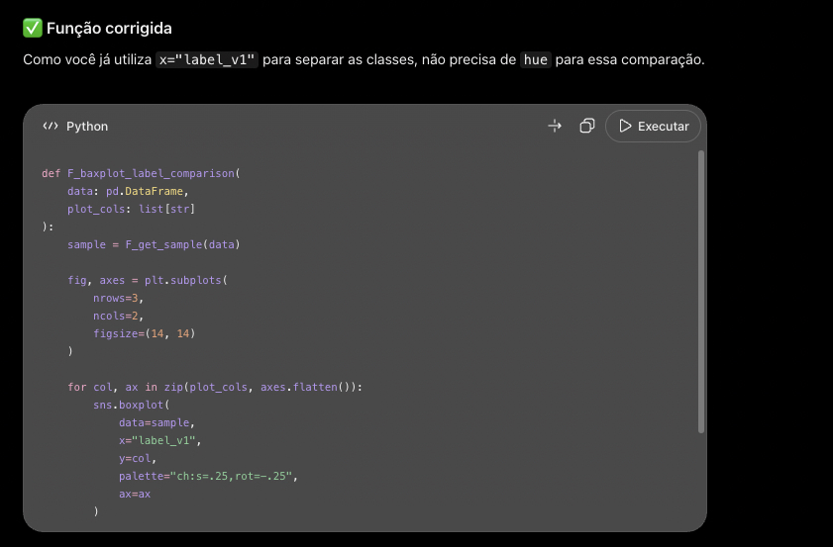

References AI-04.02
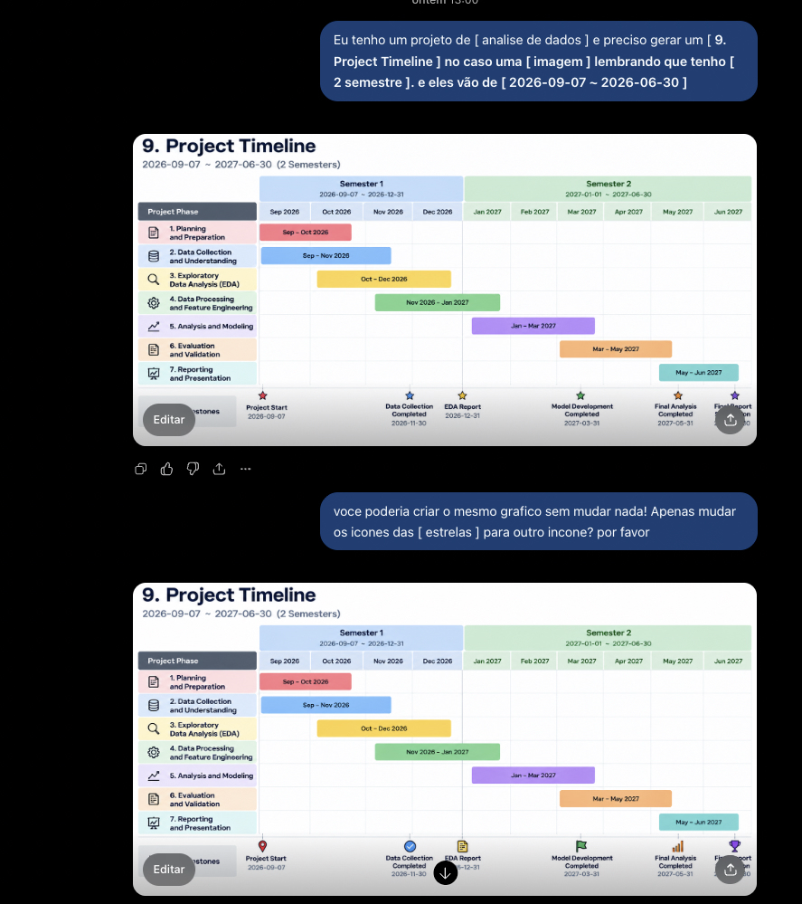
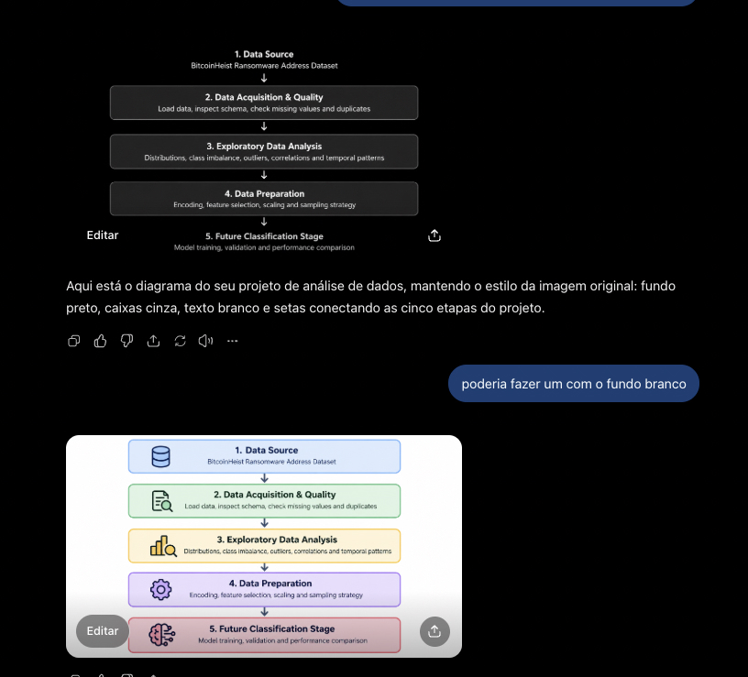

References AI-05
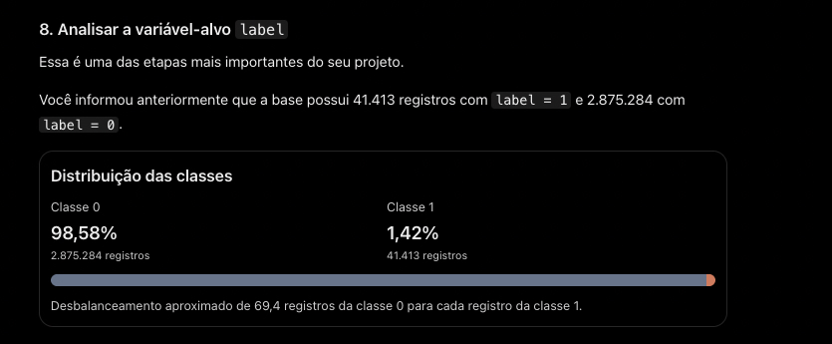
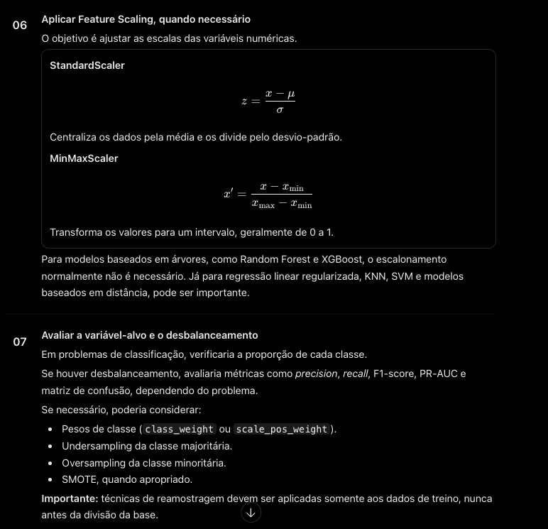
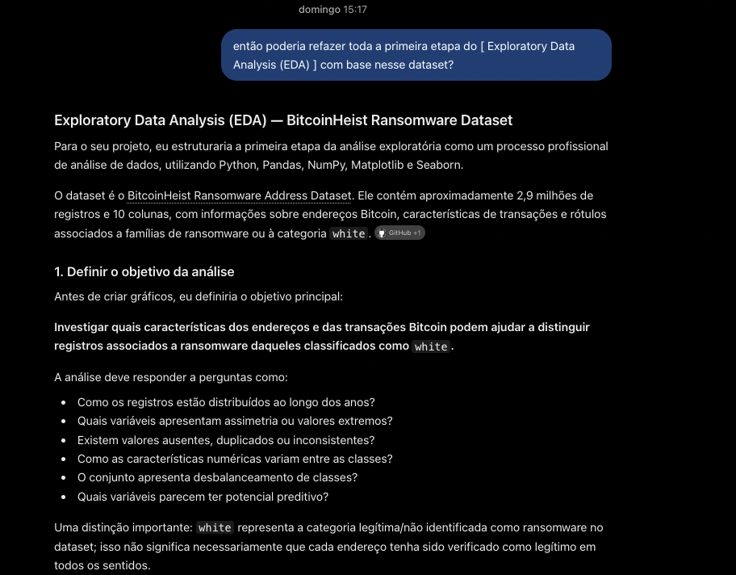

References AI-06
