­

|  |  |
| --- | --- |
| *Student Full Name:* | Aline Menezes da Silva |
| *Student Number:* | Sba23164 |
| *Module Title:* | Strategic Thinking |
| *Assessment Title:* | CA1 Capstone Project Proposal |
| *Assessment Due Date:* | 27th October 2024 |
| *Date of Submission:* | 27th October 2024 |

**Declaration**

By submitting this assessment, I confirm that I have read the CCT policy on academic misconduct and understand the implications of submitting work that is not my own or does not appropriately reference material taken from a third party or other source.

I declare it to be my own work and that all material from third parties has been appropriately referenced.

I further confirm that this work has not previously been submitted for assessment by myself or someone else in CCT College Dublin or any other higher education institution.

Capstone Project Proposal

Predictive Analytics for Passenger and Freight Demand

Aline Menezes da Silva

Strategic Thinking

Lecturer: James Garza/ Neil Doyle

CCT College Dublin

27th October 2024

https://github.com/CCT-Dublin/ca1-capstone-project-proposal-Aline-Menezes-Silva

Contents

Introduction 2

Objectives 2

Problem Definition 2

Project Scope 3

Exclusions 3

Data Sources 4

Ethical Considerations 4

References 5

# Introduction

The aviation industry is essential for global transportation. Helping economies grow by connecting people, businesses and goods. Irish airports are key hubs for international trade and travel. Where tourism and aviation sectors are closely connected and rely on each other. Tourism depends on air travel to attract visitors, while airlines need tourists to fill their seats. This relationship is crucial for facilitating trade, investment and particularly tourism, which is Ireland's largest native industry, representing 13% of all jobs and serving as the biggest employer in many regions (THE IMPORTANCE OF AVIATION TO IRISH TOURISM, 2024).

This project aims to use predictive analytics to forecast future demand for passengers, freight, and commercial flights at Irish airports. Using historical data, the goal is to create models that can predict trends in air travel, helping with airport operations, resource planning and strategic decisions.

The capstone project addresses real-world challenges such as fluctuating passenger numbers, seasonal variations and the increasing demand for cargo transportation. By developing predictive models, the project can assist in improving operational efficiency, optimizing airport infrastructure and offering data-driven insights for decision-making.

# Objectives

**Develop Predictive Models**: Create machine learning models to forecast passenger traffic, freight volumes and commercial flights at Irish airports.

**Analyse Trends and Seasonality**: Identify key trends, seasonal patterns and external factors influencing demand for air travel and freight services.

**Optimize Airport Operations**: Provide insights for airport management to optimize staff scheduling, runway usage and terminal capacity based on predicted demand.

**Support Strategic Planning**: Deliver actionable insights that help airports and airlines to make data-driven decisions regarding capacity expansion and flight scheduling.

**Real-World Impact**:  
The project addresses challenges like fluctuating passenger numbers and increasing demand for cargo transport. By improving demand forecasting, airports can plan for peak times and make data-driven decisions about capacity and service expansion.

# Problem Definition

Airports often face challenges in predicting the demand for flights, passengers and freight services, leading to operational inefficiencies. Overestimating demand can result in underutilized resources, while underestimating it can cause congestion, delays and a poor customer experience (Airline Customer Experience – Improve Airport Experience, 2024). Predictive analytics can help airports manage these challenges by forecasting demand more accurately. This project seeks to address the problem of demand uncertainty by developing data-driven models that anticipate changes in passenger and freight flows, thereby enabling airports to better allocate resources and plan for the future.

The impact of this problem is significant, as inefficiencies in airport operations can lead to increased costs. Addressing this issue with predictive models will improve the overall functioning of Irish airports and their ability to handle future growth.

# Project Scope

The project will be organized into distinct phases, from beginning through completion, ensuring it meets goals and success criteria (Casucian, 2024). Providing ample depth and scope to be completed over two semesters.

Below is the detailed scope:

**First Semester**

**Phase 1: Data Collection and Preprocessing (Weeks 1–4)**

In this phase, the dataset will be explored, cleaned and prepared for analysis. This includes handling missing values, outliers and inconsistencies in the dataset. Feature engineering will also be performed to create new variables that may enhance model performance.  
Expected Outcome: A clean, well-structured dataset ready for analysis.

**Phase 2: Exploratory Data Analysis (Weeks 5–8)**

Conduct exploratory data analysis (EDA) to identify trends, correlations and key patterns in passenger traffic, freight volumes and flight types. Visualization techniques will be used to gain deeper insights into the factors influencing flight and passenger behaviour.  
Expected Outcome: A comprehensive report with visualizations showcasing key patterns and trends.

**Phase 3: Model Development (Weeks 9–12)**

Build predictive models using machine learning techniques (e.g., time series forecasting, regression analysis) to forecast passenger volumes, freight activity and commercial flight trends. Multiple models will be tested, with an emphasis on accuracy and interpretability.  
Expected Outcome: A fully functional predictive model capable of forecasting flight traffic.

**Second Semester**

**Phase 4: Model Evaluation and Optimization (Weeks 1–4)**

Evaluate model performance using appropriate metrics. Hyperparameter tuning and model optimization techniques will be applied to ensure the best possible performance. The models will be tested on historical data to assess their accuracy in real-world applications.  
Expected Outcome: Finalized, optimized models with documented performance metrics.

**Phase 5: Industry and Policy Insights (Weeks 5–8)**

Based on the model’s predictions, assess the impact of changes in flight demand on Irish airports and flight planning. Generate insights that can aid in decision-making for airlines and airport authorities.  
Expected Outcome: A detailed report with actionable insights for industry stakeholders.

**Phase 6: Final Refinements and Presentation (Weeks 9–12)**

Incorporate feedback, finalize the model, reports and recommendations. Develop a polished presentation of the findings and a user-friendly dashboard to showcase predictive capabilities.  
Expected Outcome: A complete capstone project submission, including the model, report and presentation materials.

**First Semester**: 12 weeks total (3 phases)

**Second Semester**: 12 weeks total (3 phases)

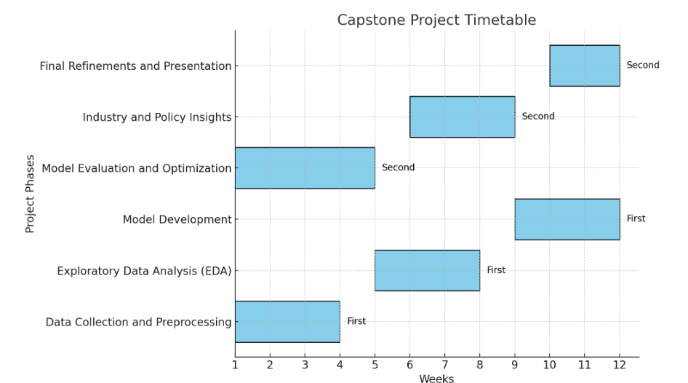

**Inclusions**:

* Forecasting passenger, freight and commercial flight volumes.
* Analysis of factors influencing air traffic, including seasonality and economic variables.
* Development of predictive models for traffic patterns.
* Recommendations for optimizing flight operations and planning based on the analysis.

**Exclusions**:

* Analysis outside of Ireland or unrelated to air traffic patterns.
* Legal or regulatory analysis of aviation laws.
* Development of new flight booking or reservation systems.

By the end of semester two, the project will deliver a comprehensive predictive analytics model and actionable insights that can guide decision-making in the Irish aviation industry. A well-documented final report and presentation will summarize the key findings and model outputs.

# Data Sources

The primary data source for this project is the **Passengers, Freight and Commercial Flights dataset** provided by the Central Statistics Office (CSO) of Ireland. This dataset includes historical data on passenger volumes, freight shipments and the number of commercial flights across Irish airports (Dorgan, 2024). The dataset is available at https://data.cso.ie/table/TAM07.

The dataset contains 516,132 entries, including details on flight statistics, routes, airports and revenue-related metrics. It will serve as the primary source for analysis and modelling. No external data sources will be necessary unless complementary industry benchmarks are needed for context.

Data permissions will be ensured for the use of this internal dataset, with particular attention to data privacy requirements and compliance with relevant data-sharing agreements.

The datasets will be cleaned and pre-processed to ensure compatibility and relevance to the project.

**Data Permissions**:

The dataset used in this project is the Irish Central Statistics Office publicly available under open-access policies. No proprietary or sensitive data will be used without proper authorization, ensuring compliance with data-sharing policies.

# Ethical Considerations

Since this project relies on publicly available data, there are no significant privacy concerns (Jayan, 2024). However, ethical considerations will include:

* **Data Privacy**: Ensuring that no personally identifiable information (PII) is included in the dataset.
* **Bias in Predictions**: Careful consideration will be given to avoid biases in the predictive models, such as over-reliance on historical data that may not reflect future trends accurately.
* **Data Use Compliance**: The project will strictly adhere to the licensing agreements of the datasets used.

Additionally, the predictions and insights provided by the model will be used responsibly, ensuring that airports do not make decisions solely based on predictions without considering other operational factors.

# References

CanYou (2024). *The Importance of Aviation to Irish Tourism: Interdependent, Symbiotic and Critical*. [online] Irish Tourism Industry Confederation - ITIC. Available at: https://www.itic.ie/aviation-report-2024/.

‌ A National Aviation Policy For Ireland. (2015). Available at: https://assets.gov.ie/14197/9b90e1b8a47d47c8950ead2492a54030.pdf.

‌ Marketing, S.I. (2023). *The Economic Impact of Airports*. [online] Airport Gurus. Available at: https://www.airportgurus.com/en/economic-impact-of-airports/.

Blasco-Puyuelo, J., Burrieza-Galán, J., Cantú, O., Herranz, R. and Mocholí, D. (n.d.). *A machine learning approach for predicting airport passenger flows*. [online] Available at: https://www.sesarju.eu/sites/default/files/documents/sid/2023/Papers/SIDs_2023_paper_67%20final.pdf [Accessed 16 Oct. 2024].

‌ Copenhagen Optimization. (n.d.). *Challenges & Opportunities in Airport Management Today | Read here*. [online] Available at: https://copenhagenoptimization.com/challenges-and-opportunities-in-airport-management/.

‌ Railway-News (2024). *Big Data’s Role in Airport Optimisation*. [online] Airport Industry-News. Available at: https://airportindustry-news.com/big-datas-role-in-airport-optimisation/.

‌ Xomnia.com. (2019). *Predictive models to reduce delays at Air Traffic Control the Netherlands*. [online] Available at: https://www.xomnia.com/predictive-models-to-reduce-air-traffic-delays-at-air-traffic-control-the-netherlands/ [Accessed 16 Oct. 2024].

‌ www.cso.ie. (n.d.). *Aviation Statistics - CSO - Central Statistics Office*. [online] Available at: https://www.cso.ie/en/statistics/transport/aviationstatistics/.

‌ Data.gov.ie. (2020). *TAA01 - Passenger, Freight and Commercial Flights - data.gov.ie*. [online] Available at: https://data.gov.ie/dataset/taa01-passenger-freight-and-commercial-flights [Accessed 14 Oct. 2024].

‌

Gold Nmesoma Okorie, Chioma Ann Udeh, Ejuma Martha Adaga and Osato Itohan Oriekhoe (2024). *ETHICAL CONSIDERATIONS IN DATA COLLECTION AND ANALYSIS: A REVIEW: INVESTIGATING ETHICAL PRACTICES AND...* [online] ResearchGate. Available at: https://www.researchgate.net/publication/378789304_ETHICAL_CONSIDERATIONS_IN_DATA_COLLECTION_AND_ANALYSIS_A_REVIEW_INVESTIGATING_ETHICAL_PRACTICES_AND_CHALLENGES_IN_MODERN_DATA_COLLECTION_AND_ANALYSIS.

Jayan, J. (2024). *Importance of Ethical Data Collection*. [online] PromptCloud. Available at: https://www.promptcloud.com/blog/importance-of-ethical-data-collection/.

‌ SKILLFLOOR (2023). *Ethical Considerations in Data Science: Privacy, Bias, and Fairness*. [online] SKILLFLOOR. Available at: https://skillfloor.com/blog/ethical-considerations-in-data-science-privacy-bias-and-fairness.

‌ Anon, (n.d.). *Airline Customer Experience - Improve Airport Experience – Wavetec*. [online] Available at: https://www.wavetec.com/customer-experience/airline/.

‌