­

|  |  |
| --- | --- |
| ***Student Full Name:*** | Aline Menezes da Silva |
| ***Student Number:*** | Sba23164 |
| ***Module Title:*** | Strategic Thinking |
| ***Assessment Title:*** | CA2 Capstone Project Proposal |
| ***Assessment Due Date:*** | 2nd Jan 2025 |
| ***Date of Submission:*** | 2nd Jan 2025 |

**Declaration**

By submitting this assessment, I confirm that I have read the CCT policy on academic misconduct and understand the implications of submitting work that is not my own or does not appropriately reference material taken from a third party or other source.

I declare it to be my own work and that all material from third parties has been appropriately referenced.

I further confirm that this work has not previously been submitted for assessment by myself or someone else in CCT College Dublin or any other higher education institution.

**Capstone Project Proposal**

**Marketing Analysis Ryanair Dataset**

**Aline Menezes da Silva**

Strategic Thinking

Lecturer: Neil Doyle

CCT College Dublin

2nd Jan 2025

https://github.com/CCT-Dublin/ca1-capstone-project-proposal-Aline-Menezes-Silva

Table of Contents

Introduction 3

Business Understanding 3

Project Plan 4

Business Description 4

Data Information 4

Data Preparation 5

Descriptive Statistic 5

Visualisations 6

Conclusions and Recommendation 14

References 15

**Table of Figures**

Figure 1 - Descriptive Statistic - Numerical Feature. 5

Figure 2 - Descriptive Statistic - Categorical Features. 6

Figure 3 - Numerical Features Distribution 7

Figure 4- BoxPlot Numerical Features 8

Figure 5- Distribution of Overall Ratings 9

Figure 6- Overall Rating by Traveller Type 9

Figure 7- Trends - Overall Rating Over Time 11

Figure 8- BoxPlot Seat comfort Ratings by Seat Type 12

# **Introduction**

This report is designed to fulfil the requirements of a capstone project aimed at applying project management methodologies to a real-world dataset analysis. The primary goal is to explore a selected dataset thoroughly, ensuring that insights extracted are relevant and actionable for the assigned business context. As part of this analysis, the report will cover various components, including a strategic overview of the underlying business problem, a comprehensive project plan outlining the steps taken, and an in-depth understanding of both the business and data itself.

# **Business Understanding**

In the highly competitive airline industry, particularly in the budget sector, customer satisfaction is crucial for retaining and attracting passengers. Ryanair, one of Europe's largest low-cost airlines, faces continuous pressure to improve its services while keeping costs down. The airline's reputation is built on its ability to deliver affordable travel options; however, the satisfaction levels of its passengers directly impact customer loyalty and future sales.

This report aims to analyse the Ryanair dataset, focusing on passenger feedback to identify strengths and weaknesses in service delivery. The dataset includes various ratings across critical service areas such as seat comfort, cabin staff service, food and beverages, and value for money. Understanding how these ratings correlate with overall passenger satisfaction is key to formulating strategies for improvement.

The primary business problem revolves around the need to identify the factors affecting passenger satisfaction, address areas of dissatisfaction, and develop actionable strategies to enhance the overall customer experience.

# **Project Plan**

The analysis will follow a structured project plan, which includes the following stages:

* Business Understanding: Define the objectives and key questions to be answered, focusing on impact areas for passenger satisfaction.
* Data Understanding: Explore the dataset to assess its structure, quality, and insights related to passenger experiences.
* Data Preparation: Clean and preprocess the data, addressing missing values and ensuring data consistency for analysis.
* Exploratory Data Analysis (EDA): Conduct detailed statistical analysis and visualisation to uncover trends, patterns, and correlations in the data.
* Findings and Recommendations: Summarise insights from the analysis and provide actionable recommendations to enhance Ryanair’s service offerings.

# **Business Description**

The primary aim of this analysis is to understand how various factors affect passenger satisfaction by analysing the Ryanair dataset. The analysis will focus on answering the following key questions:

* How do overall ratings vary across different service aspects, such as seat comfort and cabin staff service?
* Are there differences in ratings based on passenger country, origin, or destination?
* Is there a correlation between overall satisfaction ratings and the perceived value for money, comfort levels, and staff interactions?
* What trends or patterns can be observed in passenger ratings over time?

By answering these questions, Ryanair can obtain insights into its strengths and weaknesses, which will allow for informed decision-making to improve the customer experience.

**Data Source**:

The data has been taken from an online source that is Kaggle. www.kaggle.com. (n.d.). *✈️ Ryanair Passenger Experience Reviews*. [online] Available at: https://www.kaggle.com/datasets/cristaliss/ryanair-reviews-ratings/data.

# **Data Information**

The Ryanair dataset consists of 2,249 entries across 21 columns, capturing feedback from passengers. Each entry is identified in the 'Unnamed: 0' column, and the 'Date Published' shows when feedback was recorded. The 'Overall Rating' reflects customer satisfaction, though there are some missing values with 2,119 completed entries. Key passenger details are found in columns like 'Passenger Country', which is fully populated, and 'Type Of Traveller', which has missing data along with limited entries for 'Aircraft' and 'Recommended'. The dataset provides insights into flight experiences through ratings for 'Seat Comfort', 'Cabin Staff Service', and 'Food & Beverages', although some feedback lacks these ratings. There is also minimal feedback on the technology features 'Inflight Entertainment' and 'Wifi & Connectivity', indicating these services might not be consistently available. The 'Value For Money' column is nearly complete, likely offering a good measure of service value, while the 'Recommended' column suggests customer loyalty but has limited entries.

# **Data Preparation**

To prepare for the analysis, several steps were taken. First, columns with over 60% missing data, like 'Recommended' and 'Inflight Entertainment', were excluded to avoid skewing the results, while columns with lower missing percentages, such as 'Overall Rating', were carefully retained. Next, the dataset was cleaned by renaming columns for clarity and removing duplicates. Lastly, the 'Published' column was converted to a datetime format, and categorical variables were set up for grouping and analysis.

# Descriptive Statistic

In the descriptive statistics section, the analysis was conducted in the dataset by employing commands such as head and simple descriptive functions. The subsequent findings presented a statistical summary of the numerical attributes within the dataset.

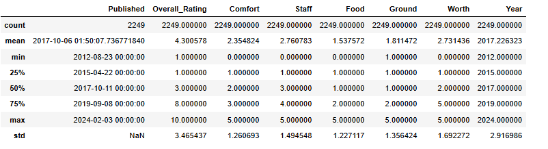

Figure 1 - Descriptive Statistic - Numerical Feature.

From the results, it can be observed that:

The dataset spans from 23rd August 2012 to 3rd February 2024, offering a thorough view of passenger experiences over the years. The average overall rating is around 4.30, suggesting a generally positive experience, but there is considerable variability in customer satisfaction with ratings ranging from 1 to 10. Specific areas, such as seat comfort, have a low average rating of 2.35, indicating a clear need for improvements. Similarly, cabin staff service averages at 2.76, showing only modest satisfaction.

Food and beverages received the lowest average rating at 1.54, highlighting a significant area for enhancement. Ground service also fares poorly, with an average of 1.81, indicating possible dissatisfaction among passengers. Lastly, the value for money scores an average of 2.73, suggesting that while some passengers find it acceptable, many do not consider it good value. Overall, these findings point to several service aspects requiring attention to improve passenger satisfaction.

Descriptive statistic - Categorical features:

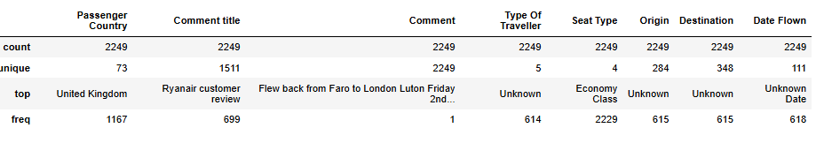

Figure 2 - Descriptive Statistic - Categorical Features.

The dataset features 73 unique countries, highlighting a diverse mix of nationalities, with the UK being the most represented at 1,167 mentions. There are 1,511 unique comment titles and 2,249 comments, indicating a wide variety of passenger experiences, with the most common title appearing 699 times, pointing to shared concerns.

Many entries for aircraft and seat type are marked as "Unknown," predominantly referring to Economy Class, which shows a lack of detail regarding the aircraft used. In the traveller type category, "Unknown" is the most frequent classification, appearing 614 times, indicating gaps in identifying specific traveller types. The dataset includes 284 unique origin airports and 348 destinations, but "Unknown" is the most common entry for both, suggesting issues with data completeness. Additionally, many flight dates are unspecified, with "Unknown Date" noted 618 times, restricting further analysis of trends over time.

# **Visualisations:**

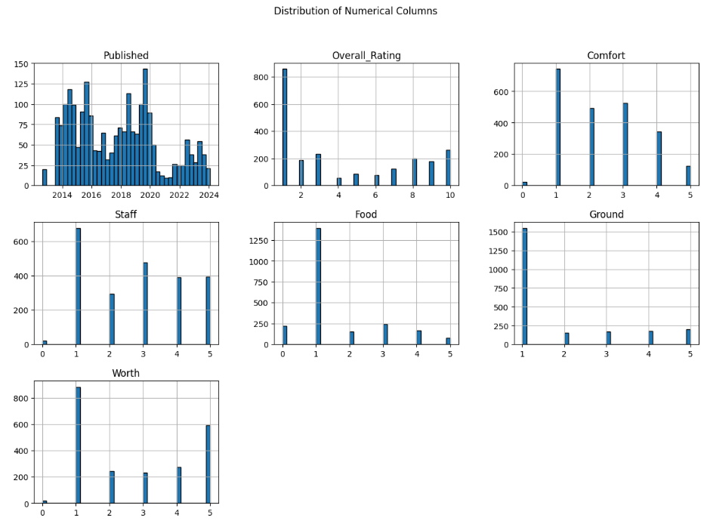

Figure 3 - Numerical Features Distribution

**Based on the Distribution of Numerical Columns:**

The dataset spans a wide time range, providing valuable insights into trends in passenger perceptions over time. Overall, many passengers report positive experiences, but there is significant variability in the ratings. Seat comfort consistently receives low ratings, indicating a need for airlines to enhance comfort levels to improve satisfaction. Passengers show moderate satisfaction with cabin staff, with some positive experiences but still room for improvement.

Food and beverage services are a major concern for many, as numerous passengers give very low ratings, suggesting these offerings do not meet expectations. Issues with ground services also appear to exist, which could negatively affect the overall travel experience. Regarding value for money, opinions vary widely; while some passengers believe the services justify the price, many feel they do not.

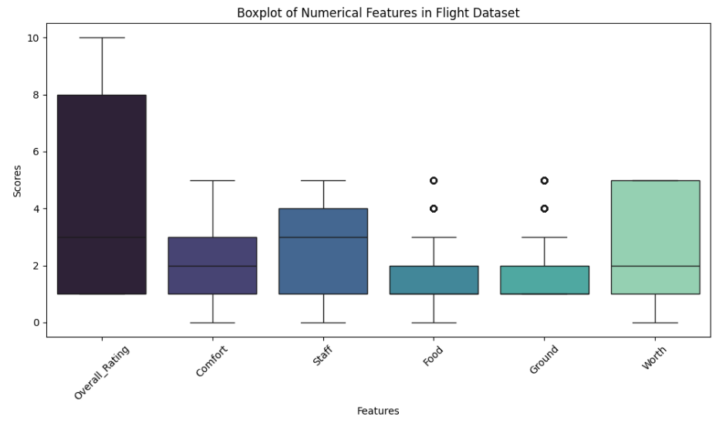

Figure 4- BoxPlot Numerical Features

**BOXPLOT analysis:**

The boxplot for overall ratings shows that while some passengers gave high scores, many rated their experiences low, indicating dissatisfaction. The presence of low outliers suggests that some passengers encountered extremely poor service, which contrasts with a few high ratings.

In terms of seat comfort, the category has a low median score, with many passengers finding the seating uncomfortable, signaling a need for improvement. Cabin staff service also has a low median rating but includes a few high outliers, indicating varied experiences. Food and beverage ratings feature many low outliers, suggesting dissatisfaction with quality, while higher ratings show limited variation. Ground service displays a better median rating, but low outliers point to disappointing experiences. Finally, the value for money aspect indicates widespread dissatisfaction, as many passengers feel that the services do not justify the prices they paid.

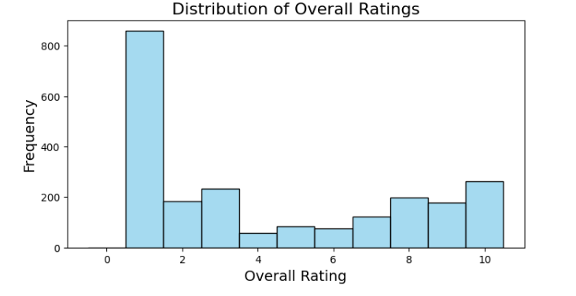

Figure 5- Distribution of Overall Ratings

The distribution of ratings indicates that many passengers tend to rate their experiences lower, particularly around the scores of 1, 2, and 3, with about 800 passengers giving these ratings each. There is a noticeable drop in the number of ratings as they increase to 4, 5, 6, and 7, where roughly 100 passengers rated their experience at each of these scores. Ratings start to increase again with scores of 8 and 9, fetching around 200 ratings each. The highest score of 10 sees the greatest number of responses, with about 300 passengers giving this rating.

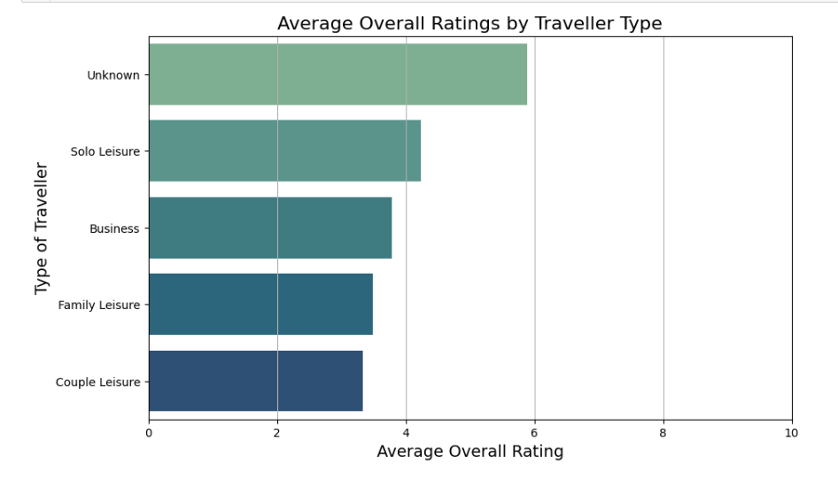

Figure 6- Overall Rating by Traveller Type

The 'Unknown' category indicates missing data that has been filled in, meaning these ratings may not accurately represent a specific group. Solo leisure travellers have a moderate average rating, showing general satisfaction but highlighting areas like comfort and service that need improvement. In contrast, business travellers report lower satisfaction, suggesting that their expectations for efficiency and quality are not being met, which requires the airline to enhance its offerings for them. Families also have lower ratings, indicating dissatisfaction and suggesting a need for better family-friendly amenities and seating options. Lastly, the couple leisure group has the lowest average rating, reflecting significant dissatisfaction, possibly due to a lack of tailored services for couples.

**Conclusions on Overall Rating by Traveller Type:**

* The variation in average ratings shows different satisfaction levels among traveller types. The 'Unknown' group seems satisfied, but business, family, and couple leisure travellers report lower satisfaction, which needs addressing.
* The low ratings for families and couples highlight the need for specific improvements in service. Enhancing amenities for these groups can help meet their expectations.
* Business travellers also require attention due to their high expectations. Airlines should focus on improving comfort, service speed, and tailored facilities for this group.
* The high rating in the 'Unknown' category suggests that airlines should investigate the reasons behind the missing data.
* **How Do Overall Ratings Change Over Time?**

Analysing trends in overall ratings over time can reveal patterns in customer satisfaction:

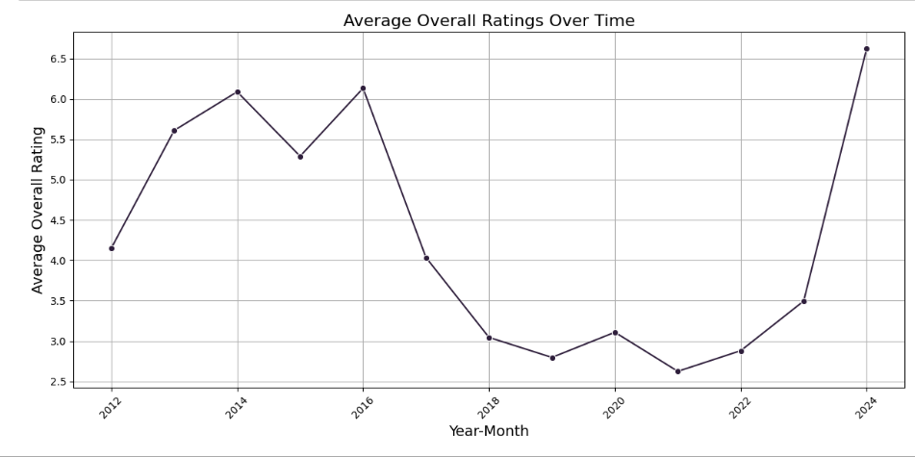

Figure 7- Trends - Overall Rating Over Time

Average overall ratings for Ryanair increased from about 4.15 in 2012 to 6.09 in 2014, indicating better service or customer satisfaction. However, after peaking in 2014, ratings fluctuated, dropping in 2015, slightly rising in 2016, and then declining again from 2017 to 2019, suggesting challenges in service quality. Ratings remained below 4.0 from 2018 to 2022, highlighting persistent dissatisfaction among passengers. Interestingly, there was a significant recovery in 2024, with ratings rising to an average of 6.63, indicating that recent improvements may have effectively addressed previous issues and enhanced passenger satisfaction.

**- Are there significant differences in seat comfort ratings based on seat type?**

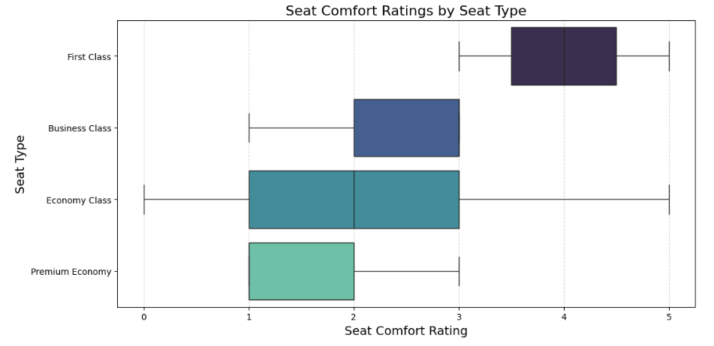

Figure 8- BoxPlot Seat comfort Ratings by Seat Type

- From the boxplot above it is possible to see that:

Economy Class has the most data points, with an average comfort rating of around 2.36. Ratings range from 0 to 5, showing that passengers have varied experiences, likely due to the diverse needs and expectations of many users.

Business Class, with only three entries, has an average comfort rating of about 2.33. The limited data reflects more consistent but relatively low comfort levels, which is unusual for this class, and the small sample size affects the reliability of the results.

First Class consists of just two entries but boasts a higher average comfort rating of 4, aligning with expectations of superior comfort and amenities. However, the small number of entries means that one should be cautious in interpreting these results definitively.

Premium Economy, with 15 entries, has the lowest average comfort rating at 1.67. This suggests that the amenities offered may not justify the upgrade from Economy Class. The limited data might not fully represent the experience in this class. Overall, there are notable differences in comfort ratings across seat types, indicating potential areas for improvement, especially in Premium Economy.

* **Do ratings vary by passenger country, origin, or destination?**

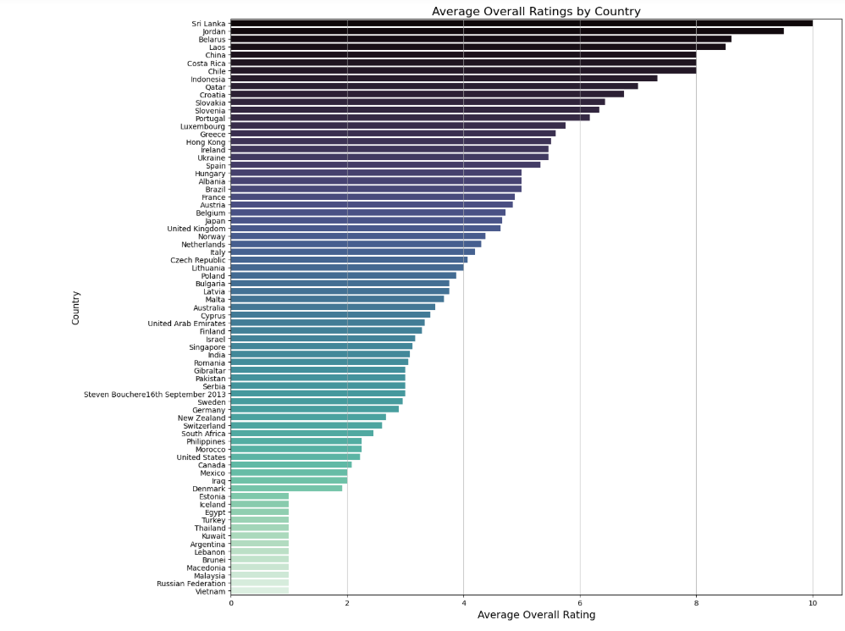

Countries such as Sri Lanka, Jordan, Belarus, Laos, and China have high average ratings, particularly Sri Lanka, indicating that passengers from these regions generally have positive experiences, likely due to good service or effective routes.

In contrast, countries like Brunei, Macedonia, Malaysia, the Russian Federation, and Vietnam have very low ratings, suggesting dissatisfaction due to poor service or unmet expectations. The differences in ratings across countries demonstrate the need to understand regional preferences and adjust services accordingly.

For the countries with lower ratings, Ryanair should explore the reasons behind the dissatisfaction by analysing feedback and engaging with passengers to address their concerns. Additionally, it is important for airlines to consider cultural and regional factors that influence satisfaction, as high ratings in certain countries might indicate a strong brand presence, while lower ratings highlight areas needing improvement.

**Correlation Analysis**

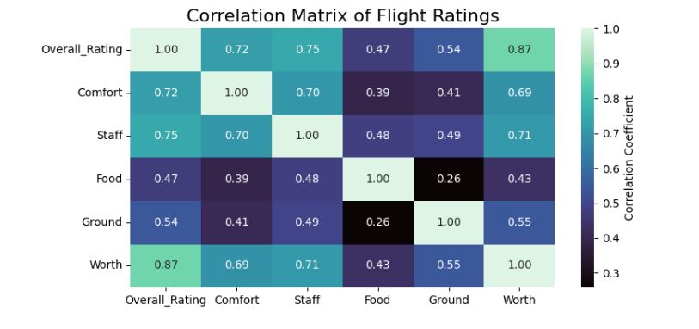

The 'Overall Rating' strongly correlates with 'Worth' at 0.869, meaning that passengers who feel they get good value for money usually rate their experience higher. Comfort and staff service also have strong correlations with the overall rating, at 0.721 and 0.746, showing they are important for passenger satisfaction.

There is a significant correlation of 0.708 between 'Staff' and 'Worth', indicating that positive staff interactions enhance the perception of value. 'Comfort' affects both ratings.

# **Conclusions and Recommendation**

The average overall rating indicates a generally positive view among passengers, but there is notable variability that needs to be addressed. Key service areas, especially 'Seat Comfort' and 'Food & Beverages,' received lower ratings, signalling dissatisfaction. The high number of missing values in these categories suggests that either the services were rarely available, or passengers opted not to provide ratings, limiting the assessment of how these factors impact overall satisfaction.

Analysis shows particularly low ratings for 'Food & Beverages' and 'Ground Service,' highlighting critical areas that need improvement. Many passengers expressed disappointment with food quality, which may suggest that meal options do not meet expectations. Ratings also varied widely across passenger countries, with countries like Sri Lanka, Jordan, and Belarus scoring high, while Brunei and Vietnam recorded lower scores, indicating that cultural factors or differing service expectations may influence satisfaction levels.

To address these findings, Ryanair should consider revising its food offerings by surveying customers to better understand their preferences and introducing healthier meal options. Improving seating comfort is essential, which may involve redesigning cabin layouts. Additionally, enhancing staff training can positively impact passenger satisfaction. Ryanair should also focus on understanding the needs of passengers from countries with low ratings and investigate the reasons behind the missing values in 'Inflight Entertainment' and 'Wifi & Connectivity'. Establishing a system for continuous feedback will help the airline adapt its services to meet customer expectations effectively.

# **References**

www.kaggle.com. (n.d.). *✈️ Ryanair Passenger Experience Reviews*. [online] Available at: https://www.kaggle.com/datasets/cristaliss/ryanair-reviews-ratings/data.

ekaterinabrepina (2024). *📝 Exploring Ryanair reviews*. [online] Kaggle.com. Available at: https://www.kaggle.com/code/ekaterinabrepina/exploring-ryanair-reviews [Accessed 2 Jan. 2025].

‌Elisa Niinimaa CUSTOMER SATISFACTION SURVEY ON RYANAIR WEBPAGES. (n.d.). Available at: https://www.theseus.fi/bitstream/handle/10024/27950/Niinimaa_Elisa.pdf.‌

Stobierski, T. (2020). *4 Ways to Develop Your Strategic Thinking Skills | HBS Online*. [online] Business Insights - Blog. Available at: https://online.hbs.edu/blog/post/how-to-develop-strategic-thinking-skills.‌

Uchicago.edu. (2025). *Capstone Projects – DSI*. [online] Available at: https://datascience.uchicago.edu/education/masters-programs/ms-in-applied-data-science/capstone-projects/ [Accessed 2 Jan. 2025].