Caroline Alves Ferreira

2022188@student.cct.ie

A Roof Over Our Heads: Homeownership Challenges in Ireland

CA 2 – Capstone Report

Link GitHub: <https://github.com/CCT-Dublin/ca1-capstone-project-proposal-C2022188.git>

**Assessment Cover Page**

|  |  |
| --- | --- |
| *Student Full Name* | Caroline Alves Ferreira |
| *Student Number* | 2022188 |
| *Module Title* | Strategic Thinking |
| *Assessment Title* | CA 2 – Capstone Report |
| *Assessment Due Date* | Sunday, 02nd January 2025 |
| *Date of Submission* | Tuesday, 03rd December 2025 |

**Declaration**

By submitting this assessment, I confirm that I have read the CCT policy on academic misconduct and understand the implications of submitting work that is not my own or does not appropriately reference material taken from a third party or other source.

I declare it to be my own work and that all material from third parties has been appropriately referenced.

I further confirm that this work has not previously been submitted for assessment by myself or someone else in CCT College Dublin or any other higher education institution.

Contents

Figures ii

Introduction 1

Business Understanding 2

Data Understanding 3

Data Preparation 5

Findings & Conclusions 9

Machine Learning (ML) 16

References 18

# Figures

Figure 1 - Info of dataset "Rent as Percentage of Disposable Income" 3

Figure 2 - Info of dataset "RTB Average Monthly Rent Report" 4

Figure 3 - Info of dataset "House Prices" 4

Figure 4 - Handling Missing Values in the 'House Prices' Dataset 5

Figure 5 - Dropping Columns in the 'House Prices' Dataset 6

Figure 6 - Dropping Columns in the 'RTB Average Monthly Rent Report' Dataset 6

Figure 7 - Missing Values in the 'RTB Average Monthly Rent Report' Dataset 6

Figure 8 - Missing values by location in the 'RTB Average Monthly Rent Report' Dataset 7

Figure 9 - Missing Values by Quarter in the 'RTB Average Monthly Rent Report' Dataset 7

Figure 10 - Handling Missing Value in the 'RTB Average Monthly Rent Report' Dataset 8

Figure 11 - Info of dataset 'RTB Tenants' 8

Figure 12 – Barplot - Percentage of Income Spent on Rent by Region 9

Figure 13 - LinePlot - Average House Price Over Time 10

Figure 14 - LinePlot - House Price Trends by Region 11

Figure 15 - BoxPlot - Distribution of House Prices by Region 12

Figure 16 - HistPlot - Distribution of Rental Prices 13

Figure 17 - BarPlot - Top 10 Regions with Highest Average Monthly Rent 14

Figure 18 - BarPlot - Percentage of RTB Tenants by Income Group 15

Figure 19 - Scatterplot - Linear Regression model 16

# Introduction

The housing crisis is one of the most talked-about problems in Ireland today. Property prices continue to rise, affecting both rent and the dream of owning a home. Families paying rent, especially in Dublin, one of the most expensive cities in Ireland, find it very difficult to save enough money to buy their own homes. For single people, the challenge is even greater, as reaching the income level needed for mortgage approval can feel impossible without additional support.

This project will explore the main barriers to affordable housing by analysing rent costs across regions and comparing them with income levels. It will also look at house prices in different areas, highlighting how they have consistently increased year after year. To structure the work, the report will follow the CRISP-DM framework, covering Social Understanding, Data Understanding, Data Preparation, Modelling, Evaluation, and Deployment.

# Business Understanding

The first stage of the CRISP-DM framework focuses on understanding the problem and the needs of the project. Since housing prices are a social issue, this stage is called Social Understanding. The goal is to identify the main objectives of the project and understand the challenges related to the crisis.

Ireland is experiencing a serious housing crisis caused by high demand and a lack of available homes. This imbalance has led to rising house prices and rents, making housing less affordable, especially for low-income families. Many people cannot save enough money to buy a home because of the high cost of living and strict mortgage rules. According to Hearne (2017), this crisis is linked to economic inequality. Housing policies often treat homes as investments rather than a basic human need, making homeownership even harder to achieve for many people.

The crisis is not just about the shortage of homes. Potts (2020) explains that the real issue is affordability. While everyone needs a place to live, people can only live where they can afford it. Gillespie (2018) points out that private housing developments tend to focus on higher-income groups, leaving lower-income families with very few options. This housing crisis affects not only individuals and families but also society as a whole. Hansen (2013) states that affordable and secure housing is essential for physical and mental health, children’s education, and family stability. However, Hearne (2020) argues that weak tenant protections and treating housing as a financial asset have made it even harder for many people to find safe and affordable homes.

The housing crisis is a complex issue that affects not only individuals and families but also the overall stability of society. Understanding the financial barriers and regional disparities is essential to address this problem effectively. This project will focus on identifying these challenges, analyzing the social and economic impacts of the crisis, and providing data-driven insights to propose potential solutions for making housing more affordable and accessible in Ireland.

# Data Understanding

The data understanding phase of CRISP-DM involves taking a closer look at the data available for mining. This step is critical in avoiding unexpected problems during the next phase--data preparation--which is typically the longest part of a project (IBM, 2021.). The data for this study was collected from reliable sources, mainly the Central Statistics Office (CSO) in Ireland. The datasets cover important aspects of the housing crisis, such as rent, house prices, disposable income, and inflation. These datasets are key to understanding the current situation and finding solutions.

The tools and technologies that will be used in the project are:

* Pandas
* Matplotlib
* Seaborn

One dataset, *"Rent as Percentage of Disposable Income"*, shows how much of their income tenants spend on rent. It highlights the financial pressure of rent in different regions. By using the .info() function, it is possible to observe that the dataset contains 124 entries and 5 columns: Statistic Label, Rental Year, Local Authority, Unit, and Value, and there are no missing values.

Figure 1 - Info of dataset "Rent as Percentage of Disposable Income"

Another key dataset is the "RTB Average Monthly Rent Report," which provides detailed information on average monthly rents across various regions. The dataset consists of 393,372 entries with 7 columns. During the data cleaning process, it will be necessary to address missing values by imputing them with the average for each region. Overall, the dataset is reliable, offering strong coverage across both time periods and locations.

Figure 2 - Info of dataset "RTB Average Monthly Rent Report"

The *"House Prices"*  dataset contains information about average house prices over time. It helps identify trends and changes in the housing market. Using the .info() it is possible to see that the dataset contains 334,656 entries and 8 columns:

Figure 3 - Info of dataset "House Prices"

It is observed that in the column “VALUE” are 826 missing values, which will be dropped in the next stage of data cleaning process. Overall, this dataset is well-organized by year, regions and value, with no significant missing data relative to the total number of entries.

All the data has been carefully prepared to ensure consistency across sources and suitability for analysis. With this strong foundation, the next step will be to explore these patterns further and connect them to the housing challenges faced in Ireland.

# Data Preparation

According to Conroy (2023), data preparation involves selecting, cleaning, merging, formatting, and transforming data to make it suitable for use in a data product. This phase focuses on resolving issues and errors in the dataset to ensure it is clean and ready for machine learning model implementation.

The first step in cleaning this dataset “House_Prices” is to remove rows that have missing values, as they do not contribute to the analysis:

Figure 4 - Handling Missing Values in the 'House Prices' Dataset

The next step of the data cleaning, for this dataset, was dropping the columns that are not useful:

Figure 5 - Dropping Columns in the 'House Prices' Dataset

Another dataset where it was necessary to drop columns was the *"RTB Average Monthly Rent Report,"* as those columns were deemed irrelevant:

Figure 6 - Dropping Columns in the 'RTB Average Monthly Rent Report' Dataset

During the Data Understanding process, it was observed that this dataset has some missing values. By using the command .isnull().sum(), we can see an overview of how much data is missing in the *VALUE* column:

Figure 7 - Missing Values in the 'RTB Average Monthly Rent Report' Dataset

The next step involves identifying the locations where the *VALUE* column has missing data and counting the number of missing entries for each location. This helps pinpoint areas with significant data gaps.

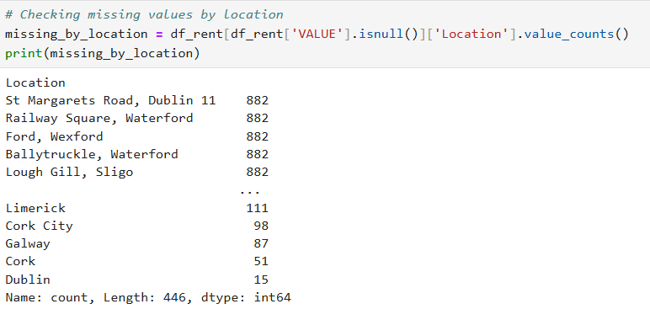

Figure 8 - Missing values by location in the 'RTB Average Monthly Rent Report' Dataset

Similarly, the data is analysed to count the number of missing entries in the *VALUE* column grouped by the *Quarter*. This helps to check if the missing data is concentrated in specific time periods:

Figure 9 - Missing Values by Quarter in the 'RTB Average Monthly Rent Report' Dataset

After these analyses, the next step was to fill the missing values in the *VALUE* column by replacing them with the median *VALUE* of the corresponding *Location* group. The transform function is used to ensure the replacements are applied at the group level while keeping the DataFrame structure intact:

Figure 10 - Handling Missing Value in the 'RTB Average Monthly Rent Report' Dataset

Finally, after filling the missing values using the location-specific medians, any remaining missing values were replaced with the overall median of the *VALUE* column. This ensures that the missing data is handled effectively with minimal impact on the overall dataset quality.

In the other dataset, *"RTB Tenants"* , since there were no missing values, the only modification made was dropping the columns that were irrelevant.

Figure 11 - Info of dataset 'RTB Tenants'

# Findings & Conclusions

The data shows that Ireland is experiencing a housing crisis, with considerable discrepancies across regions and socioeconomic levels. The percentage of income spent on rent varies substantially depending on location, with urban regions such as Dublin placing the most financial strain on tenants. The figures show that tenants in Dublin frequently pay more than 35% of their disposable income on rent, which is significantly more than in rural areas. This highlights the huge disparity between countryside and urban home affordability.

Figure 12 – Barplot - Percentage of Income Spent on Rent by Region

The data *Houses Prices* indicate that house prices have risen steadily over the last decade (Figure 13). Since 2014, average housing prices have steadily increased, with a particularly strong spike in metropolitan locations such as Dublin. This trend shows rising demand for housing, combined with limited supply, which has pushed prices to unprecedented highs.

Figure 13 - LinePlot - Average House Price Over Time

A closer study into Dublin finds that property prices not only exceed the national average, but are also more volatile, as it showing in the graphs below. These swings emphasise the vulnerability of urban markets to economic and policy changes, intensifying affordability issues.

Figure 14 - LinePlot - House Price Trends by Region

The distribution of housing prices around the country provides more insight into these inequalities. Dublin regularly has the highest median house prices and a wide range of values, indicating considerable disparities in housing availability. Countryside locations, on the other hand, tend to have more stable and cheap housing markets, although lacking the economic prospects that urban centres provide.

Figure 15 - BoxPlot - Distribution of House Prices by Region

Rent distribution follows a similar pattern, with rents in Dublin and nearby areas concentrating at greater levels. This pattern is consistent with the data on average rent costs, which reveal that the top ten most costly regions are all in or near Dublin (Figure 17). The concentration of high rental charges in metropolitan areas emphasises the need for focused initiatives to help solve the affordability challenge.

Figure 16 - HistPlot - Distribution of Rental Prices

Figure 17 - BarPlot - Top 10 Regions with Highest Average Monthly Rent

Furthermore, income discrepancies among tenants highlight the seriousness of the problem. A large proportion of RTB tenants earn less than €30,000 per year (as showing below), making it difficult to pay rent or owning. This income distribution demonstrates that a significant percentage of the population struggles with housing costs, particularly in places where prices are high.

Figure 18 - BarPlot - Percentage of RTB Tenants by Income Group

Overall, the findings highlight the crucial need for comprehensive housing policy that address these concerns. Solutions could include expanding the supply of affordable housing, implementing rent control measures in high-demand regions, and providing financial support to low-income individuals. The current trends in rent, home prices, and income distribution emphasise the importance of these actions to establish a more fair housing market in Ireland.

# Machine Learning (ML)

### Average Monthly Rent Prediction

To further support the analysis, a supervised machine learning approach was applied to predict the average monthly rent across Ireland based on regional and time-based features. A random sample of 5,000 entries from the RTB Average Monthly Rent dataset was selected to ensure manageability and balance.

The predictive modelling included three algorithms: Linear Regression, Random Forest, and Gradient Boosting. After preprocessing categorical variables using OneHotEncoding and splitting the data into training and test sets (80/20), the models were trained and evaluated based on RMSE, MAE, and R² metrics.

The Linear Regression model delivered the best overall performance, achieving an R² score of 0.93 and a Mean Absolute Error (MAE) of approximately €59. The Random Forest followed closely with an R² of 0.92 and a slightly lower MAE of €54. However, Gradient Boosting significantly underperformed, indicating potential overfitting or sensitivity to outliers.

To visualize the effectiveness of the best model, a scatterplot was generated to compare actual vs. predicted rent values. As shown in the figure below, the predictions closely follow the ideal trend line, reinforcing the model’s high accuracy.

Figure 19 - RTB Average Monthly Rent - Actual vs Predicted

This machine learning analysis confirms that rent prices in Ireland can be accurately predicted using basic attributes such as location and rental quarter. These results provide strong evidence that pricing follows discernible patterns, supporting earlier findings about regional disparities and affordability issues in the Irish housing market.

### House Price Prediction

In addition to rental price prediction, a machine learning model was trained to estimate house sale prices across Ireland. A random sample of 5,000 records was extracted from the House Prices dataset to ensure performance and generalization. The features used included the year, month, and RPPI region.

Three regression models were applied: Linear Regression, Random Forest, and Gradient Boosting. Among them, Gradient Boosting achieved the best performance, with an R² of 0.699, a Root Mean Squared Error (RMSE) of €64,450, and a Mean Absolute Error (MAE) of €45,587.

While the predictive power was lower than the rent model, the results still show a strong ability to estimate house prices with limited features. These findings highlight the complexity and variability of the housing market in Ireland and reinforce the challenges of homeownership for the average buyer.

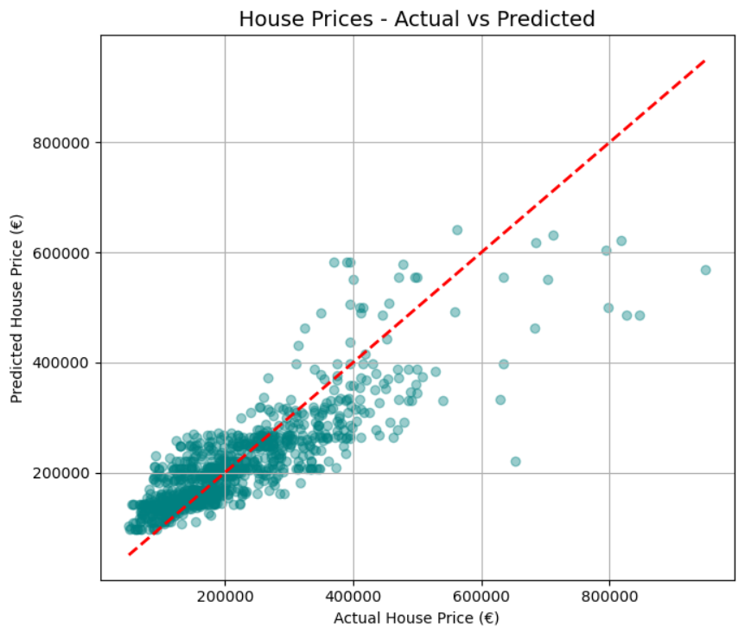

Figure 20 - House Prices - Actual vs Predicted

The scatterplot above compares the actual house sale prices with the predictions made by the Gradient Boosting model. The data points closely follow the red dashed line, which represents perfect prediction. Although some deviation exists—particularly for higher-priced properties—the overall alignment demonstrates that the model was able to capture the underlying trend in housing prices with good accuracy.

### Forecasting House Prices Using Time Series Analysis

To complement the machine learning models that predicted current house prices based on regional features, a time series analysis was conducted to forecast the future trend of housing prices in Ireland.

The monthly average house prices were calculated from the full dataset and plotted to observe historical trends. As shown in Figure 21, the data reveals a consistent increase in prices since 2013, with a sharp acceleration following 2020. This trend highlights the persistent growth in the housing market and the increasing difficulty of homeownership.

Figure 21 - Monthly Average House Prices in Ireland

To estimate future values, a SARIMA model was implemented. This model captured both trend and seasonal effects within the housing data. The forecast extended from January 2025 to December 2027, as shown in Figure 22.

Figure 22 - Forecast of Average House Prices in Ireland (2025–2027)

The model predicts a continued increase in average prices over the next three years. While the confidence interval (shaded in green) indicates possible fluctuations, the upward trajectory remains clear. These findings reinforce previous conclusions: the Irish housing market remains on a path of rising prices, with limited signs of stabilization.

This projection underlines the urgency of structural reforms and targeted policies to ensure long-term affordability for first-time buyers and low-income households.

### What the Models Cannot Predict

While the machine learning and time series models applied in this project demonstrated strong performance in forecasting housing trends based on historical data, it is important to acknowledge their limitations. These models rely on past patterns to estimate future behavior, which means they cannot account for unexpected or external shocks. Factors such as changes in government policy, new housing regulations, tax reforms, or the introduction of public subsidies can significantly alter market dynamics in ways the model cannot foresee (Chakraborty and Joseph, 2017). Similarly, economic recessions, global inflation trends, political instability, or events like pandemics and wars can cause abrupt shifts in housing supply, demand, and pricing.

For instance, the COVID-19 pandemic disrupted global housing markets through sudden interest rate changes, remote work culture shifts, and construction delays — none of which would have been predicted using historical trends alone (OECD, 2021). Therefore, while data-driven models provide valuable insights and short-term guidance, they must be interpreted alongside real-world developments and expert judgement to inform effective housing strategy.

# Strategic Reflections and Government Response

The persistent increase in housing prices and rent levels in Ireland has prompted a series of national strategies and policy interventions. The Irish government’s central housing strategy, *Housing for All*, was launched in 2021 and revised in 2024 as a long-term roadmap to address the housing crisis by 2030. It aims to deliver over 300,000 new homes across all tenures — including social, affordable, and private housing — and commits €4 billion annually in state investment (Government of Ireland, 2024a).

A key focus of this strategy is the acceleration of housing supply. As of early 2024, 37,400 new homes were commenced within a 12-month period — the highest level recorded since 2008 and a 63% year-on-year increase (Housing for All, 2024). This progress demonstrates a positive shift, but supply still struggles to meet the growing demand, particularly in urban centers like Dublin.

To address affordability for first-time buyers, the government introduced the *First Home Scheme (FHS)* in 2022. This shared equity program allows eligible buyers to receive up to 30% of a property's market value, reducing the size of required mortgages and deposits (Government of Ireland, 2024b). While this initiative helps increase access to homeownership, critics argue it may indirectly push prices upward by increasing purchasing power without matching supply growth (Hearne, 2023).

For renters and vulnerable groups, the **Social Housing Current Expenditure Programme (SHCEP)** received a record €517 million in Budget 2024, enabling local authorities and Approved Housing Bodies (AHBs) to secure over 6,000 additional social housing units (Irish Council for Social Housing, 2023). Despite this, waiting lists for social housing remain long, particularly in high-demand regions.

In parallel, the **Climate Action Plan 2024** addresses the environmental dimension of the housing crisis, setting a goal to reduce building-related emissions by 40% through retrofitting and energy-efficient upgrades (Government of Ireland, 2024c). This integration of climate policy with housing shows a strategic shift toward long-term sustainable development.

Another critical dimension is homelessness. The Mid-East Region Homelessness Action Plan 2024–2026 outlines prevention strategies, emergency response coordination, and tenancy sustainment supports across Kildare, Meath, and Wicklow (Kildare County Council, 2024). These local strategies play a crucial role in addressing immediate housing insecurity while broader systemic solutions evolve.

Although these policies represent a coordinated effort, gaps remain. Homeownership continues to be out of reach for many, and rental costs often exceed 35% of disposable income — a threshold considered unaffordable by international standards. To strengthen housing accessibility, it is recommended that Ireland combine supply-side investment with stronger rent regulation, expand regional development incentives, and improve data transparency in the property market to enable proactive policy design.

# References

Conroy, M. (2023). CRISP-DM, Phase 3: Data Preparation. [online] Data Lab Notes. Available at: <https://datalabnotes.com/data-preparation-crisp-dm/>.

IBM (2021). Data Understanding Overview. [online] www.ibm.com. Available at: https://www.ibm.com/docs/en/spss-modeler/saas?topic=understanding-data-overview.

Gillespie, T. (2017). Collective Self-Help, Financial Inclusion, and the Commons: Searching for Solutions to Accra’s Housing Crisis. *Housing Policy Debate*, 28(1), pp.64–78. doi:https://doi.org/10.1080/10511482.2017.1324892.

Hansen, T. (2013). The Housing Crisis and the Working Poor: Problems and Solutions from the Community Level. *SSRN Electronic Journal*. doi:https://doi.org/10.2139/ssrn.2344505.

Hearne, R. (2017). *A home or a wealth generator? Inequality, financialisation and the Irish housing crisis Cherishing All Equally 2017 Economic Inequality in Ireland*. [online] Available at: https://mural.maynoothuniversity.ie/12052/1/RH_Home%20or.pdf [Accessed 14 Oct. 2024].

Hearne, R. (2020). *Housing Shock - The Irish Housing Crisis and How to Solve It*. [online] Google Books. Available at: https://books.google.ie/books?hl=en&lr=&id=0AfpDwAAQBAJ&oi=fnd&pg=PP1&dq=info:7WxXMmIZinYJ:scholar.google.com&ots=wClvYQHBqv&sig=J47cGhbuv_accuQu0neARbZk724&redir_esc=y#v=onepage&q&f=false [Accessed 28 Nov. 2024].

Potts, D. (2020). *Broken Cities*. [online] Google Books. Available at: https://books.google.ie/books?hl=en&lr=&id=cDhOEAAAQBAJ&oi=fnd&pg=PP1&dq=housing+crisis&ots=pVl_ytkO-v&sig=QF8JIHYrVdak6qI-4Hr0H39WRxU&redir_esc=y#v=onepage&q&f=false [Accessed 28 Nov. 2024].