Tourism Market Segmentation – A Step by Step Guide

Please cite as:
Dolnicar, S. (2013) Tourism Market Segmentation — A Step by Step Guide. In: Tisdell, C. (ed.) Handbook of Tourism Economics: Analysis, New Applications and Case Studies. New Jersey: World Scientific, 87-105.

Abstract
Different tourists have different needs. This fact is widely acknowledged among both tourism researchers and in industry. As a consequence, market segmentation has developed to become a very popular marketing strategy among tourism destinations and businesses. They aim to develop a competitive advantage by identifying suitable segments of tourists and offer them the tourism service that will most satisfy their needs. Market segmentation strategy, however, can only be as good as the market segmentation analysis that is used as its basis. In this chapter we first provide a brief history of tourism market segmentation, outlining both successful approaches as well as sub-optimal standard approaches that have developed over the last few decades. Then we offer a guide to data-driven market segmentation with the aim of ensuring maximum validity of tourism market segmentation studies.

Keywords: Market segmentation, tourist segments, a priori, a posteriori, commonsense, data-driven, post-hoc

Introduction
“Market segmentation […] consists of viewing a heterogeneous market … as a number of smaller homogeneous markets” (Smith, 1956, p. 6). This enables providers of tourism services – who are operating in a fiercely competitive market – to focus their attention on one or a small number of segments, determine what these segments want and ensure that their needs are satisfied. As a consequence they (1) are not wasting marketing dollars on market segments that are not interested in their offer and (2) have the opportunity to develop a competitive advantage in the segments they target. Tourists who belong to these segments will be more satisfied and may therefore return to the tourism destination or business and share their positive experiences with friends and family.
A market segmentation strategy commits a tourism destination or business to focus on one or a small number of segments for a long period of time. It is therefore crucial to use all available market intelligence to select market segments wisely. The key sources of market intelligence used for this purpose is market segmentation analysis. However, market segmentation analysis is not a trivial computation like an addition. In an addition, 2 and 2 always gives 4. In market segmentation many factors relating to the data and method as well as many decisions made by the data analyst influence the final segmentation solution. To arrive at a valid market segmentation solution it is therefore critical to be aware of all the factors that impact on the final solution and make transparent all decisions taken throughout the process of data analysis. It is the aim of this chapter (1) to highlight to researchers and data analysts in industry some of the difficulties they may face in the course of conducting a market segmentation analysis, and (2) to offer available options to address these difficulties to ensure a transparent and valid market segmentation solution which can form a strong basis for the development of a long term segmentation strategy.

Segmentation research in tourism – a brief history
Market segmentation studies can broadly be divided into a priori (Mazanec, 2000) or commonsense studies (Dolnicar, 2004) or post-hoc (Myers and Tauber, 1977), a posteriori (Mazanec, 2000) or data-driven (Dolnicar, 2004) studies.
In the case of a priori or commonsense segmentation studies one tourist characteristic is chosen in advance, for example age, gender or main purpose of travel (Collins and Tisdell, 2000, 2002a, 2002b). Tourists are then grouped accordingly, for example into age segments, female and male tourists or frequent and infrequent travellers. Once grouped, profiles for each of the groups are developed using other variables of interest, such as travel motivations and travel behaviour.
In the case of post-hoc, a posteriori or data-driven segmentation not only one variable is chosen to determine which segment a tourist belongs to. Instead, a number of variables is selected, for example: ten different travel motives to derive a benefit segmentation or seven typical vacation activities to determine activity segments. In this case it is not as simple to assign tourists to the groups because it first has to be established which groups exist or are managerially useful. This is achieved in a step-wise process involving a grouping algorithm (which will be discussed in detail in the next section). Once the segments have been determined, each of the groups are described using other variables of interest, such as travel expenditures, frequency of taking a holiday, etc. This last step is the same as for a commonsense segmentation.
A summary comparison of steps involved with data-driven and commonsense segmentation are provided in Table 3.1.

Table 3.1. Commonsense versus data-driven segmentation
 | Commonsense segmentation | Data-driven segmentation
Grouping criterion | Relevant tourist characteristic is known and is one single variables (e.g. age, gender, country of origin) | Single relevant tourist characteristic is not known. Sets of variables are suspected to be of interest (e.g. travel motives, vacation activities)
Assignment of  tourists to groups | Simple assignment based on tourist characteristic (e.g. males in one group, females in another group) | Step by step process, including  - Data collection  - Variable selection  - Clarification of the segmentation concept  - Number of clusters selection  - Algorithm selection  - Visualisation and interpretation
Testing for differences (validation) | Testing whether the segments  differ in variables other than the grouping criterion | Testing whether the segments differ in variables other than the grouping criterion
Evaluation | Comparative analysis and selection of the most suitable segment | Comparative analysis and selection of the most suitable segment

Commonsense segmentation has been used in tourism industry since the industry’s very existence. Destination management organisations have traditionally used geographic criteria to define commonsense segments which then formed the basis for differentiated communication strategies. Geographical commonsense segmentations were often motivated by practicalities, rather than the aim to achieve a competitive advantage. For example, the Austrian tourism organisation, in order to communicate its tourism offers to all neighbouring countries needs to develop communication messages in six different languages. Academic segmentation research profiling a priori segments like older travellers, female travellers etc. also has a long history.
Data-driven segmentation studies (both academic and applied) have a more recent history. Haley (1968) was the pioneer of this approach to segmentation. The first data-driven tourism segmentation studies were published in the early 1980ties (Calantone, Schewe and Allen, 1980; Goodrich, 1980; Crask, 1981 and Mazanec, 1984). Since then the popularity of segmentation studies in tourism has skyrocketed. A few authors have attempted to summarize the developments in tourism segmentation research during this time (Frochot and Morrison, 2000; Dolnicar, 2002). Most recently, Zins (2009) asked the question whether any progress has been made in the last 20 years of segmentation research in tourism. He concludes that segmentation research holds, almost consistently over the past 20 years, a market share of 5% of all tourism studies, with data-driven segmentation studies gaining popularity over commonsense segmentation studies. He also identifies that few methodological advances have been made and that significant weaknesses can still be detected in the areas of segmenting prospects rather than current customers, integrating segmentation studies with positioning and other strategic matters, paying more attention to changes in segments over time and evaluating resulting segments in terms of their managerial usefulness (Dibb and Simkin, 1994; 1997; 2001).
Overall, it can be concluded that a standard segmentation approach has developed over the years in tourism research, which does not necessarily represent the optimal methodological solution. This standard approach can be characterised as follows: researchers typically use an available data set (rather than collecting data specifically for the purpose of the segmentation study), they tend to prefer complicated multi-step segmentation procedures (such as factor-cluster segmentation), they generally do not have a strong justification for selecting a particular number of clusters, they run a segmentation algorithms once (not acknowledging the exploratory nature of most algorithms used in segmentation), they often (wrongly) test for statistical significance of the differences in the variables which they used to segment the market, they run analyses of variance of chi-square tests without correcting for multiple testing, they present findings in tables, which practitioners find very difficult to interpret and they do not provide guidance with respect to which segment the most useful one is from a managers point of view.

A guide to data-driven tourism market segmentation
Data-driven market segmentation analysis consists of a sequence of steps: (1) clarification of the conceptual foundation, (2) determination of tourists characteristics expected to be of most value to the determination of managerially useful market segments, (3) data collection, (4) item (variable) selection, (5) selection of the number of clusters, (6) algorithm selection, (7) visualisation and interpretation, (8) validation and, finally (9) evaluation of the resulting market segments and selection of the most promising market segment to choose for long term targeting. These steps are depicted in Figure 3.1., which also illustrates that, at every stage, a number of alternative approaches are available and that the approaches chosen at each of the steps interacts with approaches chosen in other steps, thus affecting significantly the final segmentation results.

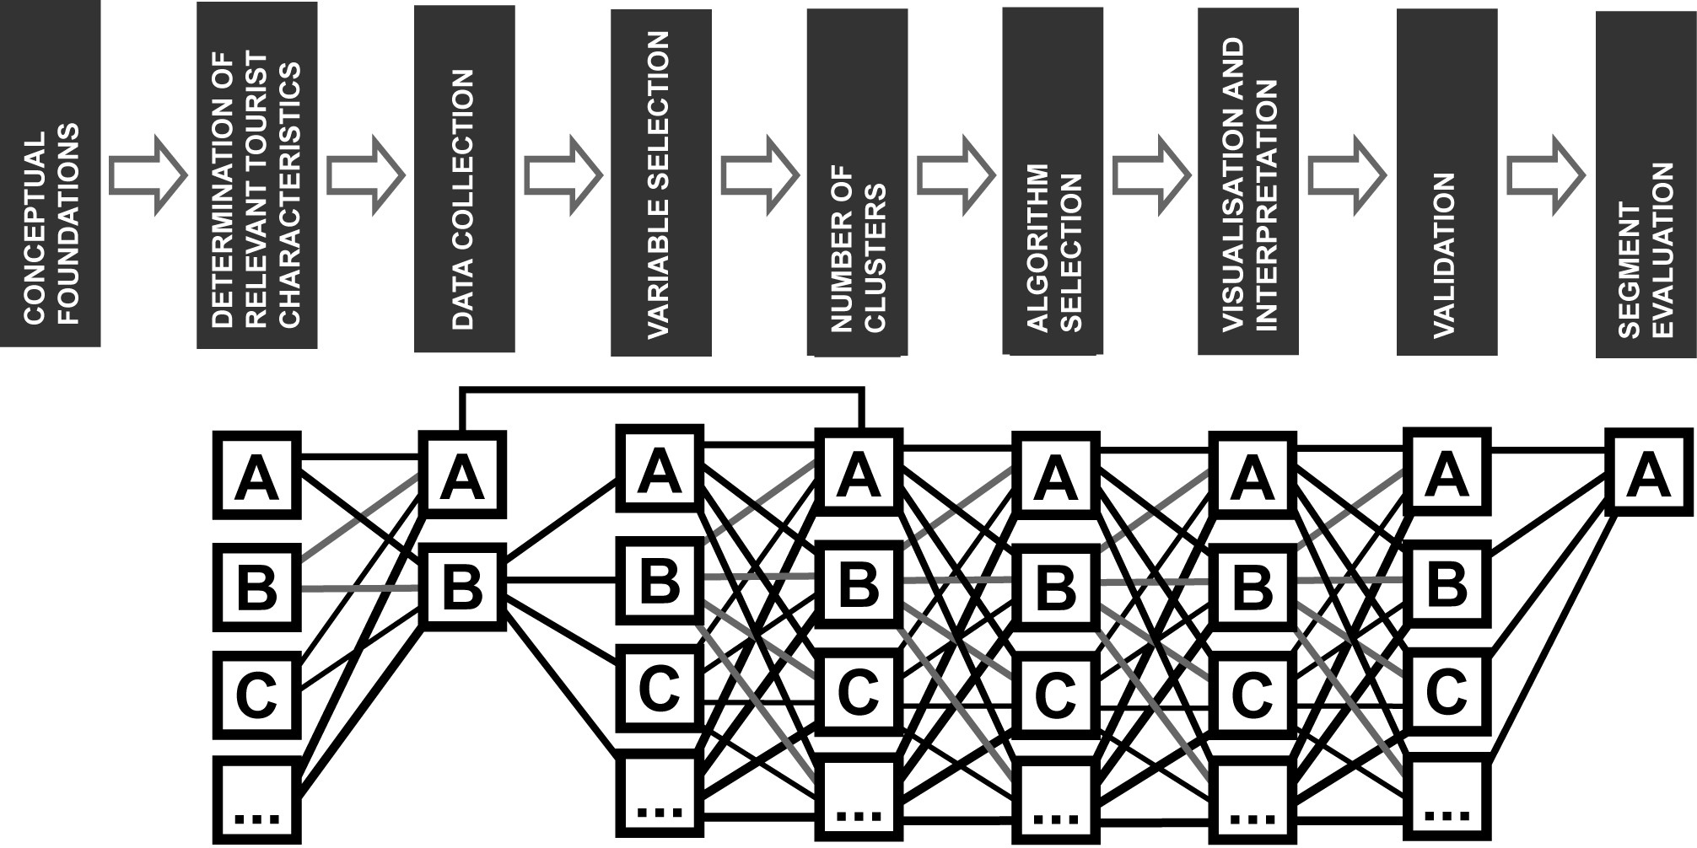
Fig. 3.1. Steps in data-driven market segmentation

STEP 1: Conceptual Foundations
Before a data-driven segmentation study is commenced, the data analyst and client have to be aware of a few basic features of market segmentation analysis. First of all: data-driven market segmentation is an exploratory process. Despite this fact, data-driven segmentation would detect the true market segments if they would indeed exist in the data (as illustrated in Figure 3.2.a). But this is typically not the case. Typical consumer data does not contain distinctly separated tourist clusters. Instead, tourists come in all “shapes and forms” and thus cover the entire space, typically without a clear separation line (as shown in Figure 3.2.c). Because most segmentation algorithms draw random starting points at the beginning of the computation, every repeated calculation leads to a different grouping (illustrated by the lines in Figure 3.2.c which represent segment borders over repeated computations). This problem cannot be avoided, it is therefore essential that data analysts and clients are aware of the fact that, most likely, they will be confronted with a situation as in Figure 3.2. c and will have to, consequently, manually inspect a number of segmentation solutions to determine the most managerially useful one. (In fact, if such a data situation is identified, it may not even be required to cluster the data; management may simply prefer to define their target segment as a subset of consumers.) If the data analyst is lucky, she or he may find a situation like that illustrated in Figure 3.2.b, where true clusters do not exist in the data, but repeated computations still arrive at the same solution, giving data analyst and client more confidence in the results because of higher reliability across replications. In the end, clustering is “little more than plausible algorithms that can be used to create clusters of cases” (Aldenderfer and Blashfield, 1984).

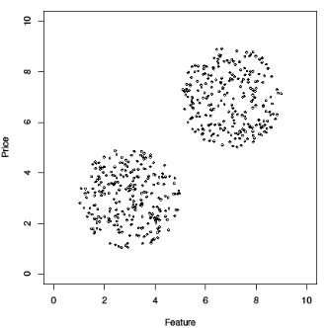 | 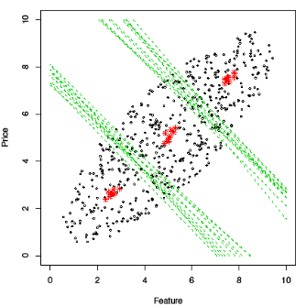 | 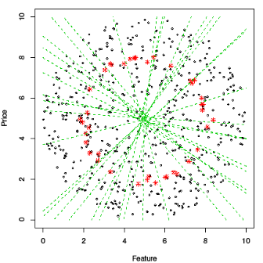
(a) | (b) | (c)
Fig. 3.2. Possible two-dimensional data situations (adapted from Dolnicar & Leisch, 2010)

Second: in most cases only one good segment is needed. It is therefore irrelevant what the complete segmentation solution looks like. Ultimately only the one segment that will be selected for targeting matters, so the aim of a data-driven segmentation solution should be to find that one segment that will become the long term focus of a tourism destination or business rather than trying to find the best overall segmentation solution.
Third: segmentation analysis does not stand alone. It is strongly interrelated with, at least, two other strategic areas: positioning and competition. This becomes relevant when one or more segments are chosen for targeting. These segments need to be in line with both the position of the destination or tourism business and they should not be exposed to fierce market competition. Yet, these two aspects typically are not considered in the actual segmentation analysis, thus requiring data analyst and client to assess the segmentation solution within the destination’s or tourism businesses’ context.
Fourth: the market changes all the time. Therefore also market segments change over time and have to be continuously monitored. Conducting one single segmentation analysis at one point in time merely provides a snapshot of the segment structure at one point in time, specifically at the time the data was collected.
Finally: data analysts should use the simplest possible methodology that solves the managerial problem. Often, therefore, it is worth questioning if data-driven segmentation is necessary. If commonsense segmentation solves the problem, it should be considered and not dismissed as “not sophisticated enough”.

STEP #2: Determination of relevant tourists characteristics
Before data can be collected the data analyst and client need to determine which tourist characteristics can be expected to be useful in creating distinct segments. This decision cannot be made by the data analyst alone, nor can it be made by a method. The data analyst and client, based on prior market knowledge or qualitative research preceding the data collection for the segmentation study, could, for example, determine that activities tourists wish to undertake during their vacation are likely to be the most promising segmentation base because of the unique activities a tourism destination may be able to offer.

STEP #3: Data collection
Data collection should be undertaken in view of the managerial objectives of the segmentation study. The managerial objectives affect the data collection process in at least two direct ways: First, it affects the sample of respondents. As Zins (2009) rightly raises, most segmentation studies look at current customers only (e.g. people are surveyed when they are already at a destination, so they have clearly already make the decision to come to the destination once) as opposed to including a broader tourist population which will help management understand not only segments among current customers but also segments among non-customers which potentially could be converted to become visitors.
Second, it affects the questions that are being asked. If vacation activities are the segmentation base of interest, the focus lies on developing the most valid set of items to capture relevant vacation activities. In addition, other information the client may require needs to be included, for example, general travel behaviour but also sources of information used when choosing a destination or tourism business.
Two more general aspects should also be taken into consideration when developing questionnaires for data-driven segmentation studies: (1) as will be discussed in section 3.4., the number of items (variables, survey questions) that can be used given a certain sample size is limited. It is therefore important that questions are not carelessly included in into the questionnaire, which causes problems down the track in the analysis. Instead, questions should be very carefully selected and kept to the minimum without information loss. There is no need to include redundant items. (2) The key underlying computation of data-driven segmentation analysis is distance measurement. Clear distance measures exist for metric data (e.g. age in years) as well as binary data (e.g. yes, no), but this is not the case for ordinal data (e.g. 5 or 7 point agreement scales). Furthermore, ordinal scales are susceptible to capturing response styles (e.g. people’s tendencies to use the extreme answer options or the middle answer options, irrespective of content, Paulhus, 1991). This is especially critical when international tourists are surveyed for segmentation studies because people from different cultural backgrounds are known to have different response styles (Chun et al, 1974; Hui and Triandis, 1989; Marin, Gamba and Marin, 1992; Marshall and Lee, 1998; Roster, Rogers and Albaum, 2003; van Herk, Poortinga and Verhallen, 2004; Welkenhuysen-Gybels, Billiet and Cambre, 2003; Zax and Takahashi, 1967). If there is no compelling reason that multi-category answer options are required, binary (yes-no) answer formats may be preferable. This choice simplifies the market segmentation process and is especially preferable in cases where perceptions or attribute beliefs are measures because no loss of information occurs due to the lower number of answer options (Dolnicar, 2003; Dolnicar and Grün, 2007; Dolnicar, Grün and Leisch, in press).

STEP #4: Item (variable) selection
If the data collection was designed well, the number of variables (survey questions) that is used as segmentation base should be suitable to the sample size. A rough rule of thumb for a desirable proportion of sample size and number of variables is 2^{k} for binary questions where k represents the number of variables (Formann, 1984).
If the data analyst finds themselves in the situation of having to work with a data set that was not collected with the segmentation study in mind, it is likely that the number of variables will be too large for the sample size at hand (Dolnicar, 2002). In this case it is necessary to select a subset of variables to be included in the analysis.
In tourism research the typical procedure to deal with too many variables is to use something called (uniquely so in tourism research) “factor-cluster analysis”. This means that the original variables are first subjected to factor analysis and the factor scores resulting from the factor analysis are used as segmentation base. This approach is not recommended because a substantial amount of information is lost when raw data is reduced to factors (if the % variance explained is 60%, for example, that means 40% of information in the data is removed before even commencing the segmentation analysis), the relations of variables to each other change, differences between segments can be reduced and segments are identified in a different space than originally postulated (Arabie and Hubert, 1994; Milligan, 1996; Ketchen and Shook, 1996). For empirical studies demonstrating the problems associated with factor-cluster segmentation in the tourism context see Sheppard (1997) and Dolnicar and Grun (2008).
Data analysts should therefore follow the recommendations by and Dolnicar and Grun (2008) and by Sheppard (1997) of using raw items, not factor scores: “Cluster analysis on raw item scores, as opposed to factor scores, may produce more accurate or detailed segmentation as it preserves a greater degree of the original data.” (Sheppard, 1997, p. 57). If the number of raw items is too large, a few ways can be chosen to reduce the number of variables for the segmentation analysis:
A subset of variable can be selected based on eliminating redundant variables. Redundant variables are frequently present in sets of variables. They can be detected either by sitting down and analysing the consent of the items, or by running a factor analysis and selecting original items from each of the resulting groups of variables. Note, factor analysis is NOT used to derive factor scores which then represent sets of variables in the subsequent analysis. Instead factor analysis is merely used to identify groups of items which are associated with each other to enable the data analyst to select original items for each group for inclusion into the segmentation base.
Another option is the use of an algorithm called biclustering which simultaneously selects variables and segments the data (Kaiser and Leisch, 2008). For an example of how biclustering can be used in data-driven tourism market segmentation see Dolnicar et al (in press).

STEP #5: Number of clusters
Most segmentation algorithms require the data analyst to make a decision about the number of segments or clusters. This is a key decision in the process of segmentation analysis because it influences dramatically the nature of the resulting segments.
Depending on the algorithm chosen a number of measures, plots and indices exist to help make this decision. When analysing a data set that contains clear clusters (as illustrated for the two-dimensional case in Figure 3.2.a) any of these heuristics are capable to indicate the correct number of clusters (as demonstrated in Buchta et al, 1997).
If, however, the data does not contain clear density clusters and, in the worst case, contains no structure at all (as illustrated in Figure 3.2.c) these measures, plots and indices are not informative and provide no guidance whatsoever to the data analyst. Such situations should be clearly specified in the report on the segmentation analysis. In this case the data analyst has no other option but to generate a number of solutions and, in interaction with the client, determine which one of them is managerially most useful. This approach is perfectly legitimate in situations where there is a lack of data structure.
Frequently data does not contain density clusters but still does have some kind of structure (as illustrated in Figure 3.2.b). In this case a number of clusters can be selected based on the highest stability over a number of replications. This means that for a range of numbers of clusters (e.g. 3 to 10) multiple segmentation solutions are computed and compared with respect to similarity using the Rand index (Rand, 1971). The most stable number of clusters is then chosen. This approach is described in detail in Dolnicar and Leisch (2010) and can be replicated using the statistical computation environment R version 2.3.1 (R Development Core Team 2006) with the extension package flexclust (Leisch, 2006), both available as free software from http://cran.R-project.org.
If this procedure does not indicate higher stability for any number of clusters, it has to be assumed that no structure exists and, as described above, data analyst and client have to “manually” inspect a range of solutions and choose the managerially most useful.

STEP #6: Algorithm selection
A huge number of algorithms are available, parametric and non-parametric, partitioning and hierarchical, response-based, not response based (Everitt et al, 2001; Wedel and Kamakura, 1998). Yet, a review of previous work indicates that only two of those algorithms are used in most tourism segmentation studies: Ward’s hierarchical clustering and the k-means partitioning algorithm are chosen in 80% of studies (Dolnicar, 2002).
Unless response-based clustering is being performed, in which case finite mixture models (Wedel and Kamakura, 1998) are the typical algorithm of choice, the data analyst needs to be aware of the structure-imposing nature of algorithms. For example, single linkage hierarchical clustering is known to produce long clusters, k-means is known to produce spherical clusters of approximately equal size. These properties of algorithms are described in detail in Everitt et al (2009) and are critical when data does not contain much structure.
In an analysis with artificial data sets (Buchta et al, 1997) determined that the topology representing network (Martinetz and Schulten, 1994, also referred to a hard competitive learning) slightly outperforms other partitioning algorithms on a range of data sets which differed in nature and clearness of structure. This study also led to the conclusion that, if data is well structured, any algorithm is able to identify this true structure, in which case the choice of algorithms is not critical.

STEP #7: Visualisation and Interpretation
In order to interpret segmentation solutions correctly, it is crucial to present results in a way that is easy to understand and not misleading. Traditionally, results are either presented in tables or in highly simplified summaries. Both approaches have dangers. Tables, the preferred form of presentation in academic reports of segmentation studies (the author herself is guilty of this, as she is of most other mistakes described in this Chapter), are usually very large and thus hard to interpret quickly and correctly. If, for example, a five segment solution is chosen and ten variables were used in the segmentation base, the reader would have to assess 50 numbers when attempting to understand the characteristics of the resulting segments and differences between them. Even more numbers have to be studied if differences in information other than that in included in the segmentation base are provided (for example, differences in socio-demographics, general travel behaviour etc.).
Simplified summaries are often used when data analysts present results to commercial clients. Such summaries may include charts of key variables and a few dot points on the main differences. This approach simplifies the complex task of making sense of a segmentation solution. The danger associated with it, however, is that the client may only be presented with part of the results, the part the data analyst views as most interesting.
One way of simplifying the interpretation of segmentation solutions is to provide a simple bar chart of results for the segmentation base (an example which can easily be generated in R is provided in Figure 3.3. and ensure that the clients fully understand the differences between segments on this chart. The example in Figure 3.3. provides details for six segments using 20 variables. In a Table this would mean providing 120 numbers. In the Figure the client merely has to look at variables where the horizontal bar (indicating the percentage of segment members who agreed, in this case with travel motivations) differs strongly from the black horizontal line with the dot at the end (representing the percentage of people who agreed with this motivation in the total sample). Such variables are referred to as marker variables and represent the key characteristics of resulting segments.

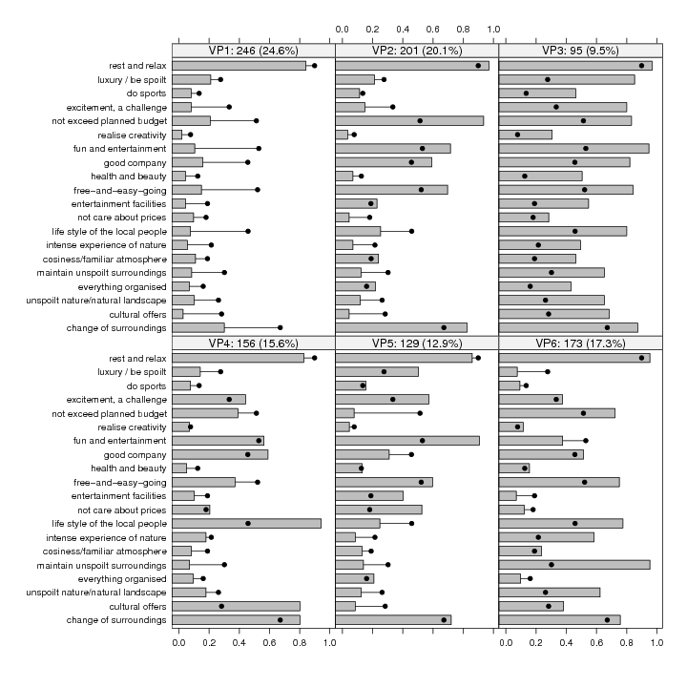
Fig. 3.3. Visualising differences in the segmentation base (source: Dolnicar & Leisch, 2008)

Note that is not permissible to test whether the variables in the segmentation base differ significantly between segments because the cluster algorithm identifies the solution in which these differences are maximal. A test against random differences therefore makes no sense.
After the marker variables have been identified and segments interpreted, differences in additional variables can be selectively provided for those segments that are of interest to the client.

STEP #8: Validation
Testing for difference in variables other than those in the segmentation base has two functions: first, it allows a more detailed profile of the resulting segments to be developed. This is important because if forms the basis of the targeted marketing activities to be developed for the chosen segment or segments. Secondly, it serves as external validation of the segmentation solution.
Typical background variables include socio-demographics, and general travel behaviour. It is of particular value, however, to include questions about the information search and processing behaviour or respondents in order to be able to create a customized marketing mix.
Again, a number of approaches are available to test for differences in background variables. A common way to doing this is to conduct analyses of variance for metric variables (such as age in years, number of nights stayed at the destination) and Chi-square tests for nominal and ordinal variables (such as country of origin, gender, satisfaction level). Note, however, that it is necessary to correct the p-values resulting from these computations for multiple testing. This can be achieved through Bonferroni correction.
Other options are to run discriminant analyses or regressions using the cluster membership as dependent variable. The advantage of these approaches is that correction for multiple testing is not required because all variables are included in one model and thus accounted for simultaneously.

STEP #9: Evaluation
Finally, if the most managerially useful segment has not resulted from the analysis of differences in the segmentation base, resulting segments need to be systematically assessed in view of their attractiveness as target segments for the destination or tourism organisation undertaking the segmentation analysis.
A number of authors have recommended sets of criteria to achieve that (Frank, Massy and Wind, 1972; Kotler et al, 2001; Morritt, 2007; Wedel and Kamakura, 1998). Typically, general criteria include distinctiveness of segments, identifyability, reachability through communication channels, a minimum size to be economically viable and a good match with the strengths of the tourism destination or tourism business planning to target the segment.
More recently, Lazarevski and Dolnicar (under review) – adopting an approach proposed by Mazanec (1996) for advertising expenditure allocation - have proposed an approach which can be used to derive key evaluation criteria from the user or users of the segmentation analysis and use such a customized set to assess results segments.

Conclusions
Harvesting consumer heterogeneity in tourism is important, especially given the increasingly competitive market tourism destinations and businesses are facing. Heterogeneity can only be harvested effectively if it is well understood. Market segmentation is a powerful tool to understanding consumer heterogeneity, but any segmentation strategy is only as good as the segmentation analysis that informs its development. Segmentation analysis is simple, but not trivial. Data analysts and clients therefore have to be aware of the impact of a number of decisions which are made in the course of a segmentation analysis to not only ensure that the best decisions are made at each step of analysis, but also to keep the analysis transparent and be able to understand why certain market segments emerged. .
Dolnicar and Lazarevski (2009), in a survey of 167 marketing managers, found that 68 percent agree with the following statement: “When a data-driven segmentation solution is presented to me, I sometimes feel that it is like a black box: data goes in and a segmentation solution comes out at the other end, but it is not entirely clear what is happening in between.” This is not a satisfactory situation. Therefore, data analysts need to openly report how the segmentation analysis was conducted, whether naturally occurring segments were revealed or segments were artificially constructed form a data set with little structure. And clients need to understand enough about market segmentation analysis to be able to question what they are purchasing and basing long term strategic decisions on.

Acknowledgements
This chapter summarizes results of many years of joint research work with Friedrich Leisch and Bettina Gruen on market segmentation which was supported by the Australian Research Council under grants LX0881890 and LX0559628.

References
Aldenderfer, MS and RK Blashfield (1984). Cluster Analysis. Beverly Hills: Sage Publications.
Arabie, P and L Hubert (1994). Cluster analysis in marketing research, In: Advanced methods of marketing research edited by R Bagozzi. Cambridge: Blackwell, 160-189.
Buchta, C, E Dimitriadou, S Dolnicar, F Leisch and A Weingessel (1997). A comparison of several cluster algorithms on artificial binary data scenarios from travel market segmentation. Working Paper # 7, SFB ‘Adaptive Information Systems and Modelling in Economics and Management Science’, Vienna.
Chun, KT, JB Campbell and JH Yoo (1974). Extreme response style in cross-cultural research – Reminder. Journal of Cross-Cultural Psychology, 5(4), 465-480.
Collins, D and C Tisdell (2000). Changing travel patterns with age: Australian evidence and the need to modify current theories. Australian Journal of Hospitality Management, 7(1), 15-25.
Collins, D and C Tisdell (2002a). Gender and differences in travel life cycles. Journal of Travel Research, 41(2), 1333-143.
Collins, D and C Tisdell (2002b). Age-related lifecycles: purpose variations. Annals of Tourism Research, 29(3), 801-808.
Crask, M (1981). Segmenting the vacationer market: identifying the vacation preferences, demographics, and magazine readership of each group. Journal of Travel Research, 20(2), 29-34.
Dibb, S and L Simkin (1994). Implementation problems in industrial market segmentation. Industrial Marketing Management, 23, 55–63.
Dibb, S and L Simkin (1997). A program for implementing market segmentation. Journal of Business and Industrial Marketing, 12(1), 51–65.
Dibb, S and L Simkin (2001). Market segmentation: diagnosing and treating the barriers Industrial Marketing Management, 30(8), 609–625.
Dolnicar, S and F Leisch (2008). An investigation of tourists’ patterns of obligation to protect the environment. Journal of Travel Research, 46(4), 381-391.
Dolnicar, S (2003). Simplifying three-way questionnaires - do the advantages of binary answer categories compensate for the loss of information? Australia and New Zealand Marketing Academy (ANZMAC) CD Proceedings.
Dolnicar, S, B Grün and F Leisch (in press, accepted 23.6.2010). Quick, simple and reliable: forced binary survey questions. International Journal of Market Research.
Dolnicar, S and B Grün (2007). User-friendliness of answer formats – an empirical comparison. Australasian Journal of Market & Social Research, 15(1), 19-28.
Dolnicar, S and B Grün (2008). Challenging “factor cluster segmentation”. Journal of Travel Research, 47(1), 63-71.
Dolnicar, S and K Lazarevski (2009). Methodological reasons for the theory/practice divide in market segmentation. Journal of Marketing Management, 25(3-4), 357-374.
Dolnicar, S and F Leisch (2010). Evaluation of structure and reproducibility of cluster solutions using the bootstrap. Marketing Letters, 21(1): 83-101.
Dolnicar, S (2002). Review of data-driven market segmentation in tourism. Journal of Travel and Tourism Marketing, 12(1), 1-22.
Dolnicar, S (2004). Beyond “commonsense segmentation” – a systematics of segmentation approaches in tourism. Journal of Travel Research, 42(3), 244-250.
Dolnicar, S, S Kaiser, K Lazarevski and F Leisch (in press, accepted 5.1.2010). Biclustering - overcoming data dimensionality problems in market segmentation. Journal of Travel Research.
Everitt, B, S Landau and M Leese (2009). Cluster Analysis. Oxford: Oxford University Press.
Formann, AK (1984). Die Latent-Class-Analyse: Einführung in die Theorie und Anwendung. Weinheim: Beltz.
Frank, RE, Massy, WF and Y Wind (1972). Market Segmentation. Englewood Cliffs: Prentice-Hall.
Frochot, I and AM Morrison (2000). Benefit segmentation: a review of its application to travel and tourism research. Journal of Travel and Tourism Marketing, 9(4), 21-45.
Haley, RJ (1968). Benefit segmentation: a decision oriented research tool. Journal of Marketing, 32, 30 35.
Hui, CH and HC Triandis (1989), Effects of culture and response format on extreme response style. Journal of Cross-Cultural Psychology, 20(3), 296-309.
Kaiser, S and F Leisch (2008). A toolbox for bicluster analysis in R. In: P Brito, Compstat 2008: Proceedings in Computational Statistics. Physica Verlag: Heidelberg, Germany, 201-208.
Ketchen, D J Jr. and CL Shook (1996). The application of cluster analysis in strategic management research: an analysis and critique. Strategic Management Journal, 17, 441-458.
Kotler, P, S Adam, L Brown and G Armstrong (2001). Principles of Marketing. Frenchs Forest: Pearson Education Australia.
Leisch, F (2006). A toolbox for k-centroids cluster analysis. Computational Statistics and Data Analysis, 51(2), 526–544.
Marin, G, RJ Gamba and BVMarin (1992). Extreme response style and acquiescence among Hispanics - the role of acculturation and education. Journal of Cross-Cultural Psychology, 23(4), 498-509.
Marshall, R and C Lee (1998). A cross-cultural, between-gender study of extreme response style. In: European Advances in Consumer Research Vol. 3, The Association for Consumer Research, 90-95.
Martinetz, Th and K Schulten (1994). Topology representing networks. Neural Networks, 7(5), 507-522.
Mazanec, JA (2000). Market segmentation. In: J Jafari (ed), Encyclopedia of Tourism. London: Routledge.
Mazanec, JA (1986). Allocating an advertising budget to international travel markets. Annals of Tourism Research, 13(4), 609-634.
Mazanec, JA (1984). How to detect travel market segments: a clustering approach. Journal of Travel Research, 23(1), 17-21.
Milligan, GW (1980). An examination of the effect of six types of error perturbation on fifteen clustering algorithms. Psychometrika, 45, 325-342.
Milligan, GW (1996). Clustering validation: results and implications for applied analyses. In: P Arabie and LJ Hubert (eds), Clustering and Classification. River Edge: World Scientific Publications.
Morritt, R (2007). Segmentation Strategies for Hospitality Managers: Target Marketing for Competitive Advantage. Binghampton, New York: Haworth Press.
Myers, JH and E Tauber (1977). Market structure analysis. American Marketing Association: Chicago.
Paulhus, DL (1991), Measurement and control of response bias, In: JP Robinson, PR Shaver and LS Wrightsman (eds), Measures of Personality and Social Psychological Attitudes, San Diego: Academic Press, 17-59.
R Development Core Team (2006). R: A language and environment for statistical computing and graphics. R Foundation for Statistical Computing, Vienna, Austria.
Rand, WM (1971). Objective criteria for the evaluation of clustering methods. Journal of the American Statistical Association, 66(336), 846–850.
Roster, CA, R Rogers and G Albaum (2003). A cross-cultural use of extreme categories for rating scales, In: SM Smith (ed), Proceedings of Ninth Annual Cross Cultural Research Conference.
Sheppard, AG (1996). The sequence of factor analysis and cluster analysis: differences in segmentation and dimensionality through the use of raw and factor scores. Tourism Analysis, 1, 49-57.
Smith, W (1956). Product differentiation and market segmentation as alternative marketing strategies. Journal of Marketing, 21, 3-8.
van Herk, H, YH Poortinga and MM Verhallen (2004). Response styles in rating scales - evidence of method bias in data from six EU countries. Journal of Cross-Cultural Psychology, 35(3), 346-360.
Wedel, M and W Kamakura (1998). Market Segmentation - Conceptual and Methodological Foundations. Boston: Kluwer Academic Publishers.
Welkenhuysen-Gybels, J, J Billiet and B Cambre (2003). Adjustment for acquiescence in the assessment of the construct equivalence of Likert-type score items. Journal of Cross-Cultural Psychology, 34(6), 702-722.
Zax, M and S Takahashi (1967). Cultural influences on response style: comparison of Japanese and American college students. Journal of Social Psychology, 71, 2-10.
Zins, AH (2008). Market segmentation in tourism: A critical review of 20 years’ research effort. In: Kronenberg, S, M Muller, B Peters, B Pikkemaat and K Weiermair (eds) Change Management in Tourism: From Old to New. Berlin: Erich Schmidt, Verlag, 289-301.

