**Statistics and Machine Learning Analysis on the Irish Agriculture Sector**

Author: Jefferson William Teixeira

e-mail: [sba22201@student.cct.ie](mailto:sba22201@student.cct.ie)

Student ID: sba22201

**Abstract**

*Several organizations across the world collect data on the agriculture sector, such as the United Nations and local authorities. Statistics and machine learning can be used to acquire insights from the huge amount of data available on that area. In this project, four datasets were analysed using these tools, where the main goal was to compare the Irish agriculture sector with countries worldwide. In this project, the following questions were discussed: (i) how is the organic farming growing in Europe over the years? (ii) how does Ireland compare to other countries in terms of import and export average amounts of crops and livestock? (iii) which machine learning models could predict the import and export average amounts? (iv) how does Ireland compare to other countries in terms of food price inflation? (v) which classification models could be used to perform sentiment analysis on tweets about agriculture? CRISP-DM framework was adopted to guide the analytical process from the data understanding step to the evaluation of the results. On the statistical logic part, a confidence interval was used to estimate the organic farming growth in Europe. The non-parametric statistical tests Shapiro, Levene, Kruskal, Mannwhitneyu, Wilcoxon and one parametric test, ANOVA, were used to discuss similarities between Ireland and other countries. Moreover, several experiments were executed using different machine learning classification and regression models. Naïve Bayes and Logistic Regression models were used to classify tweets based on their sentiment, while Linear Regression and KNN Regression were used to predict the import and export average amounts of agricultural goods in Ireland and similar countries. Different text processing techniques were used in the sentiment analysis such as Lemmatizer, Porter Stemmer, as well as Count and TF-IDF vectorization strategies. The models were evaluated using cross validation and compared using the appropriate scoring system. GridSearchCV was also used to obtain the best hyperparameters for the models.*

Contents

1 Introduction 4

2 Materials and Methods 4

3 Data Preparation and Visualization 5

4 Statistics Logic 7

4.1 Confidence Interval 7

4.2 Inferential Statistics on Agriculture Import and Export 8

4.3 Inferential Statistics on Food Price Inflation 10

5 Machine Learning 11

5.1 Sentiment Analysis 11

5.1.1 Experiment Setup 11

5.1.2 Results 12

5.2 Agriculture Import and Export Prediction 13

5.2.1 Experiment Setup 13

5.2.2 Results 14

6 Conclusions 20

7 References 20

# Introduction

In this project, machine learning (ML) and statistical logic was applied to the Irish agriculture sector. For this purpose, the following datasets were used: Organic Farming Growth, Import/Export of Crops and Livestock Products, Food Price Inflation and Twitter’s comments about agriculture. The collected data was analysed under different perspectives and compared with other countries in Europe.

This report is organized as follows: Section 2 describes the framework, scope and tools used to complete this project. In Section 3, the datasets and the interactive dashboard are described. In Section 4, the main insights obtained from the statistical analysis are presented, while Section 5 covers the machine learning experiments. Finally, in Section 0, the conclusions are summarized.

# Materials and Methods

In this project, the Cross Industry Standard Process (CRISP-DM) framework (Chapman *et al.*, 2000) was adapted. The advantage of using such a framework is that it can be applied to any domain, so the main tasks are known before the project starts, which contributes to the organization of the required steps. Thus, this project was divided into the following parts:

1. **Data preparation and visualization**: In this part, the exploratory data analysis (EDA) was performed on the datasets, where they were pre-processed for the statistical and ML analysis. This step was carried on separately, so the output data could be consumed by both analyses, avoiding rework and code duplication. In this step, it was also created an interactive dashboard with the main graphs that describe the information collected from the datasets.
2. **Statistical logic**: In the statistical analysis, a confidence interval was calculated to estimate the organic farming growth in Europe based on the countries data. The import/export of crops and livestock as well as the food price inflation datasets were explored using inferential statistics tests to compare Ireland’s indicators with similar countries.
3. **ML analysis**: In the ML part, it was performed sentiment analysis on a curated dataset collected from Twitter’s platform with recent user’s comments about the agriculture topic. More specifically, the sentiment of the tweets was extracted, and classification models were evaluated on these data. Moreover, forecasting analysis was performed on the crops and livestock import/export dataset, where different models were tested.

The EDA steps were implemented in the accompanying Jupyter notebook called **DataPrepVis**. The statistical logic and ML analysis can be found in the **Statistics** and **ML** Jupyter notebooks, respectively.

The source code was mainly implemented in the Jupyter notebooks, where each one has its own set of auxiliary functions. However, the following Python modules and helpers were also developed under the *jupyter/modules* folder:

1. **TextProcessor:** It contains the text processing methods used in this project.
2. **TwitterAPI**: It contains the logic to access the Twitter platform and retrieve the recent tweets based on the search criteria.
3. **JsonHelper**: It was used to convert dictionaries into JSON format.
4. **Constants**: It contains all the shared constants used by all notebooks.

The reason to separate these modules from the Jupyter notebooks was to keep the code organised and to follow the best programming practices with regards to reuse and code modularization.

The source code and files used in this project are hosted on GitHub under a public organization called [CCT-MastersDA](https://github.com/CCT-MastersDA). The project’s repository is called [cct-ca2](https://github.com/CCT-MastersDA/cct-ca2), which can be accessed with the following command in any terminal: *git clone* [*https://github.com/CCT-MastersDA/cct-ca2.git*](https://github.com/CCT-MastersDA/cct-ca2.git).

In this project, an Excel file was used to organize the tasks and project requirements due to its simplicity. This way, the *CA2-Planning.xlsx* file under the *project-mngmt* folder was used to keep track of the deliverables and mark the items as completed using checkboxes.

# Data Preparation and Visualization

Table 1 describes the datasets used in this project. Each dataset has a reference to its respective section in the **DataPrepVis** Jupyter notebook, where the EDA tasks were implemented and discussed in more detail.

|  |  |  |  |  |  |
| --- | --- | --- | --- | --- | --- |
| **Dataset ID** | **Dataset name** | **Description** | **Original Size** | **Source** | **EDA Section** |
| 1 | Organic Farming | Dataset that gathers the percent of utilized agricultural area (UAA) occupied by organic farming per country over the years. There are data about 34 countries from 2000 until 2020. | 37 | [Eurostat](https://ec.europa.eu/eurostat/databrowser/view/sdg_02_40/default/table?lang=en) | DataPrepVis, Section 3 |
| 2 | Crops and Livestock Products Import/Export | Dataset on the amount of import and export of crops and livestock products from several countries with data from 1961 until 2020. The main elements tracked are the import and export quantity, in tonnes, and value, in 1000 US$. | 196,344 | [FAO](https://www.fao.org/faostat/en/#data/QCL) | DataPrepVis, Section 4 |
| 3 | Food Price Inflation | Dataset on the food price inflation from several countries with data from 2001 until 2022. | 783 | [FAO](https://www.fao.org/faostat/en/#data/CP) | DataPrepVis, Section 5 |
| 4 | Twitter Dataset | This dataset was collected directly from the Twitter’s platform using their [Developer’s API](https://developer.twitter.com/). | 200 | Custom solution. | DataPrepVis, Section 6 |

Table 1- Agriculture Datasets.

Due to the large amount of data available, the countries comparisons were limited to Irland, Finland and Slovakia. The reason for that choice was the size of their populations, which, according to Eurostat, is around 5M people (Eurostat, 2022).

All datasets came from good sources that facilitate data collection, so, in this step, the main tasks were about preparing the datasets to be consumed by the other Jupyter notebooks easily.

The dataset 1was cleaned to remove unnecessary columns and to convert the percent data into numeric data type. That step was necessary to fit the dataset into the functions used as part of the statistical analysis. Since Ireland’s data was compared against Europe, the main dataset was also split into two, one with all 34 countries data and another one with Ireland's data only.

The main steps performed on dataset 2 were the split of the dataset into quantity and value import/export datasets. This step was required because the quantity dataset had data in different measurement units other than tonnes. Since the other quantity units were less frequent, they were removed so the data could be compared using a standardized measurement unit. Regarding dataset 3, only an invalid column was removed as no other data anomaly was detected.

Dataset 4 was created from scratch using the Twitter’s API. A Twitter API module was implemented to collect recent tweets about agriculture using the keywords “inflation”, “food price”, “agriculture” and “Europe”. The tweets were cleaned and different versions of them were stored after applying text processing techniques implemented in the Text Processor module. For each version, the sentiment of the tweet was obtained. Each tweet version provided a different sentiment, so they had to be calculated individually.

In this step, some graphs were also generated to visualize the datasets. For the numeric datasets, the main concept used was getting the average growth of import or food price inflation per year, so the reader has an idea of the behaviour of the datasets. For the import/export dataset, it was also created an interactive graph to display the quantity and value growth of the top 10 import items in Ireland. This graph was created so the reader can explore the dataset in a more granular level. For the text datasets, a word cloud was created, so the reader can easily see the most frequent words collected.

Finally, a dashboard called **DataPrepVisDashboard** was also created using the Voila tool containing the static and interactive graphs created in the EDA steps. The previously extracted HTML version of the dashboard can be found in the *jupyter/dashboard* folder.

# Statistics Logic

The analysis described in this section was implemented and discussed in more detail in the accompanying Jupyter notebook called **Statistics**.

In section 4.1, it is presented how a confidence interval was calculated to estimate the organic farming growth in Europe. In section 4.2, the import/export of agricultural products are analysed, while in section 4.3, the countries food price inflation indicators are compared.

## Confidence Interval

The question being solved in this section is: How is the organic farming growing in Europe over the years? This analysis was implemented in the Section 3 of the **Statistics** Jupyter notebook.

Using the dataset 1, it was calculated the standard deviation and the average of the percent of land under organic farming in Europe based on the available countries and years. This way, it was possible to calculate the confidence interval to estimate the range in which the real percent of land under organic farming lies over the years in Europe with a specified level of confidence.

Table 2 shows some characteristics of the dataset and the parameters used to calculate the confidence interval. The variable being counted is the percent UAA under organic farming because the dataset is provided in terms of percent of land. The dataset only has data ranging from 2000 to 2020. There are 34 countries in the dataset, but not all of them have data for every year, so the maximum degree of freedom in this study was 34, as the null values were removed from the calculation. Since the standard deviation is unknown for this analysis, the distribution used to calculate the interval was T-Student. The alpha parameter means the level of confidence used for the calculation, which was 97%.

|  |  |
| --- | --- |
| **Parameter** | **Description** |
| Variable | X = Percent of UAA under organic farming |
| Distribution | T-Student |
| Alpha | 0.03 |
| 1 - alpha | 0.97 |
| Years range | [2000, 2020] |
| Degree of freedom (n) | <=34 |

Table 2- Confidence Interval Parameters and Dataset Details.

Figure 1 shows the confidence interval calculated for the growth of organic farming in Europe as compared to the actual Irish data over the years. Based on these results, it is possible to say that, with 97% confidence, the percent of UAA under organic farming in Europe in 2020 was between 6.14% and 11.18%.

Figure 1 - Organic Farming Growth in Europe and Ireland.

According to the [Agridata](https://agridata.ec.europa.eu/extensions/CountryFactsheets/CountryFactsheets.html?memberstate=Ireland) website, in 2020, the percent of land under organic farming in Europe was about 9%, which shows that the confidence interval obtained by this method was accurate.

## Inferential Statistics on Agriculture Import and Export

Using the dataset 2, the question being solved in this section is: How does Ireland compare to other countries in terms of import and export average amounts of crops and livestock products? This analysis was implemented in the Section 4.1 of the **Statistics** Jupyter notebook.

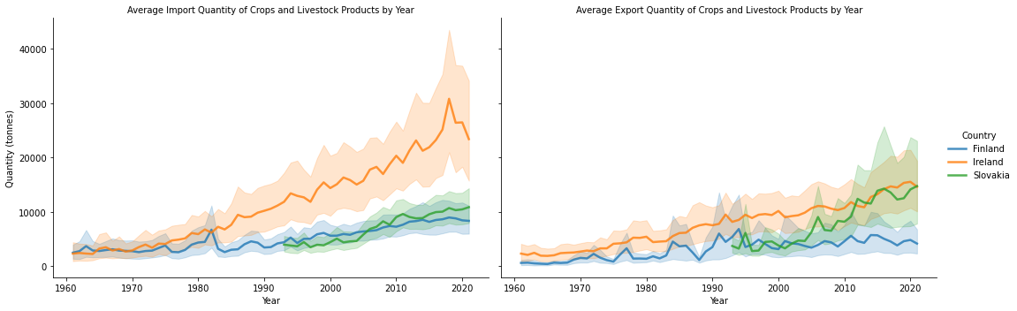

Figure 2 - Average Import/Export Quantity by Year.

Figure 3 - Average Import/Export Value by Year.

Figure 2 and Figure 3 give an idea of how the average import and export amounts per year behave for each country. They also show that Ireland's amounts are higher than the other countries, mainly in terms of export values in 1000 US$ (Graph 4). Regarding Slovakia and Finland, they import about the same quantity and values, having slightly different behaviour with regards to the export numbers, where Slovakia shows more exports than Finland (Graph 2 and 4).

For this analysis the variable being counted was the average quantity (in tonnes) or the value (in 1000 US$) of the import or export for each country. Table 3 shows some of the inferential tests that were executed in this project.

|  |  |  |
| --- | --- | --- |
| **Inferential Statistics Test** | **Description** | **Results** |
| Shapiro | Test if the dataset is normal. | None of the dataset’s variables being tested were normally distributed. |
| Kruskal | Since data was not normally distributed, this non-parametric test was applied to check if populations of both Finland and Slovakia could be considered similar or not. | Based on the results from the Kruskal test and assuming 5% significance level, it was possible to conclude that, Finland and Slovakia are different regarding their export quantity. However, both countries have similar average import value and quantity as well as export value of crops and livestock products. |
| Mann-Whitneyu | Since data was not normally distributed, this non-parametric test was applied to check if populations of both Ireland and Finland could be considered similar or not. | The results confirmed that, with 5% of significance level, Ireland and Finland were similar on their import value only, whereas in the other aspects there was enough evidence to confirm they had different trading average. |

Table 3 - Inferential Statistics Tests on the Import/Export Dataset.

According to the tests described in Table 3, Finland and Slovakia can be considered similar countries with regards to import and export of agricultural products. They only diverge in the quantity of goods that were exported from each country. Ireland, on the other hand exported and imported much more than the other two countries, which could be confirmed by the inferential tests that showed the average of import/export between Ireland and Finland were substantially different.

These results could be verified by checking the graphs in Figure 2 and Figure 3, where it was observed that these countries curves are distant from each other in most of the cases, expect for their import values.

## Inferential Statistics on Food Price Inflation

Using the dataset 3, the question being solved in this section is: How does Ireland compare to other countries in terms of food price inflation? This analysis was implemented in the Section 4.2 of the **Statistics** Jupyter notebook.

Figure 4 - Food Price Inflation over the Years

According to the Figure 4, Slovakia presented the highest food inflation among the three countries, whereas Ireland had the lowest numbers. The inferential tests described in Table 4 were used to compare these countries.

|  |  |  |
| --- | --- | --- |
| **Inferential Statistics Test** | **Description** | **Results** |
| Shapiro | Test if the dataset is normal. | Finland and Ireland’s datasets were normally distributed, while Slovakia data wasn’t. |
| Wilcoxon | Non-parametric test to compare the aggregated food price inflation between Slovakia and Finland. | The result showed that, with 5% of significance level, the average food price inflation are similar between Slovakia and Finland. |
| Levene | This test was used to check if the food price inflation data between Ireland and the other countries have the same variance. | The results suggested that, with 5% of significance level, there is no significant difference in the variance of the average food price inflation between Ireland and Finland and Finland and Slovakia. However, this result also indicated that, with 5% of significance level, Ireland and Slovakia food price inflation variance were different. |
| Anova One Way Test | This parametric test was used with Ireland and Finland summarized food price inflation dataset as they met the normality requirement as per Shapiro test. | Based on the results, with 5% of significance level, there was evidence to say that Ireland and Finland have similar food price inflation. |

Table 4 - Inferential Statistics Tests on the Food Price Inflation.

The above results suggested that, with 5% of significance level, there is no significant difference in the variance of the average food price inflation between Ireland and Finland and Finland and Slovakia. However, this result also indicated that, with 5% of significance level, Ireland and Slovakia food price inflation variance were different. These results confirmed the first analysis of Figure 4.

# Machine Learning

The analysis described in this section was implemented and discussed in more detail in the accompanying Jupyter notebook called **ML**.

In section 5.1, it is discussed the sentiment analysis performed on the tweet’s dataset about agriculture. In section 5.2, the ML models used to predict the import and export of agriculture products in Ireland and other countries are presented.

## Sentiment Analysis

Using the dataset 4, the sentiment analysis described in this section focuses on the classification of user’s comments about agriculture, extracted from the Twitter platform, into negative, neutral, or positive categories. This analysis was implemented in the Section 3 of the **ML** Jupyter notebook.

### Experiment Setup

As described in the Section 6 of the **DataPrepVis** Jupyter notebook, four versions of the tweets were generated from the raw text: (1) cleaned with stop words, (2) cleaned without stop words, (3) *lemmatized,* and (4) *stemmerized* tweets. Stop words do not add much information to the text, so their frequency could bias the models, therefore, they are usually removed from the dataset. *Lemmatization* and *Porter Stemmer* are common ways to extract the core meaning from the words, this way these techniques were applied to the datasets to evaluate their impact in the performance of the classifiers.

This dataset was collected from a live platform, so it was likely to be unbalanced in terms of the distribution of the sentiment classes, which was confirmed during the experiments, as shown in Section 3.1.2 of the **ML** Jupyter notebook. Therefore, SMOTE technique was used to oversample the dataset, turning it into a balanced one, because it is known that unbalanced data can led to a poor classification performance.

The tweets dataset cannot be fed directly to the ML algorithms themselves as most of them expect numerical feature vectors with a fixed size rather than the raw text documents with variable length (Scikit-learn, 2022). As a result, The TF-IDF and Count vectorizers techniques were used to extract feature vectors from the tweets, generating the independent variables used for the classification. In this case, the target variable was the sentiment.

Every feature in the vectorized tweets can be treated as independent and makes equal contribution to the result, this way the Naïve Bayes (NB) model was used. On the other hand, Logistic Regression (LGR) algorithm was also tested due to its efficiency in predicting classes based on the features relationships.

### Results

NB classifier was tested against the four versions of the tweets using TF-IDF and Count vectorizer. The model run with cross validation in which 10 folds were generated from the dataset that was split into train and test data. The average accuracy was calculated for each model so the results could be evaluated. This analysis was implemented in the Section 3.2 of the **ML** Jupyter notebook.

LGR was tested using GridSearchCV, which was applied to decide the best parameters to run this model. In this test, TF-IDF option was used, as it provided the best results with NB classifier. The parameters evaluated by GridSearchCV were related to the vectorizer strategy. So, it was tested if LGR performs better with or without stop words and which tokenizer provides good results when applied to the cleaned tweet version (1). This way, the result given by GridSearchCV could be evaluated. This analysis was implemented in the Section 3.3 of the **ML** Jupyter notebook.

Figure 5 - NB Classification Accuracy.

Based on the results illustrated in Figure 5, the NB approach on the Lemmatized tweets using TF-IDF provided the best accuracy of about 72%. The lowest accuracy obtained was 48% by using Stemmer and Count vectorizer on this dataset.

Stemmer approach produced the lowest accuracy with both vectorizer methods. Also, keeping the stop words produced better results than removing them in both cases, which can be explained by the small size of this dataset.

|  |  |
| --- | --- |
| **Parameter** | **Value** |
| Keep stop words? | Yes |
| Tokenizer | Stemmer |
| CV accuracy | 55% |
| Test accuracy | 48% |

Table 5 - GridSearchCV Results using LGR.

According to Table 5, the LGR model provided an accuracy of just 55% using the parameters given by GridSearchCV. This way, LGR performed worse than the NB approach in this dataset.

|  |  |  |
| --- | --- | --- |
| **Parameters** | **NB Model** | **LGR Model** |
| Use stop words? | No | Yes |
| Tokenizer | Lemmatizer | Stemmer |

Table 6 - Model Parameters Comparison.

Table 6 shows the difference between the models with regards to their optimal parameters. According to on the GridSearchCV output, the best hyperparameters for LGR were keeping the stop words and applying the Stemmer technique, while NB performed better without stop words and by using Lemmatizer.

## Agriculture Import and Export Prediction

This analysis focuses on applying ML models to make predictions about the average import and export amounts in Ireland and Finland. This analysis was implemented in the Section 4 of the **ML** Jupyter notebook.

### Experiment Setup

To run the ML models, the dataset was split and converted into a timeseries, because each aspect of the dataset had to be predicted separately. Thus, a dummy time index column was created to represent the time for each of the following data from Ireland and Finland datasets: import-quantity, import-value, export-quantity, and export-value. The quantity and value import/export amounts were also scaled in their respective datasets. Therefore, eight tables were created, i.e., Import-Quantity Ireland, Import-Value Finland, etc. The Figure 6 illustrates the datasets after the pre-processing step.

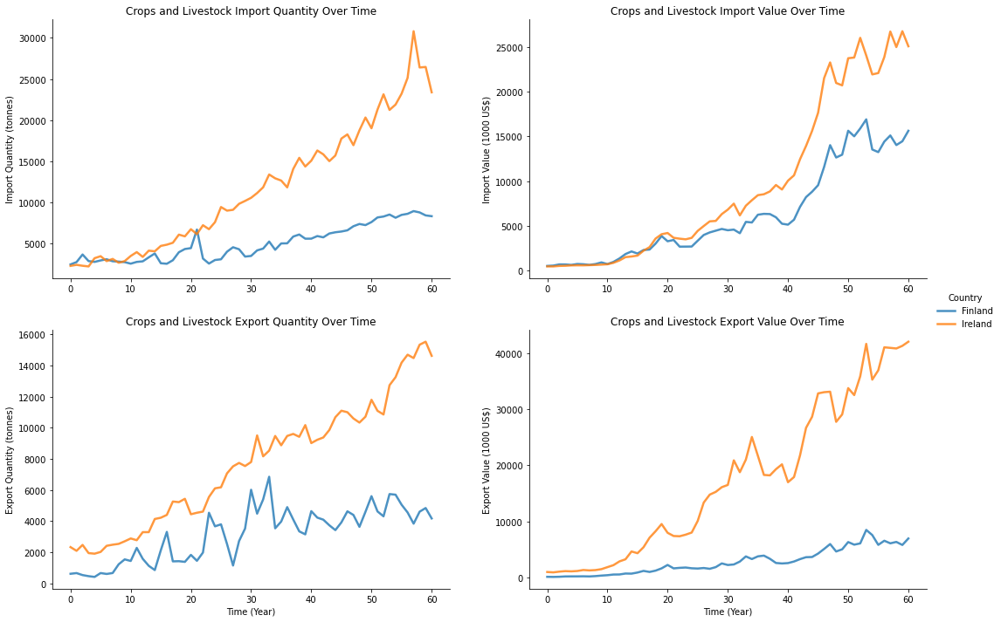

Figure 6 - Scaled Import/Export Amounts over time

The prediction models were created using supervised regression algorithms, where the independent variable is the time, whereas the target is the import/export average amount. Therefore, based on the nature of the data, which is numerical and continuous, and the problem being solved, which is a prediction problem, the following approaches were used: Polynomial Regression (PR) and KNN Regression algorithms.

### Results

Each model was executed manually with different predefined parameters, and their performance was calculated using cross validation. The dataset was split into train and test dataset, but due to the small size of the datasets, 40% of the data was used for test against 60% for train. For each model, GridSearchCV with K Fold technique were executed to retrieve the best parameters for the models. The results were compared based on a score function given by the coefficient of determination (R2). This score provides an indication of goodness of fit and therefore a measure of how well unseen samples are likely to be predicted by the model (Scikit-learn, 2022).

Figure 7 and Figure 8 show how the KNN model predicted the test and train datasets for Ireland and Finland datasets, while Figure 9 and Figure 10 illustrate the predictions obtained from the PR model in Ireland and Finland datasets, respectively.

Figure 7 - KNN Regression Prediction Results for Ireland

Figure 8 - KNN Regression Prediction Results for Finland

Figure 9 – PR Prediction Results for Ireland

Figure 10 – PR Prediction Results for Finland

Figure 11 and Figure 12 show the R2 score obtained from the execution of KNN and PR models using different number of neighbours and degrees on each dataset. Based on the R2-Score obtained, it was possible to say that both models performed well in predicting the import and export amounts over time. Table 7 shows the GridSearchCV output obtained for the Finland datasets only so the results could be discussed in more depth.

Figure 11 - R2 Score from KNN Regression Models

Figure 12 - R2 Score from PR Regression Models.

|  |  |  |  |
| --- | --- | --- | --- |
| Dataset | Country | Model | Param |
| Export Quantity | Finland | PR | 1 |
| Export Quantity | Finland | KNN | 5 |
| Export Value | Finland | PR | 1 |
| Export Value | Finland | KNN | 2 |
| **Import Quantity** | **Finland** | **PR** | **5** |
| **Import Quantity** | **Finland** | **KNN** | **3** |
| Import Value | Finland | PR | 10 |
| Import Value | Finland | KNN | 1 |

Table 7 - Parameters Chosen by GridSearchCV on Finland Datasets.

According to the GridSearchCV results highlighted in Table 7, the best parameter for PR in the Finland import quantity dataset was 5 degrees, while for KNN it was 3 neighbours. The first result was confirmed by the R2 score obtained by cross-validation, which is shown the first graph of Figure 11 and Figure 12, where PR model with 5 degrees had the maximum score of 96% on the train set. However, the KNN best result of 100% was obtained with only 1 neighbour on the train dataset. These differences can be explained by the size of the datasets that are too small for a definite score.

It was also noted that the PR model declines as the number of degrees increases after 10. The same behaviour was observed with KNN, as the number of neighbours increases, the model performance starts to decline.

# Conclusions

In this project, it was discussed several ML and statistical methods to acquire insights from the datasets. The main challenges faced in this project was the number of datasets needed to attend the brief. Each dataset had different characteristics and needed specific EDA discipline. Multiple datasets also complicated the organization of the Jupyter notebooks that had to be split to avoid rework and code duplication, while keeping good programming practices.

It was also difficult think of all different questions in order to apply the required techniques. In the statistical part, seeing the aggregated data graphs was very helpful to guide the discussions on the results of the inferential tests applied. For the ML, several datasets had to be extracted from the import/export dataset, which made the analysis complex and hard to explain. This problem could be simplified by focusing on a single aspect of the dataset (e.g., Import quantity in Ireland) not trying to model the whole dataset.

It was also very laborious to keep several Jupyter files and the report synchronized so the references to the code from this report are correct. Knowing which content to keep in each document was another challenge.

# References

Chapman, P. *et al.* (2000) *CRISP-DM 1.0 Step-by-step data mining guide*. Available at: http://www.crisp-dm.org/CRISPWP-0800.pdf.

Eurostat (2022) *Facts and figures on life in the European Union*, *Eurostat*. Available at: https://european-union.europa.eu/principles-countries-history/key-facts-and-figures/life-eu_en (Accessed: 24 December 2022).

Scikit-learn (2022) *Scikit-learn: Machine Learning in Python*, *https://scikit-learn.org*.