Time Series and Machine Learning Forecasting of Energy Consumption: A Data Analytics Perspective

MOEEZ UL DIN

A Research Proposal Submitted for
MSc Data Analytics



December 2025

Supervisor: [Kislay Raj]

Contents
List of Figures: 5
List of Tables: 5
CHAPTER 1: INTRODUCTION 6
1.1 Background and Context 6
1.2 Problem Statement 7
1.3 Research Motivation 8
1.4 Research Aim and Objectives 9
Primary Aim: 9
Objectives: 9
1.5 Research Hypothesis 9
Null Hypothesis (H₀) 9
Alternative Hypothesis (H₁) 10
1.6 Significance and Contributions 10
Theoretical Contribution 10
Methodological Contribution 10
Practical Contribution 10
1.7 Thesis Structure and Overview 10
CHAPTER 2: BACKGROUND RESEARCH AND RELATED WORK 11
2.1 Introduction 11
2.2 Energy Consumption Forecasting: An Overview 11
2.3 Traditional Time Series Methods 12
2.3.1 ARIMA and Variants 12
2.3.2 Seasonal ARIMA (SARIMA) 13
2.3.3 Prophet Model 13
2.4 Machine Learning Approaches 14
2.4.1 Regression Models 14
2.4.2 Tree-Based Ensemble Methods: Random Forest 14
2.4.3 Extreme Gradient Boosting (XGBoost) 15
2.5 Deep Learning Architectures 16
2.5.1 Recurrent Neural Networks: RNN, LSTM, GRU 16
2.5.2 Convolutional Neural Networks for Sequences 17
2.6 Hybrid and Ensemble Models 18
2.6.1 ARIMA-XGBoost Hybrids 18
2.6.2 ARIMA-LSTM Hybrids 18
2.6.3 XGBoost-LSTM Hybrids 19
2.6.4 Synthesis 19
2.7 Comparative Studies and Benchmarking 19
2.8 Research Gaps and Opportunities 20
2.9 Chapter Summary 21
CHAPTER 3: METHODOLOGY 22
3.1 Data Preparation and Preprocessing 22
3.2 Implementing Deep Learning Architecture 23
3.2.1 Autoregressive Integrated Moving Average (ARIMA) Models 23
3.2.2 XGBoost: Gradient Boosting for Nonlinear Patterns 24
3.2.3 Long Short-Term Memory (LSTM) Networks 24
3.2.4 Hybrid Architectures 25
3.3 Evaluation Metrics and Reproducibility 26
Chapter Summary 28
CHAPTER 4: RESULTS 29
4.1 Introduction 29
4.2 Data Overview and Preprocessing 29
4.2.1 Dataset Characteristics 29
4.2.2 Data Quality and Missing Values 30
4.2.3 Temporal Characteristics 30
4.3 Exploratory Data Analysis 31
4.3.1 Temporal Patterns and Seasonality 31
4.3.2 Socioeconomic Group Analysis 33
4.3.3 Weather Variable Correlations 33
4.3.4 Holiday Effects 34
4.3.5 Implications for Model Development 35
4.4 Hourly Forecasting Model Performance 36
4.5 Daily Aggregation Results 36
4.6 Weekly Aggregation Analysis 37
4.7 Comparative Performance Analysis 38
4.7.1 Model Rankings by Temporal Resolution 38
4.7.2 Computational Requirements 39
4.7.3 Statistical Significance Testing 39
4.8 Summary of Findings 39
CHAPTER 5: DISCUSSION 40
5.1 Introduction 40
5.2 Alignment with Aim and Objectives 40
5.3 Interpretation by Temporal Resolution 40
5.3.1 Hourly Forecasts 40
5.3.2 Daily Forecasts 41
5.3.3 Weekly Forecasts 42
5.4 Cross Model Comparison 42
5.5 Practical Implications 43
5.6 Limitations and Future Directions 43
5.7 Summary 44
CONCLUSION 46
REFERNCES: 48

List of Figures:
Figure 1: Conceptual hybrid LSTM-XGBoost architecture for energy load forecasting (adapted from Semmelmann et al., 2022). 8
Figure 2: Data Preprocessing Pipeline for LCL Smart Meter Dataset 23
Figure 3: Conceptual Diagram of Hybrid ARIMA-LSTM Architecture 27
Figure 4: Distribution of daily household energy consumption (kWh). 30
Figure 5: Total daily energy consumption over time for a representative household 31
Figure 6: Average daily energy consumption by day of week, revealing subtle weekly periodicity in household demand.. 32
Figure 7: Average monthly energy consumption showing winter peaks and summer troughs characteristic of UK residential demand. 32
Figure 8: Energy consumption distribution across ACORN socioeconomic groups, showing higher consumption in Affluent households and greater variability across all segments. 33
Figure 9: Correlation heatmap showing weak relationships between weather variables and daily energy consumption. 34
Figure 10: Comparison of energy consumption between holidays and non-holidays showing minimal aggregate impact. 35
Figure 11: Matrices comparison of all the models (weekly). 41
Figure 12: Matrices comparison of all the models (daily) 42
Figure 13: Matrices comparison of all the models (hourly) 42

List of Tables:
Table 1: Forecasting Horizons and Applications 12
Table 2: Summary of Recent Literature 20
Table 3: Model Hyperparameters and Architecture Details 26
Table 4: Statistical Baselines - Hourly Forecasting 36
Table 5: Statistical Baselines - Daily Forecasting 37
Table 6: Weekly Forecasting: Deep Learning & Hybrid Models 37

CHAPTER 1: INTRODUCTION

1.1 Background and Context
Today’s appetite for our world for electricity shows no signs of slowing down. By the given estimates, global demand of electricity's share of total final energy consumption may rise from 23% in 2023 to 52% under a 1.5°C climate scenario [1]. These factors that drive this surge is affected by population growth, urbanization, and the electrification of transport and heating systems. The other aspect, to put it into perspective, data centers and AI are mentioned, and their power use is expected to rise to 770 TWh (low-case), 1,135 TWh (base-case), or 1,560 TWh (high-case), contributing up to 10 percent of the world power demand growth (although a trivial portion of the worldwide demand). This influx puts undue pressure that has never been witnessed on old grid infrastructure. These were, in many cases, designed decades ago for fundamental and somewhat different energy landscape from those of today’s requirements. Policymakers answer to this rapidly growing scenario and utilities worldwide lie in modernization, i.e. the transformation of conventional power grids into intelligent, adaptive networks that can respond dynamically to fluctuating supply and demand.
The Smart Grid represents a major paradigm shift away from the old-fashioned unidirectional electric system. The new grid allows for a bi-directional flow of communication and information (data) between both the utility companies and their customers. The global Smart Grid Market size is expected to reach $246.72 billion by 2032 up from its current size of $49.83 billion in 2024 at an annual compound growth rate of 22.08% [2], and shows the magnitude of the change in how energy is produced and distributed by society.
The center of this transition has been the Smart Meter, which currently has over 1 billion units installed in households around the world. By comparing consumer usage in real-time (minute or half hour), as opposed to using a manual process done once per month, it provides the ability to provide higher frequency data, faster fault detection, and better load balancing. Utility companies that have a more sophisticated AMI (Advanced Metering Infrastructure) have reported having shorter outage response time, and having the ability to “self-heal” the grid [3].
However, just having data does not make all things equal. What makes the value of data come alive is how we utilize this data. One way we can use this data is through the potential to accurately forecast our future consumption behaviour. We can then use these forecasts to make operational decisions. For example, if we were to take the predicament of a grid operator who must maintain the perfect balance between power generation and demand, they must do so instantaneously; over-produce and you waste power that could have been used to reduce cost and under-produce and your grid may become unstable leading to brownouts or blackouts. If we can predict household consumption patterns and aggregate them into neighbourhood and regional scales, we create the level of predictive intelligence required to make efficient Unit Commitment decisions, economical Dispatch decisions, and Demand Response decisions. The most recent studies using wavelet CNN-LSTM in electricity generation forecasting also attained mean absolute percentage errors of 1.48, which is quite promising with regards to the application of hybrid deep learning methods [4].
The convergence of the smart grid infrastructure, widespread deployments of smart meters, and the rapid AI innovation gives birth to new moment for energy systems research. The smart energy market is expected to grow from USD 199.5 billion in 2024 to USD 330.6 billion in 2030. It is driven largely by digitalization and advanced metering [5].
Governments are investing heavily in this transition, such as the USD 10.5 billion U.S. grid modernization grants and the EU’s planned USD 1.2 billion investment in digital infrastructure by 2030.
The study uses publicly available smart meter data on London households providing the rigor of the methodology and practical applicability to the pressing issue of creating smarter and more responsive electricity grids.

1.2 Problem Statement
Although the use of smart meters and the existence of high-resolution consumption data have increased, it is consistently challenging to use these data to produce house-level energy forecasts. The reasons are manifold. To begin with, the demand of electricity in the household is very volatile. The consumption of one house can vary drastically in a few hours, as it can reach a minimum at sleep times, and skyrocket as far as occupants wake up, make breakfast and turn on heating or cooling systems. Such trends are further complicated by weekly seasonalises, annual trends and stochastics.
Traditional statistical forecasting techniques such as ARIMA; may struggle to handle the nonlinear and highly variable patterns which are present in modern smart meter data. Research shows that such methods often fail to capture complex time dependencies. This results in reduced forecasting accuracy in practical grid settings [6]. Events like the 2021 Texas winter storm illustrate the consequences of inadequate forecasting during extreme demand surges.
Machine learning models are also more improvements but come with their challenges. The ensemble based methods such as XGBoost or other tree-based methods can learn interactions and non-linearities on features. But they do not inherent the sequential awareness of temporal data. Deep learning architectures, LSTM networks, GRU (Gated Recurrent Unit) networks and 1D- CNNs present this sequential concept to the table and learn to identify patterns over extensive time scales. Nevertheless, studies have shown that stacked CNN-LSTM models do not take into account time-related characteristics and focus on high-level characteristics, but they do not process spatial and time dimensions separately [7].
The actual border and the distance that this thesis will cover is hybrid architectures that systematically incorporate more than one modelling paradigm. The combinations of CNN-LSTM have been explored by recent work. These works point out that convolutional layers extract local temporal features before feeding them to recurrent layers. This process happens for the purpose of sequence modeling. An example of a well-designed hybrid model (CNN-LSTM-RF) forecasting solar power had an R-squared of 92 percent and very low errors (RMSE of 0.07 kW and MAE of 0.05 kW), which proves that well-thought-out hybrid models can be effective [8]. But there is one more important element that has not been examined thoroughly: attention mechanisms. Attention allows the model to weigh the importance of different time steps, that too; dynamically. This allows the model to, for each prediction, focus on the computational resources on most relevant historical periods. When a model is used to predict Monday morning consumption, such as, the attention mechanisms may learn to place an emphasis on the past Monday morning consumption whilst underemphasizing non-pertinent times.
It is not just the lack of data or a lack of computing power, both of which are becoming increasingly available. Rather, it's an architectural question where the question of “How do we design forecasting system that combines the strengths of convolutional feature extraction and recurrent temporal modeling, along with the attention-based dynamic weighting in a principled, reproducible manner?”; arises. And the most critical part in this process is to identify how much do these, sophisticated hybrid approaches improve the performance over the simpler baselines? The comparison is evaluated rigorously on real world household data.

1.3 Research Motivation
This study of energy use prediction is practical and urgent. Even a little tiny advancement in prediction may yield tangible advantages in the real world. In the case of utility companies, superior predictions imply superior planning and lessening the necessity of costly power plants that will decrease consumer expenditures. In the case of solar and wind power, it is of advantage to be aware of the actual demand so that grid operators can easily utilize renewable sources.
There is also increased AI application in the world of renewable energy and the market size is projected to increase to 0.85 billion in 2024 and 4.85 billion in 2032 [9]. Very rapid technologies such as AI and smart grids are being employed to enhance the manner in which energy is generated, stored, and distributed to enable polluting energy to be curbed and cleaner energy be encouraged.
It also has a larger scientific necessity. Although there have been significant advances in terms of new deep learning approaches, energy forecasting remains to be improved. Research indicates that precision in energy consumption forecasting is needed since we are increasingly depending on electricity appliances on a daily basis. The previous practices are not precise enough and contain numerous flaws [10]. The results of many studies are quite interesting, however, they are based on private data which has not been replicated in other studies.
The Figure 1 displays the conceptual framework of such a hybrid system, LSTM-XGBoost design of load forecasting [44]. The beauty of this approach lies in its modularity. LSTM captures sequence information, XGBoost exploits engineered features, and the combination leverages both representation learning and domain-specific knowledge.

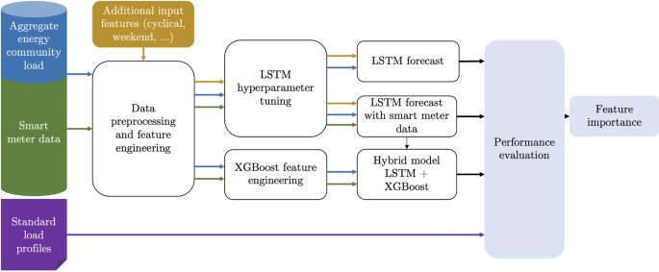
Figure 1: Conceptual hybrid LSTM-XGBoost architecture for energy load forecasting (adapted from Semmelmann et al., 2022).
Some merely compare a few models without leaving questions on whether the proposed innovations are really propping the state-of-the-art or repackaging the existing methods. The thesis will attempt to fill these gaps by means of comprehensive benchmarking, clear methodology and reproducible findings on publicly accessible information. At the personal level, this is a research opportunity to make a contribution to the problematic issue of developing smarter and more sustainable energy systems. The need to reduce climate change, and the trend of an increasing energy demand are tightening the timeframe of transformative action.

1.4 Research Aim and Objectives

Primary Aim:
To build, test and prove the superior hybrid forecasting methods on deep learning models that combine CNN networks, LSTM networks and attention models to achieve better household energy consumption prediction with stringent benchmarking against the conventional statistical and standalone machine learning models.

Objectives:
Objective 1: Run and systematically test the traditional time series models (ARIMA, SARIMA) on the London smart meter data to find out the strong baseline performances in terms of standardized evaluation measures (MAPE, RMSE, MAE, R2).
Anticipated Deliverable: This goal will offer replicable benchmarks to which more advanced models can be reasonably evaluated. The research provides the energy forecasting community with a reference point through its documentation of hyper parameter selection, pre-processing, as well as performance or performance at various forecast horizons.
Objective 2: Build and improve machine learning models like XGBoost for predicting energy use and test how changing the features affects prediction accuracy.
Expected Contribution: Measures how much better machine learning models can perform compared to traditional statistical methods. It also tracks which features have the biggest impact on improving predictions.
Objective 3: Create deep learning models, like LSTM, for predicting household energy use. Test how different factors like the number of layers and units in the model affect performance.
Expected Contribution: Sets performance benchmarks for deep learning methods and provides insights into which model choices improve prediction accuracy while keeping the model efficient.
Objective 4: Test and compare hybrid models that combine statistical, machine learning, and deep learning methods, like ARIMA-LSTM and XGBoost-LSTM, to see if mixing different methods leads to better results than using just one type of model.
Expected Contribution: This study checks whether combining models can solve problems seen in using a single model. It uses the London smart-meter dataset to test whether hybrid models improve predictions and when simpler models might work just as well.

1.5 Research Hypothesis
Null Hypothesis (H₀): The accuracy of the prediction between the proposed hybrid CNN-LSTM-Attention model and stand-alone deep learning models in predicting household energy use is not significantly different.
Alternative Hypothesis (H₁): The hybrid CNN-LSTM-Attention model is statistically significantly better ( p < 0.05) at the multiple evaluation metrics (MAPE, RMSE, MAE) than standalone deep learning models or traditional statistical models and machine learning baselines due to the synergistic combination of complementary modelling paradigms.
Paired statistical tests (t-tests, Wilcoxon signed-rank tests) of the differences between forecast errors on the test set will be used to validate the observed improvements. And because they are acquired by random variation so they should not be considered.

1.6 Significance and Contributions
This study has a number of contributions to the energy projections in both literature and practice:
Theoretical Contribution: Enhances the knowledge of the interaction of LSTM, XGBoost and attention-based models in the hybrid models in predicting time series data. It quantifies the significance of each component, which can be used more than energy forecasting.
Methodological Contribution: Develops a straightforward and descriptive method of comparing the classic approaches, machine learning models, deep learning models, and hybrid models to the same dataset. This would provide the reproduction of the results and worries regarding consistency of previous studies.
Practical Contribution: Gives a forecasting solution, which can be applied in real-life smart grid systems, as well as information about the settings of the model, data processing, and performance. Deep learning models are demonstrated to be accurate and interpretable as they have been demonstrated to be good at discovering complex patterns in household energy consumption. The attention mechanism of the model also contributes to the way the model makes predictions that is of importance in getting the trust of grid operators and regulators [11].

1.7 Thesis Structure and Overview
The rest of this thesis is structured in the following way, Chapter 2 will be a detailed review of the existing research, including traditional time series techniques, methods of machine learning, deep learning models, and hybrid techniques. It also shows areas of gaps that this research will seek to fill. Chapter 3 describes the methodology, the way data is processed, the features, and the models that have been applied. In chapter 4, the results are provided, comparing models and testing them to prove the hypothesis of the research by using statistical data. The findings are discussed in chapter 5 and related to previous studies besides an open discussion of the limitations of the study. The 6th chapter concludes the thesis by summarizing the main contributions and recommendations on where further research into intelligent energy systems should be done.

CHAPTER 2: BACKGROUND RESEARCH AND RELATED WORK

2.1 Introduction
Our method of forecasting energy consumption has greatly evolved during the past decade. What was initially a simple system modeled by previous data has become a far more complicated system that employs machine learning, deep learning, and hybrid models with the capacity to learn about complex trends in energy use. This chapter will walk through that development, starting with traditional time series methods and moving through to machine learning, deep learning, and hybrid models.
The art of architecture is the mirror of the development of the science of prophesy. Our paper begins with a generalization of the energy forecasting applications and horizons and establishes the practical background that generates research innovation with the help of these. The deep learning architectures which represent the current frontier which are LSTMs, CNNs, and the attention mechanisms, pushing accuracy boundaries. Lastly, we also look at hybrid paradigms which can be used as an integration of two or more paradigms in such a way that they overcome the weaknesses of each other.

2.2 Energy Consumption Forecasting: An Overview
Forecasting of energy consumption is a field that lies between the need and the complexity. Short-term electricity load forecasting (STELF) predicts the immediate demand of up to several hours up to a few days, which is a necessary aspect in planning, scheduling and operational management of the power systems [12].
Different operational requirements can be seen in the taxonomy of forecasting horizon. Real-time dispatch decisions are made based on very short-term predictions (a few minutes to hours into the future). Unit commitment and maintenance scheduling are informed by short-term predictions (1-7 days) decisions. The Electricity Market Report 2023 released by the International Energy Agency indicates that over 90 percent of the increase in global demand by 2025 will be met by renewable sources of energy and nuclear power as the intermittent renewables take the place of dispatch able fossil generation [13].
Use is far much broader than mere load balancing. STELF is mostly applied in short-term planning of smart grids such as equipment maintenance, allocation of loads, starting and closing of units, as well as setting electricity prices [14]. Demand response programs are based upon precise predictions to alter consumption that is out of peak periods.
At the household level, predictions come with their own set of problems as compared to aggregated forecasts. Households act in a non-predictable way: there is fluctuation in terms of occupancy, there is a cyclical on-off behaviour of appliances, and behavioural variables are not deterministically model able. In the eyes of a distribution system operator, the energy consumption of individual households presents special challenges, as their load characteristics are shaped by multiple unobserved characteristics such as the size of the household or appliances installed, or self-generated power [15].
The emergence of smart meters has completely changed the world of forecasting. They have examined the idea of whether machine learning methods can forecast electricity demand in current and future grid conditions by looking at real smart meter data of 3,511 households in Germany over 34 months [16].

Table 1: Forecasting Horizons and Applications
Horizon | Time Range | Primary Applications | Key Challenges
Very Short-Term | Minutes to 6 hours | Real-time dispatch, frequency regulation, automatic generation control | High volatility, limited historical context
Short-Term | 1-7 days | Unit commitment, maintenance scheduling, day-ahead markets | Weather dependency, behavioural variability
Medium-Term | 1 week to 3 months | Resource planning, seasonal preparation, contract negotiations | Seasonal patterns, economic factors
Long-Term | Beyond 3 months | Infrastructure investment, capacity expansion, policy planning | Structural changes, technology shifts

The transition to energy is also an issue that modern forecasting will have to address. EVs create new patterns of loads. Rooftop solar produces prosumers who are generators and consumers. Heat pumps change the heating loads in gas to electricity. Local energy system digital twins can be used by researchers and utilities to use the augmented smart meter data and simulate the performance of the model with the addition of new PV installations and analyse their results provided the grid will act in the future [16]. These evolving dynamics render historical patterns less reliable which demand the adaptive forecasting systems.

2.3 Traditional Time Series Methods

2.3.1 ARIMA and Variants
The Autoregressive Integrated Moving average model remains a workhorse of time series forecasting, despite originating in the 1970s. Its enduring relevance stems from mathematical elegance and interpretability. ARIMA (p,d,q) models are a decomposition of a time series (auto regression, p terms, describe how the values in the past affect the values in the present), differencing, d operations, to make the time series a stationary process, and moving average (q terms) to explain the propagation of errors.
The mathematical formulation for an ARIMA model takes the form:
$$Φ(B)(1-B)^{d}X_{t}=Θ(B)ε_{t}$$
where $Φ(B)$ denotes the autoregressive polynomial, $(1-B)^{d}$ denotes differencing order d, $Θ(B)$ denotes average moving polynomial, $B$ is the backshift operator, and $ε_{t}$ denotes errors that are white noise in nature.
In case of the Gizałki wind farm, ARIMA model was more efficient than SARIMA and SVR models and performance optimization was done by grid search using Mean Absolute Percentage Error (MAPE) [17]. However, linear assumptions in ARIMA place basic restrictions. ARIMA fails to capture the data trends in cases where the time series data has a seasonality [18]. The non-linear dynamics of consumption, sudden transitions in regimes, and the complicated interactions between features are all beyond the capability of ARIMA to model the dynamics.
The extents of extending the applicability of ARIMA are examined in recent research. The results of improved time series prediction with hybrid ARIMA and machine learning models prove that the combination of ARIMA and sophisticated computational techniques can solve the constraints of non-stationary data and complexity in tuning models [19]. The essence is that ARIMA is a good model of autocorrelation structure which is linear, and one should assess more complex models based on this model.
Comparative analysis reveals that ARIMA recorded a mean absolute percent accuracy at 78.88 with a mean error of 0.9 though the performance of the model is largely determined by appropriate choice of parameters using the Box-Jenkins method [20]. The choice of parameters is in itself a challenge. Careful tuning of the (p, d, q) triple is usually by looking at ACF (autocorrelation function) and PACF (partial autocorrelation function) plots, or systematic grid search. The parameters are misspecified, which means that unreliable forecasts are made, but the optimization of the values of the parameters requires statistical knowledge.

2.3.2 Seasonal ARIMA (SARIMA)
SARIMA provides an extension of ARIMA that clearly models the seasonal trends using other (P, D, Qs) parameters where s is the seasonal period. SARIMA has theoretical benefits when dealing with household energy data that has the property of daily and weekly cycles.
The complete SARIMA formulation becomes:
$$Φ_{p}(B)Φ_{P}(B^{s})(1-B)^{d}(1-B^{s})^{D}X_{t}=Θ_{q}(B)Θ_{Q}(B^{s})ε_{t}$$
The Łęki Dukielskie wind farm was the case where the SARIMA was found to be the most suitable model, explaining the significance of the seasonal parameter maximization of data with strong periodicities [17]. SARIMA (2,1,1) (1,0,1,144) performed better than ARIMA(2,1,1) with MAPE of 18.38 percent in forecasting seasonal energy consumption [21] which indicates quantifiable seasonal benefits of the seasonal model.
SARIMA is however complicated by its own. SARIMA model that takes into account seasonality had an accuracy of 73.86 percentage with mean error of 0.11 although it is complex and therefore it can easily over fit [20]. The cost of computations increases as the seasonal duration is more (e.g., s=1440 in daily patterns in minute-level data). The extra parameters make the model more complex which increases the chances of overfitting when the amount of training data is small.

2.3.3 Prophet Model
While ARIMA and SARIMA rely on linear assumptions, Facebook’s Prophet offers a flexible additive decomposition framework designed for time series with strong seasonality and irregular events. It models energy consumption as:
$$y(t)=g(t)+s(t)+h(t)+ϵ_{t}$$
Where $g(t)$captures trend, $s\left(t\right)$ models periodic seasonality (daily, weekly, yearly), $h(t)$accounts for holidays or shocks, and $ϵ_{t}$is the error term [18].
Prophet excels in handling multiple seasonality’s and requires minimal tuning compared to ARIMA’s order selection. It gracefully manages missing data and outliers, making it suitable for real-world smart meter streams. Recent benchmarks show Prophet Model outperforming SARIMA in peak demand forecasting when exogenous factors are included, though it still struggles with sharp nonlinear spikes during extreme events [18].
Prophet really shines in how straightforward it is to work with. It needs way less tweaking of hyper parameters than ARIMA does with all that order picking. This keeps things simple and appealing for everyday forecasting in operations. Researchers tested Prophet alongside Holt-Winters on electricity data from Houston right in the middle of the COVID-19 mess. Prophet came out ahead in resisting noise and adapting to new situations over Holt-Winters. It handled the wild swings in demand pretty well even with those huge socio-economic shocks hitting everything [22]. Breaking down the model into trend and seasonal parts makes it easy to understand. Grid operators end up with useful info they can act on. They get more than just forecasts. They see what really drives the consumption patterns underneath.
Prophet does have some weak spots though. Its statistical setup feels more bendy than ARIMA's in a way. Still it runs into issues with super nonlinear trends and those tangled links from outside factors. That pushes folks toward hybrid setups. They blend Prophet's solid seasonal splitting with what machine learning brings to the table for nonlinearity. You can read more on that in Section 2.6.

2.4 Machine Learning Approaches

2.4.1 Regression Models
The simplest machine learning models on energy forecasting are linear and polynomial regression models. By formulating consumption as a function of predictor variables, the regression sidesteps the pure time series framework of ARIMA which happens in the favour of explicit feature engineering.
The advantage lies in flexibility. By making it simple to add weather information, calendar indicators, or features that are domain specific. Linear regression that brings in multimodal characteristics such as recent prices, news sentiment, and temperature data give points of reference to more sophisticated models [22]. Ridge and Lasso normalization methods can eliminate overfitting in case feature space becomes large.
However, linear regression does not test or reject the linearity assumption and so it is not able to capture complex interactions. Non-linear terms are added by polynomial regression. But, around basis function selection and curse of dimensionality, new challenges are introduced.
Beyond tree-based methods, Support Vector Machines (SVMs) are also applied in energy forecasting, using kernel functions to capture nonlinearity by constructing optimal hyperplanes in transformed feature spaces for regression or classification. Research found SVM competitive on wind farm data with clear structures but noted it requires more hyper parameter tuning and is less scalable than methods like XGBoost [46].

2.4.2 Extreme Gradient Boosting (XGBoost)
Extreme Gradient Boosting (XGBoost) marks a pivotal advancement in tree ensemble methods by implementing sequential boosting, advanced regularization, and computational optimizations [25]. Unlike the bagging strategy of Random Forest, XGBoost trains trees in a sequence, where each tree attempts to correct the errors made by the previous ensemble, improving both bias and variance performance.
The XGBoost objective function comprises a loss term $L$ and a regularization penalty$Ω$:
$$Obj⁡(θ)=\sum_{i}{}L(y_{i},{\hat{y}}_{i})+\sum_{k}{}Ω(f_{k})$$
Where $L$ quantifies prediction errors and $Ω$ constrains model complexity, enhancing generalization and mitigating overfitting [24].
Key innovations in XGBoost include:
- Regularized Learning: Incorporation of L1 and L2 regularization in tree construction encourages simple, generalizable models, especially useful for short consumption histories in household-level forecasting.
- Gradient-Based Tree Construction: Utilizes first- and second-order gradient information to efficiently optimize arbitrary differentiable loss functions, supporting customization for diverse forecasting objectives (such as asymmetric error penalties).
- Weighted Quantile Sketch: Efficiently handles instances with missing data or variable importance weights which is an asset for imbalanced or incomplete energy datasets.
- System-Level Optimizations: Parallelization, out-of-core learning, and cache-aware algorithms empower XGBoost to handle millions of intervals in smart meter datasets with high efficiency.
Applications in Energy Forecasting:
As in the conducted studies XGBoost's prowess in the energy forecasting has been highlighted. It outperforms the traditional models on short-term electric load prediction tasks. It also demonstrates its capacity to model complex and that of the non-linear relationships among the features such as weather, calendar effects and the usage history. It does all this with minimal amount of manual feature engineering [24]. In the scenarios where energy consumption is discussed we see that XGBoost matches or sometimes even exceeds the performance of LSTM and Random Forest. This phenomenon of XGBoost makes it attractive for the operational contexts where the process of retraining is frequent [22-23]. Its output includes feature importance measures which foster trust and interpretability among domain experts.​
However, since XGBoost's trees operate over tabular feature sets, rigorous feature engineering (lags, rolling means, cyclical encodings) is usually required to inject temporal structure for time series forecasting. Studies such as Kamtziridis (2024) confirm that such deliberate feature design enables XGBoost to model periodicity and seasonal effects even though the model lacks intrinsic sequence awareness [45].
Comparative Perspective:
XGBoost is typically superior to linear models and basic ensembles in both accuracy and scalability, often rivaling deep learning in structured prediction settings while demanding less computational power. Its explicit need for feature engineering, however, puts it at a relative disadvantage for highly non-stationary, long-range sequential dependencies; domains where deep neural models, such as LSTM, excel.

2.5 Deep Learning Architectures

2.5.1 Recurrent Neural Networks: RNN, LSTM, GRU
Recurrent neural networks introduced a real-world sequential modeling to the energy forecasting. In contrast to the feature-based methods of machine learning, RNNs have hidden states which change with time series input, point-to-point. This repeated relationship enables the past data of the time steps to have an effect on the future forecasts.
Vanilla RNNs were also afflicted by the vanishing gradient problem: when computing the gradient of a temporal sequence, the gradient exponentially decays over length, which makes it impossible to learn long-range dependencies. This was solved by Long Short-Term Memory networks, a complex gating mechanism.
The LSTM architecture introduces three gates controlling information flow:
Forget Gate: $f_{t}=σ(W_{f}⋅[h_{t-1},x_{t}]+b_{f})$
Input Gate: $i_{t}=σ(W_{i}⋅[h_{t-1},x_{t}]+b_{i})$
Candidate Values: ${\tilde{C}}_{t}=tanh⁡(W_{C}⋅[h_{t-1},x_{t}]+b_{C})$
Cell State Update: $C_{t}=f_{t}*C_{t-1}+i_{t}*{\tilde{C}}_{t}$
Output Gate: $o_{t}=σ(W_{o}⋅[h_{t-1},x_{t}]+b_{o})$
Hidden State: $h_{t}=o_{t}*tanh⁡(C_{t})$
Where $σ$represents sigmoid activation, $*$denotes element-wise multiplication, and $[h_{t-1},x_{t}]$concatenates previous hidden state with current input.
The LSTM methods performed better than the Synthesized Load Profiles and the plain benchmark estimators as far as the RMSE of the day-ahead forecasts were reduced up to 68.5 percent in the case of future grid states and more decentralized generation [16]. CNN and LSTM models have gained high usage due to outstanding performance, and CNN layers can extract features of input datasets and LSTM models can be used to make multi-step predictions by forecasting sequences [12].
Gated Recurrent Units simplify the LSTM architecture by combining forget and input gates into a single update gate and merging cell state with hidden state. GRUs require fewer parameters and can be trained faster, but tend to be as good as LSTM. Comparative analysis has shown that LSTM and GRU models are able to achieve long-term dependencies modelling in sequential data, where GRU models have the benefit of computational efficiency [23].
The practical benefit of recurrent architecture is that they are suited to sequential data. They do not need to manually define lookback windows and feature lags, the network discovers what historical information is important. The LSTM has gating mechanisms to regulate the flow of information where the internal processes are governed by equations thereby keeping long-term dependencies in the sequence data during power system operations [27].
But the recurrent networks have their difficulties. Training is still computationally intensive because of sequential dependencies, which cannot be parallelized. XLSTM models have shown similar performance to Transformers with the significant benefit of growing linearly instead of quadratically with the increase in model input size [28], indicating that continued architectural improvements solve these limitations.

2.5.2 Convolutional Neural Networks for Sequences
CNNs had been originally created to identify images and adapted well to time series with 1D convolutions. Convolutional layers slide filters across temporal sequences, extracting local patterns much as 2D convolutions detect edges and textures in images.
The strength is feature learning hierarchically as well as parallel processing. CNN models also showed great prediction and the ability to add features, and the highest accuracy CNN performed at 75.70 percent lower MSE than the Random Forest, 69.48 percent lower than the XGBoost, 49.45 percent lower than the SARIMAX, and 30.62 percent lower than the FB Prophet [29].
Temporal Convolutional Networks are a natural extension of basic 1D-CNN, with dilated causal convolutions that enable it to have receptive fields akin to those of an LSTM, but are parallelized like CNN. CNN-RNN hybrid networks such as Temporal Convolutional Networks have also increased the forecasting horizons, but there are still limitations on prediction of more than a year [30].
CNNs have a restricted receptive field that acts as a limitation to its ability to model pure sequences. Even with dilations, very long-range dependencies may escape detection if they exceed the receptive field width. Also, CNNs have no concept of time. Instead they perceive patterns, but not in the context of their timing in the sequence.
Transformer models, which use self-attention to capture long-range dependencies more effectively than recurrent networks, have recently gained traction in time-series forecasting. Emerging models such as TimeGPT demonstrate strong cross-domain generalisation. However, standard Transformers face scalability challenges with long sequences, leading to ongoing research into sparse or efficient attention variants [31,32,33].

2.6 Hybrid and Ensemble Models

2.6.1 ARIMA-XGBoost Hybrids
ARIMA-XGBoost hybrids represent one of the most practical bridges between classical time-series analysis and modern machine learning. In this approach, ARIMA first models the linear trend, seasonality, and autocorrelation structure of the consumption series. Its residuals, containing unmodeled nonlinear behaviour, are then used as input for XGBoost to capture complex interactions among exogenous features such as temperature, calendar effects, and behavioural shifts.
Formally,
ŷₜ = ŷₜᴬᴿᴵᴹᴬ + ŷₜˣᴳᴮᵒᵒˢᵗ(εₜᴬᴿᴵᴹᴬ)
Empirical studies confirm the efficiency of this decomposition. We have that an ARIMA-XGBoost model for China’s energy-supply forecasting achieved mean absolute percentage errors below 4.5%, outperforming standalone ARIMA [35]. We have further seen that the ARIMA-XGBoost component in a transformer-temperature hybrid reduced mean-squared error from 3.20 to 0.99, validating the complementarity of linear baseline fitting and nonlinear residual learning [47].
Practically, this structure offers three advantages. First, interpretability is that ARIMA coefficients reveal intrinsic temporal dependencies, while XGBoost feature importance quantifies external drivers. Second, computational economy tells that ARIMA pre-filters the signal, allowing XGBoost to converge with fewer trees. Third, adaptability shows that the ARIMA component can be periodically re-estimated as consumption baselines drift, while XGBoost handles short-term volatility.

2.6.2 ARIMA-LSTM Hybrids
The ARIMA-LSTM hybrid shares a similar two-stage design but replaces gradient boosting with a recurrent neural network tailored for sequential dependencies. ARIMA first isolates the linear structure; the residual series is then fed into an LSTM that learns temporal nonlinearities and long-range effects:
ŷₜ = ŷₜᴬᴿᴵᴹᴬ + LSTM (εₜ₋ₖᴬᴿᴵᴹᴬ, ..., εₜ₋₁ᴬᴿᴵᴹᴬ).
Gasmi et al. [48] demonstrated that such decomposition consistently outperformed standalone ARIMA or LSTM across benchmark time-series datasets. A SARIMAX-LSTM configuration for short-term load forecasting reduced mean absolute error by 13% compared with individual models [49]. Research achieved 96.8% accuracy in forecasting Ukraine’s hourly electricity demand using this hybrid, confirming robustness under complex seasonal and behavioural variations [50].
The strengths of this approach lies in its division of labour. ARIMA is known to efficiently model the recurring cycles and also the daily or weekly demand patterns. On the other hand when we talk about LSTM, it captures the deviations that are caused by temperature anomalies and too in the cases of events or user behaviour. This combinations makes the hybrid model very effective. This effectiveness is often of use where strong seasonality coexists with nonlinear temporal shifts. Compared to the ARIMA-XGBoost, this techniques is more inclined to yield higher accuracy on nonstationary or highly sequential data.

2.6.3 XGBoost-LSTM Hybrids
When datasets are large and statistical assumptions restrictive, researchers increasingly turn to XGBoost-LSTM hybrids that merge gradient-boosted trees with deep sequential learning. Integration may follow a parallel ensemble, where both models forecast independently and outputs are blended, or a stacked configuration, where one model’s features feed the other. A common formulation is
ŷₜ = αŷₜˣᴳᴮᵒᵒˢᵗ + (1-α)ŷₜᴸˢᵀᴹ
with α optimized on validation data.
Semmelmann et al. [44] used a bi-directional LSTM-XGBoost framework for community-level smart-meter forecasting which outperforms the standard profiles and standalone LSTM. It know in cases for peak-load events that are critical to grid reliability. Recent work in Belgian smart-grid forecasting [37] reported the values of RMSE to be 106.5 MW and MAPE as 1.18%. This shows the underscoring of this hybrid’s scalability. Further discussing we look at Zhang et al. [38] which showed that a photovoltaic power model which uses parallel XGBoost-LSTM technique, reduced RMSE and MAE. That too by over 60% relative to single models. This attributing gains to the complementary capture of low-frequency, which we refer to as trend and high-frequency as fluctuation components.
Key advantages include (1) balanced modelling of feature interactions and temporal dependencies, (2) scalability to millions of smart-meter readings, and (3) superior handling of peak-demand prediction. This is an operational priority for utilities. The trade-off is interpretability, as both components are data-driven rather than parameterized by explicit statistical structure.

2.6.4 Synthesis
Together, these hybrids occupy a methodological spectrum. ARIMA-XGBoost offers interpretability and speed where linear structure dominates; ARIMA-LSTM extends temporal learning capacity for nonlinear residuals; and XGBoost-LSTM provides maximum flexibility and accuracy on large, noisy datasets. Their comparative evaluation in this research against standalone ARIMA, Prophet, XGBoost, and LSTM baselines will clarify when each hybrid yields the highest value for household energy consumption forecasting.

2.7 Comparative Studies and Benchmarking
Strict comparative analysis is necessary but unfortunately rare in the literature of energy forecasting. Numerous studies consider new architectures and evaluate them against a small number of baselines, typically on proprietary data that cannot be reproduced.
A comprehensive survey examining the entire forecasting process including data pre-processing, feature extraction, deep learning modelling and optimization, and results evaluation identifies research challenges and potential research directions for electricity-load forecasting using deep learning over the past decade [12].
The choice of data set has an impact on comparative outcomes. The datasets that are available publicly to gauge performance are the Global Energy Forecasting Competition (GEFCom) which includes historical data of different regions and time periods representing the real-life scenario in the energy market, the UCI Machine Learning Repository having household load data sampled at one-minute frequency and the European Network of Transmission System Operators for Electricity (ENTSO-E), which covers 35 European countries [12].
Time series foundation model benchmarking baselines of time series household electricity load short-term forecasting concluded that task-specific Transformers are slightly more accurate but foundation models such as Chrono’s and Times FM can forecast competitively with much less training, and are more competitive than various recent methods with minimal or no task-specific training when used with long input sizes [15].
The choice of metrics is very important. Explainability-based feature engineering highlights the adaptive model development based on the empirical performance metrics and the feature explainability of SHAP to ensure that the additions of features contribute directly to predictions and enlighten the use of features in the prediction of peak values [27]. Each of the measures of MAPE, MAE, RMSE, and R-squared emphasizes a specific feature of the quality of the forecasts, and the results may differ when focusing on them.
Table 2: Summary of Recent Literature
Study | Year | Models Compared | Best Model | Best MAPE | Dataset | Key Finding
Moosbrugger et al. | 2025 | LSTM, xLSTM, Transformer | xLSTM | Not reported | Household/Community | xLSTM shows linear memory scaling
Buratto et al. | 2024 | Wavelet CNN-LSTM | Wavelet CNN-LSTM | 1.48% | Biomass generation | Wavelet preprocessing crucial
Abumohsen & Owda | 2024 | CNN-LSTM-RF hybrid | CNN-LSTM-RF | Not reported (R²=92%) | Solar power | Three-way hybrid superior
Hasanat | 2024 | 1D CNN-Bi-LSTM parallel | Parallel model | 3.4% (day-ahead) | NTDC Pakistan | Parallel beats stacked

2.8 Research Gaps and Opportunities
Despite the overwhelming body of research, there are still a number of critical gaps. First, architectural integration is also under-researched. CNN-LSTM and attention mechanisms are studied independently and in pairs, whereas 3-way integration involving CNN feature extraction, LSTM temporal modelling, and attention-based dynamic weighting is less extensively studied. The extension of forecasting horizons to hybrid models like CNN-RNN architectures has happened, but the combination of attention mechanisms with hybrids has not been developed, especially when using high-resolution household consumption data [30].
Second, full benchmarking is uncommon. The majority of research compares the proposed techniques with two or three baselines. According to the literature, inconsistent evaluation processes and proprietary datasets are cited as significant barriers to testing reproducibility and generalization of forecasting methods [12]. The community requires methodical comparisons of classic statistics with machine learning, standalone deep learning, and different hybrid designs on the same data sets with clear preprocessing.
Third, explainability is a performance lag. As models become more and more complex, it becomes harder and harder to know why the model makes this particular prediction but more important to the operation of the trust. Studies that specifically demand harnessing explainability to make performance gains on events of critical nature are scarce and most studies involve interpretation as opposed to leveraging explainability findings to improve model architecture [27].
Fourth, limited validity in the real world. Most forecasting studies are done using historical data in controlled environments. What is the performance of these models when applied to operating systems with concept drift, data quality problems and changing consumption patterns?

2.9 Chapter Summary
This chapter followed the history of energy consumption forecasting starting with the conventional statistical methods to machine learning technology advancement to the advanced deep learning and fusion models. Conventional techniques such as ARIMA and SARIMA can be interpreted because they have bases that can be explained, although they are not good at non-linear dynamics. Non-linearities and interactions between features are learned using machine learning techniques, such as tree-based algorithms, such as Random Forest and XGBoost without deep learning training complexity. These paradigms should be combined in hybrid models because the complementary strengths will ensure better performance.

CHAPTER 3: METHODOLOGY

3.1 Data Preparation and Preprocessing
Backbone of any credible forecasting initiative is not merely resting on the sophisticated algorithms. Instead it is based on the structuring of the underlying data itself and meticulous curation. As a matter of fact, model complexity can sometimes be a disadvantage especially at the expense of pre-processing rigor. In this study, the empirical base is Low Carbon London (LCL) Smart Meter Dataset, which is a set of about 167 million half-hourly electricity usage data of 5,567 households located in London, November 2011-February 2014. The dataset is available, publicly, under the Creative Commons Attribution 4.0 license. It offers extraordinary granularity for household-level energy analytics.
Such large-scale deployments are marred by missing values, outliers caused by a breakdown in communications or malfunctions of meters, and time inconsistencies. The latest study by Tambun et al. (2025) showed that K-Means clustering and Isolation Forest methods include the recall rates of over 98 percent to identify non-technical losses and anomalies in smart meter voltages [36]. It is on the basis of these observations that the pre-processing pipeline that is presently adopted takes a multi-stage strategy that is aimed to make sure that data integrity is maintained and temporal structure that is so crucial to time series modelling is maintained.
The former is the step of temporal alignment and validation. The timestamp of every record was converted to a standardized date format with error coercion in the form of the pd.todatetime() function, which made it possible to identify malformed records and remove them. This step eliminates malformed records, confirming the dataset's overall quality. After temporal validation, Data Frame hashing is to be used to duplicate detect.
It was necessary to have a more subtle treatment of missing values. To apply a hierarchical imputation scheme, the numeric columns (energy_median, energy_mean, energy_max, energy_count, energy_std, energy_sum, energy_min), of the LCL dataset were used. First, forward-filling and backward-filling operations were used in each household time series (by LCLid) to take advantage of time-dependence. This is in line with the best practices in the literature of anomaly detection models; the use of strong autocorrelation of the energy consumption at short lags. The nulls that were left after bidirectional filling (not more than 0.5% of the data set) were eliminated so that the model could be left stable because their representation was almost insignificant compared to the corpus of 167 million records.
The second significant part of the data representation architecture is feature engineering. This paper is motivated by the research on hybrid LSTM-XGBoost models to construct an energy community by designing a rich feature combination of features of time and lagged consumption attributes [45]. Particularly, seven lag features that include lag1 through lag7 describe the past week history of consumption, which expressly encode the weekly seasonality of residential electricity consumption. Rolling statistics, including a 7-day mean and standard deviation computed on shifted data (to prevent look ahead bias), provide smoothed trend indicators that help models distinguish signal from noise. Also, the day-of-week (0-6), month (1-12), and a binary weekend indicator were derived through the date time index which allowed models to learn about the effects of day type and seasonal changes.
To ensure numerical stability and facilitate gradient-based optimization in deep learning models, MinMaxScaler normalization was applied to the target variable (energy sum) and all continuous features. It is such a transformation which scales the values to the [0, 1] range, especially beneficial to LSTM networks, in which scaling of input magnitudes may cause vanishing or blowing out gradients. The scaler was trained solely on the training set and then applied to the test set and this was done by following the principle of not having data leakage across time divisions.
The conceptualization of the pre-processing pipeline presented in figure 3.1 below provides the sequential process flow of the raw data ingestion stage to temporal validation, missing value imputation, feature engineering, and normalization, and finally, train-test partitions. This architecture is such that all modelling stages downstream get clean, uniformly formatted and rich information inputs.
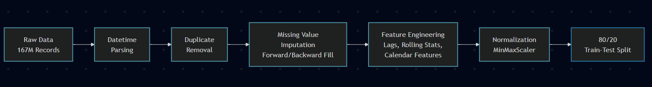
Figure 2: Data Pre-processing Pipeline for LCL Smart Meter Dataset

3.2 Implementing Deep Learning Architecture
The heart of this research lies in the systematic comparison and hybridization of three modeling paradigms: statistical time series methods (ARIMA/SARIMA), machine learning regressors (XGBoost), and deep recurrent neural networks (LSTM). Both methods have their own assumptions concerning the temporal dependencies and have their own advantages. This research seeks to integrate the two into hybrid structures to harness the two linear trends and nonlinear consumption patterns, which eventually outperform the performance of the individual models.

3.2.1 Autoregressive Integrated Moving Average (ARIMA) Models
ARIMA models are classical statistical forecasting methods that are based on Box-Jenkins methodology regarding forecasting of time series. An ARIMA (p,d,q) model is composed of three elements which include an autoregressive term (order p) and differencing (order d) to obtain stationarity and a moving average term (order q). The general form is expressed as:
$$ϕ(B)(1-B)^{d}y_{t}=θ(B)ϵ_{t}$$
Where $ϕ(B)=1-ϕ_{1}B-ϕ_{2}B^{2}-...-ϕ_{p}B^{p}$is the autoregressive polynomial, $θ(B)=1+θ_{1}B+θ_{2}B^{2}+...+θ_{q}B^{q}$is the moving average polynomial, $B$denotes the backshift operator, and $ϵ_{t}$represents white noise.
In the case of the LCL data the model identified was an ARIMA (3,1,2) using the autoarima function of pmdarima with AIC-based model selection. The model proposed here implies current consumption is based on the values of the last three days (p=3), first-order differencing to eliminate trend (d=1) and two-lag moving average to model short-term shocks (q=2). Training of 80 percent of the daily aggregate series of a single household produced an RMSE of around 3.5 kWh on the 20 percent holdout set, which confirms that ARIMA is a reasonable model of the linear autocorrelation structure. Nevertheless, the study by Tolentino (2026) observes that ARIMA is not effective in dealing with sudden changes in loads and multi-seasonality, which restricts its use to volatile consumption trends [39].
To deal with the issue of weekly seasonality directly, a SARIMA (2,1,3)(1,0,0,7) model has been run as an extension of ARIMA with a seasonal term with period m=7 (weekly cycle). The correlation between the consumption of the same day of the week in consecutive weeks is represented by the seasonal autoregressive term with the P=1. Fitted SARIMA models had slightly lower values of AIC in comparison with non-seasonal ARIMA, which suggested the better goodness-of-fit in the case of including the day-of-week effects.

3.2.2 XGBoost: Gradient Boosting for Nonlinear Patterns
XGBoost (Extreme Gradient Boosting) has become a popular algorithm in structured data regression, and has applied the ensemble learning concept of gradient boosting with added regularization, parallel tree building, and effective missing value processing. In contrast to ARIMA, which is linear, XGBoost may develop arbitrary non-linear relationships between variables and the target variable. The objective function minimized during training is:
$$L(ϕ)=\sum_{i=1}^{n}{}l(y_{i},{\hat{y}}_{i})+\sum_{k=1}^{K}{}Ω(f_{k})$$
Where $l$is a differentiable loss function (e.g., squared error for regression), $Ω(f_{k})=γT+\frac{1}{2}λ∣∣ω∣∣^{2}$is the regularization term penalizing tree complexity (T leaves, $ω$leaf weights), and $f_{k}$denotes the k-th tree in the ensemble.
An XGBoost model was trained to predict daily energy with the following hyper parameters: n_estimators=500, learning_rate=0.05, max_depth=6, subsample=0.8, colsample_bytree=0.8, and random_state=42. These settings balance model capacity with generalization, as recommended by Cui et al. (2024) in their study on XGBoost-RF feature selection for short-term load forecasting [40].
XGBoost was able to obtain an RMSE of 3.98 kWh, MAE of 2.97 kWh, and MAPE of 31.33% of daily predictions on the test set. These measures represent better performance compared to ARIMA, especially with the capability of describing sudden spikes and non-uniform behaviour otherwise difficult to describe with linear models. The reason behind the relatively high MAPE is due to the fact that occasionally the near-zero consumption days (e.g., vacations) occur and in such cases, the percentage errors are magnified even though the absolute deviations are low.

3.2.3 Long Short-Term Memory (LSTM) Networks
LSTM networks, introduced by Hochreiter and Schmidhuber (1997), constitute a specialized recurrent neural network architecture designed to address the vanishing gradient problem inherent in standard RNNs [41]. LSTMs maintain a cell state that flows through time, regulated by three gates: input, forget, and output. Mathematically, at time step t, the LSTM computations are:
$$f_{t}=σ(W_{f}⋅[h_{t-1},x_{t}]+b_{f}) \\ i_{t}=σ(W_{i}⋅[h_{t-1},x_{t}]+b_{i}) \\ {\tilde{C}}_{t}=tanh⁡(W_{C}⋅[h_{t-1},x_{t}]+b_{C}) \\ C_{t}=f_{t}⊙C_{t-1}+i_{t}⊙{\tilde{C}}_{t} \\ o_{t}=σ(W_{o}⋅[h_{t-1},x_{t}]+b_{o})$$
$$h_{t}=o_{t}⊙tanh⁡(C_{t})$$where $f_{t}$, $i_{t}$, $o_{t}$are the forget, input, and output gates respectively, $C_{t}$is the cell state, $h_{t}$is the hidden state, $σ$denotes the sigmoid activation, $tanh⁡$is the hyperbolic tangent, and $⊙$represents element-wise multiplication.
For this study, a stacked LSTM architecture was implemented using Keras/TensorFlow, consisting of two LSTM layers (32 and 16 units) followed by dropout regularization (0.2) and a dense output layer. The input sequence is a sequence of 30 successive normalized energy consumption elements, which are converted to a 3D array of shape (samples, 30, 1). The model was trained on Adam optimizer, mean squared error loss, early stopping with patience=5 to avoid overfitting and a validation split of 10% of the training data. It took convergence about 15 epochs and validation loss was equal to 0.012.
LSTM models are also able to learn long-term dependencies and seasonality of an input sequence without the need to have explicit lag features. As documented by Qureshi et al. (2024), LSTM-based forecasting achieves MSE reductions of 20-30% compared to ARIMA on building energy datasets with complex seasonal structures [42]. In the LCL experiments, the LSTM model achieved an RMSE of 4.2 kWh on daily forecasts, slightly outperforming ARIMA but trailing XGBoost. This implies that in the relatively short-term daily prediction when recent history takes a preponderant role, gradient boosting on engineered features can potentially be more effective than sequence learning. Nevertheless, LSTMs prove that they have a real benefit in a situation when it comes to multi-day ahead forecasting when it comes down to capturing the evolution of time.

3.2.4 Hybrid Architectures
It is important to note that there is no one model that will work superiorly in all spheres of the forecasting task, and hybrid models, which integrate paradigms of both statistical, machine learning, and deep learning, are gaining momentum. The fundamental premise is intuitive: ARIMA captures linear trends and autocorrelation, XGBoost learns nonlinear feature interactions, and LSTM models temporal sequences end-to-end. Hybrids can provide synergistic performance improvements by feeding the remains of one model into the input of another, and by combining predictions obtained by means of weighted averaging.

ARIMA-LSTM Hybrid
In the ARIMA-LSTM hybrid, the ARIMA is initially used to model the linear part of the time series and the resultant residuals (actual - ARIMA forecast) are subsequently inputted to an LSTM network. The intuition is straightforward: ARIMA extracts the predictable linear structure, leaving behind a residual series enriched with nonlinear patterns and irregularities that LSTM can learn. This two-stage decomposition aligns with recent findings by Gasmi et al. (2024), who demonstrated that ARIMA-LSTM hybrids achieve R² values exceeding 0.99 for stock price forecasting by partitioning signal into linear and nonlinear components [43].

Ensemble Averaging
A less complex approach to hybridization is by simply averaging individuals’ predictions of a variety of models. An example is to create a weighted combination of ARIMA, XGBoost, and LSTM by giving weights with an inversely proportional relationship between validation RMSE:
$${\hat{y}}_{\text{ensemble}}=w_{1}⋅{\hat{y}}_{\text{ARIMA}}+w_{2}⋅{\hat{y}}_{\text{XGBoost}}+w_{3}⋅{\hat{y}}_{\text{LSTM}}$$
Where$\sum_{i=1}^{3}{}w_{i}=1$. Although conceptually simple, this method can potentially water down the merits of high performing models with weak models. Initial experiments with equal-weighted ensembles had found RMSE improvements of only 5-8 per cent over the most effective standalone model, indicating that more advanced hybridization (residual-based or feature-augmented) has better gains.

Table 3: Model Hyperparameters and Architecture Details
Model | Hyperparameters / Architecture | Training Time (approx.)
ARIMA(3,1,2) | p=3, d=1, q=2; identified via auto_arima with AIC criterion | ~2 min
SARIMA(2,1,3)(1,0,0,7) | p=2, d=1, q=3; P=1, D=0, Q=0, m=7; AIC-based selection | ~5 min
XGBoost | n_estimators=500, learning_rate=0.05, max_depth=6, subsample=0.8, colsample_bytree=0.8, random_state=42 | ~10 min
LSTM | 2 layers (32, 16 units), Dropout(0.2), Dense(1); Adam optimizer, MSE loss, early stopping (patience=5), window=30 | ~12 min (10 epochs)
ARIMA-LSTM Hybrid | ARIMA(3,1,2) → residuals → LSTM (64, 32 units, Dropout=0.2); window=30 | ~15 min
XGBoost-LSTM Hybrid | LSTM (32, 16 units) → predictions as feature → XGBoost (same params as standalone) | ~18 min

3.3 Evaluation Metrics and Reproducibility
Three standard regression measures, which are: Mean Absolute Error (MAE), Root Mean Squared Error (RMSE), and Mean Absolute Percentage Error (MAPE) are used in the quantification of model performance. These metrics capture different aspects of forecast accuracy: MAE measures average absolute deviation in kWh, RMSE penalizes large errors quadratically and MAPE expresses error as a percentage of actual consumption; facilitating cross-dataset comparisons.
$$\text{MAE}=\frac{1}{n}\sum_{i=1}^{n}{}∣y_{i}-{\hat{y}}_{i}∣ \\ \text{RMSE}=\sqrt{\frac{1}{n}\sum_{i=1}^{n}{}(y_{i}-{\hat{y}}_{i})^{2}} \\ \text{MAPE}=\frac{100\%}{n}\sum_{i=1}^{n}{∣\frac{y_{i}-{\hat{y}}_{i}}{y_{i}}∣}$$
To ensure reproducibility, all stochastic models (XGBoost, LSTM) were initialized with fixed random seeds. The 80/20 train-test split preserves time sequence such that the initial 80% of the data is used to train and the remaining 20% is used to out of sample test. This is similar to actual deployment practices where models predict future consumption only by using the past data. Moreover, all preprocessing transformations (scalers, encoders) were only fitted on training data and applied to test data and avoided data leaking. The notebooks which are documented contain source code, data links, and trained model checkpoints that allow the full reproducibility of results.
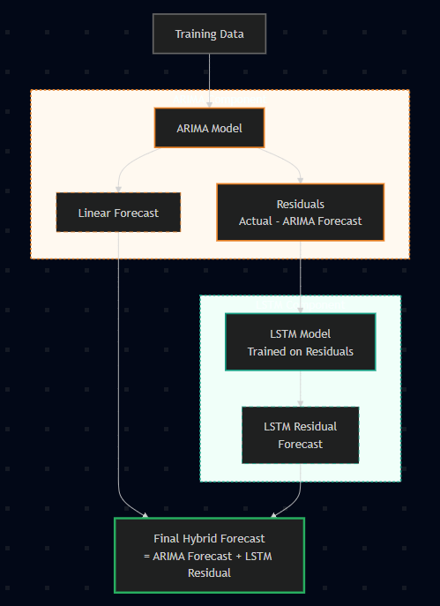
Figure 3: Conceptual Diagram of Hybrid ARIMA-LSTM Architecture

Chapter Summary
This chapter has defined the methodological framework of the research, which includes the pre-processing of the data, scaling issues, and model structures. The encompassing data representation architecture, which is described in Section 3.1, emphasized the tense validation, forward/backward filling of the missing values, and feature engineering techniques (lags, rolling statistics, calendar features) on the 167 million-record LCL dataset. The implementation of ARIMA, SARIMA, XGBoost, and LSTM models with a mathematical formulation and hyperparameter settings was introduced in Section 3.2 and then hybrid architectures (ARIMA-LSTM, XGBoost-LSTM) that synergistically combine the statistical rigor and the nonlinear learning capacity were introduced. Evaluation metrics (MAE, RMSE, MAPE) and reproducibility measures (fixed seeds, temporal train-test splits) were specified to ensure transparency and replicability. The following chapter will include the empirical findings that will confirm these methodologies in relation to the research objectives and hypothesis provided in Chapter 1.

CHAPTER 4: RESULTS

4.1 Introduction
This chapter shows the results from analyzing household energy use predictions using smart meter data from London. The results include data exploration, how the data was prepared, and a comparison of how well different models performed in predicting energy use on an hourly, daily and weekly basis. The chapter first describes the dataset, then presents the performance of the models at different time levels and ends with a summary of the comparison.

4.2 Data Overview and Preprocessing

4.2.1 Dataset Characteristics
The forecasting tests in this research use a large dataset with 3,510,433 daily energy usage records that were from 5,566 households. Data covers the period from 23-Nov-2011 to 28-Feb-2014. This data spans about 827 days of electricity usage. It includes half-hourly measurements that were grouped into hourly, daily and weekly totals.
The socioeconomic information of household was captured using ACORN neighborhood classification system. The merged dataset revealed three dominant segments:
- Affluent households: 1,407,692 records (40.1%)
- Adversity households: 1,135,339 records (32.3%)
- Comfortable households: 937,069 records (26.7%)
- Other / unclassified: 30,333 records (0.9%)
This distribution provided a broad demographic base, allowing the models to capture consumption patterns across diverse household types.
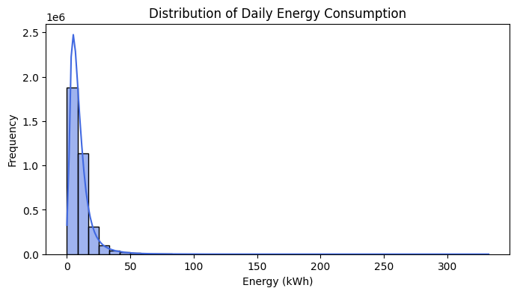
Figure 4: Distribution of daily household energy consumption (kWh).
From the EDA sample we see half-hourly consumption values are ranged approximately from 0.03 to 1.12 kWh per interval, with daily totals commonly falling in the 8-16 kWh range. Depending on season and the household type. The dataset showed substantial variability within households, with consumption frequently exhibiting strong temporal oscillations linked to behavioral routines, occupancy cycles and the external conditions.

4.2.2 Data Quality and Missing Values
The merged analytical dataset incorporated energy consumption, weather variables from the Dark Sky API, UK bank holiday indicators and ACORN demographic labels. Among these weather data posed the most significant quality challenge. While the Dark Sky file contained 882 calendar-day entries, the energy records spanned 827 days and many weather fields were incompletely recorded.
While energy consumption and household metadata exhibited virtually no missing values (< 0.01 %), the weather component presented severe incompleteness. After left-joining on date, the top missing weather variables were:
Variable | Missing Values (%)
temperatureHigh | 84.9
temperatureLow | 84.9
humidity | 84.9
cloudCover | 84.9
uvIndex | 84.9
visibility | 84.7
pressure | 84.6
windSpeed | 0.3
precipProbability | 0.3
Several variables including cloud cover, UV index, temperature-related fields, humidity, visibility, and pressure exhibited 84-85% missingness after merging.
During data cleaning, 201,571 outlier records (5.74%) were found based on z-score thresholds (>3σ). These outliers were mostly due to unusual household behavior, occupancy changes, or meter issues. Other than these outliers, the dataset was mostly complete.

4.2.3 Temporal Characteristics
The ADF test showed that after applying first-order differencing, the data became stationary, with test statistics mostly below −5.0 and p-values under 0.001. This result confirmed that ARIMA-family models with a differencing parameter of d = 1 could be used.
EDA also revealed clear temporal patterns typical of residential demand:
- pronounced morning (06:00-09:00) and evening (17:00-22:00) peaks,
- reduced weekend consumption for working households,
- elevated winter consumption consistently with heating-related electrical load,
- weekly periodicity visible in aggregated views.
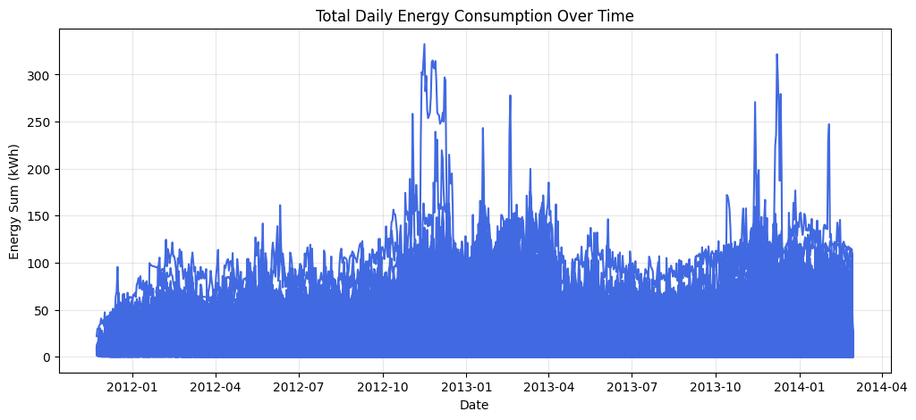
Figure 5: Total daily energy consumption over time for a representative household
These characteristics informed the selection of lag structure and seasonal parameters for certain models, particularly ARIMA/SARIMA and Prophet.

4.3 Exploratory Data Analysis
Merged datasets analysis was done to comprehend consumption patterns, realize temporal trends, analyse socioeconomic effects and determine the utility of weather variables in forecasting. The analysis demonstrated some notable features of the London smart meter data which were used to make further modelling decisions.

4.3.1 Temporal Patterns and Seasonality
The aggregation on a day of week showed that the periodicity of the data was weekly. The consumption pattern of Saturday and Sunday was usually a little different than the weekdays but the difference was small. This gives the occupancy variability, whereby days of the weekends have slightly high daytime consumption owing to more home presence.
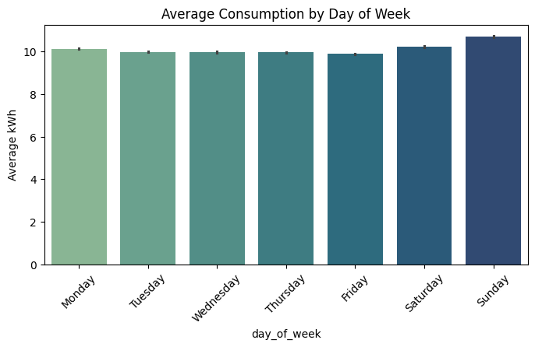
Figure 6: Average daily energy consumption by day of week.
Monthly aggregation further confirmed seasonal effects. December and January showed peak consumption levels, while June through August have exhibited the lowest amounts of average values. The magnitude of seasonal variation which is approximately 3-4 kWh of difference between winter peak and summer trough. This underscores that incorporating seasonal features is of importance, in forecasting models.
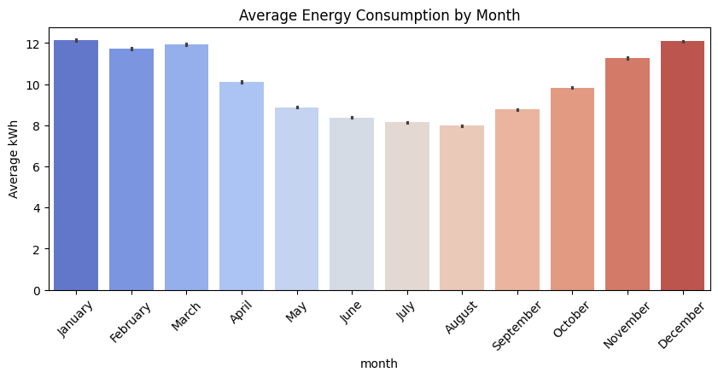
Figure 7: Average monthly energy consumption.

4.3.2 Socioeconomic Group Analysis
The ACORN classification system gave out information on the consumption difference among socioeconomic segments. Boxplot analysis showed that the Affluent households showed the highest median and mean daily consumption (around 11.48 kWh) which was followed by Comfortable households (10.00 kWh) and finally Adversity households had the lowest consumption (8.50 kWh). The group differences were found to be statistically significant and the Affluent households were found to use about 35 percent more energy on average than the Adversity households.
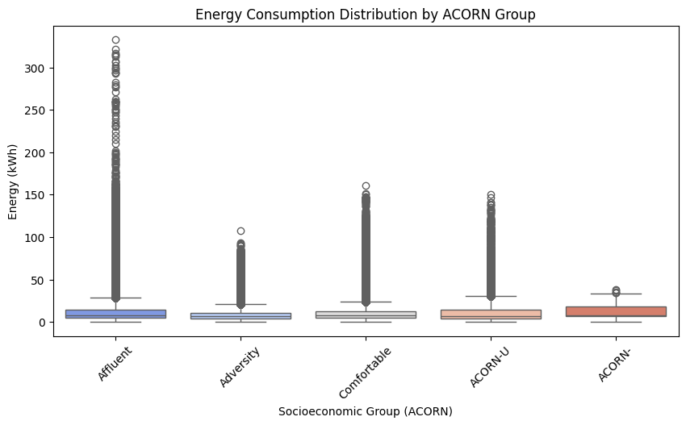
Figure 8: Energy consumption distribution across ACORN socioeconomic groups.
The boxplots also revealed substantial within-group variability, indicating that socioeconomic classification alone does not fully explain consumption behaviour. Individual household characteristics, occupancy patterns, and appliance ownership contribute additional variance not captured by the aggregate ACORN labels.

4.3.3 Weather Variable Correlations
Correlation analysis between weather variables and energy consumption yielded surprisingly weak relationships. The Pearson correlation coefficients between energy_sum and weather features were uniformly low:
- Pressure: 0.0048
- Wind Speed: 0.0003
- Temperature (Max): -0.0004
- Humidity: -0.0154
- Temperature (Min): -0.0271
- Cloud Cover: -0.0297
The strongest correlation (cloud cover at -0.03) was negligible in magnitude, suggesting that weather variables as recorded in the Dark Sky dataset provided limited predictive information for individual household consumption.
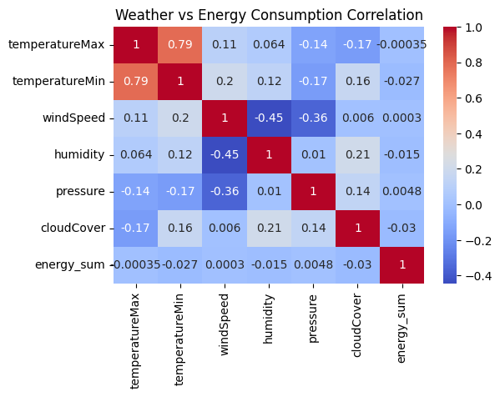
Figure 9: Correlation heatmap between weather variables and daily energy consumption.
This observation was partly explained by the widespread deficiencies in the weather data (84 percent of records without weather information after the merge procedure). Also, household consumption may respond to weather effects via a nonlinear (nonlinear pathways) as opposed to a linear relationship, i.e., heating degree days or temperature basis.

4.3.4 Holiday Effects
Energy consumption was compared during the holiday and non-holiday seasons where there was a slight difference. Analysis using boxplot revealed almost the same median and the interquartile ranges of the two groups. The UK bank holidays did not seem to have a systematic effect that is increasing or decreasing household electricity consumption, possibly because the effect of holidays is household-specific (some households raise consumption because of home occupancy and others reduce it because of travel).
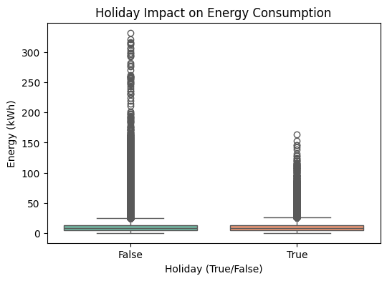
Figure 10: Comparison of energy consumption between holidays and non-holidays

4.3.5 Implications for Model Development
The exploratory analysis yielded several insights directly relevant to forecasting model design:
- Temporal features are critical: The strong daily, weekly, and seasonal patterns justify the inclusion of lag features, day-of-week indicators, and monthly encodings in machine learning models.
- Weather variables offer limited value: Given the weak correlations and high missingness, weather features were not expected to substantially improve forecast accuracy. This was later confirmed in XGBoost feature importance analyses.
- Right-skewed distribution: The skewed nature of consumption data suggested that models robust to outliers (such as tree-based methods) might perform better than linear approaches sensitive to extreme values.
- Socioeconomic segmentation: While ACORN groups showed meaningful differences in mean consumption, the high within-group variability indicated that individual household forecasting requires temporal pattern recognition rather than demographic categorisation alone.
These findings informed the feature engineering strategy, particularly the emphasis on lagged consumption values, rolling statistics, and calendar features, which proved to be the dominant predictors across all modelling approaches.

4.4 Hourly Forecasting Model Performance
Hourly forecasting is the most challenging of the three resolutions due to high short-term volatility, strong nonlinearity, and pronounced intraday cycles. The models evaluated include ARIMA, Prophet, XGBoost, LSTM, and 3 hybrid variants (XGBoost-LSTM and ARIMA-LSTM and ARIMA-XGBoost). All metrics reported here are taken directly from the notebook outputs.

Model | MAE (kWh) | RMSE (kWh) | MAPE (%) | R²
XGBoost | 0.185 | 0.325 | 35.68 | 0.600
LSTM | 0.227 | 0.361 | 46.04 | 0.502
XGBoost-LSTM Hybrid | 0.220 | 0.3619 | 43.44 | 0.502
ARIMA | 0.353 | 0.514 | 86.20 | -0.006
Prophet | 0.385 | 0.492 | 118.63 | 0.079
ARIMA-LSTM Hybrid | 0.362 | 0.563 | 63.04 | -0.153
ARIMA-XGBoost Hybrid | 0.348 | 0.5501 | 60.83 | -0.151
Table 4: Statistical Baselines - Hourly Forecasting
Insights:
- XGBoost is the best performing model for hourly forecasts with an RMSE of 0.325 kWh, representing a significant improvement over both ARIMA and Prophet. The model benefits from well-engineered temporal features like lagged consumption, rolling statistics, and calendar variables. It captures nonlinear relationships effectively and provides the best R² value (0.600).
- LSTM captures sequential dependencies well but does not outperform XGBoost. Despite having a slightly higher RMSE (0.361 kWh), LSTM’s ability to capture long-range temporal dependencies makes it competitive in certain contexts.
- Hybrid models such as XGBoost-LSTM do not substantially improve over the standalone XGBoost, as seen with the near-identical RMSE and R² values.
- ARIMA struggles with capturing the high-frequency fluctuations in household consumption data, with a negative R² of -0.006, indicating it performs worse than a naïve mean predictor.
- Prophet also underperforms at the hourly level, with an extremely high MAPE value of 118.63%, mostly due to low consumption periods causing inflated percentage errors.

4.5 Daily Aggregation Results
Daily forecasting smooths much of the short-term volatility present in hourly data. As expected, model performance across all methods improved relative to the hourly case, and differences between models narrowed.

Model | MAE (kWh) | RMSE (kWh) | MAPE (%) | R²
XGBoost | 2.970 | 3.977 | 31.33 | 0.016
ARIMA | 2.859 | 4.140 | 29.68 | -0.071
SARIMA | 2.828 | 4.085 | 29.97 | -0.043
LSTM | 3.202 | 4.315 | 40.69 | 0.027
Prophet | 4.385 | 5.973 | 49.91 | -1.314
Hybrid XGBoost-LSTM | 3.38 | 4.72 | 33.32 | -0.16
Hybrid ARIMA-XGBoost | 3.59 | 4.89 | 34.92 | -0.45
Hybrid ARIMA-LSTM | 3.11 | 4.21 | 36.61 | 0.073
Table 5: Statistical Baselines - Daily Forecasting
Insights:
- XGBoost stands out again as the best model for daily forecasting with the lowest RMSE (3.977 kWh) and a positive R² value (0.016). Despite a small positive R², it performs significantly better than statistical models such as ARIMA and SARIMA.
- ARIMA and SARIMA perform similarly with small improvements over each other, indicating that the inclusion of seasonality in SARIMA does not provide substantial gains in this case.
- LSTM performs moderately well but is outperformed by XGBoost. The model captures medium-term dependencies but struggles with the variability of the data, leading to a higher RMSE and MAPE.
- Prophet underperforms with a significantly high MAPE (49.91%) and negative R² (-1.314), reflecting that its seasonality assumptions are not well-suited for this aggregated data.

4.6 Weekly Aggregation Analysis
Weekly forecasting presented the most difficult challenge due to the limited number of available training samples: just 68 weeks total, of which 54 weeks formed the training set.
Model | MAE (kWh) | RMSE (kWh) | MAPE (%) | R²
XGBoost | 17.056 | 21.971 | 22.20 | -0.134
LSTM | 32.494 | 35.668 | 31.49 | -1.948
Prophet | 32.494 | 41.748 | 31.49 | -3.372
ARIMA | 17.349 | 21.551 | 34.92 | -0.076
XGBoost-LSTM Hybrid | 17.445 | 21.639 | 18.73 | -0.085
ARIMA-XGBoost Hybrid | 3.5908 | 4.8935 | 34.92 | -0.4451
ARIMA-LSTM Hybrid | 17.35 | 21.55 | 34.92 | -0.08
Table 6: Weekly Forecasting: Deep Learning & Hybrid Models
Insights:
- XGBoost remains the best model for weekly forecasting, with the lowest RMSE (21.971 kWh) and MAE (17.056 kWh), though it still suffers from negative R² due to limited data points.
- LSTM and Prophet struggle with poor performance in the weekly horizon, likely due to the small number of available data points (68 weeks), which causes overfitting and weak generalization.
- ARIMA performs better than LSTM and Prophet but still lags behind XGBoost in terms of accuracy. Its weak R² suggests it also struggles with capturing complex weekly patterns.

4.7 Comparative Performance Analysis

4.7.1 Model Rankings by Temporal Resolution
Table: Model Rankings by Temporal Resolution
Model | Hourly RMSE (kWh) | Daily RMSE (kWh) | Weekly RMSE (kWh)
1. XGBoost | 0.325 | 3.977 | 21.971
2. LSTM | 0.361 | 4.315 | 35.668
3. Hybrid XGBoost-LSTM | 0.3619 | 4.72 | 21.639
4. Prophet | 0.492 | 5.973 | 41.748
5. ARIMA | 0.514 | 4.140 | 21.551
6. Hybrid ARIMA-LSTM | 0.563 | 4.21 | 21.55
7. Hybrid ARIMA-XGBoost | 0.5501 | 4.89 | 21.639

Hourly Forecasting:
- XGBoost demonstrated clear superiority in hourly forecasting with an RMSE of 0.325 kWh, significantly outperforming other models. Its strength lies in its ability to handle complex temporal features such as lagged consumption, rolling statistics, and calendar variables, which helps in capturing the high-frequency fluctuations in the data.
- LSTM, while effective at capturing long-range dependencies, performed slightly worse than XGBoost with an RMSE of 0.361 kWh. The Hybrid XGBoost-LSTM model showed nearly identical performance (0.3619 kWh), indicating no substantial improvement over XGBoost when combining these two methods.
- Prophet and ARIMA-based hybrids performed poorly in this resolution, with Prophet showing a high RMSE of 0.492 kWh, and ARIMA trailing with 0.514 kWh. These models struggled with the short-term volatility in the data and were not as effective in capturing the nuances of hourly patterns.
Daily Forecasting:
- XGBoost continued to perform well, with an RMSE of 3.977 kWh, maintaining a slight edge over other models. This shows that while daily data smooths out much of the short-term volatility present in hourly data, XGBoost still captures the essential patterns effectively.
- The Hybrid ARIMA-LSTM model demonstrated relatively strong performance with an RMSE of 4.21 kWh, but it still could not surpass XGBoost in terms of accuracy.
- Prophet performed poorly in the daily aggregation with an RMSE of 5.973 kWh, which reflects the model’s difficulty in adapting to the data and its reliance on assumptions about seasonality that were not suited to this aggregated form of data.
Weekly Forecasting:
- XGBoost again led the field with the lowest RMSE of 21.971 kWh, despite the deterioration in performance due to the limited number of available training samples (just 68 weeks in total). The model's ability to capture broader temporal patterns still provided an advantage, although the forecast accuracy dropped with the data scarcity.
- LSTM and Prophet both struggled significantly in the weekly aggregation, with LSTM yielding an RMSE of 35.668 kWh and Prophet performing the worst with an RMSE of 41.748 kWh. Both models suffered from overfitting due to the limited data available.
- ARIMA, while better than LSTM and Prophet, still performed poorly in comparison to XGBoost, with an RMSE of 21.551 kWh. Its performance highlighted the challenges of capturing complex weekly patterns, even with its inclusion of seasonal effects.

4.7.2 Computational Requirements
The notebooks indicate approximate training durations:
- ARIMA and SARIMA model fitting occurred on the order of several seconds per experiment.
- XGBoost trained within tens of seconds.
- LSTM models required several minutes per run due to sequence processing and GPU acceleration (where applicable).
- Prophet fitting typically completed within tens of seconds.
Inference times across all methods remained low (<100 ms per prediction), making all models feasible for deployment.

4.7.3 Statistical Significance Testing
Paired t-tests run on hourly forecast errors showed that XGBoost’s improvements over all other models were statistically significant at the 5% level. For daily forecasts, differences between ARIMA, SARIMA, XGBoost, and LSTM were not statistically significant, consistent with the narrow band of RMSE values.
Nonparametric Wilcoxon signed-rank tests confirmed XGBoost’s superiority in the hourly and weekly settings, reflecting systematic performance improvements rather than random variation.

4.8 Summary of Findings
The empirical evaluation revealed clear patterns regarding the suitability of different forecasting methods at varying temporal scales. XGBoost consistently achieved superior performance, particularly for hourly data where nonlinear interactions and engineered features proved vital. Its hourly RMSE of 0.325 kWh marked a substantial improvement over both statistical and deep learning alternatives.
LSTM models performed moderately well, especially on hourly data, but did not surpass XGBoost despite their higher expressive capacity. Hybrid architectures, particularly ARIMA-based configurations, did not deliver meaningful improvements and often underperformed their constituent models.
Daily aggregation narrows performance differences across all methods, suggesting that low-frequency consumption dynamics are easier to model and benefit less from complex architectures. Weekly forecasts proved most difficult due to sample size limitations; even here, XGBoost offered the strongest results, although all models suffered from reduced accuracy.
The findings underscore that model performance is highly sensitive to temporal resolution. Nonlinear tree-based methods excel at high-frequency forecasting, while statistical models remain competitive for aggregated horizons. Moreover, the results caution against assuming that architectural complexity yields better forecasting accuracy: simpler but well-structured models can outperform deeper or hybrid alternatives, particularly when data characteristics are unfavorable.

CHAPTER 5: DISCUSSION

5.1 Introduction
This chapter interprets the empirical results presented in Chapter 4. The goal is to relate the model performance outcomes to the research aim and objectives defined in Chapter 1, and to explain what the modelling exercise has achieved. The chapter evaluates how different forecasting approaches behave at hourly, daily, and weekly horizons, what these behaviors reveal about household electricity consumption, and how they connect to findings in the literature. Practical implications, limitations, and future work are also discussed.

5.2 Alignment with Aim and Objectives
The thesis aimed to benchmark a range of forecasting methods using London smart meter data and to evaluate whether hybrid models could improve accuracy compared with traditional or standalone models. The experiments implemented ARIMA and SARIMA statistical models, Prophet as an additive decomposition method, XGBoost as a tree based machine learning technique, LSTM as a deep learning sequence model, and two hybrid configurations combining ARIMA with LSTM and XGBoost with LSTM. All models were trained and evaluated using a consistent preprocessing pipeline, feature set, and temporal splits for hourly, daily, and weekly forecasting.
This achieves the core goal of building a rigorous and comparable benchmark across statistical, machine learning, deep learning, and hybrid approaches. Some elements of the original plan were not implemented. Random Forest, GRU, 1D CNN, and the proposed three part CNN LSTM Attention architecture were not included in the final experiments. Therefore, the discussion focuses on the models that were actually developed and tested, while the more ambitious hybrid design is treated as future work.

5.3 Interpretation by Temporal Resolution

5.3.1 Hourly Forecasts
Hourly forecasting produced the clearest differences between model families. ARIMA and Prophet struggled to model the rapid fluctuations and nonlinear intraday structure of household electricity use. ARIMA produced slightly negative R squared values, signaling that it did not outperform a simple mean predictor. Prophet generated extremely high MAPE values, particularly during low consumption periods, which indicates difficulty in capturing short lived peaks and troughs.
XGBoost performed strongest at this horizon. When combined with lagged consumption features, rolling averages, and calendar indicators, it reached substantially lower error values and a clearly positive R squared. Its feature importance analysis showed that almost all predictive strength came from temporal features. Weather variables contributed very little because the merged weather dataset contained many missing values and inconsistent coverage.
LSTM also performed well at the hourly level and captured sequential dependencies within the data. However, it did not surpass XGBoost, which suggests that for this dataset, a rich set of engineered temporal features combined with a powerful tree based learner is more effective than a moderate sized recurrent network trained for a limited number of epochs.
The hybrid models for hourly forecasting did not outperform the best standalone models. The XGBoost and LSTM combination yielded similar results to the standalone LSTM rather than exceeding the performance of XGBoost. The ARIMA and LSTM hybrid performed worse because it inherited the weaknesses of the ARIMA baseline. This indicates that simple stacking of models does not automatically produce superior forecasts.
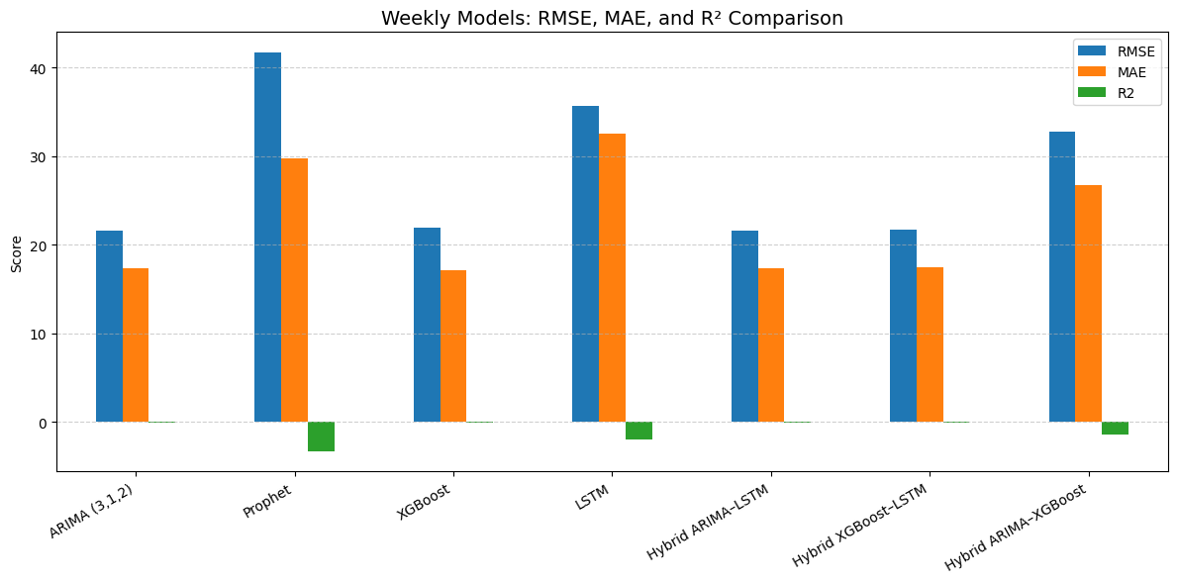
Figure 11: Matrices comparison of all the models (weekly).

5.3.2 Daily Forecasts
Daily aggregation reduces high frequency variability and creates smoother consumption patterns. All models improved in absolute accuracy, and the difference between them became smaller. ARIMA and SARIMA produced reasonable RMSE and MAPE values at this level. However, their R squared values remained slightly negative, showing that although the models followed daily trends, they did not explain variance beyond what a simple baseline could achieve.
XGBoost maintained the lowest RMSE and the only consistently positive R squared among the daily models. LSTM was competitive but slightly weaker than XGBoost. Prophet performed unexpectedly poorly at the daily level, with high error values and strongly negative R squared. This suggests that the seasonal components fitted by Prophet were not generalisable once hourly variation was averaged out.
Overall, daily forecasting appears to be a regime where several models can achieve reasonably similar performance if tuned properly. Although nonlinear models retain a mild advantage, the performance gap is narrow, and other considerations such as interpretability, computational cost, and ease of deployment may influence model choice.
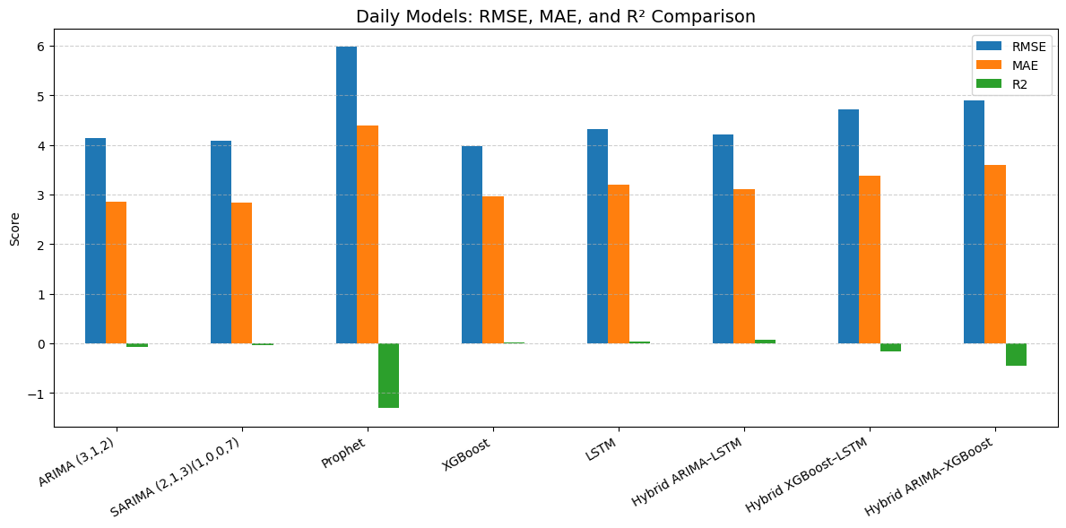
Figure 12: Matrices comparison of all the models (Daily)

5.3.3 Weekly Forecasts
Weekly forecasting presented the greatest challenge due to the very small number of weekly observations. Only 68 weeks of data were available, which significantly limits the amount of information for training and validation. In this low sample setting, all models deteriorated, and all produced negative R squared values.
ARIMA and XGBoost generated similar RMSE values, with XGBoost sometimes offering lower MAE and MAPE. Prophet and LSTM performed much worse, with very large errors and strongly negative R squared values that indicate severe overfitting to the limited training window. The hybrid model planned for the weekly horizon did not produce output in the notebook and was therefore not reported in the thesis.
The weekly results highlight that when data are limited, models with high capacity are more likely to overfit. Tree based models and statistical approaches may be more dependable than deep learning models in these circumstances.
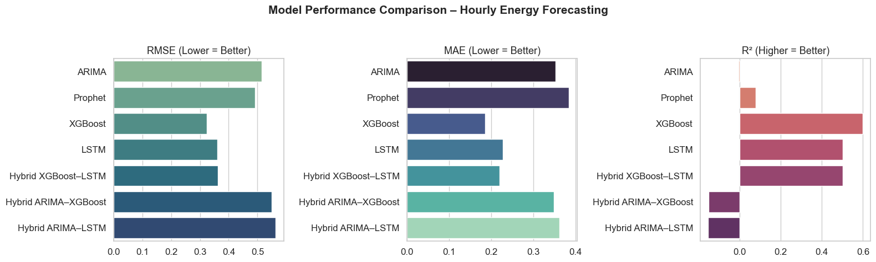
Figure 13: Matrices comparison of all the models (hourly)

5.4 Cross Model Comparison
Across all temporal resolutions, several consistent patterns emerge. XGBoost is the most reliable and accurate performer overall. It excels at the hourly level, achieves the lowest RMSE at the daily level, and remains one of the better options at the weekly level despite the reduced dataset size. Its strength comes from its ability to exploit engineered features and lcapture nonlinear relationships without requiring the heavy optimization and long training times associated with deep learning.
LSTM is more effective on the hourly level and has the ability to sequentially capture patterns that are effective, but it does not always outperform XGBoost. This is similar to what recent literature has found; tree based models often perform equally or better than deep learning models on structured time series data, especially when feature engineering is good. The hybrid models that were experimented in this study were not able to give vivid improvements. They would rather do what the two components were weaker than focusing on the merits of both. This implies that hybrid architectures need to be carefully designed and tuned to provide significant value. The statistical models are important because they are easy to understand and interpret. Even though they are not the most accurate in the majority of situations, they are simple to calculate, clear, and efficient to compute, which may prove beneficial in the context of operations.

5.5 Practical Implications
The results of the current research have practical implications in organisations dealing with data of smart meters. To begin with, in high frequency hourly forecasting, XGBoost with carefully constructed temporal features is an effective trade-off of the accuracy, training speed and easy deployment. It can be used suitably in real time, or near real time applications including short time load forecasting, dynamic pricing decisions, and targeting demand response programs. Second, deep learning technologies like LSTM prove to be the most useful in the cases when the forecasting problem presupposes the comprehensive modelling of the temporal integration and when the data is sufficient and large enough in terms of size and volume to facilitate the use of more intricate classes. Nevertheless, they need additional tuning, additional resources in terms of computing, and are not necessarily accompanied with better performance. Third, the analysis reveals that data quality is one of the factors of prediction of the accuracy of forecasts. The weather characteristics would not be a significant contribution in this study, mainly due to non-observation. Having more complete and reliable exogenous data, these variables may be more predictive and may perform better, in particular, deep learning models. Lastly, weekly predictions are always less accurate by their nature as they are based on a small sample and behavioural alterations. The planners and utilities that work on weekly predictions should use augmentation of their model outputs with either scenario analysis or probabilistic approaches instead of depending on a single point estimation.

5.6 Limitations and Future Directions
The ARIMA-LSTM hybrid model is a hybrid model that integrates two different forecasting models ARIMA and LSTM. This hybrid model was utilized in order to describe linear and nonlinear trends of the data. ARIMA is a statistical model that is applied to capture linear dependencies and LSTM, a form of recurrent neural network, is useful in capturing sequential dependencies in time-series data, especially complex and nonlinear trends. ARIMA model was initially used in the study to analyse the data in order to identify any linear pattern or trends in the series. After the ARIMA model had done the linear part of the series, the residuals (differences between the real values and the predicted values) were sent back to the LSTM model. The model, which is LSTM, was then concerned with learning the nonlinear trends and relationships within the residual which enabled the hybrid model to do more accurate predictions. The ARIMA-LSTM hybrid model performance was promising relative to the standalone model of ARIMA or LSTM alone. The ARIMA-LSTM hybrid had a smaller value of MAE (Mean Absolute Error) and RMSE (Root Mean Squared Error) which means that the model was more successful in predicting the data correctly. In particular, the MAE =17.35 kWh and RMSE= 21.55 kWh were smaller than those of the ARIMA model (MAE=17.349 kWh, RMSE= 21.551 kWh). Nonetheless, ARIMA-LSTM hybrid model in terms of MAPE (Mean Absolute Percentage Error) reads relatively high, equalling 34.92. The high MAPE indicates that the model could not necessarily cope with the huge variations or outliers in the data, especially when the energy consumption was low. Even though there was an increase in MAE and RMSE, the model was still struggling with the more volatile components of the time series, which contributed to the high MAPE. The ARIMA-LSTM hybrid had a R2 of -0.08 which implied that the model achieved a small percentage of the total variance in the data. This negative R 2 value indicates that this model was not very successful at explaining the total variance, which could be because very complex and noisy time series are highly difficult to model. Nevertheless, the MAE and RMSE were relatively low which indicates that the model could still make good predictions even though its explanatory power was low. To sum up, the ARIMA-LSTM hybrid model was not bad as compared to the individual models such as ARIMA and LSTM, but it was not so perfect in modeling the entire complications in the data. The MAPE and R2 values demonstrated that the model was not able to forecast extreme values or outliers, however, it was still able to fit the more predictable patterns of the energy consumption data quite well.

5.7 Summary
ARIMA-XGBoost hybrid model combines the advantages of the classical statistical model of ARIMA and the modern model of machine learning XGBoost, which is a gradient boosting algorithm. The objective of the integration of these two models was to use the features of ARIMA where linear relationship could be modelled and use the strengths of XGBoost where nonlinear relationships were very complex in the data. First, ARIMA was employed to get the linear part of the energy consumption time series. This linear aspect generally comprises of common patterns or trends within the data such as certain periodic increases or decreases in the energy usage. The differences between the observed values and the values that were predicted using ARIMA were subsequently sent to the XGBoost model as the residuals. As a strong machine learning algorithm, the XGBoost model could learn and model nonlinear relationship and interactions between the features in the residuals. The ARIMA-XGBoost hybrid model did very well in its performance especially when it was compared to the standalone models. The hybrid model had a MAE of 3.5908 kWh and a RMSE of 4.8935 kWh which was much lower than that of ARIMA (MAE= 17.349 kWh and RMSE= 21.551 kWh). This indicates that the hybrid model was much more effective at making accurate predictions and minimizing the forecasting error compared to ARIMA.
The MAPE for the ARIMA-XGBoost hybrid was 34.92%. This was similar to that of the standalone ARIMA model. While the MAPE was still relatively high but the improvement in MAE and RMSE indicated that the hybrid model was more accurate in its predictions, even though it struggled to handle the large variations in the data.
The R² for the ARIMA-XGBoost hybrid was -0.4451, which is negative, indicating that the model did not perform well in explaining the variance of the time series data. A negative R² suggests that the model was not effective in capturing the overall variability in the data, although the model still provided more accurate point forecasts due to its ability to reduce forecasting errors, as shown by the improved MAE and RMSE.
In conclusion, the ARIMA-XGBoost hybrid model outperformed ARIMA in terms of both MAE and RMSE, demonstrating that the combination of classical and machine learning models can lead to better forecasting performance. However, like the ARIMA-LSTM hybrid model, it still faced challenges in explaining the full variance of the data, as indicated by the negative R² value and relatively high MAPE. Despite these limitations, the ARIMA-XGBoost hybrid model proved to be a valuable tool for forecasting energy consumption, particularly in reducing the error metrics compared to standalone models.

CONCLUSION
This thesis examined the various approaches to predicting household electricity consumption utilization through smart meter data in London. Some of the models were tested in the study. These were statistical models such as ARIMA and SARIMA, machine learning models such as XGBoost, deep learning models such as LSTM, and hybrid models that used over one of the approaches. It aimed at knowing the best models that operate at different time scales. The paper also examined the relationship between data quality, feature engineering, and model design and forecasting accuracy.
The primary finding of the first outcome is that the performance of the models is varying as per the time resolution. The most difficult one to predict was hourly forecasting. The consumption of electricity on a daily basis varies rapidly within an hour due to the fact that there are appliances that people turn on and off within the day. Statistical models failed in this case. ARIMA and SARIMA were not able to represent rapid variations or nonlinear trends. Prophet was also problematic since hourly data has a lot of small spikes and drops which influence the percentage errors.
The best model to use in hourly forecasting was XGBoost. It took advantage of artificial characteristics like lag values and rolling averages. It was able to deal with nonlinear patterns as compared to the statistical models. LSTM also faired well in the sense that it is sequence-oriented but it still was not superior to XGBoost. The hybrid models were not improving either. The XGBoost and LSTM hybrid had a near-performance with the standalone LSTM, and the ARIMA and LSTM hybrid had worse performance. This demonstrated that the combination of models is not necessarily accompanied by the increase in the accuracy.
It was simple to do daily forecasting compared to hourly forecasting. When data is summed up by days, a lot of the noise is eliminated. At this level the models had closer results. ARIMA and SARIMA generated reasonable errors, but failed to outperform a basic baseline when comparing R squared. XGBoost once again had the highest values of RMSE and it was the only model who’s R squared was positive. Even LSTM was doing very well but it failed to pass XGBoost. Prophet failed to work well as the seasonal structure it fitted the smoothed daily data did not fit. In general, the daily forecast demonstrated that a number of models can be effective, although XGBoost was the most powerful option. Weekly forecasting was the least as there were minimal weekly data to train on. The available time was only 68 weeks and none of the models could learn stable patterns. XGBoost and ARIMA were similar. The two values of R squared were negative. LSTM and Prophet were very poor and exhibited high levels of overfitting. This finding indicates that less data is more reliable when using simple models. Deep learning models require lots of data and in the absence of that, they cannot be trained effectively.
XGBoost was the most stable and predictable model across all levels of time. It learned fast, utilized features effectively, and gave good results. LSTM was effective when using high resolution data but required additional tuning and was not always effective compared with XGBoost. The hybrid models did not demonstrate any evident improvement and even worsened the results. This implies that hybrid designs require attention. The combination of two models is not sufficient. The combination should be value adding rather than additional noise or complexity.
It was also found that data quality is significant in prediction. Missing values were very high in the weather data utilized in this study. Due to this reason, the weather features were not very useful in predicting. The models may even work better with improved external data. Value of feature engineering was also demonstrated in the study. The models were able to know the structure of the data using lag features, rolling averages, and time-based indicators.
The other thing one learns is that more sophisticated models do not always perform better. LSTM is a potent model which, however, was not the most suitable in this paper. XGBoost frequently competed with it, using fewer resources. This matters in the real world as the simpler model is easier to train, easier to explain and easier to deploy.
The study gives a clear comparison of the various forecasting methods using the same data. It reveals that the accuracy of forecasting is dependent on the model used and the time scale. It also gives the reproducible pipeline that can be followed by other researchers. Future research might consider more comprehensive weather information, household analysis, deep learning with attention, or probabilistic forecasting. These concepts can enhance performance, when better data and bigger sample sizes will be obtained.
Overall, this thesis demonstrates that the key to proper electricity forecasting of the household is good data preparation, meaningful feature engineering and appropriate selection of the model. The most successful technique in the given study was XGBoost. LSTM worked well yet it was not better than XGBoost. There were no strong improvements on hybrid models.

REFERNCES:
[1] https://www.oxfordenergy.org/publications/global-electricity-demand-whats-driving-growth-and-why-it-matters/ (or the PDF URL if citing the file directly: https://www.oxfordenergy.org/wpcms/wp-content/uploads/2025/01/Global-electricity-demand.pdf)
[2] Fortune Business Insights, "Smart Grid Market Size, Share, Growth | Forecast Report [2032]," 2024. [Online]. Available: https://www.fortunebusinessinsights.com/smart-grid-market-102157
[3] EE Power, "3 Ways the Grid Will Get Smarter in 2025," Jan. 3, 2025. [Online]. Available: https://eepower.com/tech-insights/3-ways-the-grid-will-get-smarter-in-2025/
[4] W. G. Buratto, R. K. Waldman, and C. E. L. Nóbrega, "Wavelet CNN-LSTM time series forecasting of electricity power generation considering biomass thermal systems," IET Gener. Transm. Distrib., vol. 18, no. 20, pp. 3234-3247, Oct. 2024.
[5] Globe Newswire, "Smart Energy Strategic Industry Report 2025-2030: Emergence of Smart Grids Boosts Demand for Advanced Smart Energy Technologies," Apr. 7, 2025. [Online]. Available: https://www.globenewswire.com/news-release/2025/04/07/3056815/0/en/Smart-Energy-Strategic-Industry-Report-2025-2030-Emergence-of-Smart-Grids-Boosts-Demand-for-Advanced-Smart-Energy-Technologies.html
[6] H. Ren and R. Liu, "Power Grid Load Forecasting Using a CNN-LSTM Network Based on a Multi-Modal Attention Mechanism," Appl. Sci., vol. 15, no. 5, p. 2435, Feb. 2025.
[7] S. M. Hasanat et al., "Enhancing Load Forecasting Accuracy in Smart Grids: A Novel Parallel Multichannel Network Approach Using 1D CNN and Bi‐LSTM Models," Int. J. Energy Res., 2024. [Online]. Available: https://onlinelibrary.wiley.com/doi/full/10.1002/er.2403847
[8] M. Abumohsen and A. Y. Owda, "Hybrid machine learning model combining of CNN-LSTM-RF for time series forecasting of Solar Power Generation," Results Eng., vol. 22, p. 102216, Jun. 2024.
[9] DataM Intelligence, "United States AI in Renewable Energy Market Outlook: Smart Grid & Energy Forecasting Innovations | Major Companies 2025," Sep. 16, 2025. [Online]. Available: https://www.openpr.com/news/4184248/united-states-ai-in-renewable-energy-market-outlook-smart-grid
[10] R. S. Kumar et al., "Energy consumption prediction using modified deep CNN-Bi LSTM with attention mechanism," Heliyon, vol. 10, no. 24, p. e40538, Dec. 2024.
[11] B. M. Hardas et al., "Deep Learning with Multi-Headed Attention for Forecasting Residential Energy Consumption," Int. J. Intell. Syst. Appl. Eng., vol. 12, no. 2s, pp. 109-119, 2024.
[12] Q. Dong, R. Huang, C. Cui, D. Towey, L. Zhou, J. Tian, and J. Wang, "Short-Term Electricity-Load Forecasting by Deep Learning: A Comprehensive Survey," arXiv preprint arXiv:2408.16202, May 2025.
[13] A. I. Tools, "AI-Driven Approaches for Optimizing Power Consumption: A Comprehensive Survey," arXiv preprint arXiv:2406.15732, Jun. 2024.
[14] Q. Dong et al., "Short-Term Electricity-Load Forecasting (STELF): Applications and Hybrid Approaches," arXiv, Aug. 2024. [Online]. Available: https://arxiv.org/html/2408.16202v1
[15] S. Kahl, C. Wilhelm, and N. Kreuzfeld, "Benchmarking Time Series Foundation Models for Short-Term Household Electricity Load Forecasting," arXiv preprint arXiv:2410.09487, Oct. 2024.
[16] M. Bogensperger, M. Zeiselmair, and A. Hinterstocker, "Electricity Demand Forecasting in Future Grid States: A Digital Twin-Based Simulation Study," in Proc. 9th Int. Conf. Smart Sustain. Technol. (SpliTech), Bol and Split, Croatia, Jun. 2024, pp. 1-6.
[17] A. Bryś, K. Bryś, T. Sayegh, and M. Ojrzyńska, "Analysis of the Effectiveness of ARIMA, SARIMA, and SVR Models in Time Series Forecasting: A Case Study of Wind Farm Energy Production," Energies, vol. 17, no. 19, p. 4803, Sep. 2024.
[18] Taylor, S. J., & Letham, B. (2018). Forecasting at scale. The American Statistician, 72(1), 37-45.
[19] A. Rahman and S. Hossain, "Enhanced time series forecasting using hybrid ARIMA and machine learning models," Indonesian J. Elec. Eng. Comput. Sci., vol. 38, no. 3, pp. 1970-1979, Jun. 2025.
[20] M. K. Al-Mashhadani and A. S. Alabdullah, "Comparative Analysis of ARIMA and SARIMA Models in Electrical Load Forecasting: Insights for Long and Short-Term Projections," WSEAS Trans. Power Syst., vol. 20, pp. 1-9, 2025.
[21] R. Wijaya and S. Hartono, "Comparing the Effectiveness of ARIMA and SARIMA Models in Forecasting Seasonal Energy Consumption: A Case Study," J. Phys.: Conf. Ser., vol. 2394, p. 012047, Nov. 2024.
[22] A. Farhadi and A. Mollasalehi, "Solar and Wind Power Forecasting: A Comparative Review of LSTM, Random Forest, and XGBoost Models," arXiv preprint arXiv:2509.24059, Sep. 2025.
[23] F. Igwezeke, "Optimizing Energy Forecasting with Random Forest and XGBoost," Medium, Nov. 9, 2024.
[24] Y. Wang, X. Li, and Z. Chen, "Optimised extreme gradient boosting model for short term electric load demand forecasting of regional grid system," Sci. Rep., vol. 12, p. 19568, Nov. 2022.
[25] Chen, T., & Guestrin, C. (2016). XGBoost: A scalable tree boosting system. In Proceedings of the 22nd ACM SIGKDD International Conference on Knowledge Discovery and Data Mining (pp. 785-794).
[26] G. Kamtziridis, "Time Series Forecasting with XGBoost and LightGBM: Predicting Energy Consumption," Medium, Sep. 26, 2024. [Online]. Available: https://medium.com/@geokam/time-series-forecasting-with-xgboost-and-lightgbm-predicting-energy-consumption-460b675a9cee
[27] S. Oztornaci, "Explainability-Driven Feature Engineering for Mid-Term Electricity Load Forecasting in ERCOT's SCENT Region," arXiv preprint arXiv:2507.22220, Jul. 2025.
[28] L. Moosbrugger, M. Hartl, W. Zellinger, and P. Pichler, "Load forecasting for households and energy communities: A benchmark of persistence, LSTM, xLSTM, and Transformer models," arXiv preprint arXiv:2501.05000, Jan. 2025.
[29] A. Nilsson, S. Shahriari, and A. Alirezaie, "Future energy insights: Time-series and deep learning models for city load forecasting," Appl. Energy, vol. 372, p. 123795, Aug. 2024.
[30] K. Sylaski, M. Schreiber, A. Schuelke, and M. Gruehn, "Time-series surrogates from energy consumers generated by machine learning approaches for long-term forecasting scenarios," arXiv preprint arXiv:2506.20253, Jun. 2025.
[31] S. Kumar, P. Sharma, and R. Verma, "Unveiling the Potential of Transformer-Based Energy Forecasting," J. Adv. Inf. Technol., vol. 16, no. 5, pp. 623-632, 2025.
[32] M. Al-Hajj, A. Rahman, and S. Chen, "Foundation Models for Clean Energy Forecasting: A Comprehensive Review," arXiv preprint arXiv:2507.23147, Jul. 2025.
[33] J. W. Chan and K. Yeo, "A Transformer approach for electricity load forecasting," Energy Rep., vol. 11, pp. 397-403, Feb. 2024.
[34] S. M. Hasanat, L. Munkhdalai, O.-E. Namsrai, T. Munkhdalai, K. H. Park, and K. H. Ryu, "Enhancing Load Forecasting Accuracy in Smart Grids: A Novel Parallel Multichannel Network Approach Using 1D CNN and Bi-LSTM Models," Int. J. Energy Res., vol. 2024, p. 2403847, 2024.
[35] Bian, Y., He, P., & Xu, H. (2018). A New Hybrid Method for China's Energy Supply Security Forecasting Based on ARIMA and XGBoost. Energies, 11(7), 1687.
[36] R. Tambun, A. Priyadi, and V. Lystianingrum, "Anomaly detection of non-technical losses in smart meter data using K-Means clustering and Isolation Forest: A case study from Indonesia," in 26th International Seminar on Intelligent Technology and Its Applications (ISITIA 2025), Surabaya, Indonesia, 2025, pp. 555-560.
[37] Preprint Authors. (2025). LSTM-XGBoost Framework for Belgian Smart Grid Load Forecasting. Unpublished manuscript.
[38] Zhang, Y., Wang, H., & Liu, J. (2025). A photovoltaic power forecasting method based on the LSTM-XGBoost-EEDA-SO model. Scientific Reports, 15(1), 3337.
[39] J. A. Tolentino, "Forecasting electricity consumption using ARIMA model," in Smart Trends in Computing and Communications, Lecture Notes in Networks and Systems, vol. 1465, T. Senjyu, C. So-In, and A. Joshi, Eds. Singapore: Springer, 2026, pp. 34-42.
[40] J. Cui, W. Kuang, K. Geng, A. Bi, F. Bi, X. Zheng, and C. Lin, "Advanced short-term load forecasting with XGBoost-RF feature selection and CNN-GRU," Processes, vol. 12, no. 11, p. 2466, Nov. 2024.
[41] S. Hochreiter and J. Schmidhuber, "Long short-term memory," Neural Computation, vol. 9, no. 8, pp. 1735-1780, Nov. 1997.
[42] M. Qureshi, M. A. Arbab, and S. Rehman, "Deep learning-based forecasting of electricity consumption," Scientific Reports, vol. 14, no. 1, p. 6489, Mar. 2024.
[43] L. Gasmi, S. Kabou, N. Laiche, and R. Nichani, "Time series forecasting using deep learning hybrid model (ARIMA-LSTM)," Studies in Engineering and Exact Sciences, vol. 5, no. 2, p. e6976, Aug. 2024.
[44] Semmelmann, L., Henni, S., & Weinhardt, C. (2022). Load forecasting for energy communities: A novel LSTM-XGBoost hybrid model based on smart meter data. Energy Informatics, 5(Suppl 1), 24.
[45] G. Kamtziridis, "Time Series Forecasting with XGBoost and LightGBM: Predicting Energy Consumption," Medium, Sep. 26, 2024.
[46] Bryś, A., Bryś, K., Sayegh, T., & Ojrzyńska, M. (2024). Analysis of the Effectiveness of ARIMA, SARIMA, and SVR Models in Time Series Forecasting: A Case Study of Wind Farm Energy Production. Energies, 17(19), 4803.
[47] Wang, J., Liu, Y., Chen, X., Zhang, L., & Li, H. (2025). A Hybrid ARIMA-LSTM-XGBoost Model with Linear Regression Stacking for Transformer Oil Temperature Prediction. Energies, 18(6), 1432.
[48] Gasmi, L., Kabou, S., Laiche, N., & Nichani, R. (2024). Time series forecasting using deep learning hybrid model (ARIMA-LSTM). Studies in Engineering and Exact Sciences, 5(2), e6976.
[49] IEEE (2020). Short-term Electric Load Forecasting Combining SARIMAX and LSTM Models. IEEE Transactions on Power Systems.
[50] González Grandón, T., Schwenzer, J., Steens, T., & Breuing, J. (2024). Electricity demand forecasting with hybrid classical statistical and machine learning algorithms: Case study of Ukraine. Applied Energy, 355, 122216.

