Project Title
‘Predicting the optimal time to sell a property across Cork City and County’. This is a data driven approach for Property Investment Ltd.
Github link: https://github.com/CCTsba25038/Capstone-Project---2026
Introduction
Property Investment Ltd. is a property investment company based in Cork. The company owns 20 properties around Cork City and County comprising of both houses and apartments. The company was started in the 1990’s and built up its property portfolio over time. It has amassed the 20 properties over this period; the last property being purchased in the early 2000s before the Celtic Tiger and the crash. The value of these properties has risen drastically since that point. Residential properties in the 1990s was €88,664, as of June 2023 that figure now stands at €318,000. (Residential Property Prices Economy Ireland and the EU at 50 - Central Statistics Office, 2023). Cork has one of the fastest growing property prices in Ireland, in fact Dublin is the only place that beats it. In Cork City alone prices have risen by 1.2% in the last 3 months. The asking price is now €420,000 for a second hand 3-bedroom semi detached house. (Fox, 2026)

Problem Definition
The pressing issue for Property Investment Ltd. are the new rent controls that are having a huge impact on landlords. Previously, residential property had been viewed as the smart long-term investment plan but changes in regulatory controls have resulted in landlords leaving the market. These changes have been strict rent caps, longer-term tenancies and changes in terms of termination of contracts meaning that it is harder for the tenant to be evicted. Very good for renters but can be hard when landlords need to sell on the house or change rents in order to maintain repayments. This has forced landlords to look at the option of selling but the time in which you sell can have an impact on your return of investment. (Why So Many Landlords Are Selling in 2026 — And What It Means for the Market – Keane Thompson, no date). The problem for Property Investment Ltd., is that the company relies on agent advice to inform them of when is the right time to sell. This may not be backed by data to prove whether it is the best time to sell for the company to maximise the returns. By doing some data analysis on publicly available data, it is possible to reveal that there are seasonal and regional patterns in terms of historic sales price, and a predictive modelling approach estimate an expected price for a given property, location and time of year.

Aim and Objectives
The aim of this project is to develop a predictive solution to help Property Investment Ltd, decide on when is the best time to sell each of its 20 properties.
The objectives of this capstone project are:
- Collect and clean Cork residential property sales over the last 10 years.
- Make location a feature from the dataset, Eircode’s are widely available from 2022-2026 but prior to this they are not used.
- Analyse the sale prices to identify any trends in terms of seasonality, region or property time.
- Create a dashboard recommending the best timeframe for Property Investment Ltd. to sell their portfolio.

Scope
The scope of this model will be:
- The residential sales price of properties in Cork from 2015 to mid-2026.
- Both second-hand and new properties.
- The time of year of each of the property sales during 2015-2026.
Excluded from this model:
- The sales price of a residential property from other counties.
- The sales price of a residential property outside of 2015-2026 timeline.
- The rental income ascertained from the property.
The scope of this is sufficient to cover over two semesters and I will outline methodology below.

Methodology
The method behind this project is to use publicly available data from the propertypriceregister.ie and along with any available dataset from the CSO on market trends during that time period. I will identify a suitable dataset to use for this analysis; I will then clean this dataset and make it more useful for this analysis. Looking at the dataset, Eircode’s came in roughly in 2022. The property sales before this time period do not have any Eircode’s. To make my location analysis, I will derive the location from a town lookup learned from the 2022-2026 dataset and apply this to the 2015-2021 data. During this preparation step I will also look to remove any duplicate or any null values which have not disclosed the sales price.
The features that I will be looking for are, region, property type, new or second-hand, year, month and price. This will allow me to analyse based on price trends, seasonality by knowing sale month and to compare regions by Eircode.
I will look to use a few different types of models in the hopes of finding the best one. Linear regression will be used as a benchmark to compare other models against. Linear regression is good but not the best for this type of analysis, therefore for any model to be defined as the best for this example needs to at a minimum outperform linear regression. Linear regression isn’t the best choice for the final prediction because optimal selling time rarely follow straight lines, for example interest rate changes can cause varying impacts to the market, it is not linear. I will use the results from the linear regression model as comparison against other models such as Random Forest or time-series models like SARIMAX. (Duca, Muellbauer and Murphy, 2021; European Central Bank., 2023). I will compare model performance by using Mean Absolute Error (MAE) to give on average how far off is the prediction and Root Mean Squared Error (RMSE) will give the magnitude of error, weighted towards larger errors which will help to see anomalies in the model.
Register
Firm records
CSO
Propertyregister.ie
Central Bank / ECB
Rates, credit
Ingestion
Cleaning data
Exploratory analysis
Trends, correlations, gaps
Model training and evaluation
Model selection
Forecasting
Projections and scenarios
Streamlit dashboard
Interactive charts, filters
Firm decision makers
Planning and strategy
Figure 1: High-Level Architectural Diagram (Claude)
The green boxes represent the data sources for this model. The firm has its own internal records for each of the 20 properties. This data includes when they were purchased, what price, and what location there are in along with other pieces of information such as area and number of rooms. The purple boxes represent what must be carried out on the data in other to extract a prediction model for Property Investment Ltd. The Streamlit or similar dashboard platform will provide a visual aid to the management of Property Investment Ltd., in terms of when would be best to sell each of their properties.

Data Sources
The two main sources of data for this model will be the company’s internal dataset regarding their 20-property portfolio and the residential property register from properypriceregister.ie. From this website I was able to download each year individually from 2015 to mid-2026. I will combine all these years into one dataset for ease of exploratory data analysis. The total rows of which will be well above the required 20,000 rows. It is roughly 74,000 rows of data during this time period. The features of which include ‘Date of Sale’, ‘Address’, ‘County’, ‘Eircode’, ‘Price’ and ‘Description of Property’.
Regarding the firm’s internal dataset. I will have the company permission to use the data, but I will change the property names and give generalised areas rather than Eircode for this purpose.

Expected Deliverables
The expectation out of this capstone project is to have a predicted timeline for when Property Investment Ltd., should sell each of its 20 properties in order to maximise returns and clear all monies owed by the company. In order to do this, the dataset will have to be cleaned, both the internal and that available from the CSO. Exploratory data analysis to be performed on the datasets. This data in turn will need to be trained on and tested using various models to evaluate the effectiveness of the models are predicting. The models such as Linear Regression (baseline), random forest and SARIMAX will be compared against each other using RMSE and MAE. For a model to be considered, it must at a minimum outperform the linear regression model. In other for the board of directors to make decisions, and as they are not data analysts, the final outcome of this capstone project will be a dashboard. This dashboard will be a simple and clear visual that will give them a predicted timeline of when they should sell each property in the portfolio in order to maximise potential returns.

Project Timeline
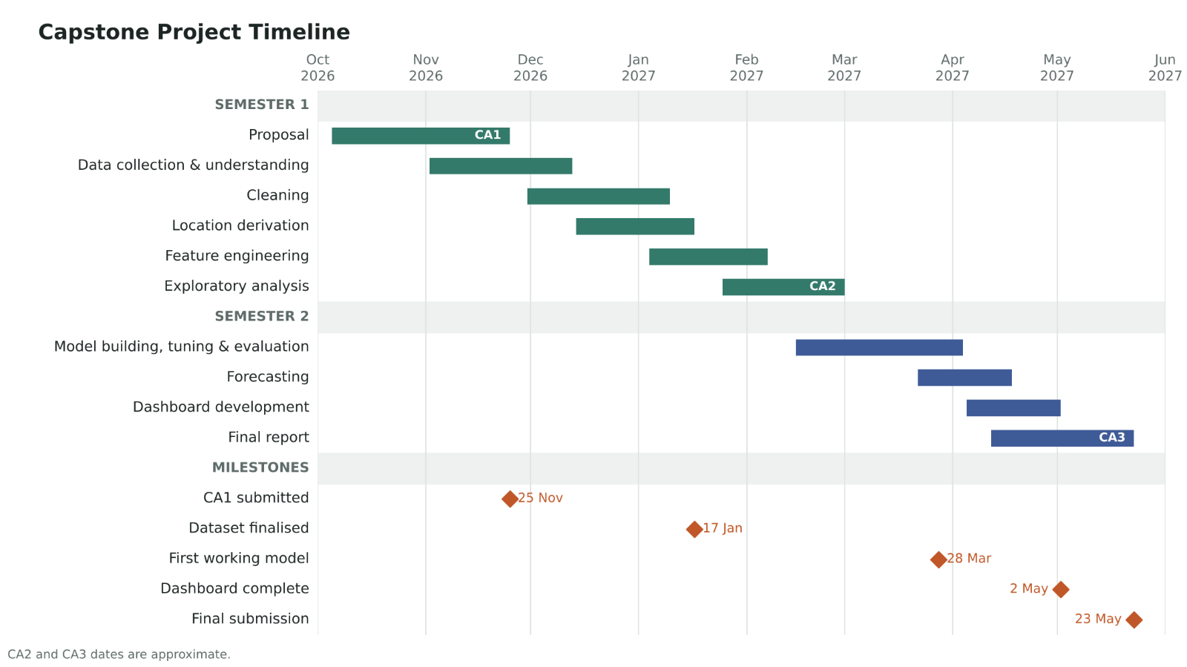
Figure 2: Project Gantt Chart (Claude)

Ethical and Legal Considerations
Written permission will be obtained before I start any EDA or data wrangling on the internal company data. Any identifiable information or exact addresses will be removed or anonymised by the company. This ensures GDPR and the Irish Data Protection Act 2018 are being adhered to. The data source from the Residential Property Price Register is a free to use, provided that the PSRA is acknowledged. The data will be stored on a password protected device and will be deleted once the project has been assessed. And to ensure privacy of the outcome of this capstone project my GitHub private repository and will only be shared directly with the lecturer. The data will only be used for the stated academic purpose to cover the objectives of this assessment.
The outcomes of this predicted model will be shared as guidelines and a caveat that prices or timings may vary depending on economic conditions not taken into consideration during this model development for example an outbreak of war in the country.

References:
Duca, J.V., Muellbauer, J. and Murphy, A. (2021) ‘What Drives House Price Cycles? International Experience and Policy Issues.’, Journal of Economic Literature, 59(3), pp. 773–864. Available at: https://doi.org/10.1257/jel.20201325.
European Central Bank. (2023) House prices and ultra-low interest rates: exploring the non linear nexus. LU: Publications Office. Available at: https://doi.org/10.2866/657427.
Fox, S. (2026) House prices rise again across Cork, Cork Independent. Available at: https://www.corkindependent.com/2026/06/23/house-prices-rise-again-across-cork/ (Accessed: 13 October 2026).
Residential Property Prices Economy Ireland and the EU at 50 - Central Statistics Office (2023). CSO. Available at: https://www.cso.ie/en/releasesandpublications/ep/p-ieu50/irelandandtheeuat50/economy/residentialpropertyprices/ (Accessed: 17 October 2026).
Why So Many Landlords Are Selling in 2026 — And What It Means for the Market – Keane Thompson (no date). Available at: https://keanethompson.ie/why-so-many-landlords-are-selling-in-2026-and-what-it-means-for-the-market/ (Accessed: 17 October 2026).

AI Claude:
https://claude.ai/share/1b09c0f6-885d-471f-893b-35fd61ee16e7
https://claude.ai/share/c6f12c4d-a221-460b-830d-4accf866e536

