A Role-Exchangeable, System-Level Redundancy Framework for Fault Tolerance
Sih-Kai Shen, Yao-Long Cai, and Peng-Sheng Chen*, Member, IEEE
Abstract—In this paper we design and implement a role-exchangeable, system-level redundancy technique for embedded systems. The complete system consists of a primary system and a redundant system that are connected via a network. A heartbeat mechanism is adopted to monitor whether the primary and redundant systems are working normally. The open-source, distributed file system GlusterFS is leveraged to aggregate disk-storage resources for providing dependable storage. In addition, the checkpoint tool DMTCP (Distributed Multithreaded Checkpointing) is used to store the execution states of the application that can be used to resume from a failure. The redundant system can detect when the primary system fails and then rapidly take over the work. A GUI-based assistant tool is also developed to help users automatically construct such systems. Experimental results obtained using different benchmarks and scenarios show that the proposed approach can improve the fault tolerance of an embedded system, including its ability to resume operating after a failure.

Index Terms—Redundancy, Software reliability, Fault tolerance, Availability

INTRODUCTION
T
he ongoing developments in hardware and software technologies are resulting in computer systems permeating our everyday lives. Computer systems can now be found in diverse applications such as general personal assistants, medical systems, industrial control systems, aviation systems, self-driving cars, and robots. Some of these systems require high reliability and stability to ensure their everyday operation, since their failure can lead to severe and even life-threatening problems [1]. This indicates the importance of developing techniques to enhance system reliability [2,3]. System-level redundancy is a fault-tolerance technique that involves the use of multiple redundant systems [4]. If the primary system fails, a redundant system can take over control to resume the normal operations. However, general users experience a steep learning curve when adding such a fault-tolerance feature to a computing system.
In this paper we design and implement a role-exchangeable, system-level redundancy programming model for embedded systems. The complete system consists of a primary system and a redundant system that are connected via a network. We implemented the proposed technique using the low cost and widely used Raspberry Pi 3 Model B+ evaluation board [5]. Figure 1 shows the concept of the proposed system-level redundancy method. A heartbeat mechanism is adopted to monitor whether the primary system is operating normally, whereby the redundant system transmits a heartbeat signal to the primary system at regular time intervals. When the primary system receives the heartbeat signal it will return an appropriate message. If the redundant system does not receive that message, it will assume that a failure has occurred on the primary system and will then execute the appropriate process to take over control to resume the work. The open-source, distributed file system GlusterFS [6] is leveraged to aggregate disk-storage resources from the primary and redundant systems. The data in the file system are replicated to ensure high availability. In addition, the checkpoint tool DMTCP (Distributed Multithreaded Checkpointing) [7] is used to store the execution states of the application that can be used to resume from a failure. A GUI-based assistant tool is also developed to help users automatically construct such systems. Experimental results obtained using different benchmarks and scenarios show that the proposed approach can improve the fault tolerance of an embedded system, including its ability to resume operating after a failure.
Fig. 1: Concept of the proposed system-level redundancy.
The key contributions of this paper are summarized as follows:
- System-level redundancy. We propose a programming model with system-level redundancy to achieve fault tolerance.
- Integration. The watchdog function from Raspberry Pi, GlusterFS, and DMTCP are integrated to construct a system-level redundancy method to protect critical computing systems and enhance fault tolerance.
- Short recovery time. A role-exchangeable algorithm is developed to reduce the recovery time. The redundant system changes its role to the primary system when it detects that the primary system has failed. After the primary system recovers and rejoins the complete system, it switches its role to monitoring.
- Assistant tool. A GUI-based assistant tool is developed to help users to construct the complete system. According to the parameters provided, a system with system-level redundancy can be constructed automatically.
The remainder of this paper is organized as follows: Section II describes the proposed technique, Section III describes the GUI-based assistant tool, Section IV presents the experimental results, and Section V provides conclusions.

Design and Implementation
The proposed system-level redundancy technique consists of two systems: a primary system and a redundant system. The primary system executes a target program that we want to protect. The two systems are connected via a network. A heartbeat mechanism is adopted to monitor whether the primary and redundant systems are working normally. Figures 2 and 3 show the situation of the primary system crashing. When the primary system crashes (marked as 1), this is detected by the redundant system via the heartbeat mechanism (marked as 2). The redundant system then takes over control and changes its role to the primary system in order to resume the work of that system (marked as 3 and 4). The original primary system automatically restarts by invoking the Raspberry Pi watchdog function (marked as 5). It reconnects to the original redundant system, discovers that the target program is running, and then changes its role to a monitoring redundant system (marked as 6). The complete system now works in the same way as depicted in Figure 1, but where the roles of two systems have been reversed. Figure 4 shows the situation of the redundant system crashing. After crashing, the redundant system is automatically restarted by the watchdog function, and it then rejoins the complete system to continue monitoring the primary system again.
The checkpoint tool DMTCP is used to store the execution status (image) of the target program for resuming from a failure. The distributed file system GlusterFS is leveraged to duplicate storage data (images and program data) for enhancing reliability. Integrating with GlusterFS means that the target program can be regularly executed/resumed as long as one of the systems is available. If both systems crash, they will be rebooted by the watchdog function and then reconnect to each other to form the dependable system in which the target program will be re-executed.
Fig. 2: Crash of the primary system (part 1).

Fig. 3: Crash of the primary system (part 2).
Fig. 4: Crash of the redundant system.
To ensure that the complete system is efficient, we classify the target program into two types. Mode 1 represents the target program, which does not need to record the running status for resuming the work. A system that periodically collects sensor data (e.g., temperature and humidity) is an example of Mode 1. Mode 2 is where the runtime image of the target program needs to be recorded so that it can be resumed when necessary. This type of implementation is suitable for general-purpose programs, and DMTCP and GlusterFS are used in this type.
The development of the complete framework is divided into three major parts. The first is providing an algorithm that allows the primary and redundant systems to notify the other when failure occurs and perform the appropriate operations to ensure that the protected program can be executed as normal. The second part is introducing a dependable storage system to enhance the reliability of the checkpoint images and program data. The third part is supporting the checkpointing of a running program. An image of the running program is periodically stored to allow a previous execution status to be resumed after the hardware has recovered from a crash. The following subsections describe these three parts in detail.
Fig. 5: Execution flow between the primary and redundant systems.

Algorithm
The communication between the primary and redundant systems is based on a client–server architecture using the TCP/IP protocol. For the first connection, the primary system handles heartbeat data transmission and forks a child process to execute the target program. The redundant system forks a child process to send and receive heartbeat messages. Figure 5 shows the execution flow between the systems. The algorithms in each system are described in the subsections below.

Primary system
The primary system forks a child process to execute the target program. The redundant system forks a child process to monitor whether the primary system is working normally. The parent process handles data transmission and detects whether the connection is lost. The heartbeat mechanism monitors the link between the primary and redundant systems. If the connection to the redundant system is lost, the primary system will close the connection and periodically try to reconnect to the redundant system. The left part of Figure 5 shows the execution flow of the primary system. For failure detection, the redundant system acts as a monitor, periodically sending a heartbeat signal to the primary system to check whether it is working normally. When the primary system receives a signal, it replies to the redundant system. If the redundant system does not receive a message within a certain period of time, the primary system is assumed to have failed, and the recovery process is launched.
For failure recovery, the Raspberry Pi watchdog function is used to automatically reboot the system after crashing. The watchdog kernel module can be enabled and properly configured to automatically re-establish the connection with the redundant system. After successfully connecting, the primary system will switch its role to being a monitor while the redundant system executes the target program.

Role exchange
In order to realize the role exchange, a system needs to know its status. It is difficult for a system itself to identify that it is rebooting for the first time or rebooting after a crash, whereas the other system can easily observe this issue. Accordingly, for each system, two NC (number of crashes) variables are used to identify its status and role: one is from self-observation and the other is obtained from the other system. Variable NC_{X}(Y) represents the number of the crash of system Y observed by system X. The example in Figure 6 depicts the algorithm. For system A, NC_{A}(A) is the number of the crash of system A, which is observed by system A itself. NC_{A}(B) is the number of the crash of system B, which is observed by system A. System B also has two variables: NC_{B}(A) and NC_{B}(B). After a system reboots, its NC value observed by itself [i.e., NC_{A}(A) of system A and NC_{B}(B) of system B] is reset to 0. When reconnecting after the crash, the other system will send the correct NC value. This design means that a system can use the two NC values to identify its status and role.
Figure 6 (I) shows that systems A and B reconnect after their first reboot, and they have an NC value of 0. For system A, its NC value observed by the other system, NC_{B}(A), is continuously transmitted from system B. System A continuously sends NC_{A}(B) to system B. If system A is down, system B can detect that, and NC_{B}(A) is incremented by 1 [as shown in Figure 6 (II)]. After system A has rebooted and rejoined, it resets NC_{A}(A) to 0 and gets NC_{B}(A) from system B. NC_{A}(A)is 0, which represents that system A has just rebooted. NC_{B}(A) represents the correct number of the crash of system A. According to the two values, system A knows that it has just been restarted from a crash and system B takes the role of the primary system. System A changes its role to the redundant system [as shown in Figure 6 (III)]. Figure 6 (IV) and (V) depict the situation of system B having crashed.
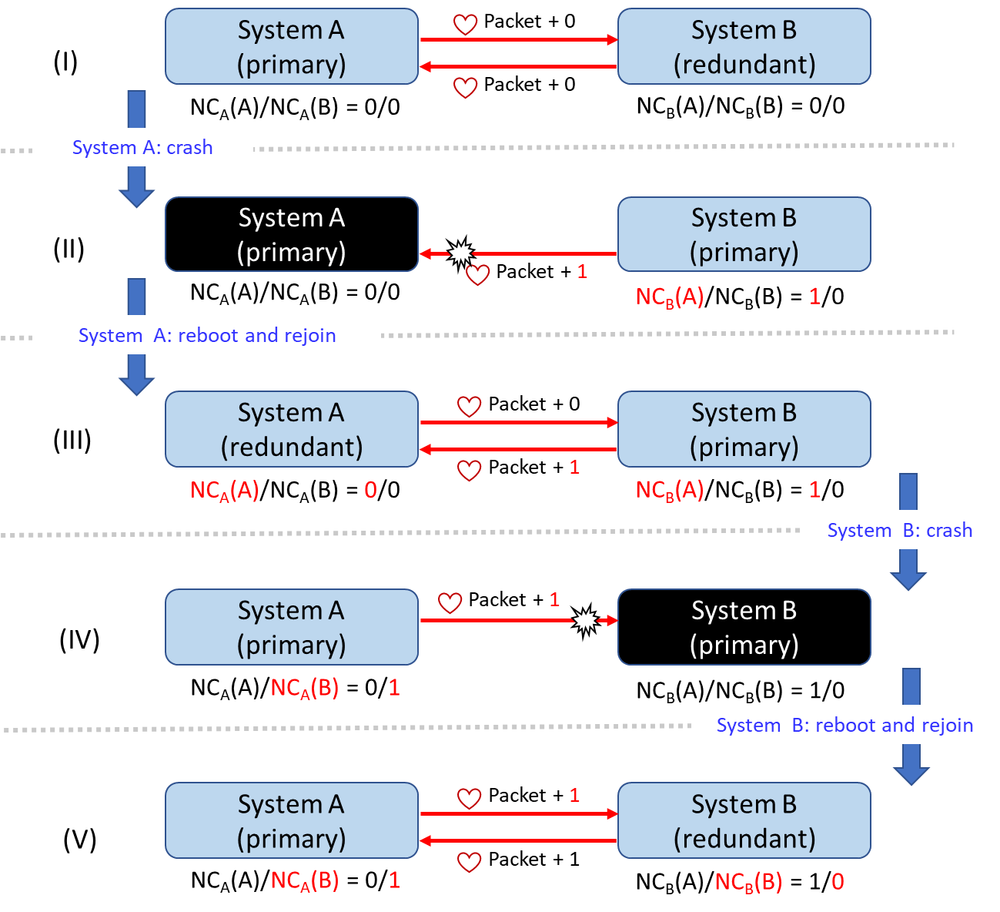
Fig. 6: Example of role exchange.

Dependable Storage
GlusterFS is a scalable, open-source distributed file system that has the advantages of being easy to use, highly stable, and capable of handling thousands of file access requests. For enhancing the reliability of program data files, we use the Replicated Volume that replicates data and stores them in a distributed manner. Using this feature makes it possible to continue accessing data files whenever one of the systems fails.

Checkpointing
Checkpointing [8] is a technique that creates images of the running program, saves the current state of the program, and resumes the program execution from a saved state. This study added the DMTCP tool to implement checkpointing. Users can decide how often to perform checkpointing and generate images. If the program crashes, its execution can be resumed from a checkpointed image. When integrating DMTCP and GlusterFS, we found that the image generated by DMTCP cannot be directly stored in the GlusterFS distributed file system. Therefore, the checkpointed image is stored in the local storage before being moved to GlusterFS. A plugin was developed for moving the image files to a dedicated directory.

GUI-Based Assistant Tool
In order to help the user to implement system-level redundancy, a GUI-based assistant tool is developed so that users can rapidly construct a complete system without having to know the details of the fault-tolerance technique. The functions of the proposed GUI-based assistant tool are designed to include installing software tools, setting the environment configuration required to use the software tools, and executing the primary and redundant systems. Figure 7 shows a screenshot of the proposed tool.
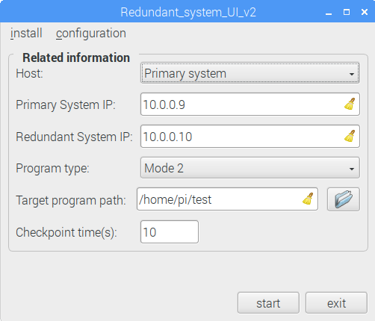
Fig. 7: Screenshot of the GUI-based assistant tool.

Experiments
The proposed system-level redundancy technique was evaluated on the Raspberry Pi 3 Model B+ platform. Table I lists the configuration of the experimental environment. DMTCP was set to generate a checkpointed image every 5 sec. The tested benchmarks are listed in Table II.

TABLE I
Experimental environment.
Item | Description
SoC | Broadcom BCM2387B0 chipset
CPU | 1.4 GHz quad-core ARM Cortex-A53
RAM | 1 GB
OS | Linux (kernel version 4.14.73-v7+)
Native C compiler | GNU GCC 6.3.0 (default options)
DMTCP | Version 3.0
GlusterFS | Version 3.8.8 (node: 2, brick: 2, volume: 2)

TABLE II
Tested benchmarks.
Benchmark | Program type | Description
simpletest.py | Mode 1 | Adafruit_Python_MAX31855 temperature sensor
dht11_example.py | Mode 1 | DHT11 temperature and humidity sensor
basicmath_small | Mode 2 | Basic math (MiBench [9])
basicmath_large | Mode 2 | Basic math (MiBench)
matrix2 | Mode 2 | Generic matrix (DSPstone [10])
counter | Mode 2 | Count number (from 0) every second (hand coded)
In the evaluation, the target program was executed on the primary system while the redundant system monitored the primary system. In order to test the proposed functionalities, we manually killed the target program and used the fork bomb command to crash the primary system. In addition to evaluating the functionality, for Mode-2 programs we also measured the size of the checkpoint image and monitored the recovery process from the primary system crashing to the target program resuming execution in the redundant system. The frequency of checkpointing was set to 5 sec. Table III lists the evaluation results, which are the average values obtained over ten executions.

TABLE III
Evaluation results.
Benchmark | Image size (bytes) | Recovery time (sec)  (kill program) | Recovery time (sec)  (fork bomb)
basicmath_small | 2,211,556 | 5.3 | 50.8
basicmath_large | 2,211,761 | 5.6 | 50.8
matrix2 | 2,210,821 | 5.3 | 54.5
counter | 2,205,265 | 5.5 | 44.7
The experimental results demonstrate that the proposed complete system can successfully resume the work performed by the target program and correctly swap the roles of the two systems so as to shorten the recovery time.

Conclusion

This paper has developed a role-exchange, system-level redundancy technique. A primary system and a redundant system are formulated into a dependable structure, with these two systems connected via a network. The heartbeat mechanism is used to monitor whether the systems are working normally. The checkpointing from the DMTCP tool is integrated to provide the capability of resuming the execution of the target program. In addition, GlusterFS is leveraged to provide dependable storage in which the checkpointed images will be stored. Based on the proposed technique, a GUI-based assistant tool is developed to guide users to easily construct the complete system. The experimental results obtained using the tested benchmarks and scenarios show that the target program can continuously and correctly perform its work when one of the systems fails. This study has provided an easy and systematic approach to adding the feature of system-level redundancy for users who want to improve the fault tolerance of embedded systems.

References
- R. C. Baumann, “Radiation-induced soft errors in advanced semiconductor technologies,” in IEEE Transactions on Device and Materials Reliability, vol. 5, no. 3, pp. 305–316, Sep. 2005.
- G. A. Reis, J. Chang, N. Vachharajani, R. Rangan, and D. I. August, “Swift: Software implemented fault tolerance,” in Proceedings of the International Symposium on Code Generation and Optimization (CGO’05), Washington, DC, USA: IEEE Computer Society, pp. 243–254, 2005.
- A. Shye, J. Blomstedt, T. Moseley, V. J. Reddi, and D. A. Connors, “PLR: A software approach to transient fault tolerance for multicore architectures,” in IEEE Transactions on Dependable and Secure Computing, vol. 6, no. 2, pp. 135–148, April 2009.
- A. Avizienis, “The N-version Approach to Fault-Tolerant Software,” in IEEE Transactions on Software Engineering, vol. 11, no. 12, pp 1491-1501, Dec., 1985.
- Raspberry Pi official website. https://www.raspberrypi.org. [Online; accessed 1-Dec-2018].
- Alex Davies and Alessandro Orsaria, “Scale out with GlusterFS,” in Linux Journal, vol. 2013, no. 235, November, 2013.
- Jason Ansel, Kapil Arya and Gene Cooperman, “DMTCP: Transparent Checkpointing for Cluster Computations and the Desktop,” in 23rd IEEE International Parallel and Distributed Processing Symposium (IPDPS’09), Rome, Italy, May, 2009.
- James S. Plank, Micah Beck, Gerry Kingsley, and Kai Li, “Libckpt: transparent checkpointing under Unix,” in Proceedings of the USENIX 1995 Technical Conference, p.18-18, January 16-20, 1995.
- M. R. Guthaus, J. S. Ringenberg, D. Ernst, T. M. Austin, T. Mudge and R. B. Brown, "MiBench: A free, commercially representative embedded benchmark suite," in Proceedings of the Fourth Annual IEEE International Workshop on Workload Characterization, WWC-4, Austin, TX, USA, 2001, pp. 3-14.
- V. z̆ivojnović, J. M. Velarde, C. Schläger, and H. Meyr, "DSPstone: a DSP-oriented benchmarking methodology," in Proceedings of the International Conference on Signal Processing and Technology (ICSPAT), 1994.

This work was supported by the Taiwan Ministry of Science and Technology under grant MOST 105-2221-E-194-056-MY3. The authors are grateful to the National Center for High-Performance Computing for computer time and facilities. The authors are with the Department of Computer Science and Information Engineering and Advanced Institute of Manufacturing for High-tech Innovations, National Chung Cheng University, Taiwan, ROC (e-mail: a0975551609@gmail.com; eddy7880123@yahoo.com.tw; pschen@cs.ccu.edu.tw). *Corresponding author – pschen@cs.ccu.edu.tw

