Hi Sir,

              Below is my report of the software development for the month of January 2021.

1. **Ongoing Project: Project Access – HR Module: 201 and Announcement**

Project Access is an intranet software wherein it will generate an automated report and customized digitalized system based on the need of the organization.

The 201 and Announcement Module is a module under HR Department. The 201 holds the master list of the employee information and the announcement holds the announcements posted by the HR.

1. **Team Accomplishments**

**Project Critical:**

It is recommended that the team prioritize the closure of the HRIS 201 Module before proceeding to Timekeeping.

**Team Highlights:**

* Migration of intranet to Codeigniter framework
* Updating of intranet user interface
* Migration of employee data to intranet
* Changing of intranet link to <http://www.blaineintranet/>
* Exporting of employee data to excel, pdf, and csv file
* Copying and printing of employee data

**Team Lowlights:**

* Email notification when an employee reached their 4th month of probationary status

**Development Process Flow:**

Process Flow: Below process flow shows the iteration of the software development. As of January 29, 2021, the project is ongoing through Beta Testing. Beta Testing is wherein the users will test the developed software.

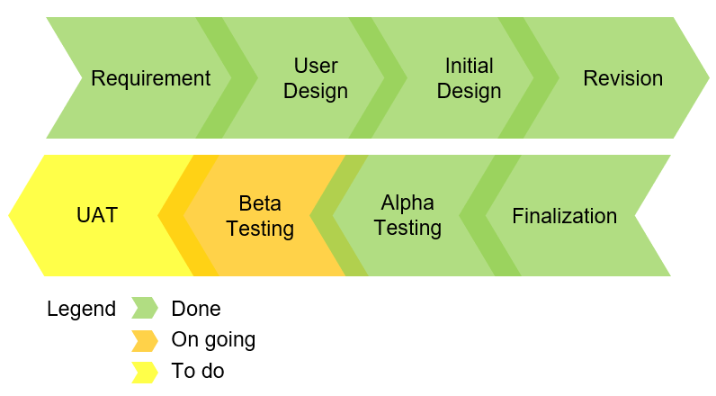

1. **Sprint Summary**

As of January 29, 2021, the team has closed 132 out of 134 sprints.

Team Sprint:

|  |  |  |  |  |
| --- | --- | --- | --- | --- |
|  | Open Sprint | Closed Sprint | Cancelled Sprint | Total Sprint |
| Front-end | 0 | 57 | 0 | 57 |
| Back-end | 2* | 66 | 0 | 68 |
| Others | 0 | 9 | 0 | 9 |
| Total Sprint | 2 | 132 | 0 | 134 |

*Open Sprints: Video Uploader and Delete Activity Logs

**Individual Sprint:**

|  |  |  |  |  |
| --- | --- | --- | --- | --- |
|  | Open Sprint | Closed Sprint | Cancelled Sprint | Total Sprint |
| Front-end | 0 | 27 | 0 | 27 |
| Back-end | 0 | 34 | 0 | 34 |
| Others | 0 | 1 | 0 | 1 |
| Total Sprint | 0 | 62 | 0 | 62 |

Moving Forward:

* Conceptualization and user interface creation of Project Timekeeping.

Kind regards,

**Christian Guarin**

*Software Developer*

**Blaine Corporation**

Blaine Industrial Complex,

Governor’s Drive, Kamias Road

Brgy. 14, Bancal, Carmona Cavite

Philippines 4116

Phone number: [+63 (02) 584 4256](tel:%2B63%20%2802%29%20584%204256)

Fax number:      [+63 (02)584 4258](tel:%2B63%20%2802%29584%204258)

Email: [jesa.lacambra@blainegroup.com](mailto:jesa.lacambra@blainegroup.com).ph

Website: [www.blainegroup.com.ph](http://www.blainegroup.com.ph/)



*Disclaimer: This message and its attachments are intended to be confidential and for the exclusive use of the intended recipient(s). If you are not the intended recipient (or authorized to receive for the intended recipient), you may not read, print, use, copy, alter, distribute or disclose to anyone the message or any information contained in the message. Please contact the sender immediately if you believe you have received this email in error and delete all copies of the original message (including attachments).*

*The company accepts no liability for damages of any kind resulting from the risk inherent in the electronic transmission of messages.*