Peering into the twilight - a systematic review on visual-based investigation of mesophotic ecosystems - TROPICAL
Claudia Campanini
2026-03-31
Table of Contents

DATA PREPARATION

Load libraries
library(here)
## here() starts at C:/Users/claud/Documents/COMUNE/STUDIO_LAVORO/Data_analysis/Projects/Mesophotic_systematic_lit_rev_analysis
library(dplyr)
##
## Caricamento pacchetto: 'dplyr'
## I seguenti oggetti sono mascherati da 'package:stats':
##
## filter, lag
## I seguenti oggetti sono mascherati da 'package:base':
##
## intersect, setdiff, setequal, union
library(ggplot2)
library(readxl) # to import excel data sets
library(magrittr)
library(stringr) #many data wrangling functions
library(readxl)

Load data
tropical <- read_excel(here("Extracted_data_analysis","Input_data","extracted_raw.xlsx"))

Subset for studies encompassing tropical latitudinal region
tropical <- subset(tropical, str_detect(tropical$latitudinalRegion, "tropical"))

Cleaning
Clean year columns
#keep the year only in the year column (in some rows exact time is specified)
tropical$publicationYear <- stringr::str_remove(tropical$publicationYear,
pattern = "\\-.*")

MISSING / ND / NOTAPP VALUES
Create a summary table
library(purrr)
##
## Caricamento pacchetto: 'purrr'
## Il seguente oggetto è mascherato da 'package:magrittr':
##
## set_names
library(tibble)
# Get all column names
cols <- names(tropical[,-c(1:13)])
# Create a summary list
summary_list <- map(cols, function(col) {
data <- tropical[,-c(1:13)][[col]]
tibble(
Column = col,
unique = paste(unique(data), collapse = ", "),
nd = sum(data == "nd", na.rm = TRUE),
notapp = sum(data == "notapp", na.rm = TRUE),
assigned = sum(!is.na(data) & data != "nd" & data != "notapp"),
`NA` = sum(is.na(data)),
total = sum(data == "nd", na.rm = TRUE) +
sum(data == "notapp", na.rm = TRUE) +
sum(!is.na(data) & data != "nd" & data != "notapp")
)
})
# Combine into one dataframe
summary_df <- bind_rows(summary_list)
summary_df
## # A tibble: 72 × 7
## Column unique nd notapp assigned `NA` total
## <chr> <chr> <int> <int> <int> <int> <int>
## 1 meso_direct_indirect indirect, mixed, di… 3 0 439 0 442
## 2 meso_samplingPlatform acou+bruv+tcs, bruv… 3 0 439 0 442
## 3 taxonomic_publication NA, taxa, taxa++ 0 0 60 382 60
## 4 meso_substrate hard, mixed, nd, so… 19 0 385 38 404
## 5 meso_habitat coralreef, mixed, N… 11 0 415 16 426
## 6 meso_protection mixed, nd, yes, no 344 0 98 0 442
## 7 taxonomicTargetLevel comm, group, single… 0 3 439 0 442
## 8 habit mixed, vagile, sess… 0 2 440 0 442
## 9 environmentalPosition dem+epi, epi, endo+… 0 1 441 0 442
## 10 detected_meso_seagrass NA, x, notapp 0 1 6 435 7
## # ℹ 62 more rows
rm(summary_list, cols)

GEOGRAPHICAL DISTRIBUTION
location <- tropical[,c (
"recordTitle","DOI","publicationYear","prov_code","ecoreg_code")]
Load Marine Ecoregion of the World data
meow <- read.csv(file=here("Extracted_data_analysis","Input_data","MEOW.csv"))

Provinces
prov <- location
prov_lvls <-
unique(
unlist(
str_split(location$prov_code, "\\_")
)
)
prov[,prov_lvls] <- sapply(prov_lvls,
function(y){
str_count(location$prov_code, y)
}
)
rm(prov_lvls)
Create a column with the sum of provinces per publication
prov %<>%
mutate(
prov_per_record = rowSums(
across(
where(is.numeric)
)
)
)
prov$prov_per_record <- as.factor(prov$prov_per_record)
prov_per_record_df <- prov %>%
group_by(prov_per_record) %>%
summarise(n_records = length(prov_per_record)) %>%
mutate(percentage= round(n_records / sum(n_records) * 100,0))
prov_per_record_df
## # A tibble: 8 × 3
## prov_per_record n_records percentage
## <fct> <int> <dbl>
## 1 1 68 15
## 2 2 298 67
## 3 3 59 13
## 4 4 3 1
## 5 5 8 2
## 6 6 4 1
## 7 7 1 0
## 8 21 1 0
Create a data frame with number of publication per province
prov_tot <-
prov [, -(length(prov)-1)] %>% # filter out the sum column
summarise(across(where(is.numeric),
list(sum)
)
)
prov_tot <- reshape2::melt(prov_tot, id.vars = NULL)
colnames(prov_tot) <- c("Province", "Count")
prov_tot %<>%
mutate_at("Province",
stringr::str_replace, "_1", "")

Ecoregions
ecoreg <- location
ecoreg_lvls <-
unique(
unlist(
str_split(ecoreg$ecoreg_code, "\\_")
)
)
ecoreg_lvls<- ecoreg_lvls[! ecoreg_lvls %in% c("")]
ecoreg[,ecoreg_lvls] <- sapply(ecoreg_lvls,
function(y){
str_count(ecoreg$ecoreg_code, y)
}
)
Create a column with the number of ecoregions per study
ecoreg %<>%
mutate(
ecoreg_per_record = rowSums(
across(
where(is.numeric)
)
)
)
ecoreg$ecoreg_per_record <- as.factor(ecoreg$ecoreg_per_record)
Calculate number of records by number of ecoregions in %
ecoreg_per_record_df <- ecoreg %>%
group_by(ecoreg_per_record) %>%
summarise(n_records = length(ecoreg_per_record)) %>%
mutate(percentage= round(n_records / sum(n_records) * 100,1))
ecoreg_per_record_df
## # A tibble: 6 × 3
## ecoreg_per_record n_records percentage
## <fct> <int> <dbl>
## 1 1 379 85.7
## 2 2 39 8.8
## 3 3 18 4.1
## 4 4 3 0.7
## 5 5 2 0.5
## 6 12 1 0.2
Create a data frame with number of publication per ecoregion
ecoreg_tot <-
ecoreg [, -(length(ecoreg)-1)] %>% # filter out the sum column
summarise(across(where(is.numeric),
list(sum)
)
)
ecoreg_tot <- reshape2::melt(ecoreg_tot, id.vars = NULL)
colnames(ecoreg_tot) <- c("Ecoregion", "Count")
ecoreg_tot %<>%
mutate_at("Ecoregion",
stringr::str_replace, "_1", "")
Add count column to Meow and set 0 to all the ecoregions where no study was conducted
colnames(ecoreg_tot)[colnames(ecoreg_tot) == 'Ecoregion'] <- 'ECO_CODE'
ecoreg_tot$ECO_CODE <- as.character(ecoreg_tot$ECO_CODE)
meow$ECO_CODE <- as.character(meow$ECO_CODE)
ecoreg_tot <-
left_join(meow, ecoreg_tot, by = 'ECO_CODE') %>%
mutate(Count = replace(Count, is.na(Count), 0))
Export count per ecoregion to csv for the map in QGIS
writexl::write_xlsx(ecoreg_tot,
here("Extracted_data_analysis","tropical","Output-Transformed_data","eco_reg_tot.xlsx"))

Realms
realms <- ecoreg_tot %>%
group_by(RLM_CODE, REALM) %>%
summarise(Count=sum(Count))
## `summarise()` has regrouped the output.
## ℹ Summaries were computed grouped by RLM_CODE and REALM.
## ℹ Output is grouped by RLM_CODE.
## ℹ Use `summarise(.groups = "drop_last")` to silence this message.
## ℹ Use `summarise(.by = c(RLM_CODE, REALM))` for per-operation grouping
## (`?dplyr::dplyr_by`) instead.
realms %<>%
rename(Code = RLM_CODE,
Realm = REALM)
writexl::write_xlsx(realms,
here("Extracted_data_analysis","tropical","Output-Transformed_data","Realm_count.xlsx"))

Export geographical distribution summary tables
writexl::write_xlsx(list(realms, prov_tot, prov_per_record_df, ecoreg_tot, ecoreg_per_record_df),
here("Extracted_data_analysis","tropical","Output-Transformed_data","geographical_distribution_summary.xlsx"))

COUNT COLUMNS WITH COMBO
Create a subset of columns
count_columns <- tropical %>%
select(File,
meso_substrate,
habit,
environmentalPosition,
observationalORexperimental,
taxonomicTargetLevel,
indicators,
collectedDataType,
molecularAnalyses)
Prepare data set with columns that need count only and add percentage column
count_columns[,] <- lapply(count_columns[,], as.factor)
count_results <- list()
for (col_name in colnames(count_columns)) {
counts <- count(count_columns, !!sym(col_name))
count_results[[col_name]] <- counts
colnames(count_results[[col_name]]) <- c(col_name, "Count")
count_results[[col_name]] %<>%
filter(
if_all(.cols = everything(), ~ !grepl("notapp", .x))
) %>%
# delete rows with "notapp"
tidyr::drop_na()
count_results[[col_name]] %<>%
mutate(Percentage= round(Count / sum(Count) * 100,2))
}
rm(col_name, counts)
count_results <- count_results[names(count_results) != "File"]

Export summary tables
library(openxlsx)
write.xlsx(count_results,
file = here("Extracted_data_analysis",
"tropical",
"Output-Transformed_data",
"summary_counts_question_1-3.xlsx"))
Create treemaps charts
treemap_func = function(dat,var) {
ggplot(dat,
aes(area=Count,
fill=.data[[var]],
line = "black",
label=paste0(.data[[var]],
" \n ",Percentage,"%"))
)+
treemapify::geom_treemap(layout = "squarified")+
treemapify::geom_treemap_text(place = "centre",
size = 20)+
labs(title = var)+
theme(plot.title = element_text(hjust = 0.5, size= 20),
legend.position = "none")
}
treemap_counts <- list()
for (col_name in colnames(count_columns[,-1])) {
treemap_counts[[col_name]] <- treemap_func(dat= count_results[[col_name]], var = col_name)
}
treemap_counts[[1]]
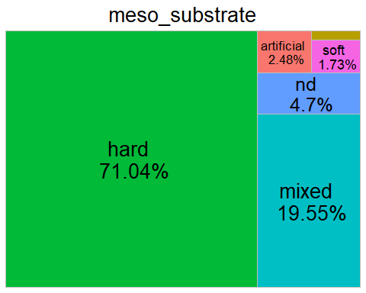
Save all tree maps plots
lapply(names(treemap_counts), function(x){
ggsave(filename=paste0(x,".tiff"),
plot=treemap_counts[[x]],
units = "in", width=12, height=4, dpi=300, compression = 'lzw',
path = here("Extracted_data_analysis",
"tropical",
"Output-Visualization",
"Treemap_counts"),
create.dir = T
)
})
## [[1]]
## [1] "C:/Users/claud/Documents/COMUNE/STUDIO_LAVORO/Data_analysis/Projects/Mesophotic_systematic_lit_rev_analysis/Extracted_data_analysis/tropical/Output-Visualization/Treemap_counts/meso_substrate.tiff"
##
## [[2]]
## [1] "C:/Users/claud/Documents/COMUNE/STUDIO_LAVORO/Data_analysis/Projects/Mesophotic_systematic_lit_rev_analysis/Extracted_data_analysis/tropical/Output-Visualization/Treemap_counts/habit.tiff"
##
## [[3]]
## [1] "C:/Users/claud/Documents/COMUNE/STUDIO_LAVORO/Data_analysis/Projects/Mesophotic_systematic_lit_rev_analysis/Extracted_data_analysis/tropical/Output-Visualization/Treemap_counts/environmentalPosition.tiff"
##
## [[4]]
## [1] "C:/Users/claud/Documents/COMUNE/STUDIO_LAVORO/Data_analysis/Projects/Mesophotic_systematic_lit_rev_analysis/Extracted_data_analysis/tropical/Output-Visualization/Treemap_counts/observationalORexperimental.tiff"
##
## [[5]]
## [1] "C:/Users/claud/Documents/COMUNE/STUDIO_LAVORO/Data_analysis/Projects/Mesophotic_systematic_lit_rev_analysis/Extracted_data_analysis/tropical/Output-Visualization/Treemap_counts/taxonomicTargetLevel.tiff"
##
## [[6]]
## [1] "C:/Users/claud/Documents/COMUNE/STUDIO_LAVORO/Data_analysis/Projects/Mesophotic_systematic_lit_rev_analysis/Extracted_data_analysis/tropical/Output-Visualization/Treemap_counts/indicators.tiff"
##
## [[7]]
## [1] "C:/Users/claud/Documents/COMUNE/STUDIO_LAVORO/Data_analysis/Projects/Mesophotic_systematic_lit_rev_analysis/Extracted_data_analysis/tropical/Output-Visualization/Treemap_counts/collectedDataType.tiff"
##
## [[8]]
## [1] "C:/Users/claud/Documents/COMUNE/STUDIO_LAVORO/Data_analysis/Projects/Mesophotic_systematic_lit_rev_analysis/Extracted_data_analysis/tropical/Output-Visualization/Treemap_counts/molecularAnalyses.tiff"
lapply(names(treemap_counts), function(x){
ggsave(filename=paste0(x,".png"),
plot=treemap_counts[[x]],
units = "in", width=12, height=4, dpi=300,
path = here("Extracted_data_analysis",
"tropical",
"Output-Visualization",
"Treemap_counts"),
create.dir = T
)
})
## [[1]]
## [1] "C:/Users/claud/Documents/COMUNE/STUDIO_LAVORO/Data_analysis/Projects/Mesophotic_systematic_lit_rev_analysis/Extracted_data_analysis/tropical/Output-Visualization/Treemap_counts/meso_substrate.png"
##
## [[2]]
## [1] "C:/Users/claud/Documents/COMUNE/STUDIO_LAVORO/Data_analysis/Projects/Mesophotic_systematic_lit_rev_analysis/Extracted_data_analysis/tropical/Output-Visualization/Treemap_counts/habit.png"
##
## [[3]]
## [1] "C:/Users/claud/Documents/COMUNE/STUDIO_LAVORO/Data_analysis/Projects/Mesophotic_systematic_lit_rev_analysis/Extracted_data_analysis/tropical/Output-Visualization/Treemap_counts/environmentalPosition.png"
##
## [[4]]
## [1] "C:/Users/claud/Documents/COMUNE/STUDIO_LAVORO/Data_analysis/Projects/Mesophotic_systematic_lit_rev_analysis/Extracted_data_analysis/tropical/Output-Visualization/Treemap_counts/observationalORexperimental.png"
##
## [[5]]
## [1] "C:/Users/claud/Documents/COMUNE/STUDIO_LAVORO/Data_analysis/Projects/Mesophotic_systematic_lit_rev_analysis/Extracted_data_analysis/tropical/Output-Visualization/Treemap_counts/taxonomicTargetLevel.png"
##
## [[6]]
## [1] "C:/Users/claud/Documents/COMUNE/STUDIO_LAVORO/Data_analysis/Projects/Mesophotic_systematic_lit_rev_analysis/Extracted_data_analysis/tropical/Output-Visualization/Treemap_counts/indicators.png"
##
## [[7]]
## [1] "C:/Users/claud/Documents/COMUNE/STUDIO_LAVORO/Data_analysis/Projects/Mesophotic_systematic_lit_rev_analysis/Extracted_data_analysis/tropical/Output-Visualization/Treemap_counts/collectedDataType.png"
##
## [[8]]
## [1] "C:/Users/claud/Documents/COMUNE/STUDIO_LAVORO/Data_analysis/Projects/Mesophotic_systematic_lit_rev_analysis/Extracted_data_analysis/tropical/Output-Visualization/Treemap_counts/molecularAnalyses.png"

COUNT METHODS (PURELY TAXONOMIC STUDIES EXCLUDED)
Remove purely taxonomic studies and subset columns (taxa++ was assigned to studies that led to the description of new species but where also ecological e.g. describing community for a given taxonomic group)
methods <- tropical %>%
filter(taxonomic_publication == "taxa++" | is.na(taxonomic_publication) ) %>%
select(File,
meso_design,
meso_replicates,
temporalReplicates,
abioticVariablesCollection,
abioticVariables)
count_columns_method <- methods
Prepare data set with columns that need count only and add percentage column
count_columns_method[,] <- lapply(count_columns_method[,], as.factor)
count_results_method <- list()
for (col_name in colnames(count_columns_method)) {
counts <- count(count_columns_method, !!sym(col_name))
count_results_method[[col_name]] <- counts
colnames(count_results_method[[col_name]]) <- c(col_name, "Count")
count_results_method[[col_name]] %<>%
filter(
if_all(.cols = everything(), ~ !grepl("notapp", .x))
) %>%
# delete rows with "notapp"
tidyr::drop_na()
count_results_method[[col_name]] %<>%
mutate(Percentage= round(Count / sum(Count) * 100,1))
}
rm(col_name, counts)
count_results_method <- count_results_method[names(count_results_method) != "File"]
Export summary tables
library(openxlsx)
write.xlsx(count_results_method,
file = here("Extracted_data_analysis", "tropical", "Output-Transformed_data",
"summary_counts_question_4.xlsx"))
Create treemaps charts
treemap_func = function(dat,var) {
ggplot(dat,
aes(area=Count,
fill=.data[[var]],
line = "black",
label=paste0(.data[[var]],
" \n ",Percentage,"%"))
)+
treemapify::geom_treemap(layout = "squarified")+
treemapify::geom_treemap_text(place = "centre",
size = 20)+
labs(title = var)+
theme(plot.title = element_text(hjust = 0.5, size= 20),
legend.position = "none")
}
treemap_counts <- list()
for (col_name in colnames(count_columns_method[,-1])) {
treemap_counts[[col_name]] <- treemap_func(dat= count_results_method[[col_name]], var = col_name)
}
treemap_counts[[1]]
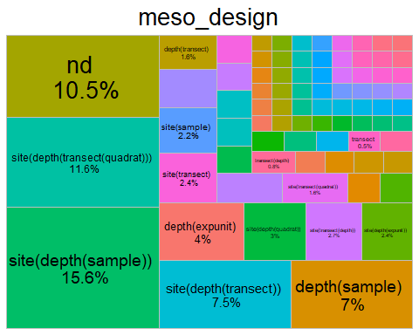
Save all tree maps plots
lapply(names(treemap_counts), function(x){
ggsave(filename=paste0("treemap",x,".tiff"),
plot=treemap_counts[[x]],
units = "in", width=12, height=4, dpi=300, compression = 'lzw',
path = here("Extracted_data_analysis","tropical", "Output-Visualization","Treemaps_methods"),
create.dir = T
)
})
lapply(names(treemap_counts), function(x){
ggsave(filename=paste0("treemap",x,".png"),
plot=treemap_counts[[x]],
units = "in", width=12, height=4, dpi=300,
path = here("Extracted_data_analysis", "tropical", "Output-Visualization","Treemaps_methods"),
create.dir = T
)
})

COUNT COLUMNS SPLIT
Create a list of data frame splitting values
split_columns <- tropical %>%
select(meso_substrate,
habit,
environmentalPosition,
observationalORexperimental,
taxonomicTargetLevel,
indicators,
collectedDataType,
molecularAnalyses)
split_columns[,] <- lapply(split_columns[,], as.factor)
Prepare data set with columns
split_results <- list()
for (col_name in colnames(split_columns)) {
# Split the values of each column by "+"
lvls <- unique(unlist(str_split(split_columns[[col_name]], "\\+")))
# Initialize a list to store counts for each level
split_counts <- sapply(lvls, function(y) {
# Count how many times each unique level appears in the column
str_count(split_columns[[col_name]], fixed(y))
}
)
split_results[[col_name]] <- split_counts
}
## Warning in stri_count_fixed(string, pattern, opts_fixed = opts(pattern)): empty
## search patterns are not supported
rm(lvls)
Add percentage column
split_tot <- list()
for(col_name in colnames(split_columns)) {
split_results[[col_name]] <- as.data.frame(split_results[[col_name]])
split_results[[col_name]] %<>% # delete rows with missing values
select(where(function(x) any(!is.na(x)))) %>%
select(-any_of("notapp")) %>%
tidyr::drop_na()
split_tot[[col_name]] <- as.data.frame(split_results[[col_name]]) %>%
summarise(across(where(is.numeric), list(sum)))
split_tot[[col_name]] <- reshape2::melt(split_tot[[col_name]], id.vars = NULL)
colnames(split_tot[[col_name]]) <- c(col_name, "Count")
split_tot[[col_name]] %<>%
mutate_at(col_name,
stringr::str_replace, "_1", "")
split_tot[[col_name]] %<>%
mutate(Percentage= round(Count / nrow(split_results[[col_name]] ) * 100,2))
}
rm(col_name)
Export summary tables
library(openxlsx)
write.xlsx(split_tot,
file = here("Extracted_data_analysis", "tropical", "Output-Transformed_data",
"summary_split_counts_question_1_3.xlsx"))
Create bar charts for each collected parameter
barchart_func = function(dat,var) {
ggplot(dat,
aes(x = reorder(.data[[var]], Count), y = Count, fill= .data[[var]])) +
geom_bar(stat = "identity", fill = "#0097A7") +
geom_text(
data = dat %>% filter(Percentage >= 2),
aes(label = paste0(round(Percentage, 0), "%")),
position = position_stack(vjust =0.5),
color = "black",
size = 2.5
)+
labs(y = "# Publications", x = var) +
theme_minimal() +
coord_flip()+ # optional: flips for horizontal bars
theme(legend.position ="none")
}
barchart_counts <- list()
for (col_name in colnames(split_columns)) {
barchart_counts[[col_name]] <- barchart_func(dat= split_tot[[col_name]], var = as.character(col_name))
}
barchart_counts[[1]]
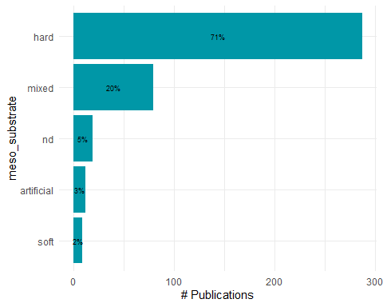
lapply(names(barchart_counts), function(x){
ggsave(filename=paste0("bar_",x,".tiff"),
plot=barchart_counts[[x]],
units = "in", width=12, height=4, dpi=300, compression = 'lzw',
path = here("Extracted_data_analysis", "tropical", "Output-Visualization","Barcharts_split"),
create.dir = T
)
})
## [[1]]
## [1] "C:/Users/claud/Documents/COMUNE/STUDIO_LAVORO/Data_analysis/Projects/Mesophotic_systematic_lit_rev_analysis/Extracted_data_analysis/tropical/Output-Visualization/Barcharts_split/bar_meso_substrate.tiff"
##
## [[2]]
## [1] "C:/Users/claud/Documents/COMUNE/STUDIO_LAVORO/Data_analysis/Projects/Mesophotic_systematic_lit_rev_analysis/Extracted_data_analysis/tropical/Output-Visualization/Barcharts_split/bar_habit.tiff"
##
## [[3]]
## [1] "C:/Users/claud/Documents/COMUNE/STUDIO_LAVORO/Data_analysis/Projects/Mesophotic_systematic_lit_rev_analysis/Extracted_data_analysis/tropical/Output-Visualization/Barcharts_split/bar_environmentalPosition.tiff"
##
## [[4]]
## [1] "C:/Users/claud/Documents/COMUNE/STUDIO_LAVORO/Data_analysis/Projects/Mesophotic_systematic_lit_rev_analysis/Extracted_data_analysis/tropical/Output-Visualization/Barcharts_split/bar_observationalORexperimental.tiff"
##
## [[5]]
## [1] "C:/Users/claud/Documents/COMUNE/STUDIO_LAVORO/Data_analysis/Projects/Mesophotic_systematic_lit_rev_analysis/Extracted_data_analysis/tropical/Output-Visualization/Barcharts_split/bar_taxonomicTargetLevel.tiff"
##
## [[6]]
## [1] "C:/Users/claud/Documents/COMUNE/STUDIO_LAVORO/Data_analysis/Projects/Mesophotic_systematic_lit_rev_analysis/Extracted_data_analysis/tropical/Output-Visualization/Barcharts_split/bar_indicators.tiff"
##
## [[7]]
## [1] "C:/Users/claud/Documents/COMUNE/STUDIO_LAVORO/Data_analysis/Projects/Mesophotic_systematic_lit_rev_analysis/Extracted_data_analysis/tropical/Output-Visualization/Barcharts_split/bar_collectedDataType.tiff"
##
## [[8]]
## [1] "C:/Users/claud/Documents/COMUNE/STUDIO_LAVORO/Data_analysis/Projects/Mesophotic_systematic_lit_rev_analysis/Extracted_data_analysis/tropical/Output-Visualization/Barcharts_split/bar_molecularAnalyses.tiff"
lapply(names(barchart_counts), function(x){
ggsave(filename=paste0("bar_",x,".png"),
plot=barchart_counts[[x]],
units = "in", width=12, height=4, dpi=300,
path = here("Extracted_data_analysis", "tropical", "Output-Visualization","Barcharts_split"),
create.dir = T
)
})
## [[1]]
## [1] "C:/Users/claud/Documents/COMUNE/STUDIO_LAVORO/Data_analysis/Projects/Mesophotic_systematic_lit_rev_analysis/Extracted_data_analysis/tropical/Output-Visualization/Barcharts_split/bar_meso_substrate.png"
##
## [[2]]
## [1] "C:/Users/claud/Documents/COMUNE/STUDIO_LAVORO/Data_analysis/Projects/Mesophotic_systematic_lit_rev_analysis/Extracted_data_analysis/tropical/Output-Visualization/Barcharts_split/bar_habit.png"
##
## [[3]]
## [1] "C:/Users/claud/Documents/COMUNE/STUDIO_LAVORO/Data_analysis/Projects/Mesophotic_systematic_lit_rev_analysis/Extracted_data_analysis/tropical/Output-Visualization/Barcharts_split/bar_environmentalPosition.png"
##
## [[4]]
## [1] "C:/Users/claud/Documents/COMUNE/STUDIO_LAVORO/Data_analysis/Projects/Mesophotic_systematic_lit_rev_analysis/Extracted_data_analysis/tropical/Output-Visualization/Barcharts_split/bar_observationalORexperimental.png"
##
## [[5]]
## [1] "C:/Users/claud/Documents/COMUNE/STUDIO_LAVORO/Data_analysis/Projects/Mesophotic_systematic_lit_rev_analysis/Extracted_data_analysis/tropical/Output-Visualization/Barcharts_split/bar_taxonomicTargetLevel.png"
##
## [[6]]
## [1] "C:/Users/claud/Documents/COMUNE/STUDIO_LAVORO/Data_analysis/Projects/Mesophotic_systematic_lit_rev_analysis/Extracted_data_analysis/tropical/Output-Visualization/Barcharts_split/bar_indicators.png"
##
## [[7]]
## [1] "C:/Users/claud/Documents/COMUNE/STUDIO_LAVORO/Data_analysis/Projects/Mesophotic_systematic_lit_rev_analysis/Extracted_data_analysis/tropical/Output-Visualization/Barcharts_split/bar_collectedDataType.png"
##
## [[8]]
## [1] "C:/Users/claud/Documents/COMUNE/STUDIO_LAVORO/Data_analysis/Projects/Mesophotic_systematic_lit_rev_analysis/Extracted_data_analysis/tropical/Output-Visualization/Barcharts_split/bar_molecularAnalyses.png"

COUNT METHODS (PURELY TAXONOMIC STUDIES EXCLUDED)
Create data frame with subset
split_columns_methods <- methods
split_columns_methods[,] <- lapply(split_columns_methods[,], as.factor)
Prepare data set with columns
split_results_methods <- list()
for (col_name in colnames(split_columns_methods)) {
# Split the values of each column by "+"
lvls <- unique(unlist(str_split(split_columns_methods[[col_name]], "\\+")))
# Initialize a list to store counts for each level
split_counts_methods <- sapply(lvls, function(y) {
# Count how many times each unique level appears in the column
str_count(split_columns_methods[[col_name]], fixed(y))
}
)
split_results_methods[[col_name]] <- split_counts_methods
}
rm(lvls)
Add percentage column
split_tot_methods <- list()
for(col_name in colnames(split_columns_methods)) {
split_results_methods[[col_name]] <- as.data.frame(split_results_methods[[col_name]])
split_results_methods[[col_name]] %<>% # delete rows with missing values
select(where(function(x) any(!is.na(x)))) %>%
select(-any_of("notapp")) %>%
tidyr::drop_na()
split_tot_methods[[col_name]] <- as.data.frame(split_results_methods[[col_name]]) %>%
summarise(across(where(is.numeric), list(sum)))
split_tot_methods[[col_name]] <- reshape2::melt(split_tot_methods[[col_name]], id.vars = NULL)
colnames(split_tot_methods[[col_name]]) <- c(col_name, "Count")
split_tot_methods[[col_name]] %<>%
mutate_at(col_name,
stringr::str_replace, "_1", "")
split_tot_methods[[col_name]] %<>%
mutate(Percentage= round(Count / nrow(split_results_methods[[col_name]] ) * 100,2))
}
rm(col_name)
Export summary tables
library(openxlsx)
write.xlsx(split_results_methods,
file = here("Extracted_data_analysis", "tropical", "Output-Transformed_data",
"summary_split_counts_question_4.xlsx"))
Create bar charts per each parameter collected
barchart_func = function(dat,var) {
ggplot(dat,
aes(x = reorder(.data[[var]], Count), y = Count, fill= .data[[var]])) +
geom_bar(stat = "identity", fill = "#0097A7") +
geom_text(
data = dat %>% filter(Percentage >= 2),
aes(label = paste0(round(Percentage, 0), "%")),
position = position_stack(vjust =0.5),
color = "black",
size = 2.5
)+
labs(y = "# Publications", x = var) +
theme_minimal() +
coord_flip()+ # optional: flips for horizontal bars
theme(legend.position ="none")
}
barchart_split_methods <- list()
for (col_name in colnames(split_columns_methods)) {
barchart_split_methods[[col_name]] <- barchart_func(dat= split_tot_methods[[col_name]], var = as.character(col_name))
}
barchart_split_methods[[4]]
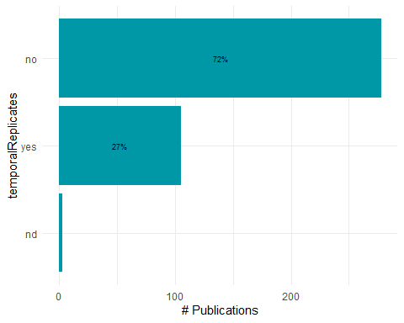
Export bar charts in a dedicated folder
lapply(names(barchart_counts), function(x){
ggsave(filename=paste0("bar_",x,".tiff"),
plot=barchart_counts[[x]],
units = "in", width=12, height=4, dpi=300, compression = 'lzw',
path = here("Extracted_data_analysis", "tropical", "Output-Visualization","Barcharts_split_methods"), create.dir = T
)
})
lapply(names(barchart_counts), function(x){
ggsave(filename=paste0("bar_",x,".png"),
plot=barchart_counts[[x]],
units = "in", width=12, height=4, dpi=300,
path = here("Extracted_data_analysis", "tropical", "Output-Visualization","Barcharts_split"), create.dir = T
)
})

PUBLICATIONS PER DEPTH
tropical$mininumSurveyedDepthInMeters <- as.numeric(tropical$mininumSurveyedDepthInMeters)
tropical$maximumSurveyedDepthInMeters <- as.numeric(tropical$maximumSurveyedDepthInMeters)
# Define depth bins
bins <- seq(31, 151, by = 10)
# Create a data frame to hold bin counts
pubs_depth <- data.frame(
bin_start = bins[-length(bins)],
bin_end = bins[-1]-1,
count = 0
)
# For each bin, count how many studies cover that depth range
for (i in 1:nrow(pubs_depth)) {
bin_start <- pubs_depth$bin_start[i]
bin_end <- pubs_depth$bin_end[i]
pubs_depth$count[i] <- sum(tropical$maximumSurveyedDepthInMeters >= bin_start & tropical$mininumSurveyedDepthInMeters < bin_end, na.rm = TRUE)
}
pubs_depth$depth_bin <- paste(pubs_depth$bin_start, "-", pubs_depth$bin_end)
pubs_depth$depth_bin <- reorder(pubs_depth$depth_bin, -pubs_depth$bin_start)
ggplot(pubs_depth, aes(x = factor(depth_bin), y = count)) +
geom_bar(stat = "identity", fill = "darkorange") +
labs(x = "Depth interval (m)", y = "Number of publications") +
theme_minimal()+
coord_flip()+
scale_y_continuous(position="right")
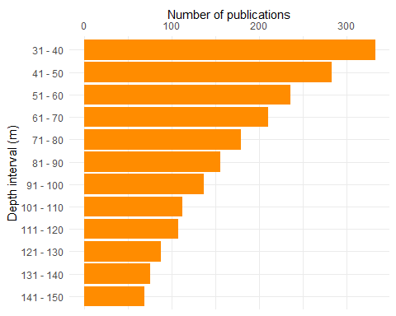
Export pubs per depth bar plot

PLATFORM BY DEPTH
Create a platform by depth data frame and keep meso_samplingPlatform
platform_depth <- tropical %>%
select(File,
mininumSurveyedDepthInMeters,
maximumSurveyedDepthInMeters,
meso_direct_indirect,
meso_samplingPlatform,
max_depth_hov, min_depth_hov,
max_depth_rov, min_depth_rov,
max_depth_ccr, min_depth_ccr,
max_depth_open, min_depth_open,
max_depth_scuba, min_depth_scuba
)
Split the platform column in one binary column per platform
platform_lvls <-
unique(
unlist(
str_split(platform_depth$meso_samplingPlatform, "\\+")
)
)
platform_lvls<- platform_lvls[! platform_lvls %in% c("",NA,"notapp",",","nd")]
platform_depth[,platform_lvls] <- sapply(platform_lvls,
function(y){
str_count(platform_depth$meso_samplingPlatform, y)
}
)
rm(platform_lvls)
platform_depth[,-c(1:15)] <- lapply(platform_depth[,-c(1:15)], as.numeric)
platform_depth[,c(1:15)] <- lapply(platform_depth[,c(1:15)], as.character)
platform_depth %<>%
rename(open_direct = open,
ccr_direct = ccr,
scuba_direct = scuba) %>%
select(-meso_samplingPlatform)
Create a summary table with # studies per platform
platform_summary <- platform_depth %>%
summarise(across(where(is.numeric), ~ sum(.x, na.rm = TRUE)))
platform_summary <- as.data.frame(t(platform_summary))
platform_summary %<>%
mutate(Platform = rownames(platform_summary)) %>%
rename(Count = V1) %>%
relocate(Count,.after = where(is.character))
platform_summary
## Platform Count
## acou acou 26
## bruv bruv 8
## tcs tcs 16
## dredge dredge 15
## fishery fishery 6
## scuba_direct scuba_direct 74
## trawl trawl 2
## open_direct open_direct 169
## hov hov 85
## rov rov 100
## ccr_direct ccr_direct 80
## auv auv 8
## grab grab 13
## vams vams 2
## mixed mixed 1
## drop drop 8
## station station 1
Create a column with the number of platforms per study
platform_per_record <- platform_depth %>%
filter(meso_direct_indirect != "nd") %>%
mutate(
platform_per_record = rowSums(
across(
where(is.numeric)
)
)
)
platform_per_record$platform_per_record <- as.factor(platform_per_record$platform_per_record)
Calculate number of records by number of platforms in %
platform_per_record <- platform_per_record %>%
group_by(platform_per_record) %>%
summarise(n_records = length(platform_per_record)) %>%
mutate(percentage= round(n_records / sum(n_records) * 100,1))
platform_per_record
## # A tibble: 4 × 3
## platform_per_record n_records percentage
## <fct> <int> <dbl>
## 1 1 307 69.9
## 2 2 97 22.1
## 3 3 27 6.2
## 4 4 8 1.8
Keep most common visual platforms only
platform_depth_mod <- cbind(platform_depth[,c(1:14)],
platform_depth$ccr_direct,
platform_depth$open_direct,
platform_depth$scuba_direct,
platform_depth$hov,
platform_depth$rov)
names(platform_depth_mod) <- gsub("platform_depth\\$", "", names(platform_depth_mod))
Set max depth of studies with max depth > 150 to 150 so they fit into the plot
platform_depth_long <- within(platform_depth_mod, rm(mininumSurveyedDepthInMeters, maximumSurveyedDepthInMeters, max_depth_direct, meso_direct_indirect, hov, rov, open_direct, ccr_direct, scuba_direct))
platform_depth_long[,-1] <- lapply(platform_depth_long[,-1], as.numeric)
str(platform_depth_long)
## 'data.frame': 442 obs. of 11 variables:
## $ File : chr "AbdulWahabEtAl_2018_Biodiversity_spatial_patterns.md" "AbesamisEtAl_2018_Benthic_habitat_fish.md" "AlbanoEtAl_2011_challenge_small_rare.md" "AlbeldaEtAl_2020_Juvenile_scleractinian_assemblage.md" ...
## $ max_depth_hov : num NA NA NA NA NA NA NA NA NA 150 ...
## $ min_depth_hov : num NA NA NA NA NA NA NA NA NA 45 ...
## $ max_depth_rov : num NA NA NA NA NA NA 100 70 NA NA ...
## $ min_depth_rov : num NA NA NA NA NA NA 20 20 NA NA ...
## $ max_depth_ccr : num NA NA NA NA NA NA NA NA NA NA ...
## $ min_depth_ccr : num NA NA NA NA NA NA NA NA NA NA ...
## $ max_depth_open : num NA NA NA 40 NA NA 53 NA NA NA ...
## $ min_depth_open : num NA NA NA 3 NA NA 10 20 NA NA ...
## $ max_depth_scuba: num NA NA NA NA NA 55 NA NA NA NA ...
## $ min_depth_scuba: num NA NA 1 NA 72 4 NA NA NA NA ...
platform_depth_long %<>%
mutate(max_depth_scuba = case_when(max_depth_scuba >= 150 ~ 150,
TRUE ~ max_depth_scuba)
) %>%
mutate(max_depth_hov = case_when(max_depth_hov >= 150 ~ 150,
TRUE ~ max_depth_hov)
) %>%
mutate(max_depth_rov = case_when(max_depth_rov >= 150 ~ 150,
TRUE ~ max_depth_rov)
) %>%
mutate(max_depth_ccr = case_when(max_depth_ccr >= 150 ~ 150,
TRUE ~ max_depth_ccr)) %>%
mutate(max_depth_open = case_when(max_depth_open >= 150 ~ 150,
TRUE ~ max_depth_open))
Set min depth of studies with min depth <30 to 30 so they fit into the plot
platform_depth_long %<>%
mutate(min_depth_scuba = case_when(min_depth_scuba <= 30 ~ 30,
TRUE ~ min_depth_scuba)
) %>%
mutate(min_depth_hov = case_when(min_depth_hov <= 30 ~ 30,
TRUE ~ min_depth_hov)
) %>%
mutate(min_depth_rov = case_when(min_depth_rov <= 30 ~ 30,
TRUE ~ min_depth_rov)
) %>%
mutate(min_depth_ccr = case_when(min_depth_ccr <= 30 ~ 30,
TRUE ~ min_depth_ccr)) %>%
mutate(min_depth_open = case_when(min_depth_open <= 30 ~ 30,
TRUE ~ min_depth_open))
Convert platform_depth_long to long format
platform_min_depth_long <- platform_depth_long %>%
select(-c(max_depth_hov, max_depth_rov, max_depth_open, max_depth_scuba, max_depth_ccr))
platform_min_depth_long[,c(1,2)] <- lapply(platform_min_depth_long[,c(1,2)], as.factor)
platform_min_depth_long %<>%
reshape2::melt(platform_min_depth_long,
id.vars = c("File"),
measure.vars = grep("^min_depth_|^max_depth_",
names(platform_min_depth_long),
value = TRUE),
variable.name = "Platform",
value.name = "min_depth"
)
## Warning: attributes are not identical across measure variables; they will be
## dropped
platform_max_depth_long <- platform_depth_long %>%
select(-c(min_depth_hov, min_depth_rov, min_depth_open, min_depth_scuba, min_depth_ccr))
platform_max_depth_long %<>%
reshape2::melt(platform_max_depth_long,
id.vars = c("File"),
measure.vars = grep("^min_depth_|^max_depth_",
names(platform_max_depth_long),
value = TRUE),
variable.name = "Platform",
value.name = "max_depth"
)
platform_depth_lat_long <- cbind(platform_min_depth_long, platform_max_depth_long$max_depth)
rm(platform_min_depth_long, platform_max_depth_long)
platform_depth_lat_long %<>%
rename(max_depth =`platform_max_depth_long$max_depth`)
platform_depth_lat_long$Platform <- gsub("min_depth_", "", platform_depth_lat_long$Platform)
platform_depth_lat_long$Platform <- gsub("max_depth_", "", platform_depth_lat_long$Platform)
Set proper labelling for platform
platform_depth_lat_long %<>%
mutate(Platform = case_when(Platform == "ccr" ~ "CCR",
Platform == "scuba" ~ "SCUBA",
Platform == "open" ~ "OC",
Platform == "rov" ~ "ROV",
Platform == "hov" ~ "HOV",
TRUE ~ Platform)
) %>%
mutate(Platform = as.factor(Platform))
Add visual column to reorder platform
platform_depth_lat_long %<>%
mutate(Visual = as.factor(case_when(Platform == "OC" |
Platform == "SCUBA" |
Platform == "CCR" ~ "direct",
TRUE ~ "indirect" )
)
)
platform_depth_lat_long %<>%
mutate(Platform = forcats::fct_reorder(Platform, as.integer(Visual)))
Create a bar plot with depth bins by platform and latitudinalRegion
depth_bins <- tibble(
bin_start = seq(-30, -140, by = -10),
bin_end = seq(-40, -150, by = -10)
) %>%
mutate(bin_label = paste0(abs(bin_start), "-", abs(bin_end)))
platform_depth_lat_long <- platform_depth_lat_long %>%
mutate(
min_depth = as.numeric(min_depth), # positive e.g., 30
max_depth = as.numeric(max_depth) # positive e.g., 150
)
expanded_data <- platform_depth_lat_long %>%
tidyr::crossing(depth_bins) %>%
# Convert study range to negative depths: [-max_depth, -min_depth]
filter(bin_end >= -max_depth, bin_start <= -min_depth) %>%
mutate(
bin_label = factor(bin_label, levels = rev(depth_bins$bin_label))
)
# Plot with count labels on the right
platform_depth_plot <- ggplot(expanded_data, aes(x = bin_label)) +
geom_bar(position = "stack", alpha= 0.8, fill= "darkorange") +
scale_y_continuous(name = "Number of Studies",
expand = expansion(mult = c(0, 0.15))) + # Make room for text
scale_x_discrete(name = "Depth (m)") +
coord_flip() + # Depth on y-axis (shallow at top)
facet_wrap(~ Platform, nrow = 1) +
theme_minimal() +
theme(legend.position = "none")
platform_depth_plot
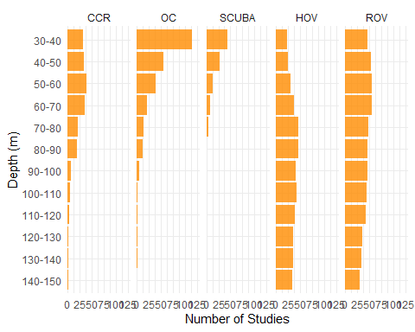
Export bar plot of most common platform per depth interval
ggsave("platform_depth_plot.tiff",
plot = platform_depth_plot,
units = "in", width = 8, height = 6, dpi = 300, compression = 'lzw',
path = here ("Extracted_data_analysis", "tropical", "Output-Visualization"))
ggsave("platform_depth_plot.png",
plot = platform_depth_plot,
units = "in", width = 8, height = 5,
path = here ("Extracted_data_analysis", "tropical", "Output-Visualization"))

DIRECT - INDIRECT BY DECADE
dir_ind_by_decade <- tropical
dir_ind_by_decade %<>%
mutate(decade = case_when(publicationYear >= 1960 & publicationYear < 1970 ~ "1970-1979",
publicationYear >= 1970 & publicationYear < 1980 ~ "1970-1979",
publicationYear >= 1980 & publicationYear < 1990 ~ "1980-1989",
publicationYear >= 1990 & publicationYear < 2000 ~ "1990-1999",
publicationYear >= 2000 & publicationYear < 2010 ~ "2000-2009",
publicationYear >= 2010 & publicationYear < 2020 ~ "2010-2019",
publicationYear >= 2020 ~ "2020-2023")
)
dir_ind_by_decade_lat <- dir_ind_by_decade
dir_ind_by_decade <- dir_ind_by_decade [, c("meso_direct_indirect","decade")] %>%
group_by(decade,meso_direct_indirect) %>%
tally()
colnames(dir_ind_by_decade) <- c("Decade", "Technique","Count")
unique(dir_ind_by_decade$Technique)
## [1] "direct" "mixed" "indirect" "nd"
dir_ind_by_decade %<>%
filter(Technique != "nd" & Technique != "NA") %>% #remove nd from viz because they accounted for a really small percentage
group_by(Decade) %>%
mutate(Percentage = round(Count / sum(Count) * 100,1))
Make bar plot of technique by decade
technique_decade_barplot <- ggplot(subset(dir_ind_by_decade,
dir_ind_by_decade$Decade != "1970-1979"),
aes(x=Technique, y=Count, label = Technique)
) +
geom_bar(position="dodge",
stat="identity", alpha= 0.8, fill = "darkorange" ) +
geom_text(aes(label = paste(round(Percentage,0),"%", sep="")),
parse = F,
vjust = -0.25,
size=3.9)+
facet_grid(~ Decade,
switch = "y") +
theme_classic() +
theme(legend.position = "bottom",
legend.text = element_text(size = 10),
axis.text.x = element_blank(),
axis.text.y = element_text(size=8.7),
axis.title.x = element_blank(),
axis.title.y = element_text(size=13),
strip.text = element_text(size = 13))+
labs(y= "Number of publications")
technique_decade_barplot
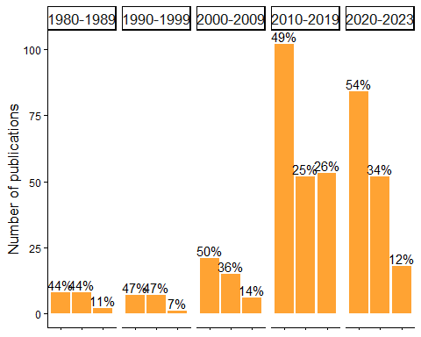
Export bar plot of technique by decade
ggsave("technique_decade_barplot.tiff",
plot = technique_decade_barplot,
units = "in", width = 7, height = 6, dpi = 300, compression = 'lzw',
path = here ("Extracted_data_analysis", "tropical", "Output-Visualization"))
ggsave("technique_decade_barplot.png",
plot = technique_decade_barplot,
units = "in", width = 7, height = 6,
path = here ("Extracted_data_analysis", "tropical", "Output-Visualization"))

FIELD & INDICATORS
Create subset for field & indicators
field_merged <- tropical[,c(59:length(tropical))]
field_merged[,] <- lapply(field_merged[,], as.numeric)
colSums(field_merged)
## field_cons field_commdesc
## 24 146
## field_map field_impass
## 46 66
## field_troph field_taxo
## 37 106
## field_dist field_aqua
## 171 1
## field_method field_physio
## 13 124
## field_func field_habtype
## 17 0
## field_fishery field_stock
## 8 7
## field_paleo field_phylo
## 0 31
## field_rest field_archaeo
## 1 0
## field_micro field_biomedicine
## 7 1
## field_chem field_Molecular_ecology
## 1 120
## field_Acoustics field_environmental_drivers
## 26 136
## field_Behaviour field_Geomorphology
## 27 12
## field_Taxonomy
## 91
Select only the most common fields
field_merged <- field_merged[, colSums(field_merged) > 30]
field_merged$field_Taxonomy <- NULL
field_merged$field_taxo <- NULL
colSums(field_merged)
## field_commdesc field_map
## 146 46
## field_impass field_troph
## 66 37
## field_dist field_physio
## 171 124
## field_phylo field_Molecular_ecology
## 31 120
## field_environmental_drivers
## 136
field_merged <- field_merged[, order(colSums(field_merged), decreasing = F)]
colSums(field_merged)
## field_phylo field_troph
## 31 37
## field_map field_impass
## 46 66
## field_Molecular_ecology field_physio
## 120 124
## field_environmental_drivers field_commdesc
## 136 146
## field_dist
## 171
Rename fields with long version names
field_merged %<>%
rename(`Biodiversity and \n community structure (146)` = field_commdesc,
`Distribution and \n connectivity (171)` = field_dist,
`Disturbances (66)` = field_impass,
`Mapping (46)` = field_map,
`Physiology (124)` = field_physio,
`Phylogenesis (31)` = field_phylo,
`Trophic ecology (37)` = field_troph,
`Molecular ecology (120)` = field_Molecular_ecology,
`Environmental drivers and \n spatio-temporal patterns (136)` = field_environmental_drivers
)
colSums(field_merged)
## Phylogenesis (31)
## 31
## Trophic ecology (37)
## 37
## Mapping (46)
## 46
## Disturbances (66)
## 66
## Molecular ecology (120)
## 120
## Physiology (124)
## 124
## Environmental drivers and \n spatio-temporal patterns (136)
## 136
## Biodiversity and \n community structure (146)
## 146
## Distribution and \n connectivity (171)
## 171
Prepare the indicator matrix
ind_matrix <- split_results[["indicators"]]
Select only the most common indicators
colSums(ind_matrix)
## Abundance Cover Diversity Habitat
## 92 134 179 56
## Morphological complexity Size geneticSequences
## 142 3 70 120
## Density taxo Biomass Trophic
## 36 89 26 37
## rugosity Mortality Physiological growth
## 1 15 94 22
## Recruitment surv sex Health
## 14 15 7 27
## taxonomy Behaviour NIS disease
## 1 17 8 6
## impact ALDFGs Litter func
## 5 3 4 10
## fecundity
## 1
ind_common_matrix <- ind_matrix[, colSums(ind_matrix) > 30]
colSums(ind_common_matrix)
## Abundance Cover Diversity Habitat
## 92 134 179 56
## Morphological Size geneticSequences Density
## 142 70 120 36
## taxo Trophic Physiological
## 89 37 94
ind_common_matrix <- ind_common_matrix[, order(colSums(ind_common_matrix), decreasing = TRUE)]
ind_common_matrix <- as.data.frame(ind_common_matrix)
ind_common_matrix <- ind_common_matrix[!purrr::map_lgl(ind_common_matrix, ~ all(is.na(.)))] # remove empty column
Remove taxonomy studies which have a dedicated section
ind_common_matrix$taxo <- NULL
colSums(ind_common_matrix)
## Diversity Morphological Cover geneticSequences
## 179 142 134 120
## Physiological Abundance Size Habitat
## 94 92 70 56
## Trophic Density
## 37 36
Rename indicators with long version names
ind_common_matrix %<>%
rename(`Abundance \n (92)` = Abundance,
`Cover \n (134)` = Cover,
`Diversity \n (179)` = Diversity,
`Habitat \n (56)` = Habitat,
`Morphology \n (142)` = Morphological,
`Size \n (70) ` = Size,
`Density \n (36)` = Density,
`Physiological \n indicator \n (94)` = Physiological,
`Trophic \n (37)` = Trophic,
`Genetic \n sequence \n (120)` = geneticSequences
)
colSums(ind_common_matrix)
## Diversity \n (179) Morphology \n (142)
## 179 142
## Cover \n (134) Genetic \n sequence \n (120)
## 134 120
## Physiological \n indicator \n (94) Abundance \n (92)
## 94 92
## Size \n (70) Habitat \n (56)
## 70 56
## Trophic \n (37) Density \n (36)
## 37 36
Multiply the transpose of the field matrix with the indicator matrix
co_occurrence_matrix <- t(as.matrix(field_merged)) %*% as.matrix(ind_common_matrix)
Reshape the co-occurrence matrix for plotting}
co_occurrence_df <- reshape2::melt(co_occurrence_matrix)
colnames(co_occurrence_df) <- c("Field", "Indicator", "Count")
Plot the heatmap
field_ind_heat <- ggplot(co_occurrence_df, aes(x = Indicator, y = Field, fill = Count)) +
geom_tile(color = "white") +
scale_fill_gradient(low = "white", high = "deepskyblue4") +
geom_text(aes(label = Count), color = "black") +
theme_minimal()+
scale_x_discrete(position="top")
field_ind_heat
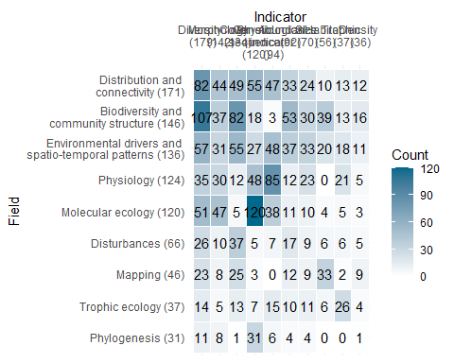
Export plot
ggsave("field_ind_heat.png",
units = "in", width = 12.5, height = 5.5,
path = here ("Extracted_data_analysis", "tropical", "Output-Visualization"))

Calculate # of ecological indicators per record
Create a column with the sum of ecological indicators values to see how many different sampling units were adopted by each study
ind_summary <- as.data.frame(split_results[["indicators"]])
ind_summary <- ind_summary[!purrr::map_lgl(ind_summary, ~ all(is.na(.)))] # remove empty column
ind_summary %<>% rowwise() %>%
mutate(ind_per_record = sum(c_across(where(is.numeric))))
Calculate number of records by number of sampling units in %
ind_summary$ind_per_record <- as.factor(ind_summary$ind_per_record)
ind_per_record <- ind_summary %>%
group_by(ind_per_record) %>%
summarise(n_records = length(ind_per_record)) %>%
mutate(percentage= round(n_records / sum(n_records) * 100,1))
ind_per_record
## # A tibble: 10 × 3
## ind_per_record n_records percentage
## <fct> <int> <dbl>
## 1 0 3 0.7
## 2 1 66 14.9
## 3 2 136 30.8
## 4 3 136 30.8
## 5 4 50 11.3
## 6 5 31 7
## 7 6 11 2.5
## 8 7 6 1.4
## 9 8 2 0.5
## 10 9 1 0.2

SAMPLING UNIT

Prepare a data frame for sampling unit
sampling_df <- tropical %>%
filter(is.na(taxonomic_publication)) %>% # remove purely taxonomic studies
select(File,recordTitle,DOI,publicationYear,mininumSurveyedDepthInMeters,maximumSurveyedDepthInMeters,samplingUnit)
sampling_df %>% tidyr::drop_na(samplingUnit)
sampling_df[!is.na(sampling_df$samplingUnit),]
sampling_df %<>%
filter(samplingUnit != "notapp")
sampling_df$samplingUnit <- as.character(sampling_df$samplingUnit)
Prepare columns per sampling units
sampling_lvls <- unique(unlist(str_split(sampling_df$samplingUnit,
"\\+")
)
)
rownames(is.na(sampling_df$samplingUnit))
## NULL
sampling_df[,sampling_lvls] <- sapply(sampling_lvls,
function(y){
str_count(sampling_df$samplingUnit, y)
}
)
rm(sampling_lvls)
colnames(sampling_df)
## [1] "File" "recordTitle"
## [3] "DOI" "publicationYear"
## [5] "mininumSurveyedDepthInMeters" "maximumSurveyedDepthInMeters"
## [7] "samplingUnit" "quadrat"
## [9] "sample" "transect"
## [11] "permquad" "pit"
## [13] "permtrans" "expunit"
## [15] "lit" "nd"
## [17] "permlit" "roaming_transect"
## [19] "random_swim" "arms"
## [21] "plotless" "stationary"
## [23] "radial_transect"

Calculate # of sampling unit per record
Create a column with the sum of sampling units values to see how many different sampling units were adopted by each study
sampling_df %<>%
mutate(type_per_record = rowSums(across(quadrat:permlit)
)
)
Calculate number of records by number of sampling units in %
sampling_df$type_per_record <- as.factor(sampling_df$type_per_record)
sampling_unit_per_record <- sampling_df %>%
group_by(type_per_record) %>%
summarise(n_records = length(type_per_record)) %>%
mutate(percentage= round(n_records / sum(n_records) * 100,0))
sampling_unit_per_record
## # A tibble: 4 × 3
## type_per_record n_records percentage
## <fct> <int> <dbl>
## 1 0 5 1
## 2 1 284 76
## 3 2 70 19
## 4 3 15 4
Create a data frame with number of publication per sampling unit type
sampling_unit_tot <- sampling_df %>%
summarise(across(c(8:(length(sampling_df)-1)),
list(sum)))
sampling_unit_tot <- reshape2::melt(sampling_unit_tot)
## No id variables; using all as measure variables
colnames(sampling_unit_tot) <- c("Sampling_unit", "Count")
sampling_unit_tot %<>%
mutate_at("Sampling_unit",
stringr::str_replace, "_1", "")

Simplified sampling units
Create a column with a simplified sampling units for transect and quadrat
sampling_unit_tot %<>%
mutate(Sampling_unit_macro = case_when(Sampling_unit == 'quadrat' |
Sampling_unit == "permquad" ~ "Quadrat",
Sampling_unit == "transect"|
Sampling_unit == "lit" |
Sampling_unit == "pit" |
Sampling_unit == "permlit" |
Sampling_unit == "permtrans" |
Sampling_unit == "circular_transect" |
Sampling_unit == "radial_transect"~ "Transect",
Sampling_unit == "nd" ~ "ND",
Sampling_unit == "stationary" ~ "Stationary",
Sampling_unit == "expunit" ~ "Experimental unit",
Sampling_unit == "sample" ~ "Sample",
.default = "Other")
)
# Change columns order
sampling_unit_tot <- cbind(sampling_unit_tot$Sampling_unit_macro,
sampling_unit_tot$Sampling_unit,
sampling_unit_tot$Count)
colnames(sampling_unit_tot) <- c("Sampling_unit_macro","Sampling_unit","Count")
sampling_unit_tot <- as.data.frame(sampling_unit_tot)
sampling_unit_tot[,1:2] <- lapply(sampling_unit_tot[,1:2], as.factor)
sampling_unit_tot$Count <- as.numeric(sampling_unit_tot$Count)
sampling_unit_simplified <- aggregate(Count ~ Sampling_unit_macro, data = sampling_unit_tot, FUN = sum)
sampling_unit_simplified %<>%
group_by(Sampling_unit_macro) %>%
mutate(Percentage_macro= round(Count / sum(sampling_unit_simplified$Count) * 100,1))
sampling_unit_simplified
## # A tibble: 7 × 3
## # Groups: Sampling_unit_macro [7]
## Sampling_unit_macro Count Percentage_macro
## <fct> <dbl> <dbl>
## 1 Experimental unit 45 9.2
## 2 ND 21 4.3
## 3 Other 10 2
## 4 Quadrat 109 22.2
## 5 Sample 167 34.1
## 6 Stationary 10 2
## 7 Transect 128 26.1
Build a treemap with simplified sampling unit
library(treemapify)
RdYlBu <- RColorBrewer::brewer.pal(7, "RdYlBu")
RdYlBu
## [1] "#D73027" "#FC8D59" "#FEE090" "#FFFFBF" "#E0F3F8" "#91BFDB" "#4575B4"
sampling_simplified_treemap <-
ggplot(sampling_unit_simplified,
aes(area=Count,
fill=Sampling_unit_macro,
line = "black",
label=paste0(Sampling_unit_macro, " \n ",Percentage_macro,"%"))
)+
treemapify::geom_treemap(layout = "squarified")+
geom_treemap_text(place = "centre",
size = 20)+
theme(plot.title = element_text(hjust = 0.5, size= 20),
legend.position = "none")+
scale_fill_manual(values= c("#FC8D59", "#FEE090","#FFFFBF", "#E0F3F8", "#D73027", "#91BFDB", "#4575B4"))
scale_fill_brewer(palette = "RdYlBu")
## <ggproto object: Class ScaleDiscrete, Scale, gg>
## aesthetics: fill
## axis_order: function
## break_info: function
## break_positions: function
## breaks: waiver
## call: call
## clone: function
## dimension: function
## drop: TRUE
## expand: waiver
## fallback_palette: function
## get_breaks: function
## get_breaks_minor: function
## get_labels: function
## get_limits: function
## get_transformation: function
## guide: legend
## is_discrete: function
## is_empty: function
## labels: waiver
## limits: NULL
## make_sec_title: function
## make_title: function
## map: function
## map_df: function
## minor_breaks: waiver
## n.breaks.cache: NULL
## na.translate: TRUE
## na.value: NA
## name: waiver
## palette: function
## palette.cache: NULL
## position: left
## range: environment
## rescale: function
## reset: function
## train: function
## train_df: function
## transform: function
## transform_df: function
## super: <ggproto object: Class ScaleDiscrete, Scale, gg>
sampling_unit_simplified %<>%
mutate(case_when(Sampling_unit_macro == "Experimental unit" ~
"Experimental \n unit", T ~ Sampling_unit_macro))
sampling_simplified_treemap <-
ggplot(sampling_unit_simplified,
aes(area=Count,
fill= reorder(Sampling_unit_macro, -Count),
line = "black",
label=paste0(Sampling_unit_macro, " \n ",Percentage_macro,"%"))
)+
treemapify::geom_treemap(layout = "squarified")+
geom_treemap_text(place = "centre", fontface = "bold",
size = 20)+
theme(plot.title = element_text(hjust = 0.5, size= 20),
legend.position = "none")+
scale_fill_manual(values=c("#01665E","#5AB4AC","#C7EAE5", "#8C510A","#D8B365","#F6E8C3","#F5F5F5")) # selected from "BrBG" palette of RBrewer
sampling_simplified_treemap
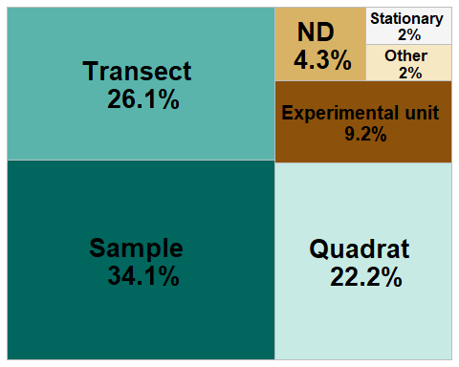
Export sampling_simplified_treemap
ggsave("sampling_simplified_treemap.png",
plot = sampling_simplified_treemap,
units = "in", width = 7, height = 6,
path = here ("Extracted_data_analysis",
"tropical",
"Output-Visualization"))
Export sampling_unit_tot table for supplementary materials
library(openxlsx)
openxlsx::write.xlsx(sampling_unit_tot,
file = here("Extracted_data_analysis", "tropical", "Output-Transformed_data",
"sampling_unit_tot.xlsx"))

Quadrat extracted from transect
print(paste("Number of publications where quadrat is the sampling unit or one of the sampling unit: ",
nrow(quad_design <- subset(tropical,grepl("quad", samplingUnit)
) )
)
)
## [1] "Number of publications where quadrat is the sampling unit or one of the sampling unit: 108"
print(paste("Number of publications where quadrats were collected along transects: ", nrow(subset(quad_design,
grepl("transect\\(quadrat", meso_design) |
grepl("transect\\(depth\\(quadrat", meso_design)
)
)
)
)
## [1] "Number of publications where quadrats were collected along transects: 80"

DATA TYPE
data_type <- count_results[["collectedDataType"]]
data_type$Percentage <- round(data_type$Percentage, 1)
data_type
## # A tibble: 29 × 3
## collectedDataType Count Percentage
## <fct> <int> <dbl>
## 1 photo 47 10.6
## 2 photo+specimen 50 11.3
## 3 photo+specimen+sediment 1 0.2
## 4 photo+specimen+sediment+video 3 0.7
## 5 photo+specimen+video 9 2
## 6 photo+specimen+video+visual 4 0.9
## 7 photo+specimen+visual 7 1.6
## 8 photo+specimen+water 1 0.2
## 9 photo+video 14 3.2
## 10 photo+video+visual 4 0.9
## # ℹ 19 more rows
Lump uncommon combination into “Other”
data_type_simplified <- data_type %>%
rename(`Data type`= collectedDataType) %>%
mutate(`Data type` = as.character(`Data type`)) %>%
filter(Percentage > 2) %>%
bind_rows(
data_type %>%
filter(Percentage <= 2) %>%
summarise(
`Data type` = "other",
Count = sum(.data$Count),
Percentage = sum(.data$Percentage)
)
)
data_type_simplified %<>%
mutate(`Data type` =
case_when(`Data type` == 'photo' ~ "Photo",
`Data type` == "video"~ "Video",
`Data type` == "other" ~ "Other",
`Data type` == "specimen" ~ "Specimen",
`Data type` == "photo+specimen" ~ "Photo + \n Specimen",
`Data type` == "photo+specimen+video" ~ "Photo + Video + \n Specimen",
`Data type` == "photo+video" ~ "Photo + \n Video",
`Data type` == "photo+visual" ~ "Photo + \n Visual",
`Data type` == "specimen+visual" ~ "Specimen + \n Visual",
`Data type` == "specimen+video" ~ "Specimen + \n Video",
.default = "Other")
)
Build a treemap with data type
library(treemapify)
library(RColorBrewer)
data_type_treemap <-
ggplot(data_type_simplified,
aes(area=Count,
fill=`Data type`,
line = "black",
label=paste0(`Data type`, " \n ",Percentage,"%"))
)+
treemapify::geom_treemap(layout = "squarified")+
geom_treemap_text(place = "centre", fontface = "bold",
size = 20)+
theme(plot.title = element_text(hjust = 0.5, size= 20),
legend.position = "none")+
scale_fill_brewer(palette = "RdYlBu")
data_type_treemap
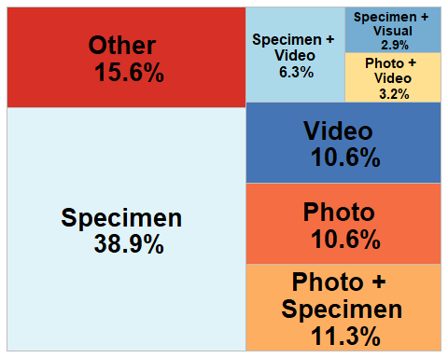
Export sampling_simplified_treemap
ggsave("data_type_treemap.png",
plot = data_type_treemap,
units = "in", width = 7, height = 6,
path = here ("Extracted_data_analysis", "tropical", "Output-Visualization"))

HABIT
habit <- as.data.frame(count_results["habit"])
# Rename columns
habit %<>%
rename(Habit = habit.habit,
Count = habit.Count,
Percentage = habit.Percentage)
Make the habit donut plot
habit %<>%
mutate(ymax = cumsum(Count),
ymin = c(0, head(ymax, n = -1)),
mid = (ymin + ymax) / 2,
angle = 90 - (mid / sum(Count)) * 360
)
# Split and assign labels
habit_inside <- habit %>%
mutate(label = paste0(round(Percentage,1), "%"))
habit_outside <- habit %>%
mutate(label = Habit)
# Plot
habit_donut <- ggplot() +
# Donut segments
geom_rect(data = habit,
aes(ymin = ymin, ymax = ymax, xmin = 2.5, xmax = 4, fill = Habit),
color = "black") +
# Inside labels
geom_text(data = habit_inside,
aes(x = 3.2, y = mid, label = label),
size = 5, color = "black",
fontface = "bold") +
# Outside labels with Habit name
ggrepel::geom_text_repel(data = habit_outside,
aes(x = 4.3, y = mid, label = label),
size = 5.5,
nudge_x = 0.5,
direction = "y",
segment.color = "black",
hjust = 0,
box.padding = 0.3,
max.overlaps = Inf) +
coord_polar(theta = "y") +
xlim(0.2, 5) +
scale_fill_brewer(palette = "Purples") +
theme_void() +
theme(legend.position = "none")+
annotate(geom = 'text', x = 0.5, y = 0,
label = c("HABIT"), size = 8)
habit_donut
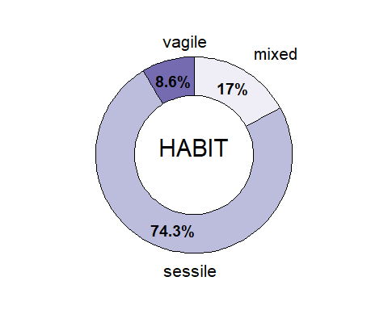
Export habit_donut
ggsave("habit_donut.png",
plot = habit_donut,
units = "in", width = 7, height = 6,
path = here ("Extracted_data_analysis", "tropical", "Output-Visualization"))

SUBSTRATE
substrate <- as.data.frame(count_results["meso_substrate"])
# Rename columns
substrate %<>%
rename(Substrate = meso_substrate.meso_substrate,
Count = meso_substrate.Count,
Percentage = meso_substrate.Percentage)
# Remove rows with nd
substrate <- substrate[!substrate$Substrate %in% "nd",]
# Merge substrate combination with less than 3% and recalculate Count and Percentages
substrate <- substrate %>%
mutate(Substrate = if_else(Percentage < 3, "Other combinations", Substrate)) %>%
group_by(Substrate) %>%
select(-Percentage) %>%
summarise(
Count = sum(Count)) %>%
mutate(Percentage = round(Count / sum(Count) * 100,1)
)
substrate %<>%
mutate(
Substrate = case_when(Substrate == "hard" ~ "Hard",
Substrate == "soft"~ "Soft",
Substrate == "mixed" ~ paste0("Hard+","\n","Soft"),
Substrate == "artificial" ~ "Artificial",
Substrate == "Other combinations" ~ "Other combinations"))
Make the substrate donut plot
substrate %<>%
mutate(
ymax = cumsum(Count),
ymin = c(0, head(ymax, n = -1)),
mid = (ymin + ymax) / 2,
angle = 90 - (mid / sum(Count)) * 360
)
# Split and assign labels
substrate_inside <- substrate %>%
filter(Percentage >= 5) %>%
mutate(label = paste0(Percentage, "%"))
substrate_outside <- substrate %>%
mutate(label = Substrate)
# Plot
substrate_donut <- ggplot() +
# Donut segments
geom_rect(data = substrate,
aes(ymin = ymin, ymax = ymax, xmin = 2.5, xmax = 4, fill = Substrate),
color = "black") +
# Inside labels
geom_text(data = substrate_inside,
aes(x = 3.2, y = mid, label = label),
size = 5, color = "black",
fontface = "bold") +
# Outside labels with substrate name
ggrepel::geom_text_repel(data = substrate_outside,
aes(x = 4.4, y = mid, label = label),
size = 5.5,
nudge_x = 0.3,
direction = "y",
segment.color = "black",
hjust = 0,
box.padding = 0.3,
max.overlaps = Inf) +
coord_polar(theta = "y") +
xlim(0.2, 5) +
scale_fill_brewer(palette = "GnBu") +
theme_void() +
theme(legend.position = "none")+
annotate(geom = 'text', x = 0.5, y = 0,
label = c("SUBSTRATE"), size = 8)
substrate_donut
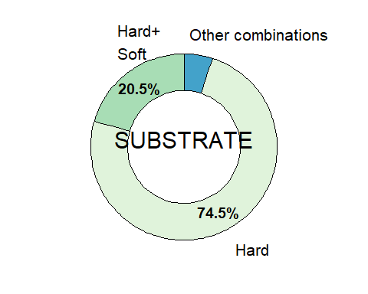 Export the substrate donut plot
ggsave("substrate_donut.png",
plot = substrate_donut,
units = "in", width = 7, height = 6,
path = here ("Extracted_data_analysis", "tropical", "Output-Visualization"))

BENTHIC POSITION
Create a data frame with benthic position
position <- as.data.frame(count_results["environmentalPosition"])
# Rename columns
position %<>%
rename(Position = environmentalPosition.environmentalPosition,
Count = environmentalPosition.Count,
Percentage = environmentalPosition.Percentage)
# Merge position combination with less than 3% and recalculate Count and Percentages
position <- position %>%
mutate(Position = if_else(Percentage < 1, "Other combinations", Position)) %>%
group_by(Position) %>%
select(-Percentage) %>%
summarise(
Count = sum(Count)) %>%
mutate(Percentage = round(Count / sum(Count) * 100,1)
)
Make the benthic position donut plot
position %<>%
mutate(
Position = case_when(Position == "epi" ~ "Epi",
Position == "endo"~ "Endo",
Position == "dem+epi" ~ "Hyper + \n Epi",
Position == "endo+epi" ~ "Endo + \n Epi",
Position == "Other combinations" ~ "Other combinations"),
ymax = cumsum(Count),
ymin = c(0, head(ymax, n = -1)),
mid = (ymin + ymax) / 2,
angle = 90 - (mid / sum(Count)) * 360
)
# Split and assign labels
position_inside <- position %>%
filter(Percentage > 3) %>%
mutate(label = paste0(Percentage, "%"))
position_outside <- position %>%
mutate(label = Position)
# Plot
benthic_position_donut <- ggplot() +
# Donut segments
geom_rect(data = position,
aes(ymin = ymin, ymax = ymax, xmin = 2.5, xmax = 4, fill = Position),
color = "black") +
# Inside labels
geom_text(data = position_inside,
aes(x = 3.2, y = mid, label = label),
size = 5, color = "black",
fontface = "bold") +
# Outside labels with Position name
ggrepel::geom_text_repel(data = position_outside,
aes(x = 4.2, y = mid, label = label),
size = 5.5,
nudge_x = 0.3,
direction = "y",
segment.color = "black",
hjust = 0,
box.padding = 0.3,
max.overlaps = Inf) +
coord_polar(theta = "y") +
xlim(0.2, 5) +
scale_fill_brewer(palette = "OrRd") +
theme_void() +
theme(legend.position = "none")+
annotate(geom = 'text', x = 0.5, y = 0,
label = c("BENTHIC \n POSITION"), size = 8)
benthic_position_donut
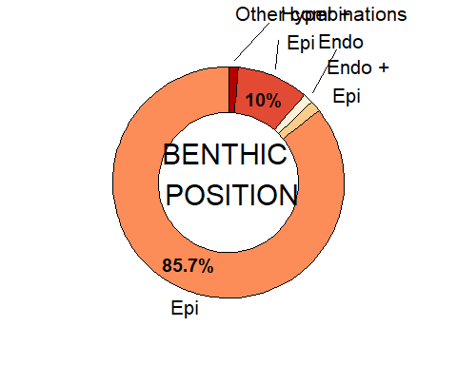
Export the benthic_position donut plot
ggsave("benthic_position_donut.png",
plot = benthic_position_donut,
units = "in", width = 7, height = 6,
path = here ("Extracted_data_analysis", "tropical", "Output-Visualization"))

TARGET

Target level
target_level <- as.data.frame(count_results["taxonomicTargetLevel"])
# Rename columns
target_level %<>%
rename(Level = taxonomicTargetLevel.taxonomicTargetLevel,
Count = taxonomicTargetLevel.Count,
Percentage = taxonomicTargetLevel.Percentage)
# Remove rows with nd
target_level <- target_level[!target_level$Level %in% "species,species",]
target_level <- target_level[!target_level$Level %in% ",species",]
# Merge habit combination with less than 3% and recalculate Count and Percentages
target_level <- target_level %>%
mutate(Level = if_else(Percentage < 3, "Other combinations", Level)) %>%
group_by(Level) %>%
select(-Percentage) %>%
summarise(
Count = sum(Count)) %>%
mutate(Percentage = round(Count / sum(Count) * 100,1)
)
Treemap with the taxonomic target level
target_level_labels <- target_level %<>%
mutate(
Level = case_when(Level == "comm" ~ "Community",
Level == "group"~ "Group",
Level == "single" ~ "Single species",
Level == "species" ~ ">1 species",
Level == "comm+group" ~ "Community+Group",
Level == "comm+species" ~ "Community+Species",
Level == "group+species" ~ "Group+\nSpecies",
Level == "Other combinations" ~ "Other")
)
target_level_treemap <- ggplot(target_level_labels,
aes(area=Count,
fill=Level,
line = "black",
label=paste0(Level,
" \n ",Percentage,"%"))
)+
treemapify::geom_treemap(layout = "squarified")+
treemapify::geom_treemap_text(place = "centre",
size = 20)+
theme(plot.title = element_text(hjust = 0.5, size= 20),
legend.position = "none")+
scale_fill_manual(values= c("#A6D854" ,"#66C2A5","#E78AC3", "#8DA0CB","#FFD92F","#B3B3B3", "#E5C494", "#FC8D62"))
target_level_treemap
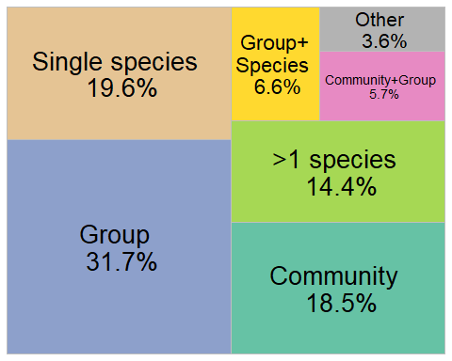
ggsave("target_level_treemap.png",
plot = target_level_treemap,
units = "in", width = 9, height = 6,
path = here ("Extracted_data_analysis", "tropical", "Output-Visualization"))

Detected phyla in community studies
detected <- tropical %>%
filter(str_detect(taxonomicTargetLevel,"comm")) %>%
select(File,
detected_meso_cnidaria,
detected_meso_sponges,
detected_meso_seagrass,
detected_meso_algae,
detected_meso_mollusca,
detected_meso_chondrichthyes,
detected_meso_fish,
detected_meso_crustacea,
detected_meso_echino,
detected_meso_other_taxa)
detected_lvls <-
unique(
unlist(
str_split(detected$detected_meso_other_taxa, "\\+")
)
)
detected_lvls<- detected_lvls[! detected_lvls %in% c("",NA,"notapp",",","nd")]
detected[,detected_lvls] <- sapply(detected_lvls,
function(y){
str_count(detected$detected_meso_other_taxa, y)
}
)
rm(detected_lvls)
detected %<>%
mutate(across(everything(), as.character)) %>%
replace(is.na(.), "0") %>%
select(-detected_meso_other_taxa) %>%
filter(if_all(everything(), ~ !grepl("notapp", .x)))
detected <- detected %>%
mutate(across(-File, ~ case_when(
.x %in% c("x", "x,", "xx") ~ "1",
.x == "," ~ "0",
TRUE ~ .x
))) %>%
mutate(across(-File, as.numeric))
Calculate number of publications per taxonomic group
detected_tot <-
detected %>%
summarise(across(where(is.numeric),
list(sum)
)
)
detected_tot <- reshape2::melt(detected_tot, id.vars = NULL)
colnames(detected_tot) <- c("Taxa", "Count")
detected_tot %<>%
mutate_at("Taxa",
stringr::str_replace, "_1", "") %>%
mutate_at("Taxa",
stringr::str_replace, "detected_meso_", "")
detected_tot %<>%
mutate(Percentage= round(Count / nrow(detected) * 100,1))
rm(detected)
Merge poorly represented taxonomic groups into “Other”
detected_tot_collapsed <- detected_tot %>%
mutate(Taxa = if_else(Percentage < 3, "Other", Taxa)) %>%
group_by(Taxa) %>%
summarise(
Count = sum(Count),
Percentage = sum(Percentage)
)
Create a bar chart with detected taxonomic groups
detected_bar <- ggplot(detected_tot_collapsed, aes(x = reorder(Taxa, Count), y = Count, fill= Taxa)) +
geom_bar(stat = "identity") +
geom_text(
data = detected_tot_collapsed %>% filter(Percentage > 11),
aes(label = paste0(round(Percentage, 0), "%")),
position = position_stack(vjust = 0.5),
color = "black",
size = 3.5
)+
labs(y = "# Publications at the community level", x = "Detected taxonomic group") +
theme_minimal() +
coord_flip()+ # optional: flips for horizontal bars
theme(legend.position ="none")+
scale_x_discrete(labels = rev(c("Cnidaria",
"Porifera",
"macroalgae*",
"Osteichthyes",
"Echinodermata",
"Other",
"Mollusca",
"Crustacea",
"Tunicata",
"Bryozoa",
"Chondrichthyes",
"Annelida",
"Cyanobacteria")))
detected_palette <- c("algae" ="darkseagreen3",
"cnidaria" = "mediumvioletred",
"crustacea" = "indianred1",
"sponges" = "khaki1",
"mollusca" = "darkorange3",
"fish" = "paleturquoise2",
"echino" = "royalblue4",
"Tunicata" = "mediumpurple4",
"chondrichthyes" = "gray69",
"Brachiopoda" = "gray69",
"Other" = "gray69",
"Cyanobacteria" = "gray69",
"Bryozoa" = "goldenrod1",
"Annelida" = "burlywood4")
detected_bar +
scale_fill_manual(values = detected_palette,
limits = names(detected_palette))+
theme(axis.text = element_text(size = 14),
axis.title = element_text(size = 16)
)
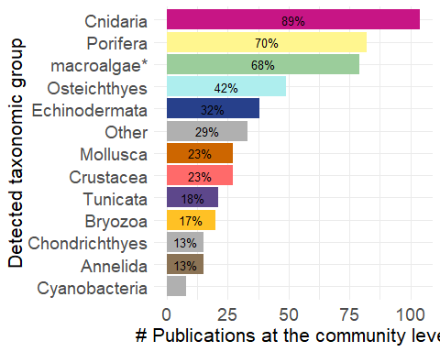
ggsave("detected_bar.png",
units = "in", width = 7, height = 6,
path = here ("Extracted_data_analysis", "tropical", "Output-Visualization"))

Target taxonomic groups not at the community level
group <- tropical %>%
filter(taxonomicTargetLevel != "comm") %>%
select(File,
detected_meso_cnidaria,
detected_meso_sponges,
detected_meso_seagrass,
detected_meso_algae,
detected_meso_mollusca,
detected_meso_chondrichthyes,
detected_meso_fish,
detected_meso_crustacea,
detected_meso_echino,
detected_meso_other_taxa,
targetTaxa)
group_lvls <-
unique(
unlist(
str_split(group$detected_meso_other_taxa, "\\+")
)
)
group_lvls<- group_lvls[! group_lvls %in% c("",NA,"notapp",",","nd")]
group[,group_lvls] <- sapply(group_lvls,
function(y){
str_count(group$detected_meso_other_taxa, y)
}
)
rm(group_lvls)
group <- group %>%
mutate(across(everything(), as.character)) %>%
replace(is.na(.), "0") %>%
select(-detected_meso_other_taxa,-targetTaxa) %>%
filter(if_all(everything(), ~ !grepl("notapp", .x))) %>%
mutate(across(-File, ~ case_when(
.x %in% c("x", "x,", "xx") ~ "1",
.x == "," ~ "0",
TRUE ~ .x
))) %>%
mutate(across(-File, as.numeric))
group_tot <-
group %>%
summarise(across(where(is.numeric),
list(sum)
)
)
group_tot <- reshape2::melt(group_tot, id.vars = NULL)
colnames(group_tot) <- c("Taxa", "Count")
group_tot %<>%
mutate_at("Taxa",
stringr::str_replace, "_1", "") %>%
mutate_at("Taxa",
stringr::str_replace, "detected_meso_", "")
group_tot %<>%
mutate(Percentage= round(Count / nrow(group) * 100,1))
group_tot_collapsed <- group_tot %>%
mutate(Taxa = if_else(Percentage < 3, "Other", Taxa)) %>%
group_by(Taxa) %>%
summarise(
Count = sum(Count),
Percentage = sum(Percentage),
.groups = "drop"
)
group_tot_collapsed %<>%
mutate(Taxa = case_when(Taxa == 'echino' ~ "Echinodermata",
Taxa == 'fish' ~ "Osteichthyes",
Taxa == "Symbiodiniaceae" ~ "Symbiodiniaceae",
Taxa == "sponges" ~ "Porifera",
Taxa == "crustacea" ~ "Crustacea",
Taxa == "cnidaria" ~ "Cnidaria",
Taxa == "algae" ~ "macroalgae*",
.default = Taxa))
group_bar <- ggplot(group_tot_collapsed, aes(x = reorder(Taxa, Count), y = Count, fill= Taxa)) +
geom_bar(stat = "identity") +
geom_text(
data = group_tot_collapsed %>% filter(Percentage > 10),
aes(label = paste0(round(Percentage, 0), "%")),
position = position_stack(vjust = 0.5),
color = "black",
size = 3.5
)+
labs(y = "N of publications not at community level", x = "Taxonomic group") +
theme_minimal() +
coord_flip()+ # optional: flips for horizontal bars
theme(legend.position ="none")
group_palette <- c("macroalgae*" ="darkseagreen3",
"Cnidaria" = "mediumvioletred",
"Crustacea" = "indianred1",
"Porifera" = "khaki1",
"Mollusca" = "darkorange3",
"Osteichthyes" = "paleturquoise2",
"Echinodermata" = "royalblue4",
"Tunicata" = "mediumpurple4",
"Chondrichthyes" = "gray69",
"Other" = "gray69",
"Alismatales (seagrasses)" = "gray69",
"Bryozoa" = "goldenrod1",
"Annelida" = "burlywood4")
group_bar <- group_bar +
scale_fill_manual(values = group_palette,
limits = names(group_palette))+
theme(axis.text = element_text(size = 14),
axis.title = element_text(size = 16)
)
group_bar
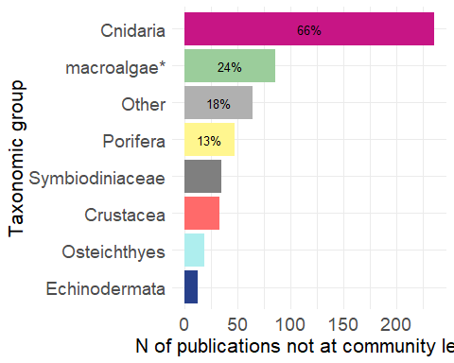 Export bar plot
ggsave("group_bar.png",
plot = group_bar,
units = "in", width = 7, height = 6,
path = here ("Extracted_data_analysis", "tropical", "Output-Visualization"))

New species described per phyla
new_spec <- tropical %>%
filter(str_detect(taxonomic_publication, "taxa"))
new_spec %<>%
select(File,
detected_meso_cnidaria,
detected_meso_sponges,
detected_meso_seagrass,
detected_meso_algae,
detected_meso_mollusca,
detected_meso_chondrichthyes,
detected_meso_fish,
detected_meso_crustacea,
detected_meso_echino,
detected_meso_other_taxa)
new_spec_lvls <-
unique(
unlist(
str_split(new_spec$detected_meso_other_taxa, "\\+")
)
)
new_spec_lvls<- new_spec_lvls[! new_spec_lvls %in% c("",NA,"notapp")]
new_spec[,new_spec_lvls] <- sapply(new_spec_lvls,
function(y){
str_count(new_spec$detected_meso_other_taxa, y)
}
)
rm(new_spec_lvls)
new_spec %<>%
mutate(across(everything(), as.character)) %>%
replace(is.na(.), "0") %>%
select(-detected_meso_other_taxa) %>%
filter(if_all(everything(), ~ !grepl("notapp", .x))) %>%
mutate(across(-File, ~ case_when(
.x %in% c("x") ~ "1",
TRUE ~ .x
))) %>%
mutate(across(-File, as.numeric))
new_spec_tot <-
new_spec %>%
summarise(across(where(is.numeric),
list(sum)
)
)
rm(new_spec)
new_spec_tot <- reshape2::melt(new_spec_tot, id.vars = NULL)
colnames(new_spec_tot) <- c("Taxa", "Count")
new_spec_tot %<>%
mutate_at("Taxa",
stringr::str_replace, "_1", "") %>%
mutate_at("Taxa",
stringr::str_replace, "detected_meso_", "")
new_spec_tot %<>%
filter(Count>0) %>%
mutate(Percentage= round(Count / sum(Count) * 100,1))
new_spec_plot <- ggplot(new_spec_tot,
aes(x = reorder(Taxa, Count), y = Count,
fill= Taxa)) +
geom_bar(stat = "identity") +
geom_text(
data = new_spec_tot %>% filter(Percentage > 8),
aes(label = paste0(round(Percentage, 0), "%")),
position = position_stack(vjust = 0.5),
color = "black",
size = 3.5
)+
labs(y = "N of Publications with new species descriptions", x = "Taxonomic group") +
theme_minimal() +
coord_flip()+ # optional: flips for horizontal bars
theme(legend.position ="none")+
scale_x_discrete(labels = rev(c("macroalgae*",
"Cnidaria",
"Crustacea",
"Porifera",
"Acari",
"Symbiodiniaceae",
"Mollusca"))
)
new_spec_palette <- c("algae" ="darkseagreen3",
"cnidaria" = "mediumvioletred",
"crustacea" = "indianred1",
"sponges" = "khaki1",
"mollusca" = "tan1",
"Acari" = "gray69",
"Symbiodiniaceae" = "gray69")
new_species_bar <- new_spec_plot +
scale_fill_manual(values = new_spec_palette,
limits = names(new_spec_palette))+
theme(axis.text = element_text(size = 14),
axis.title = element_text(size = 16)
)
new_species_bar
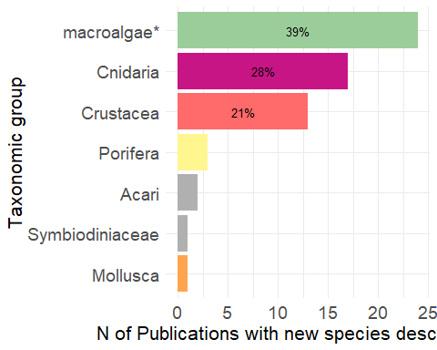
Export bar plot
ggsave("new_species_bar.png",
plot = new_species_bar,
units = "in", width = 7, height = 6,
path = here ("Extracted_data_analysis", "tropical", "Output-Visualization"))

New species descriptions that included molecular analyses
new_spec_molecular <- tropical %>%
filter(str_detect(taxonomic_publication, "taxa") &
molecularAnalyses != "no" &
molecularAnalyses != "nd" &
molecularAnalyses != "notapp")
nrow(new_spec_molecular)
## [1] 29

DATA CROSSING
table(tropical$meso_protection)
##
## mixed nd no yes
## 34 344 14 50

VISUALLY SURVEYED SURFACE
tropical$visuallySurveyedSurface <- as.factor(tropical$visuallySurveyedSurface)
summary(subset(tropical, is.na(tropical$taxonomic_publication))$visuallySurveyedSurface)
## <1 >1 >10 >100 >1000 >10000 >100000 >1000000
## 1 6 22 49 30 11 9 3
## nd notapp
## 171 80

Observation
print(paste("Number of manipulative experimental studies:",nrow(subset(tropical, grepl("exp", tropical$observationalORexperimental)))))
## [1] "Number of manipulative experimental studies: 65"
print(paste("Number of manipulative experimental studies in the field of restoration:", nrow(subset(tropical, grepl("exp", tropical$observationalORexperimental) & tropical$field_rest != 0)
)
)
)
## [1] "Number of manipulative experimental studies in the field of restoration: 0"

Temp replicates & exp
print(paste("# Publications that included temporal replicates:", nrow(subset(tropical, grepl("yes", temporalReplicates)))))
## [1] "# Publications that included temporal replicates: 105"
print(paste("# Publications that included temporal replicates:", nrow(subset(tropical, (grepl("exp", tropical$observationalORexperimental) & grepl("yes", temporalReplicates))))))
## [1] "# Publications that included temporal replicates: 43"

Health
health <- subset(tropical, grepl("Health", indicators) | grepl("Disease", indicators))
unique(health$targetTaxa)
## [1] "Agaricia_grahamae+Agaricia_undata+Madracis_pharensis"
## [2] "Scleractinia"
## [3] "Alveopora_allingi+Alveopora_ocellata"
## [4] "Xestospongia_muta"
## [5] "Amphiprion_chrysopterus"
## [6] "notapp"
## [7] "Scleractinia+Sarcophyton_spp"
## [8] "Antipathes_dichotoma+Antipathes_grandis+Carijoa_riisei"
## [9] "Agaricia_lamarcki"
## [10] "Montastraea_cavernosa+Siderastrea_stellata"
## [11] "Stylophora_pistillata+Symbiodiniaceae"
## [12] "Seriatopora_hystrix"
## [13] "Ectocarpus_sp+Clodophora_sp+Lyngbya_sp+Pseudoanabaena_sp"
## [14] "Plakortis_angulospiculatus"
## [15] "+Ellisella_elongata+Octocorallia+Porifera"
## [16] "Anthozoa"
## [17] "Orbicella_spp"
## [18] "Montastraea_cavernosa+Symbiodiniaceae"
## [19] "Agaricia_lamarcki+Orbicella_franksi"

ROV & sample
rov <- subset(tropical, grepl("rov", meso_samplingPlatform) )
rov_specimen <- subset(rov, grepl("specimen", collectedDataType) )
print(paste("Percentage of publications relying solely on ROV where specimens were collected:", round(nrow(rov_specimen)/nrow(rov)*100,1),"%"))
## [1] "Percentage of publications relying solely on ROV where specimens were collected: 60 %"
rm(rov, rov_specimen)

Molecular techniques in taxonomic and non-taxonomic studies
tropical$taxonomic_publication <- as.factor(tropical$taxonomic_publication )
molecular <- tropical %>%
filter(molecularAnalyses != "no" &
molecularAnalyses != "notapp" &
molecularAnalyses != "nd")
print(paste("# Publications that adopted molecular techniques: ",nrow(molecular)))
## [1] "# Publications that adopted molecular techniques: 120"
molecular_notaxa <- molecular %>%
filter(is.na(taxonomic_publication))
print(paste("# Publications that adopted molecular techniques not for taxonomy: ",nrow(molecular_notaxa)))
## [1] "# Publications that adopted molecular techniques not for taxonomy: 91"
rm(molecular, molecular_notaxa)

