fOptics Usage documentation

- Data acquisition

Acquire a video of the exposed cortex using a RGB camera (surgical camera experimental setup).

Data must be acquired with a task-based paradigm. The duration of the rest and activity periods could be changed, as well as the number of repetitions of the paradigm, see Figure 1.

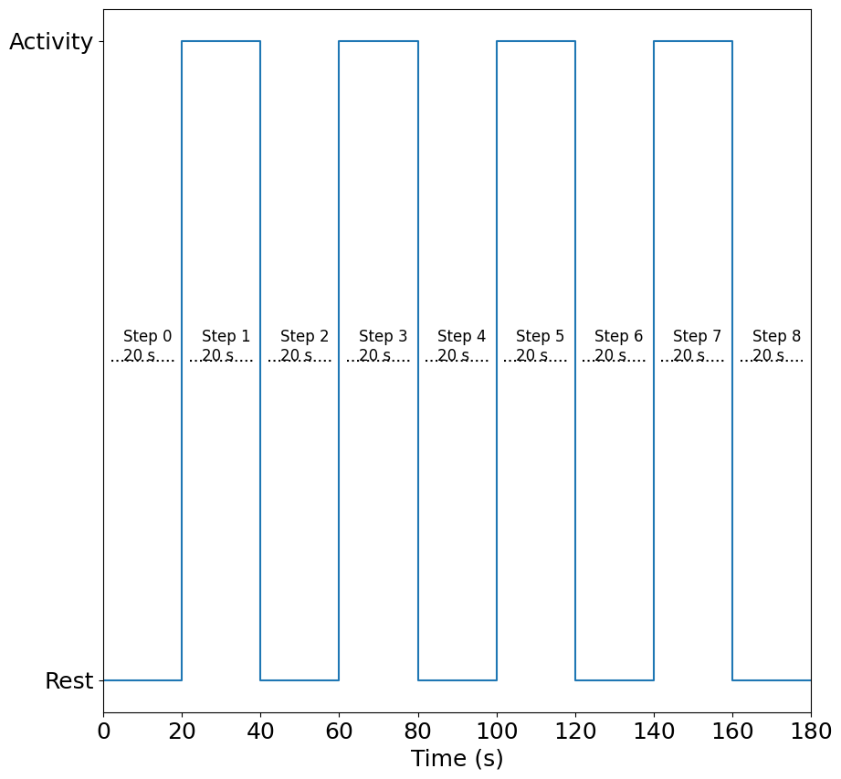
Figure 1- Task-based paradigm.

Alongside the RGB video, a text file “Acquisition_infos.txt” must be created. This file contains paradigm information. Please use the template located in the Doc folder.
These values must be adapted depending on your acquisition.
Camera Frame Rate (FPS) : 60.0
Theorical Frame Rate (FPS) : 60.0
Step 0 : 4228
Step 1 : 5434
Step 2 : 6616
Step 3 : 7855
Step 4 : 9007
Step 5 : 10211
Step 6 : 11357
Step 7 : 12595
Step 8 : 14451
Start task-based : 3022
End task-based : 14451
Frame count 1 : 14452

Camera Frame Rate (FPS) and Theorical Frame Rate (FPS) correspond to the camera frame rate (frame per seconds). These values must be changed according to your camera.

Important: The following parameters must be indicated in frame indexes, not in seconds. You can convert seconds in frame indexes by multiplying acquisition times by the camera framerate.

Start task-based corresponds to the frame index of the beginning of the task-based paradigm (frame index acquired at t=0 s in Figure 1).
End task-based corresponds to the frame index of the end of the task-based paradigm (frame index acquired at t=180 s in Figure 1).

Frame count 1 corresponds to the total number of frames contained in the video.

Step 0 to 8, correspond to the frame indexes of the activity and rest steps of the task-based paradigm (4 task repetitions), see Figure 1.

For example,
Step 0 is the frame index of the beginning of the first activation task (frame index acquired at t=20 s in Figure 1).
Step 1 is the frame index of the end of the first activation task (frame index acquired at t=40 s in Figure 1).
And so on….

If you use less than 4 task repetitions, lines must be deleted. Inversely, if you use more than 4 task repetitions, lines must be created.

- Execute fOptics.exe

- Load a video
Click on the button … to load a video. Select the video file.
Import: Acquisition_info.txt file must be located next to the video file.
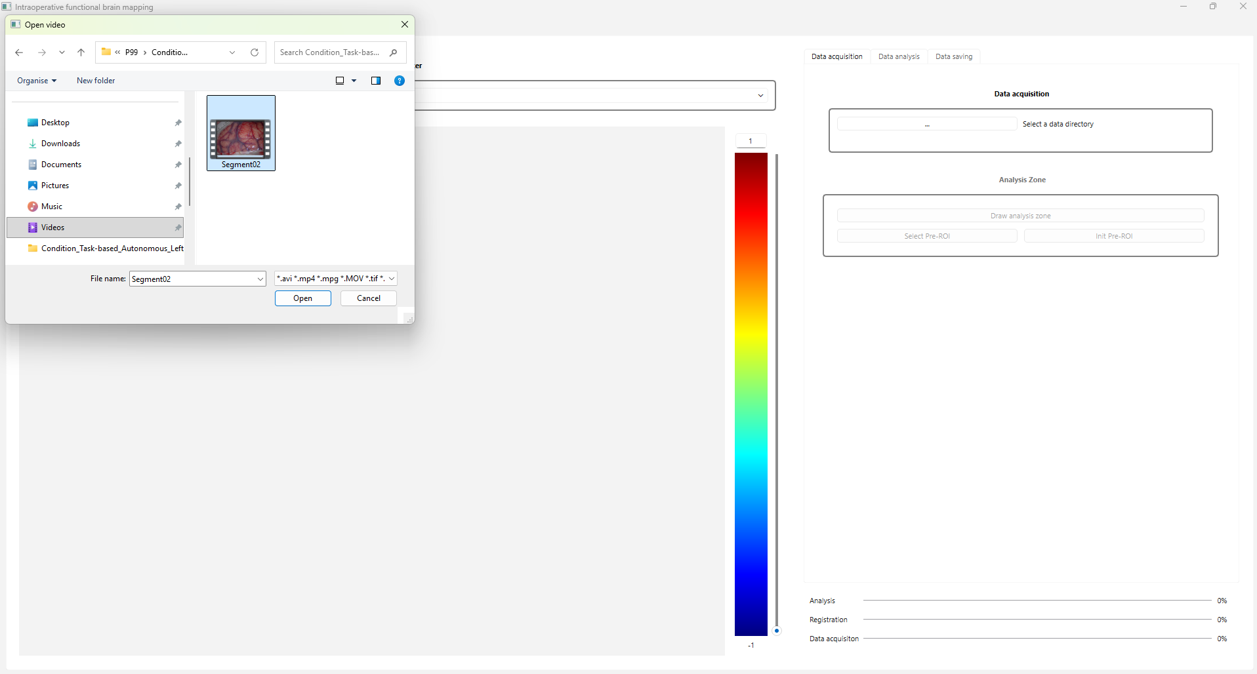
Figure 2 - Load video.

b) Choose the result directory (directory in which result files will be written).

c) Select the analysis you want to perform (task-based) and click on OK.

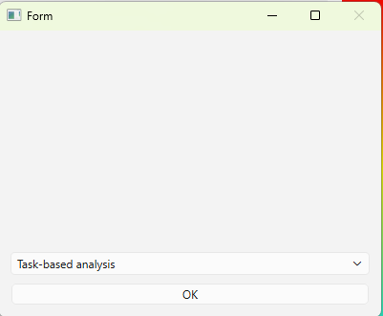
Figure 3- Select analysis.

Wait the closing of the window.
d ) Click on Select Pre-Roi and draw a rectangle Region of Interest (ROI) around the surgical window on the

To draw the rectangle, left-click on one corner of the surgical window (e.g. the top left corner),
Then, holding down the click, drag the mouse to the opposite corner (e.g. the bottom right-hand corner) and release the left mouse button. You can click on Init Pre-ROI, if you want to redo the rectangle ROI.
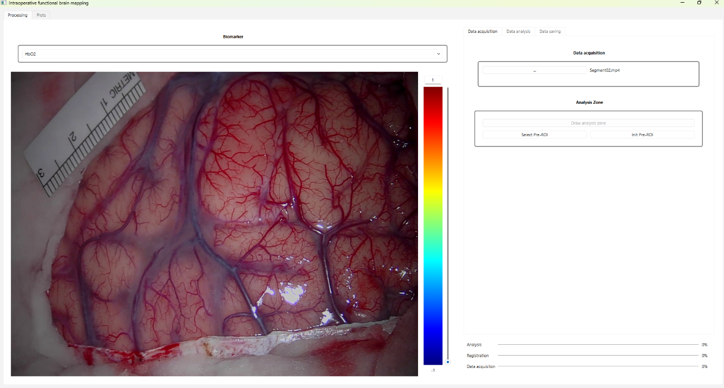
Figure 4- Select rectangle region of Interest.

e) Click on Draw analysis zone and draw the analysis zone on the image.

To draw the analysis area, left-click on a pixel in the image, then hold down the mouse click and draw the analysis area. When the outline is complete, release the left mouse click.

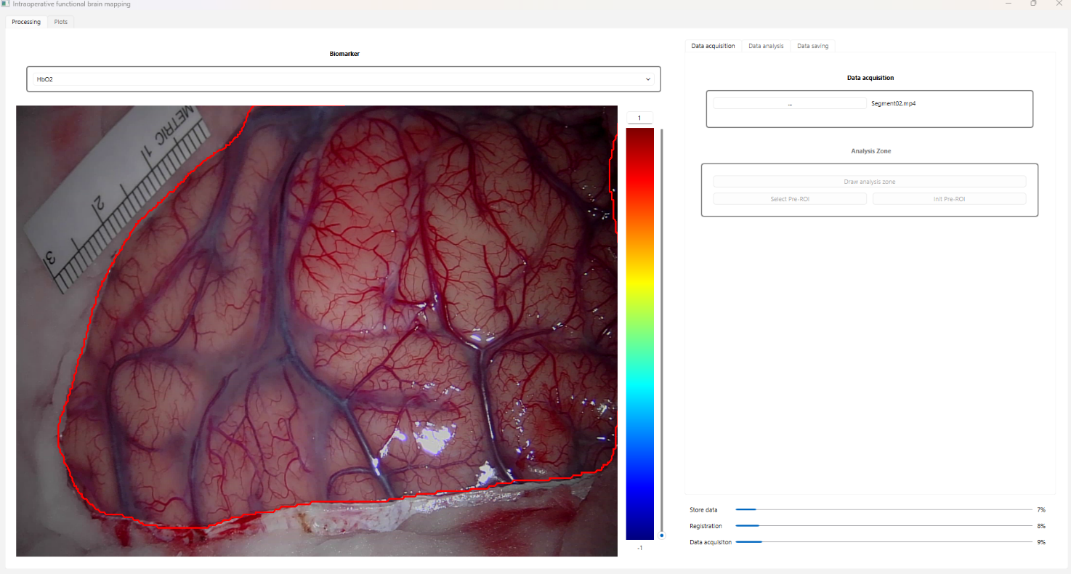
Figure 5 - Draw the analysis region of interest
f) Wait for the end of the progress bars until you obtain this 100% on all bars:

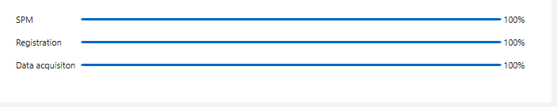
Figure 6 - Progression bars.

g) On « Data analysis » tab, Click on the drop-down menu « Activated cortical area definition » and select on the analysis method.

- SPM (Random Field theory) Statistical parametric maps are calculated using the random field theory.
- SPM (auto. Threshold) Statistical parametric maps are calculated using the automatic thresholding procedure.
- Mean concentration changes Concentration changes are averaged during patient activity
- Hemodynamic response correlation Correlation metrics calculated between measured and expected concentration changes.

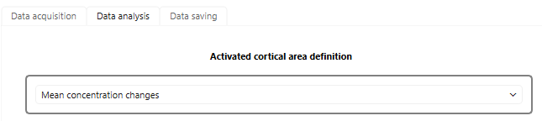
Figure 7- Data analysis.
Wait for the end of the calculation, the image will display on the screen.

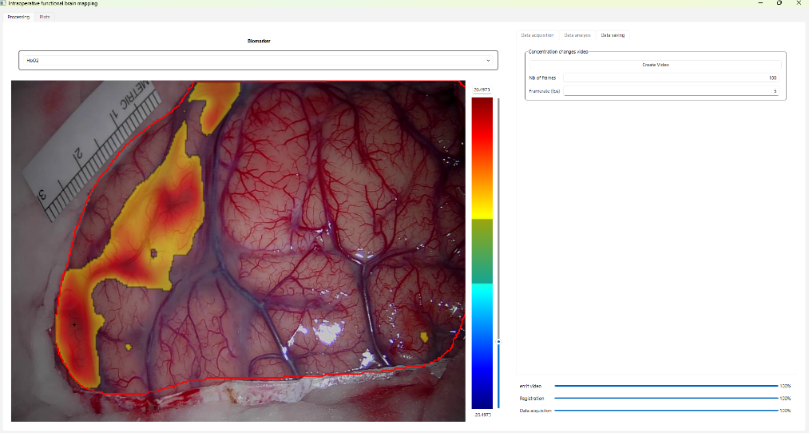
Figure 8- Result image (SPM with random field theory).
The SPM (statistical map) is displayed in jet colormap. You can adapt the statistical threshold with
the vertical slide bar on the right side or by changing the maximum Zstats value.
The results for other biomarkers can be displayed using the Biomarker drop-down menu.

h) After running an analysis, the result images are saved in the result directory.

- In Data saving menu, raw camera intensities and concentration changes time courses can be saved in .dat files (binary format).

Details regarding saved concentration changes and camera intensity images
- Spatio-temporal concentration changes images are named MBLL_0.dat for HbO2, MBLL_1.dat for Hb and MBLL_2.dat for HbT.
Spatio-temporal camera intensities are named I_0.dat, I_1.dat and I_2.dat for the RGB channels.

- Data are saved in a single column in the .dat file. The first element in the dat files is the number of frames (T), the second element is the number of pixels (S).
From the third element contained in the dat files, data cam be reshaped in a matrix B having T rows and S columns.

- Once data have been reshaped (step b), you can reconstruct spatio-temporal images from matrix B.
1) Use pixel_pos.txt to load the (x,y) position for each element of matrix B. pixel_pos has shape (S,2).
2) Use img_size.txt to load the dimension (N,M) of the image to reconstruct.
3) You can then remap image B (of shape (T,S) into a tensor C of shape (T,N,M).

- The size (N,M) of concentration changes and camera intensity images do not correspond to displayed image size. These images have been down sampled to avoid RAM saturation.

Note
Sometimes, videos acquired with a surgical microscope can be corrupted (corrupted time stamps). You can correct the videos before using the software using ffmpeg command lines:

ffmpeg -fflags +genpts -i Segment01.mp4 \
-vf "setpts=PTS-STARTPTS,fps=60000/1001" \
-af "asetpts=PTS-STARTPTS" \
-c:v libx264 -preset fast -crf 18 \
-c:a aac -b:a 192k \
-movflags faststart \
Segmentfixed_01.mp4

