Supplementary material
Recovery-aware coordinated scheduling of computing workloads and energy storage for deliverable consecutive demand response in AI data centers
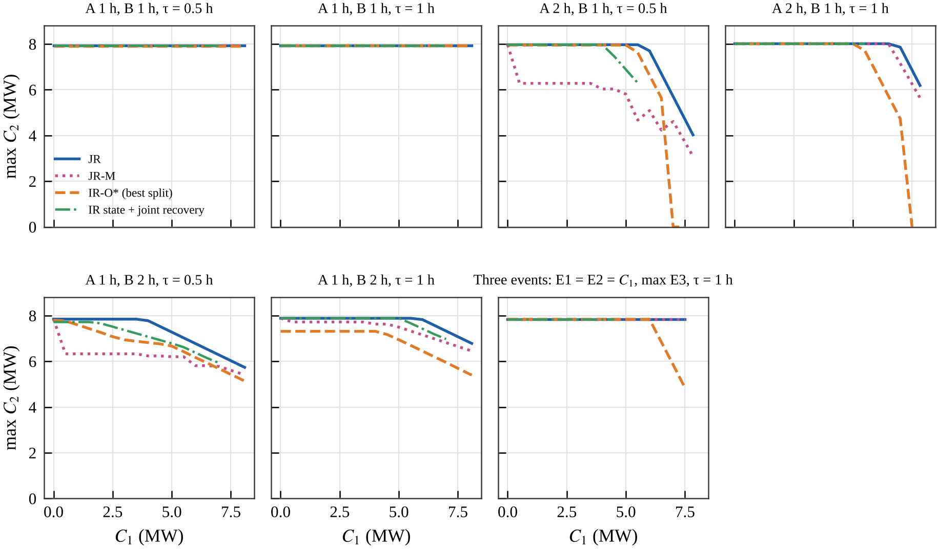
Fig. S1. Two-event capability regions with perfect information on the DR day for different event durations and intervals, and for three events (E1 = E2 = $C_{1}$, E3 maximised), for joint recovery, event-by-event joint recovery, independent recovery with the best static split and the independent post-event state with joint recovery.
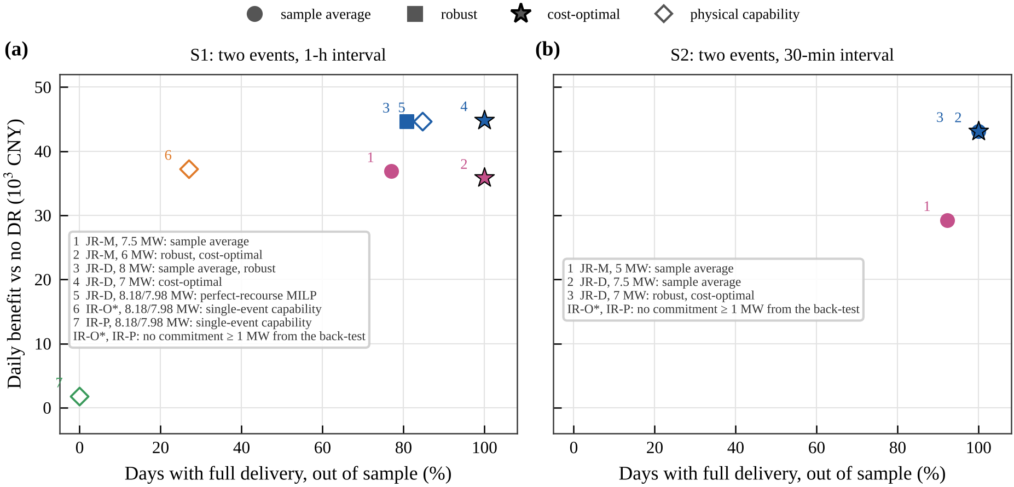
Fig. S2. Day-ahead commitment methods in the plane of out-of-sample full delivery and daily benefit (Table 5): closed-loop back-test with sample-average, robust and cost-optimal commitments, and commitments from physical capability (perfect-recourse MILP, single-event capability).
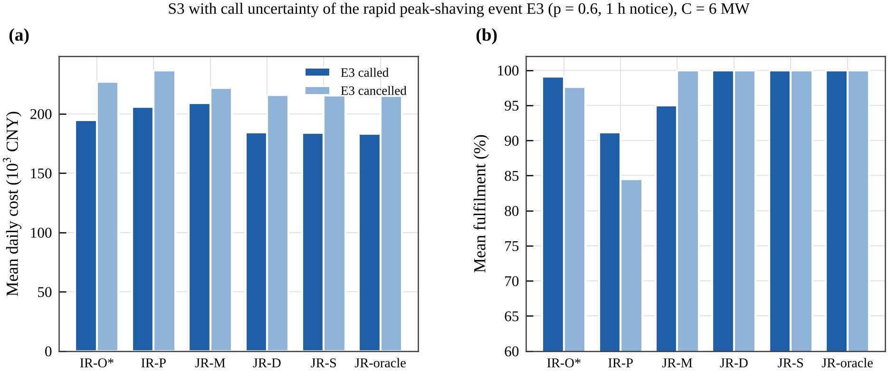
Fig. S3. Event-call uncertainty (S3 with the third event called with probability 0.6 and confirmed 1 h ahead, 6 MW per event): (a) mean daily cost and (b) mean fulfilment on the days on which the third event is called or cancelled.
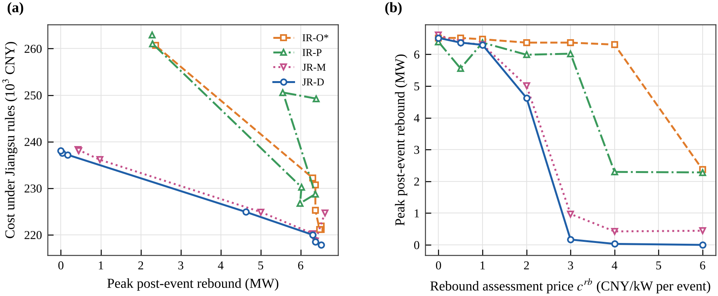
Fig. S4. Post-event rebound as a policy parameter (S1, 6 MW, DR day): (a) cost under the Jiangsu rules alone versus the peak post-event rebound, (b) peak rebound versus the rebound assessment price.
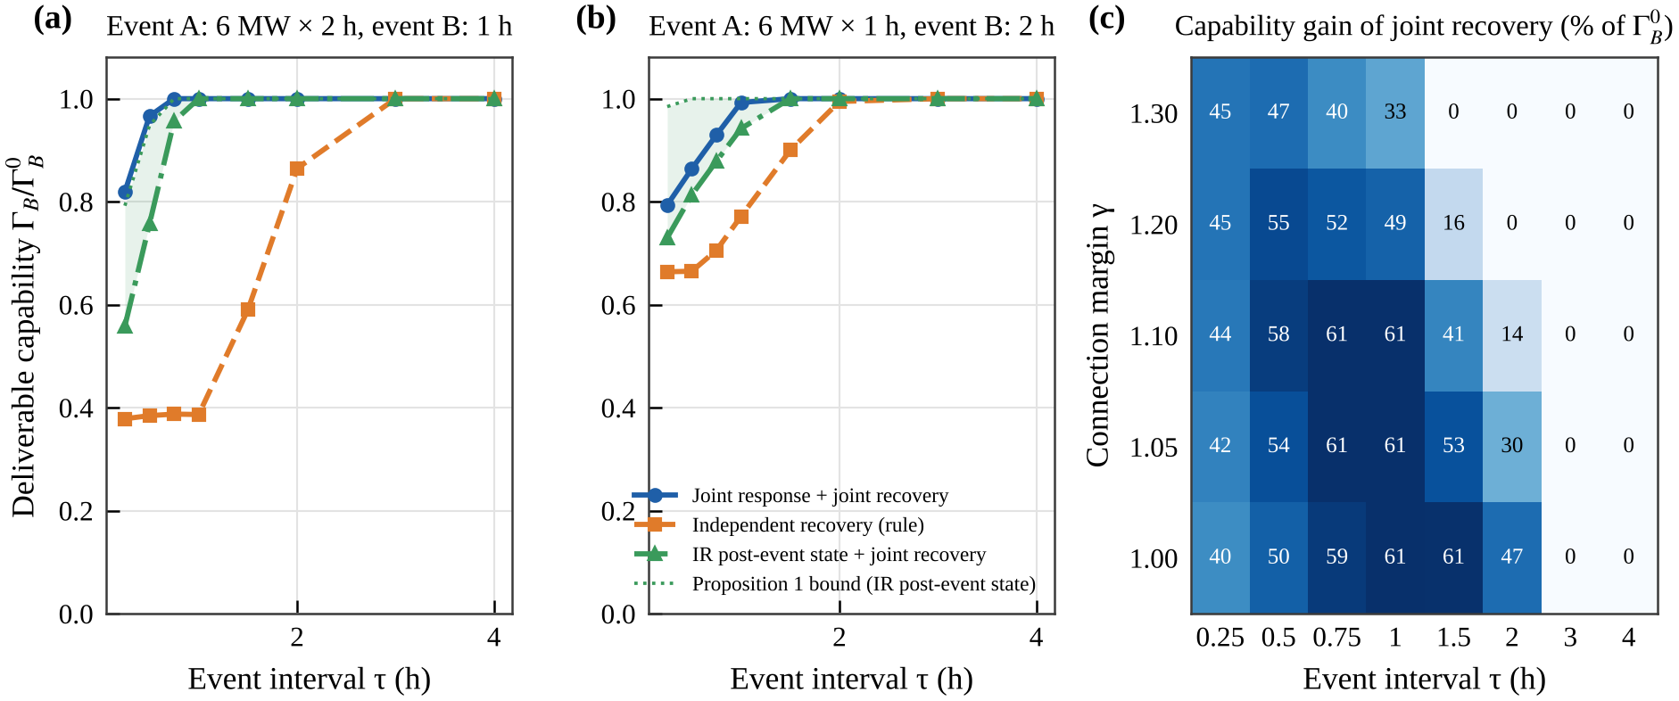
Fig. S5. Proposition 1 on the DR day: deliverable capability of event B relative to its single-event capability versus the interval, for joint response and recovery, independent recovery, the independent post-event state with joint recovery and the bound of Proposition 1, for (a) a 2-h first event and (b) a 2-h second event; (c) capability gain of joint recovery over the interval and the connection margin.
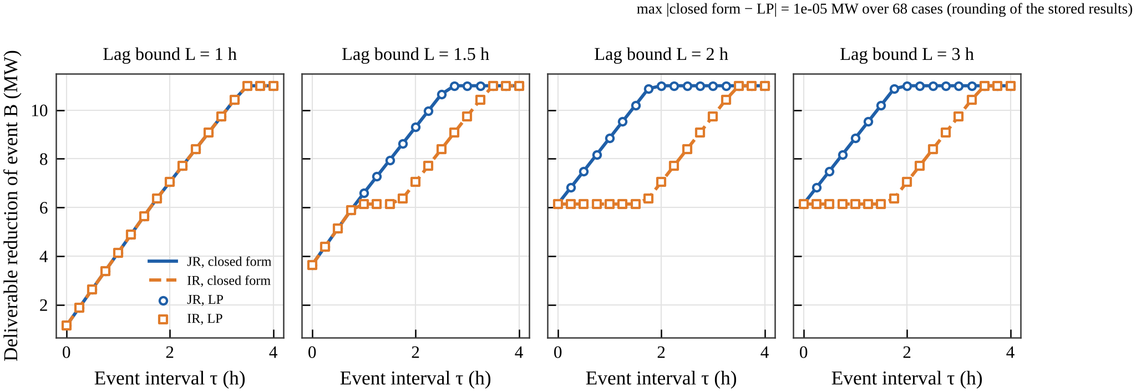
Fig. S6. Proposition 2: deliverable reduction of the next event versus the interval in the single-class model, closed form (lines) and discrete-time LP (markers), for lag bounds of 1, 1.5, 2 and 3 h.
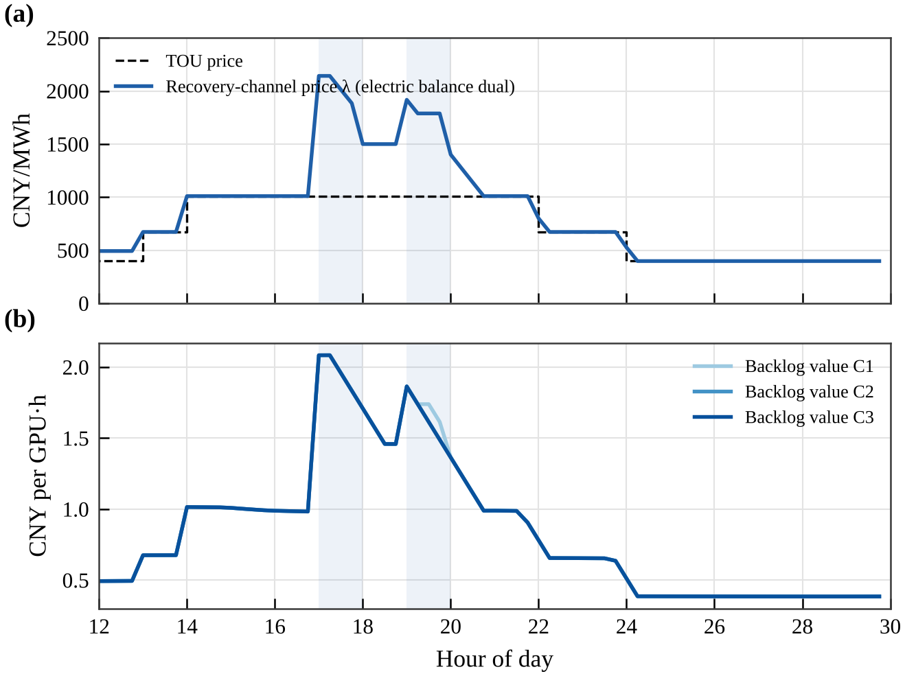
Fig. S7. Single channel price (Remark B.1): (a) dual of the electric balance (recovery-channel price) and TOU price; (b) duals of the backlog equations of the three classes, which coincide with the channel price when catch-up and recharge are both interior.

