**EE307 assignment1 Homework**

12112441 曹子惠

1. **Explain why antenna radiates**

There exists in every atom in the universe particles that contain positive and negative charge (protons and electrons, respectively). Suppose that for some reason, there is a negatively charged particle sitting somewhere in space. The universe has decided, for unknown reasons, that all charged particles will have an associated electric field with them. This is illustrated in Figure 1.

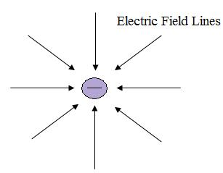

Figure 1. A negative charge has an associated Electric Field with it, everywhere in space.

So this negatively charged particle produces an electric field around it, everywhere in space. The Electric Field is a vector quantity - it has a magnitude (how strong the field strength is) and a direction (which direction does the field point). The field strength dies off (becomes smaller in magnitude) as you move away from the charge. Further, the magnitude of the E-field depends on how much charge exists. If the charge is positive, the E-field lines point away from the charge.

Now, suppose someone came up and punched the charge with their fist, for the fun of it. The charge would accelerate and travel away at a constant velocity. The universe has decided (for no apparent reason) that disturbances due to moving (or accelerating) charges will propagate away from the charge at the speed of light - c0 = 300,000,000 meters/second. This means the electric fields around the charge will be disturbed, and this disturbance propagates away from the charge. This is illustrated in Figure 2.

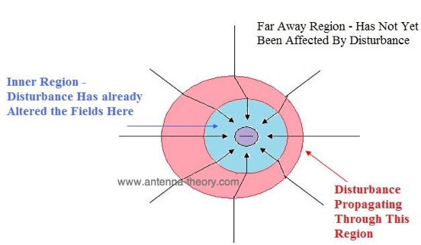

Figure 2. The E-fields when the charge is accelerated.

Once the charge is accelerated, the fields need to re-align themselves. Remember, the fields want to surround the charge exactly as they did in Figure 1. However, the fields can only respond to events at the speed of light. Hence, if a point is very far away from the charge, it will take time for the disturbance (or change in electric fields) to propagate to the point. This is illustrated in Figure 2. In Figure 2, we have 3 regions. In the light blue (inner) region, the fields close to the charge have readapted themselves and now line up as they do in Figure 1. In the white region (outermost), the fields are still undisturbed and have the same magnitude and direction as they would if the charge had not moved. In the pink region, the fields are changing - from their old magnitude and direction to their new magnitude and direction.

Hence, we have arrived at the fundamental reason for radiation - **the fields change because charges are accelerated.** The fields always try to align themselves as in Figure 1 around charges. If we can produce a moving set of charges (this is simply electric current), then we will have radiation.

In summary, all radiation is caused by accelerating charges which produce changing electric fields. And due to Maxwell's Equations, changing electric fields give rise to changing magnetic fields, and hence we have electromagnetic radiation.

When the conductor carries alternating current, it radiates electromagnetic waves, and its radiation capacity is related to the length and shape of the conductor. If the distance between the two wires is very close, the electric field is bound between the two wires, and thus the radiation is very weak; will be two wires open, the electric field is spread in the surrounding space, and thus the radiation is enhanced. When the length of the wire is much smaller than the wavelength of the radiated electromagnetic wave, radiation is very weak; when the length of the wire can be compared with the wavelength of the radiated electromagnetic wave, the current on the wire is greatly increased, the formation of stronger radiation. Usually the above can produce significant radiation straight wire called vibrator, vibrator is a simple antenna. The subject of antenna theory is concerned with transferring power from your receiver (the energy is contained in voltages and currents) into electromagnetic radiation (where the energy is contained in the E- and H-fields) travelling away from the antenna. This requires the impedance of your antenna to be roughly matched to your receiver, and that the currents that cause radiation add up in-phase (that is, they don't cancel each other out as they would in a transmission line).

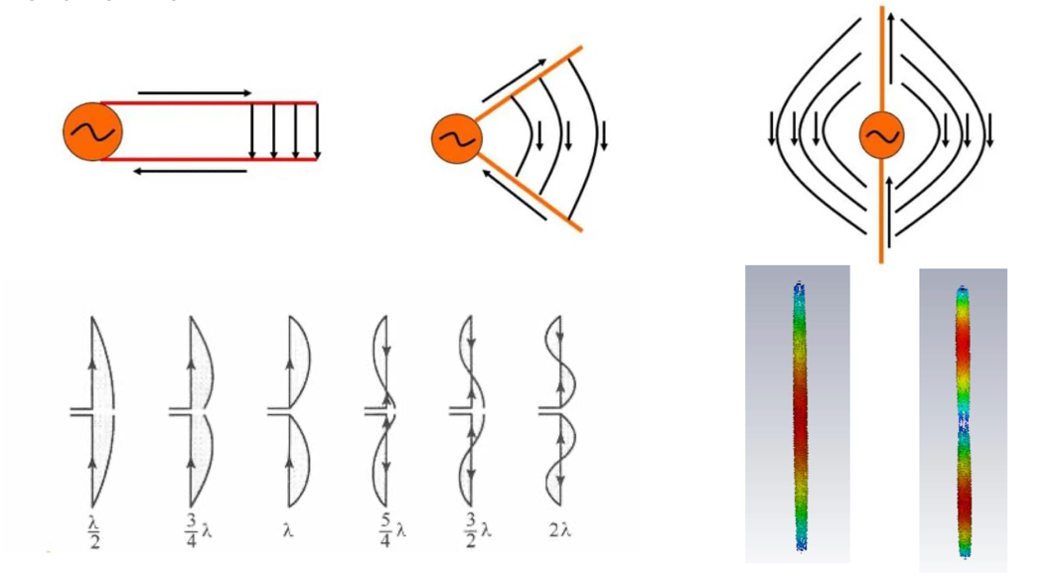

Figure 3. Half-wave oscillator antenna.

In MATLAB, I visualize the radiation pattern of an antenna using the following code:

% Define the angle for plotting the radiation pattern

theta = linspace(0, 2*pi, 100);

% Define the radiation intensity as a function of theta

I = abs(sin(theta)); % Just an example pattern, actual formulas depend on the antenna type

% Plot the radiation pattern

polarplot(theta, I);

title('Radiation Pattern of the Antenna');

This MATLAB code will plot the radiation pattern of the antenna as a function of the angle, providing a visual representation of the directionality and intensity of the radiated electromagnetic wave.

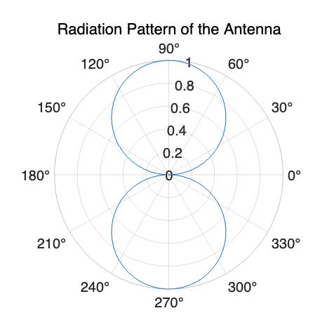

1. **Use Matlab or Python to plot the current distribution along the halfwave dipole and full wave dipole.**

Below is the code for plotting the current distribution along the halfwave dipole and full wave dipole with Matlab:

% Define the length of the antennas

L = 0.5; % Half-wave dipole antenna

L_full = 1.0; % Full-wave dipole antenna

% Generate x values along the length of the antennas

x_values = linspace(0, L, 100);

x_values_full = linspace(0, L_full, 100);

% Calculate the current distribution along the half-wave dipole antenna

current_distribution_halfwave = sin(pi * x_values / L);

% Calculate the current distribution along the full-wave dipole antenna

current_distribution_fullwave = sin(2 * pi * x_values_full / L_full);

% Plot the current distribution along the half-wave dipole antenna

figure;

plot(x_values, current_distribution_halfwave);

title('Current Distribution Along Half-Wave Dipole Antenna');

xlabel('Antenna Length (m)');

ylabel('Current Distribution');

grid on;

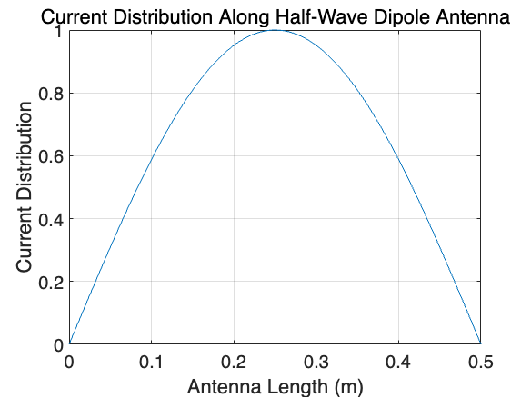

% Plot the current distribution along the full-wave dipole antenna

figure;

plot(x_values_full, current_distribution_fullwave);

title('Current Distribution Along Full-Wave Dipole Antenna');

xlabel('Antenna Length (m)');

ylabel('Current Distribution');

grid on;

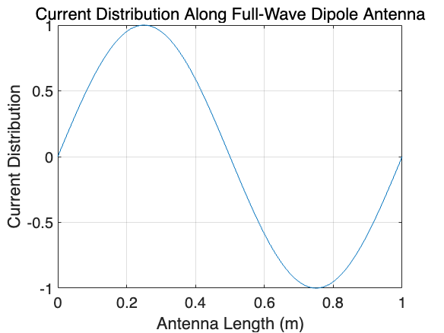

By comparing, we can easily get that the half-wave dipole has one-half wavelength and exhibits a sinusoidal current distribution. The current amplitude at the center is maximum and decreases towards the ends when the full-wave dipole has a full wavelength and also exhibits a sinusoidal current distribution. It has two points with maximum current amplitude, unlike the half-wave dipole. And in phase, the half-wave dipole’s current distribution has a phase change of 180 degrees from the center to the ends when the current distribution of the full-wave dipole repeats twice in the same length, resulting in a phase change of 360 degrees.