**EE307 assignment2 Homework**

12112441 曹子惠

1. Write Matlab code to plot radiation pattern in 2D polar coordinates. Calculate exact maximum directivity

HPBW and FNBW in azmuth plane

HPBW and FNBW in elevation plane

Plot 3D radiation pattern using Matlab

Test your program using normalized radiation intensity

U= $\sin^{2}θ \cos^{2}φ$

for 0 ≤ θ ≤ 180˚ 0 ≤ φ ≤360˚

Below is the code for plotting radiation pattern in 2D polar coordinates with Matlab:

clc,clear

% Define the angles for the spherical coordinates

theta = linspace(0,pi,500);

phi = linspace(0,2*pi,500);

[theta0,phi0] = meshgrid(phi,theta);

%plot the 2d the azmuth and elevation plane

F_azmuth = cos(phi).^2;

figure

polar(phi,F_azmuth);

title('HPBW and FNBW in azmuth plane');

F_elevation = sin(theta).^2;

figure

polar (theta,F_elevation);

title('HPBW and FNBW in elevation plane')

Then we will get two figures below:

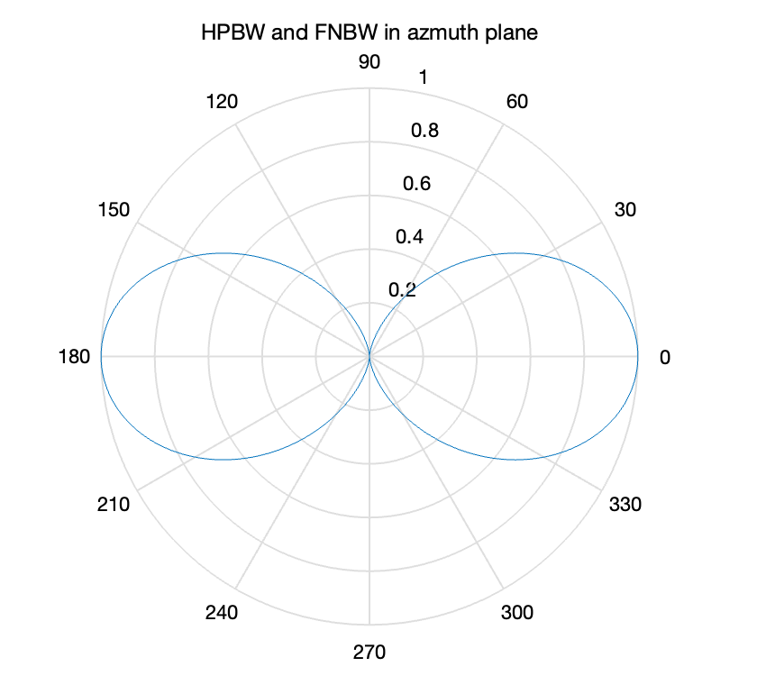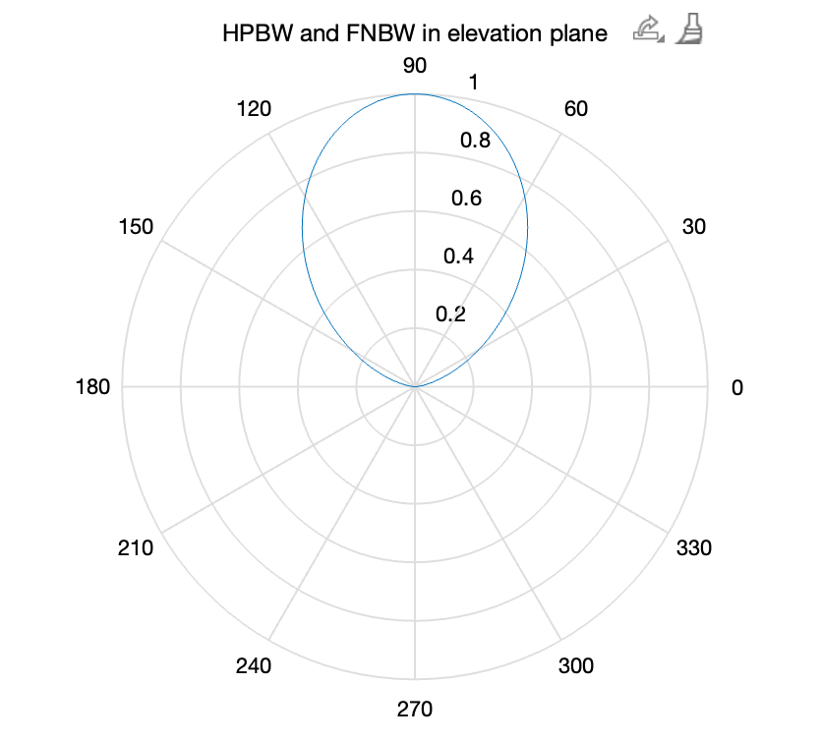

And Below is the code for plotting radiation pattern in 3D polar coordinates with Matlab:

clc,clear

% Define the angles for the spherical coordinates

theta = linspace(0,pi,500);

phi = linspace(0,2*pi,500);

[theta0,phi0] = meshgrid(phi,theta);

% Compute the normalized radiation intensity U

U = sin(phi0).^2 .* cos(theta0).^2;

% Convert spherical coordinates to Cartesian coordinates

[x,y,z] = sph2cart(theta0,pi/2-phi0,U);

% Plot the 3D radiation pattern

figure

mesh(x, y, z);

title('Normalized Radiation Intensity 3D Pattern to Cartesian coordinates');

xlabel('x'), ylabel('y'), zlabel('U(\theta,\phi)');

figure

mesh(phi,pi/2-theta,U);

title('Normalized Radiation Intensity 3D Pattern');

xlabel('x'), ylabel('y'), zlabel('U(\theta,\phi)');

Then we will get two figures below:

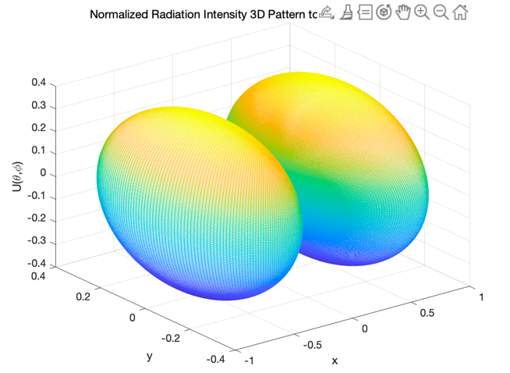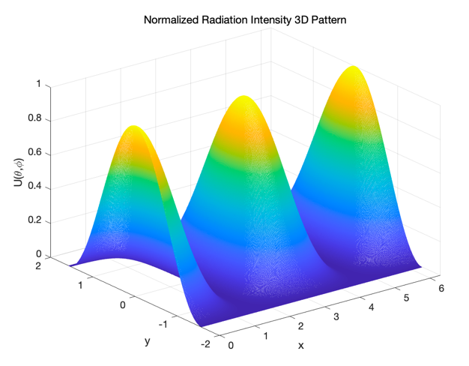

2. What is HPBW and FNBW of the antenna pattern plot on the right?

Please estimated maximum directivity (explain).

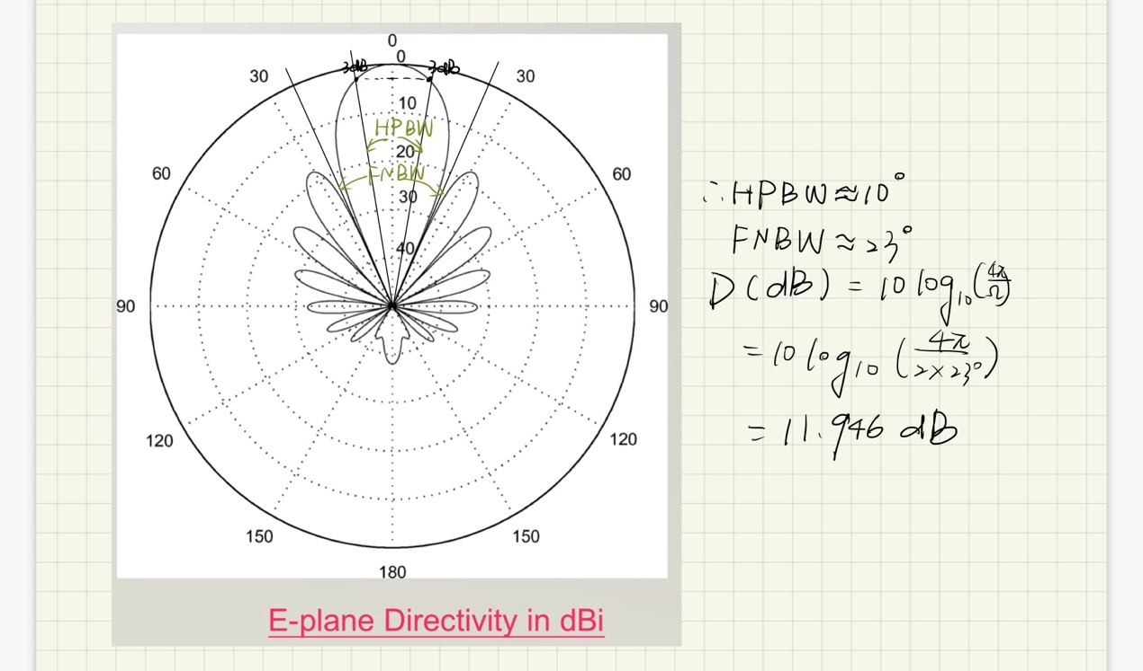

Explain：

