**EE307 assignment7 Homework**

12112441 曹子惠

Question：

1. You need to design a yagi antenna with a frequency of 260 MHz. The maximum estimated directivity is 12.93 dBi. Using the table below, calculate the dimensions of all the elements of your antenna and draw it by specifying all these dimensions.

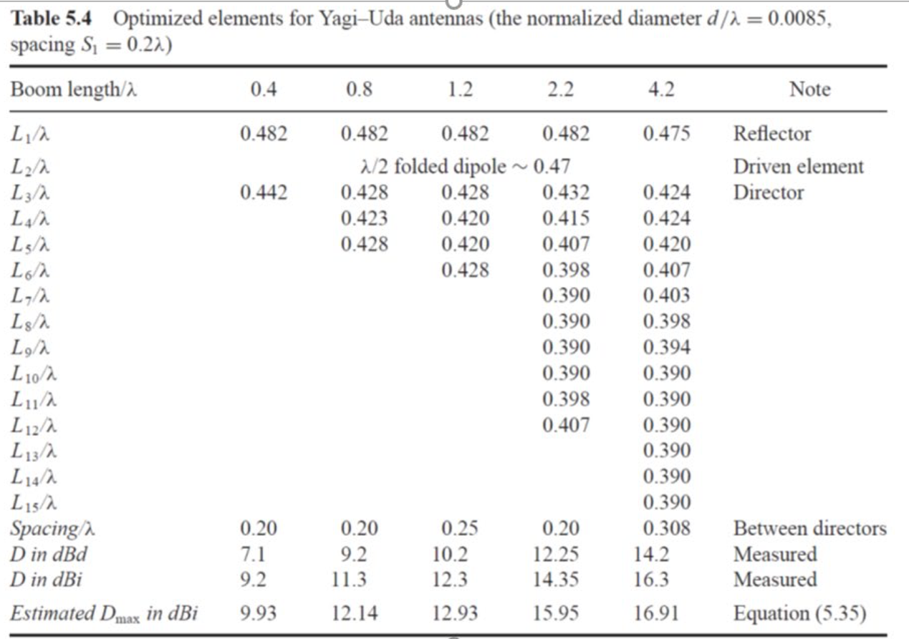

1. Design a 10-turn helix to operate in the axial mode.

Determine

1. The circumference in wavelengths, the pitch angle in degrees,

and separation between turns (in wavelengths)

b) HPBW of the main lobe in degrees

c) Directivity in dB

Answers:

1. According to the question, write the code as follows:

% Given frequency

f = 260e6;

% Calculate wavelength

lambda = 3e8 / f;

% Dimensions of the elements (in meters)

R = 0.482 * lambda; % Reflector length

A = 0.47 * lambda; % Driven element length

D1 = 0.428 * lambda; % Director 1 length

D2 = 0.420 * lambda; % Director 2 length

D3 = 0.420 * lambda; % Director 3 length

D4 = 0.428 * lambda; % Director 4 length

SD = 0.25 * lambda; % Director spacing

SR = 0.2 * lambda; % Reflector-to-driven-element spacing

% Display the dimensions

disp('Dimensions of Yagi Antenna Elements:');

disp(['Reflector Length: ', num2str(R), ' meters']);

disp(['Driven Element Length: ', num2str(A), ' meters']);

disp(['Director 1 Length: ', num2str(D1), ' meters']);

disp(['Director 2 Length: ', num2str(D2), ' meters']);

disp(['Director 3 Length: ', num2str(D3), ' meters']);

disp(['Director 4 Length: ', num2str(D4), ' meters']);

disp(['Director Spacing: ', num2str(SD), ' meters']);

disp(['Reflector-to-Driven-Element Spacing: ', num2str(SR), ' meters']);

% Create a YagiUda antenna object

antennaObject = design(yagiUda, f);

antennaObject.NumDirectors = 4;

antennaObject.DirectorLength = [0.4938, 0.4846, 0.4846, 0.4938];

antennaObject.DirectorSpacing = 0.2885;

antennaObject.ReflectorLength = 0.5562;

antennaObject.ReflectorSpacing = 0.2308;

%% Antenna Analysis

% Define plot frequency

plotFrequency = 260*1e6;

% Define frequency range

freqRange = (234:2.6:286)*1e6;

% pattern

figure;

pattern(antennaObject, plotFrequency)

% azimuth

figure;

patternAzimuth(antennaObject, plotFrequency, 0, 'Azimuth', 0:5:360)

% elevation

figure;

patternElevation(antennaObject, plotFrequency,0,'Elevation',0:5:360)

This code computes the dimensions of the Yagi antenna elements based on the given frequency and then creates a YagiUda antenna object using MATLAB's Antenna Toolbox.

And we get results as below:

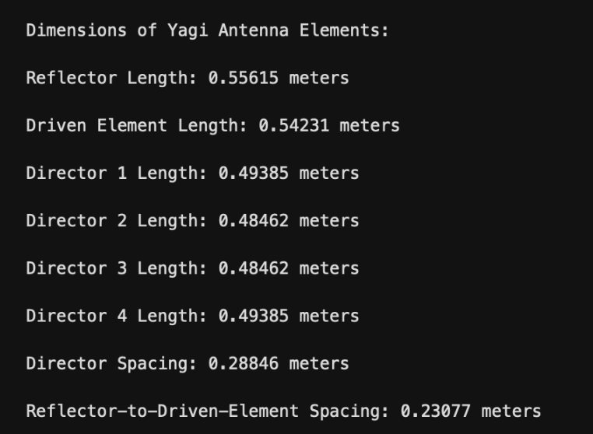

The figure below displays a visual representation of the Yagi-Uda antenna structure.

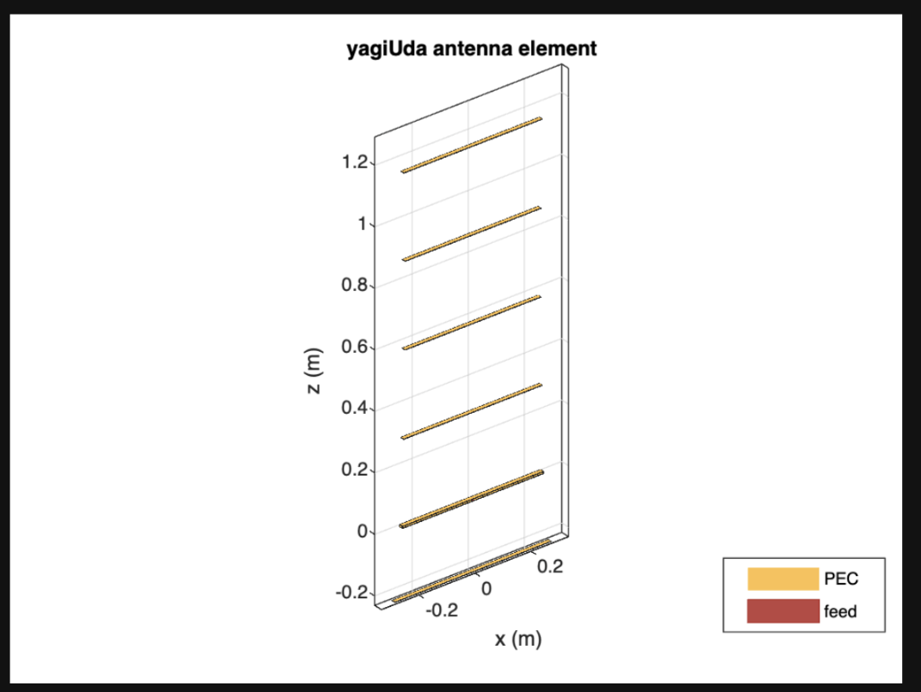

The plot below shows the radiation pattern of the Yagi-Uda antenna at the specified frequency.

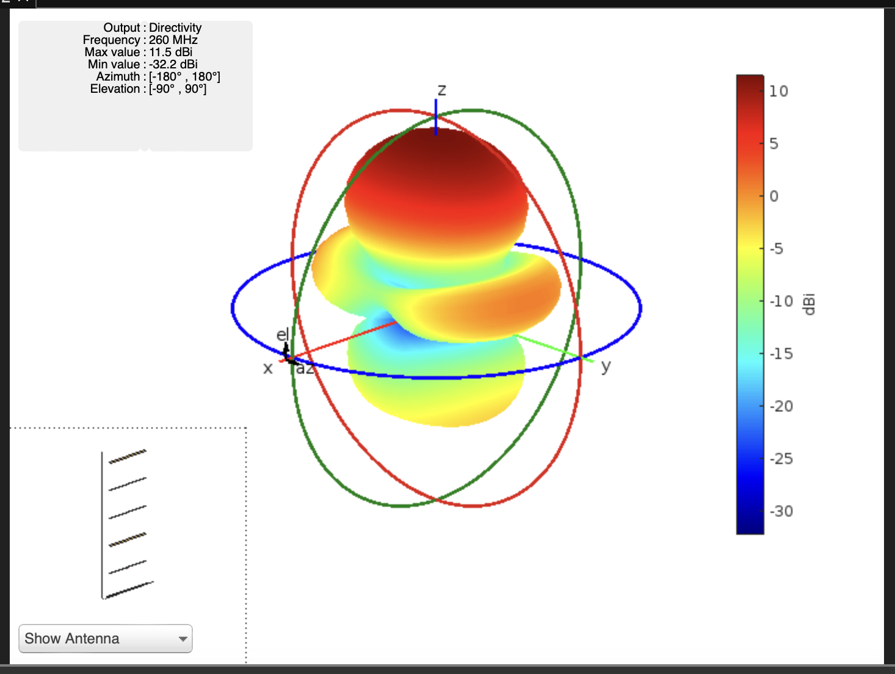

Here is a plot of the antenna's radiation pattern in the azimuth plane (horizontal plane).

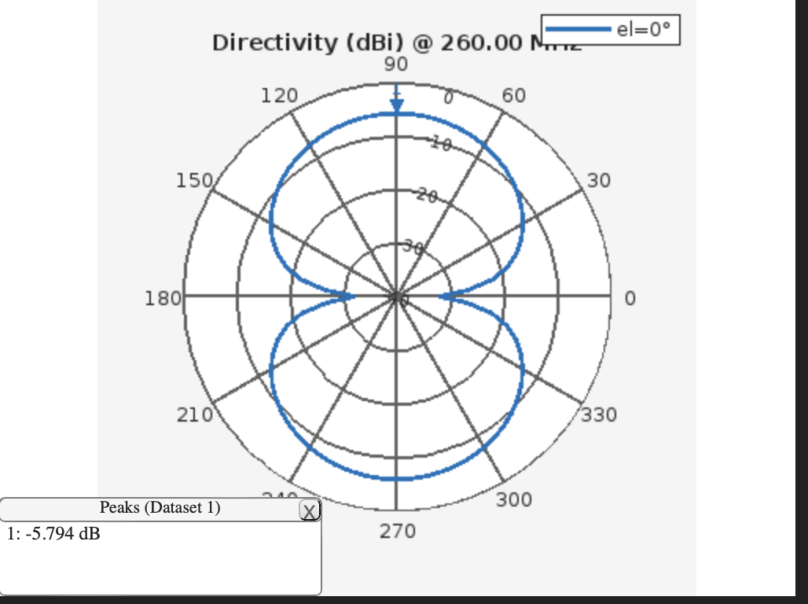

And here is a plot of the antenna's radiation pattern in the elevation plane (vertical plane).

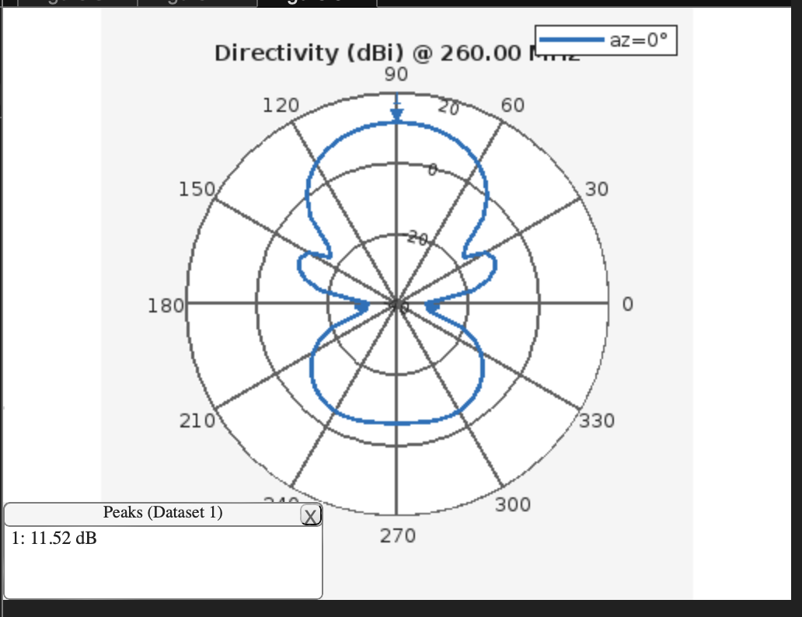

2.

% Design a 10-turn helix antenna to operate in the axial mode

%% Determine Parameters

% Given parameters

N = 10; % Number of turns

lambda_0 = 1; % Default wavelength (normalized to 1 for convenience)

C_lambda = 1; % Circumference in wavelengths is 1

alpha = 14; % Pitch angle in degrees

a)

% Calculate separation between turns in wavelengths

S_lambda = C_lambda * tand(alpha);

And get the results below:



b)

%% Determine HPBW (Half-Power Beamwidth)

% Formula for HPBW calculation

HPBW = (52 * lambda_0^(1.5)) / (C_lambda * sqrt(N * S_lambda));

And get the results below:



c)

%% Calculate Directivity

% Formula for directivity calculation

D0 = (15 * N * C_lambda^(2) * S_lambda) / lambda_0^(3);

% Convert directivity to dBi

D0_dBi = 10 * log10(D0);

And get the results below:

