**EE307 assignment3 Homework**

12112441 曹子惠

Question：

• Prove vector field $3yz^{2}i+4xzj-3xyk$ is a solenoidal field.

• Show directivity of Hertzian dipole is 1.5

• Plot 2D and 3D radiation power patterns of Hertzian dipole

• Show how changes in the frequency and length of the Hertzian dipole impact its far-field radiation pattern

Answer:

1. In the definition a vector field $F=Pi+Qj+Rk$ is said to be solenoidal if $∇⋅F=0$, where $∇⋅$ is the divergence operator.

Given vector field $F=3yz^{2}i+4xzj-3xyk$, compute its divergence we get:

$$∇⋅F=\frac{∂}{∂x}\left(3yz^{2}\right)+\frac{∂}{∂y}\left(4xz\right)+\frac{∂}{∂z}\left(-3xy\right)= 0 + 0 + 0 = 0$$

Thus, $∇⋅F=0$, and the given vector field is a solenoidal field.

1. Poynting vector of the far fields compoments of Hertzian dipole antenna is:

$$P=\frac{1}{2}E×H^{*}=\frac{1}{2}E_{θ}H_{θ}^{*}\hat{r}$$

And power density (real part of poynting vector) is:

$$P=\frac{I_{0}^{2}∆z^{2}ωμk}{{2(4πr)}^{2}}\sin^{2}θ\hat{r}$$

So we get:

$$U=r^{2} P=\frac{I_{0}^{2}∆z^{2}ωμk}{{2(4πr)}^{2}}\sin^{2}θ\hat{r}∙r^{2}=\frac{I_{0}^{2}∆z^{2}ωμk}{32π}\sin^{2}θ\hat{r}$$

When:

$$\sin^{2}θ=±1$$

$$U_{max}=\frac{I_{0}^{2}∆z^{2}ωμk}{32π}$$

$P_{rad}=∯{udΩ=}\int_{0}^{2π}{\int_{0}^{π}{\frac{I_{0}^{2}∆z^{2}ωμk}{32π}}}\sin^{2}θ∙sinθ∙dθdϕ=\frac{I_{0}^{2}∆z^{2}ωμk}{32π}\int_{0}^{2π}{\int_{0}^{π}{\sin^{3}θdθdϕ}}$ = $\frac{I_{0}^{2}∆z^{2}ωμk}{32π}·\frac{8π}{3}$

Therefore,

$$D_{max}=D_{0}=\frac{4πU_{max}}{P_{rad}}= \frac{4π}{\frac{8π}{3}}=1.5$$

The directivity of Hertzian dipole is 1.5.

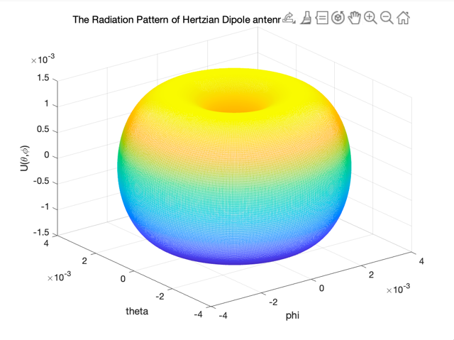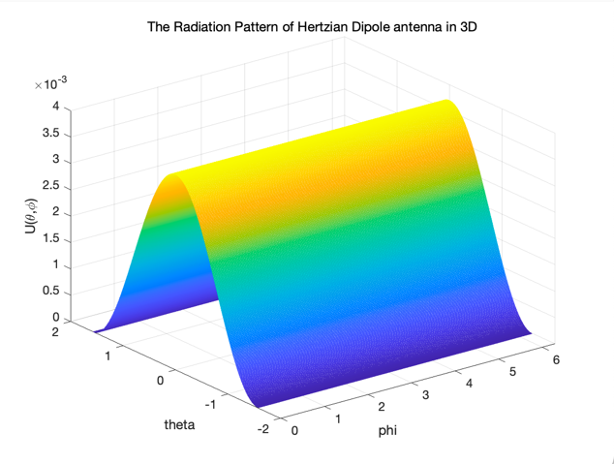

The figure 1 is The Radiation Pattern of Hertzian Dipole antenna in 3D by using sph2cart;

The figure 2 is The Radiation Pattern of Hertzian Dipole antenna in 3D;

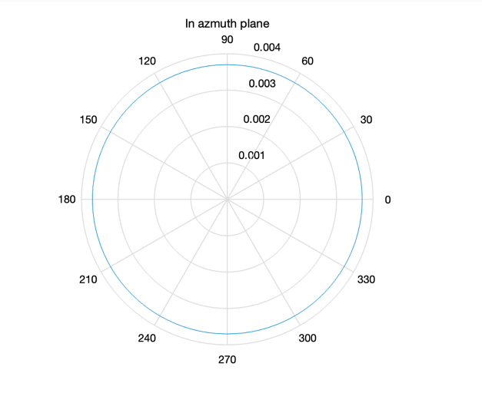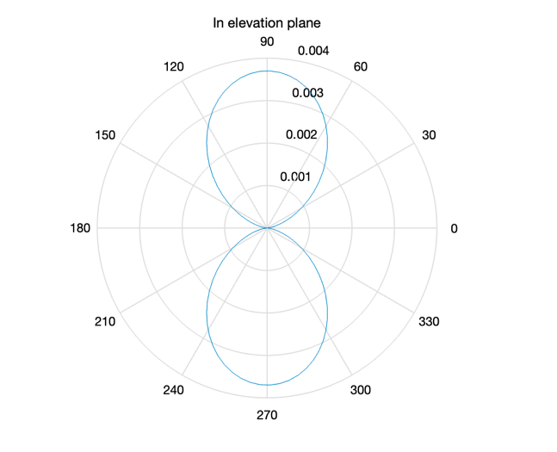

The figure 3 is 2D radiation power patterns of Hertzian dipole in azmuth plane;

The figure 4 is 2D radiation power patterns of Hertzian dipole in elevation plane;

And the code I use is in below:

clear;

clc;

f_antenna = 2*pi*2.4e9;

c = 3e8;

z0 = 1/200 * (c/(f_antenna/2/pi));

I0 = 1;

miu = 0.9999 *4 * pi *1e-7;

phi = linspace(0,2*pi,500);

theta = linspace(0,pi,500);

[tt,pp] = meshgrid(phi,theta);

U = (I0^2) *(z0^2)*(f_antenna^2 *miu)*(1/c)*(1/(32*pi))*((sin(pp).^2));

[x,y,z] = sph2cart(tt,pi/2-pp,U);

figure

mesh(x,y,z);

title('The Radiation Pattern of Hertzian Dipole antenna in 3D by using sph2cart');

xlabel('phi'),ylabel('theta'),zlabel('U(\theta,\phi)');

figure

mesh(phi,pi/2-theta,U);

title('The Radiation Pattern of Hertzian Dipole antenna in 3D');

xlabel('phi'),ylabel('theta'),zlabel('U(\theta,\phi)');

phi = linspace(eps , 2*pi , 100);

theta = linspace(pi/2, pi/2 , 100);

F_azmuth = (I0^2) *(z0^2)*(f_antenna^2 *miu)*(1/c)*(1/(32*pi))*(sin(theta).^2);

figure

polar(phi,F_azmuth);

title('In azmuth plane');

theta = linspace (-pi,pi,100);

F_elevation = (I0^2) *(z0^2)*(f_antenna^2 *miu)*(1/c)*(1/(32*pi))*((sin(theta).^2));

figure

polar(theta,F_elevation);

title('In elevation plane');

1. To show how changes in the frequency and length of the Hertzian dipole impact its far-field radiation pattern, we can use some figure to view:

% Parameters

c = 3e8; % Speed of light in meters per second

frequencies = [100e6, 500e6, 1e9]; % Frequencies in Hertz

lengths = [0.1, 0.5, 1]; % Lengths of the dipole in meters

% Create figure

figure;

for i = 1:length(frequencies)

for j = 1:length(lengths)

frequency = frequencies(i);

length_dipole = lengths(j);

% Calculate wavelength

lambda = c / frequency;

% Calculate normalized dipole length

normalized_length = length_dipole / lambda;

% Calculate radiation pattern

theta = linspace(0, 2*pi, 1000);

radiation_pattern = sin(pi * normalized_length * cos(theta))./(pi * normalized_length * cos(theta));

% Normalize the radiation pattern

radiation_pattern = radiation_pattern / max(abs(radiation_pattern));

% Plot the radiation pattern

subplot(length(frequencies), length(lengths), (i-1)*length(lengths) + j);

polarplot(theta, abs(radiation_pattern), 'LineWidth', 2);

title(sprintf('Frequency = %.2e Hz, Length = %.2f m', frequency, length_dipole));

end

end

% Adjust subplot layout

sgtitle('Hertzian Dipole Radiation Patterns');

And we get 9 figures in below:

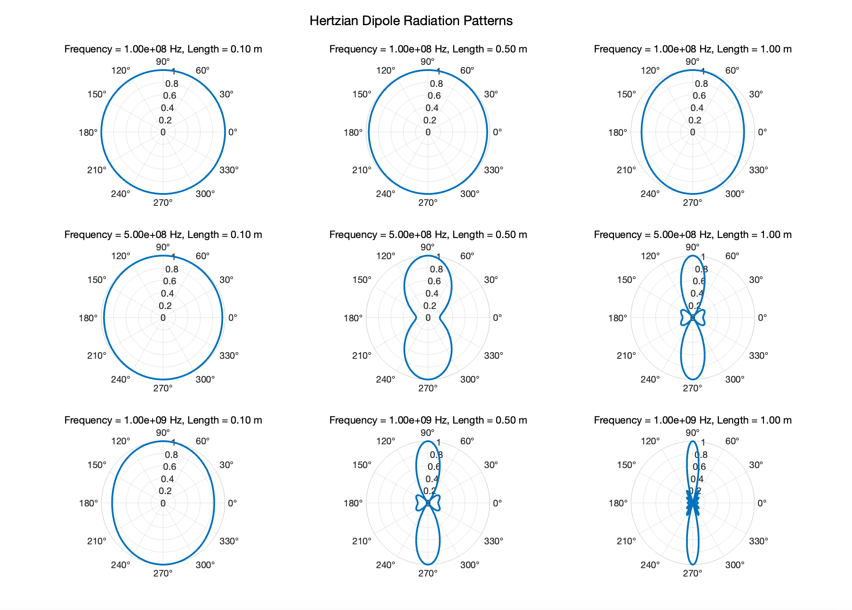

1. Fix a row and compare columns, we get different frequencies’ impacts:

At higher frequencies (shorter wavelengths), the radiation pattern is more concentrated, resulting in a more directional emission; At lower frequencies (longer wavelengths), the radiation pattern is more scattered, leading to a more omnidirectional emission.

1. Fix a column and compare rows, we get different lengths’ impacts:

Longer dipole lengths tend to produce more directional radiation patterns, while shorter lengths result in more omnidirectional patterns.

In summary, these plots that higher frequencies and longer dipole lengths generally lead to more directional radiation, while lower frequencies and shorter lengths result in more omnidirectional radiation patterns.