**EE307 assignment4 Homework**

12112441 曹子惠

**Homework1:**

Derive H and E field from Vector Potential on page 19

A 1-m–long dipole is excited by a 1-MHz current with an amplitude of 12 A.What is the average power density radiated by the dipole at a distance of 5 km in a direction that is 45◦ from the dipole axis?

Calculate radiation resistance of a 0.25-meter dipole antenna working at 600MHz

Plot radiation pattern for

half wavelength dipole

quarter wavelength monopole (infinite ground)

Calculate directivity and HPBW for each antenna

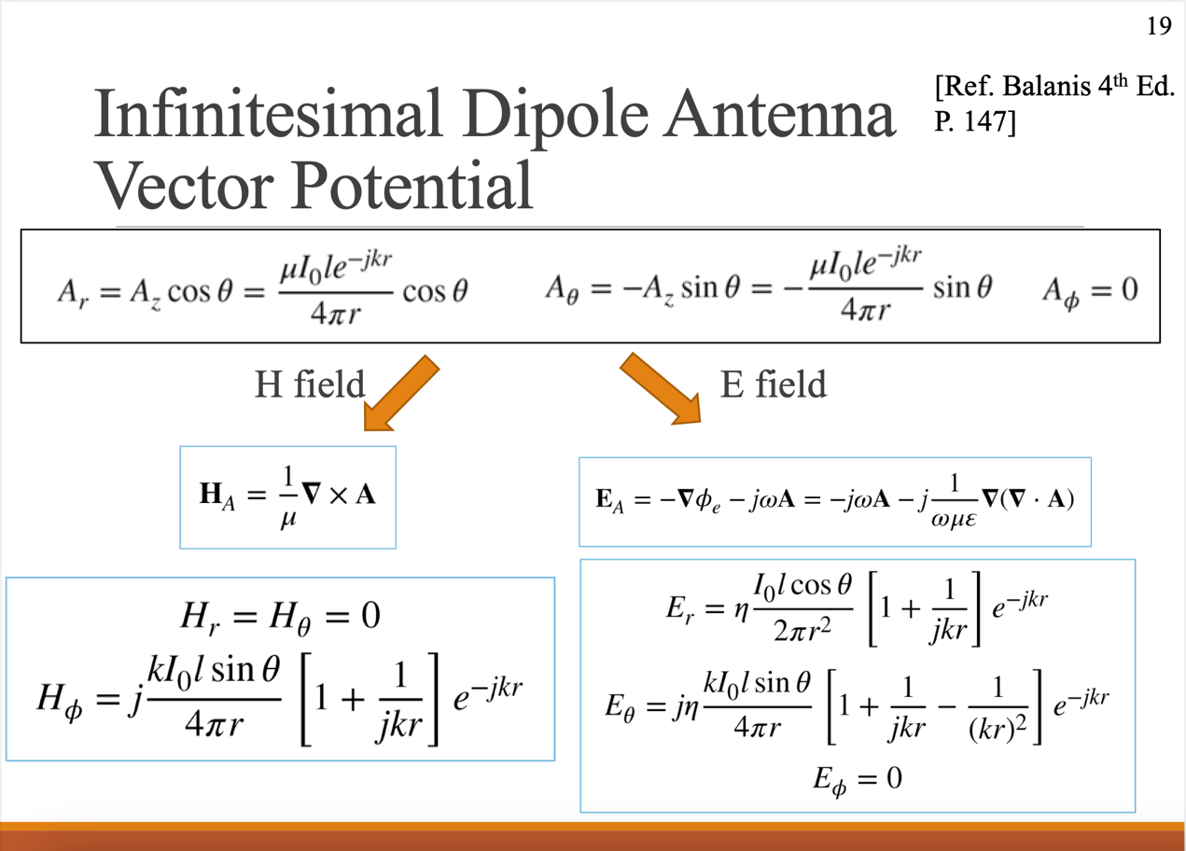

1. Because $A=A_{r}+A_{θ}+A_{phi}=\frac{μI_{o}le^{-jkr}}{4πr}cosθ⋅a_{r}-\frac{μI_{o}le^{-jkr}}{4πr}sinθ⋅a_{θ}$

So in H field, we get $H_{A}=\frac{1}{μ}\left[0⋅a_{r}+0⋅a_{θ}+\frac{a_{ϕ}}{r}\left[\frac{∂\left(rA_{θ}\right)}{∂r}-\frac{∂A_{r}}{∂θ}\right]\right]=\frac{a_{ϕ}}{μr}\left[\frac{jkμI_{0}le^{-jkr}}{4π}sinθ+\frac{μI_{0}le^{-jkr}}{4π}sinθ\right]=\frac{jkI_{0}lsinθ}{4πr}\left[1+\frac{1}{jkr}\right]e^{-jkr}a_{ϕ}$

$$H_{r}=H_{θ}=0$$

$$H_{ϕ}=\frac{jkI_{0}lsinθ}{4πr}\left[1+\frac{1}{jkr}\right]e^{-jkr}$$

$$E_{A}=-∇Φ_{e}-jwA=-jwA-j\frac{1}{wμε}∇\left(∇⋅A\right)$$

$$∇A=\frac{1}{r^{2}}⋅\frac{∂}{∂r}\left(\frac{μI_{o}\left(r.e^{-ikr}\cos{θ}\right)}{4π}\right)+\frac{1}{r⋅\sin{θ}}⋅\frac{∂}{∂θ}\left(\frac{-μI_{o}le^{-ikr}\sin^{2}{θ}}{4πr}\right)=\frac{1}{r^{2}}\left(\frac{μ_{0}Ile^{-jkr}\cos{θ}}{4π}+\frac{-jkrμI_{0}e^{-jkr}\cos{θ}}{4π}\right)$$

**Homework2:**