**EE307 assignment5 Homework**

12112441 曹子惠

**Homework1:**

Plot Left-hand circular polarization animation in 2D

Plot left-hand circular polarization vector Ex + Ey at from ωt= 0 to 6*pi on the same time axis

Plot animated elliptical polarization using LHCP and RHCP

**Answers:**

The matlab code using for ploting left-hand circular polarization animation in 2D is in below:

Ey = sin(t);

% Create figure

figure;

hold on;

axis equal;

grid on;

xlim([-1.5, 1.5]);

ylim([-1.5, 1.5]);

title('Left-hand Circular Polarization Animation');

% Initialize plot elements

lineHandle = plot([0, Ex(1)], [0, Ey(1)], 'LineWidth', 2);

pointHandle = plot(Ex(1), Ey(1), 'ro');

trailHandle = plot(Ex(1), Ey(1), 'b.');

% Initialize trail data

trailX = [];

trailY = [];

% Animation loop

for i = 1:length(t)

% Update line and point positions

set(lineHandle, 'XData', [0, Ex(i)], 'YData', [0, Ey(i)]);

set(pointHandle, 'XData', Ex(i), 'YData', Ey(i));

% Update trail

trailX = [trailX, Ex(i)];

trailY = [trailY, Ey(i)];

set(trailHandle, 'XData', trailX, 'YData', trailY);

drawnow;

pause(0.05); % Control animation speed

end

And the figure we get is:

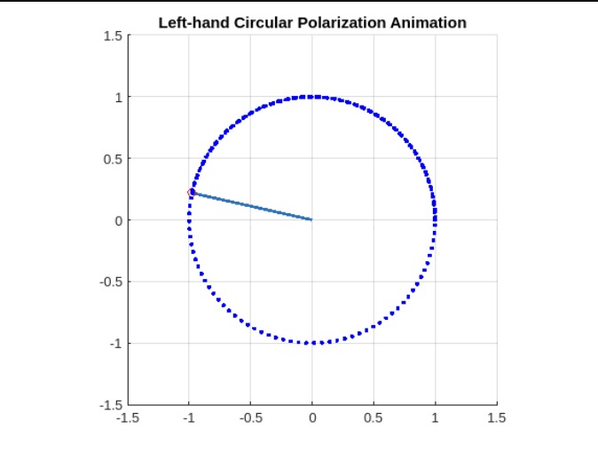

Fig.1 The Plot of Left-hand Circular Polarization Animation

The code of matlab using for ploting left-hand circular polarization vector Ex + Ey at from ωt= 0 to 6*pi on the same time axis is in below:

% 设置时间范围

t = linspace(0, 6*pi, 300);

% 计算左旋圆极化和右旋圆极化的Ex和Ey

Ex_LHCP = cos(t);

Ey_LHCP = sin(t);

Ex_RHCP = cos(t);

Ey_RHCP = -sin(t);

% 创建图形窗口

figure;

hold on;

grid on;

axis equal;

xlim([-1.5, 1.5]);

ylim([-1.5, 1.5]);

title('Elliptical Polarization Animation');

% 初始化画线和点

lineHandle_LHCP = plot([0, Ex_LHCP(1)], [0, Ey_LHCP(1)], 'LineWidth', 2, 'Color', 'blue');

lineHandle_RHCP = plot([0, Ex_RHCP(1)], [0, Ey_RHCP(1)], 'LineWidth', 2, 'Color', 'red');

pointHandle_LHCP = plot(Ex_LHCP(1), Ey_LHCP(1), 'bo', 'MarkerFaceColor', 'blue');

pointHandle_RHCP = plot(Ex_RHCP(1), Ey_RHCP(1), 'ro', 'MarkerFaceColor', 'red');

% 初始化轨迹

trail_LHCP = plot(Ex_LHCP(1), Ey_LHCP(1), 'b.');

trail_RHCP = plot(Ex_RHCP(1), Ey_RHCP(1), 'r.');

% 循环绘制动画

for i = 1:length(t)

% 更新左旋圆极化线和点的位置

set(lineHandle_LHCP, 'XData', [0, Ex_LHCP(i)], 'YData', [0, Ey_LHCP(i)]);

set(pointHandle_LHCP, 'XData', Ex_LHCP(i), 'YData', Ey_LHCP(i));

% 更新右旋圆极化线和点的位置

set(lineHandle_RHCP, 'XData', [0, Ex_RHCP(i)], 'YData', [0, Ey_RHCP(i)]);

set(pointHandle_RHCP, 'XData', Ex_RHCP(i), 'YData', Ey_RHCP(i));

% 更新轨迹

set(trail_LHCP, 'XData', [get(trail_LHCP, 'XData'), Ex_LHCP(i)], 'YData', [get(trail_LHCP, 'YData'), Ey_LHCP(i)]);

set(trail_RHCP, 'XData', [get(trail_RHCP, 'XData'), Ex_RHCP(i)], 'YData', [get(trail_RHCP, 'YData'), Ey_RHCP(i)]);

drawnow;

pause(0.05); % 控制动画速度

end

And the figure we get is:

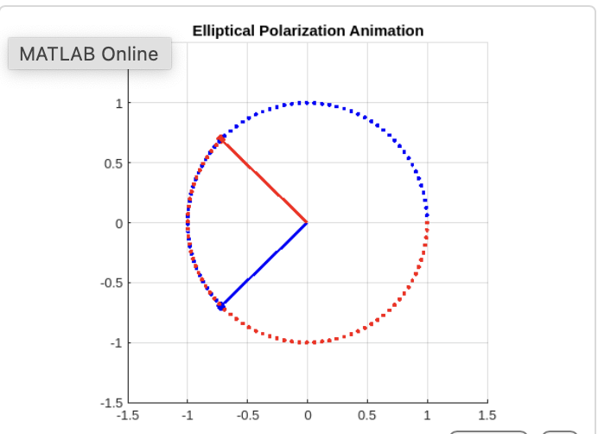

Fig.2 The Plot of left-hand circular polarization vector Ex + Ey at from ωt= 0 to 6*pi on the same time axis

The code of matlab using for ploting animated elliptical polarization using LHCP is in below:

And we get the figure in below:

wt=linspace(0,6*pi,900);

a=cos(wt);

b=cos(wt+pi/6);

for i=1:900

plot(a,b,'k','LineWidth',2);

hold on

scatter(0,0,108,'k','filled');

title('animated elliptical polarization using LHCP')

hold on;

axis equal;

quiver(0,0,a(i),b(i),1,'k','LineWidth',2);

quiver(0,0,a(i),0,1,'r','LineWidth',2);

quiver(0,0,0,b(i),1,'b','LineWidth',2);

hold off

getframe;end

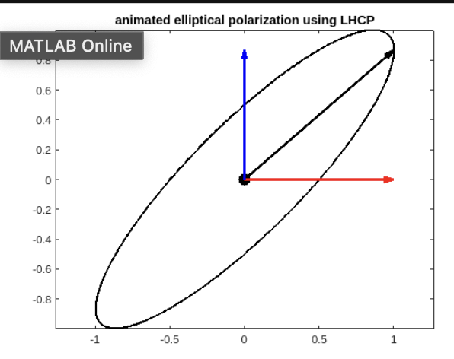

Fig.3 The Plot of animated elliptical polarization using LHCP

The code of matlab using for ploting animated elliptical polarization using RHCP is in below:

wt=linspace(0,6*pi,900);

a=cos(wt);

b=cos(wt-pi/6);

for i=1:900

plot(a,b,'k','LineWidth',2);

hold on

scatter(0,0,108,'k','filled');

title('The Plot of animated elliptical polarization using RHCP')

hold on;

axis equal;

quiver(0,0,a(i),b(i),1,'k','LineWidth',2);

quiver(0,0,a(i),0,1,'r','LineWidth',2);

quiver(0,0,0,b(i),1,'b','LineWidth',2);

hold off

getframe;

end

And we get the figure in below:

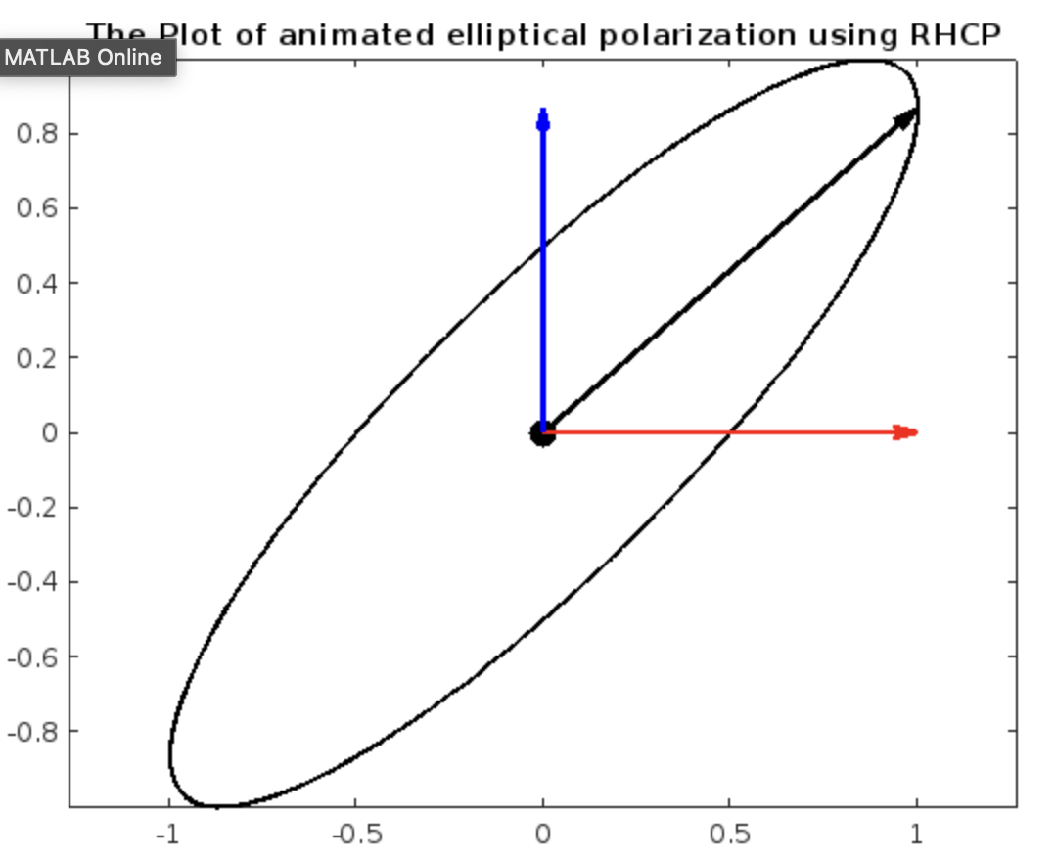

Fig.4 The Plot of animated elliptical polarization using RHCP

**Homework2:**

[UG] Calculate the Effective Isotropic Radiated Power (EIRP) of a wireless link that has a transmitter outputting 50 watts of power and uses an antenna with a gain of 16 dBi. The link includes a transmission line that introduces a loss of 3 dB. Determine if the EIRP exceeds the regulatory limit of 200 watts. If it does, calculate the necessary adjustment to the transmitter's power output to comply with this limit. Provide your answers including the steps you used to arrive at them.

Transmitter Power(dBm): P = 10 lg (50w/1w) + 30 = 47 dBm

Loss = 3 dB

Antenna gain: G = 16 dBi

So EIRP = P - Loss + G = 60 dBm

Limit EIRP = 200w = 53 dBm, it is less than the value we calculate.

So the P = EIRP + Loss – G = 40 dBm = 10 watts