**EE307 assignment6 Homework**

12112441 曹子惠

**Homework:**

Design a probe-fed rectangular patch antenna on a substrate having a relative permittivity of 2.33 and a thickness of 62 mils (0.1575 cm). (This is Rogers RT Duroid 5870.) Choose an aspect ratio of W / L = 1.5. The patch should resonate at the operating frequency of 1.575 GHz (the GPS L1 frequency). Ignore the probe inductance in your design, but account for fringing at the patch edges when you determine the dimensions. At the operating frequency the input impedance should be 50 Ω (ignoring the probe inductance). Assume an SMA connector is used to feed the patch along the centerline (at y = W / 2), and that the inner conductor of the SMA connector has a radius of 0.635 mm. The copper patch and ground plane have a conductivity of σ = 3.0 ×107 S/m and the dielectric substrate has a loss tangent of tanδ = 0.001.

1) Calculate the following:

1. The final patch dimensions L and W (in cm)

2. The feed location x0 (distance of the feed from the closest patch edge, in cm)

3. The bandwidth of the antenna (SWR < 2 definition, expressed in percent)

4. The radiation efficiency of the antenna (accounting for conductor, dielectric, and surface- wave loss, and expressed in percent)

5. The probe reactance Xp at the operating frequency (in Ω)

6. The expected complex input impedance (in Ω) at the operating frequency, accounting for the probe inductance

7. Directivity

8. Gain

2) Plot the input impedance vs. frequency.

**Answer:**

1. First, list the basic parameters.

% Given parameters

epsilon_r = 2.33; % Relative permittivity

e0 = 8.854187817e-12; % Vacuum permittivity (F/m)

gamm = 0.577216; % Euler's constant

miu0 = 4 * pi * 1e-7; % Permeability of free space (H/m)

yita0 = 376.7303; % Characteristic impedance of free space (ohm)

sigma = 3e7; % Conductivity of the material (S/m)

frequency = 1.575e9; % Operating frequency (Hz)

h = 0.1575; % Substrate thickness (m)

c = 3e8; % Speed of light in vacuum (m/s)

lambda0 = c / frequency; % Wavelength in free space (m)

w = 2 * pi * frequency; % Angular frequency (rad/s)

k0 = 2 * pi / lambda0; % Wave number (rad/m)

W_divi_L = 1.5; % Aspect ratio

tand = 0.001; % Loss tangent

Zin_real = 50; % Desired input impedance (real part)

R_resonance = 50; % Resonance resistance

a = 0.635e-3; % Radius of inner conductor (m)

a. The final patch dimensions L and W (in cm)

% 1. Calculate the final patch dimensions (L and W)

L = 3e8 / (2 * frequency * sqrt(epsilon_r)); % Length in meters

W = W_L_ratio * L; % Width in meters

And the results:

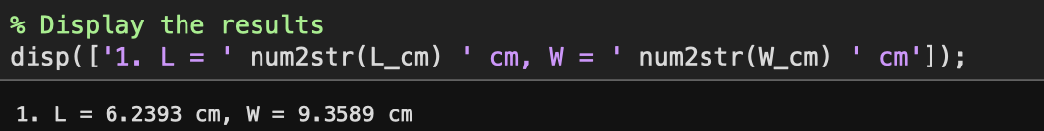

b. The feed location x0

% 2. Calculate the feed location (x0)

c1=1-1/er+2/5/(er)^2;

c2=-0.0914153;

a2=-0.16605;

a4=0.00761;

p=1+a2/10*(k0*W)^2+(a2^2+2*a4)*(3/560)*(k0*W)^4+c2*(1/5)*(k0*L)^2+a2*c2*(1/70)*(k0*W)^2*(k0*L)^2;

e_rhed=1/(1+3/4*pi*(k0*h)*(1/c1)*(1-1/er)^3);

Re=(4*yita0/pi)*(1/W_divi_L)*(h/lambda0)/(tand+(Rs/pi/yita0)*(1/(h/lambda0))+(16/3)*(p*c1/er)*(W_divi_L)*(h/lambda0)*(1/e_rhed));

x0=(L/pi)*acos(sqrt(Rin/Re))*1e2;

And the results:

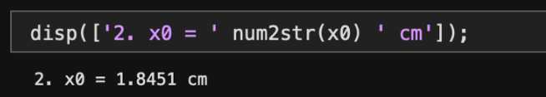

c. The bandwidth of the antenna (SWR < 2 definition, expressed in percent)

% 3. Determine the bandwidth of the antenna

BW=1/(sqrt(2))*(tand+(Rs/pi/yita0)*(1/(h/lambda0))+(16/3)*(p*c1/er)*(h/lambda0)*(W_divi_L)*(1/e_rhed));

BW=BW*100; %转化为百分比

And the results:

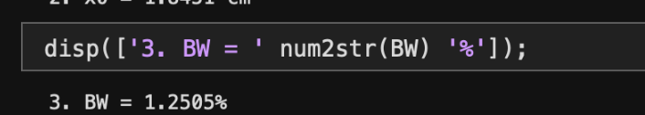

d. The radiation efficiency of the antenna (accounting for conductor, dielectric, and surface- wave loss, and expressed in percent)

% 4. Calculate the radiation efficiency

eff=e_rhed/(1+e_rhed*(tand+(Rs/pi/yita0)*(1/(h/lambda0)))*(3/16)*(er/p/c1)*(1/W_divi_L)*(1/(h/lambda0)));

effiency=eff*100;

And the results:

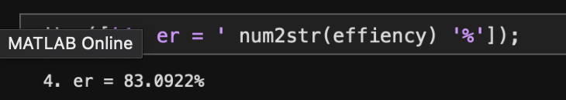

e. The probe reactance Xp at the operating frequency (in Ω)

% 5. Determine the probe reactance (Xp) at the operating frequency

Xp=(yita0/2/pi)*(k0*h)*(-gamm+log( 2/(sqrt(er)*k0*a)));

And the results:



f. The expected complex input impedance (in Ω) at the operating frequency, accounting for the probe inductance

% 6. Calculate the expected complex input impedance at the operating frequency

Zin=Rin+1i*Xp;

And the results:

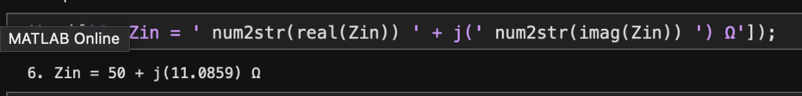

g. Directivity and Gain

% 7. Calculate directivity and gain

k1=k0*sqrt(er);

D=(3/p/c1)*(er/(er+(tan(k1*h)^2))*(tan(k1*h)/(k1*h))^2);

G=D*eff;

And the results:

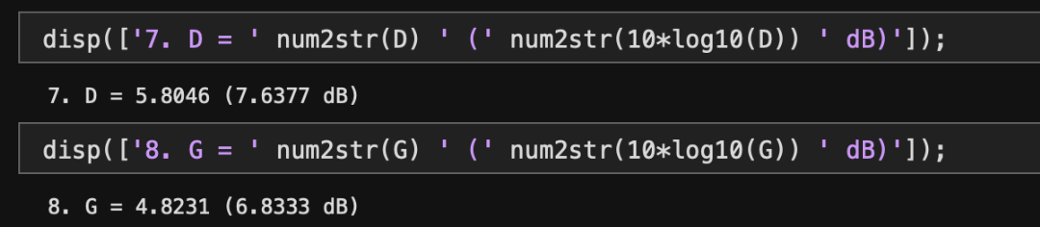

1. Plot the input impedance vs. frequency.

Below is the code we use:

f_test=linspace(1.5e9,1.65e9,2000); %对频段进行扫描

k_test=2*pi*f_test/c; %由频率推出k值

Q=1/(BW/100*sqrt(2));

R=R_resonance./(1+(Q*(f_test./f-f./f_test)).^2); %计算在某一频率处天线端的阻抗

Zin_test = 1i*Xp + R_resonance./(1+1i*Q.*(f_test./f-f./f_test));

Xin = imag(Zin_test);

plot(f_test, R,'lineWidth',2)

hold on

plot(f_test, Xin,'-r','lineWidth',2)

axis([1.5e9,1.65e9,-20,50]);

% set(gca,'ytick',-20:10:60);

grid on

set(gca, 'FontWeight','bold','LineWidth',2);

title('Relationship between Input Impedance and Frequency')

xlabel('Frequency');

ylabel('Input Impedance');

legend('Rin','Xin');

Then we get the figure:

