Benchmarking deep and hybrid quantum-classical models for Gallo-Roman ceramic sherd classification: a reproducible evaluation framework
Cyrille Chaidron¹*, Hafsa Taiebi Imrani²

¹ UMR 7041 ArScAn & U.R. 4284 TrAme, University of Picardie Jules Verne, Amiens, France
² Faculty of Science, Ibn Tofail University, Kenitra, Morocco
*Corresponding author: Cyrille Chaidron
Email: cyrille@arteka.tech

Abstract
The typological and technological identification of ceramic sherds is a central task in archaeological analysis, yet it still relies largely on expert visual assessment. In Gallo-Roman ceramics, some technological groups can be distinguished visually through surface appearance, firing colour, and fabric-related features, making this domain a relevant test case for computer vision.
This study proposes a reproducible evaluation framework to compare two computer-vision paradigms applied to ceramic fragments: crop-based classification and end-to-end object detection. The protocol is applied to a corpus of Gallo-Roman ceramics mainly from Amiens (France) and evaluates representative architectures, including compact convolutional networks (ResNet-18, MobileNetV3-Small), recent detectors (YOLOv8-s, YOLOv11-s, RT-DETR-L), and hybrid quantum-classical models (QCNN, QCNN-VQE).
Results show that crop-based classification achieves the highest and most stable performance, whereas end-to-end detectors are more sensitive to class imbalance and operating-point selection. Terra sigillata is consistently the most recognisable category, while most residual errors arise from confusions between the two common-ware classes (OW and RW). More broadly, the same archaeological dataset yields substantially different conclusions depending on whether the task is formulated as conditioned crop classification or full end-to-end detection.
Beyond model comparison, this work establishes a controlled and reproducible evaluation framework for computer vision applied to archaeological ceramics, and shows that task formulation is itself a major methodological factor in the interpretation of AI performance in heritage science.

Introduction
Ancient ceramics constitute one of the primary chronological and cultural markers in archaeology. Their abundance and diversity provide key evidence for understanding production systems, exchange networks, circulation patterns, acculturation processes, and social status [1]. In routine archaeological practice, however, the identification of ceramic categories still relies largely on visual expertise, which is time-consuming to acquire and may remain sensitive to inter-operator variability. This difficulty is especially pronounced when classification depends on subtle differences in paste, inclusions, firing conditions, or surface treatment. Computer vision therefore offers promising opportunities to objectify and accelerate ceramic analysis workflows. Yet fine-grained discrimination between visually similar classes remains challenging, particularly when the most informative cues lie in fabric-related visual characteristics and when archaeological datasets are inherently imbalanced [2–3].
In ceramic studies, visual inspection has long been used, particularly since the 1990s, to identify technological groups and, in some cases, to characterise workshop traditions. In northern Gaul, comparisons between sherds recovered from production contexts and fragments found on consumption sites have shown that certain workshop groups can be distinguished through macroscopic features such as paste texture, inclusions, firing colour, and surface appearance, sometimes complemented by stereomicroscopic observation [4]. These observations suggest that some ceramic productions retain relatively stable visual signatures reflecting technological practices and raw material choices. In this perspective, computer vision may help formalise, quantify, and test the visual criteria traditionally used by ceramic specialists within large archaeological assemblages.
Despite recent progress in computer vision applications to archaeology and cultural heritage, ceramic analysis remains a demanding case study. Archaeological image datasets typically combine modest sample sizes, high intra-class variability, heterogeneous acquisition conditions, and strong class imbalance [5–9]. These characteristics complicate model training and evaluation and make it difficult to assess the relative performance of different computer vision paradigms. In particular, global accuracy measures may mask poor performance on minority classes that are nevertheless archaeologically informative.
One widely used approach relies on one-stage detectors of the YOLO family, which have become popular because of their favourable speed–accuracy trade-off and mature software ecosystem [10–13]. In heritage contexts, such detectors are attractive when artefacts or fragments must first be localised within full images, especially in scenes containing multiple objects. However, two limitations frequently appear in the literature. First, comparisons between paradigms—end-to-end detection versus conditioned classification—are still rarely conducted under strictly harmonised experimental protocols. Second, the impact of class imbalance is often insufficiently analysed, despite the fact that it represents a central bias in archaeological datasets.
DETR-type detectors approach object detection as the direct prediction of the objects present in an image through attention mechanisms [14]. This formulation removes the need for heuristic post-processing such as non-maximum suppression and allows the model to reason more globally about the scene. However, early DETR architectures were computationally demanding and required large annotated datasets, which limited their practical use. RT-DETR was introduced to make Transformer-based detection more compatible with real-time constraints [15]. Whether such architectures remain competitive on relatively small and imbalanced archaeological corpora remains an empirical question.
Another emerging direction concerns hybrid quantum–classical learning approaches. Quantum convolutional neural networks (QCNNs), initially proposed by Cong et al. [16], illustrate how parameterised quantum circuits can be integrated into learning architectures. More generally, parameterised quantum circuits (PQCs) have been proposed as expressive non-linear transformations in low-dimensional latent spaces [17–23]. Because direct quantum encoding of high-dimensional images remains constrained by current hardware limitations, most practical implementations rely on hybrid pipelines in which a classical feature extractor compresses visual information before a quantum head performs the final transformation and decision. However, evaluations of such approaches against strong compact deep-learning baselines on real-world datasets remain limited, particularly in applied domains such as cultural heritage.
In this study, we investigate these questions using a real archaeological corpus of ceramic sherd photographs derived primarily from preventive excavations conducted in Amiens (Somme, France), in urban Gallo-Roman contexts dated to the 1st–2nd centuries AD. Three technological classes are considered: terra sigillata, oxidised common ware (OW), and reduced common ware (RW). According to the classification proposed by M. Picon [24], terra sigillata corresponds to firing mode C, whereas common wares are characterised by modes A (OW) and B (RW), corresponding respectively to oxidising and reducing firing conditions. These categories are generally easy to identify visually; however, some common wares, particularly those altered by use or firing defects, are more difficult to classify than terra sigillata, which typically exhibits more homogeneous surface characteristics. Examples of the three classes are shown in Figures 1 to 3.
To analyse model behaviour under realistic archaeological conditions, we compare two complementary computer vision paradigms corresponding to two distinct analytical situations. The first is crop-based classification, in which the sherd is already isolated and tightly framed. This setting corresponds to a stage of real-world practice in which the ceramologist isolates a fragment in order to examine the surface or the fabric visible in an ancient or recent break. The second paradigm is end-to-end object detection, in which localisation and classification must be solved jointly on full images, as when several fragments appear within the same scene. This corresponds to another stage of the ceramologist’s workflow, namely the initial sorting phase, when sherds are spread out for a first visual assessment of the different categories. These paradigms differ both in their level of difficulty and in their analytical purpose: the former evaluates recognition conditioned by localisation, whereas the latter assesses a complete decision pipeline at the image level.
To evaluate the impact of class-frequency bias, we consider two training scenarios derived from the same source corpus and the same image-level split. In the imbalanced scenario, class proportions reflect the original corpus distribution, as close as possible to field reality. In the balanced scenario, rebalancing is applied only to the training subset after splitting through controlled augmentation of minority classes and adjustment of majority-class counts. Validation is never augmented. Full dataset construction details and class distributions are reported in the Methods section.
These characteristics justify the use of imbalance-robust evaluation metrics. In particular, we prioritise macro-averaged F1, which assigns equal weight to each class and prevents majority classes from masking degradation on rarer but archaeologically informative categories. For detection tasks, we also report standard object-detection metrics while analysing the influence of the detector operating point, since practical decision-support systems often rely on fixed confidence thresholds.
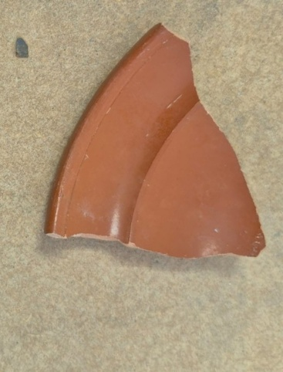
Figure 1 | Terra sigillata alone.
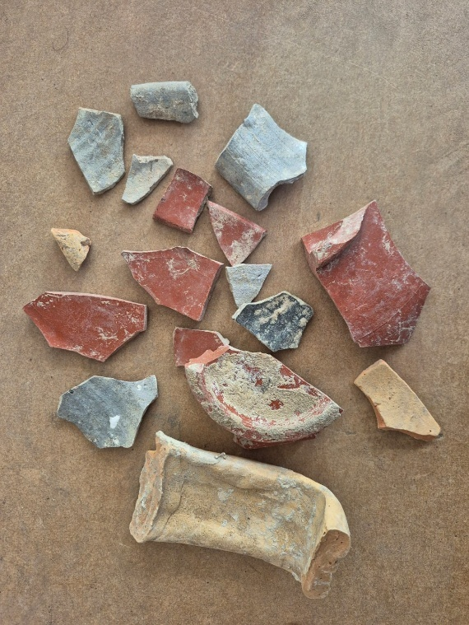
Figure 2 | Terra sigillata, oxidised common ware (OW) and reduced common ware (RW).
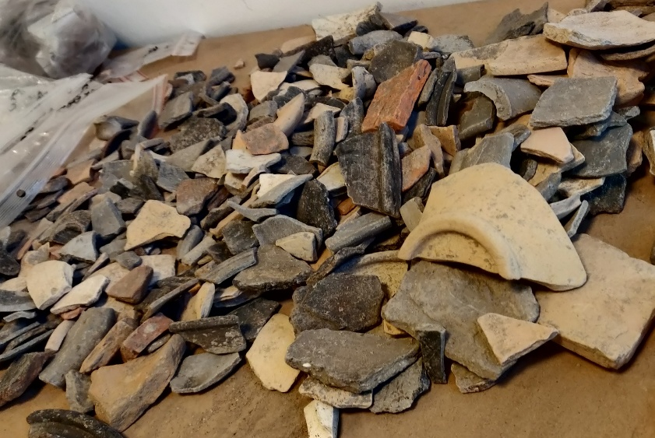
Figure 3 | Group of oxidised common ware (OW) and reduced common ware (RW).
The models evaluated include reference convolutional classifiers (ResNet-18 and MobileNetV3-Small), modern one-stage detectors (YOLOv8-s and YOLOv11-s), a real-time Transformer detector (RT-DETR-L), and hybrid quantum–classical classifiers. In this study, the term “QCNN” is used for convenience to denote a hybrid CNN–PQC classifier in which a lightweight convolutional encoder produces a compact latent representation before a parameterised quantum circuit performs the final transformation and decision. All quantum experiments are conducted in simulation on classical hardware. The aim is therefore not to claim a quantum computational advantage, but rather to assess the representational interest and compactness of a PQC head within an applied classification pipeline.
This study does not propose a new model architecture. Its main contribution is a controlled and reproducible evaluation framework that compares, under matched image-level splits and harmonised reporting conditions, conditioned classification on ground-truth crops and end-to-end detection on full images derived from the same source corpus. The same dataset yields substantially different conclusions depending on whether the task is formulated as conditioned crop classification or full end-to-end detection. This is not merely a performance difference, but a methodological shift. The reusable contribution of this work therefore lies in the evaluation design rather than in claims of architectural novelty. While the numerical results reported here remain specific to the Amiens corpus, the protocol itself is intended as a reproducible evaluation design for future archaeological imaging benchmarks.
The following section describes the corpus, dataset construction protocol, model architectures, and training procedures used to ensure a controlled comparison across paradigms.

Methods

Ceramic image corpus (Amiens, Gallo-Roman context)
The corpus consists of photographs of ceramic sherds derived mainly from rescue excavations in Amiens (France), acquired during the ceramological study phase. The images share a broadly similar working-surface background, but show non-negligible variability in scale, orientation, partial overlap, and number of objects per image, ranging from a single fragment to several dozen. Each sherd was annotated by an expert ceramologist with a bounding box and assigned to one of three technological categories: terra sigillata, oxidised common ware (OW), and reduced common ware (RW). Annotations were produced with LabelMe (JSON) and converted to COCO/YOLO format for detector training.
These classes correspond to firing and finishing differences described in the ceramological literature. In Picon’s classification, terra sigillata corresponds to firing mode C, whereas common wares correspond to modes A and B. Visually, these differences translate into variations in hue, gloss, and surface texture, with partial overlap between OW and RW when fabrics are altered, heterogeneous, or partially blackened.
Given the corpus size and the difficulty of building a fully independent external test set with comparable acquisition conditions, we adopted a strict image-level train/validation split (80/20). Ground-truth crops used for conditioned classification were generated only after splitting, separately within each subset, in order to prevent any information leakage between training and validation. The validation subset was used exclusively for early stopping and final evaluation.
Scenario | Split | OW | RW | Terra sigillata | Total
Crops - imbalanced | Train | 1322 | 1604 | 866 | 3792
Crops - imbalanced | Val | 215 | 279 | 200 | 694
Crops - imbalanced | Total | 1537 | 1883 | 1096 | 4516
Crops - balanced | Train | 978 | 1025 | 1075 | 3078
Crops - balanced | Val | 212 | 277 | 204 | 693
Crops - balanced | Total | 1190 | 1302 | 1279 | 3771
Table 1 | Crop totals across the imbalanced and balanced scenarios (train, validation, and total). Counts correspond to derived crop datasets generated after image-level splitting. In the imbalanced scenario, train-only resampling was applied for crop classification, which explains the training counts reported here. The slight difference between validation crop totals (694 vs 693) reflects separate dataset derivation and filtering after splitting, not any leakage between training and validation.

Imbalanced and balanced scenarios
To evaluate sensitivity to class-frequency bias, we defined two scenarios derived from the same source corpus and the same image-level train/validation split: an imbalanced scenario reflecting the original corpus distribution, and a balanced scenario obtained through train-only rebalancing after splitting. In all cases, augmentation and resampling were applied exclusively to the training set. Validation was never augmented. The resulting class distributions are reported in Tables 1 to 3.
In this study, the term balanced refers only to the distribution of training samples used during optimisation; it does not describe a modification of the underlying archaeological corpus itself. Its implementation is task-dependent.
For crop-based classification, balancing was performed at the crop level by increasing the representation of minority-class crops and adjusting the contribution of majority-class crops in the training set. For end-to-end detection, balancing was performed at the training-image level by increasing the sampling and augmentation of images containing under-represented classes while preserving the original image structure. As a result, the balanced scenario should be understood as a train-time strategy rather than as a new dataset distribution.
For end-to-end detection, the validation set is identical across the imbalanced and balanced scenarios (109 images, 693 annotated instances), which ensures a strict comparison under matched evaluation conditions. For crop-based classification, the same image-level validation split is used in both scenarios, but the resulting derived validation crop sets differ slightly in size (694 vs 693 crops), because the imbalanced and balanced crop datasets were generated separately after splitting and filtering. This difference is reported explicitly and does not affect the image-level separation between training and validation.
In the imbalanced scenario, the original class distribution is preserved at the corpus level. However, for crop-based classification, limited train-only resampling was applied to mitigate the under-representation of terra sigillata, which explains the training counts reported in Table 1. For end-to-end detection, the imbalanced scenario uses raw training annotations without class rebalancing. The resulting class distributions are reported in Table 2 for end-to-end detection and in Table 3 for crop-based classification.
Representative learning curves for the main seed-42 runs are provided in the Supplementary Materials for both balanced and imbalanced settings. For classification, these include training loss, validation loss, and validation macro-F1. For detection, training classification loss is reported, whereas intermediate validation curves were not sufficiently dense to support informative epoch-by-epoch interpretation.

Crop generation and filtering (classification)
For the crop-based classification task, each annotated instance was extracted from the source image as a 64 × 64 ground-truth (GT) crop centred on the object. The classification dataset is therefore a derived dataset generated from the image-level annotations after splitting. In the imbalanced scenario, limited train-only resampling was applied to compensate partially for the under-representation of terra sigillata while preserving a clearly imbalanced class distribution overall. Validation crops were never augmented.

Dataset statistics
Dataset statistics for end-to-end detection and crop-based classification are summarised in Tables 2 and 3, corresponding respectively to full-image annotations and derived crop datasets generated after image-level splitting.
Dataset | Split | # images | # instances | Terra sigillata (%) | OW (%) | RW (%)
Imbalanced | Train | 486 | 3682 | 23.6 | 36.8 | 39.7
Imbalanced | Val | 109 | 693 | 29.4 | 30.6 | 40.0
Balanced | Train | 723 | 3078 | 34.9 | 31.8 | 33.3
Balanced | Val | 109 | 693 | 29.4 | 30.6 | 40.0
Table 2 | Dataset composition for end-to-end detection on full images. Counts correspond to the full-image datasets used in the imbalanced and balanced scenarios. The validation set is identical across both scenarios (109 images, 693 annotated instances). Classes: 0 = terra sigillata, 1 = oxidised common ware (OW), 2 = reduced common ware (RW).
Dataset | Split | # crops | Terra sigillata (%) | OW (%) | RW (%)
Imbalanced | Train | 3792 | 23.4 | 34.6 | 42.0
Imbalanced | Val | 694 | 28.8 | 31.0 | 40.2
Balanced | Train | 3078 | 34.9 | 31.8 | 33.3
Balanced | Val | 693 | 29.4 | 30.6 | 40.0
Table 3 | Dataset composition for crop-based classification. Counts correspond to derived crop datasets generated after image-level splitting. The slight difference between validation crop totals (694 vs 693) results from separate dataset derivation and filtering after splitting, not any leakage between training and validation.

Managing class imbalance
Class distributions observed in archaeological contexts are intrinsically imbalanced, with some categories (in particular terra sigillata) being naturally less represented than common wares [25-26]. In our imbalanced crop-classification scenario, the training set includes 3792 isolated objects, with 23.4% terra sigillata (866/3792), 34.6% OW (1322/3792) and 42.0% RW (1604/3792). The associated validation set includes 694 crops with a similar distribution dominated by common wares (terra sigillata 28.8%, OW 31.0%, RW 40.2%). This scenario reflects a realistic field situation, in which common wares largely dominate archaeological assemblages, while terra sigillata remains a minority, both in the High Empire and the Late Empire in northern Gaul. The “ground-truth” distribution considered here corresponds more or less to urban datasets from the late 1st century AD to the first half of the 2nd century AD, in a civitas capital such as Amiens [4, 27].
In order to reflect field reality, we retain this imbalanced scenario and evaluate the models using metrics robust to class imbalance (notably macro-F1), which are more informative than global accuracy. In parallel, to analyse architectural sensitivity to frequency bias and to provide a controlled comparison point, we construct a balanced scenario from the same initial corpus. After image-level splitting (80% training / 20% validation), the minority class (terra sigillata) is augmented exclusively on training via mild geometric transformations (moderate rotation and recropping), while random undersampling is applied to the majority classes.
The balanced training set thus contains 3078 crops with a near-uniform distribution (terra sigillata 34.9%, OW 31.8%, RW 33.3%). The validation subset is strictly excluded from any augmentation or resampling operation and is used only for evaluation and early stopping.
We intentionally favour a simple augmentation strategy (mild geometric transformations and recroppings), because it is reproducible, adapted to modest corpora, and limits the risk of introducing unrealistic visual artefacts, which is critical for ceramic texture analysis [28].
We did not select cost-sensitive learning methods (e.g., loss reweighting or focal loss [29-31]) as our main approach. Although such techniques can be effective, they introduce additional hyperparameters requiring careful, model- and dataset-dependent tuning. For moderate-sized archaeological corpora, they can also lead to over-correction of minority classes, at the expense of inter-class stability and comparability between model families. Our choice therefore favors a conservative and reproducible methodological framework, directly transferable to real ceramological study conditions, while allowing the explicit quantification of the effect of controlled rebalancing.

Methodological pipeline and controlled evaluation protocol
Our experiments follow a single reproducible workflow derived from the same annotated image-level corpus. The train/validation split is first defined at the full-image level. Ground-truth crops for classification are extracted only after this step, preventing any overlap between objects originating from the same source image across different subsets.
This workflow defines two related but distinct task settings: conditioned classification on ground-truth crops and end-to-end detection on full images. The former isolates visual discrimination performance under perfect localisation, whereas the latter evaluates the complete decision pipeline, including localisation, classification, and post-processing.
Performance is evaluated using imbalance-robust metrics, with macro-F1 as the primary indicator and COCO metrics reported for detection models. This protocol is designed as a reproducible evaluation framework in which object isolation and full-scene deployment correspond to different operational needs, enabling a controlled comparison between idealised recognition and realistic archaeological use cases.

Architecture of QCNN and QCNN-VQE models
Hybrid quantum-classical models (QCNN and QCNN-VQE) are implemented as conditioned classifiers operating on 64×64 RGB crops. A lightweight classical CNN first compresses each crop into a low-dimensional feature vector, which is then processed by a parameterised quantum circuit acting as a non-linear decision head. QCNN and QCNN-VQE share the same classical backbone and encoding scheme, differing only in the formulation of the quantum decision layer. The aim is not to claim a quantum computational advantage or a stable advantage under class imbalance, but rather to assess whether a highly compact quantum-classical head can remain competitive under controlled archaeological classification settings. Full architectural and mathematical details are provided in the Supplementary Materials.

Models evaluated and training protocols
We evaluated seven representative architectures: YOLOv8-s, YOLOv11-s and RT-DETR-L for end-to-end detection on full images, and ResNet-18, MobileNetV3-Small, QCNN and QCNN-VQE for conditioned classification on ground-truth crops. All models were trained and evaluated on the same image-level splits under two learning scenarios (imbalanced and balanced training), with rebalancing applied to the training set only when relevant.
Performance was assessed using imbalance-robust metrics, with macro-averaged F1 as the primary indicator for both classification and end-to-end detection, complemented by standard COCO metrics (AP@0.5 and AP@[0.5:0.95]) for detectors. End-to-end F1 scores were computed via a one-to-one IoU-based matching procedure at a fixed operating point, enabling a joint evaluation of localisation and classification quality.
Detailed architectural descriptions, hyperparameters, training schedules and evaluation procedures for each model are provided in the Supplementary Materials.

Colour representation for crops (conditioned classification)
For all crop-based classifiers (ResNet-18, MobileNetV3-Small, QCNN and QCNN-VQE), cropped objects are processed in colour, RGB format (3 channels). Images are loaded with torchvision.datasets.ImageFolder (forced conversion to RGB), resized and converted to PyTorch tensors; intensities are thus rescaled to the interval [0, 1] (ToTensor). No explicit conversion to grayscale is applied in the classification pipeline in order to preserve potentially discriminative chromatic information (notably for terra sigillata and subtle OW/RW fabric hues) and ensure strict input comparability between architectures, in particular for ImageNet-initialised backbones that assume 3-channel input.

Training protocol and hyperparameters
We trained all models under harmonized conditions in order to enable a fair comparison between paradigms. For crop-based classifiers, optimisation relied on the AdamW optimizer with early stopping based on validation loss [34], whereas detectors were trained using their reference implementations with identical hyperparameters whenever possible. Fixed random seeds and controlled data splits were used throughout. The best validation checkpoint was retained for evaluation in all cases. Detailed hyperparameters and training schedules are reported in the Supplementary Materials.

Evaluation metrics
All end-to-end detection macro-F1 scores reported in this study are computed using a unified evaluation protocol based on one-to-one IoU-constrained matching (IoU ≥ 0.5) at a fixed confidence threshold (conf = 0.25; max_det = 300), ensuring consistent comparison across models.
Standard COCO detection metrics (mAP@0.5 and mAP@[0.5:0.95]) are obtained from the reference Ultralytics evaluation pipeline and are not affected by this protocol. We distinguish two evaluation settings consistent with the two tasks: conditioned classification on GT crops (one isolated sherd already localised), and end-to-end detection on full images (localisation and classification).
For multi-class crop classification (terra sigillata, OW, RW), we systematically report on the validation crop set derived after image-level splitting: precision, recall and F1-score per class, macro-F1 (unweighted mean of per-class F1), used as the main metric because it is robust to imbalance, and accuracy and weighted-F1 as complementary indicators. Macro-F1 is prioritised because it assigns equal weight to each class regardless of frequency, preventing high performance on majority classes from masking degradation on the minority class.
For end-to-end detection, we report standard detection metrics mAP (AP@0.5 and AP@[0.5:0.95]) from the COCO protocol, which jointly aggregate localisation and classification quality, and a synthetic “end-to-end per-class F1” computed at a fixed operating point, to provide a more direct interpretation in terms of category-specific errors. End-to-end precision, recall and F1 are computed after class-agnostic one-to-one greedy matching between predicted and ground-truth bounding boxes using an IoU ≥ 0.5 criterion. Candidate prediction–ground-truth pairs with IoU ≥ 0.5 are ranked by decreasing IoU, with prediction confidence used as a tie-break when necessary, and matches are selected sequentially so that each prediction and each ground-truth box are used at most once. A matched pair counts as a true positive if the predicted class matches the ground-truth class; in case of class mismatch, it contributes a false positive for the predicted class and a false negative for the ground-truth class. Unmatched predictions count as false positives, and unmatched ground-truth boxes count as false negatives. Detector predictions are generated with explicit and identical inference settings across models (notably input size, confidence threshold, and maximum number of detections per image, max_det = 300); on this basis we compute precision, recall and F1 per class, and macro-averaged end-to-end F1. This metric does not replace mAP (more standard for detection) but complements it by providing a per-class reading at a fixed threshold, which is particularly relevant for decision-support use cases.
Class-index mapping was kept identical across annotation conversion, detector training and evaluation (0 = terra sigillata, 1 = OW, 2 = RW), and was manually checked before computing the final metrics. The same post-processing and inference settings were applied consistently across detectors, including input size, confidence threshold and maximum number of detections
For detectors, the main benchmark tables report end-to-end macro-F1 values at the fixed operating point used in the primary evaluation. In addition, the confidence-threshold sweep shown in Figure 12 is computed using the same unified evaluation protocol across a range of confidence thresholds. The value at conf = 0.25 is therefore directly comparable to the macro-F1 values reported in Tables 4 and 5, while the full curve provides additional insight into the sensitivity of detector performance to threshold selection.
In all cases, final metrics are reported based on the best checkpoint selected on the validation set (primary criterion: Macro-F1 for classification on crops; standard Ultralytics criteria for detection, supplemented by our fixed-threshold end-to-end metrics). Learning curves (training and validation losses, as well as the primary metric) are provided as supplementary material to document training convergence and stability.

Results

Imbalanced scenario
On the imbalanced scenario, reflecting a realistic distribution with terra sigillata as a minority class, the models exhibit clear performance gaps. Detailed results for per-class F1 scores and Macro-F1 are illustrated in Figures 4, 5, and 10, as well as in Table 4, while the overall model performances are represented in Figure 6.
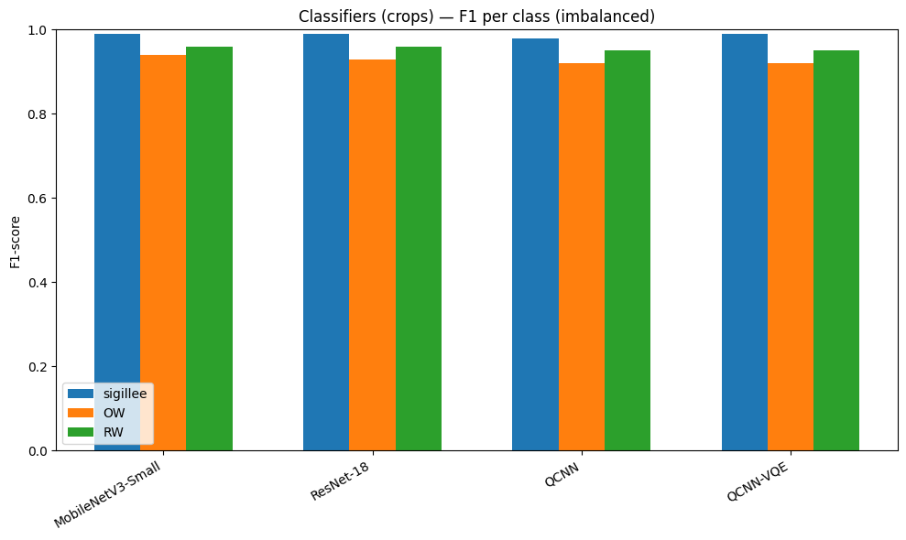
Figure 4 | Overall performance on the imbalanced dataset—per-class F1 and macro-F1 for classification models.
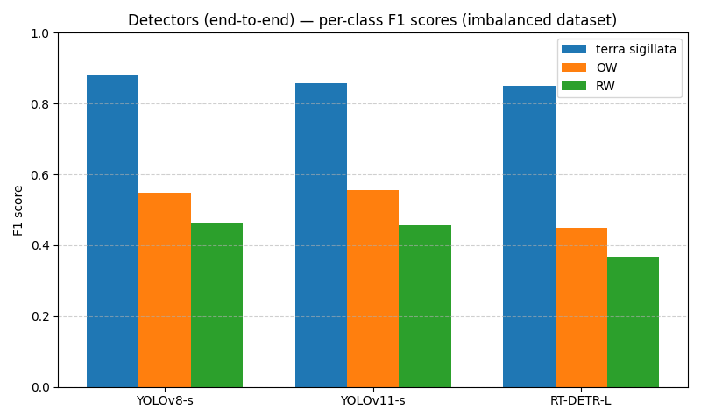
Figure 5 | Overall performance on the imbalanced dataset—per-class F1 scores compared across detection models.
Model | Task | Weights-only size (MiB) | F1 (terra sigillata) | F1 (OW) | F1 (RW) | Macro-F1 | mAP@0.5 | mAP@[0.5:0.95]
MobileNetV3-Small | Classification (GT crops) | 5.93 | 0.987469 | 0.942584 | 0.963222 | 0.964425 | – | –
ResNet-18 | Classification (GT crops) | 42.72 | 0.984925 | 0.933649 | 0.957746 | 0.958773 | – | –
QCNN-VQE | Classification (GT crops) | 0.36 | 0.979798 | 0.919540 | 0.951526 | 0.950288 | – | –
QCNN | Classification (GT crops) | 0.21 | 0.975124 | 0.917051 | 0.945652 | 0.945942 | – | –
YOLOv8-s | End-to-end detection | 21.47 | 0.947891 | 0.808824 | 0.841155 | 0.865957 | 0.893256 | 0.789157
YOLOv11-s | End-to-end detection | 18.29 | 0.960199 | 0.794258 | 0.825397 | 0.859951 | 0.892271 | 0.784194
RT-DETR-L | End-to-end detection | 63.22 | 0.850962 | 0.449123 | 0.367510 | 0.555865 | 0.831693 | 0.732254
Table 4 | Imbalanced scenario: per-class F1, macro-F1 and model sizes (weights-only). For classification models, metrics are computed on ground-truth crops (perfect localisation). For detection models, metrics correspond to end-to-end evaluation on full images, combining localisation and classification. Standard COCO detection metrics (mAP@0.5 and mAP@[0.5:0.95]) are also reported for detectors. A confidence-threshold sweep computed with the same unified evaluation protocol is reported separately in Figure 12.
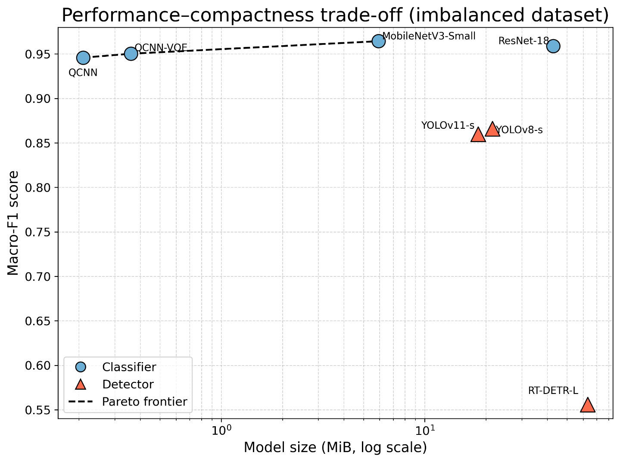
Figure 6 | Performance-compactness trade-off under class imbalance. Macro-F1 score as a function of model size (weights-only, log scale) for all evaluated architectures in the imbalanced scenario. Marker shape indicates model family (CNN classifier, hybrid QCNN, or detector). The dashed line denotes the Pareto frontier, highlighting models that are not dominated in terms of both performance and compactness.
In the imbalanced scenario, results must be interpreted by distinguishing conditioned classification on GT crops (perfect localisation) and end-to-end detection (localisation and classification). On GT crops, the four classifiers present high and relatively homogeneous performance: MobileNetV3-Small reaches macro-F1 = 0.964 (F1_ terra sigillata = 0.987; F1_OW = 0.943; F1_RW = 0.963), ResNet-18 macro-F1 = 0.959 (0.985; 0.934; 0.958), QCNN-VQE macro-F1 = 0.950 (0.980; 0.921; 0.952) and QCNN macro-F1 = 0.946 (0.975; 0.917; 0.946). In all cases, OW is the most difficult class, suggesting a structurally dominant OW-RW confusion in realistic conditions.
In end-to-end detection (IoU >= 0.5, conf >= 0.25, max_det = 300), YOLOv8-s and YOLOv11-s remain performant (macro-F1 = 0.865957 and 0.859951), whereas RT-DETR-L is clearly behind (macro-F1 = 0.555865), mainly due to a marked degradation on OW and RW.
In terms of standard detection metrics, YOLOv8-s and YOLOv11-s obtain similar mAP@0.5 (about 0.893 and 0.892) and mAP@[0.5:0.95] of about 0.789 and 0.784 respectively. RT-DETR-L remains weaker (mAP@0.5 ~ 0.832; mAP@[0.5:0.95] ~ 0.732) and is much more parameter-expensive, motivating the post-hoc fusion strategy (detection + reclassification) presented below.

Balanced scenario
With the balanced training set (terra sigillata training images increased to approach the other classes), we observe score changes for some models, but the overall hierarchy largely persists. Figures 7, 8, 11 and Table 5 present the per-class F1 scores in this scenario, while the overall model performances are represented in Figure 9.
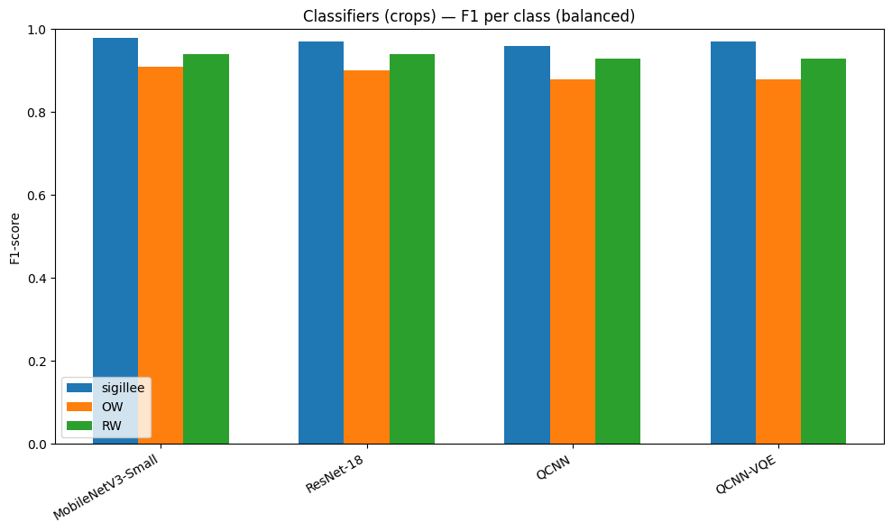
Figure 7 | Overall performance on the balanced dataset: per-class F1 and macro-F1 for classification models.
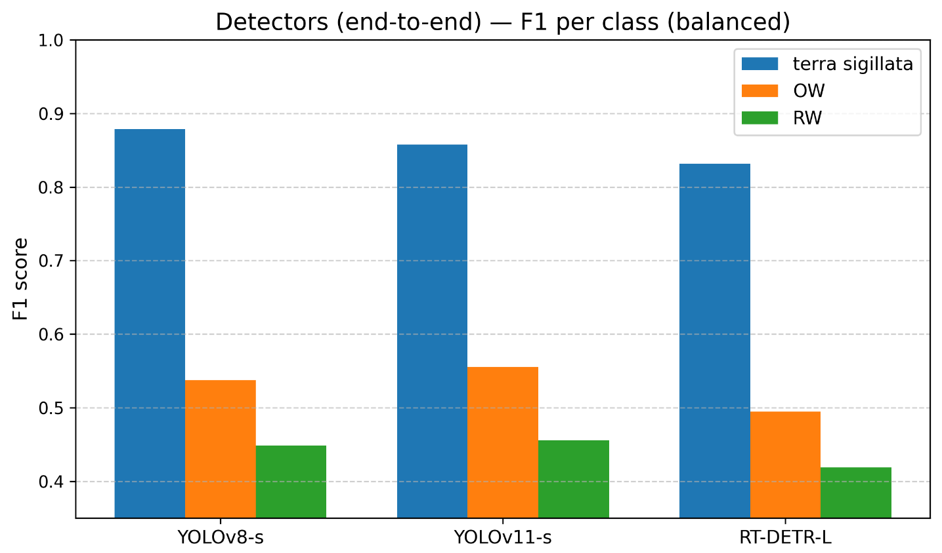
Figure 8 | Overall performance on the balanced dataset: per-class F1 compared across detection models.

Model | Task | Weights-only size (MiB) | F1 (terra sigillata) | F1 (OW) | F1 (RW) | Macro-F1
MobileNetV3-Small | Classification (GT crops) | 5.93 | 0.977995 | 0.907834 | 0.939227 | 0.941685
ResNet-18 | Classification (GT crops) | 42.72 | 0.970588 | 0.897862 | 0.937163 | 0.935205
QCNN-VQE | Classification (GT crops) | 0.36 | 0.968370 | 0.881671 | 0.926471 | 0.925504
QCNN | Classification (GT crops) | 0.21 | 0.960591 | 0.879433 | 0.926391 | 0.922138
YOLOv8-s | End-to-end detection | 21.47 | 0.8788 | 0.5375 | 0.4487 | 0.6217
YOLOv11-s | End-to-end detection | 18.29 | 0.8578 | 0.5553 | 0.4556 | 0.6229
RT-DETR-L | End-to-end detection | 63.22 | 0.8318 | 0.4948 | 0.4189 | 0.5818
Table 5 | Balanced scenario: per-class F1, macro-F1 and model sizes (weights-only). For classification models, metrics are computed on ground-truth crops (perfect localisation). For detection models, metrics correspond to end-to-end evaluation on full images using a unified evaluation protocol (IoU ≥ 0.5, conf = 0.25, max_det = 300).

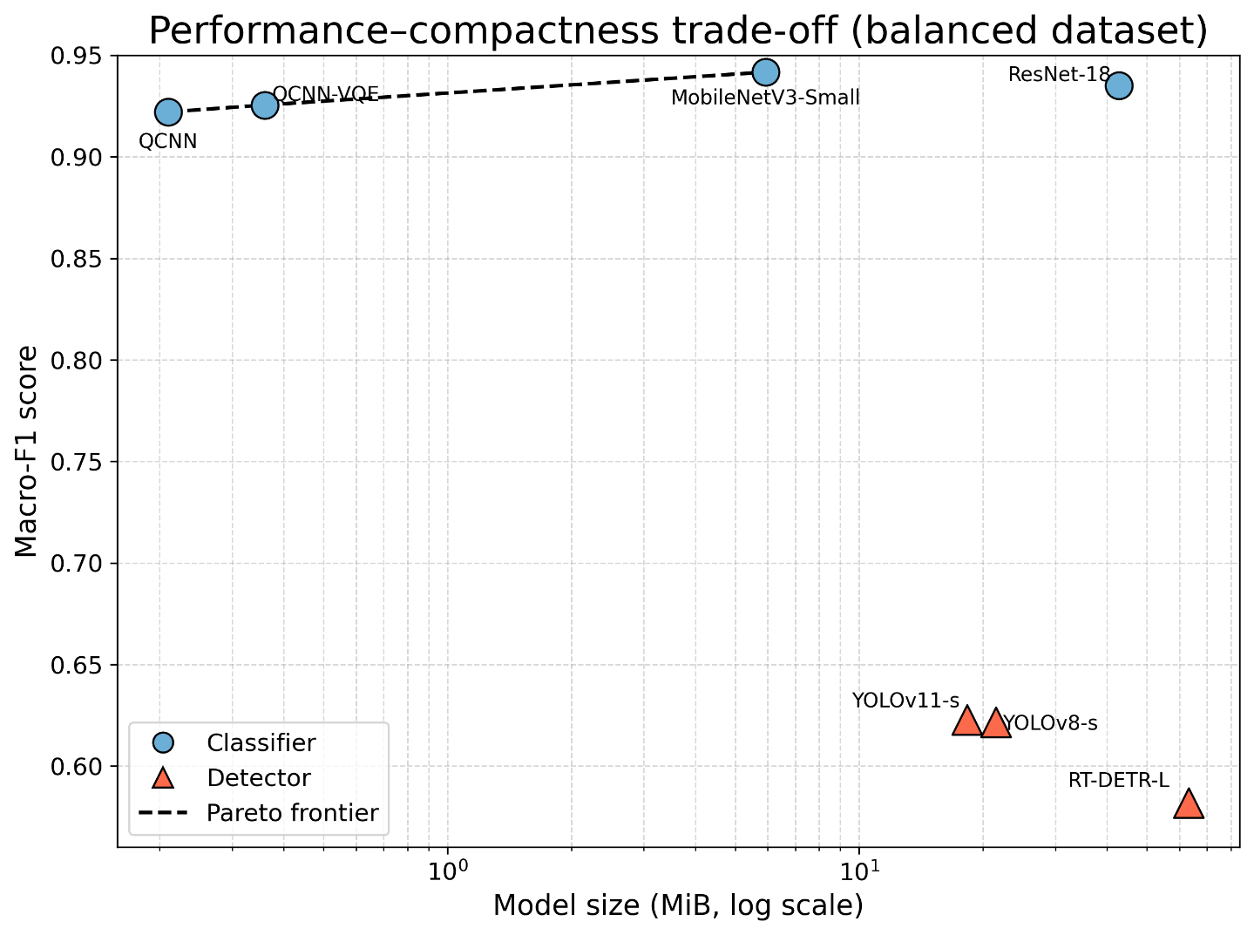Figure 9 | Performance-compactness trade-off on the balanced dataset. Macro-F1 as a function of model size (weights-only, log scale). Marker shape indicates model family (classifier vs detector). The dashed line denotes the Pareto frontier, highlighting non-dominated architectures. Hybrid QCNN models and MobileNetV3-Small lie on the frontier, whereas larger classifiers and detectors are dominated for fine-grained classification.
Under the balanced scenario, end-to-end detection models achieve lower macro-F1 scores than crop-based classifiers, reflecting the additional difficulty introduced by joint localisation and classification. YOLOv8-s and YOLOv11-s exhibit nearly identical performance (macro-F1 ≈ 0.62), indicating stable behaviour across architectures at the chosen operating point. In contrast, RT-DETR-L remains less effective, which can be attributed to a higher rate of false positives and less stable class-level decisions. Across all detection models, terra sigillata remains the most reliably identified class, while OW and RW continue to present greater difficulty due to occasional visual similarity and inter-class confusion.
In the balanced scenario (rebalancing applied to training only), crop classifiers remain at a high level, but balancing does not translate automatically into a validation gain: MobileNetV3-Small decreases from macro-F1 0.964 to 0.942, ResNet-18 from 0.959 to 0.935, QCNN-VQE from 0.950 to 0.926 and QCNN from 0.946 to 0.922. This drop is mostly driven by OW, which is consistent with a reduction of majority-class diversity induced by under-sampling during rebalancing, and highlights the importance of preserving intra-class variability for common wares.
In end-to-end detection, YOLOv8-s and YOLOv11-s show their best performance in the realistic imbalanced scenario (macro-F1 = 0.866 and 0.860). In our rebalancing protocol, global validation performance does not increase (macro-F1 ≈ 0.62 for both YOLOv8-s and YOLOv11-s) and the decrease is again mainly driven by OW. This suggests that a rebalancing strategy based on under-sampling and augmentation can reduce useful diversity of majority classes in a modest corpus. RT-DETR-L remains clearly below YOLO-based detectors on the end-to-end benchmark measure (macro-F1 ≈ 0.58), reinforcing the interest of a post-hoc fusion in which the final class decision is delegated to a more reliable crop classifier. To assess whether this behaviour is robust to stochastic training effects, we conducted an additional multi-seed analysis (seeds 42, 123 and 777). Under the unified fixed-threshold evaluation protocol (conf = 0.25), RT-DETR-L remains consistently below YOLO-based detectors across runs, with macro-F1 values in the 0.53–0.58 range. The confidence-threshold sweep shown in Figure 12 further indicates moderate threshold sensitivity, with RT-DETR reaching its best macro-F1 at a higher confidence threshold (~0.53) than the benchmark operating point.
These results highlight a clear distinction between conditioned classification on GT crops (perfect localisation) and end-to-end detection on full images (localisation + classification). On GT crops, all classifiers reach high performance in the imbalanced scenario (macro-F1 ~ 0.946-0.964), with MobileNetV3-Small leading and hybrid models remaining very competitive (QCNN-VQE macro-F1 = 0.950; QCNN = 0.946). In all cases, OW is the most difficult class, confirming a structurally dominant OW-RW confusion in realistic conditions.
On the balanced scenario, classifiers do not automatically gain in macro-F1 on validation (a decrease of about 2-3 points), suggesting that rebalancing achieved by augmenting the minority class and under-sampling majority classes may reduce useful diversity of common-ware classes at training time, despite a more uniform distribution.
For end-to-end detection, YOLO-type detectors remain robust in the imbalanced scenario but exhibit a substantial drop in performance under the balanced training protocol (macro-F1 ≈ 0.62), highlighting their sensitivity to training-time rebalancing in limited datasets. In contrast, RT-DETR-L remains markedly weaker (macro-F1 ≈ 0.58) and shows reduced class-level reliability on OW and RW, despite achieving acceptable localisation performance under the COCO protocol. Finally, the performance-versus-compactness analysis highlights the interest of hybrid approaches: QCNN and QCNN-VQE achieve macro-F1 values close to lightweight CNNs while remaining extremely compact (about 0.21–0.36 MiB weights-only), motivating a post-hoc fusion strategy in which a compact classifier requalifies the proposals of a detector that is less reliable for fine-grained classification, without requiring retraining.
Although MobileNetV3-Small achieves the highest crop-classification performance, QCNN-based models remain competitive while using far fewer trainable weights. Their interest in this benchmark therefore lies less in absolute performance leadership than in compactness-oriented design.

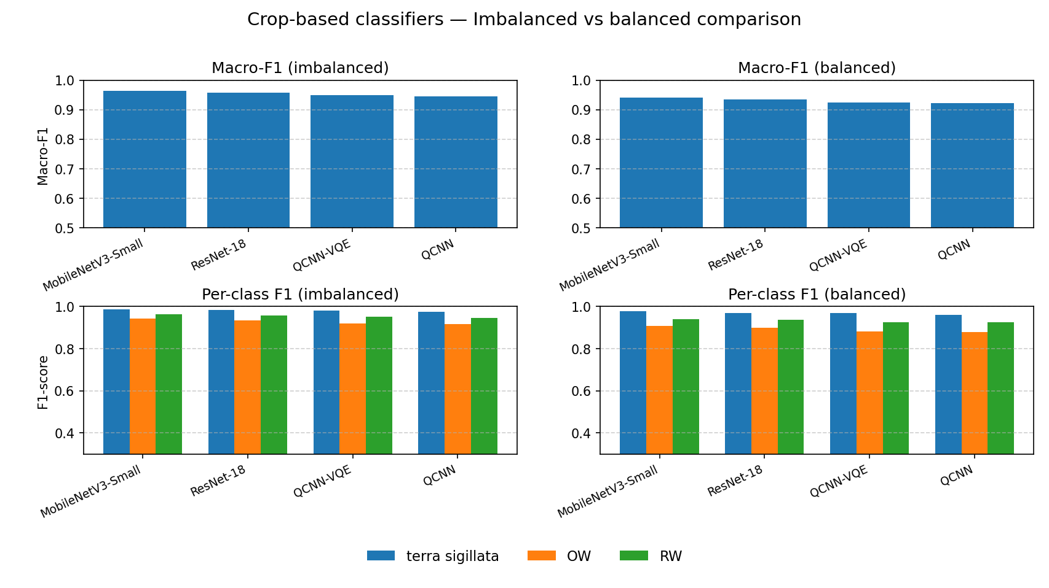
Figure 10 | Comparison of per-class F1 scores for classification models.
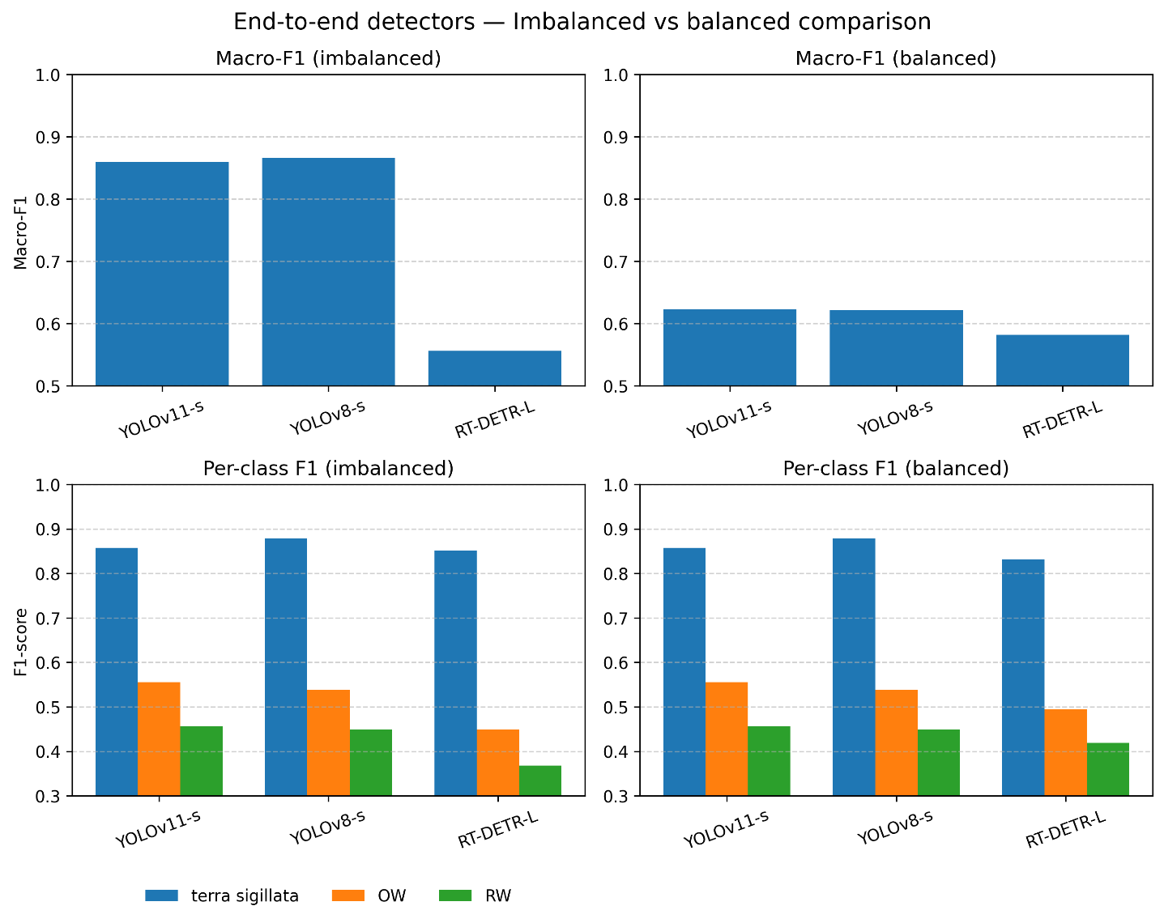
Figure 11 | Comparison of per-class F1 scores for detection models.

Confidence-threshold sensitivity and per-class detection behaviour
To further analyse detector behaviour beyond the fixed benchmark operating point, we performed a sweep over confidence thresholds. This sweep was computed using the same unified evaluation protocol as in Tables 4 and 5, thereby extending the fixed-threshold analysis across a range of operating points.
To investigate the apparent discrepancy between COCO-style detection metrics and end-to-end macro-F1 scores, we conducted a confidence-threshold sweep analysis. The end-to-end macro-F1 metric was recomputed across a wide range of confidence thresholds using the unified evaluation protocol (IoU ≥ 0.5, one-to-one matching), while standard COCO metrics (mAP) remain unchanged.
For YOLOv8-s, macro-F1 remains relatively stable across a broad range of thresholds and reaches a maximum value of 0.630 at a confidence threshold of approximately 0.37. The operating point used in the main evaluation (conf = 0.25) lies within this plateau, indicating that the reported performance is only weakly sensitive to the exact threshold selection.
The optimal threshold (~0.37) yields a slightly higher macro-F1 than the fixed evaluation threshold (conf = 0.25), but the latter is retained for consistency across all benchmark tables.
In contrast, RT-DETR retains non-negligible end-to-end performance but shows greater sensitivity to the confidence threshold. In the balanced scenario (seed 42) shown in Figure 12, it reaches macro-F1 = 0.582 at the benchmark operating point (conf = 0.25) and a maximum of 0.598 at a confidence threshold of approximately 0.53. This behaviour indicates that RT-DETR is more sensitive to confidence calibration and operating-point selection than YOLOv8-s. The value obtained at conf = 0.25 is consistent with the fixed-threshold macro-F1 reported for the balanced scenario in Table 5.
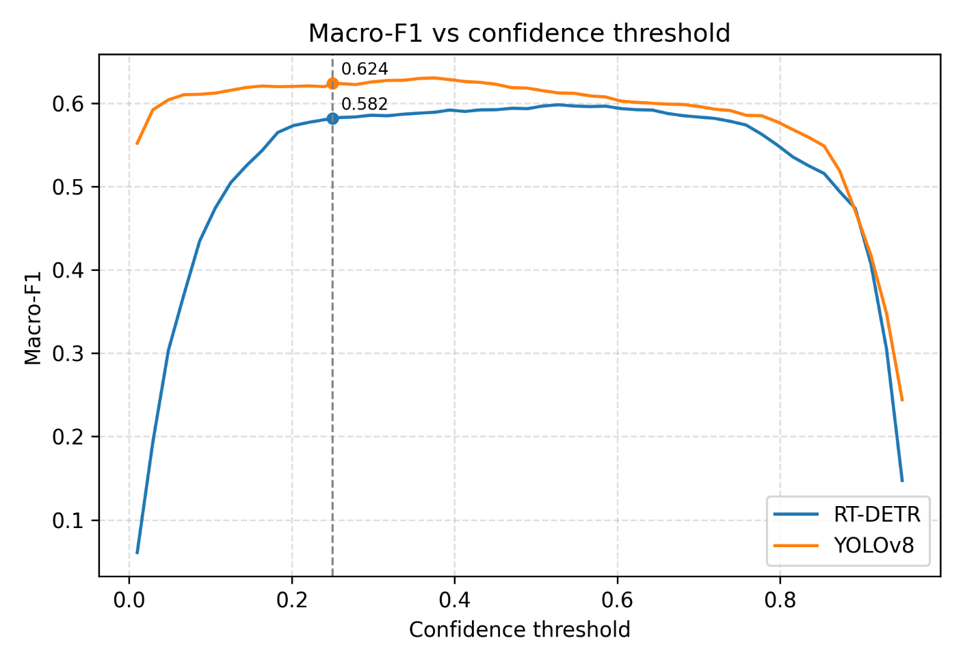
Figure 12 | Macro-F1 as a function of confidence threshold for YOLOv8-s and RT-DETR in the balanced scenario (seed 42), under the unified evaluation protocol. The dashed vertical line indicates the benchmark operating point used in the main evaluation (conf = 0.25). YOLOv8-s achieves higher and more stable macro-F1 across a wide range of thresholds, whereas RT-DETR shows moderate sensitivity to threshold selection, with its best performance reached at a higher confidence threshold (~0.53). The value at conf = 0.25 is consistent with the macro-F1 reported in the main benchmark tables, confirming the consistency between the fixed-threshold evaluation and the threshold-sweep analysis.
To explain the discrepancy between mAP and fixed-threshold macro-F1, a per-class diagnostic analysis was conducted at the benchmark operating point (conf = 0.25).
RT-DETR achieves a macro-F1 of 0.582, but produces a substantially higher number of false positives (804 predictions in total) than YOLOv8-s (642), resulting in lower precision. Terra sigillata remains highly reliable (F1 = 0.832), indicating strong visual separability.
By contrast, OW and RW show markedly lower precision (0.445 and 0.394), due to a high number of false positives (147 and 191), which reduces their F1 scores.
This indicates that the gap between mAP and macro-F1 is not due to localisation failure, but rather to confidence calibration and class confusion, especially between OW and RW.
Class | TP | FP | FN | Precision | Recall | F1
Terra sigillata | 178 | 46 | 26 | 0.795 | 0.873 | 0.832
OW | 118 | 147 | 94 | 0.445 | 0.557 | 0.495
RW | 124 | 191 | 153 | 0.394 | 0.448 | 0.419
Table 6 | Diagnostic analysis of RT-DETR at the benchmark operating point (conf = 0.25), balanced scenario (seed 42), computed using the unified evaluation protocol.
RT-DETR reaches its optimal macro-F1 at a higher confidence threshold (~0.53) than the benchmark operating point (0.25), indicating moderate sensitivity to confidence calibration. Its lower macro-F1 relative to YOLOv8-s therefore appears to stem less from localisation failure than from over-prediction and reduced class-level calibration at the fixed operating threshold.

Quantitative comparison: performance and compactness
To synthesise the compromise between predictive performance and model compactness, Table 7 provides a comparative view of all evaluated architectures. It gathers macro-F1 obtained in the imbalanced and balanced learning scenarios, model sizes (weights-only), and a complementary efficiency index. It provides a concise summary of how performance, robustness to class imbalance, and memory footprint jointly vary across model families.
For readability, we define a simple efficiency index as the ratio between predictive performance and model size, computed as macro-F1 divided by weights-only size (in MiB). This metric provides an approximate measure of performance per unit of memory and is intended to highlight performance–compactness trade-offs between architectures.
This index is not meant to be a universal metric, but rather a complementary indicator to be interpreted jointly with Pareto-front analysis. It is also of interest in the context of embedded solutions, as it makes it possible to assess the trade-off between performance and memory footprint for use during archaeological excavations by ceramologists or non-expert archaeologists.
Because RT-DETR shows a marked discrepancy between global detection metrics and fixed-threshold macro-F1 in Table 7, we further examine its class-wise behaviour and threshold sensitivity in the following section.

Model | Task | Size (MiB) | Macro-F1 (Imbalanced) | Macro-F1 (Balanced) | Efficiency Index (Balanced) | Pareto-optimal
QCNN | Classification (crops) | 0.21 | 0.9459 | 0.9221 | 4.39 | Yes
QCNN-VQE | Classification (crops) | 0.36 | 0.9503 | 0.9255 | 2.57 | Yes
MobileNetV3-Small | Classification (crops) | 5.93 | 0.9644 | 0.9417 | 0.159 | Yes
ResNet-18 | Classification (crops) | 42.72 | 0.9588 | 0.9352 | 0.022 | No
YOLOv8-s | Detection (end-to-end) | 21.47 | 0.8659 | 0.6217 | 0.0293 | No
YOLOv11-s | Detection (end-to-end) | 18.29 | 0.8599 | 0.6229 | 0.0341 | No
RT-DETR-L | Detection (end-to-end) | 63.22 | 0.5559 | 0.5818 | 0.0092 | No
Table 7 | Comparative performance and compactness of all evaluated architectures across the imbalanced and balanced scenarios. Macro-F1 values, model size (weights-only), efficiency index, and Pareto-optimal status are reported to summarise the trade-off between predictive performance and memory footprint.
While classification models maintain high macro-F1 scores across both settings, detection models exhibit a strong sensitivity to the evaluation scenario. In particular, YOLO-based detectors achieve high performance under realistic imbalanced conditions (macro-F1 ≈ 0.86), but exhibit a moderate decrease under balanced training (macro-F1 ≈ 0.62), reflecting increased confusion between common-ware classes (OW and RW) rather than a uniform degradation across all classes.
Table 7 highlights the trade-off between performance and compactness across model families. MobileNetV3-Small achieves the highest classification performance, while QCNN models maximise efficiency due to their extremely small size.
For detection models, macro-F1 scores are lower than in classification due to the added localisation challenge. YOLOv8-s and YOLOv11-s exhibit comparable performance under the balanced scenario, with nearly identical macro-F1 values (~0.62), while RT-DETR exhibits lower performance and efficiency, likely associated with higher false positive rates.
As a result, QCNN-based models and MobileNetV3-Small remain Pareto-optimal, while detection models are dominated in terms of efficiency.

Per-class detection performance and threshold sensitivity of RT-DETR
Additional per-class analyses were conducted to clarify the gap between global COCO-style detection metrics and fixed-threshold macro-F1. Under the COCO protocol, RT-DETR achieved AP50 values of 0.906, 0.777, and 0.811 for terra sigillata, OW, and RW, respectively, on the imbalanced dataset (mAP50 = 0.832), and 0.901, 0.697, and 0.746 on the balanced dataset (mAP50 = 0.781). These results indicate that RT-DETR detects all classes with reasonable localisation accuracy, with systematically stronger performance for terra sigillata. However, the fixed-threshold and threshold-sweep analyses reported in Figure 12 show that this localisation performance does not translate into equally strong class-balanced decisions at the benchmark operating point. The discrepancy between mAP and macro-F1 therefore reflects threshold sensitivity and persistent inter-class confusions rather than localisation failure alone, and this behaviour remains consistent across multiple seeds (Table 9).
At the fixed operating point used for end-to-end evaluation (IoU ≥ 0.5, conf = 0.25), RT-DETR-L reaches macro-F1 = 0.556 in the imbalanced scenario. This result is driven by a strong class imbalance in detection performance, with F1 = 0.851 for terra sigillata, but only 0.449 for OW and 0.368 for RW.
Dataset | AP50 (terra sigillata) | AP50 (OW) | AP50 (RW) | mAP50
Imbalanced | 0.906 | 0.777 | 0.811 | 0.832
Balanced | 0.901 | 0.697 | 0.746 | 0.781
Table 8 | Per-class RT-DETR detection performance under the COCO protocol on the imbalanced and balanced datasets. Per-class AP50 values are reported for terra sigillata, OW and RW, together with the global mAP50. These localisation-oriented metrics complement the end-to-end macro-F1 analyses reported in Figure 12, including both the fixed-threshold benchmark point and the confidence-threshold sweep.

Complementary analysis and typical errors
A cross-cutting analysis of results highlights a robust trend: the terra sigillata class is systematically the best recognised, for all models. In conditioned crop classification, its F1 exceeds 0.97 in both scenarios and reaches up to about 0.99 for some models. This high performance is explained by the visual specificity of terra sigillata (homogeneous red slip, surface gloss, generally smooth texture), which contrasts with the duller and more heterogeneous appearance of common wares. Thus, despite its low frequency in the imbalanced scenario, terra sigillata is a class with a strong discriminative signal that is captured by all evaluated architectures (CNNs, QCNNs, and end-to-end detectors).
By contrast, the distinction between oxidised common ware (OW) and reduced common ware (RW) is the main challenge of the problem. These two categories share many visual characteristics: unglazed surfaces, variable roughness, and sometimes intermediate hues (browns, greys, blackened zones), especially on altered fragments. The difficult distinction, even for a human expert, between an OW-category sherd with a beige hue and an RW-category sherd with a light grey hue, for example, is an instance of such confusions. In all our experiments, most residual errors correspond to OW-RW confusions, regardless of model family. To ensure that these observations are not dependent on a single training run, we evaluated the robustness of the results across multiple random seeds.

Robustness across random seeds
To evaluate the robustness of the benchmark results, key models were retrained using three different random seeds (42, 123 and 777). The results reported in Table 9 show very limited variability across runs for the classification models, with macro-F1 scores remaining within a narrow range (e.g., MobileNetV3-Small: 0.940 ± 0.002; ResNet-18: 0.936 ± 0.001). For detection models, macro-F1 values at the fixed operating point (conf = 0.25) remain stable across seeds for YOLO architectures (YOLOv8-s: 0.621 ± 0.005; YOLOv11-s: 0.621 ± 0.002), while RT-DETR-L exhibits higher variability (0.561 ± 0.023), reflecting increased sensitivity to class-level ambiguity and confidence calibration.
For detection models, robustness across seeds is reported using both standard COCO metrics (mAP50 and mAP50–95) and macro-F1 at the fixed benchmark threshold (conf = 0.25), ensuring consistency with the evaluation protocol used in the main benchmark tables and Figure 12.
Model | Metric | Seed 42 | Seed 123 | Seed 777 | Mean ± SD | 95% CI
MobileNetV3-Small | Macro-F1 (classification) | 0.9417 | 0.9377 | 0.9420 | 0.940 ± 0.002 | [0.934, 0.946]
QCNN-VQE | Macro-F1 (classification) | 0.9255 | 0.9394 | 0.9307 | 0.932 ± 0.007 | [0.914, 0.949]
ResNet-18 | Macro-F1 (classification) | 0.9352 | 0.9372 | 0.9346 | 0.936 ± 0.001 | [0.932, 0.939]
YOLOv8-s | mAP50 | 0.8668 | 0.8732 | 0.8714 | 0.870 ± 0.003 | [0.862, 0.879]
YOLOv8-s | mAP50-95 | 0.7542 | 0.7660 | 0.7596 | 0.760 ± 0.006 | [0.745, 0.775]
YOLOv8-s | Macro-F1 (detection) | 0.6217 | 0.6275 | 0.6151 | 0.621 ± 0.005 | [0.609, 0.634]
YOLOv11-s | mAP50 | 0.8741 | 0.8779 | 0.8820 | 0.878 ± 0.004 | [0.868, 0.888]
YOLOv11-s | mAP50-95 | 0.7641 | 0.7669 | 0.7687 | 0.767 ± 0.002 | [0.762, 0.772]
YOLOv11-s | Macro-F1 (detection) | 0.6229 | 0.6174 | 0.6218 | 0.621 ± 0.002 | [0.615, 0.627]
RT-DETR-L | mAP50 | 0.7813 | 0.8087 | 0.8137 | 0.801 ± 0.018 | [0.756, 0.846]
RT-DETR-L | mAP50-95 | 0.6871 | 0.7044 | 0.7069 | 0.699 ± 0.011 | [0.672, 0.726]
RT-DETR-L | Macro-F1 (detection) | 0.5818 | 0.5642 | 0.5364 | 0.561 ± 0.023 | [0.504, 0.619]
Table 9 | Multi-seed evaluation (seeds 42, 123, 777) of classification and detection models. For classification, macro-F1 is reported under the balanced crop-based scenario. For detection, COCO metrics (mAP50 and mAP50–95) and macro-F1 at a fixed confidence threshold (conf = 0.25) are provided. Detection macro-F1 values are computed using the unified evaluation protocol (IoU ≥ 0.5, one-to-one matching). Mean and standard deviation (SD) are computed across seeds, with corresponding 95% confidence intervals.
Importantly, the ranking of the architectures remains unchanged across seeds, confirming that the conclusions of the benchmark do not depend on a particular random initialization.

Illustrative fusion correction (RT-DETR + QCNN, imbalanced scenario)
To exploit the observed complementarity between end-to-end detectors and specialised crop classifiers, we evaluated a post-hoc fusion strategy in which detection proposals of RT-DETR-L are reclassified by a QCNN when the latter provides higher confidence and better inter-class consistency. This fusion does not modify box localisation and does not involve any retraining of the detector; it consists only of substituting the predicted class when the crop classifier is deemed more reliable.
The analysis was conducted on the imbalanced scenario, from end-to-end predictions of RT-DETR-L (IoU >= 0.5, confidence threshold identical to standard evaluation). For each detected object, we compared the RT-DETR score and the QCNN score on the corresponding crop, and computed the confidence gain associated with a possible substitution.
As shown in Figure 13a, a representative case of errors observed for RT-DETR-L in the imbalanced scenario. In this image, the detector localises two sherds correctly but classifies both as terra sigillata with high confidence (score ~ 0.94-0.95). From a ceramological perspective, these fragments correspond to reduced common wares (RW), characterised by a matte grey-black fabric and the absence of red slip.
When the same objects are cropped from the detection boxes and analysed by QCNN, the classifier predicts class RW with higher confidence (score ~ 0.98) while assigning very low probability to terra sigillata. The post-hoc fusion then substitutes the class proposed by RT-DETR with that of QCNN, leading to an effective correction of the final prediction without modifying localisation.
This case highlights a situation where a high detector score (~0.95) does not correspond to a correct prediction, due to poor calibration of the classification head on visually close textures. QCNN, specialised on isolated-object crops, relies more on micro-variations of texture and surface reflectance, which allows it to correct a terra sigillata-vs-RW confusion. The score gain associated with the final decision is of the order of +0.03 in absolute value, but more importantly corresponds to a semantic correction of an obvious error.
This example is not a global statistical measure of end-to-end improvement, but qualitatively illustrates the fusion mechanism made possible by complementarity between a generalist detector and a specialised crop classifier, particularly relevant for the structurally dominant OW-RW confusions in the imbalanced context.
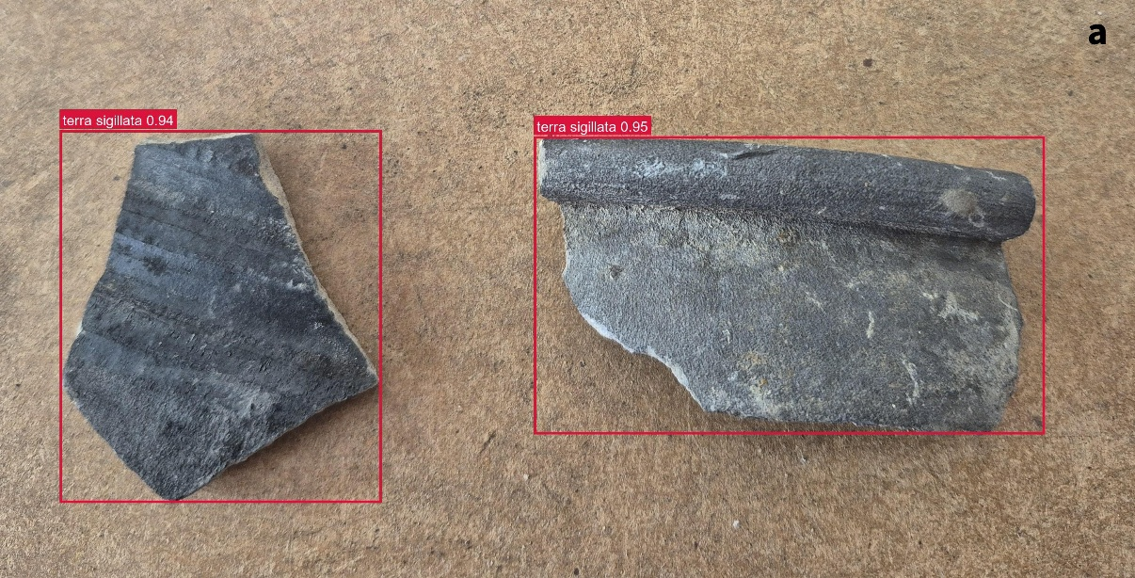
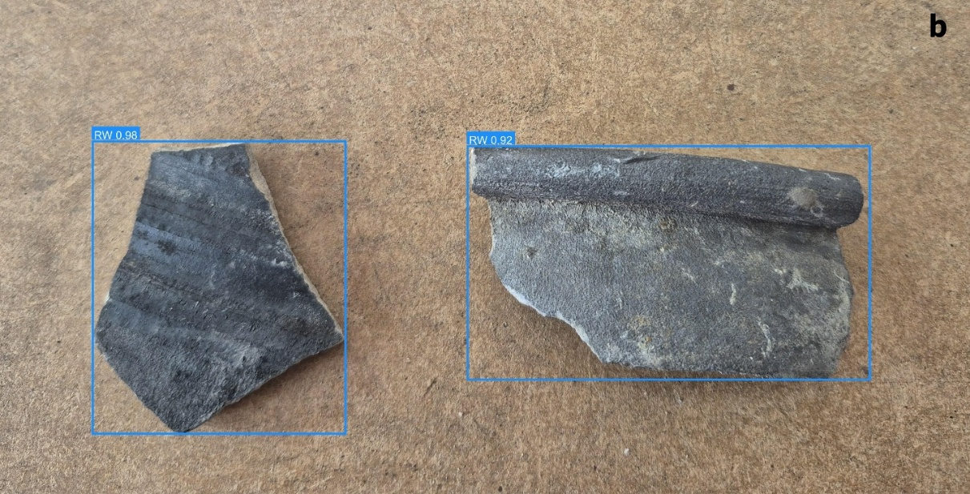
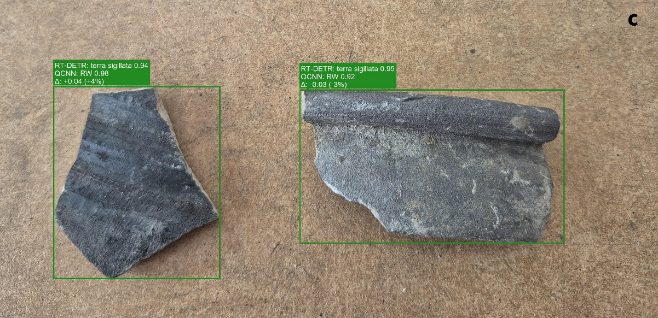

Figure 13 | Example of correction by fusion RT-DETR + QCNN (imbalanced scenario).
(a) Output of RT-DETR-L alone: both sherds are accurately localised but misclassified as terra sigillata with high confidence (0.94–0.95). From a ceramological perspective, these fragments correspond to reduced common wares (RW), characterised by a matte grey–black fabric and the absence of red slip.
(b) QCNN quantum–classical classification applied to crops extracted from the RT-DETR-L bounding boxes. The displayed class labels and confidence scores (RW 0.98 and 0.92) correspond to QCNN predictions and are consistent with expert interpretation, identifying both sherds as RW.
(c) Post-hoc fusion result: QCNN reclassification replaces the incorrect RT-DETR-L class labels while preserving the original localisation, yielding the correct final prediction (RW) with higher confidence (0.98).
This illustrative example highlights the operational potential of a post-hoc fusion strategy to correct specific OW–RW confusions without modifying localisation or retraining the detector.

Discussion
This comparative study highlights the strengths and limitations of different model families applied to Gallo-Roman ceramic classification and provides both methodological and operational insights for archaeological practice. By explicitly distinguishing conditioned classification on isolated objects (crops) and end-to-end detection on full images, our results show that performance depends strongly on the task definition and on each architecture’s inductive biases.
Beyond model ranking alone, the main result of this study is methodological: the same archaeological classification problem yields markedly different conclusions depending on whether the task is framed as conditioned crop classification or full end-to-end detection. This distinction is critical for interpreting AI performance in realistic heritage workflows.
The contribution is not merely benchmarking, but a methodological demonstration that the evaluation protocol fundamentally changes the interpretation of AI performance in archaeology.
A key methodological outcome of this work is that model behaviour must be interpreted relative to task definition. Crop-based classification and end-to-end detection cannot be treated as interchangeable benchmarks, even when derived from the same annotated corpus. The former measures recognition under perfect localisation, whereas the latter evaluates the full operational chain. This distinction directly reflects ceramological practice: cropped images correspond to a fine-grained analysis stage aimed at the precise identification of individual sherds, whereas full images containing multiple fragments relate to the initial sorting phase into broad categories. The most diagnostically relevant sherds are then examined individually to refine their identification and improve the accuracy of chronological attribution.
From an archaeological perspective, the results confirm that AI tools can reach high accuracy for identifying major ceramic technical categories, including under realistic conditions of strong class imbalance. Paradoxically, the rarest class (terra sigillata) is the best recognised by all models. In conditioned crop classification, terra sigillata F1 reaches 0.987469 for MobileNetV3-Small, 0.984925 for ResNet-18, 0.979798 for QCNN-VQE and 0.975124 for QCNN in the imbalanced scenario, and remains above 0.960591 in all cases in the balanced scenario. This result is consistent with ceramological expertise: terra sigillata stands out clearly through its homogeneous, glossy red slip, which constitutes a strongly discriminative visual signal. Learning curves (Supplementary Material) further indicate stable convergence without marked overfitting, reinforcing the robustness of comparisons between the imbalanced and balanced scenarios.
By contrast, in some cases, the distinction between oxidised common ware (OW) and reduced common ware (RW) remains the main challenge, both for human expertise and for automated models. In conditioned crop classification, F1 for OW and RW ranges respectively between 0.917051–0.942584 and 0.945652–0.963222 in the imbalanced scenario, and between 0.879433–0.907834 and 0.926391–0.939227 in the balanced scenario for the best classifiers. Residual errors are almost exclusively concentrated on OW–RW confusions, reflecting the visual proximity of these categories (un-slipped pastes, coarse textures, and occasionally intermediate hues resulting from incomplete firing, use-related wear, ancient events, or post-depositional weathering).
From a heritage science perspective, these results also provide insight into the technological structure of the ceramic categories themselves. The consistently high recognition rate of terra sigillata can likely be explained by the relative homogeneity of this production. In Roman Gaul, these ceramics were predominantly produced in large specialised centres (La Graufesenque, Lezoux, Argonne) using standardised techniques. However, Argonne productions are easily identifiable due to their typically orange colour (not represented here as they fall outside the chronological scope). By contrast, terra sigillata from La Graufesenque (southern France) and Lezoux (Puy-de-Dôme, central France) exhibit strong visual similarities, making their identification complex in certain contexts even for human experts. Firing mode C, characteristic of these productions, involves radiant heat circulation that enables the vitrification of the slip, producing highly homogeneous and visually distinctive surfaces.
By contrast, oxidising common wares (mode A) and reducing common wares (mode B) originate from a wider variety of workshops, often with more rudimentary firing structures. Their colour depends largely on post-firing conditions (oxygen input through kiln opening, carbon input through kiln closure). They also encompass a range of functional uses (storage, preparation, cooking). In the case of light-coloured common wares (OW), accidental fire events of varying intensity, relatively frequent in Antiquity, as well as handling accidents, may alter the surfaces, making them visually similar to reducing wares. These technological and functional factors help explain the visual proximity between OW and RW and therefore the persistent confusions observed both for human experts and for automated models.
When constructing an image dataset, a ceramic specialist photographing batches of sherds would naturally reproduce a similar structure: common wares, which are abundant, would frequently appear in groups of fragments within the same image, whereas fine wares, which are less numerous but easier to identify, would more often be represented by isolated fragments. The imbalanced scenario used in this study reflects this field reality, whereas the balanced scenario corresponds to a controlled learning setup in which the proportions of fine and common wares are adjusted to better evaluate the sensitivity of the models to class imbalance.
The notion of class balancing differs between classification and detection tasks due to their structural differences. While classification operates on isolated object crops, detection involves full images where class distributions are coupled with spatial context.
Consequently, balancing strategies are applied at different levels and are not strictly equivalent. This distinction is essential for interpreting performance differences across tasks.
In end-to-end detection, contrasts are more pronounced. YOLOv8-s and YOLOv11-s reach macro-F1 values of 0.865957 and 0.859951 in the imbalanced scenario, and 0.62 in the balanced scenario for both YOLOv8-s and YOLOv11-s, while maintaining strong localisation performance (mAP@0.5 = 0.893256 and 0.892271 in the imbalanced scenario). RT-DETR-L, by contrast, remains significantly weaker on the end-to-end decision metric, with macro-F1 ≈ 0.556 (imbalanced) and ≈ 0.582 (balanced), despite strong localisation performance under the COCO protocol (mAP@0.5 = 0.831693 and 0.781, respectively). This contrast illustrates that a strong COCO detection score does not necessarily translate into reliable class decisions at a fixed operating point. While AP integrates performance over the full precision–recall curve, the end-to-end macro-F1 reflects class-balanced decisions at a single threshold, making it more sensitive to inter-class confusion when discrimination relies on fine-grained surface textures.
The discrepancy between high mAP values and lower macro-F1 scores arises from the fundamental difference between ranking-based and decision-based evaluation metrics. While mAP evaluates the global ordering of predictions across confidence thresholds, macro-F1 depends on a fixed operating point.
In the balanced seed-42 diagnostic analysis at the benchmark operating point (conf = 0.25), RT-DETR produces more detections than YOLOv8-s (804 vs 642), resulting in substantially more false positives. This leads to lower precision and reduced F1-score despite acceptable ranking performance.
Conversely, YOLO models exhibit more conservative prediction behaviour, yielding a better precision–recall balance and higher macro-F1.
All end-to-end detection macro-F1 values discussed here, including the main benchmark tables, the RT-DETR diagnostic analysis, and the multi-seed comparison, were computed using the same unified evaluation protocol, whereas COCO-style detection metrics (mAP) remain unchanged. This distinction is critical for interpreting detection performance in applied archaeological contexts, where decisions must be taken at fixed operating points.
The qualitative analysis highlights a structural complementarity between detectors and specialised classifiers. Detectors are effective for object localisation, whereas crop-based classifiers provide more stable class decisions. This observation motivates a lightweight post-hoc fusion strategy (detection followed by reclassification), in which the bounding boxes proposed by a detector are reclassified by a QCNN whenever the latter exhibits higher confidence. The quantitative example presented in the Results section (Figure 13c) illustrates an effective semantic correction: RT-DETR assigns a high confidence score (0.94–0.95) to an incorrect class (terra sigillata), whereas the QCNN correctly identifies the RW class with higher confidence (0.98), without any modification of localisation.
Another observation from our experiments is that terra sigillata is consistently well recognized across all tested architectures. Beyond its implications for automated classification, this finding highlights the potential value of such visual signatures for the design of future studies combining artificial intelligence and ceramic analysis.
A second observation concerns the practical relevance of crop-based classification for ceramological workflows. While end-to-end detection approaches aim to automatically locate objects within complex scenes, much of ceramological work in practice focuses on the analysis of already isolated fragments. In this context, the ability of classification models to recognise ceramic groups from simple images of individual sherds may correspond more closely to the needs of specialists. The results obtained here show that such models remain highly effective even under strong class imbalance.
This perspective may be relevant for future work on rarer or less well documented productions. For example, in many Romanised urban contexts of northern Gaul during the late first century AD, certain productions such as lead-glazed wares represent only a very small proportion of ceramic assemblages. In such situations, AI-based tools could in principle provide probabilistic support when specialists encounter categories for which reference material is limited, although this application was not evaluated directly in the present study.
From a heritage-science perspective, the most consistent result of this benchmark is not only that some models outperform others, but that the three ceramic categories are not equally legible in standard photographs. Across model families and evaluation settings, terra sigillata is systematically the easiest class to recognise, which is consistent with its more homogeneous and visually distinctive surface appearance. By contrast, OW and RW remain substantially more confusable, suggesting that their technological and taphonomic variability is less fully captured by RGB imagery alone.
In this sense, the benchmark contributes not only to computer-vision evaluation, but also to the operational understanding of which ceramic distinctions are likely to be robustly supported by image-based decision tools in field or post-excavation contexts.
Beyond model comparison, the study suggests that image-based AI captures some ceramic distinctions more robustly than others: terra sigillata appears consistently identifiable from photographs, whereas OW and RW remain more ambiguous. This result is relevant for heritage workflows, as it helps define where AI-assisted sorting is most reliable and where expert review remains essential.
The proposed protocol is reusable for other datasets (e.g., small objects, bones, or ecofacts), although the numerical results remain specific to the studied corpus and its empirical validity must still be tested on independent datasets. Its main contribution lies in highlighting the difference between recognition on isolated objects and performance under real end-to-end conditions, a distinction that is essential for realistic evaluation in heritage science. In practice, archaeologists examine artefacts as part of an assemblage but typically carry out identification at the individual level, which directly corresponds to the protocol adopted in this study.
With regard to PQC models, the results presented do not demonstrate any quantum computational advantage and do not suggest that QCNN-based models are universally superior to classical CNNs. All experiments were performed in a classical simulation setting, and the main insight is instead architectural: hybrid quantum-classical heads can retain competitive classification performance under strong model-size constraints. In this sense, their relevance in the present benchmark is primarily linked to compactness and efficiency trade-offs rather than absolute accuracy. We do not claim, at this stage, that the QCNN or QCNN-VQE head offers a stable advantage under specific data-noise regimes, extreme low-data conditions, or real quantum hardware constraints. These questions remain open and fall outside the scope of the present benchmark.
QCNN-based models emerge here as compact and competitive baselines rather than performance-dominant alternatives, supporting their interest for efficiency-oriented benchmarking but not as evidence of quantum advantage.
Several limitations and extensions follow from this study. First, it would be necessary to evaluate the robustness and generalisation of the models on data from different sites and excavation campaigns, in order to better account for the diversity of archaeological contexts (stratigraphy, lighting, acquisition, and preservation conditions). Second, methodological rigour could be strengthened by introducing an independent frozen test set or cross-validation performed at the level of source images. Finally, from an operational standpoint, integrated pipelines combining detection and specialised classification appear particularly promising for archaeological applications.
These observations highlight that the behaviour of the models reflects not only algorithmic performance but also the technological organisation and visual variability of the ceramic productions themselves.
AI applications to archaeological ceramics are not limited to photographed sherd recognition. Recent work such as PyPotteryLens has also addressed the automated digitisation of published pottery drawings through an open-source deep learning framework [35]. Unlike such documentary-oriented approaches, our study focuses on photographed sherds and on a controlled benchmark separating crop-based classification from end-to-end detection.
In summary, this work does not introduce a new architecture, but establishes a reproducible evaluation framework for comparing crop-based classification and end-to-end detection on archaeological ceramics. The study shows that very high recognition performance on isolated crops does not directly translate to full-image deployment conditions, and that the gap is driven by localisation, thresholding and false-positive behaviour. From a heritage-science perspective, the results also confirm that visually distinctive classes such as terra sigillata are more reliably captured from photographs than more heterogeneous categories such as OW and RW.
Finally, this study suggests that the relevance of AI architectures closely depends on the phase of the archaeological reasoning process considered. Single-stage detection models (such as YOLO) or those based on global contextual analysis (such as DETR) appear well suited to the initial stages of observation and sorting, where multiple fragments must be localized and categorized within the same scene. By contrast, they are less suited to fine-grained identification tasks, which rely on the detailed analysis of an isolated artefact.
Conversely, classification models operating on cropped objects more directly correspond to expert ceramological practices, in which identification relies on the precise examination of the visual characteristics of an individual sherd. This distinction reflects the reality of archaeological work, where analysis typically proceeds in two stages: an initial phase of global sorting within an assemblage, followed by a phase of individual diagnosis.
In this context, architectures should not be considered as competing, but rather as complementary, each paradigm addressing a specific operational need. This perspective opens the way to hybrid pipelines combining detection and specialised classification, better aligned with field practices.
In practice, the work of the ceramologist often consists in identifying an element within a set, and then refining its identification at the individual level. While broad technical categories are generally well recognised, the identification of specific productions, particularly in the Gallo-Roman context, requires more refined expertise, for which specialised classification models may provide useful support.

Data availability
The datasets generated and/or analysed during the current study are available from the corresponding author upon reasonable request.

Code availability
The code used for data preprocessing, model training, evaluation, and figure generation is publicly available in a GitHub repository: https://github.com/CChaid80/archeo_benchmark

Acknowledgments
This research received no specific grant from any funding agency in the public, commercial, or not-for-profit sectors.

Author contributions
CC and HTI designed the study, annotated the corpus, developed the training pipelines and conducted the experiments. CC and HTI analysed the results. CC and HTI wrote the first version of the manuscript. All authors reviewed and approved the final version of the manuscript.

Competing interests
The authors declare no competing interests.

References

- Chaidron, C. & Dubois, S. De La Tene finale à l’époque augustéenne : premiers apports du monde méditerranéen dans le nord-ouest de la Gaule… In: SFECAG: Actes du Congrés d’Amiens (2013), 13-63.
- Chaidron, C. & Lermenier, S. Multispectral imaging and artificial intelligence for archaeology: first results and first projects. SCIRES-IT 12(2), 87-98 (2022).
- Willems, S., Chaidron, C. & Borgers, B. Don’t judge coarse wares by their ugliness… The benefits of fabric analysis and the use of supervised deep learning algorithms for the study of Roman pottery (FabricAI). Bollettino di Archeologia Online, Supplemento 1, Anno XV, 73-96 (2024). https://doi.org/10.60978/BAO_XV_Suppl_1_2024.
- Chaidron, C. & Binet, E. La couche 625 de la rue Lamartine : un ensemble céramique de référence à Amiens (Somme) pour la période flavienne. Revue Archéologique de Picardie, n°1/2 (2006), 5-25. https://www.persee.fr/doc/pica_0752-5656_2006_num_1_1_2427.
- Makridis, M. & Daras, P. Automatic classification of archaeological pottery sherds. J. Comput. Cult. Herit. 5, 4, Article 15 (December 2012), 2013, 21 pages. https://doi.org/10.1145/2399180.2399183
- Anichini, F. et al. The automatic recognition of ceramics from only one photo: The ArchAIDE app. Journal of Archaeological Science: Reports 36, 102788 (2021). https://doi.org/10.1016/j.jasrep.2020.102788.
- Pawlowicz, L. M. & Downum, C. E. Applications of deep learning to decorated ceramic typology and classification: A case study using Tusayan White Ware from Northeast Arizona. Journal of Archaeological Science 130, 105375 (2021). https://doi.org/10.1016/j.jas.2021.105375.
- Ling, Z., Delnevo, G., Salomoni, P. & Mirri, S. Findings on machine learning for identification of archaeological ceramics: a systematic literature review. IEEE Access 12, 100167-100185 (2024). https://doi.org/10.1109/ACCESS.2024.3429623.
- Hu, Y., Wu, S., Ma, Z. et al. Integrating deep learning and machine learning for ceramic artifact classification and market value prediction. npj Herit. Sci. 13, 306 (2025). https://doi.org/10.1038/s40494-025-01886-6.
- Redmon, J., Divvala, S., Girshick, R. & Farhadi, A. You Only Look Once: Unified, Real-Time Object Detection. In: Proceedings of CVPR (2016). https://doi.org/10.1109/CVPR.2016.91.
- Bochkovskiy, A., Wang, C.-Y. & Liao, H.-Y. M. YOLOv4: Optimal Speed and Accuracy of Object Detection. arXiv:2004.10934 (2020).
- Ultralytics. YOLOv8 - Official Documentation. https://docs.ultralytics.com/ (2023). Accessed 21 Dec 2025.
- Ultralytics. YOLOv11 - Official Documentation. https://docs.ultralytics.com/models/YOLOv11/ (2024). Accessed 21 Dec 2025.
- Carion, N. et al. End-to-End Object Detection with Transformers (DETR). arXiv:2005.12872 (2020).
- Zhao, Y. et al. DETRs Beat YOLOs on Real-time Object Detection (RT-DETR). arXiv:2304.08069 (2023).
- Cong, I., Choi, S. & Lukin, M. D. Quantum convolutional neural networks. Nature Physics 15, 1273-1278 (2019). arXiv:1810.03787v2
- Biamonte, J. et al. Quantum machine learning. Nature 549, 195-202 (2017). https://doi.org/10.1038/nature23474.
- Peruzzo, A. et al. A variational eigenvalue solver on a photonic quantum processor. Nature Communications 5, 4213 (2014). https://doi.org/10.1038/ncomms5213.
- McClean, J. R. et al. Barren plateaus in quantum neural network training landscapes. Nature Communications 9, 4812 (2018). https://doi.org/10.1038/s41467-018-07090-4.
- Cerezo, M. et al. Variational quantum algorithms. Nature Reviews Physics 3, 625-644 (2021). https://doi.org/10.1038/s42254-021-00348-9.
- Wei, S. A quantum convolutional neural network on NISQ devices. AAPPS Bulletin 32, 1 (2022). https://doi.org/10.48550/arXiv.2104.06918.
- Long, C. et al. Hybrid quantum-classical-quantum convolutional neural networks. Sci Rep 15, 31780 (2025). https://doi.org/10.1038/s41598-025-13417-1.
- Bergholm, V. et al. PennyLane: Automatic differentiation of hybrid quantum-classical computations. arXiv:1811.04968 (2018).
- Picon, M. Introduction à l’étude technique des céramiques sigillées de Lezoux. Dijon (1973).
- Chen, W. et al. A survey on imbalanced learning: latest research, applications and future directions. Artif Intell Rev 57, 137 (2024). https://doi.org/10.1007/s10462-024-10759-6.
- Miftahushudur T, Sahin HM, Grieve B, Yin H. A Survey of Methods for Addressing Imbalance Data Problems in Agriculture Applications. Remote Sensing. 2025; 17(3):454. https://doi.org/10.3390/rs17030454
- Dubois, S. & Binet, E. La céramique a Amiens (Somme) dans la deuxième moitié du Ier siècle, d’après les fouilles du Palais des Sports. In: Rivet, L. (ed.), SFECAG: Actes du Congrés de Dijon (Marseille: SFECAG, 1996), 331-352.
- He, H. & Garcia, E. A. Learning from imbalanced data. IEEE Transactions on Knowledge and Data Engineering 21(9), 1263-1284 (2009). https://doi.org/10.1109/TKDE.2008.239.
- Lin, T.-Y. et al. Focal Loss for Dense Object Detection. In: Proceedings of ICCV (2017). arXiv:1708.02002v2.
- Cui, Y. et al. Class-Balanced Loss Based on Effective Number of Samples. In: Proceedings of CVPR (2019). arXiv:1901.05555.
- Ren, J. et al. Balanced Meta-Softmax for Long-Tailed Visual Recognition. In: Advances in Neural Information Processing Systems (NeurIPS) (2020). arXiv:2007.10740
- He, K., Zhang, X., Ren, S. & Sun, J. Deep Residual Learning for Image Recognition. In: Proceedings of CVPR (2016), 770-778. https://doi.org/10.1109/CVPR.2016.90
- Howard, A. et al. Searching for MobileNetV3. In: Proceedings of ICCV (2019). arXiv:1905.02244v5
- Loshchilov, I. & Hutter, F. Decoupled Weight Decay Regularization (AdamW). arXiv:1711.05101; ICLR (2019).
- Cardarelli, L. PyPotteryLens: An open-source deep learning framework for automated digitisation of archaeological pottery documentation, Digital Applications in Archaeology and Cultural Heritage, Volume 38 (2025). https://doi.org/10.1016/j.daach.2025.e00452.

