Bayesian Piecewise Exponential Survival Model
Overall Survival in Clear-Cell Renal Cell Carcinoma (TCGA-KIRC)
STAT 638 – Group 6 · Working document

Contents

1. Overview and status
This document describes the Bayesian piecewise exponential model, one of the three survival-time models the group is comparing (Weibull, piecewise exponential and log-normal/log-logistic). It covers the data, the model, how the priors were derived from the group's shared prior specification, how the posterior was sampled, the convergence diagnostics, and the results for a reference 60-year-old patient. Section 10 reports the standardized survival curves and the model-comparison metrics against the Weibull model.
The piecewise exponential model divides follow-up time into intervals and assumes a constant hazard within each interval. Unlike the Weibull, which forces the hazard to follow one smooth increasing or decreasing curve, the piecewise model lets the baseline hazard move up or down freely between intervals. It is therefore a useful check on whether the conclusions depend on the shape assumed for the hazard over time.
Component | Status | Section
Data preparation and long-format split (days / 365) | Complete | 2
Model specification and likelihood | Complete | 3
Prior derivation (shared with Weibull) | Complete | 4
Metropolis-within-Gibbs sampler | Complete | 5
Convergence diagnostics | Complete | 6
Posterior hazard ratios and baseline hazards | Complete | 7
Study A: survival at reference age 60 | Complete | 8
Prior sensitivity analysis | Complete | 9
Harmonization with group conventions | Complete | 10.1
Study B: standardized curves (stage, age, grade) | Complete | 10.2–10.5
PSIS-LOO, Brier score, IBS, comparison with Weibull | Complete | 10.6–10.8
Three-model comparison (with log-normal / log-logistic) | Pending | 10.8

2. Data
The analysis uses the TCGA-KIRC clinical file restricted to primary-tumor samples. After the group's cleaning (removing duplicate tissue samples, 2 patients with inconsistent stage coding and 2 with zero follow-up), 529 patients remained. A further 8 patients with histologic grade GX (5) or missing grade (3) were excluded, because grade is a model covariate. The final cohort is 521 patients with 173 deaths (33.2%); the remaining 348 patients (66.8%) are right-censored.
For patient i, the outcome is the pair (tᵢ, δᵢ), where tᵢ is the overall-survival time in years and δᵢ = 1 if death was observed and 0 if the patient was alive at last follow-up. Survival time was converted from days to years by dividing by 365, the same convention as the group's Weibull model.

Covariates
Variable | Coding | Reference level | Distribution (n = 521)
Pathologic stage | Indicators for Stage II, III, IV | Stage I | I: 261 (45 deaths), II: 54 (13), III: 122 (48), IV: 84 (67)
Age at diagnosis | Age10 = (age − 60) / 10 | Age 60 | Range 26–90, median 60, mean 60.6
Sex | Male = 1, Female = 0 | Female | Male: 339 (110 deaths), Female: 182 (63)
Histologic grade | Indicators for G3, G4 | G1–G2 combined | G1–G2: 241 (45 deaths), G3: 205 (73), G4: 75 (55)

Grades G1 and G2 were combined because only 13 patients were G1 and none of them died, so a separate G1 effect cannot be estimated. Death rates rise sharply with grade (19%, 36% and 73%), which motivated including grade as a secondary covariate measuring tumor aggressiveness. Age is centered at 60 and scaled per decade so that the reference patient is a realistic one and the age coefficient is on a scale comparable to the others.

3. Model specification

3.1 Piecewise constant hazard
Follow-up is divided into K = 5 intervals with cutpoints at 1, 2, 3 and 5 years: 0–1, 1–2, 2–3, 3–5 and 5+ years. The cutpoints were chosen so that every interval contains enough deaths to estimate its own hazard (48, 32, 29, 39 and 25 deaths). Everything after 5 years forms a single interval because only about two deaths occur after year 8.
Within interval k, the hazard of patient i is a baseline hazard multiplied by a patient-specific factor:
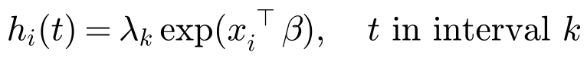
The model has two kinds of parameters:
- Baseline hazards λ₁, …, λ₅ describe when risk is high. Each λₖ is the death rate per person-year of the reference patient (Stage I, age 60, female, G1–G2) in interval k.
- Regression coefficients β describe who is at higher risk. Each e^β is a hazard ratio that multiplies the baseline hazard by the same factor in every interval (the proportional-hazards assumption).

3.2 Survival function
Let eᵢₖ(t) be the time patient i spends in interval k up to time t (for example, by t = 5 years the times are 1, 1, 1, 2 and 0). The cumulative hazard is the sum of each interval's hazard multiplied by the time spent in it, so
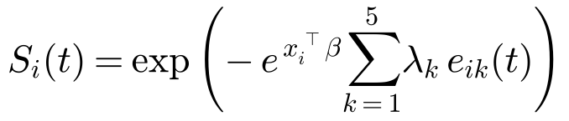
Because the hazard is constant within each interval, the survival curve is a sequence of exponential pieces joined at the cutpoints, which is why the plotted curves show small bends at 1, 2, 3 and 5 years.

3.3 Likelihood with right censoring
A patient who died contributes the density at the death time, which is the hazard at that time multiplied by the probability of surviving to it. A censored patient contributes only the probability of surviving beyond the censoring time:

3.4 The Poisson trick
To fit the model, each patient's record is split into one row per interval they entered, using survSplit() from the survival package. Each row r records the interval k(r), the exposure eᵣ (years at risk in that interval) and dᵣ, which equals 1 only if the patient died in that interval. A patient followed for 4.13 years without dying contributes four rows with exposures 1, 1, 1 and 1.13, all with dᵣ = 0. The 521 patients produce 1,746 rows and still 173 deaths.
With the data in this form, the censored likelihood above is proportional to a Poisson likelihood in which dᵣ is a count with mean λₖ eᵣ exp(xᵣᵀβ):
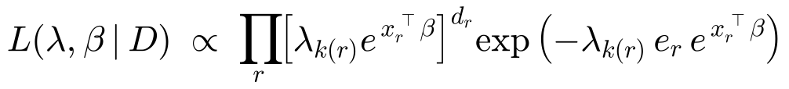
The two likelihoods differ only by a constant (the log-exposure of each death), so they give the same posterior. The Poisson form is what makes the baseline hazards conjugate to a Gamma prior (Section 5.2).

3.5 Posterior
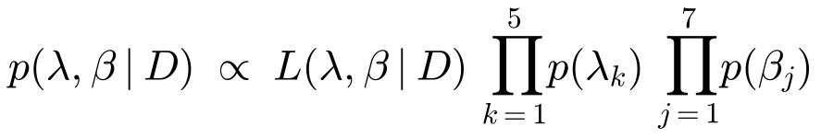

4. Prior specification
To make the three survival models comparable, the group agreed on one set of prior beliefs, originally built for the Weibull model. The goal was that the models differ only in the assumed survival-time distribution, not in prior information. The piecewise exponential model has different parameters from the Weibull: its coefficients are log hazard ratios rather than accelerated-failure-time coefficients, and its baseline is five interval hazards rather than a scale β₀ and shape k. The Weibull priors were therefore translated into this model's parameters rather than copied. The calculations are in PWE_Prior_Derivation.R, run once with set.seed(638) and 200,000 Monte Carlo draws.

4.1 Regression coefficients
The group write-up specifies, for each covariate, a hazard-ratio center taken from published ccRCC studies and a deliberately broad plausible range. Each range is treated as an approximate 95% prior interval on the log scale, giving a normal prior for the log hazard ratio:
Dividing the width of the range by 2 × 1.96 = 3.92 converts a 95% interval into one standard deviation. Because Age10 measures decades, the per-year age hazard ratio is multiplied by 10 on the log scale. For example:
- Stage II: μ₀ = log(1.5) = 0.405 and σ₀ = (log 2.8 − log 0.8) / 3.92 = (1.030 + 0.223) / 3.92 = 0.320, so β₂ ~ N(0.405, 0.320²).
- Age: μ₀ = 10 × log(1.04) = 0.392 and σ₀ = 10 × (log 1.06 − log 1.02) / 3.92 = 0.098.
The Weibull script applies one further step, β = −log(HR)/k, because the Weibull coefficients act on survival time: a higher hazard means a shorter scale, hence the minus sign, and the size of the effect depends on the shape k. In the piecewise exponential model the coefficient multiplies the hazard directly, so the log hazard ratio is the coefficient and that step is skipped:
Both sets of priors encode the same belief about each hazard ratio. As a check, each Weibull prior mean is close to −μ₀ / 1.2, where 1.2 is the median prior value of k.
Coefficient | HR center (plausible range) | Piecewise prior: β = log HR | Weibull prior: β = −log HR / k
β₂ Stage II vs I | 1.5 (0.8–2.8) | N(0.405, 0.320²) | N(−0.343, 0.278²)
β₃ Stage III vs I | 2.5 (1.3–4.8) | N(0.916, 0.333²) | N(−0.773, 0.307²)
β₄ Stage IV vs I | 10 (4–25) | N(2.303, 0.467²) | N(−1.939, 0.496²)
β_A Age, per 10 years | 1.04 per year (1.02–1.06) | N(0.392, 0.098²) | N(−0.330, 0.098²)
β_S Male vs female | 1.0 (0.67–1.5) | N(0, 0.206²) | N(0, 0.175²)
β_G3 G3 vs G1–G2 | 1.4 (0.9–2.2) | N(0.336, 0.228²) | N(−0.283, 0.198²)
β_G4 G4 vs G1–G2 | 2.5 (1.4–4.5) | N(0.916, 0.298²) | N(−0.773, 0.279²)

The stage, age and sex centers come from published TCGA and SEER analyses of ccRCC [1–4]. The grade centers lie between a large SEER analysis of 58,372 patients, which reported multivariable overall-survival hazard ratios of 1.31 for grade III and 2.06 for grade IV relative to grade I [5], and a TCGA analysis that reported stage-adjusted hazard ratios of 1.48 for grade 3 and 2.83 for grade 4 relative to grade 2 [6]. In SEER, grade II showed no overall-survival difference from grade I (HR 1.02), which supports combining G1 and G2 as one reference group.

4.2 Baseline hazards
The Weibull baseline prior was chosen by a prior-predictive grid search: candidate priors for β₀ = log λ₀ and log k were kept if at least 80% of prior draws gave the reference patient plausible survival, namely S(1) in 0.90–0.99, S(5) in 0.80–0.95 and S(10) in 0.55–0.90. The selected prior was β₀ ~ N(3.219, 0.2²) and log k ~ N(0.182, 0.15²), meaning a median scale of about 25 years and a median shape of about 1.2.
The piecewise model has no β₀ or k, so the same belief was translated into a prior for each interval hazard in four steps:
- Draw from the Weibull baseline prior. 200,000 pairs (β₀, k) were drawn. Each pair is one plausible Weibull survival curve for the reference patient.
- Compute the Weibull cumulative hazard for each draw, H(t) = (t / λ₀)^k.
- Average the hazard over each interval. A constant λₖ corresponds to the average Weibull hazard across interval k, which is the cumulative hazard accumulated over the interval divided by its length. The open-ended 5+ interval was matched over years 5–8, where nearly all late follow-up lies.
- Fit a Gamma distribution to each interval by matching the mean m and variance v of its 200,000 average-hazard draws.
For example, with the typical values λ₀ = 25 and k = 1.2, the average hazard over 0–1 years is (1/25)^1.2 = 0.021 deaths per year, and over 3–5 years it is [(5/25)^1.2 − (3/25)^1.2] / 2 = 0.033. Across all draws, the 0–1 year hazards had mean 0.0242 and standard deviation 0.0146, giving rate = 0.0242 / 0.0146² ≈ 113 and shape = 0.0242 × 113 ≈ 2.74.
A Gamma prior was chosen because a hazard must be positive and because the Gamma is conjugate to the Poisson-form likelihood, which keeps the update of each λₖ an exact draw (Section 5.2).
Interval | λₖ prior: Gamma(shape a₀ₖ, rate b₀ₖ) | Prior mean hazard (per year)
0–1 yr | Gamma(2.74, 112.8) | 0.024
1–2 yr | Gamma(5.99, 208.3) | 0.029
2–3 yr | Gamma(8.52, 272.6) | 0.031
3–5 yr | Gamma(11.63, 342.8) | 0.034
5+ yr | Gamma(14.94, 401.4) | 0.037

The prior means rise slowly over time because the Weibull prior expects a slowly increasing hazard (k ≈ 1.2). The piecewise model is not bound to that pattern: the data are free to move each interval's hazard up or down.

4.3 Prior predictive check
To confirm the translation preserved the group's prior beliefs, 200,000 sets of λ₁, …, λ₅ were drawn from the Gamma priors and converted into survival probabilities for the reference patient:
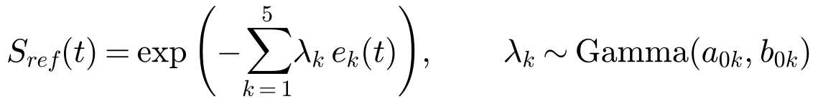
With the prior means, S(5) = exp[−(0.024 + 0.029 + 0.031 + 2 × 0.034)] ≈ 0.86 and S(10) = exp[−(0.152 + 5 × 0.037)] ≈ 0.71. The prior median survival probabilities were about 0.98, 0.86 and 0.72 at 1, 5 and 10 years, all inside the Weibull calibration targets of 0.90–0.99, 0.80–0.95 and 0.55–0.90.
One simplification: the five Gamma priors are independent, whereas in the Weibull prior the interval hazards are linked because they all come from the same β₀ and k. With 25 to 48 deaths per interval, the data dominate the baseline hazards, so this has little practical effect.

5. Posterior computation

5.1 Gibbs sampling with a Metropolis step
The joint posterior of the 12 parameters (5 baseline hazards and 7 coefficients) has no closed form, so it was explored with Markov chain Monte Carlo. Gibbs sampling updates one parameter, or one block of parameters, at a time from its full conditional distribution, meaning its posterior when all other parameters are held at their current values. Repeating these updates produces a Markov chain whose long-run distribution is the joint posterior. The sampler was hand-coded in base R.
The baseline hazards have a full conditional of known form (Gamma), so they are drawn exactly. The regression coefficients do not, so each is updated with a Metropolis step inside the Gibbs loop, a scheme called Metropolis-within-Gibbs.

5.2 Full conditional of the baseline hazards (Gibbs step)
Holding β fixed and keeping only the terms that involve λₖ, the likelihood contributes a Poisson kernel from the rows in interval k and the prior contributes a Gamma kernel:
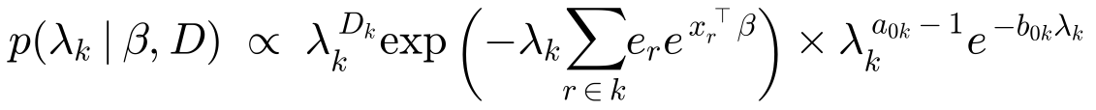
This is the kernel of a Gamma distribution, so
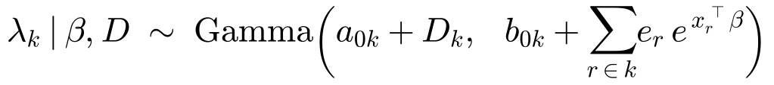
The shape adds the number of deaths in interval k, Dₖ, to the prior shape, and the rate adds the risk-weighted person-years in that interval to the prior rate. Each patient's time at risk is weighted by their e^(xᵀβ), so, for example, a year of follow-up of a Stage IV patient counts about 5.4 times as much as a year of a Stage I patient. This is the same conjugate Poisson–Gamma update used for count data, with exposure weighted by risk. Given β, the five baseline hazards are independent and are drawn together.

5.3 Full conditional of the coefficients (Metropolis step)
Holding λ and the other coefficients fixed, the log full conditional of βⱼ is
βⱼ appears both linearly and inside an exponential, so this is not a standard distribution and cannot be sampled directly. It can, however, be evaluated up to a constant, which is all a Metropolis step needs. A new value is proposed by a random walk and accepted with probability equal to the ratio of posterior heights, capped at 1:
If the proposed value is more plausible, the chain always moves there. If it is less plausible, the chain moves there only with probability α; otherwise it stays at the current value and records it again. Accepting some moves to less plausible values is what allows the chain to explore the full width of the posterior rather than climbing to its peak and staying there. The proposal standard deviation sⱼ was set to twice the standard error of the same coefficient from the frequentist Poisson fit. This affects only how efficiently the posterior is explored, not the distribution being sampled. The normal proposal is symmetric, so no correction term is needed in α.

5.4 Algorithm
Each iteration of the sampler performs the following steps:
- Draw λ₁, …, λ₅ from their Gamma full conditionals, given the current β.
- For each coefficient in turn (Stage II, Stage III, Stage IV, Age10, Male, G3, G4): propose βⱼ* = βⱼ + N(0, sⱼ²), compute the log acceptance ratio, and accept or reject. An accepted value is used immediately when updating the next coefficient.
- Store all 12 values as one posterior draw.

5.5 Run settings
Three chains were run for 30,000 iterations each, started from different random coefficient values drawn from N(0, 1). The first 2,000 iterations of each chain were discarded as burn-in, leaving 84,000 posterior draws (3 × 28,000). Hazard ratios use all 84,000 draws; survival curves use every 5th draw (16,800) to reduce memory use.

6. Convergence diagnostics
All 12 parameters converged. The three chains agree, and every effective sample size is well above 1,000.
Check | Result | Target
Metropolis acceptance rate | 0.30–0.41, nearly identical across chains | about 0.25–0.5
Burn-in | Chains reach the posterior within about 50 iterations | 2,000 discarded
R-hat (gelman.diag) | 1.00 for all parameters; multivariate 1.00 | < 1.01
Effective sample size | 5,799 (Stage IV) to 28,944 (λ₅) | > 1,000
Autocorrelation (Stage IV, G4) | Near zero by about lag 30 | Accounted for in the effective sample size
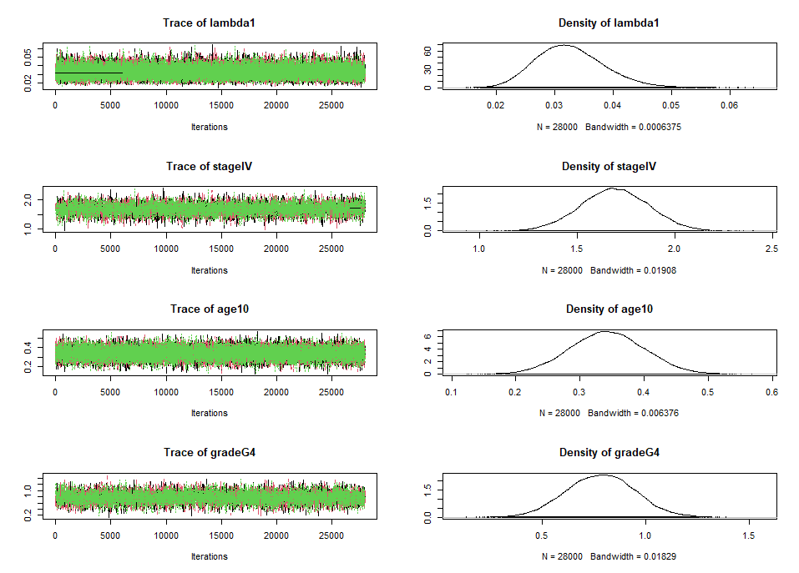
Figure 1. Trace and posterior density plots for λ₁, Stage IV, Age10 and G4 across the three chains (after burn-in).
The traces from the three chains overlap with no drift, and each posterior density is smooth with a single peak. Because each draw starts from the previous one, and rejected proposals repeat the previous value, consecutive draws are correlated. The coefficients show more autocorrelation than the baseline hazards, which are drawn exactly. The effective sample size accounts for this: the 84,000 correlated draws carry the information of roughly 5,800 independent draws for Stage IV and more than 25,000 for the baseline hazards, which is ample for stable medians and 95% credible intervals.

7. Posterior estimates

7.1 Hazard ratios
After adjusting for the other covariates, stage, age and grade are all clearly associated with higher mortality; sex is not. Each hazard ratio is the posterior median of e^β, with a 95% equal-tailed credible interval. P(HR > 1 | data) is the posterior probability that the covariate increases the hazard.
Covariate | Posterior median HR | 95% CrI | P(HR > 1 | data)
Stage II vs I | 1.371 | 0.886–2.079 | 0.924
Stage III vs I | 2.264 | 1.626–3.106 | 1.000
Stage IV vs I | 5.433 | 3.891–7.611 | 1.000
Age, per 10 years | 1.408 | 1.257–1.580 | 1.000
Male vs female | 0.948 | 0.754–1.195 | 0.323
G3 vs G1–G2 | 1.387 | 1.059–1.808 | 0.991
G4 vs G1–G2 | 2.187 | 1.579–2.998 | 1.000

- Stage: the hazard rises steadily with stage. Stage IV patients face about 5.4 times the instantaneous risk of death of Stage I patients with the same age, sex and grade. This does not mean they are 5.4 times as likely to die overall. Stage II's credible interval still includes 1.
- Age: each additional decade raises the hazard by about 41%.
- Sex: no evidence of a difference; the interval is centered near 1.
- Grade: tumor aggressiveness matters beyond stage. G4 roughly doubles the hazard of G1–G2 tumors, and G3 raises it by about 39%.

7.2 Baseline hazards
Interval | Posterior median λₖ (deaths per person-year) | 95% CrI
0–1 yr | 0.0323 | 0.0225–0.0453
1–2 yr | 0.0289 | 0.0196–0.0413
2–3 yr | 0.0329 | 0.0224–0.0468
3–5 yr | 0.0333 | 0.0238–0.0456
5+ yr | 0.0304 | 0.0211–0.0426

For the reference patient, the hazard is roughly flat at about 3% per year throughout follow-up. The prior expected a slow rise from 2.4% to 3.7%, consistent with a Weibull shape of about 1.2, but the data do not support that rise. A nearly constant baseline hazard suggests that a simple exponential model, or a Weibull with shape close to 1, would describe these data reasonably well, which is relevant to the model comparison.

8. Study A: posterior survival at reference age 60
For each posterior draw, the survival function S(t) was evaluated for each stage at a fixed patient profile: age 60 (Age10 = 0) and grade G1–G2, for females and for males. The curves show the posterior median at each time, and the bands show the 95% credible interval:
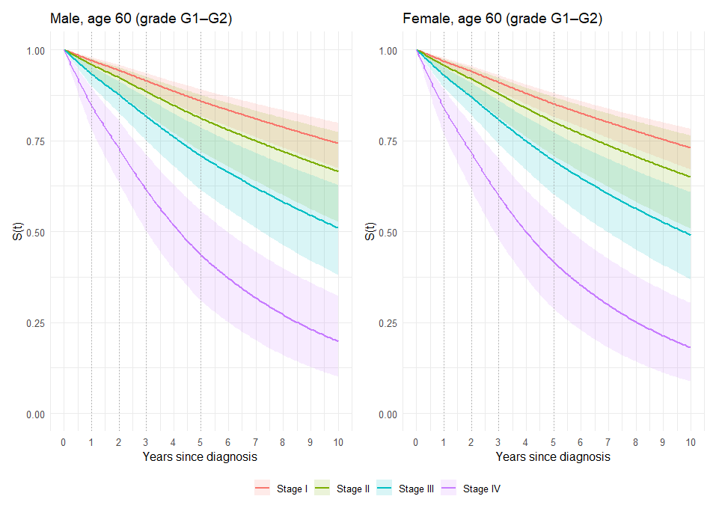
Figure 2. Posterior survival by stage for a 60-year-old male (left) and female (right) with grade G1–G2 tumors. Dotted lines mark the interval cutpoints.
Survival separates clearly by stage. For a 60-year-old with G1–G2 tumors, 5-year survival falls from about 85% at Stage I to about 41–44% at Stage IV. Stages I and II overlap substantially, and Stage II has the widest band because only 54 patients are Stage II. The male and female curves are nearly identical, consistent with the sex hazard ratio near 1.

Reference patient: 60-year-old female, grade G1–G2
Stage | Time (yrs) | Posterior mean | Posterior median | 95% CrI | Median (%) | 95% CrI (%)
Stage I | 1 | 0.968 | 0.968 | 0.956–0.978 | 96.8 | 95.6–97.8
 | 5 | 0.850 | 0.851 | 0.815–0.882 | 85.1 | 81.5–88.2
 | 10 | 0.729 | 0.730 | 0.671–0.783 | 73.0 | 67.1–78.3
Stage II | 1 | 0.955 | 0.957 | 0.929–0.974 | 95.7 | 92.9–97.4
 | 5 | 0.798 | 0.801 | 0.708–0.871 | 80.1 | 70.8–87.1
 | 10 | 0.646 | 0.650 | 0.509–0.765 | 65.0 | 50.9–76.5
Stage III | 1 | 0.928 | 0.930 | 0.896–0.953 | 93.0 | 89.6–95.3
 | 5 | 0.692 | 0.694 | 0.602–0.772 | 69.4 | 60.2–77.2
 | 10 | 0.490 | 0.491 | 0.370–0.607 | 49.1 | 37.0–60.7
Stage IV | 1 | 0.837 | 0.839 | 0.769–0.891 | 83.9 | 76.9–89.1
 | 5 | 0.415 | 0.415 | 0.288–0.540 | 41.5 | 28.8–54.0
 | 10 | 0.185 | 0.181 | 0.088–0.303 | 18.1 | 8.8–30.3

60-year-old male, grade G1–G2
Stage | Time (yrs) | Posterior mean | Posterior median | 95% CrI | Median (%) | 95% CrI (%)
Stage I | 1 | 0.969 | 0.970 | 0.957–0.979 | 97.0 | 95.7–97.9
 | 5 | 0.857 | 0.858 | 0.818–0.891 | 85.8 | 81.8–89.1
 | 10 | 0.741 | 0.743 | 0.675–0.799 | 74.3 | 67.5–79.9
Stage II | 1 | 0.958 | 0.959 | 0.933–0.976 | 95.9 | 93.3–97.6
 | 5 | 0.808 | 0.811 | 0.723–0.877 | 81.1 | 72.3–87.7
 | 10 | 0.661 | 0.665 | 0.530–0.775 | 66.5 | 53.0–77.5
Stage III | 1 | 0.932 | 0.933 | 0.901–0.956 | 93.3 | 90.1–95.6
 | 5 | 0.706 | 0.707 | 0.615–0.786 | 70.7 | 61.5–78.6
 | 10 | 0.509 | 0.510 | 0.384–0.628 | 51.0 | 38.4–62.8
Stage IV | 1 | 0.845 | 0.847 | 0.781–0.896 | 84.7 | 78.1–89.6
 | 5 | 0.435 | 0.435 | 0.311–0.557 | 43.5 | 31.1–55.7
 | 10 | 0.201 | 0.198 | 0.101–0.322 | 19.8 | 10.1–32.2

The credible intervals widen with time as fewer patients remain under follow-up. Ten-year estimates rely on a single constant hazard beyond year 5, and only 41 patients were followed past 8 years, so they are the least certain.

9. Prior sensitivity analysis
To check that the conclusions are not driven by the informative priors, the model was refit with vague priors, λₖ ~ Gamma(0.01, 0.01) and βⱼ ~ N(0, 5²), by setting prior_type <- "vague" in the script. Everything else was unchanged.
Covariate | Informative priors: HR (95% CrI) | Vague priors: HR (95% CrI)
Stage II vs I | 1.37 (0.89–2.08) | 1.16 (0.59–2.10)
Stage III vs I | 2.26 (1.63–3.11) | 2.01 (1.30–3.09)
Stage IV vs I | 5.43 (3.89–7.61) | 4.69 (3.02–7.36)
Age, per 10 years | 1.41 (1.26–1.58) | 1.37 (1.19–1.58)
Male vs female | 0.95 (0.75–1.20) | 0.93 (0.68–1.29)
G3 vs G1–G2 | 1.39 (1.06–1.81) | 1.44 (0.98–2.12)
G4 vs G1–G2 | 2.19 (1.58–3.00) | 2.26 (1.43–3.56)

The informative priors narrow the credible intervals and pull the stage effects toward the published values. Stage IV moves the most, because its prior is centered at HR 10 while the data alone suggest about 4.7. The substantive conclusions are unchanged, and 5-year survival for a 60-year-old male changes by 0.03 or less at every stage (vague priors: 0.85, 0.82, 0.71 and 0.46 for Stages I–IV).

10. Standardized survival and model comparison
This section follows the group's plan for comparing the three survival models: (a) standardized survival curves for stage, age and grade, (b) PSIS-LOO as the primary predictive comparison, and (c) survival-prediction accuracy with the Brier score and Integrated Brier Score (IBS). Every quantity was computed with the same patients, coding, time unit and time grid as the Weibull model, using KIRC_PiecewiseExp_Section10.R and the saved posterior draws from the informative-prior fit.

10.1 Harmonization with the group's conventions
- Time unit. Survival time is converted with days / 365, matching the Weibull code (the first run used 365.25), and the sampler was re-run with the informative priors. The chains are saved to PWE_Fit_informative.rds.
- Same patients. N = 521 with 173 deaths, using the same grade filter (GX and missing excluded) as the Weibull evaluation script.
- Same patient order. Rows are sorted by bcr_patient_barcode before computing the pointwise log-likelihood. This matters because loo_compare() pairs patients by row: a copy of the data file sorted differently (here, by grade) gave a meaningless SE of the difference (38.9). After sorting, the SE of the difference was 1.1. Totals such as ELPD, Brier scores and the curves do not depend on row order.
Effect of the time-unit change. Every survival time becomes 0.07% longer (about 6 hours at 1 year). No patient moved to a different interval, so the deaths per interval (48, 32, 29, 39, 25) and the 1,746 long-format rows are unchanged. Compared with the first run, hazard ratios changed by at most 0.013 and posterior median survival probabilities by at most 0.001 (credible-interval limits by at most 0.003), differences within Monte Carlo variation. All results in Sections 6–10 are from the re-run; the vague-prior column in Section 9 is from the first run.

10.2 Method: standardized (marginalized) survival
The age-60 curves in Section 8 describe one reference patient. The standardized curves instead describe the observed patient population. For each posterior draw m, the variable of interest is set to the same value for all 521 patients, each patient's survival curve is computed with their own values of the remaining covariates, and the 521 curves are averaged:
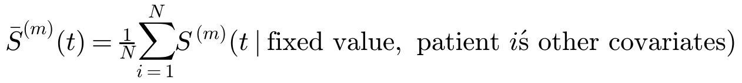
The posterior median and 95% credible interval of S̄(t) are then taken across 8,000 posterior draws (evenly spaced across the three chains), on a 0.1-year grid from 0 to 10 years. For stage, every patient is assigned Stage I, II, III or IV in turn and the average is over the observed age, sex and grade distribution; for age, every patient is assigned age 45, 55, 65 or 75 and the average is over stage, sex and grade; for grade, every patient is assigned G1–G2, G3 or G4 and the average is over stage, age and sex. This answers "what would survival look like in this cohort if every patient had this stage (or age, or grade)?" Because the curves average over the real mix of older and higher-grade patients, they sit below the age-60, G1–G2 curves of Section 8.

10.3 Standardized survival by stage
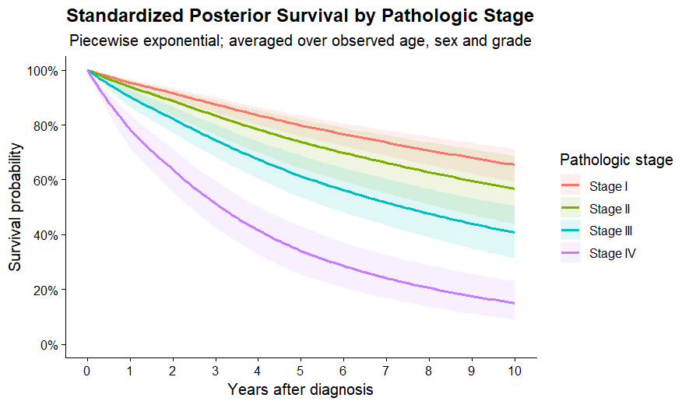
Figure 3. Standardized posterior survival by pathologic stage, averaged over the observed age, sex and grade distribution (posterior median and 95% credible interval).
Level | Time (yrs) | Posterior mean | Posterior median | 95% CrI | Median (%) | 95% CrI (%)
Stage I | 1 | 0.954 | 0.955 | 0.938–0.968 | 95.5 | 93.8–96.8
 | 5 | 0.798 | 0.799 | 0.758–0.835 | 79.9 | 75.8–83.5
 | 10 | 0.654 | 0.654 | 0.591–0.713 | 65.4 | 59.1–71.3
Stage II | 1 | 0.938 | 0.939 | 0.905–0.962 | 93.9 | 90.5–96.2
 | 5 | 0.736 | 0.738 | 0.642–0.821 | 73.8 | 64.2–82.1
 | 10 | 0.565 | 0.567 | 0.438–0.687 | 56.7 | 43.8–68.7
Stage III | 1 | 0.901 | 0.902 | 0.864–0.931 | 90.2 | 86.4–93.1
 | 5 | 0.613 | 0.613 | 0.535–0.689 | 61.3 | 53.5–68.9
 | 10 | 0.408 | 0.407 | 0.314–0.504 | 40.7 | 31.4–50.4
Stage IV | 1 | 0.783 | 0.784 | 0.716–0.841 | 78.4 | 71.6–84.1
 | 5 | 0.341 | 0.341 | 0.254–0.430 | 34.1 | 25.4–43.0
 | 10 | 0.153 | 0.150 | 0.090–0.230 | 15.0 | 9.0–23.0

Stage is the dominant driver of survival in the cohort. If every patient were Stage I, the expected 5-year survival would be about 80%; if every patient were Stage IV, it would be about 34%, and 10-year survival would fall from 65% to 15%. Stages I and II overlap substantially, while Stage IV separates from the others within the first year.

10.4 Standardized survival by age
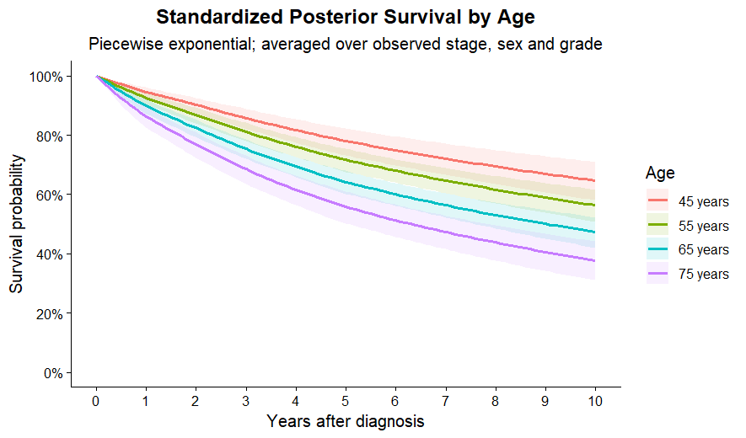
Figure 4. Standardized posterior survival at ages 45, 55, 65 and 75, averaged over the observed stage, sex and grade distribution.
Level | Time (yrs) | Posterior mean | Posterior median | 95% CrI | Median (%) | 95% CrI (%)
45 years | 1 | 0.946 | 0.946 | 0.926–0.962 | 94.6 | 92.6–96.2
 | 5 | 0.780 | 0.781 | 0.732–0.823 | 78.1 | 73.2–82.3
 | 10 | 0.646 | 0.647 | 0.580–0.709 | 64.7 | 58.0–70.9
55 years | 1 | 0.926 | 0.926 | 0.904–0.944 | 92.6 | 90.4–94.4
 | 5 | 0.717 | 0.717 | 0.676–0.755 | 71.7 | 67.6–75.5
 | 10 | 0.563 | 0.563 | 0.508–0.617 | 56.3 | 50.8–61.7
65 years | 1 | 0.899 | 0.899 | 0.872–0.922 | 89.9 | 87.2–92.2
 | 5 | 0.642 | 0.642 | 0.602–0.680 | 64.2 | 60.2–68.0
 | 10 | 0.472 | 0.473 | 0.420–0.523 | 47.3 | 42.0–52.3
75 years | 1 | 0.863 | 0.863 | 0.825–0.896 | 86.3 | 82.5–89.6
 | 5 | 0.558 | 0.558 | 0.503–0.611 | 55.8 | 50.3–61.1
 | 10 | 0.377 | 0.378 | 0.311–0.442 | 37.8 | 31.1–44.2

Survival declines steadily with age at diagnosis: 5-year survival drops by about 6–8 percentage points per decade, from 78% at age 45 to 56% at age 75. The even spacing reflects the age hazard ratio of about 1.41 per decade. Part of this effect is overall (all-cause) mortality, which rises with age independently of the cancer.

10.5 Standardized survival by grade
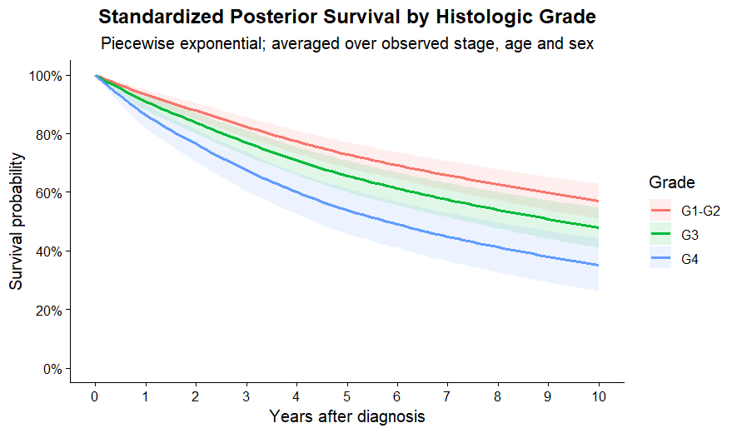
Figure 5. Standardized posterior survival by histologic grade, averaged over the observed stage, age and sex distribution.
Level | Time (yrs) | Posterior mean | Posterior median | 95% CrI | Median (%) | 95% CrI (%)
G1–G2 | 1 | 0.932 | 0.933 | 0.910–0.951 | 93.3 | 91.0–95.1
 | 5 | 0.729 | 0.729 | 0.683–0.772 | 72.9 | 68.3–77.2
 | 10 | 0.570 | 0.571 | 0.510–0.629 | 57.1 | 51.0–62.9
G3 | 1 | 0.908 | 0.909 | 0.879–0.933 | 90.9 | 87.9–93.3
 | 5 | 0.656 | 0.656 | 0.600–0.709 | 65.6 | 60.0–70.9
 | 10 | 0.480 | 0.480 | 0.410–0.548 | 48.0 | 41.0–54.8
G4 | 1 | 0.862 | 0.863 | 0.816–0.900 | 86.3 | 81.6–90.0
 | 5 | 0.538 | 0.539 | 0.458–0.613 | 53.9 | 45.8–61.3
 | 10 | 0.352 | 0.351 | 0.263–0.442 | 35.1 | 26.3–44.2

Tumor grade adds prognostic information beyond stage. Holding the cohort's stage, age and sex mix fixed, 5-year survival is about 73% for G1–G2, 66% for G3 and 54% for G4. G4 separates clearly from the low-grade group, while G1–G2 and G3 overlap more.

10.6 PSIS-LOO
PSIS-LOO estimates how well the model predicts each patient's outcome when that patient is left out of the fit. The pointwise log-likelihood was computed per patient (521 values per draw) with the survival likelihood, so it is on the same scale as the Weibull's: a death contributes log h(tᵢ) − H(tᵢ) and a censored patient contributes −H(tᵢ). The Poisson row-level form was not used, because its extra log-exposure term would put the ELPD on a different scale. The calculation used 16,800 posterior draws with chain identifiers for the relative-efficiency correction.
Quantity | Piecewise exponential
ELPD-LOO (SE) | −534.29 (27.40)
p_LOO (effective number of parameters) | 9.59 (SE 1.0)
LOOIC (SE) | 1068.58 (54.80)
Monte Carlo SE of ELPD-LOO | < 0.05
Pareto-k: maximum; number > 0.7; number > 1.0 | 0.373; 0; 0

All Pareto-k values are below 0.7, so the importance-sampling approximation is reliable for every patient. p_LOO ≈ 9.6 is a little below the 12 nominal parameters because the informative priors constrain some of them. The loo object, including the 521 pointwise elpd values required for SE(ΔELPD), is saved as LOO_PiecewiseExp_informative.rds, with a readable copy in PiecewiseExp_informative_Pointwise_ELPD.csv.

10.7 Brier score and Integrated Brier Score
Prediction accuracy was measured with the group's inverse-probability-of-censoring weighted (IPCW) Brier score, using each patient's posterior mean survival probability and a Kaplan–Meier estimate of the censoring distribution. The IBS averages the Brier score over 0–10 years on the shared 0.25-year grid. Lower is better for both.
Metric | Weibull | Piecewise exponential
Brier score at 1 year | 0.071 | 0.070
Brier score at 5 years | 0.192 | 0.193
Brier score at 10 years | 0.200 | 0.203
IBS, 0–10 years | 0.171 | 0.172

The two models predict survival probabilities almost equally well at every time point; the Brier curves are nearly identical across the full 0–10 year range. Brier scores rise over time and become noisier after about 8 years, when few patients remain under follow-up.

10.8 Model comparison with the Weibull
Metric | Weibull | Piecewise exponential
ELPD-LOO (SE) | −531.76 (26.78) | −534.29 (27.40)
LOOIC | 1063.52 | 1068.58
p_LOO | 6.81 | 9.59
Max Pareto-k (number > 0.7) | 0.33 (0) | 0.37 (0)
Brier score at 1 / 5 / 10 years | 0.071 / 0.192 / 0.200 | 0.070 / 0.193 / 0.203
IBS, 0–10 years | 0.171 | 0.172
Max R-hat | 1.001 | 1.000
Min ESS (bulk / tail) | 6,514 / 5,480 | 5,645 / 9,263
Divergences / tree-depth hits | 0 / 0 | Not applicable (Gibbs sampler)

loo_compare(): relative to the Weibull, the piecewise exponential model has ΔELPD = −2.5 with SE(ΔELPD) = 1.1 (posterior probability of predicting worse ≈ 0.99). The difference consistently favors the Weibull but is small: the loo package flags |ΔELPD| < 4 as a difference too small for the standard error to be fully trusted, meaning the two models have very similar predictive performance.
Interpretation. The Weibull is slightly preferred on PSIS-LOO, and the two models are tied on Brier scores and IBS. The piecewise model spends five parameters on the baseline hazard where the Weibull spends two, and its estimated baseline hazard was roughly constant at about 3% per year (Section 7.2), a shape the Weibull already captures. The extra flexibility of the piecewise model therefore does not improve prediction. Importantly, the substantive conclusions agree across the two models: the stage, age and grade effects and the standardized survival patterns tell the same story, so the conclusions are not sensitive to this choice of survival distribution.
[Pending]
Add the log-normal / log-logistic results and a three-model loo_compare() once available (all LOO objects must use the same arrange(bcr_patient_barcode) patient order).
Optional: posterior predictive check of model vs Kaplan–Meier curves (Section 10.8 of the script).

11. Limitations
- The cutpoints (1, 2, 3 and 5 years) are a modeling choice; the baseline hazard is assumed constant within each interval and beyond year 5.
- The model assumes proportional hazards: each covariate multiplies the hazard by the same factor at all times.
- The Gamma baseline priors are independent across intervals, a simplification of the Weibull prior they were derived from.
- Several prior sources are TCGA-based analyses that overlap with the analyzed patients, so some information may be used twice. The SEER grade estimate is independent of TCGA.
- TCGA-KIRC is an observational cohort with limited long-term follow-up, so 10-year estimates are uncertain.

References
[1]–[4] Stage, age and sex hazard-ratio sources, as cited in the group's Weibull prior write-up.
[5] Liao Z, Wang D, Song N, Xu Y, Ge H, Peng Z. Prognosis of clear cell renal cell carcinoma patients stratified by age: a research relied on SEER database. Frontiers in Oncology. 2022;12:975779. doi:10.3389/fonc.2022.975779
[6] Bläsius FM, et al. Loss of cadherin related family member 5 (CDHR5) expression in clear cell renal cell carcinoma is a prognostic marker of disease progression. Oncotarget. 2017. doi:10.18632/oncotarget.20507

