1. Scientific Question and Data
The scientific objective of this study is to evaluate how overall survival after kidney cancer diagnosis is associated with important patient and disease characteristics, including pathologic stage, age at diagnosis, sex, and histologic grade of the tumor. We also aim to identify an appropriate parametric survival model by comparing three candidate Bayesian survival models. These models are used to examine differences in survival probability over time and to assess whether the conclusions depend on the assumed survival-time distribution.
The analysis uses clinical data from the TCGA Kidney Renal Clear Cell Carcinoma (TCGA-KIRC) cohort. The original dataset contained 606 specimen-level records. After removing repeated patient records, 533 unique patients remained. Excluding two patients with discrepant stage information, two with zero follow-up time, five with grade GX, and three with missing grade information resulted in a final sample of 521 patients.
Overall survival was measured from diagnosis to death or last follow-up, with patients alive at last follow-up treated as right-censored. The predictors were pathologic stage, age, sex, and histologic grade. Stage I was used as the reference stage, while grades G1 and G2 were combined as the reference grade group and compared with G3 and G4. Age was centered at 60 years, as 60 years is close to the center of the observed age distribution. It was expressed in 10-year units.
2. Bayesian Model
Three Bayesian survival models were considered: Weibull, log-normal, and piecewise exponential. Each model incorporated the same predictors and accounted for right-censored survival times. A predictive model was then chosen from among the three based on the subsequent comparison.
For patient $i,$ let $T_{i}$ denote overall survival time and let $δ_{i}$ indicate whether death was observed $\left(δ_{i}=1\right)$ or the observation was right-censored $\left(δ_{i}=0\right)$. The survival likelihood for each patient can be written generally as $L_{i}=f{\left(T_{i}|θ_{i}\right)}^{δ_{i}}S{\left(T_{i}|θ_{i}\right)}^{{1-δ}_{i}}$, where $f\left(.\right)$is the event-time density, $S\left(.\right)$is the corresponding survival function, and $θ_{i}$represents the model-specific survival parameters. Therefore, patients who died contribute the probability density of the observed event time, whereas censored patients contribute the probability of surviving beyond their last follow-up time.
The three models differ in their assumptions about the survival-time or hazard distribution as shown in table.
Model | Model Specification | Survival Function | Event Time Density
Weibull | $$T_{i}\sim Weibull(k,λ_{i})$$ | $$S_{i}(t)=exp{\left[-\left(\frac{t}{λ_{i}}\right)\right]}^{k}$$ | $$f_{i}\left(t\right)=\frac{k}{λ_{i}}{\left(\frac{t}{λ_{i}}\right)}^{k-1}\exp\left[-{\left(\frac{t}{λ_{i}}\right)}^{k}\right].$$
Log-Normal | log$T_{i}\sim N\left(μ_{i},σ^{2}\right)$ | $$S_{i}\left(t\right)=1-Φ\left(\frac{log t-μ_{i}}{σ}\right)$$ | $$f_{i}\left(t\right)=\frac{1}{tσ\sqrt{2π}}\exp\left[-\frac{{\left(\log{t}-μ_{i}\right)}^{2}}{2σ^{2}}\right].$$
Piecewise Exponential | $h_{i}\left(t\right)=h_{ij}$ within interval $j$ | $$S_{i}(t)=exp\left[-\int_{0}^{t}{h_{i}\left(u\right)du}\right]$$ | $$f_{i}\left(t\right)=h_{i}\left(t\right)S_{i}\left(t\right)$$

The common regression component was
$$η_{i}=β_{0}+β_{2}I_{II,i}+β_{3}I_{III,i}+β_{4}I_{IV,i}+β_{A}Age{10}_{i}+β_{S}Male_{i}+γ_{3}G3_{i}+γ_{4}G4_{i}$$where Stage I, female sex, and grades G1–G2 were the reference groups, and ${Age10}_{i}=\frac{{Age}_{i}-60}{10}$. For Weibull, $η_{i}=logλ_{i}$, for log-normal $η_{i}=μ_{i}$ and for piecewise exponential,${\log{h}}_{ij}=α_{j}+x_{i}^{T}β$. The same clinical predictors were included in all three models, although they entered the survival model through different parameterizations. In the Weibull model, the linear predictor determined $logλ_{i}$; in the log-normal model, it determined the mean log-survival time $μ_{i}$; and in the piecewise exponential model, the covariate effects modified the interval-specific log hazard.
Using the same predictors across the three models allows differences in model performance to be attributed mainly to their assumptions about the survival-time or hazard distribution. Comparing the Weibull, log-normal, and piecewise exponential models therefore provides a way to evaluate the sensitivity of the analysis to the assumed survival distribution while addressing the same scientific question.
3. Prior Distributions
Prior distributions were specified using previous evidence on survival in clear-cell renal cell carcinoma (ccRCC) together with prior-predictive calibration. For stage, age, sex, and histologic grade, the same numerical priors were used across the Weibull, log-normal, and piecewise exponential models to maintain a comparable level of prior information during model comparison.
The baseline prior was selected using a grid-search prior-predictive procedure. For the Weibull calibration, the baseline scale was parameterized as $β_{0}=log⁡(λ_{0})$, and the shape parameter was modeled as $\log{k}$ to ensure $(k>0)$. Candidate priors considered baseline median survival values of 10–30 years, prior standard deviations of 0.20–0.50, median ($k$) values of 0.8–2.0, with standard deviations of 0.15–0.40. For each candidate combination, 10,000 prior draws were generated for the reference patient (Stage I, age 60, female). Prior-predictive survival at 1, 5, and 10 years was compared with clinically plausible ranges of 0.90–0.99, 0.80–0.95, and 0.55–0.90. Candidate priors were ranked by the proportion of draws within these ranges, with preference given to combinations achieving at least 80% coverage at all three time points. The selected priors were $β_{0}\sim N\left(3.219, {0.2}^{2}\right)$ and $\log\left(k\right)\sim N\left(0.182, {0.15}^{2}\right)$. Figure 1 shows the corresponding joint prior-predictive survival check.

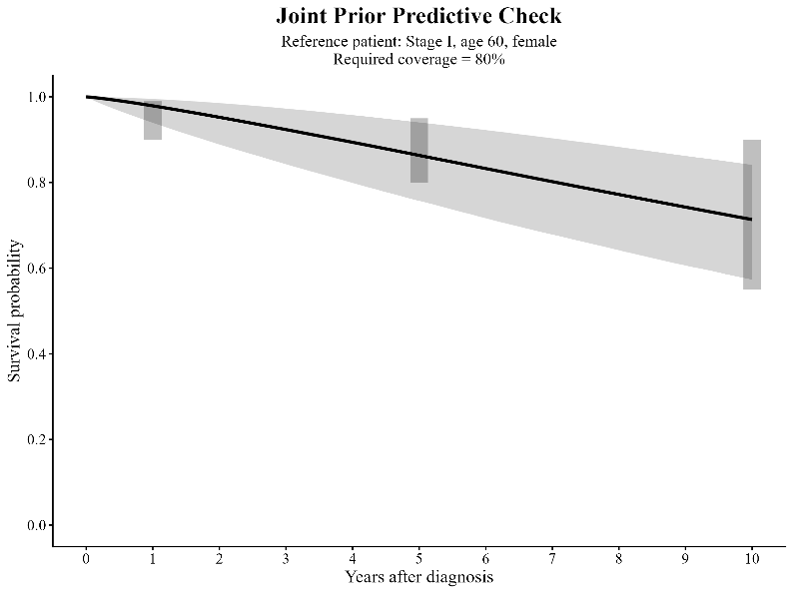’
Figure 1. Joint prior-predictive survival check for the reference patient
Published survival associations [1–4] were used to specify the common covariate priors: $β_{2}\sim N\left(-0.343, {0.278}^{2}\right)$,$β_{3}\sim N\left(-0.773, {0.307}^{2}\right), β_{4}\sim N\left(-1.939, {0.496}^{2}\right),$ $β_{A}\sim N\left(-0.33, {0.098}^{2}\right)$, $β_{S}\sim N\left(0, {0.175}^{2}\right)$, $γ_{3}\sim N\left(-0.283, {0.198}^{2}\right)$ and $γ_{4}\sim N\left(-0.773, {0.279}^{2}\right)$.
Because coefficient interpretation differs somewhat across model parameterizations, the priors should be viewed as providing comparable prior information rather than identical scientific meanings across all three models. Overall, the prior distributions combined external clinical evidence with prior-predictive calibration to ensure scientifically plausible survival behavior before observing the TCGA-KIRC data. The priors were informative enough to reflect existing knowledge while remaining sufficiently broad for the observed data to meaningfully update the posterior.
4. Posterior Computation and Diagnostics
Posterior distributions for the three models were obtained using Markov Chain Monte Carlo (MCMC) sampling. Hamiltonian Monte Carlo with the No-U-Turn Sampler (NUTS) was used to efficiently explore the posterior distribution of the model parameters. For each model, four independent chains were run with 2,000 warm-up iterations followed by 2,000 retained iterations per chain, resulting in 8,000 posterior draws. The sampler settings included an $adapt_delta$ of 0.95 and a maximum tree depth of 12 to reduce the risk of numerical and sampling problems.
Convergence was evaluated using the potential scale reduction statistic, $\left(\hat{R}\right)$, and effective sample size (ESS). Values of $\hat{R}$ were approximately 1.00 for the monitored parameters, indicating agreement among the four chains. Bulk and tail ESS values were also sufficiently large, suggesting that the posterior draws contained adequate independent information. Computational diagnostics were additionally checked for divergent transitions and excessive maximum-tree-depth warnings as presented in Table.
Model | Max $\hat{R}$ | Min Bulk ESS | Min Tail ESS | Divergences | Tree depth Issues | Max Pareto-k
Log-Normal | 1.0022 | 3487 | 5150 | 0 | 0 | 0.367
Weibull | 1.0008 | 6514 | 5480 | 0 | 0 |  | 0.329
Piecewise Exponential | 1.0004 | 5645 | 9263 | 0 | 0 |  | 0.373
Trace plots were examined to assess mixing and stability of the chains in Figure . The chains showed substantial overlap, without persistent trends or separation, providing further evidence of convergence.
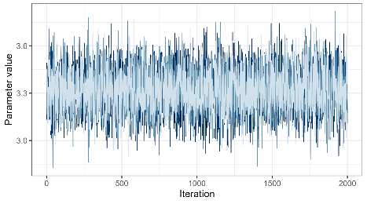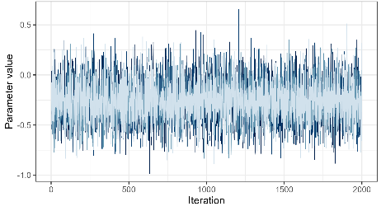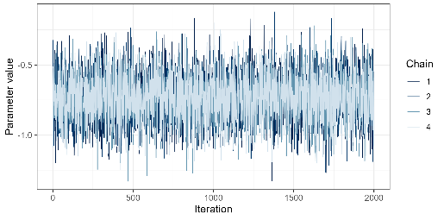
(a) | (b) | (c)
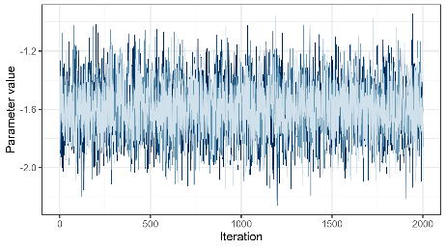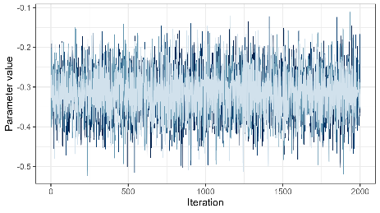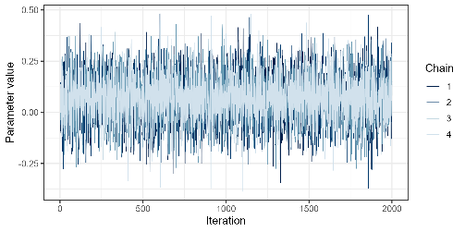
(d) | (e) | (f)
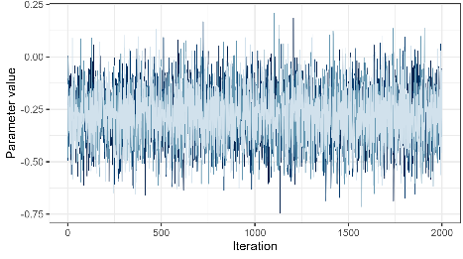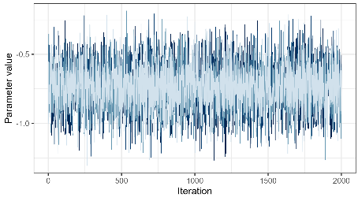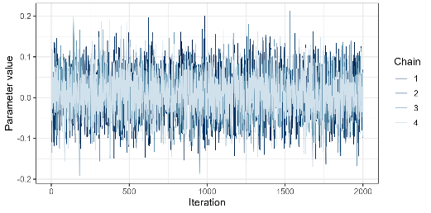
(g) | (h) | (i)
Figure. Trace plots of Weibull model for (a) $β_{0}$ (b) $β_{2}$ (c) $β_{3}$ (d) $β_{4}$ (e) $β_{A}$ (f) $β_{S}$ (g) $γ_{3}$ (h) $γ_{4}$ (i) log $k$
For predictive model comparison, Pareto-smoothed importance-sampling leave-one-out cross-validation (PSIS-LOO) diagnostics were also examined. Pareto-(k) values remained below 0.7, indicating that the importance-sampling approximation was reliable.
Overall, the near-unity $\hat{R}$ values, adequate effective sample sizes, stable trace plots, absence of important sampling problems, and satisfactory PSIS-LOO diagnostics support the reliability of the posterior estimates used in the subsequent analysis.

5. Posterior Results and Interpretation
The log-normal model was selected for primary posterior interpretation because it provided the best overall predictive performance among the three-candidate model. Detailed model-comparison results are presented in Section 6. Posterior effects were summarized using posterior medians, 95% credible intervals (CrIs), and exponentiated regression coefficients. Under the log-normal accelerated failure-time formulation, $e^{β}$ represents a survival-time ratio. Values below 1 indicate shorter survival relative to the reference group, whereas values above 1 indicate longer survival.
Predictor | Posterior Median $β$ | 95% CrI | Time Ratio $e^{β}$ | $$P\left(β<0|Data\right)$$
Stage II vs I |  |  |  | $$P\left(β_{2}<0|y\right)$$
Stage III vs I |  |  |  | $$P\left(β_{3}<0|y\right)$$
Stage IV vs I |  |  |  | $$P\left(β_{4}<0|y\right)$$
Age, per 10 years |  |  |  | $$P\left(β_{A}<0|y\right)$$
Male vs Female |  |  |  | $$P\left(β_{S}<0|y\right)$$
G3 vs G1-G2 |  |  |  | $$P\left(γ_{3}<0|y\right)$$
G4 vs G1-G2 |  |  |  | $$P\left(γ_{3}<0|y\right)$$
Pathologic stage showed the strongest association with overall survival. Relative to Stage I, the estimated time ratios were [TR-II] for Stage II, [TR-III] for Stage III, and [TR-IV] for Stage IV. The progressively smaller time ratios indicate shorter survival with advancing disease stage, with Stage IV showing the largest adverse association. Age was also negatively associated with survival. Because age was modeled in 10-year units, a time ratio of [TR-Age] indicates that each additional decade of age was associated with approximately [percentage]% shorter survival time, after adjustment for the other covariates. The male-to-female time ratio was [TR-Sex] (95% CrI: [lower, upper]), indicating [interpretation based on the interval]. Histologic grade also contributed prognostic information, with time ratios of [TR-G3] and [TR-G4] for G3 and G4 relative to G1–G2.
To provide population-level interpretations, posterior survival probabilities were also estimated using empirical standardization. For each predictor of interest, that predictor was fixed at a specified value while the remaining covariates were retained at their observed values and averaged over the study population. Thus, the resulting curves reflect the observed patient population rather than a single hypothetical reference patient.

[Insert standardized posterior survival figures here.]

The standardized survival curves showed [describe stage pattern], [describe age pattern], and [describe grade pattern]. Posterior medians and 95% CrIs at 1, 5, and 10 years further quantified these differences. Overall, the results indicate that pathologic stage was the dominant prognostic factor, while age and histologic grade provided additional information about overall survival; the evidence for a sex difference was [strong/modest/limited].

6. Sensitivity Analysis and Model Checking
Sensitivity to the assumed survival distribution was assessed by fitting Weibull, log-normal, and piecewise exponential models using the same patient cohort, predictors, and prior information. This comparison evaluated whether the conclusions depended strongly on the chosen parametric survival distribution. The metrics computed fort here models have been shown in tabl.
Table. Metric for the three models
Model | ELPD-LOO | LOOIC | IBS | Max Pareto-k | Log Marginal Likelihood
Log-Normal | -527.97 | 1055.94 | 0.169 | 0.37
Weibull | -531.76 | 1063.52 | 0.171 | 0.33
Piecewise Exponential | -534.29 | 1068.58 | 0.172 | 0.38
Predictive performance was assessed using Pareto-smoothed importance-sampling leave-one-out cross-validation (PSIS-LOO). The log-normal model had the highest ELPD-LOO (-527.97), followed by the Weibull (-531.76) and piecewise exponential (-534.29) models. The difference between the log-normal and Weibull models was modest ($∆_{ELPD}$=3.79 and SE=5.96), while the difference between the log-normal and piecewise exponential models was $∆_{ELPD}$=6.32 and SE=6.14. Thus, the log-normal model ranked highest, although the uncertainty in these differences indicates that its predictive advantage was not decisive.
Bayes factors were also calculated from the marginal likelihoods to compare the relative evidence provided by the observed data for the competing models. The resulting Bayes factors [insert BF results] provided [weak/moderate/strong] evidence in favor of log-normal model. Because marginal likelihoods and Bayes factors are sensitive to the prior distributions, they were treated as complementary to, rather than replacements for, the predictive comparison based on PSIS-LOO.
Model checking using integrated Brier scores gave similar results. The Integrated Brier Score (IBS) values were 0.1687, 0.1709, and 0.1717 for the log-normal, Weibull, and piecewise exponential models, respectively. Maximum Pareto-(k) values were below 0.4 for all models, supporting reliable LOO estimates.
Overall, the results were relatively stable across alternative distributional assumptions. The log-normal model was selected for primary interpretation because it consistently showed the best overall predictive performance, while the sensitivity analyses indicated that the main substantive conclusions were not driven by a single distributional assumption.
7. Alternative Analysis, Comparison, and Bayesian Justification

