Project 6: Survival After Kidney Cancer Diagnosis

Data and source: This project uses individual-level clinical data for Kidney Renal Clear Cell Carcinoma (KIRC) from The Cancer Genome Atlas (TCGA). The publicly available clinical file combines KIRC phenotype information with curated Pan-Cancer survival outcomes. Students should use the clinical and survival variables only; genomic data are not required.

Data webpage: TCGA Kidney Renal Clear Cell Carcinoma (KIRC) clinical data — Zenodo

Survival outcome: Use overall survival (OS) as the primary outcome. For patient i, let Tᵢ denote the PANCAN overall-survival follow-up time: time to death for a patient who died and time to last known follow-up for a patient who was alive at the end of follow-up. Let Δᵢ = 1 if death from any cause was observed and Δᵢ = 0 if the patient was alive at last follow-up. Thus, Δᵢ = 0 represents right censoring.

Disease characteristics: Pathologic stage should be treated as the principal measure of disease severity. Because overall pathologic stage is largely determined from the T, N, and M classifications, do not automatically include pathologic stage together with T, N, and M in the same model. Students may instead use the individual TNM components if scientifically justified. Other relevant patient characteristics may include age at diagnosis, sex, and a small number of additional well-defined clinical variables.

Scientific questions: How does overall survival after diagnosis vary according to pathologic stage and other relevant patient characteristics among patients with clear-cell renal cell carcinoma, and how accurately can long-term survival probabilities be estimated? How sensitive are estimates of long-term survival to the assumed survival-time distribution, particularly in the presence of right censoring?

Modeling task: Develop and justify an appropriate survival model, after comparing and assessing different models, to address the scientific questions. The analysis must appropriately incorporate right censoring. The choice of survival distribution and model structure is part of the project and should be justified from the data and scientific objectives. Compare the Bayesian analysis with an appropriate frequentist survival-analysis method.

Summary:
Dataset
Clinical survival dataset for patients diagnosed with Kidney Renal Clear Cell Carcinoma (KIRC). KIRC is a common type of kidney cancer.
Row: Information concerning a single patient
Column: Clinical characteristics of each patient and what happened during follow-up.
Data Source: The Cancer Genome Atlas (TCGA). It contains many genome characteristics. But we only need clinical and survival variables.
We are concerned with the time to event characteristics. Instead of being only concerned with whether the patient died or not, we are concerned with how long did the patient survive after diagnosis? It concerns not only the patients who died but also those who are still alive when follow-up ended.
Terms:
OS = Overall Survival. It means survival until death from any cause, not necessarily death specifically from kidney cancer.
Survival time $T_{i}$= the amount of time patient $i$was observed after diagnosis.
Event indicator $Δ_{i}$= tells us whether the patient died during observation.
Right censoring = the patient was still alive when we last knew their status, so their exact future survival time is unknown.
Pathologic stage = an overall description of how advanced the cancer is.
T, N, M = separate components describing tumor extent, lymph-node involvement, and distant metastasis.
Covariates = patient characteristics used to explain differences in survival, such as age, sex, or stage.
Survival probability $S\left(t\right)$= probability of surviving longer than time $t$.
Hazard = instantaneous risk of death at a particular time among patients who have survived up to that time.
Data Description:
For each patient, the survival information can be thought of as two numbers, ($T_{i}$, $Δ_{i})$
Patient A was diagnosed with kidney cancer and died 1,200 days later. Then: ($T_{A}=1200$, $Δ_{i}=1)$
Patient B was followed for 1,500 days and was still alive at their last recorded visit. Then: ($T_{B}=1500$, $Δ_{i}=0)$. It means $T_{B}>1500$. What happened afterwards is not known.
Overall survival is usually represented by the survival function: $S\left(t\right)=P(T>t)$
$S\left(5 years\right)=0.7:$ The estimated probability of surviving more than 5 years after diagnosis is 70%.
Pathological Stage: It summarizes how far the cancer has progressed. Stage I, II, III, IV. Stage IV often indicates distant metastatic disease, while earlier stages are more localized.
It is constructed from the T,N,M System.
T= Tumor. This describes characteristics of the primary tumor, particularly its extent. T1, T2, T3, T4 represent progressively greater local tumor involvement.
N= Nodes. This describes whether the cancer has spread to nearby lymph nodes. N0 generally means no regional lymph-node involvement, whereas positive N categories indicate nodal spread.
M= Metastasis. This describes distant spread. M0 means no known distant metastasis. M1 means distant metastasis present.
Stage, T, N, M are not independent information. Using all of then together might end up putting the same variable multiple times.
Stage+Age+Sex are better vriables than T+N+M+Age+Sex
Age: Age at the time of diagnosis. We may ask whether older patients have poorer overall survival, after accounting for stage. The important phrase is after accounting for stage.
Sex: We are not simply asking: $\text{Do males and females have different raw survival?}$ But more usefully: $\text{Do they differ after accounting for stage and age?}$
Clinical variables: age, stage, sex, T, N, M, tumor grade. The assignment intentionally says to use a small number of additional well-defined clinical variables. Do not throw every available TCGA column into the model.
Tumor grade: How abnormal/aggressive the tumor looks. It goes beyond tumor stage. We would need to inspect how complete and well coded it is in the dataset before deciding whether to use it.
Survival Curve: $S\left(t\right)$ vs $t$. It starts near $S\left(0\right)=1$ because everyone is alive at the starting point. Then the curve falls as deaths occur.
Long term survival: In your project it means survival sufficiently far after diagnosis that the tail of the survival distribution matters. Five-year survival is a natural clinically interpretable quantity. Ten-year survival may also be interesting, but only if the data contain enough long follow-up. This connects directly to the assignment's question: How sensitive are estimates of long-term survival to the assumed survival-time distribution?
Hazard: $h(t)$ represents among people who have survived until time $t$, how large is their instantaneous risk of dying around that time? Stage IV patients may have a larger hazard than Stage I patients. The Cox model commonly summarizes this using a hazard ratio. If $HR_{IV/I}=3,$ it means the instantaneous death hazard for Stage IV patients is approximately three times that for Stage I patients, conditional on the model covariates and proportional-hazards assumption. It does not mean: Stage IV patients are three times as likely to die overall.
Frequentist vs Bayesian Analysis
A frequentist analysis might use the Cox proportional hazards model: $h_{i}\left(t\right)=h_{o}(t)e^{X_{i}β}$. It produces estimates such as hazard ratios and confidence intervals.
A Bayesian analysis starts with prior distributions:$p\left(β\right)$ and combines them with the observed censored survival data: $p\left(β|data\right)∝p\left(data|β\right)p\left(β\right)$. The result is a posterior distribution.
Data Cleaning:
There are a total of 606 rows which should correspond to 606 patients. But under the column ‘sample_type’ there are repetitions with a patient being recorded twice. Once under ‘primary-tumor’ and again another ‘Solid Tissue Normal’ and ‘Additional-New Primary’. Hence, accounting for this repetition reduces the total sample size to 533.
- 533 rows are Primary Tumor
- 72 rows are Solid Tissue Normal
- 1 row is Additional - New Primary
Tumor tissue and normal tissue matters primarily for molecular analyses: gene expression, mutations, methylation, etc. But the project explicitly says to use clinical and survival variables only.
Among the 533 unique primary-tumor patients: $175\text{ deaths}$ and $358\text{ censored/alive}.$ So approximately $32.8\%$ had an observed death and $67.2\%$ are right-censored.
Variables:
Overall_Survival $≈$ Vital_Status
Overall_survival_time $≈$ Days_to_death for patients who died
Overall_survival_time $≈$ Days_to_last_followup for patients who are alive
Pathological Stage: 2 rows have [discrepancy] and should be excluded labeling it as inconsistent stage coding.
Regional lymph nodes could not be assessed, NX: 277
Distant metastasis could not be assessed, MX: 30
Therefore this main model: $\text{Stage}+\text{Age}+\text{Sex}$ makes sense.
There are two primary-tumor patients with $\text{overall}\text{_}\text{survival}\text{_}\text{time}=0.$ Both are alive/censored at day zero. That creates a problem for parametric models such as log-normal or Weibull because these models assume $T>0.$ We should not arbitrarily change zero to 0.1 or 1 day without justification.
The more defensible approach will probably be to exclude these two zero-follow-up patients from the survival modeling because they contribute essentially no follow-up information. They are not patients who “survived zero days.” Rather, the dataset has no meaningful post-diagnosis survival follow-up for them.
SO, total available samples=533-2-2=529

Weibull Distribution:
Survival Time, $T_{i}\sim Weibull\left(k,λ_{i}\right);k=Shape Parameter, λ=Scale Parameter$
$k$ controls how the risk of death changes with time and $λ$ controls the general time scale of measurement.
*The parameters are approximated from the observed patient data. An initial approximation is made on the priror.
The PDF of Weibull Distribution is: $f\left(t\right)=\frac{k}{λ}{\left(\frac{t}{λ}\right)}^{k-1}exp\left[{-\left(\frac{t}{λ}\right)}^{k}\right]$
The CDF of Weibull Distribution is: $F\left(t\right)=\int_{0}^{t}{f\left(u\right)du}=1-exp\left[{-\left(\frac{t}{λ}\right)}^{k}\right]$
The Survival Function for a patient who is alive is: $S\left(t\right)=P\left(T>t\right)=1-F\left(t\right)=exp\left[{-\left(\frac{t}{λ}\right)}^{k}\right]$
The hazard function is: $h\left(t\right)=\frac{f(t)}{S(t)}=\frac{k}{λ}{\left(\frac{t}{λ}\right)}^{k-1}$
We will use a Weibull AFT Regression:
i. Estimates a common shape and scale parameter that depends on characteristics.
ii. Estimate how patient characteristics are associated with survival time.
The problem is approximates as: $f\left(Stage, age, sex\right)→Survival Distribution$
Here, $f\left(Stage, age, sex\right)$ is a Bayesian Weibull Regression Model
*Rather than estimating one Weibull distribution for everyone, we let each patient's scale depend on their characteristics. In the standard Weibull AFT model, everyone shares the shape, but each patient has a scale determined by their characteristics.
We approximate for a patient i:
$$logλ_{i}≈β_{0}+β_{2}{StageII}_{i}+β_{3}{StageIII}_{i}+β_{4}{StageIV}_{i}+β_{A}{Age10}_{i}+β_{s}{Male}_{i}$$
$where, {Age10}_{i}=\frac{{Age}_{i}-60}{10}$ and $β_{k}$ is approximated through Bayesian approach by prior approximation.
The likelihood function is approximated as, $L\left(D | β,k\right)=\prod_{i=1}^{n}{f{(t_{i})}^{∆_{i}}S{(t_{i})}^{1-∆_{i}}}$
Where, $∆_{i}$ is the even whether the patient died of is alive. i.e. $∆_{i}=\left\{\begin{matrix}1, Patient is Dead \\ 0, Censored\end{matrix}\right.$
Hence, for a dead patient $L\left(D | β,k\right)=f(t_{i})$ and for an alive patient $L\left(D | β,k\right)=S(t_{i})$
The posterior is: $p(β,k|D)∝ L\left(D | β,k\right)p(β,k)$

Steps:
i. Prepare the KIRC dataset
ii. Draw Kaplan–Meier survival curves for all patients and separately for Stages I–IV. Examine how many patients remain at risk at 1, 3, 5 and 10 years. This shows the observed survival patterns before making any Weibull assumptions.
iii. Specify the Bayesian Weibull model and estimate the six regression coefficients and the common Weibull shape, k.
iv. Choose appropriate priors for the intercept, age and sex coefficients too. Run prior predictive checks to ensure they imply plausible survival curves.
v. Construct likelihood and run MCMC.
vi. Use each retained posterior draw to calculate $λ_{i}$ and $k$ for a specified patient profile. Repeat for all posterior draws. Summarize them to obtain the estimated five-year survival probability and its 95% credible interval. Repeat for different stages and time points.
vii. Fit and compare other survival distributions
viii. Perform frequentist comparison.
ix. Explain how stage, age and sex are associated with survival; report long-term survival probabilities and their uncertainty; discuss model fit, the effect of right censoring and sensitivity to the assumed survival distribution.
Include the limitations of the observational TCGA data and the available follow-up.
Analysis | What to show
Stage | Four survival curves at a fixed age and sex
Age | Survival curves for selected ages, holding stage and sex fixed
Sex | Two survival curves at the same age and stage
Regression Coefficients | Posterior estimates and 95% credible intervals for stage, age and sex
Long-time survival | 5-year and, if supported, 10-year survival probabilities for selected patient profiles

Kaplan_Meier Curve:
It is not mathematically required to fit the Bayesian Weibull model, but it is important because it gives you the observed, nonparametric survival pattern before imposing a Weibull assumption.
For your assignment, KM serves three purposes:
- It shows the raw overall survival experience of the cohort.
- It shows how survival differs across Stages I–IV without assuming any parametric distribution.
- Later, you can compare your Weibull-based survival curves against the KM curves to see whether the Weibull model is describing the observed data reasonably well.
So I would include at least:
- One overall KM curve.
- One KM plot with four curves for Stages I–IV.
- A risk table underneath, especially at 1, 3, 5, and 10 years.
Formula: $\hat{S}\left(t\right)=\prod_{t_{j}≤t}{\left(1-\frac{d_{j}}{n_{j}}\right)}$
$$n_{j}:\text{number of patients still at risk just before time }t_{j}$$
$$d_{j}:\text{number of deaths at time }t_{j}.$$
A patient may be censored because:
- the study ended while they were still alive,
- they stopped coming for follow-up,
- they were lost to follow-up,
- or their last known status was alive and no later information is available.
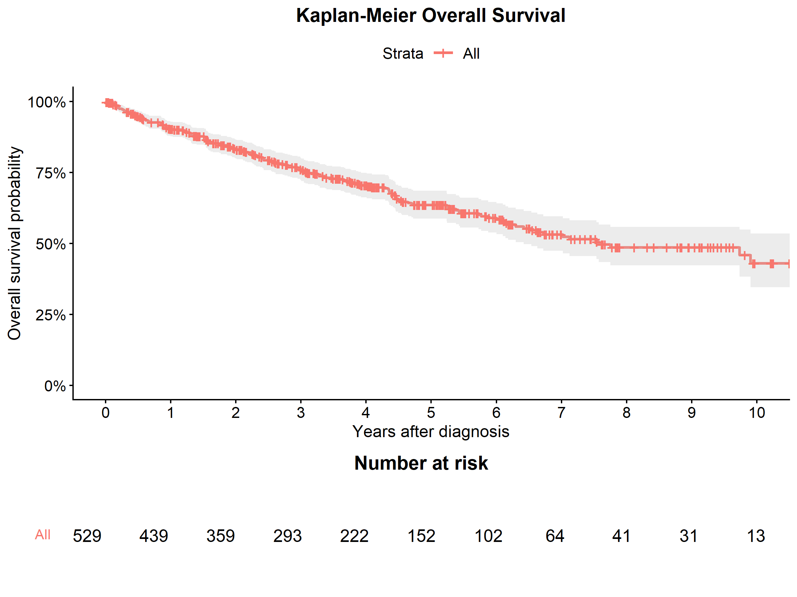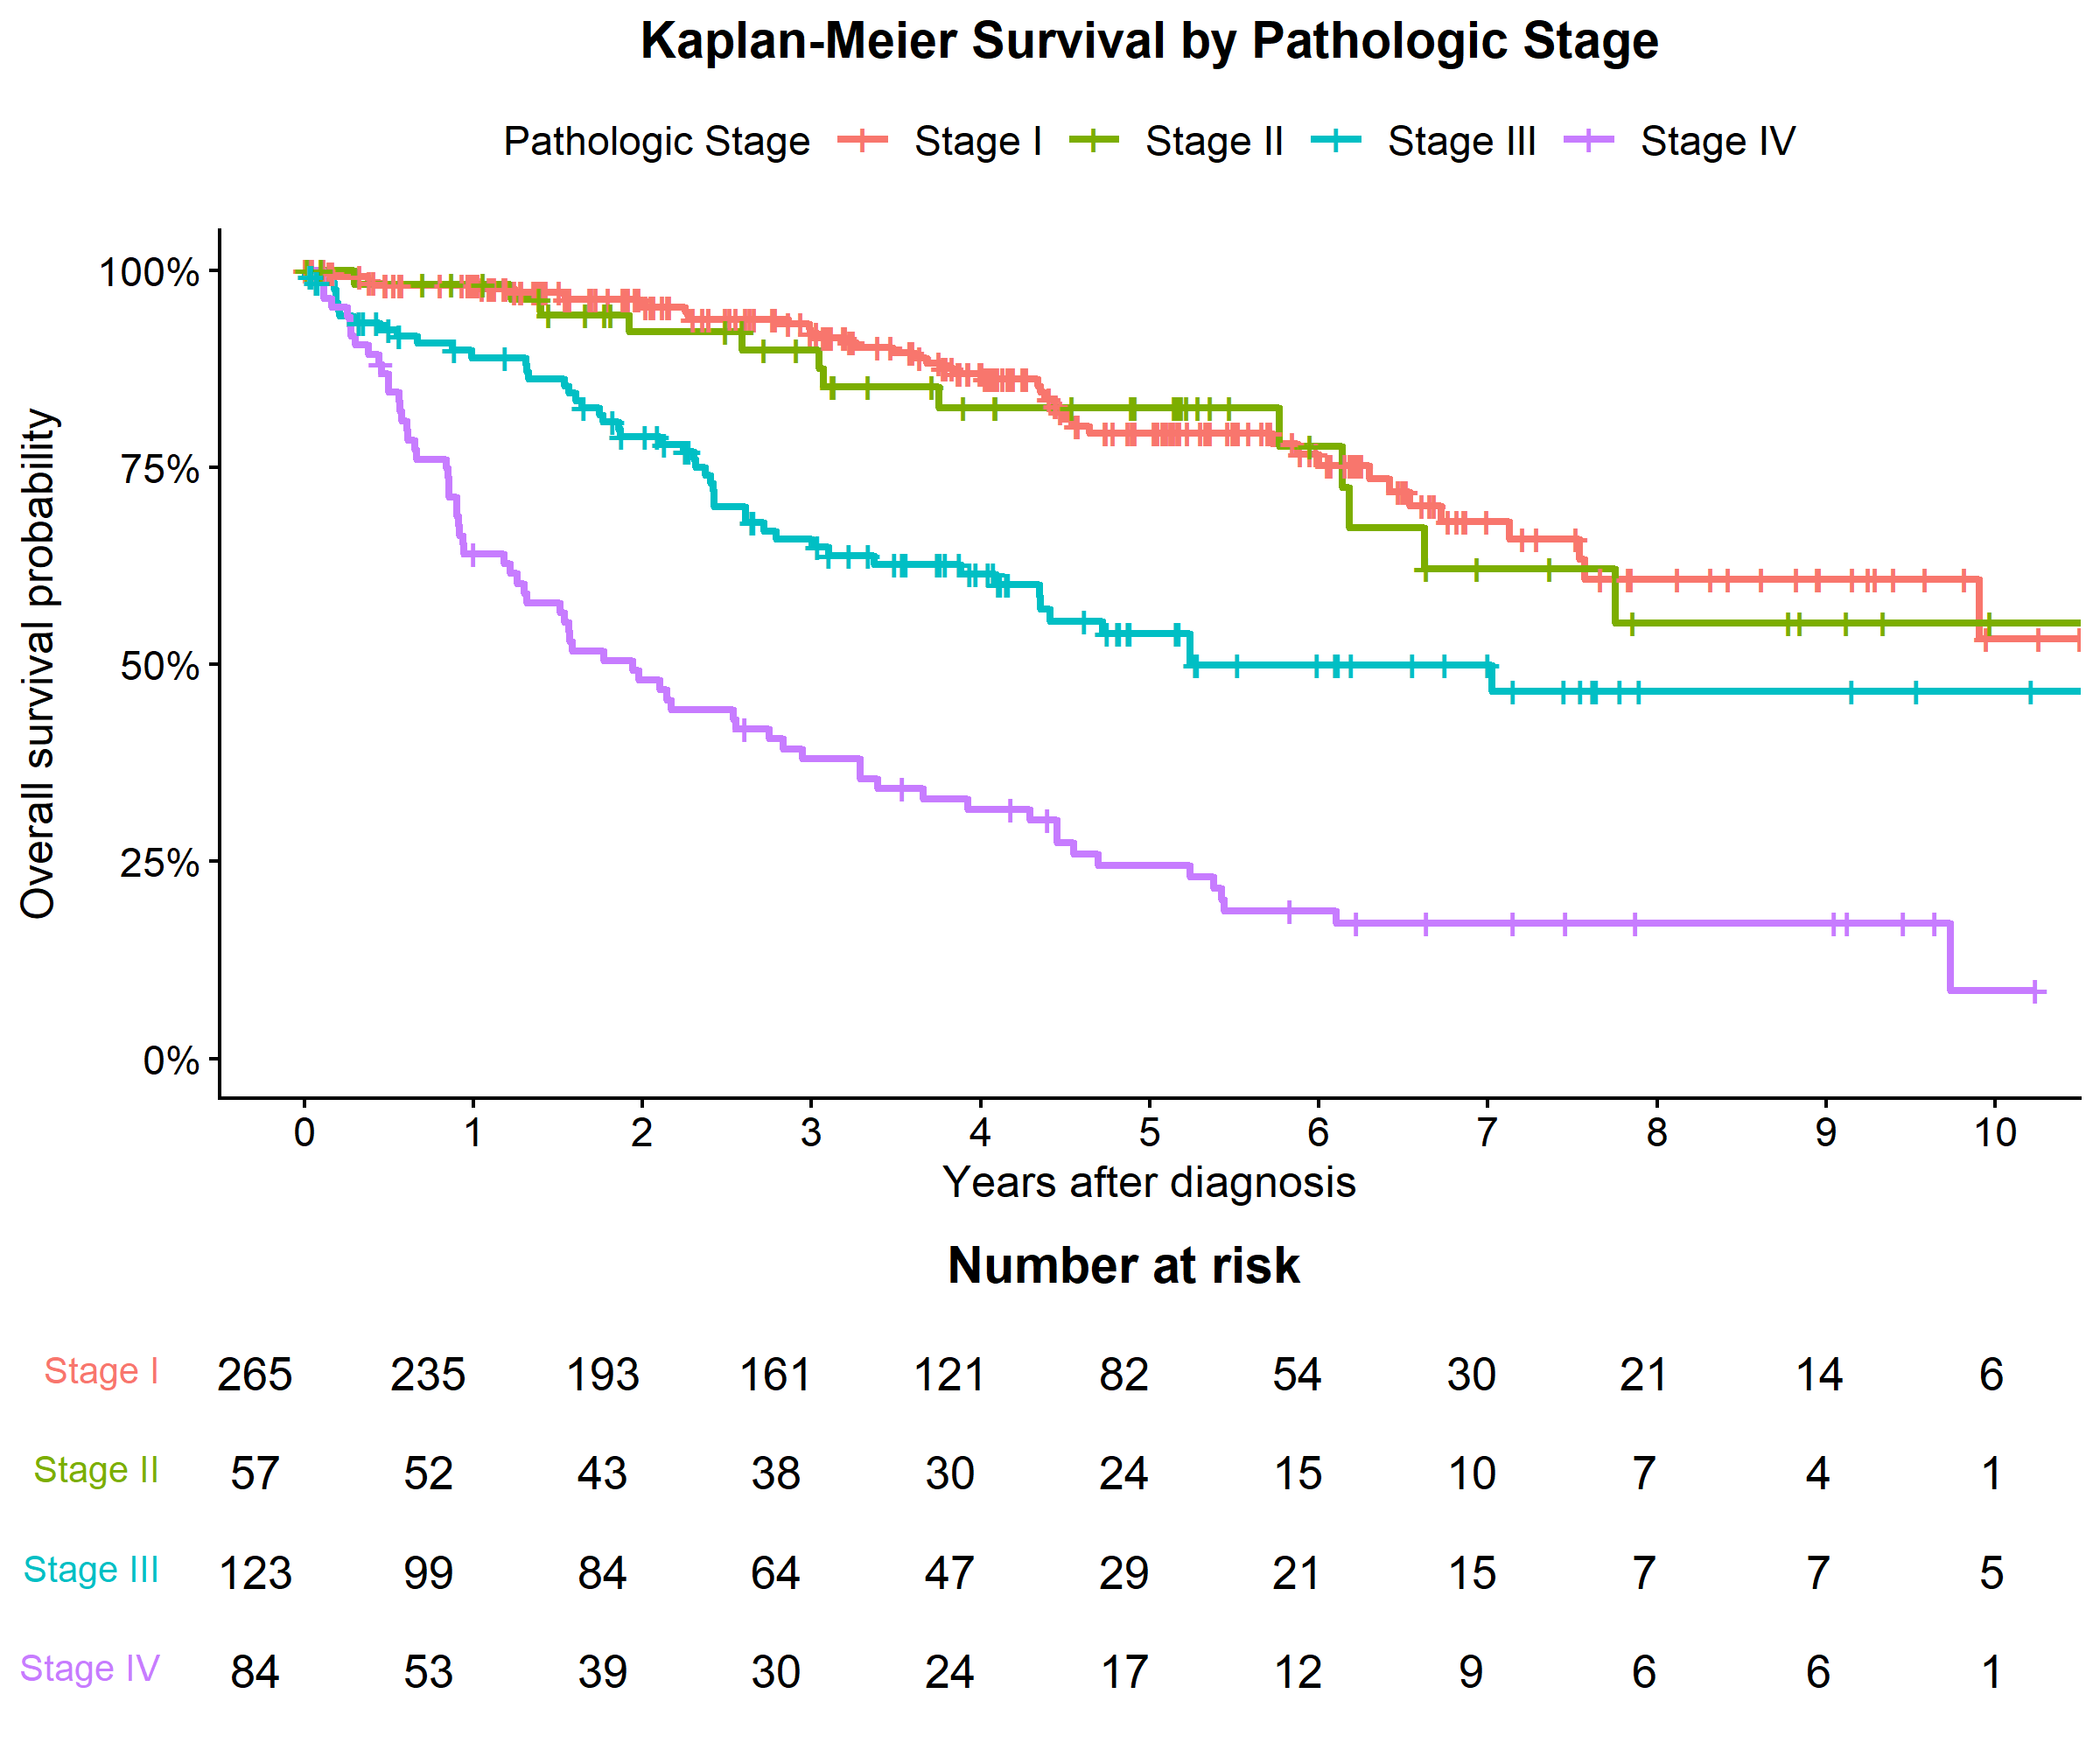
At any time $t$, Number at risk at $t$ means the patients who have not died before $t$ and have not been censored before $t$, So you can think of it as: $n\left(t\right)=N-deaths before t-censored before t$
$λ_{o}$ and $k$ prior distribution detemination:
The prior distributions for the baseline Weibull scale parameter, $λ_{o}$and shape parameter, $k$ were determined jointly through prior-predictive calibration. The baseline scale was parameterized as ${log⁡(λ}_{o})=β_{0}$with $β_{0}$ assigned a normal prior, while $log⁡(k)$ was also assigned a normal prior to ensure $k$>0. Candidate prior specifications were defined over median $λ_{0}$ values of 10–30 years with $β_{0}$standard deviations of 0.20–0.50, and median $k$ values of 0.8–2.0 with $log⁡(k)$ standard deviations of 0.15–0.40. For each candidate combination, 10,000 prior samples were generated and converted to survival probabilities using $S\left(t\right)=exp⁡\left[-{\left(\frac{t}{λ_{o}}\right)}^{k}\right]$ for the reference patient (Stage I, age 60, female). The resulting prior-predictive survival probabilities were evaluated at 1, 5, and 10 years against externally plausible ranges of 0.90–0.99, 0.80–0.95, and 0.55–0.90, respectively. These ranges were selected to be consistent with published survival outcomes for early-stage/Stage I renal cell carcinoma while remaining sufficiently broad to account for differences among study populations and follow-up durations. Candidate priors were ranked according to the proportion of prior-predictive draws falling within these ranges, with preference given to combinations for which at least 80% of the draws satisfied the specified range at all three time points. This procedure allowed the priors for $λ_{0}$ and $k$ to be calibrated jointly rather than selected independently.
$β_{0}\sim N\left(3.219, {0.2}^{2}\right)$ and $\log\left(k\right)\sim N\left(0.182, {0.15}^{2}\right)$
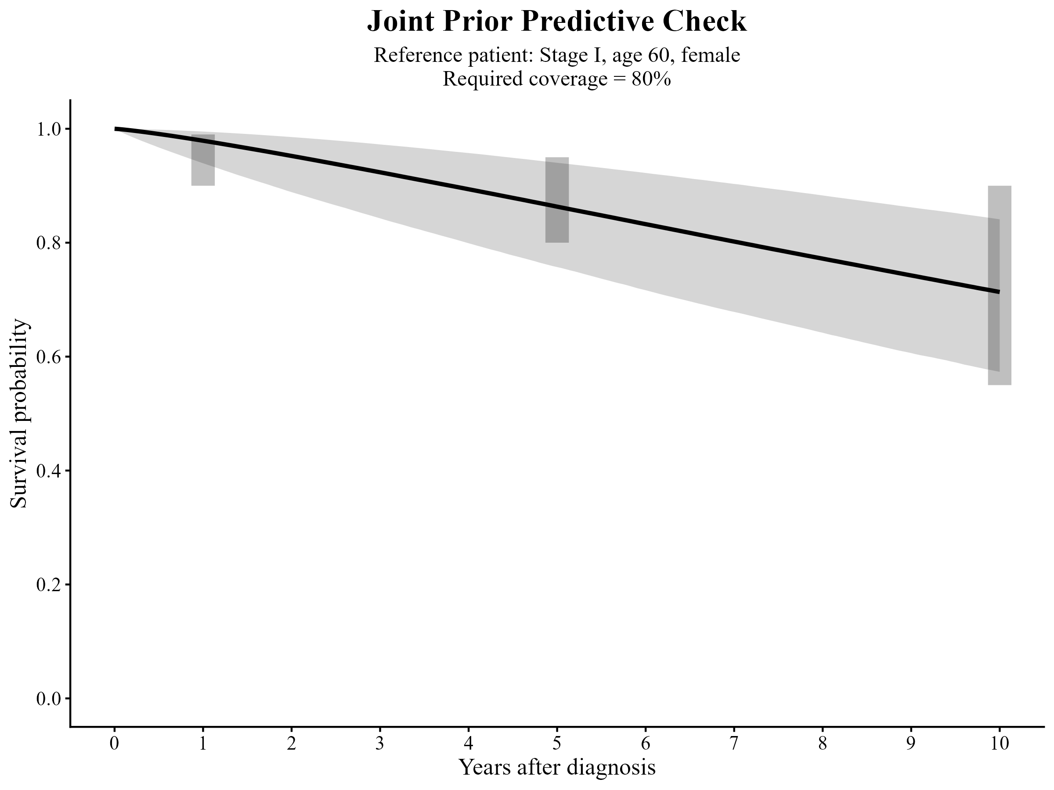
The priors for the stage, age, and sex regression coefficients were specified using previously reported associations with overall survival in clear-cell renal cell carcinoma (ccRCC). Because the Weibull regression was parameterized on the survival-time scale, published hazard ratios (HRs) were converted to Weibull regression coefficients using $β_{j}=-log\left({HR}_{j}\right)/k$, where $k$ denotes the Weibull shape parameter. Published TCGA-based analyses have consistently shown progressively poorer survival with advancing pathological stage. For example, one ccRCC analysis reported univariate overall-survival HRs of approximately 1.21, 2.71, and 6.78 for Stages II, III, and IV, respectively, relative to Stage I [1]. Another TCGA analysis similarly reported HRs of 0.90, 2.00, and 6.28 for Stages II, III, and IV, respectively, with Stage IV remaining strongly associated with mortality after multivariable adjustment [2]. Based on these findings, the stage priors were centered on increasing hazard with disease stage, while deliberately broad plausible HR ranges were used: 0.8–2.8 for Stage II, 1.3–4.8 for Stage III, and 4–25 for Stage IV—to accommodate heterogeneity among published studies and differences between external cohorts and TCGA-KIRC.
Age has also been consistently associated with poorer overall survival in ccRCC. TCGA-based studies have reported adjusted HRs of approximately 1.03–1.04 per additional year of age; for example, one study reported an adjusted HR of 1.038 (95% CI 1.014–1.063), while another reported approximately 1.030 (95% CI 1.015–1.046) [3]Consequently, an HR center of 1.04 per year with a broad prior range of 1.02–1.06 was adopted. Since age was modeled as $Age10=\frac{Age-60}{10}$, this per-year effect was converted to the corresponding 10-year effect before determining the prior for$β_{A}$.
The reported effect of sex on overall survival is less consistent. A large SEER-based ccRCC analysis reported an adjusted male-to-female HR of 1.162 (95% CI 1.136–1.190), whereas several TCGA-based analyses found little or no independent sex effect, with HRs close to unity [4]. Therefore, the prior for the sex coefficient was centered at no effect (HR=1) and assigned a relatively broad plausible range of 0.67–1.50. For each covariate, draws were generated from the corresponding log-HR distribution and jointly combined with draws from the previously calibrated prior for $k$. These were transformed through $β_{j}=-log\left({HR}_{j}\right)/k$, and the resulting distributions were approximated by normal priors for $β_{2}, β_{3}, β_{4}, β_{A} andβ_{S}$
$β_{2}\sim N\left(-0.343, {0.278}^{2}\right)$,
$$β_{3}\sim N\left(-0.773, {0.307}^{2}\right),$$
$$β_{4}\sim N\left(-1.939, {0.496}^{2}\right),$$
$β_{A}\sim N\left(-0.33, {0.098}^{2}\right)$
$$β_{S}\sim N\left(0, {0.175}^{2}\right)$$

Posterior Estimate:
a. For each patient, $i=1,2,3…, N$, the observed information is: $D_{i}=\left(t_{i},δ_{i}, {Stage}_{i}, {Age}_{i}, {Sex}_{i}\right)$
Where, $t_{i}=\left\{\begin{aligned}time to death, δ_{i}=1 \\ time to last follow up,δ_{i}=0 \end{aligned}\right.$and $δ_{i}=\left\{\begin{aligned}1, death observed \\ 0, right censored\end{aligned}\right.$
Age is centered and scaled as, ${Age10}_{i}=\frac{{Age}_{i}-60}{10}$ and sex is coded as, ${Male}_{i}=\left\{\begin{aligned}1, male \\ 0, female\end{aligned}\right.$
b. The Weibull Regression Model is defined as:
$$log\left(λ_{i}\right)=β_{0}+β_{2}{StageII}_{i}+β_{3}{StageIII}_{i}+β_{4}{StageIV}_{i}+β_{A}{Age10}_{i}+β_{s}{Male}_{i}$$
c. Weibull density and survival function:
The following quantities are used differently depending on whether the patient's death is observed.
For patient $i$, Weibull density is: $f\left(t_{i}|λ_{i},k\right)=\frac{k}{λ_{i}}{\left(\frac{t_{i}}{λ_{i}}\right)}^{k-1}exp\left[{-\left(\frac{t_{i}}{λ_{i}}\right)}^{k}\right]$
And the corresponding survival function is: $S\left(t_{i}|λ_{i},k\right)=exp\left[{-\left(\frac{t_{i}}{λ_{i}}\right)}^{k}\right]$
d. The likelihood expression is: $L_{i}={f\left(t_{i}|λ_{i},k\right)}^{δ_{i}}{S\left(t_{i}|λ_{i},k\right)}^{1-δ_{i}}$
The likelihood for all patients is: $L\left(D | β,k\right)=\prod_{i=1}^{529}{{f\left(t_{i}|λ_{i},k\right)}^{δ_{i}}{S\left(t_{i}|λ_{i},k\right)}^{1-δ_{i}}}$
e. Combine likelihood and priors to obtain the posterior:
$p\left(β,k|D\right)=\frac{L\left(D | β,k\right)p\left(β,k\right)}{p(D)}⟹p\left(β,k|D\right)L\left(D | β,k\right)p\left(β,k\right)$
f. Use MCMC to sample from the posterior
At a given step, the sampler considers a candidate parameter set such as $\left(β_{0},β_{2},β_{3},β_{4},β_{A},β_{S},k\right)$
For that candidate: $\left(β,k\right)→λ_{i},k→L_{i},p\left(β,k\right)→p\left(β,k|D\right)$
g. Use $p\left(β,k|D\right)$ to make estimation on $S\left(1\right), S\left(5\right), S\left(10\right)$
h. Study A: Posterior stage-specific survival was estimated for a fixed reference patient (60-year-old female). For each posterior MCMC draw, the Weibull survival function was evaluated over follow-up time for Stages I–IV. The posterior median survival curve and corresponding 95% credible interval were obtained for each stage. Posterior survival probabilities at 1, 5, and 10 years were additionally reported as numerical summaries.
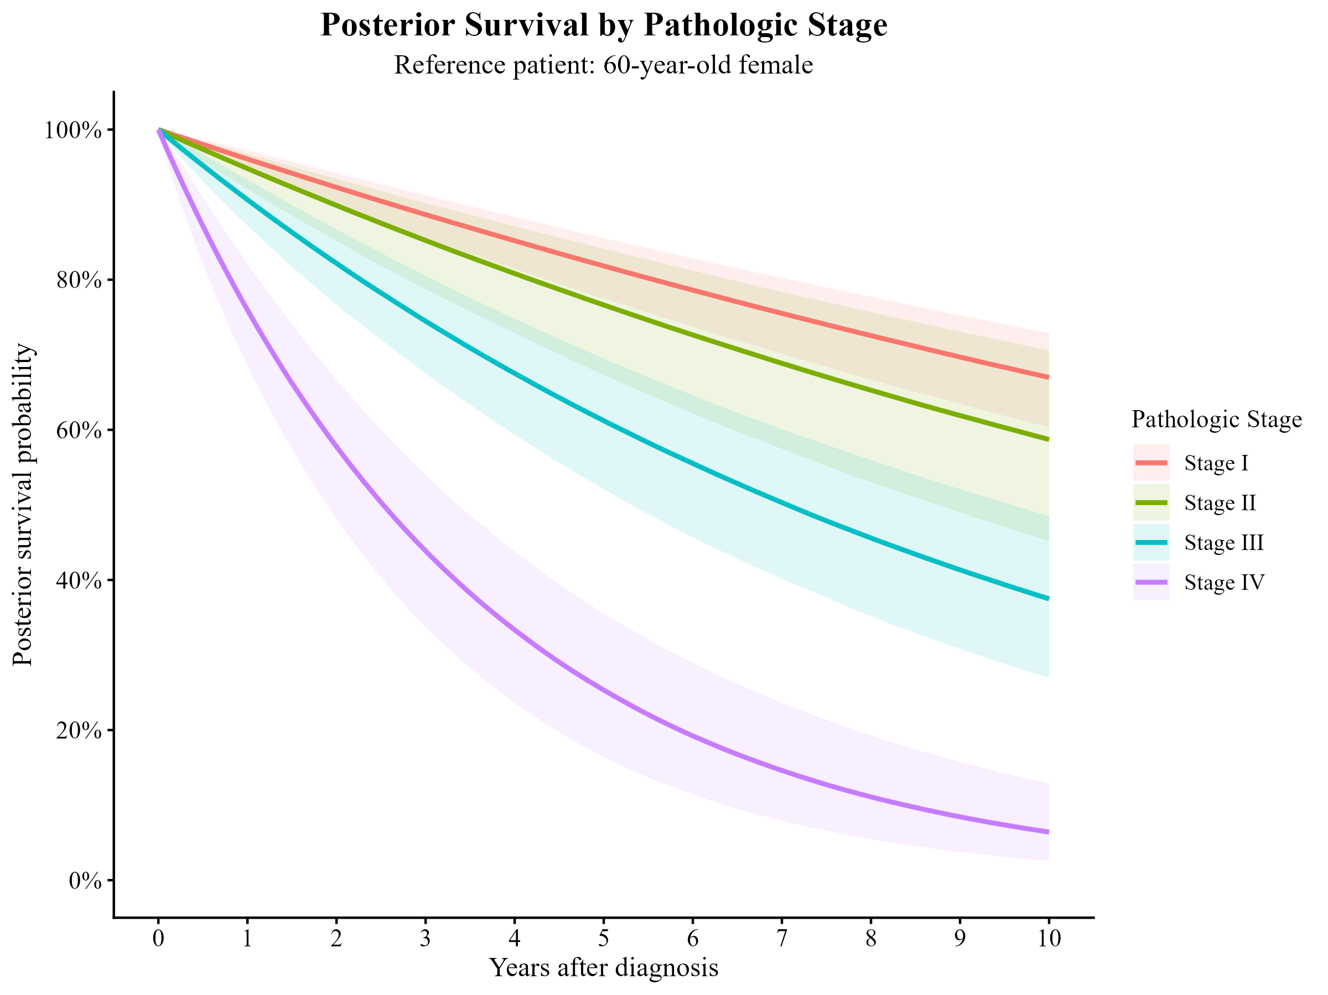
Stage | Time (Years) | Posterior Mean | Posterior Median | Lower 95 Credible Interval | Upper 95 Credible Interval | Median (%) | Lower 95 (%) | Upper 95 (%)
Stage I | 1 | 0.96 | 0.96 | 0.95 | 0.97 | 96.07 | 94.60 | 97.20
Stage I | 5 | 0.82 | 0.82 | 0.77 | 0.86 | 81.83 | 77.48 | 85.53
Stage I | 10 | 0.67 | 0.67 | 0.60 | 0.73 | 66.97 | 60.34 | 72.90
Stage II | 1 | 0.95 | 0.95 | 0.92 | 0.97 | 94.81 | 92.06 | 96.77
Stage II | 5 | 0.76 | 0.77 | 0.67 | 0.84 | 76.63 | 67.33 | 84.11
Stage II | 10 | 0.59 | 0.59 | 0.45 | 0.71 | 58.70 | 45.19 | 70.59
Stage III | 1 | 0.91 | 0.91 | 0.87 | 0.93 | 90.65 | 87.21 | 93.31
Stage III | 5 | 0.61 | 0.61 | 0.52 | 0.69 | 61.21 | 52.09 | 69.50
Stage III | 10 | 0.38 | 0.37 | 0.27 | 0.48 | 37.48 | 26.96 | 48.49
Stage IV | 1 | 0.76 | 0.76 | 0.69 | 0.82 | 75.98 | 68.55 | 82.12
Stage IV | 5 | 0.26 | 0.25 | 0.16 | 0.36 | 25.33 | 16.41 | 35.53
Stage IV | 10 | 0.07 | 0.06 | 0.03 | 0.13 | 6.41 | 2.58 | 12.88

i. Study B: Bayesian Empirical Standardization:
Keeping the actual age and sex of all 529 patients, we evaluate ${Stage}_{i}$ assuming all patients are ${Stage}_{i}$ with parameters $\left(β^{j},k\right)$, where $j$ is a posterior draw. We compute ${\overline{S}}^{j}(k)=\frac{1}{529}\sum_{i=1}^{529}{S_{i}^{j}(k)}$ and estimate median, 2.5th and 97.5th percentile across all posterior draws.
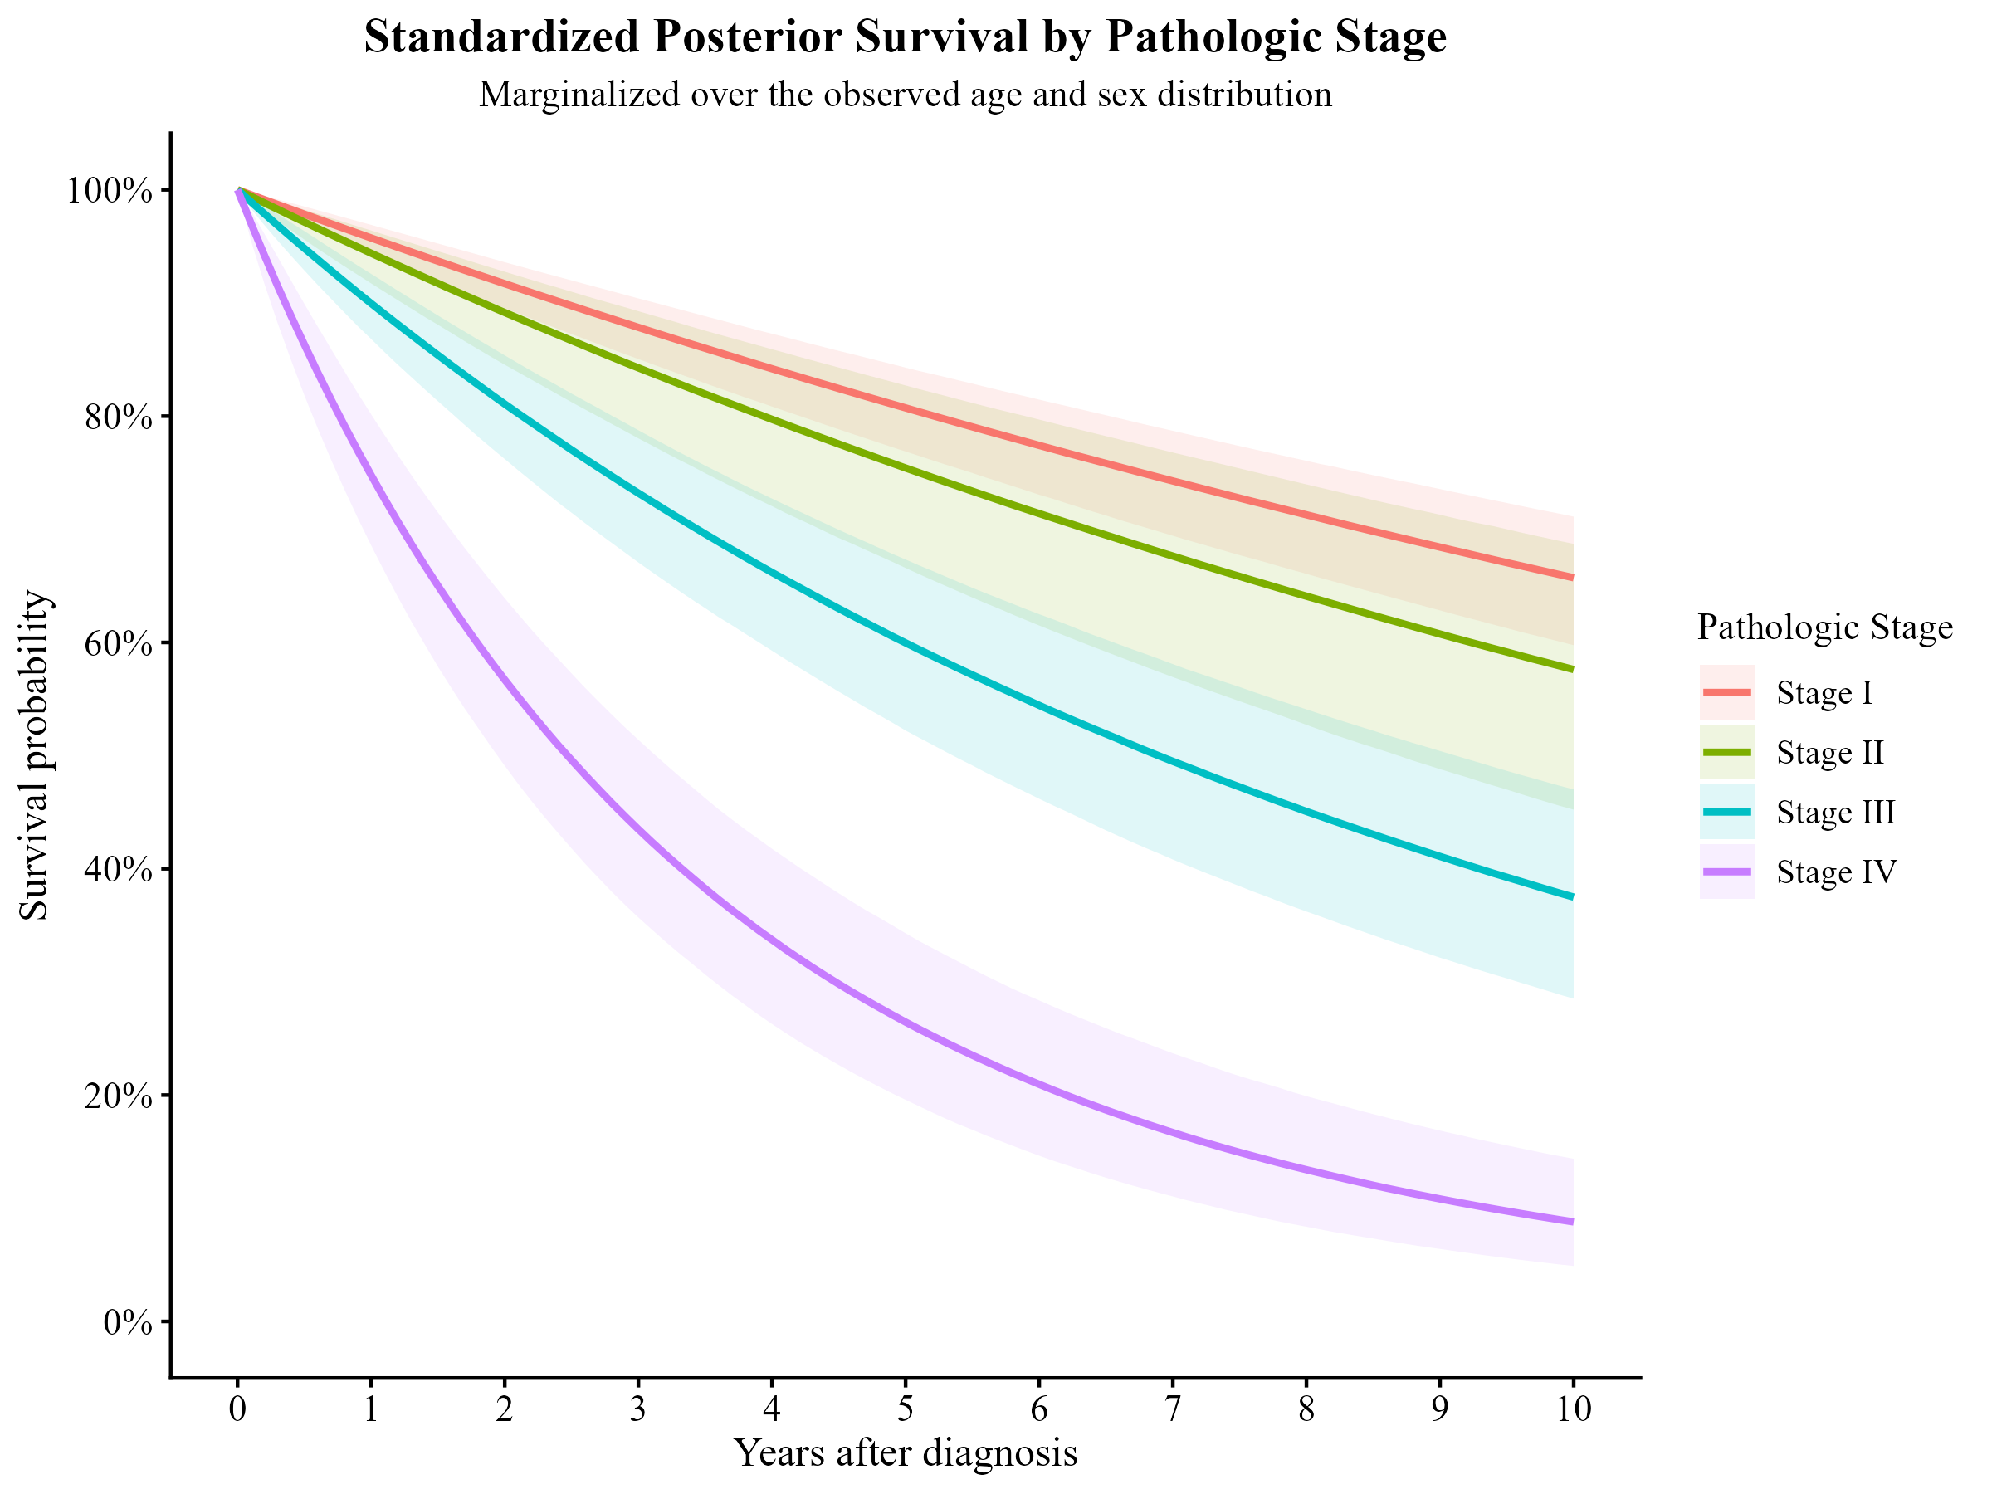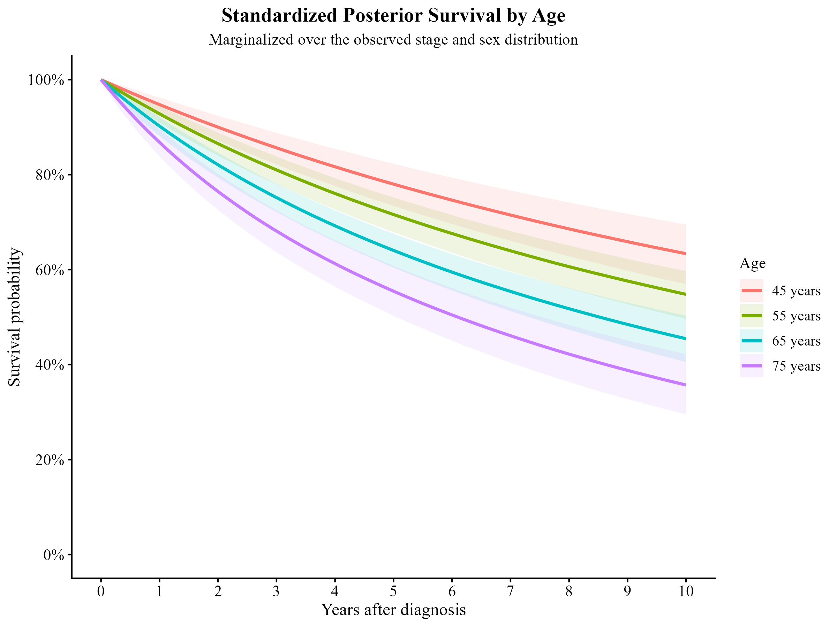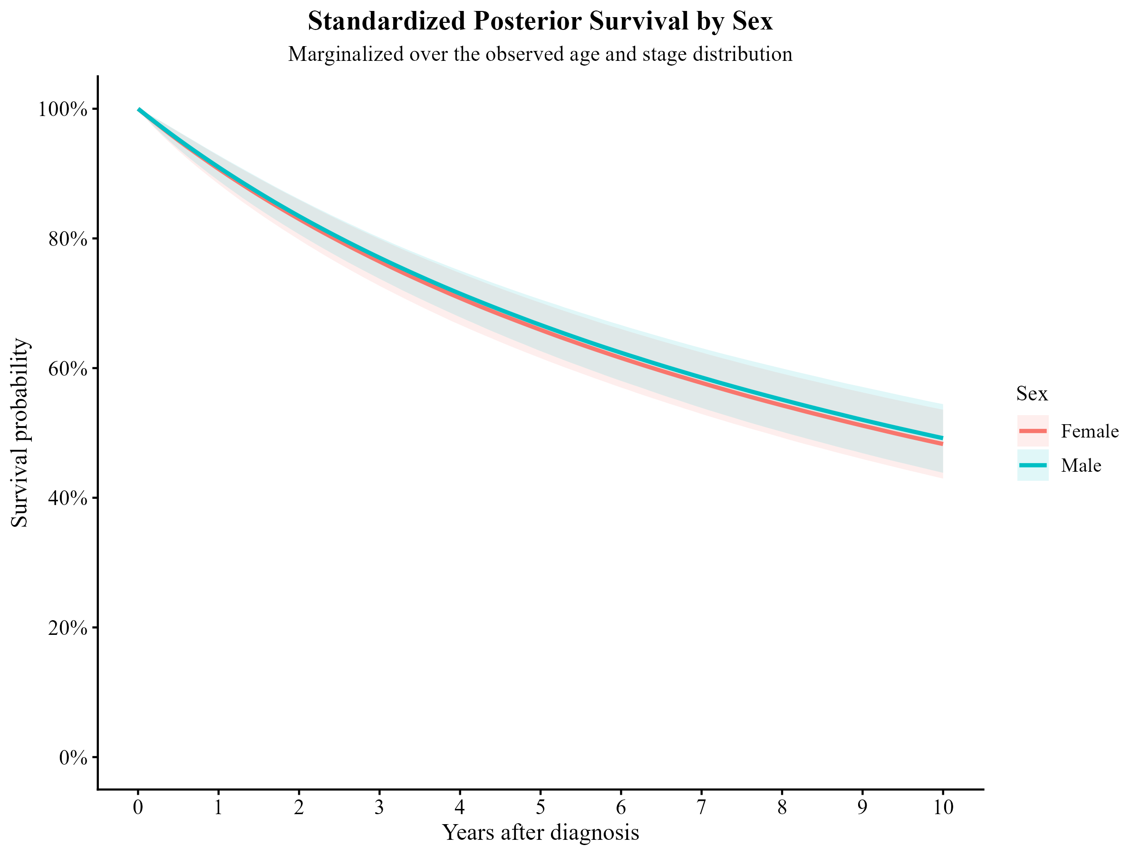
Sex | Time (Years) | Posterior Mean | Posterior Median | Lower 95 Credible Interval | Upper 95 Credible Interval | Median (%) | Lower 95 (%) | Upper 95 (%)
Female | 1.00 | 0.91 | 0.91 | 0.88 | 0.93 | 90.72 | 88.39 | 92.74
Female | 5.00 | 0.66 | 0.66 | 0.62 | 0.70 | 65.90 | 61.54 | 70.08
Female | 10.00 | 0.48 | 0.48 | 0.43 | 0.54 | 48.29 | 42.95 | 53.58
Male | 1.00 | 0.91 | 0.91 | 0.89 | 0.93 | 90.99 | 88.91 | 92.84
Male | 5.00 | 0.67 | 0.67 | 0.63 | 0.71 | 66.65 | 62.62 | 70.58
Male | 10.00 | 0.49 | 0.49 | 0.44 | 0.54 | 49.19 | 43.85 | 54.44

Stage | Time (Years) | Posterior Mean | Posterior Median | Lower 95 Credible Interval | Upper 95 Credible Interval | Median (%) | Lower 95 (%) | Upper 95 (%)
Stage I | 1 | 0.96 | 0.96 | 0.94 | 0.97 | 95.74 | 94.33 | 96.90
Stage I | 5 | 0.81 | 0.81 | 0.77 | 0.84 | 80.73 | 76.87 | 84.29
Stage I | 10 | 0.66 | 0.66 | 0.60 | 0.71 | 65.72 | 59.76 | 71.12
Stage II | 1 | 0.94 | 0.94 | 0.92 | 0.96 | 94.39 | 91.73 | 96.40
Stage II | 5 | 0.75 | 0.75 | 0.67 | 0.83 | 75.41 | 66.58 | 82.71
Stage II | 10 | 0.57 | 0.58 | 0.45 | 0.69 | 57.60 | 45.22 | 68.71
Stage III | 1 | 0.90 | 0.90 | 0.87 | 0.93 | 89.96 | 86.81 | 92.57
Stage III | 5 | 0.60 | 0.60 | 0.52 | 0.67 | 59.96 | 52.22 | 67.33
Stage III | 10 | 0.38 | 0.37 | 0.29 | 0.47 | 37.49 | 28.52 | 47.01
Stage IV | 1 | 0.75 | 0.75 | 0.69 | 0.80 | 74.78 | 68.57 | 80.16
Stage IV | 5 | 0.27 | 0.26 | 0.20 | 0.34 | 26.45 | 19.58 | 34.30
Stage IV | 10 | 0.09 | 0.09 | 0.05 | 0.14 | 8.79 | 4.90 | 14.37

Sex | Time (Years) | Posterior Mean | Posterior Median | Lower 95 Credible Interval | Upper 95 Credible Interval | Median (%) | Lower 95 (%) | Upper 95 (%)
Female | 1 | 0.91 | 0.91 | 0.88 | 0.93 | 90.72 | 88.39 | 92.74
Female | 5 | 0.66 | 0.66 | 0.62 | 0.70 | 65.90 | 61.54 | 70.08
Female | 10 | 0.48 | 0.48 | 0.43 | 0.54 | 48.29 | 42.95 | 53.58
Male | 1 | 0.91 | 0.91 | 0.89 | 0.93 | 90.99 | 88.91 | 92.84
Male | 5 | 0.67 | 0.67 | 0.63 | 0.71 | 66.65 | 62.62 | 70.58
Male | 10 | 0.49 | 0.49 | 0.44 | 0.54 | 49.19 | 43.85 | 54.44

Comparisons:
i. Posterior predictive fit to the observed survival pattern
For each candidate distribution, calculate its posterior survival curve and compare it with the Kaplan–Meier survival curve.
$\text{KM observed survival}$ vs $\text{posterior Weibull survival},$
$\text{KM observed survival}$ vs $\text{posterior }\text{log}\text{-normal survival},$
$\text{KM observed survival}$ vs $\text{posterior}\text{ log-logistic survival}.$
ii. Bayesian predictive model comparison: PSIS-LOO
For your Bayesian analysis, make PSIS-LOO cross-validation the main numerical comparison.
For every patient $i$, the pointwise log-likelihood must correctly account for censoring:
For a death, ${\log{L}}_{i}=\log{f}\left(t_{i}\right)$ and for a censored patient, ${\log{L}}_{i}=\log{S}\left(t_{i}\right).$
Then PSIS-LOO estimates how well each model predicts observations that were effectively left out during fitting.
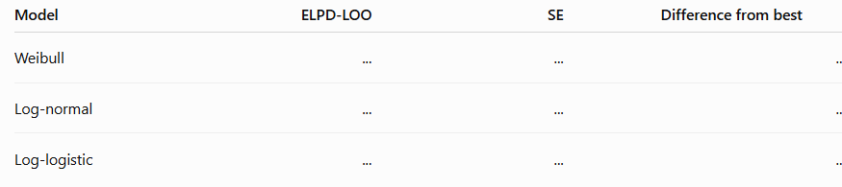
iii. Check clinically relevant survival predictions
Because your actual scientific interest includes survival at 1, 5 and 10 years and compare what the distributions predict at those times.
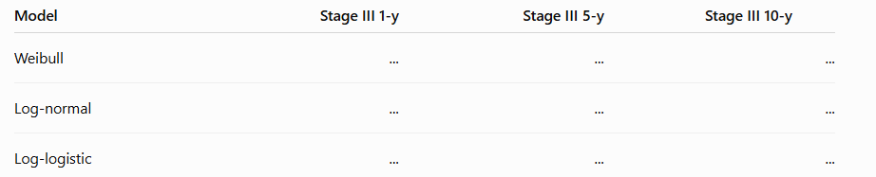
Do the same for your standardized stage curves. This tells you whether your substantive conclusions are sensitive to the assumed distribution.
iv. Check MCMC and model diagnostics for every distribution
A distribution should not be selected just because it has a good LOO value if its posterior sampling is problematic. For each model check: $\overset{ˆ}{R}<1.01,$ adequate effective sample size, trace plots, and no problematic divergent transitions.

