Christopher Corrado

SSW567 Testing, QA, & Maintenance

Week 2 - HW02a

**Description**

Obtain **Triangle.py** and **TestTriangle.py**. Update the existing test cases against the current implementation to improve coverage. Once a reasonable amount of coverage is written, update the logic to **Triangle.py** to be correct.

**Summary**

Initial Results

|  |  |  |  |  |
| --- | --- | --- | --- | --- |
| **Test ID** | **Input** | **Expected Results** | **Actual Result** | **Pass or Fail** |
| testRightTriangleA | 3, 4, 5 | Right | InvalidInput | FAIL |
| testRightTriangleB | 5, 3, 4 | Scalene | InvalidInput | FAIL |
| testEquilateralTriangles | 1, 1, 1 | Equilateral | InvalidInput | FAIL |
| testScaleneTriangle | 14,3,11 | Scalene | InvalidInput | FAIL |
| testIsoceles | 3,3,2 | Isoceles | InvalidInput | FAIL |
| testNegativeValues | -3,-3,-2 | InvalidInput | InvalidInput | PASS |
| testInvalidTriangle | 1,1,5 | NotATriangle | InvalidInput | FAIL |

Improved Results

|  |  |  |  |  |
| --- | --- | --- | --- | --- |
| **Test ID** | **Input** | **Expected Results** | **Actual Result** | **Pass or Fail** |
| testRightTriangleA | 3, 4, 5 | Right | Right | PASS |
| testRightTriangleB | 5, 3, 4 | Scalene | Scalene | PASS |
| testEquilateralTriangles | 1, 1, 1 | Equilateral | Equilateral | PASS |
| testScaleneTriangle | 14,3,11 | Scalene | Scalene | PASS |
| testIsoceles | 3,3,2 | Isoceles | Isoceles | PASS |
| testNegativeValues | -3,-3,-2 | InvalidInput | InvalidInput | PASS |
| testInvalidTriangle | 1,1,5 | NotATriangle | NotATriangle | PASS |

**Additional**

I originally assumed that the logic in Triangle.py was at least somewhat correct. This was quickly disproven through the given Test Cases. I also wrongly assumed the Test Cases provided would at least have proper expected/actual results, but this was also not the case. After getting over these hurdles, updating the test cases based on the logic gates in **Triangle.py** became apparent, so I created at least one test case for each “check” in classifyTriangle().

Screencap of Tests Passing in PyCharm

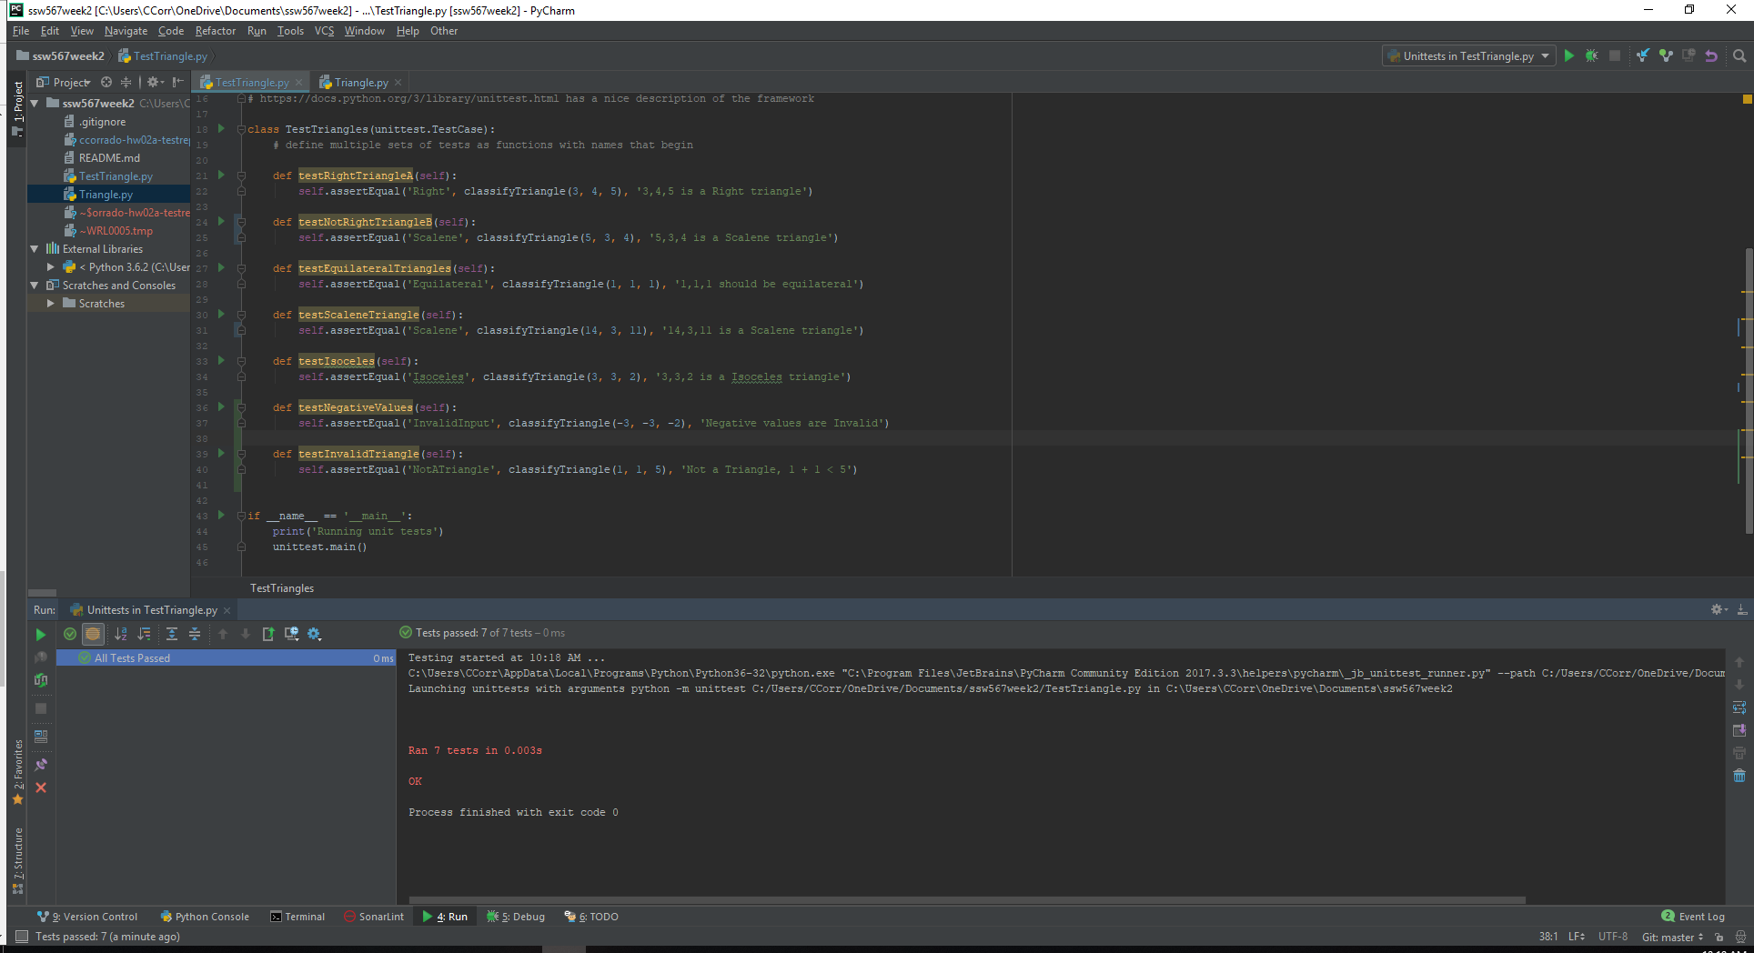

I Pledge my honor that I have abided by the Stevens Honor System