Blueberry Pie

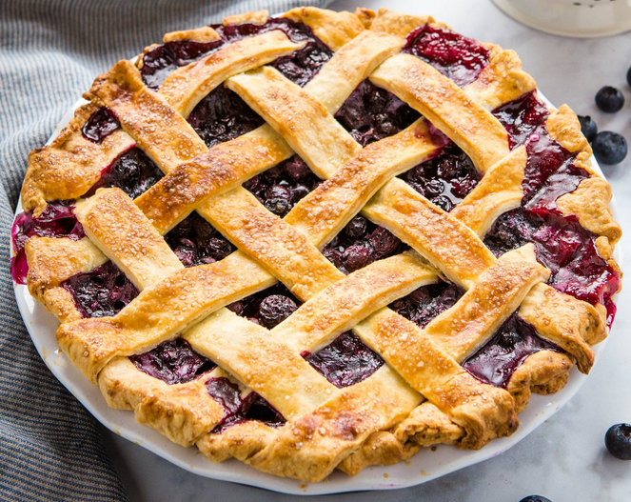

Ingredients
- 1 Cup Granulated Sugar
- 5 Tablespoons Flour
- 1 Tablespoons Corn Starch
- ½ Teaspoon Cinnamon
- 1 Teaspoon Lemon Juice you can add a bit of lemon zest if you want more tartness
- 5 Cups Fresh Blueberries
- 1 1/3 Tablespoons Butter dot the pie filling with butter just before baking
- 1 Large Egg lightly beaten (optional)
- 1 Tablespoon Coarse Sugar for sprinkling on top of the pie crust (optional)

Instructions
- Preheat the oven to 425 degrees
- In a large bowl, mix the granulated sugar, flour, corn starch, cinnamon, lemon juice, and fresh blueberries together and set aside.
- Roll out the Bottom Pastry Crust. Working on a floured surface, roll out one of the discs of chilled dough into a 10-inch circle. Place the dough into a 9-inch pie dish. Gently pat and fit the pastry down into the pan avoiding stretching the dough.
- Trim off the overhanging edges with a scissors.
- Add the blueberry pie filling spreading it evenly into the pie dish. Dot with pieces of butter on top of the filling. Set aside
- Roll out the Top Pastry Crust. Roll out the other disc of pastry for the top crust into a 10-inch circle.
- Moisten the edge of the pastry with a little water.
- Add a top crust or lattice top crust.
- There should be a 1/2-inch extra pastry dough beyond the edge. Trim off any excess beyond that.
- Seal the crusts together around the edge. Fold the extra edge of the top pastry under the edge of the lower pastry. Seal by building up a fluted edge. Crimping the edge between the thumbs and forefingers.
- Bake the pie at 425 degrees Fahrenheit for 30 minutes, then reduce the oven temperature to 375 degrees and continue baking for 20-30 minutes. Until the pie crust is golden in color and the filling is hot and bubbly.

