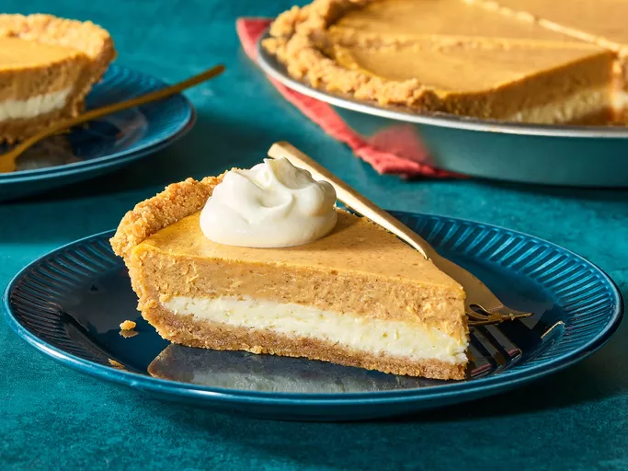

Ingredients
Cheesecake Layer:
- 2 (8 ounce) packages cream cheese, softened
- ½ cup white sugar
- ½ teaspoon vanilla extract
- 2 large eggs
- 1 (9 inch) prepared graham cracker crust
Pumpkin Layer:
- ½ cup pumpkin puree
- ½ teaspoon ground cinnamon
- 1 pinch ground cloves, or more to taste
- 1 pinch ground nutmeg, or more to taste
Directions
Gather the ingredients. Preheat the oven to 325 degrees F (165 degrees C).
To make the cheesecake layer: Beat cream cheese, sugar, and vanilla in a large bowl with an electric mixer until smooth. Add eggs, one at a time, blending well after each addition.
Spread 1 cup batter in the graham cracker crust. (9” crust)
To make the pumpkin layer: Add pumpkin puree, cinnamon, cloves, and nutmeg to the remaining batter; stir gently until well blended.
Carefully spread on top of plain cheesecake batter in the crust.
Bake in the preheated oven until the edges are puffed and the surface is firm except for a small spot in the center that jiggled when the pan is gently shaken, 35 to 40 minutes.
Remove from the oven, set on a wire rack, and cool to room temperature, 1 to 2 hours.
Refrigerate for at least 3 hours before serving, preferably overnight.

