Results

Jenny C. A. Read

21/01/2021

# Comparing memory parameters for clumped vs even conditions

## Overall performance, area under receiver operating characteristic curve

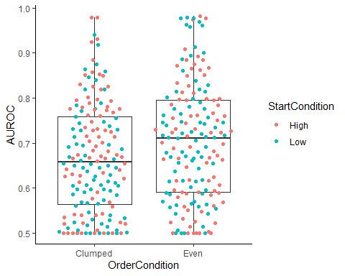

There is a significant difference in overall performance between the two conditions: p=0.0131, Wilcoxon-Mann-Whitney.

## Familiarity parameter d’

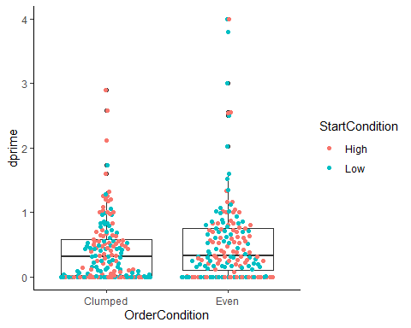

There is no significant difference in the familiarity parameter $d′$ between the two conditions: p = 0.175, Wilcoxon-Mann-Whitney.

## Recollection parameter R

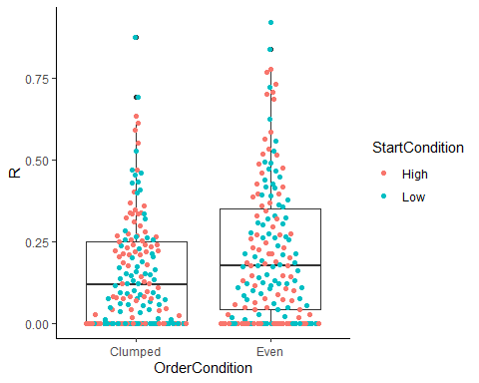

There is a significant difference in the recollection parameter $R$ between the two conditions: p = 0.014, Wilcoxon-Mann-Whitney.

Thus, the difference in performance must be driven by the difference in $R$, not $dprime$.

## Relationship between R and d’

## `geom_smooth()` using formula 'y ~ x'

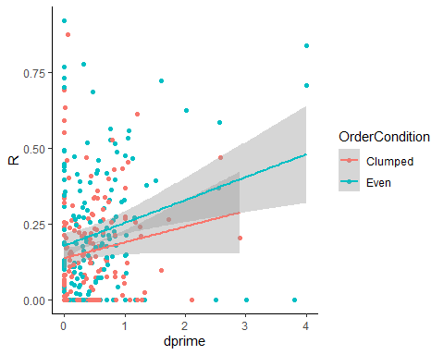

## `geom_smooth()` using formula 'y ~ x'

There is a significant positive correlation between the $R$ and $d′$ parameters: Pearson correlation: rho =0.23, p=3.6e-05, Spearman correlation: rho =0.22, p=7.9e-05.

Note that in any individual fit there tends to be a tradeoff between $R$ and $d′$. So if people were identical and any differences were due to uncertainty in the fit, we would expect a negative correlation. The positive correlation indicates that people are different: those with good recollection also tend to have good $d′$. Note that the slope is the same for both groups, but the R is higher for the “even” group, as we have seen.