Entity Relationship Diagram Mapping

by

Cheryl Dunn

100963953

Prof. Louis D. Nel

School of Computer Science

Carleton University

Ottawa, Ontario

# Abstract

Entity Relationship Mapper (ER Mapper) is an android app that takes an Entity-Relationship diagram (ER diagram) maps it to its Relations, finds Functional Dependencies, perform normalization and creates a Relational database. Users have the ability to draw an ER diagram on a canvas, such that they can create, remove and edit Entity objects from the canvas. When the user is satisfied with their diagram, they can select to save or normalize the diagram into a RelationSchema in third normal form and create a database.

# Acknowledgments

I would like to thank Professor Louis Nel for his support and expert advice as well as for use of his JavaFXNormalizer code which allowed for Functional Dependencies to be normalized preserving lossless join and dependency preservation properties.

Table of Contents

Abstract 2

Acknowledgments 2

Introduction 5

Setup 5

Using emulator in android studio 5

Using an android device. 6

Running the software 6

Work Schedule 6

Research 6

ER Diagram Components 7

Entity Relationship Diagrams 7

Entity objects 8

Attribute 8

Relationship 8

RelationSchema Mapping and Normalization 9

Decomposing Relationships 9

Finding Functional Dependencies 10

Performing Normalization 10

ER Mapper 11

Functional Requirements 11

Use Case Model 12

Use Case Descriptions 15

Object Model 21

Component Classes 24

Functional Dependencies / Dependency Set 26

Logic Classes 26

Results 32

Conclusion 35

References 36

List of Figures

Figure 1. ER Diagram Symbols 7

Figure 2 Weak Entity Example 8

Figure 3 Degree of Relationships 9

Figure 4 High Level ER Mapper Use Case 13

Figure 5. Create Diagram Use Case 14

Figure 6. Normalize Use Case 15

Figure 7. HighLevel UML Models 22

Figure 8. Components UML Model 23

Figure 9. Logic UML Model 27

Figure 10 ERMapper Drawing 29

Figure 11 Completed ERDiagram 30

Figure 12 Normalized ERDiagram 32

Figure 13. Unit Test Console 34

List of Tables

Table 1 Expected and Final Work Schedule 6

Table 2 Summary of Normal Forms Based on Primary Keys and Corresponding Normalization 11

Table 3 List of Functional Requirements 11

Table 4 Use Case Descriptions 15

Table 5. Test Case Matrix 32

# Introduction

Computers have countless applications in the world ranging from text editors to games to security and much more. An important part of each of these application is storing data and information. In some scenarios, the best way to do so is by using a Relational database. Relational databases organize a collection of data as schemas in tables. When designing a database, it is important to organize the data so that it is modeled in a realistic way to support the information being collected, with reduced redundancy. For database designers to organize data they may first make a visual diagram which will allow them to identify Entities, Attributes and their Relationships. An Entity Relationship (ER) Diagram is a widely used method for conceptualizing and visualizing the logical structure of a Relational database. By creating an ER Diagram and normalizing it to its Functional Dependencies Database Designers can easily create an accurate database for whatever data needs to be stored. ERMapper is an android app usable on any android device such as a tablet. Database designers can bring their tablet with them to meetings with the client as well as with their team. This allows for users to quickly and efficiently get an idea of what their database will look like. The ER Mapper is a program that allows users to create an ER diagram and convert it to a Relational database in order to save time, ensure consistency and accuracy. This report Demonstrates how to setup and run the ER mapper program and explains how the program talks an ER Diagram, maps it to its Relations and Functional Dependencies to create a database.

# Setup

The following are instructions that explain how to install and set up the software required to run the ERMapper application in Android studio.

1. Install Android studio 3.0 with :
   * JRE: 1.8.0_152-release-9159b01
   * JVMOpenJDK 64-bit Server VM by JetBrains s.r.o
2. In Android studio go to File -> new -> import Project
   * A dialog will pop up, select the directory where you saved ERMapper directory and the project will open

## Using emulator in android studio

1. In Android studio go to **Tools** > **Android** > **SDK Manager**
2. When the pop up screen opens select **Nougat 7.0.0 or Nougat 7.1.1**
   * ( The program requires a min API Level of 24)
3. In Android studio go to **Tools** > **Android** > **AVD Manager**
4. When the pop up screen opens select create virtual device
   * Go to **Tablets** > **Nexus 10** then press Next
5. On the Next screen make sure the SDK that you choose from step 2 is selected, and then click next and finish

## Using an android device.

1. Enable USB Debugging on your android device
   * Open the **Settings** app.
   * (Only on Android 8.0 or higher) Select **System**.
   * Scroll to the bottom and select **About phone**.
   * Scroll to the bottom and tap **Model number** **7** times.
   * Return to the previous screen to find **Developer options** near the bottom.

# Running the software

Now that you have imported the code and set up all the necessary software you can run the program. Press the green run arrow depicted in the image below, it will launch a prompt that asks you to select a device, you may choose to run on the android device or emulator and press OK. This will install the software onto your android device or launch the emulator. When it is ready the ERMapper will launch.

# Work Schedule

The table below displays the work schedule to complete this project, with expected and final dates.

Table Expected and Final Work Schedule

|  |  |  |  |
| --- | --- | --- | --- |
| **Objective** | **Estimated Time** | **Due Date** | **final date** |
| **Research** | 1 week | Sept 3 | Sept 2 |
| **Identify all functional Requirements** | 2 days | Sept 3 | Sept 2 |
| **Create Structure for ER Diagram including a user interface** | 3 weeks | Sept 30 | Sept 20 |
| **Create structure + objects for Functional Dependencies** | 1 week | Oct 10 | Oct 5 |
| **Write + Submit Mid-term Report** | 1 weeks | Oct 30 | Oct 30 |
| **Add complex Relationships** | 1 week | Nov 10 | Nov 8 |
| **Apply rules to convert ER to FD for complex Relationships** | 3 weeks | Nov 10 | Nov 14 |
| **Implement provided program for FD to DB** | 1 week | Dec 1 | Nov 20 |
| **Write + Submit First Draft report** | 2 weeks | Dec 1 | Dec 1 |
| **Testing and review** | On going | Dec 14 |  |
| **Submit Final Report** | 2 weeks | Dec 15 |  |

# Research

Within this section key ideas and concepts regarding ERDiagrams, FDNormalization and Databases will be identified. Research was taken from *The book Fundamentals of Database* Systems by Ramex Elmasri & Shamkant B. Navathe, as well as from COMP3005 Winter 2015 course notes provided by Professor Louis Nel.

## ER Diagram Components

In order to draw an ER diagram, it is important to understand what they are, along with its components. Components include symbols that are used to represent a different concept in the diagram including Entities, Attributes and Relationships.

### Entity Relationship Diagrams

ER Diagrams are a visualization that represent the Relationships of Entities. Entities, modeled as squares, represent a real-world concept, and create the tables in your Relational database. Attributes, modelled as ovals, represent properties of their corresponding Entity or Relationship and are stored as columns of the Relational table in a database. Every Entity can have multiple Attributes; however it requires at least one Attribute to be a primary key (which uniquely identifies each row in the table). In an ER diagram the key Attribute(s) are identified with an underline underneath their name. A Relationship is a line that connects Attributes and Entities, they may also indicate the cardinality of the Relationship, though at this point the program only deals with binary 1:1 Relationships. *Figure 2. ER Diagram Symbols*, from the book *Fundamentals of Database Systems* below shows the Symbols that may appear in an ER Diagram.

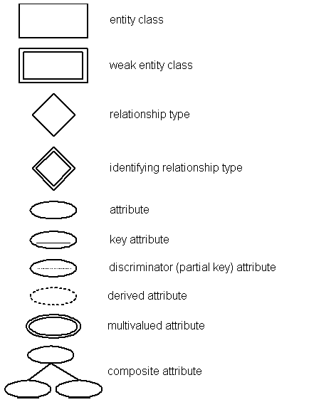

Figure 1. ER Diagram Symbols

### Entity objects

An Entity object is a distinguishable object that is part of the mini-world modeled by the database. In a Relational database, an Entity will be a Relation. Entities can have different types. Regular Entities have a primary key Attribute, and are Strong Entities. Weak Entities cannot be distinguished by themselves as they do not have a unique key Attribute. For a weak Entity to be identified a primary key is defined using a foreign key to its strong Entity and always has a total participation constraint. *Figure 2. Weak Entity Example* shows a weak Relationship where Teacher is the weak Entity, and class is the Strong Entity. The primary key of teacher is “tId”, “code”, where code references the primary key of class.

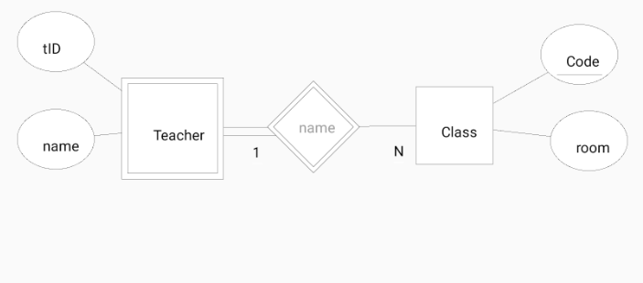

Figure 2. Weak Entity Example

### Attribute

An Attribute property describes an Entity object, and will appear as a column in a Relational table. An Attribute property may also describe a property of a Relationship. In a Relation multiple each Attribute is considered to be a candidate key. From the candidate key, a primary key can be chosen as a unique identifier. A super key is a set of Attributes in a Relation schema, where no two tuples in the Attribute set will have t1[S] = t2[S]. The removal of any Attribute from the super key will prevent it from being a super key. A Foreign key Attribute is an Attribute that references a primary key Attribute of another table. Finally, a Composite Attribute is an Attribute that is composed of several components

### Relationship

A Relationship relates two or more Entities with a specific meaning. The degree of Relationship is the number of Entities that participate in a Relationship. A binary Relationship has a degree of 2, a Ternary Relationship has a degree of 3 and a n-ary Relationship has a degree of N. Each participating Entity in a Relationship can be depicted by its cardinality which can be 1:1, 1:N or M:N. *Figure 3 Relationship Types,* is an example that depicts different types of participation and cardinality of Relations*.*  An Identifying Relationship type relates a weak Entity type to its owner. In *Figure 2, Weak Entity Example,* the Relationship Depends on represents an identifying Relationship.

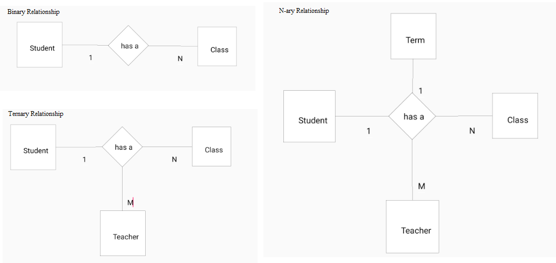

Figure 3 Relationship Types

## RelationSchema Mapping and Normalization

The outcome of this project is a RelationSchema in third normal form that is mapped from the ER diagram drawn by a user. In order to properly create a RelationSchema an algorithm must be used to: convert N-ary Relationships to binary Relationships, find Functional Dependencies and perform normalization.

### Decomposing Relationships

Before normalizing the diagram, The ER diagram gets mapped to a RelationSchema, by looking at each Relationship and its Entities and deriving Relations. As discussed in the research section, a binary Relationship is a Relationship between two Entity objects, a ternary has three Entity objects and n-ary has n Entity objects. Relationships with a higher degree make it harder to specify the constraints of a Relation. Therefore; we can decompose the higher degree Relationships to binary to simplify the process. Decomposition to binary Relationships can be done following steps from *Fundamentals of Database System*s:

1. For each ternary/ n-ary Relationship type R, where n>2, create a new Relationship S to represent R
2. Include as foreign key Attributes in S the primary keys of the Relations that represent the participating Entity types
3. Also include any simple Attributes of the n-ary Relationship type (or simple components of composite Attributes) as Attributes of S

### Finding Functional Dependencies

Once the ER diagram has been mapped to a RelationSchema, it is possible to identify the constraints for each Entity in the system. As defined in section 14.2.1 in *Fundamentals of Database systems:*

“A Functional Dependency, denoted X -> Y, between two sets of Attributes X and Y that are subsets of [Relation] R specifies a *constraint* on the possible tuples that can form a Relation state r of R. The constraint is that, for any two tuples t1 and t2 in r have t1[x] = t2[x], they must also have t1[Y] = t2[y].”

This definition means that for any value Y in a tuple is defined by X and it can be said that Y is functionally dependent on X. A Functional Dependency can have multiple different values, every Attribute of X is called the left had side, and every Attribute of Y is called the right hand side. A set of Functional Dependencies exists for each Relation, where each Relation also must have a primary key. By identifying the Functional Dependencies, it is possible to find redundant and trivial information.

### Performing Normalization

To ensure the RelationSchema has a good design that doesn’t have redundant or trivial information the normalization process is used. Normalization is the process of decomposing RelationSchemas into smaller Relations using their candidate keys and Functional Dependencies (Nel. L. D. Normal Forms). Boyce Codd proposed the normalization process using First Normal Form, Second Normal Form and Third Normal Form. Boyce Codd later suggests Boyce-Codd Normal Form and Fourth Normal Form, but for this project, third normal form is sufficient. In order to be in Third Normal form, each Relation must also meet the requirements for First and Second normal forms which are as follows:

1. First Normal Form: has no composite/multivalued Attributes along with nested Relations
2. Second Normal Form: every non-prime Attribute in a Relation is fully functionally dependent on the primary key
3. Third Normal Form: requires that no nonprime Attribute has transitive dependency, meaning each FD X->Z and Z-> Y. It also must maintain the lossless join property and dependency preservation property
   * The lossless join property ensures that any instance of the original Relation can be decomposed into smaller Relations with no loss of information
   * The dependency preservation property ensures that after the Relation is decomposed each Functional Dependency still holds

To convert Relations into their normal form one can follow the steps provided in *Table 4.* Summary of Normal forms based on Primary Keys and Corresponding Normalization from Fundamentals of Database Systems. The code provided by Professor Louis Nel, handles the normalization contains the code to maintain lossless join property and dependency preservation property.

Table Summary of Normal Forms Based on Primary Keys and Corresponding Normalization

|  |  |  |
| --- | --- | --- |
| **Normal Form** | **Test** | **Remedy** |
| **First (1NF)** | Relation should have no multivalued Attributes or nested Relations | Form a new Relation for each multivalued Attribute or nested Relation |
| **Second (2NF)** | For Relations where primary key contains multiple Attributes, no nonkey Attribute should be functionally dependent of the primary key | Decompose and set up a new Relation for each partial key with its dependent Attribute(s). Make sure to keep a Relation with the original primary key and any Attributes that are fully functionally dependent on it |
| **Third (3NF)** | Relation should not have a nonkey Attribute functionally determined by another nonkey Attribute (or by set of nonkey Attributes). That is, there should be no transitive dependency of a nonkey Attribute on the primary key. | Decompose and set up a Relation that includes the nonkey Attribute(s) that functionally determine(s) other nonkey Attribute(s). |

# ER Mapper

ER Mapper is an android app that allows the user to create an ER Diagram and generate a RelationSchema in third normal form in order to create a database. Below are descriptions of the systems function requirements, use cases, and system models that explain how the system is constructed and function.

## Functional Requirements

The following are the functional requirements of the ER Mapper system. Each functional requirement describes a set of behaviors that can be performed by the user and the system to create and map and normalize an ER diagram.

Table List of Functional Requirements

|  |
| --- |
| 1. User must be able to create/delete Entities |
| * 1. Entities require a primary key, which is a unique name |
| * 1. In the ER diagram the Entity will be represented by a square |
| 1. Users must be able to create/remove Attributes |
| * 1. Attributes must belong to an Entity |
| * 1. Attributes can be composite or multivalued |
| * 1. In the ER diagram the Attribute will be represented by an oval |
| * 1. The Primary Attribute will be the Primary key of the Entity, depicted with an underline |
| 1. Users must be able to create/ remove Relationships |
| * 1. Connections can be between 2 Entities |
| * 1. Connections can be between an Entity and an Attribute |
| * 1. Connections between 2 Attributes show composite or multivalued Attributes |
| * 1. Connects will be depicted with a Line |
| * 1. Relationships will be depicted with a diamond |
| 1. Users must be able to select a Attribute, Entity or Relationship and move it around the screen |
| 1. The system must create an ER Diagram that contains a set of Entities with its Attributes and connections |
| 1. The system must convert the ER diagram into a Relation schema |
| * 1. The system must convert all Relationships to binary Relationships, and then convert each Entity to a Relation |
| 1. The system must identify all Functional Dependencies |
| 1. The system must normalize the Relations into Third Normal Form and maintain lossless join property and dependency preservation property. |
| 1. The system must create a Relational database based on the normalized Relations. |
| 1. The user must be able to save their diagram in XML format |
| 1. The user must be able to save the created sqlite database |
| 1. The system must be able to handle and inform users of errors without crashing |

## Use Case Model

The following section describes the ER Mapper Program use cases. Each use case describes the behavior and functionality as modeled by *Figure 5. High Level ER Mapper Use* Case. The system has only one actor who has an option to create a diagram or normalize a diagram.

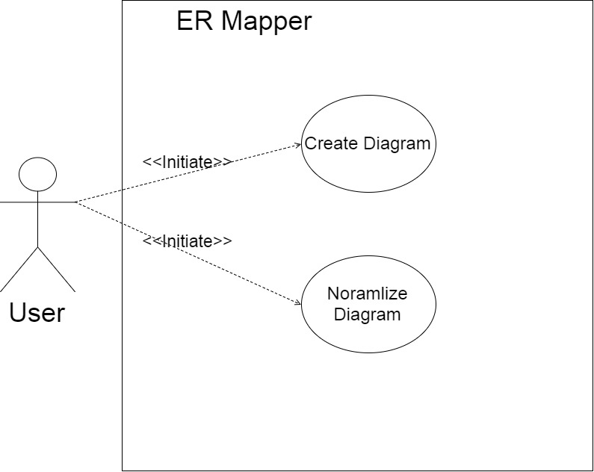

Figure High Level ER Mapper Use Case

The create diagram use case describes the functionality of the system in regard to creating and drawing a diagram, as shown in *Figure 6. Create Diagram Use Case.*

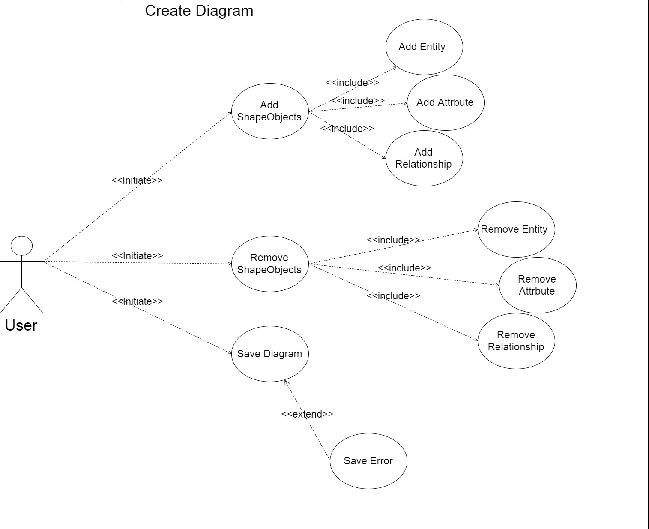

Figure . Create Diagram Use Case

The program also allows for a diagram to be normalize as shown in *Figure 7. Normalize Diagram Use* *Case*. In this process it takes the diagram and maps it to Relations to create a Relation Schema, then takes the schema and places it into third normal form. Placing the schema into third normal form ensures that the database will have a good design by removing any redundant or trivial information and meets all Functional Dependencies.

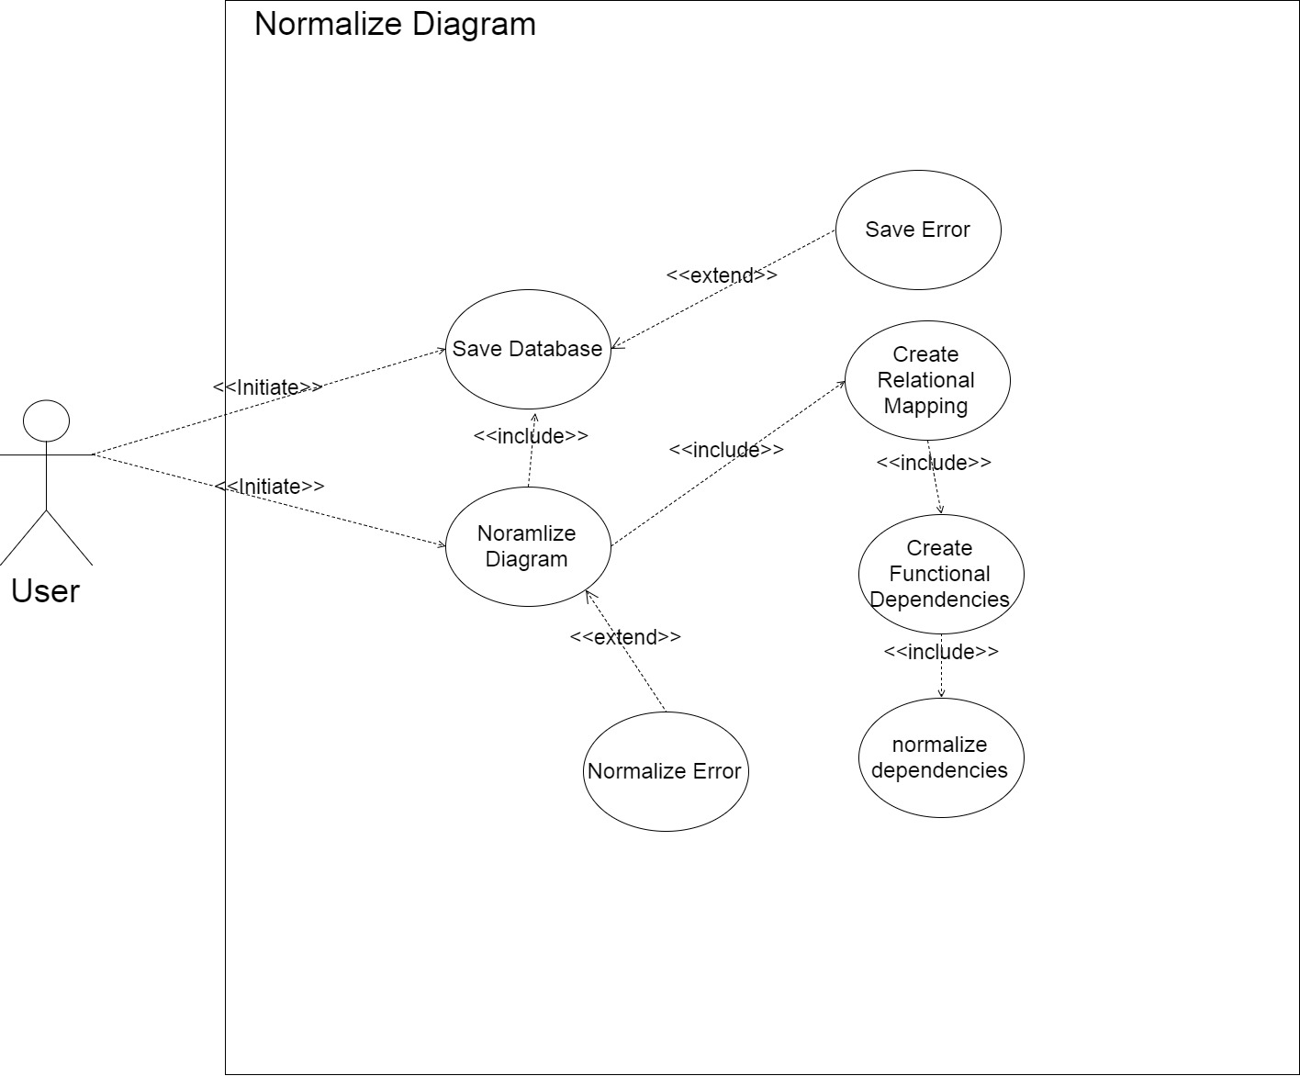

Figure . Normalize Use Case

### Use Case Descriptions

The below table describes the control flow of each use case and offers traceability back to its Functional Dependency.

Table High Level Use Case Descriptions

|  |  |
| --- | --- |
| *Use Case Identifier* |  |
| *Name* | **ERMapper** |
| *Participating actors* | User |
| *Flow of events* | 1.The user selects to create a diagram  a. the system will draw a blank canvas and allow the use to create the diagram  2. the user selects to create the diagram **Include Create Diagram**  3. the user selects to normalize the diagram **include Normalize Diagram** |
| *Entry conditions* | User selects Create new diagram |
| *Exit conditions* | User creates a diagram or exits the system |
| Traceability | F-01, F-09 |
| *Use Case Identifier* |  |
| *Name* | **Create Diagram** |
| *Participating actors* | User |
| *Flow of events* | 1.if the user selects to create an object  a. The system creates a new object of the format selected. **Include addEntity, AddAttribute, AddRelationship.**  Or the user selects to remove an object  2. the user clicks an object  a. the system removes the object corresponding to the object  clicked. **Include removeEnitty, removeAttribute,**  **removeRelationship.**  Or the user selects to save the diagram  b.The system saves the diagram. Include **save Diagram** |
| *Entry conditions* | User selects create Diagram |
| *Exit conditions* | User selects to normalize the diagram, or exits the system. |
| *Traceability* | F-01, F-05, F-06 |

Table . Create Diagram Use Case Descriptions

|  |  |
| --- | --- |
| *Use Case Identifier* |  |
| *Name* | **Normalize Diagram** |
| *Participating actors* | User |
| *Flow of events* | 1.if the user selects to normalize the diagram  a. The system creates a Relation schema. **Include Create Relational mapping.**  b. The system gets a normalize error. |
| *Entry conditions* | User selects create Diagram |
| *Exit conditions* | User selects to normalize the diagram, or exits the system. |
| Traceability | F-09 |
| *Use Case Identifier* |  |
| *Name* | **addEntity** |
| *Participating actors* | User |
| *Flow of events* | 1.The user clicks the Entity button  a. the system creates a new Entity object and draws it to the screen, and adds it to the ShapeObjects list. |
| *Entry conditions* | User selects create an Entity |
| *Exit conditions* | Entity object is drawn to the screen. |
| Traceability | F-02 |
| *Use Case Identifier* |  |
| *Name* | **removeEntity** |
| *Participating actors* | User |
| *Flow of events* | 1. The user selects delete and clicks on an Entity object    1. The system searches the list of drawn objects for the selected Entity   If the Entity is not part of a Relationship   * The sub objects are added to the ShapeObject list * The Entity is removed from the shape object list   If the Entity is part of a binary Relationship   * The system adds the sub objects of the selected Entity to the drawnshapes list. The system adds the other Entity to the ShapeObjects list. The Relationship is removed from the ShapeObject list   If the Entity part of a ternary or n-ary Relationship   * The Entity sub objects are added to the ShapeObject list * The Entity is removed from the Relationship   1. The system redraws the diagram |
| *Entry conditions* | User selects delete an Entity |
| *Exit conditions* | Object deleted and diagram is redrawn. |
| Traceability | F-02 |
| *Use Case Identifier* |  |
| *Name* | **addAttribute** |
| *Participating actors* | User |
| *Flow of events* | 1.The user selects Attribute button  a. The system creates a new Attribute object and draws it to the screen and adds it to the shape objects list |
| *Entry conditions* | User selects create an Entity |
| *Exit conditions* | The Attributed is added and diagram is redrawn |
| Traceability | F-03 |
| *Use Case Identifier* |  |
| *Name* | **removeAttribute** |
| *Participating actors* | User |
| *Flow of events* | 1.The user selects delete and clicks on an Attribute object  a. The system searches the list of drawn objects for the selected Attribute  b. The system takes any sub objects of the Attribute and adds it to the shape objects list, and removes the Attribute object from the drawn list  c. The system redraws the diagram. |
| *Entry conditions* | User selects to remove an Attribute |
| *Exit conditions* | The Attribute is removed and diagram is redrawn |
| Traceability | F-03 |
| *Use Case Identifier* |  |
| *Name* | **addRelationship** |
| *Participating actors* | User |
| *Flow of events* | 1. User selects Relationship button    1. The system creates a new Relationship object 2. The user clicks one object    1. The system sets the center of the object to the initial position, and draws a line from there that follows the mouse. 3. The user clicks a second object    1. The system sets the center of object as the second coordinates of the line.   If the Relationship is between an Entity and an Attribute   * The system adds the Attribute to the Entity Attribute list, and removes the Attribute from the ShapeObjects list.   If the Relationship is between two Attributes   * The system adds the second Attribute to the Attribute list of the first Attribute.   If the Relationship is between two Entities   * The system adds both Entities to the Relationship object. * The system creates cardinalities for each Entity * The Relationship is added to the general ShapeObjects list * Each Entity is removed from the general ShapeObjects list   If the Relationship is between an Entity and an existing Relationship   * The Entity is added to the Relationship object list * The Entity is removed from the ShapeObjects list * The Entity gets a cardinality object   If the Relationship is between an Attribute and a Relationship   * The system adds the Attribute to the Relationship   1. The system redraws the diagram. |
| *Entry conditions* | User selects create a Relationship |
| *Exit conditions* | The diagram is redrawn |
| Traceability | F-04 |
| *Use Case Identifier* |  |
| *Name* | **removeRelationship** |
| *Participating actors* | User |
| *Flow of events* | 1. User delete and clicks a Relationship object    1. The system adds all sub objects of the Relationship to the ShapeObjects list.    2. The system removes the Relationship from the ShapeObject list |
| *Entry conditions* | Relationship is removed, and diagram is redrawn |
| *Exit conditions* | The diagram is redrawn. |
| Traceability | F-04 |

Table . Normalize Diagram Use Case Descriptions

|  |  |
| --- | --- |
| *Use Case Identifier* |  |
| *Name* | **Save Diagram** |
| *Participating actors* | User |
| *Flow of events* | 1. User selects save  a. The system saves the diagram in xml format  b. The system displays a pop up with the a success or error notification |
| *Entry conditions* | The user selects save |
| *Exit conditions* | The user presses ok on the notification. |
| Traceability | F-11 |
| *Use Case Identifier* |  |
| *Name* | **Create Relational Mapping** |
| *Participating actors* | User |
| *Flow of events* | * 1. The system takes Relationships in the diagram and applies the ER-> Relational mapping rules to create all Entities   2. The system creates a Relation for each Entity   If the Entity is not weak   * adds the primary Attributes of the Entity to the primary key, and all Attributes to the candidate keys.   If the Entity is weak   * Adds the primary key of the strong Entity to the weak Entity primary key. Adds all Attributes to the candidate keys.   1. If the Entity has a multivalued Attribute * The system creates a new Relation with the Attribute containing the values list as the primary key * All Attributes in the values list are added to the candidate keys list   1. The system removes any temporary Attributes   2. The system normalizes the schema. **Include create Functional Dependencies** |
| *Entry conditions* | The system creates a new RelationSchema |
| *Exit conditions* | The RelationSchema is created |
| Traceability | F-07 |
| *Use Case Identifier* |  |
| *Name* | **Create Functional Dependencies** |
| *Participating actors* | User |
| *Flow of events* | a. The system creates a new dependency set  b. for each Relation in the schema the system adds the primary key to the left hand side, and the Attributes to the right hand side  c. The system checks if the Functional Dependency is trivial  - if it is not trivial, the Functional Dependency is added to the dependency set  d. the system performs normalization on the dependency set **include Noramlize dependencies** |
| *Entry conditions* | The system created the RelationSchema |
| *Exit conditions* | All Functional Dependencies are created |
| Traceability | F-08 |
| *Use Case Identifier* |  |
| *Name* | **Normalize dependencies** |
| *Participating actors* | User |
| *Flow of events* | * 1. The system finds the minimal cover of the dependency set   2. The system finds all candidate keys of the table   3. The system places any Attributes not in the set in a table of their own. * If none of the tables created contain a candidate key, then a new table is created with the candidate key   1. The system removes any redundant tables |
| *Entry conditions* | The system creates a dependency set |
| *Exit conditions* | The dependency set is normalized |
| Traceability | F-09 |
| *Use Case Identifier* |  |
| *Name* | **Save Database** |
| *Participating actors* | User |
| *Flow of events* | 1.The user clicks create database  a. the system opens connection to sql  b. the system creates a new database  c. the system adds each Relation to the database  d. the system displays a success/error prompt |
| *Entry conditions* | The user selects create database |
| *Exit conditions* | The user accepts prompt notification |
| Traceability | F-10, F-11 |
| *Use Case Identifier* |  |
| *Name* | **Save Error** |
| *Participating actors* | User |
| *Flow of events* | a. the system gets a file not found or database error  b. the file is not created or saved  c. the system displays an error prompt  **extends Save Diagram, Save Database** |
| *Entry conditions* | A save error occurs |
| *Exit conditions* | The user accepts prompt notification |
| Traceability | F-12 |
| *Use Case Identifier* |  |
| *Name* | **Normalize Error** |
| *Participating actors* | User |
| *Flow of events* | * 1. the system gets an exception when trying to parse the ER Diagram, **extends normalize diagram**   2. the system displays an error prompt |
| *Entry conditions* | A normalization error occurs |
| *Exit conditions* | The user accepts prompt notification |
| Traceability | F-12 |

## Object Model

The following diagrams are object models that represent the systems object models. They are packaged into two packages: Components and Logic, shown in *Figure 8*. *High Level UML Models.* The components package contains all the classes that are objects of the system, these classes include anything required to build an ERdiagram or a RelationSchema. The logic package pertains to all classes that control the behavior of the components, including the activity classes.

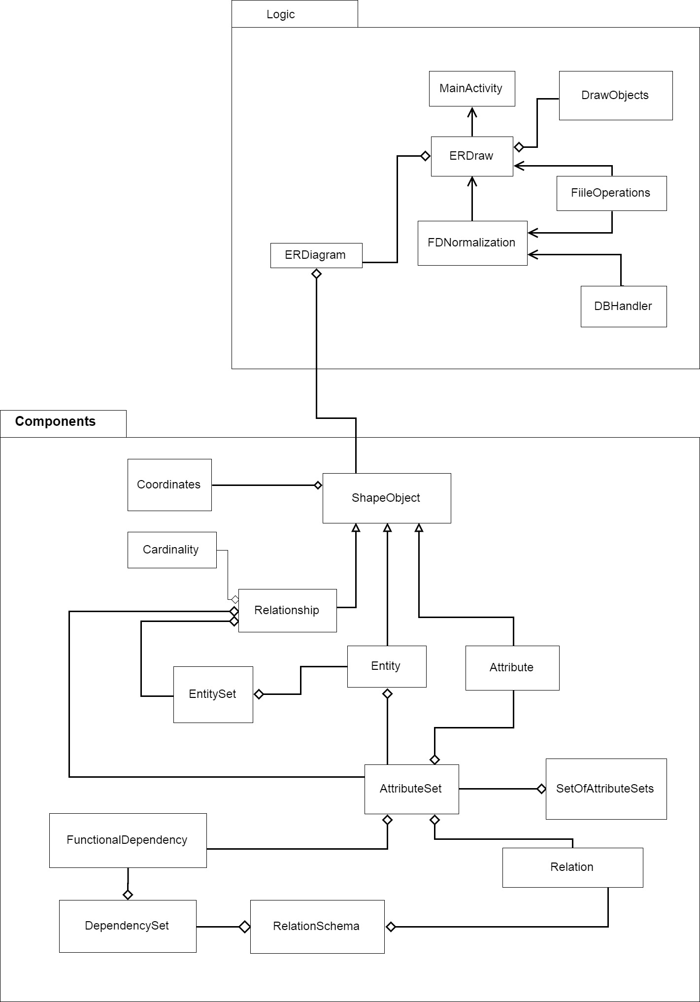

Figure . HighLevel UML Models

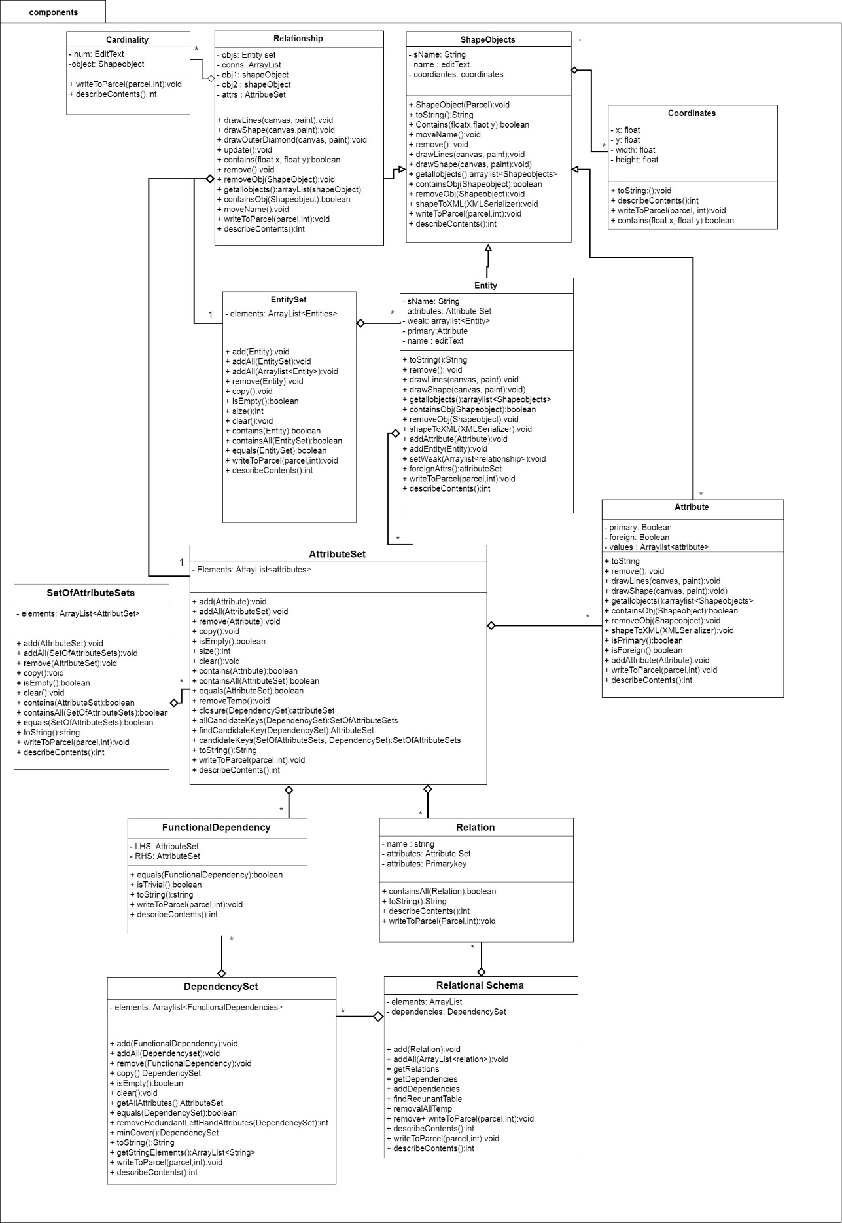

Figure . Components UML Model

### Component Classes

The component classes are modeled in *Figure 9. Components UML Model* and make up all nonlogic classes that represent an idea that needs to be modeled by the ER diagram these classes include:

* ShapeObjects,
* Entity,
* EntitySets,
* Weak Entities,
* Attribute,
* Attribute Set,
* SetOfAttributeSet,
* Relationship,
* Cardinality,
* Relation
* RelationalSchema.

#### ShapeObjects

An ER Diagram is modeled using symbols, called ShapeObjects in the ER Mapper system. A ShapeObject is an abstract class that allows for the diagram to store each ShapeObject and offers for a single interface to be used for each ShapeObjects. Within this class there are several abstract methods that get overwritten by the sub classes defining specific behavior, such as drawLines(), drawShapess(), removeObj(), getallObjects(), that cover the functionality of each ShapeObject type. Each of these objects contains a name, edit text and coordinates which allow form them all to be drawn to the canvas. Each edit text has an event listener attached to it, making it possible for the user to change any object name. ShapeObject extend Parceable so that objects can be passed between android activities. Parceable works, by decomposing an object into a parceable object using the wrtiteToParcel() method, and it then uses the readsFromParcel()method to calls a creator class to reconstruct the object from the parcel.

#### Entity/Entity sets/Weak Enitites

As explained in the research section, an Entity represented a Relational table, which models some aspect of the real world. An Entity is a subclass of a ShapeObject. An Entity is represented as a square, and contains a solid line to connect its Attributes. An Entity contains a list of Attributes along with a list of weak Entities. For an Entity to contain any weak Entities it must be part of a Relationship with a weak Entity. In which case, the weak Entity is drawn as a square outlining the original square, and two solid lines connecting the Relationship to represent total participation in the Relationship. An Entity set, contains a list of unique Entities. An Entity contains its weak Entities in an arraylist instead of an Entity set because, when a parceable creates an Entity Set it calls the creator for an Entity, which causes the creator to get stuck in a loop.

#### Attribute/Attribute sets/SetOfAttributeSets

An Attribute is also a subclass of ShapeObject and its symbol is an oval. Primary Attributes are used to uniquely identify an Entity. An attribute object represents a property of either an Entity or Relationship. In a Relational database where every Entity is a table, each Attribute identifies a column. A primary key is an Attribute that must be unique for ever row in the table. Within the ER Mapper system to create a primary Attribute, a user can double tap the attribute they want in order to set it to primary or remove the primary. A primary key attribute is identified by underlining its name in the ER Diagram. A foreign key is a primary key of a weak Entity that references the primary key of another table. The foreign key will be identified with a dashed underline of the name. Along with being primary and foreign, an Attribute can be multivalued. i.e. it can be broken down into separate components, such as a date of birth, which can be decomposed into year, month, day. If the Attribute is multivalued, the sub Attributes are stored in a list.

An Attribute set, contains a list of unique Attributes. Similar to an Entity when a parceable creates an Attribute set it calls the Attribute creator and gets stuck in a loop, which is why all multivalued Attributes are stored in an array list instead of an Attribute set. Another issue that occurs do to the parceable implementation, is that each time it calls a creator a new instance is created. Therefore; if the same Attribute has two references, the parceable creates two new references for it. Then when checking if an Attribute already contains that Attribute, it does not recognize the objects as the same. As a work around, the Attribute set checks if the names are equal. It is important to note that two Attributes with the same name cannot be added to any Attribute set. When any Attribute is created it is called “object” + count, where the count is incremented for every Attribute created making the name unique for every Attribute, so that it can be added to an Attribute set before given a unique. The SetOfAttributeSets class holds a unique set of Attribute sets.

#### Relationship/Cardinality

A Relationship is another subclass of the ShapeObject which is modeled a line connection between two or more Entity objects. If the Relationship is an identifying Relationship, it gets a diamond with a diamond outline, and has two solid lines to show total participation. A Relationship object may also contain an Attribute set, representing any properties of the Relationship. An Entity set is used to stores all Entities participating in the Relationship. Each Entity in the Relationship can contain a different cardinality in the Relationship. Therefore, for each solid line a cardinality object is drawn. A cardinality object contains an edit text, initially set to 1, and can be modified by the user to model 1:1, 1:N and M:N Relationships.

#### Relations/Relation Schema

The Relation class represents an Relational table, derived from an Entity object and its Attributes and Relationships. A Relation contains an AttributeSet of nonprimary keys, an AttributeSet of primary keys and a name. A Relation is created by iterating through all Entity Attributes, adding each to the Attribute set, checking if the Attribute is primary or foreign, and adding it to the primary set if true. The primary key should be a subset of the Attribute set. A Relation Schema, represents a unique set of Relations. When creating a Relation Schema, the program looks at every object in the general ShapeObject list representation of the ER diagram, and maps it to Relations. The rules for ER to Relational mapping rules from *Fundamentals of Database Systems* is used as follows:

1. For all 1:1 Relationships do
   1. Choose one of the Relations-say S-and include a foreign key in S the primary key of T
   2. It is better to choose an Entity type with total participation in R in the role of S
2. for All 1:N Relationships do
   1. create a Relation S that represent the participating Entity type at the N-side of the Relationship type
   2. Include as foreign key in S the primary key of the Relation T that represents the 1 side of the Relationship type
   3. Include any simple Attributes of the 1:N Relation type as Attributes of S
3. For all M:N Relationships do
   1. For each regular M:N Relationship type R, create a new Relation S to represent R
   2. Include as foreign key Attributes in S the primary keys of the Relations that represent the participating Entity types; their combination will form the primary key of S
   3. Also include any simple Attributes of the M:N Relationship type (or simple components of composite Attributes) as Attributes of S
4. For multivariable Attributesdo
   1. For each multivalued Attribute A, create a new Relation R
   2. This Relation R will include an Attribute corresponding to A, plus the primary key Attribute K-as a foreign key in R-of the Relation that represents the Entity type of Relationship type that has A as an Attribute
   3. The primary key of R is the combination of A and K. If the multivalued Attribute is composite, we include its simple components

Once the ER diagram has been mapped to its RelationSchema, the program can check for constraints and remove any trivial or redundant information.

### Functional Dependencies / Dependency Set

A Functional Dependency represents the constraints on a Relation. A Functional Dependency, contains a left had side with all primary and foreign Attributes of a Relation, as well as a right-hand side with all nonprimary Attributes of a Relation. A Dependency set contains a list of unique Functional Dependencies.

### Logic Classes

All logic classes are shown in *Figure 10. Logic UML Model* the following sections again explains and describes what each class is and how they work.

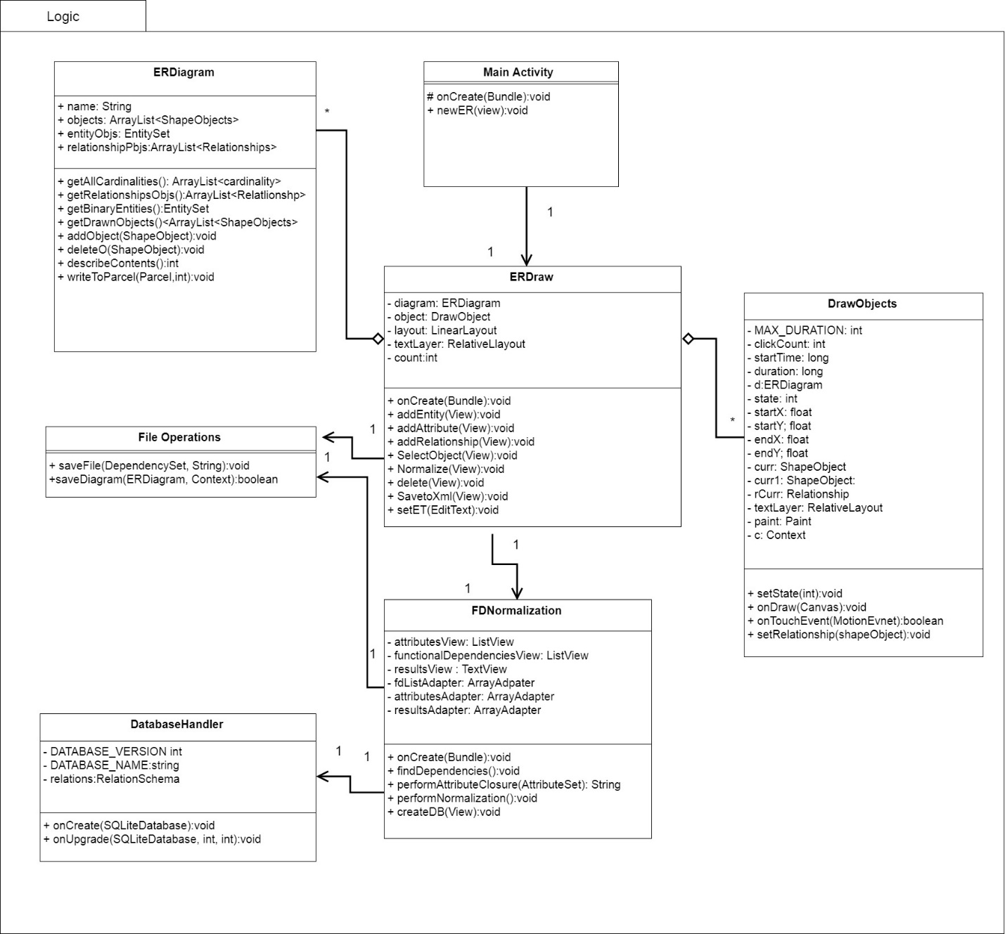

Figure . Logic UML Model

#### Activity Classes

*MainActivity*, *ERDraw* and *FDNormalizations* are each activity classes. According to Android studio API an activity class represents a single screen with a user interface. The MainActivity class is the first screen that appears when the user launches the app, it launches to a screen where the user can select to create a new ERDiagram. From there, the main activity launches the ERDraw activity and passes it a new ER Diagram object. The ERDraw activity creates the interface for the blank canvas. It contains several buttons at the bottom of the screen which allows the user to draw object, adding/removing/editing the ER diagram object. The ERDraw activity also contains a linear layout where all objects are added to, and a Relative Layout where all edit text objects are stored. This allows for all edit text objects to be placed on top of the linear layout so that they are always visible. The user may also select the normalize button which launches the FDNormalization activity, which creates a new interface that displays the RelationSchemas details. The FDNormalization activity has several textview objects within a scroll box that display all information in the system, along with a create diagram button, which will create SQLite database and save it locally to the android device.

#### ER Diagram

The ER Diagram class is used to represent an ER Diagram that will be drawn to a blank canvas. When an object is drawn it is added to an arraylist of ShapeObjects. As each object forms Relationship Attributes and Entities are added to their corresponding owner, then removed from the general ShapeObject list. In doing this it ensures if there exist any objects that are not in a Relationship, they can still get drawn, but removes storing duplicate information. Since the object is removed from the general list, the Draw class searches each object for any of its members to draw instead of just looking at the list. For example, suppose there exist an Entity and Attribute object with no Relationship. Then each object will be stored in the general ShapeObject list.

Now say a Relationship is created between he Entity and Attribute. The Attribute gets added to the Entity Attribute list, along with this a new Relationship is created, storing the Attribute and Entity as objects 1 and 2. Then the Attribute and Entity are removed from the ShapeObject list and the Relationship is added. To draw this Relationship, the Relationship drawLines() method is called to draw the lines between the Entity and Relationship, then the draw shapes method is call to draw the actual Entity and Attribute shapes.

The method getBinaryEntities() is used to look at the diagram and organize it in terms of its Entities. It starts by looping through every Relationship checking if it is not binary and decomposing it to a binary Relationship, using the steps mentioned earlier. In the conversion, several Entity objects will be created. When these Entities are created they are given the Attributes of their connecting Entities**,** in some scenarios this may create an Entity that is trivial, i.e. contains a Functional Dependency X-> Y where Y is a subset of X. To bypass this, it creates a temporary Attribute with a name of “-1”, which allows for the Entity to be considered valid while it gets mapped to a Relation. Once getBinaryEntities() is finished the system will have properly identified all Entity objects and Attributes, and the Entities can be mapped to their Relations using the steps described before in the section on Relations / Relation Schemas. Once the Relation Schema is created, there is a function removeTemps() that removes the temporary Attributes from the Schema.

#### Draw Objects

The ERMapper starts by creating a blank canvas that allows users to draw an ER diagram. The general drawnObjects() method from the ERdiagram class is used to identify which can be Entities, Attributes or Relationships, with their coordinates to be drawn to the screen. The main page of the application seen in *Figure 11. ER Mapper Drawing* shows the canvas of the page, and in the red box identifies the buttons that user can use in order to create new objects.

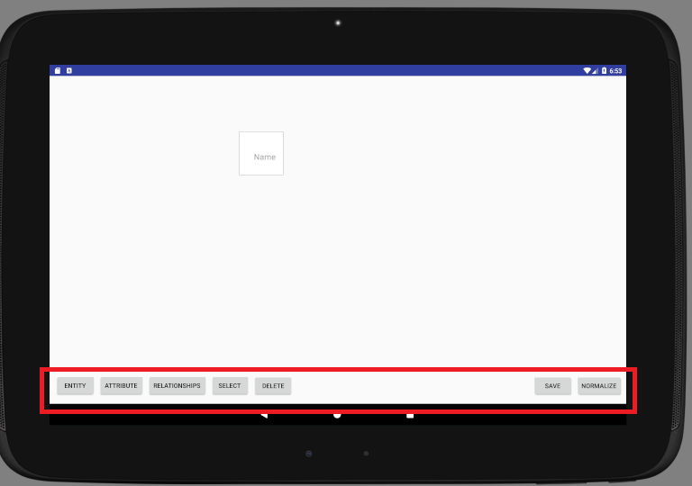

Figure ER Mapper Drawing

Once the user has selected a button, the corresponding object is created. If the user selected to create a Relationship the system creates a line that follows the mouse to connect to objects. If the Relationship is valid then it gets added to the object list. The program searches the ERDiagram list of objects and draws the correct shape, based on the object type onto the screen at the correct coordinates. The canvas also has a motion event listener which activates when the user clicks the screen. It checks if the user has clicked a coordinate that is inside a shape and then allows the user to move that object around the screen, if the object has any Relationships it will also update those coordinates. To create key Attributes a user can double click on the Attribute they want to make key, and an underline will appear. To make a weak Entity the user can double click an Entity. Once the user has completed has completed their drawing they can click normalize to normalize the objects and create a Relation diagram. *Figure 12. Completed ER Diagram* below is an image of a complete ER Diagram.

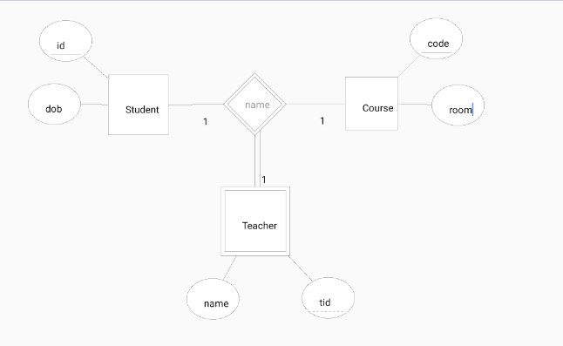

Figure Completed ERDiagram

#### FD Normalization

To normalize the diagram, one must press the Normalize button from the diagram. The ERDraw class will cause the FDNormazliation activity. This class will parse through all of its Relationships and convert them to binary Relationships, and then create an arraylist of Entities which entirely covers the scope of the diagram in terms of Entities, removing redundancy’s and any information that is not relevant to creating a database such as coordinates. It will display any relevant information in system to the screen and offer an object for the user to create a database. *Figrue 12. Normalized ERDiagram,* is an example of the FDNormalization activity. In the results section is a scroll box where the following information is displayed:

1. All Attributes
2. All Functional Dependencies
3. Minimal cover
4. Minimal cover with left had sides merged
5. Checks that the minimal cover is equivilant to all original Functional Dependencies
6. All Attribute keys of a table
7. Lossless-join and Depenency Preserving, 3NF tables
   * This are the tables that will be used to create the database

In order to get all the Attributes, Functional Dependencies and results, the class takes the created RelationSchema, normalizes it and performs Attribute closures. The FDNormalization class calls the getBinaryEntities() which as mentioned before, decomposes all Relationships to binary Relationships and returns a list of all the new and old Entities. The system can then map those Entities to Relations and create a new RelationSchema by using the following steps from the book *Fundamentals of Database Systems*:

1. for all Regular Entity types, assign a Relation, pick a primary key
   1. if the primary key is a complex Attribute: all Attributes will be included
   2. if an Attribute is complex, create a new Relation
2. for all Weak Entities, create a foreign key that references all Primary keys of its Strong Relation

Once the Relation Schema is mapped each Functional Dependency is identified such that any primary key in a Relation must functionally determine all other Attributes in the Relation. To do this the program sets the primary key to the left hand side of the Functional Dependency and all other Attributes to the right hand side. From the Functional Dependencies and primary keys of each Relation, the system can use the performnormalization() method which applies the steps that were mentioned earlier, to normalize the RelationSchema into Third Normal Form. The code that handles checking lossless-join and dependency preservation properties was provided by Professor Louis Nel. The algorithm itself was based on the four-step algorithm 16.6 presented *Fundamentals of Database systems*, which decomposes a set of Attributes with respect to Functional Dependencies F.

1. find a minimal cover Fm of F
2. for each left hand side X of FD in Fm create with columns X U A1 U A2 U ...An where X->A1, X->A2,... X->An are all the dependencies in Fm with left hand side X
3. if none of the tables created in Step 2 contains a candidate key for the universal Relation consisting of all the Attributes, then create a table consisting of a candidate key remove redundant tables. If any table is a projection of another (has all its columns appearing in another table), it is removed table

*Figure 13, Normalized ER Diagram,* shows the screen that gets displayed after the normalization process which displays the System Results. The results screen prints out information relevant to the process including, finding the minimal cover of the Relations, and finding all candidate keys which prove that the lossless join property and dependency preservation property hold still.

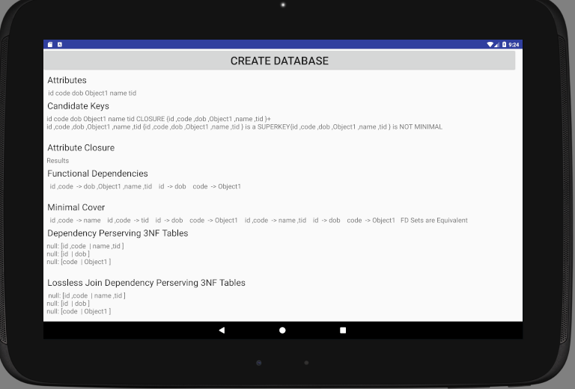

Figure 9 Normalized ERDiagram

# Results

To ensure that the system works correctly, and its actual outputs match its expected outputs, there were a series of unit tests done using unit Tests. To view the test results, in android studio, beside the green run arrow there is a dropdown box that currently says “app”, from the drop down click “All in Logic” and then press run. This will run all tests in the system and display their output to the console at the bottom of screen. The logic unit test cases test that methods have the desired response of the system to ensure that the ERDiagram is properly created and normalized. Along with the logic test cases are the diagram and database test cases which test the system response to the user in the expected way. To run tests that require emulation from the same drop down as before select “Diagram Test”, or “Database Test”. *Table 5. Test Matrix* shows all tests that were run in what test suite they will run in and how they traceback to the Functional Dependencies. *Figure 14. Unit Test Console* shows all the tests that where performed along with their output.

Table . Test Case Matrix

|  |  |  |
| --- | --- | --- |
| Test Cases | Location | Traceability |
| addAttribute() | Logic | F-02 |
| AddAttributeToEntity() | Logic | F-01, F02 |
| addEntity () | Logic | F-01 |
| addRelationship() | Logic | F-03 |
| canRemoveWeakEntity() | Logic | F-01 |
| CreateAttribute() | Diagram | F-03 |
| CreateDB() | Database | F-09, F-11 |
| CreateEntity() | Diagram | F-01 |
| CreateRelationship() | Diagram | F-02 |
| CreateWeakEntity () | Logic | F-01 |
| DeleteObject() | Diagram | F-01, F-02, F-03 |
| NormalizationTest.FunctionalDependencies () | Logic | F-07, F-08 |
| NormalizationTest.GetAllEntityObjects () | Logic | F-08 |
| NormalizationTest.RelationSchema() | Logic | F-06, F-08 |
| removeAttribute() | Logic | F-02 |
| removeAttriubteFromEntity() | Logic | F-02 |
| removeEntity() | Logic | F-01 |
| removeEntityFromBinaryRelationship() | Logic | F-01, F-03 |
| removeEntityFromTernaryRelationship() | Logic | F-01, F-03 |
| removeEntityWithAttriubte() | Logic | F-01 |
| Save() | Diagram | F-10 |
| SelectObject() | Diagram | F-04 |
| setPrimaryAttribute() | Logic | F-02 |

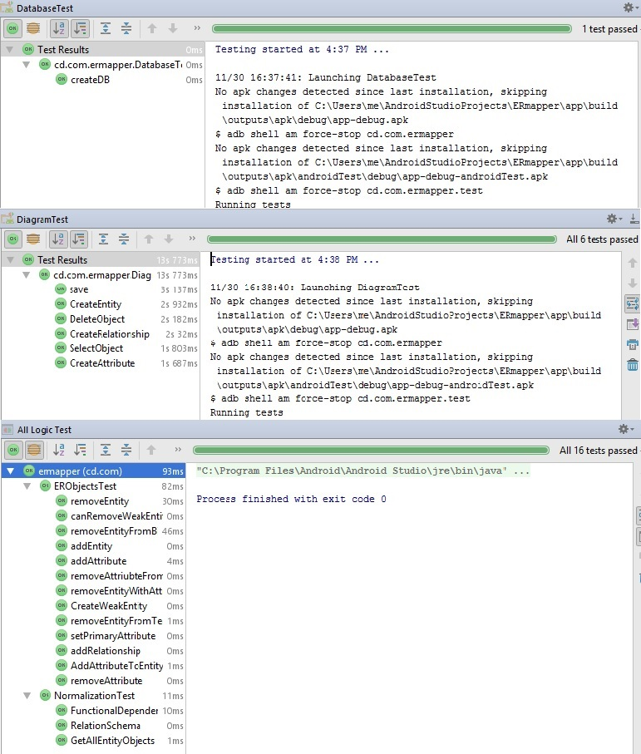

Figure . Unit Test Console

# Conclusion

The purpose of this project was to create an android app that will allows uses to drawn ER diagram and automatically generate the corresponding RelationSchema. The ERMapper program successfully meets all of its functional requirements and successfully creates a Relational database. The ER Mapper offers a simple and effortless way for database designer to quickly create a database and have an idea of how the mini-world they are modelling is related. Some issues with the system include double clicking to create a primary Attribute or set a weak Entity does not always work the first time, and you have to click 3-5 times to get the desired result. When mapping Relationships to their Entities in the getBinaryEntites() method, the system does not handle Relationships that are greater than ternary. The system also does not have a clear understanding of what the user wants as the ER diagram is ambiguous. Therefore, if you make an error in your diagram the program will not be able to fix it. Future work for the system include fixing the current issues with system, including allowing for it to handle more complex Relationships. The system could also include creating a file opener so that users can load already existing diagrams from their XML format into the system. Another downside of the system is that is works only on android devices. Which makes it difficult to access any files that are saved. By creating the same system as web application so that it is accessible on none android devices. Overall the project was a success and even though there are few systems that generate databases from an ER diagram, the ER Mapper proves that it can be done, and with a little bit more work it has a real practical application.

# References

Activity. (2017, October 25). Retrieved November 20, 2017, from

https://developer.android.com/reference/android/app/Activity.html

Elmasri, R., & Navathe, S. (n.d.). *Fundamentals of Database Systems*. Don Mills, Ont.:

Addison-Wesley.

Nel, L. D. (2017, November). *Algorithmic Design With Normal Forms*. Reading.

Nel, L. D. (2017, November). *Modeling ER Features with Functional Dependencies*. Reading.

Nel, L. D. (2017, November). *Normal Forms*. Reading.