**Team**: Redskins

**Proposal**:

* Encrypt a video frame by frame, applying an encryption algorithm to each pixel in the frame.
* frames = 30 frames per second * length of video
* frames * pixels per Image = amount of pixels to calculate

**Algorithm to parallelize**:

* Chaotic sequence generator
* https://arxiv.org/pdf/1208.0999.pdf

**Independent subtasks**:

* For a 3 value 2D tensor (Matrix that each element is a 3 value vector) the idea is to apply the Chaotic sequence generator to each pixel ( image size of 1080 x 1080 = 1,166,400 pixels)

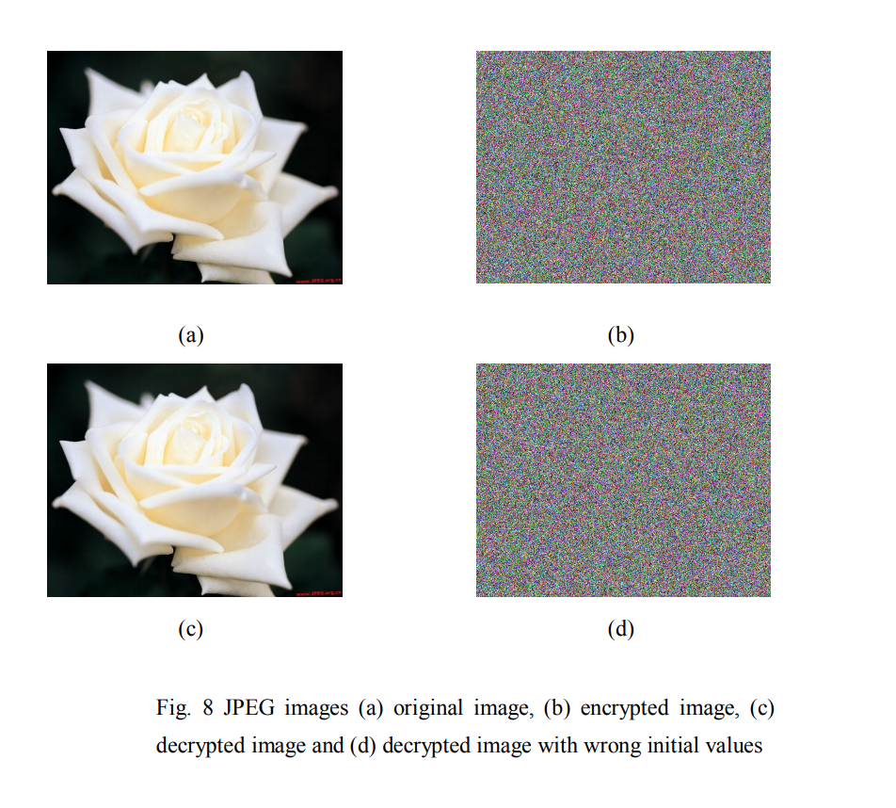

**Technique**:

* GPU