A

Project Report On

PCI DATA ACQUISITION CARD DRIVER
FOR
ESA PCI DAS
(Linux Device Driver Project)

SUBMITTED IN PARTIAL FULFILLMENT
FOR THE AWARD OF

DIPLOMA IN SYSTEM SOFTWARE DEVELOPEMENT
From C-DAC, ACTS (Bangalore)

Guided by:-

Mr. KRISHNA .C

Presented by

Aldonraj PRN: 150250122001
Asheerudin Khilji PRN: 150250122004
Deepak Kumar PRN: 150250122006
Shreyas. H PRN: 150250122028

CENTER FOR DEVELOPMENT OF ADVANCE COMPUTING

ACTS-BANGALORE

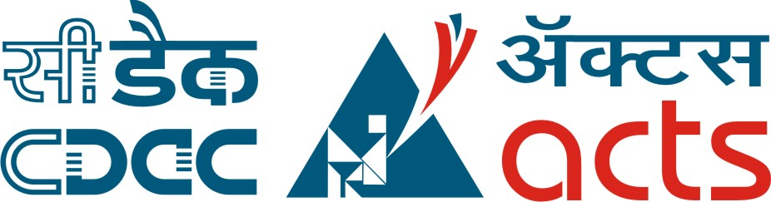

CERTIFICATE OF APPROVAL OF PROJECT WORK

This is to certify that the project report entitled “PCI DATA ACQUISITION CARD DRIVER FOR ESA PCI DAS” is a bonafide work carried out by Paramdeep Singh (E045), Radhika S (E050) and Vinutha L (E072) in fulfillment for the award of “Diploma in System Software Development”
Place: CDAC-ACTS, Bangalore, Feb-2015 Batch.

Signature Signature
Mr. Krishna Ms. Savitri
Project Guide Course Coordinator

