CHAPTER 1

INTRODUCTION

Chapter 1
Introduction
1.1 Introduction
Today, Linux is not only used as desktop and server operating system but also in embedded devices. For Linux, there exist lots of Open Source device drivers. One advantage is the availability of good Open Source components to build this applications rapidly One of the many advantages of free operating systems, as typified by Linux, is that their internals are open for all to view. The operating system, once a dark and mysterious area whose code was restricted to a small number of programmers, can now be readily examined, understood, and modified by anybody with the requisite skills. Linux has helped to democratize operating systems.
Device drivers take on a special role in the Linux kernel. They are distinct “black boxes” that make a particular piece of hardware respond to a well-defined internal programming interface; they hide completely the details of how the device works.

1.2 Problem Statement
The project is the Implementation of device driver for PCI ESA-DSA card in RTAI environment using C programming language. The RTAI-3.5 does not have a driver for this card. This card consists of:
1. One 12 bit ADC (10us),
2. Two 12 bit DAC,
3. 24 Programmable Digital Input/Output lines using 8255
4. Three 16 bit Programmable Timer / Counter using 8254.

- The data inputs will be in form of analog information which will be given to ADC. For DAC, the input will be some digital data. The data outputs will be according to the inputs provided.
- The driver must consider the concurrency issues for a device. The driver should maintain the list of devices it is handling.
- The driver for this PCI card is expected to work for RTAI environment. So it should satisfy real time constraints.

1.3 Real Time Device Drivers
The device drivers can be seen as a software layer that lies between the applications and the actual device. Device drivers are integral components of operating systems. The computational workloads imposed by device drivers tend to be aperiodic and unpredictable because they are triggered in response to events that occur in the device, and may arbitrarily block or preempt other time-critical tasks. This characteristic poses significant challenges in real-time systems, where schedulability analysis is essential to guarantee system-wide timing constraints. At the same time, device driver workloads cannot be ignored.

1.4 Motivation
The objective of writing Device Driver for the PCI (ESA-DAS) card is to increase efficiency of RTAI to communicate with this type of PCI DAS cards. The prediction and enhancement of efficiency of the kernel comes in to play after this type of generic driver

CHAPTER 2

Literature Survey

Chapter 2
Literature Survey
2.1 Device Drivers
A device driver is the set of kernel routines that makes a hardware device respond to the programming interface defined by the canonical set of VFS functions (open, read, lseek, ioctl, and so forth) that control a device. The actual implementation of all these functions is delegated to the device driver. Because each device has a different I/O controller, and thus different commands and different state information, most I/O devices have their own drivers.
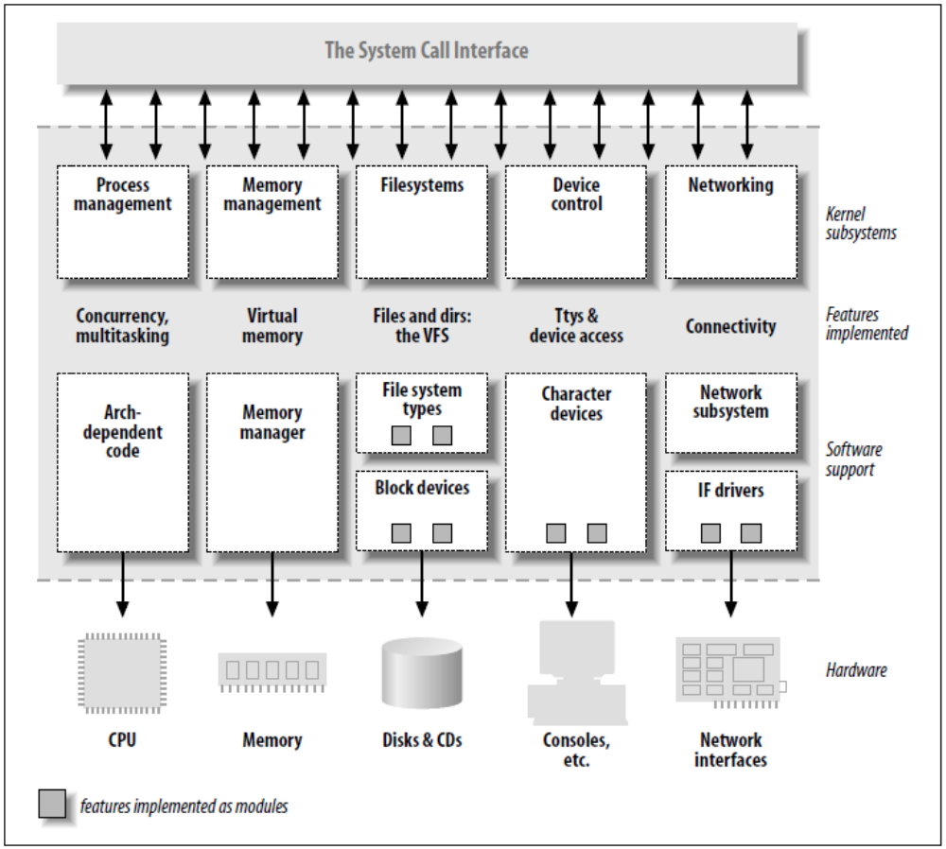

The three classes of devices are:
Character devices:
A character (char) device is one that can be accessed as a stream of bytes (like a file); a char driver is in charge of implementing this behavior. Such a driver usually implements at least the open, close, read, and write system calls. Char
devices are accessed by means of filesystem nodes, such as /dev/tty1 and /dev/lp0. The only relevant difference between a char device and a regular file is that you can always move back and forth in the regular file, whereas most char devices are just data channels, which you can only access sequentially.
Block devices:
Like char devices, block devices are accessed by filesystem nodes in the /dev
directory. A block device is a device (e.g., a disk) that can host a filesystem. Linux allows the application to read and write a block device like a char device—it permits the transfer of any number of bytes at a time. As a result, block and char devices differ only in the way data is managed internally by the kernel, and thus in the kernel/driver software interface.
Network interfaces:
Any network transaction is made through an interface, that is, a device that is
able to exchange data with other hosts. A network interface is in charge of sending and receiving data packets, driven by the network subsystem of the kernel, without knowing how individual transactions map to the actual packets being transmitted. Network devices are, usually, designed around the transmission and receipt of packets. A network driver knows nothing about individual connections; it only handles packets.
Communication between the kernel and a network device driver is completely different from that used with char and block drivers. Instead of read and write, the kernel calls functions related to packet transmission.
Loading & Unloading Device Drivers:
Most modern kernels can dynamically load & unload some portions of the kernel code, which are usually called modules. These modules can be linked on demand.
To load & unload device drivers dynamically in the kernel, they are built in form of modules. Modules are stored in the filesystem as ELF object files. A user can link a module into the running kernel by executing the insmod utility. A module can be un-linked from kernel by executing the rmmod utility.
Kernel modules usually provide two functions:
An initialization function is called if the module is loaded. It usually scans for hardware, registers functions that are called later and allocates memory. Such functions can be callback functions at different subsystems like the PCI subsystem or interrupt handlers. This function is required to load the kernel module.
A clean-up function usually reverts all the steps done in the initialization function in reverse order. It is possible for a module to provide only the initialization function; this means that it is impossible to unload the module
The reason why the license of the module must be specified in the module source code is that only modules with a GPL-compatible license such as GPL itself or the BSD license are supported by the kernel developers. If a proprietary module is loaded, a so-called “tainted” flag is set. If this flag is set, bug reports are ignored in the kernel mailing list because the source code of the module isn’t available and that module could cause the problem and makes debugging much more complicated. Most kernel developers think that proprietary kernel modules are even illegal because linking GPL code with non-GPL code is not allowed in general.

2.2 Hardware Communication
Communicating with hardware in a device driver means
• accessing I/O ports;
• accessing I/O memory regions and
• responding to interrupts.

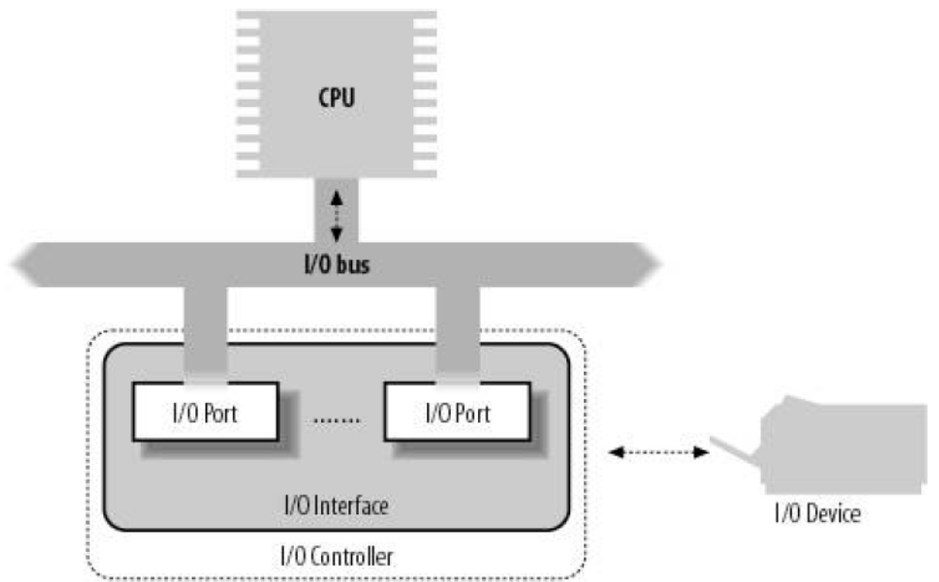

I/O Ports and I/O Memory
Hardware registers can be mapped in memory, which makes it possible to address a hardware register by dereferencing a pointer. Such memory is called I/O memory. Especially from the ISA bus on the PC architecture, the concept of I/O ports is known: a separate address space for devices. The programmer uses the inb and outb instructions to access the I/O space.
So the main difference between I/O memory and I/O ports is that to access I/O memory, the same machine instructions can be used as to access RAM and special instructions are needed to access I/O ports. As it’s important that only one

device driver uses a certain resource, the Linux kernel has functions that can allocate or release regions of I/O ports and I/O memory. After allocating an I/O region, the I/O ports can be accessed in the driver.
To access I/O memory, it must be made accessible by the driver first by calling the I/O memory map function. The kernel makes sure that the memory is accessible from the kernel virtual address space which is not identical to physical address space.

Interrupts:
Using interrupts in Linux device drivers is quite straightforward: at initialization time, a normal C function is registered by calling request_irq() with the IRQ number and a function pointer as parameter. If the requested interrupt occurred, the function gets executed. Linux supports interrupt sharing with the SH_IRQ flag when requesting the interrupt. If this flag is set, the interrupt service routine must find out first if the device for which it is responsible generated the interrupt.
In RTAI environment, where Real Time Driver Model (RTDM) is used, rtdm_irq_request () is used to install an interrupt handler.
We need a quick, asynchronous, simple handler for immediately responding to hardware and performing any time-critical actions. Interrupt handlers serve this function well; but other, less critical work should be deferred to a later point when interrupts are enabled.
In Linux environment managing interrupts is divided into two parts, or halves. The first part, interrupt handlers (top halves), are executed by the kernel asynchronously in immediate response to a hardware interrupt. For bottom half processing 3 mechanisms are provided: Soft IRQs, Tasklets and Work queues.
However in RTAI environment, the work in interrupt handler can be deferred using a Real-Time task (rt_task).

2.3 PCI Drivers
Introduction to PCI
Peripheral Component Interconnect (PCI), as its name implies is a standard that describes how to connect the peripheral components of a system together in a structured and controlled way. The standard describes the way that the system components are electrically connected and the way that they should behave.
The PCI architecture was designed with three main goals:
- to get better performance when transferring data between the computer
and its peripherals
- to be as platform independent as possible
- to simplify adding
And removing peripherals to the system

The most relevant part to the PCI driver writer is PCI’s support for autodetection
of interface boards. PCI devices are jumper less and are automatically configured at boot time. Then, the device driver must be able to access configuration information in the device in order to complete initialization.

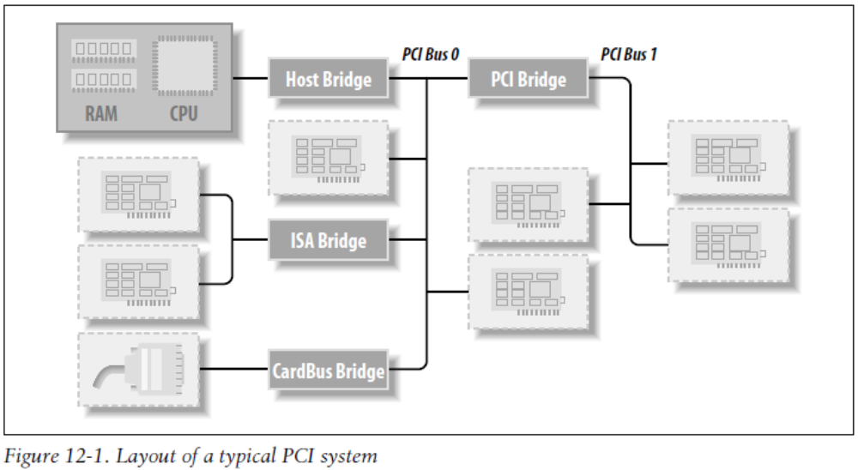

PCI Addressing
Each PCI peripheral is identified by a bus number, a device number, and a function number. The PCI specification permits a single system to host up to 256 buses. Each bus hosts up to 32 devices, and each device can be a multifunction board (such as an audio device with an accompanying CD-ROM drive) with a maximum of eight functions. Therefore, each function can be identified at hardware level by a 16-bit address, or key.
Device drivers written for Linux use a specific data structure, called pci_dev, to act on the devices.

Three Address Spaces: I/O, Memory & Configuration
The hardware circuitry of each peripheral board answers queries pertaining to three address spaces: memory locations, I/O ports, and configuration registers. The first two address spaces are shared by all the devices on the same PCI bus (i.e., when you access a memory location, all the devices on that PCI bus see the bus cycle at the same time). The configuration space, on the other hand, exploits geographical addressing. Configuration queries address only one slot at a time, so they never collide.
As far as the driver is concerned, memory and I/O regions are accessed in the usual ways via inb, readb, and so forth. Configuration transactions, on the other hand, are performed by calling specific kernel functions to access configuration registers.
The I/O space in a PCI bus uses a 32-bit address bus (leading to 4 GB of I/O ports), while the memory space can be accessed with either 32-bit or 64-bit addresses. These addresses are supposed to be unique to one device, but software may erroneously configure two devices to the same address, making it impossible to access either one.
Every memory and I/O address region offered by the interface board can be remapped by means of configuration transactions. That is, the firmware initializes

PCI hardware at system boot, mapping each region to a different address to avoid collisions. The addresses to which these regions are currently mapped can be read from the configuration space, so the Linux driver can access its devices without probing. After reading the configuration registers, the driver can safely access its hardware.

PCI Configuration Space:
The PCI configuration space consists of 256 bytes for each device function
The first 64 bytes are standardized, while the rest are device dependent.
Figure shows the layout of the device independent configuration space.

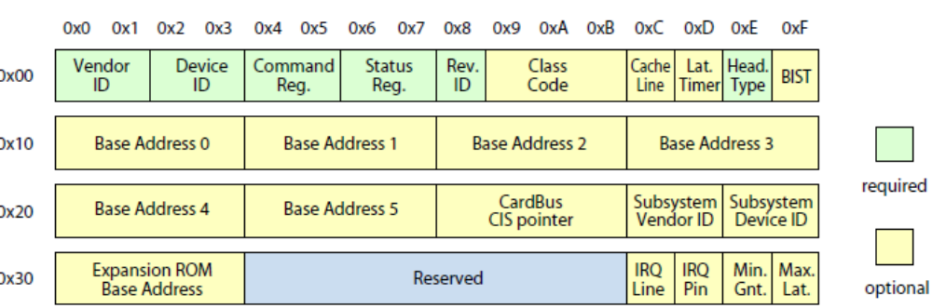

Vendor Identification - A unique number describing the originator of the PCI device. Digital's PCI Vendor Identification is 0x1011 and Intel's is 0x8086.

Device Identification - A unique number describing the device itself. For example, Digital's 21141 fast Ethernet devices have a device identification of 0x0009.

Status - This field gives the status of the device with the meaning of the bits of this field set by the standard. .

Command - By writing to this field the system controls the device, for example allowing the device to access PCI I/O memory

Class Code - This identifies the type of device that this is. There are standard classes for every sort of device; video, SCSI and so on. The class code for SCSI is 0x0100.

Subsystem vendorID & subsystem deviceID - These fields can be used for further identification of a device. If the chip is a generic interface chip to a local (onboard) bus, it is often used in several completely different roles, and the driver must identify the actual device it is talking with. The subsystem identifiers are used to this end.

Base Address Registers - These registers are used to determine and allocate the type, amount and location of PCI I/O and PCI memory space that the device can use.

Interrupt Pin - Four of the physical pins on the PCI card carry interrupts from the card to the PCI bus. The standard labels these as A, B, C and D. The Interrupt Pin field describes which of these pins this PCI device uses. Generally it is hardwired for a particular device. That is, every time the system boots, the device uses the same interrupt pin. This information allows the interrupt handling subsystem to manage interrupts from this device,

Interrupt Line - The Interrupt Line field of the device's PCI Configuration header is used to pass an interrupt handle between the PCI initialization code, the device's driver and Linux's interrupt handling subsystem. The number written there is meaningless to the device driver but it allows the interrupt handler to correctly route an interrupt from the PCI device to the correct device driver's interrupt handling code within the Linux operating system.
2.4 RTAI Environment
RTAI (Real Time Application Interface) is an extension for original Linux kernel which enables real time services. This is made by means of RTAI tasks (RTASK), in kernel or user space. Kernel tasks run in kernel space within kernel modules. User space tasks are user applications threads which are switched to RTASKs with a given priority. Tasks can also be made periodic. The user space realtime framework is named LXRT.
The Real Time Driver Model:
The Real-Time Driver Model (RTDM) is an approach to unify the interfaces for developing device drivers and associated applications under RTAI.
The RTDM is intended to act as a mediator between the application requesting a service from a certain device and the device driver offering it.
The following figure shows RTDM & related layers :
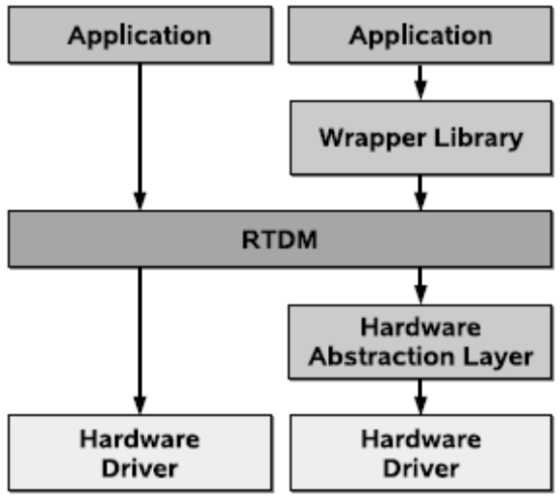.
RTDM supports two different types of devices.
1. Protocol Devices: All message-oriented devices fall in this group.
Protocol devices are registered using two identifiers, the protocol family and the

Socket type. They are addressed according to the POSIX socket model, i.e. by invoking socket () for creation and close () for destruction. At the least, they have
to provide support for sending and receiving messages: sendmsg() and recvmsg() on which send()/sendto() and accordingly recv()/recvfrom() are mapped internally. Moreover, drivers of protocol devices may handle
Requests issued via ioctl (). This interface is also used to pass the remaining socket calls bind (), connect (), listen (), accept (), shutdown (), getsockopt (), setsockopt (), getsockname (), and getpeername () to the driver. This mapping has been chosen to avoid creating a significant amount of entry points in the RTDM layer for only infrequently used functions.

2. Named Devices: These devices are registered with the real-time subsystem under a unique clear-text name and can then be instantiated using the open() function. RTDM does not maintain a specific naming hierarchy or file system. Basically, drivers are free in choosing device names, but regular schemes are specified for common classes in device profiles. Named devices can be subdivided into those which support stream-oriented I/O (read ()/write ()) and those that solely offer functionality via the ioctl () interface.

2.5 Data Acquisition Systems

Data acquisition is the sampling of the real world to generate data that can be manipulated by a computer. Sometimes abbreviated DAQ or DAS, data acquisition typically involves acquisition of signals and waveforms and processing the signals to obtain desired information. The components of data acquisition systems include appropriate sensors that convert any measurement parameter to an electrical signal, then conditioning the electrical signal which can then be acquired by data acquisition hardware.

Source
Data acquisition begins with the physical phenomenon or physical property of an object (under investigation) to be measured. This physical property or phenomenon could be the temperature or temperature change of a room, the intensity or intensity change of a light source, the pressure inside a chamber, the force applied to an object, or many other things. An effective data acquisition system can measure all of these different properties or phenomena.

DAS hardware
DAS hardware is what usually interfaces between the signal and a PC. It could be in the form of modules that can be connected to the computer's ports (parallel, serial, USB, etc...) or cards connected to slots (PCI, ISA, PCI-E, etc...) in the mother board. Usually the space on the back of a PCI card is too small for all the connections needed, so an external breakout box is required.
DAS-cards often contain multiple components (multiplexer, ADC, DAC, TTL-IO, high speed timers, RAM). These are accessible via a bus by a micro controller, which can run small programs.

DAS software
DAS software is needed in order for the DAS Hardware to work with a PC. This can come in at least three flavors: applications that register directly from the hardware, low-level software driver (usually packaged with the DAS hardware) to allow developing higher level applications to register data coming from the hardware and off-the-shelf applications
Driver software that usually comes with the DAS hardware or from other vendors, allows the operating system to recognize the DAS hardware and programs to access the signals being read by the DAS hardware.

CHAPTER 3

Software Requirements
&
Specifications

Chapter 3
Software Requirements & Specifications
3.1 Description
The project is the Implementation of device driver for PCI ESA-DSA card in RTAI environment using C programming language. RTAI 3.2 does not have driver for this card. This card consists of:
1. One 12 bit ADC (10us),
2. Two 12 bit DAC,
3. 24 programmable digital I/O(TTL comapitable)
4. Three programmable Timer/Counters,
5. One 8255 and one 8254.
This driver will be generic for all different type of application, i.e. when we are running different application then no need to change the driver configuration. And this driver will work for all similar type of card. This PCI CARD can be operated in four different modes, and different polarity.

3.2 Requirements Analysis
1. What are the data inputs and data outputs?
Data inputs will be different in different cases like in ADC it will be some analog signal, while in DAC it will be some digital data. In the similar fashion data out put will be different according to input used.
2. What are possible solutions to the problem?
It involves writing simple codes in C language using Data Structures and avoiding complexities involved in sharable interrupt generated by different sub devices in PCI card.
3. What are the complexities involved in making the project?
The project involves the implementation of generic and efficient device driver. Drivers reside in a layer of kernel space just above the hardware. I.e. Driver direct communicate with hardware and system space, if something goes wrong with in programming it can crash the system and hardware also.

3.3 System Features
- This driver is generic for different type of applications, i.e. when we are running different application then no need to change the driver configuration. And this driver should work for all similar type of card as well as more than one card at a time.
- The data inputs will be in form of analog information which will be given to ADC. For DAC, the input will be some digital data. The data outputs will be according to the inputs provided.
- The driver must consider the concurrency issues for a device. The driver should maintain the list of devices it is handling.
- The driver for this PCI card is expected to work for RTAI environment. So it should satisfy real time constraints.
- This PCI driver is designed to handle multiple device instances.
- It maintains the list of devices that are using this driver.
- This driver also implements the Real Time Driver Model which is supported by RTAI 3.2.
- The application that is using the given PCI device is allowed to provide the configuration for device. The driver will set the device as per provided configuration.

3.4 Functional Requirements
Hardware Requirements:
• ESA PCI DAS Hardware:
• Junction Box.
• ADC and DAC Interface Cable.
• DIO Cable.
• ESA PCI DAS User’s Manual.

System Requirements:
• Pentium machine or above.
• RTAI 3.2 Environment
• 64 MB of RAM.
• Empty PCI Slot

CHAPTER 4

Hardware Description

Chapter 4
Hardware Description

4.1 Introduction
ESA PCI DAS (Data Acquisition System) is a high speed PCI bus based data acquisition add-on card for PC. It upgrades PC compatible computer system to high-speed data acquisition and process control workstation. The card has been designed considering the trace impedance, inductive, capacitive coupling and noise.
The design also incorporate high frequency noise filtering and power supply decoupling in order to filter out AC noise. Ground current has been minimized by careful circuit architecture.

The ESA PCI DAS card consists of
1. One 16 Channel (16 single ended or 8 differential) 12-Bit ADC
2. Software Programmable Gain of 1, 2, 5, 10 for Analog input Channels.
3. Two 12-Bit DACs.
4. 24 Programmable Digital I/O lines (TTL compatible).
5. Three Programmable Timers/Counters.

4.2 Features
The ESA PCI DAS card has the following features:
ADC:
- 12-bit Analog to Digital (ADI1674 based) with the following features.
- Conversion time of 10ms.
- Unipolar or Bipolar range of operation:
- 0 to +10V, ±5V, ±10V.
- 16 Single Ended or 8 Differential mode of Analog input Channels.
- Up to 100K samples per sec.

Four different modes of triggering the Conversion:
a. Polled mode
b. Timer triggered mode
c. External trigger mode
d. Auto triggered mode
Three different modes of Channel selection
a. Auto increment (Auto increment of all Channels).
b. Two Channels (Toggles between first and second channel).
c. Single Channel (The channel is selected by the software).

DAC:
- Two 12 bit Digital to Analog (DAC) converters (AD7541)
- Settling time of 500ns.
- Unipolar or Bipolar Output: 0 to 10V, ±10V.
- Data can be loaded at programmed interval.

DIO:
24 Programmable Digital Input/Output lines using 8255

- 7 High Current Lines through Relay Driver – ULN2003
- 2 Opto Isolated Input Lines.
- 2 Opto Isolated Output Lines.
- 8 General-purpose I/O lines.
- 3 General-purpose Output lines.
- 2 General-purpose Input lines on Port A and Port B.
- Pull-ups on all DIO lines.
- 8 Line externally latched Digital Input Port.

TIMER:
Three 16 bit Programmable Timer / Counter using 8254.

4.3 Block Diagram

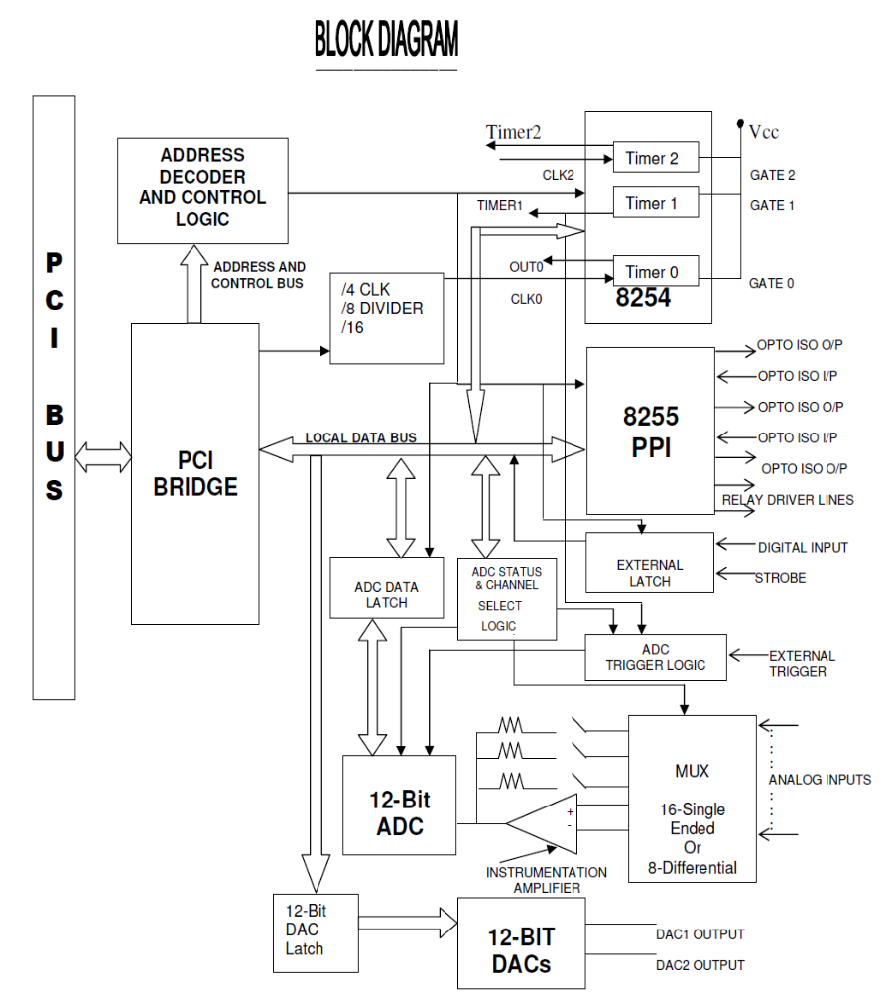
4.4 General Description
The ESA PCI DAS add on card uses a popular PCI Bridge (U31) to communicate with the PCI BUS. The PCI Bridge provides the address, data and control signals required by the card.
The Analog & Digital devices on the card, an ADC (U33), two DACs (U7 & U8), one 8255 (U23) and one 8254 (U22) are interfaced to the PCI Bridge through glue logic.
The Glue logic consists of the address decoding and control circuitry to enable and select the above-mentioned devices with user defined modes. The Glue Logic maps and provides 8-bit registers to access the devices on the card. User can access the registers through software programming. The addresses of the registers vary with different offsets from the base address of the card.
The card also uses analog circuits, to select the gain of the analog input voltages, to select the reference voltages to ADC and DAC based on the modes of operation and to convert the DAC output current into voltage etc.
The 12-Bit ADC (AD1674) is configured in Stand-Alone mode for better operation. The calibration of the ADC can be done using the trim pots provided on the card.
The Analog input channels and DAC outputs are terminated on the 25-Pin D-Type Male Connector (J1), which can be connected to Junction Box through a Flat Ribbon Cable (FRC) cable.
The Analog inputs from the Connector are fed to ADC through software selectable analog Muxs (U29 & U25) and Gain selectable Instrumentation
Amplifier. The triggering of ADC can be done in four different modes as mentioned.

The converted 12-Bit Data from the ADC can be read by software by selecting the corresponding latches.
The digital inputs to the 12-Bit DACs can be given by selecting the corresponding latches. The analog outputs of the DACs are converted to voltage and available on the 25-Pin D-Type Connector J1.
The 8254 (U22) Programmable Interval Timer (PIT) consists of 3 Timers/Counters, which can be programmed for different modes of operation using software.
The clock input to Timer0 is taken from PCI clock divider using Jumpers. The Jumper connections are as follows.

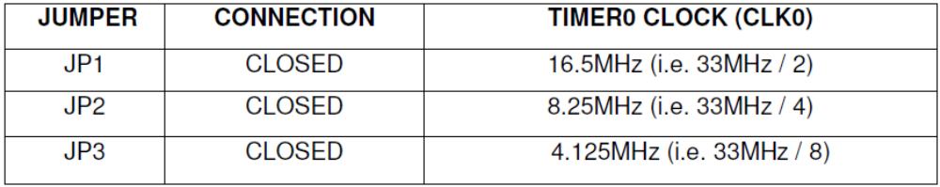

Clock input to Timer1 (CLK1) can be taken from output of Timer0 or externally (i.e. from the connector J2) using jumpers JP7 & JP8. The Timer1 output can be used to trigger the ADC and also to generate PCI interrupt using the jumpers JP6, JP9 & JP10. The Gate inputs of the 3 Timers are pulled high in the Card.
The clock inputs and outputs of all the three Timers are available on the 50-pin berg strip J2 for external interface.
JP6, JP7, JP8, JP9 and JP10 jumpers selection are as follows

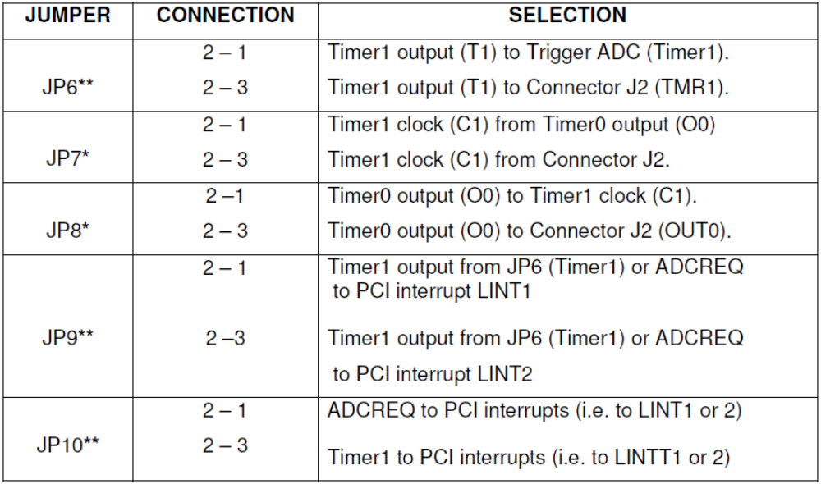
* While selecting the Clock input to Timer1 from the Timer0 output, user has to
Connect both JP8 (2-1) and JP7 (2-1).
** While connecting the PCI interrupts (LINT1 or LINT2) to Timer1, the ADC
Trigger also should be from Timer1 i.e. JP6 (2-1) and JP10 (2-3).
Other wise the interrupt can be taken from ADCREQ.

The 24 I/O lines of 8255 (U23) PPI’s are available on the 50-Pin Berg strip J2 with different I/O interfaces.
7 lines of PORT A (PA0 to PA6) are available as High Current Relay Driver lines (RLY0…RLY6) through ULN2003.
4 lines of PORT C, PC1, PC2, PC4, PC5 are available as opto-isolated lines, among them, PC1 & PC2 are opto-isolataed input lines and PC4 & PC5 are opto-isolated output lines. Opto-couplers MCT2E are used to provide opto isolation.

2 lines of PORT C, PC0 and PC3 can be used to generate the PCI interrupts (i.e. LINT1 and LINT 2) using the Jumpers JP11 and JP12.
The remaining 11 Port lines of 8255 are available as general-purpose I/O lines i.e. 8 lines of Port B, 1 line of Port A and 2 lines of Port C. Apart from these I/O lines a Latch provides 8 TTLdigital input lines (LINP0…LINP7) for external interface.
The input lines and latch enable (EXT LATCH) signal of the Latch are available on the 50-Pin Berg strip J2. The user has to enable the Latch externally.

4.5 Register Structure & Format

4.5.1 MASTER REGISTER
The ESA PCI DAS Card can be configured for different mode of operations such as Range -- Bipolar/Unipolar, mode – Single-Ended / Differential by programming the master register with the appropriate control word.

The Control Word definition is as follows:
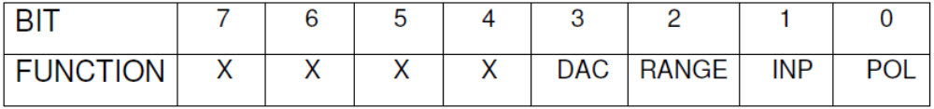

BITWISE DEFINITION OF THE MASTER REGISTER
1. DAC RANGE (BIT 3)
This selects the range of operation of both the DACs. A value of 0 sets it in the 0-10V ranges, where as a value of 1 set in the ±10V range.

2. ADC RANGE (BIT 2)
This selects the range of operation of the ADC. A value of 0 selects the ±10V range, where as a value of 1 selects the 0-10V or ±5V range.

3. INPUT TYPE (BIT 1)
This selects the type of input to the ADC. A value of 1 sets it in the differential mode (8 channels), whereas a value of 0 sets it in the single ended mode (16 channels).

4. POLARITY (BIT 0)
This selects the polarity (Unipolar or Bipolar) of the applied input signal to ADC. A value of 0 sets it in the bipolar (±10V, ±5V) mode, whereas a value of 1 sets it in the Unipolar(0- 10V) mode

4.5.2 ADC REGISTERS:
4.5.2.1 ADC MODE REGISTER
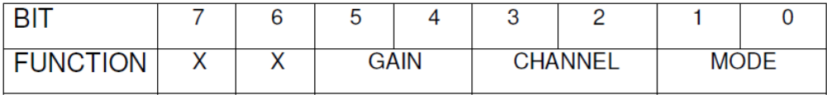
BITWISE DEFINITION OF THE MODE REGISTER
1. MODE (Bits 0 & 1)
Four different mode of triggering the ADC conversion are supported:
POLLED MODE
Conversion is initiated as soon as the Pollinit register (BADR+D) is written. This mode is useful when the data sampling is asynchronous or to initiate conversion when ever system requires.
EXTERNAL TRIGGERED MODE
Conversion is initiated when the EXTCON signal (Pin 13 of connector J1) goes high. This mode is useful when ADC conversion is to be synchronized with an external event.
TIMER TRIGGERED MODE
Conversion is initiated by the output of Timer 1 of 8254. This mode can be used to initiate single or multiple conversions at specified time intervals.
AUTO TRIGGERED MODE
The end of conversion signal of the previous ADC cycle triggers conversion. This
mode can be used for high-speed data acquisition with no delay.
In this mode, the user can transfer the data from the previous conversion cycle of the ADC to memory during the current ADC conversion cycle, thus reducing the delay and increasing the overall conversion speed.
The ADC mode control register should be programmed to select any one of the above modes of triggering.

2. CHANNEL (Bits 2 & 3)
The various modes of channel selection are as follows:
ONE CHANNEL
In this mode any one channel which is written into the Load/Clear Channel register (BADR+8) is set and the Mux address does not get incremented or decremented. For example to continuously acquire the fifth channel, first select one channel mode in the mode select register (BADR+9) and then write into the Load/Clear Channel register with 05H. This selects the fifth channel.
Writing into the same register with the last bit high can clear the Channel register. For example output (BADR+8) with FFH. This register has to be cleared before a new value is loaded.
TWO CHANNEL
In this mode the Mux address counter toggles between the first two channels. Initially it will be at the first channel and at the end of conversion it increments the counter to the next channel. At the next end of conversion, it returns to the first channel. This is useful for sampling stereo signals.
AUTO INCREMENT
In this mode the channel address of the Mux gets incremented automatically i.e., from 0-15 in sequence. The end of conversion signal can do the increment. Once this mode is set, the user does not have to program the Load / Clear Channel register.

3. GAIN (Bits 4 & 5)
The various gain options on the software programmable gain amplifier are :
GAIN X1
This provides a gain of 1, i.e. the input and output signals are equal in amplitude.
GAIN X2
This provides a gain of 2 times, i.e. the output signal is twice the input signal.
GAIN X5
This provides a gain of 5 times, i.e. the output signal is 5 times the input signal.
GAIN X10
This provides a gain of 10 times, i.e. the output signal is 10 times the input signal.
4.5.2.2 ADC LOAD/CLEAR CHANNEL REGISTER
Before starting any ADC conversion the Channel register can be set to a pre-determined channel by writing into this register. The channel register has to be cleared by setting the MSB high before selecting any channel. The channels are selected by writing the channel number in the lower Nibble with the MSB set low.

4.5.2.3 ADC STATUS REGISTER
The ADC Status Register can be read by the user to determine the ADC status as shown below:
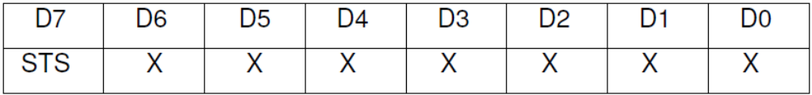
X = Unused bit STS = 0: End of Conversion. 1: Conversion in progress.

4.5.2.4 ADC DATA REGISTERS:
These are read only registers, which can be read in the LO/HI byte sequence.
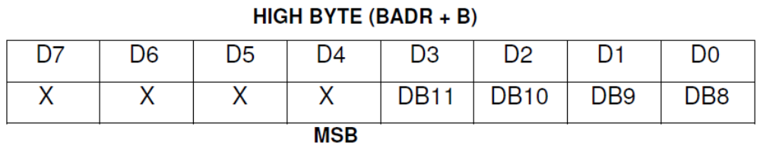
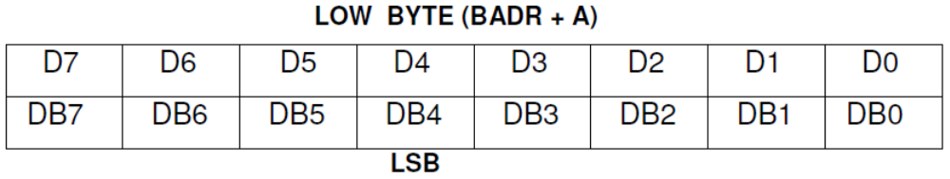

4.5.3 DAC REGISTERS
4.5.3.1 DAC DATA REGISTER:
The DAC registers are write only and are in the HI/LO byte sequence, so that the
DAC’s are not updated till the LO byte is written.
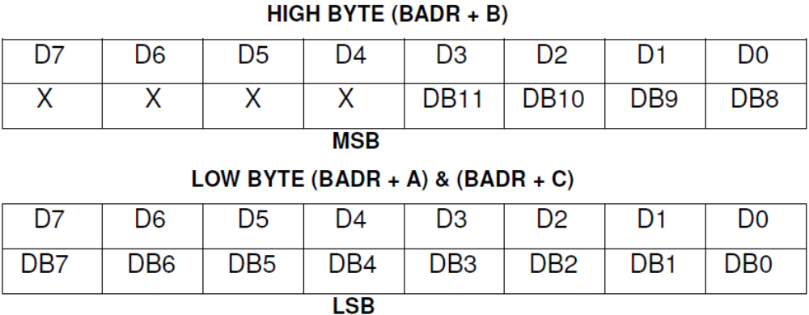
4.5.4 8254 TIMER REGISTERS:
The 8254 have three 16-bit timer/counter outputs. The clock input to the first time
(Timer 0) can be given through 74LS163 (Down Counter). Close JP1 or JP2. This will provide a clock to the timer 0 of 825 derived from 74LS163. The Timer 0 output can be fed as clock input to the timer 1 by shoring JP8 and JP7 (2-3). The user can feed the clock externally via J2 for timer 3. All the GATE outputs are pulled to Vcc through 4k7 resistances.

1. COMMAND REGISTER (BADR + 3): This register is used to set the modes of
operation of the Timer and to select which timer is to be loaded.
2. TIMER 0 (BADR + 0): This register is used to load the data to Timer 0 and also to read-back the status of the timer.
3. TIMER 1 (BADR + 1): This register is used to load the data to Timer 1 and also to read-back the status of the timer.
4. TIMER 2 (BADR + 2): This register is used to load the data to Timer 2 and also to read-back the status of the timer.

4.5.5 DIGITAL I/O REGISTERS:
The Digital I/O facility available on the card consists of 32 lines grouped below:
a. 8 Programmable Digital I/O lines.
b. 3 Digital Output lines.
c. 2 Digital Input lines.
d. 7 High Current line drivers.
e. 2 Opto Isolated Output lines
f. 2 Opto Isolated Input lines
g. 8 Externally Latched / Strobed inputs.

The group of DIO lines from a to f (24 lines) are available through a 8255 PPI, while the Group g (8lines) is available through a 74LS374 latch.
1. COMMAND PORT OF 8255 (BADR + 7): This register is used to set the mode of operation of the 8255 i.e. MODE 0, MODE 1 or MODE 2.
2. PORT A OF 8255 (BADR + 4): This register is used to write or read data from
PORT A of the 8255.
3. PORT B OF 8255 (BADR + 5): This register is used to write or read data from
PORT B of the 8255.
4. PORT C OF 8255 (BADR + 6): This register is used to write or read data from
PORT C of the 8255.
5. EXTERNAL LATCH (BADR + 8): This is a 8-bit read only port, which is connected to the 74LS374. This latch has to be clocked using an external strobe signal, which is connected to pin 35 of the connector J2.

CHAPTER 5

System Design

Chapter 5
System Design
5.1 Data Structures Used –
In this section, we will see some important data structures that are used to implement this driver.
System Defined Structures:
1. RTDM_DEVICE: This structure specifies a RTDM device.
As some fields, especially the reserved area, will be modified by RTDM during runtime, the structure must not reside in write-protected memory.
struct rtdm_device
{
int struct_version;
int device_flags;
size_t context_size;
char device_name[RTDM_MAX_DEVNAME_LEN+1];
int protocol_family;
int socket_type;
rtdm_open_handler_t open_rt;
rtdm_open_handler_t open_nrt;
struct rtdm_operations ops;
int device_class;
int device_sub_class;
const char *driver_name;
int driver_version;
const char *peripheral_name;
const char *provider_name;
const char *proc_name;
struct proc_dir_entry *proc_entry;
int device_id;
struct rtdm_dev_reserved reserved;
};

In the above structure,
Name field specifies the name of an rtdm device
context_size field is used to specify the size of driver defined device structure.
Device_id is the device identification number.
2. PCI_DEV:
Struct pci_dev
{
Struct list_head global_list;
Struct list_head bus_list;
Struct pci_bus *bus;
Struct pci_bus *subordinate;
Void *sysdata;
Struct proc_dir_entry *procent;
Unsigned int devfn;
Unsigned short vendor;
Unsigned short device;
Unsigned short subsystem_vendor;
Unsigned short subsystem_device;
Unsigned int class;
u8 hdr_type;
u8 rom_base_reg;
U8 pin;

Struct pci_driver *driver;
u64 dma_mask;
pci_power_t current_state;
pci_channel_state_t error_state;
Struct device dev;
Int cfg_size;
Unsigned int irq;

Struct resource resource [DEVICE_COUNT_RESOURCE];
Unsigned int transparent: 1;
Unsigned int multifunction: 1;
Unsigned int is_enabled:1;
Unsigned int is_busmaster:1;
Unsigned int no_msi:1;
Unsigned int block_ucfg_access:1;
u32 saved_config_space [16];
Struct hlist_head saved_cap_space;
Struct bin_attribute *rom_attr;
Int rom_attr_enabled;
Struct bin_attribute *res_attr [DEVICE_COUNT_RESOURCE];
};

Driver Defined Structures:
1. Driver structure
Struct rtai_esadas_driver
{
struct rtai_esadas_device *device_ptr;
unsigned int no_of_devices;
SPL device_list_spl;
};

This driver structure is defined to maintain the driver’s information. In the structure, device_ptr points to the first device which is using the driver.
This structure also maintains the count of devices that are using this driver (i.e. no_of_devices).
SPL is the spinlock used for locking the resources used by driver.

2. Device structure (Private object)
struct rtai_esadas_device
{
struct rtai_esadas_device *next;
char *device_name;
unsigned long int BAR;
struct pci_dev *sys_dev;
unsigned long index;
SEM in_use;
unsigned long int range;
u8 master_reg;
unsigned int irq_no;
u8 adc_mode;
u8 adc_channel;
SEM adc_read;
};
This structure represents the private object for a device instance.

- The first field i.e. pointer to a device structure is defined to maintain a list of devices using this driver.
- The BAR (Base Address Register) field stores the base address for the device which is read from configuration space of the device.
- Sys_dev points to the pci_dev structure provided by the system.
- Irq_no stores the IRQ number provided by the system.
- In the remaining fields, various registers’ values are stored

5.2 Probing Technique
There are two techniques of probing the PCI devices:
1: pci_register_driver
2: Old style PCI probing
In pci_register_driver, the list of PCI devices is scanned and matched with every element of an ID table provided by the driver. When a matching device is found, probe routine gets executed. The pci_register_driver() API leaves most of the probing for devices to the PCI layer.
However, this driver is designed for RTAI. So the minimum interaction with Linux is expected in it. In order to minimize this interaction, old style PCI probing is used.
In this technique, the list of PCI devices is walked through to look for a specific device.
A manual search may be performed using the following constructs:
Searching by vendor and device ID:
while (dev = pci_get_device(VENDOR_ID, DEVICE_ID, dev))
configure_device (dev);

Searching by class ID (iterate in a similar way):
pci_get_class (CLASS_ID, dev)
Searching by both vendor/device and subsystem vendor/device ID:
pci_get_subsys (VENDOR_ID,DEVICE_ID, SUBSYS_VENDOR_ID, SUBSYS_DEVICE_ID, dev).
You can use the constant PCI_ANY_ID as a wildcard replacement for
VENDOR_ID or DEVICE_ID. This allows searching for any device from a
specific vendor.
Once the driver knows about a PCI device and takes ownership, the driver generally needs to perform the following initialization:
Enable the device (using pci_enable_device)
Request MMIO/IOP resources (pci_request_region)
Access device configuration space (if needed)
Register IRQ handler (rt_irq_request)

5.3 Challenges
Here some of the challenges are listed that we faced during implementation of this real-time driver.
- The data sheet for the ESA-DAS card was not provided by the manufacturer. So in order to get the configuration space access, we reverse engineered the device information.
- For registering the interrupt handler (using rt_request_irq) we are expected to provide the interrupt line number (IRQ number). However, we got different values of IRQ number from Configuration space & the PCI device structure that is supplied by the system. This confusion was resolved with the help of PCI documentation provided by Linux. This documentation says:
Memory (MMIO), and I/O port addresses should NOT be read directly from the PCI device configuration space. Use the values in the pci_dev structure as the PCI "bus address" might have been remapped to a "host physical" address by the arch/chip-set specific kernel support.

So the IRQ number provided by system through pci_dev structure was used to install interrupt handler.

CHAPTER 6

IMPLEMENTATION

Chapter 6
Implementation
6.1 Layout of the Driver
As this driver is to be added to the running kernel dynamically, it has to be designed in form of a module. After compilation a kernel object will be created (.ko file) which can be added using insmod utility.
Module_init:
In this routine, the driver structure is allocated using rt_shm_alloc.
- Initialization of the driver is done here.
- List of PCI devices is scanned. (using pci_get_device)
- If the desired device is found, it is added to the driver’s list of devices.
- Then the device is enabled.
- IO port is allocated for the specified device (using pci_request_regions)
- Required information is read from configuration space of PCI device and then stored into the private object of the device.
Module_exit:
This routine is the counterpart of the init routine.
- Whatever allocation was done in init is de-allocated here.
- First driver’s every device structure is removed from the memory.
- Then the driver structure is de-allocated.

6.2 ADC (Analog-to-Digital Converter)
As stated earlier, this driver sets the device as per the configurations provided by the application. To provide this functionality, various routines are written.
Routines provided to configure and access ADC are as follows:
1. rt_adc_set_mode
This function sets the mode of triggering the ADC conversion, mode of channel selection as well as the gain options. The configuration values are written to the ADC mode register.
2. rt_adc_set_channel
Before starting any ADC conversion the Channel register can be set to a pre-determined channel by writing into ADC load/clear channel register. The channels are selected by writing the channel number in the lower Nibble with the MSB set low. This routine sets the channel as per application’s requirement.
3. rt_adc_status
This function reads the ADC conversion status from ADC status register.
4. rt_adc_read_data
This routine reads the ADC status register and if the conversion is complete, the ADC data registers (high & low) are read. The data read from ADC is returned to the application.
5. rt_adc_start
This function writes into the pollinit register to initiate the ADC conversion.

6.3 DAC (Digital-to-Analog Converter)
Routines to access DAC:
- rt_dac_write
This routine is provided to write data to the DAC data registers of the specified DAC i.e. DAC1 or DAC2.

6.4 Timers
Routines to configure the timers are as follows:
1. rt_init_timer
This function sets operational mode and the timer to be loaded. The initialization values are written to the command register. If the timer configurations are not provided by the application, the default settings are used.
2. rt_load_timer
This routine loads the data to the selected Timer register of 8254. This data, which is to be loaded, is the divisor for the Timers. The maximum value is 65535.
3. rt_read_timer_status
This function reads the current counter of the selected timer. It reads the counter on the ‘fly’ i.e. while it is counting. This read operation does not affect the counter data or operation.

6.5 Digital I/O
Following DIO functions are provided to access 8255.
1. rt_init_DIO
Initializes the 8255 Command Register and sets the 8255 Ports according to the configuration provided by the application.
2. rt_port_write
This function writes the data to the 8255’s specified Port (A,B or C) of ESA PCI DAS Hardware. The port where data is to be written is selected by the application. If the invalid port name is provided by the application, then appropriate error code is returned to the application.
3. rt_port_read
This function reads the data from the 8255’s specified Port (A, B or C) of ESA PCI DAS Hardware. If the invalid port name is provided by the application, then appropriate error code is returned to the application.
4. rt_extlatch_read
This routine reads data from externally latched Digital I/O Port. This data is read from the 74 LS 374 which requires an external clock signal to latch the data. The data read is returned to the application accessing the device.

6.6 Interrupt Handler
static int handler(unsigned irq, void * dev) /* interrupt handler........only checks the adc interrupt...may add the timer int also */
{
dbg();

struct __rtai_esadas_device *tmp = (struct __rtai_esadas_device *) dev;

if(ADC_GET_STATUS(tmp->BAR) & 0x80){
rt_sem_signal(&tmp->adc_read);
return IRQ_HANDLED;
}

return IRQ_NONE;
}
The above code shows the interrupt handler installed for ADC. Only one interrupt is handled here i.e. ADC conversion complete.

CHAPTER 7

TESTING

Chapter 7
Testing
To test this real-Time driver, some application programs are used.
1. Application to test ADC
This application sets the PCI card’s ADC in the desired mode. It can use the routines that are provided by the driver.
In module_init of the application following things can be done:
- index = rtai_open_esadas("card0", NULL);
- ret_val = rt_adc_set_mode(index, ( GAIN_1X | ONE_CHANNEL | POLLED_MODE ));
- ret_val = rt_adc_set_channel(index, 6);
- rt_adc_start(index);
After the initialization, a real time task is started which checks the ADC status and if the conversion is complete then the converted data is read.
The real time task executes following routine:
static void adc_read_thread(void)
{
RTIME curr_l=0,diff;
unsigned short data;

// while(1)
{
curr_l = rt_get_time();

diff = curr_l - expected_g;
rt_printk("TASK 1 and difference is : %lld\n",count2nano(diff));

if(!(rt_adc_status(index)))
data = rt_adc_read_data(index);
else
rt_printk("Device is busy");

expected_g = next_period();
rt_task_wait_period();

}
}

2. Application to test DIO (Digital IO)
This application tests the working of 8255’s DIO. In the init routine of the application, DIO & its ports are initialized.
ret_val = rt_init_DIO(index, ALL_OUTPUT);
This call also specifies the mode in which application wants DIO to work (i.e. input or output)

ret_val = rt_port_write(index, 'A', 0xf0);
This function is provided by the driver to facilitate the application to write to the specific port.

CONCLUSION

CONCLUSION

The project has been a great success. A working application has been completed tested and is working, fulfilling the aims and objectives set out during the requirements. Looking at the requirements that were set out earlier, most of the features of the driver are working as planned.
The device driver implementation has been finished on time at a steady pace throughout. The project is completed with proper coordination in the team. The challenging areas of this project such as design were tackled first to give maximum time to rectify any problems.
After having successfully completed this project, the syndicate has surely gained significantly from the experience. Not only a useful and working application has been developed, but a good appreciation and sound understanding of a RTAI and device drivers is also has been obtained.

BIBLOGRAPHY

References
1. Corbet Jonathan, Alessandro Rubini & Greg Kroah-Hartman
“Linux Device Drivers” O’Reilly
2. Love Robert - “Linux Kernel Development” Pearson Education.
3. Daniel P. Bovet, Marco Cesati
“Understanding the Linux Kernel”, O’Reilly

Source Code
Rtai-3.5

Web Site:
-www.rtai.org

