A
PROJECT REPORT ON
DocLink – Online Doctor Appointment Booking System

SUBMITTED IN
PARTIAL FULFILLMENT OF

DIPLOMA IN ADVANCED COMPUTING (PG-DAC)

BY

Indra Phand
Ketan Aher
Abhishek Dangare
UNDER THE GUIDENCE OF
MR. RAHUL SANSUDDI Senior Faculty Member Sunbeam Institute of Information Technology, KARAD
AT

SUNBEAM INSTITUTE OF INFORMATION TECHNOLOGY,
PUNE

SUNBEAM INSTITUTE OF INFORMATION TECHNOLOGY,
PUNE.

CERTIFICATE
This is to certify that the project
DocLink – Online Doctor Appointment Booking System
Has been submitted by
Indra Phand
Ketan Aher
Abhishek Dangare
In partial fulfillment of the requirement for the Course of PG Diploma in Advanced Computing (PG-DAC AUG2025) as prescribed by The CDAC ACTS, PUNE.
Place: Pune | Date: 30-JAN-2016
<Project Guide Name> | <Alumni Mentor Name>
Project Guide | Alumni Mentor

ACKNOWLEDGEMENT
A project usually falls short of its expectation unless aided and guided by the right persons at the right time. We avail this opportunity to express our deep sense of gratitude towards Mr. Sarang Patil (Director, SIIT Karad), Mr. Prashant Lad (Course Coordinator, SIIT, Karad) and Mr. Rahul Sansuddi (Our Project Guide and Senior Faculty Member, SIIT Karad). We are deeply indebted and grateful to them for their guidance, encouragement and deep concern for our project. Without their critical evaluation and suggestions at every stage of the project, this project could never have reached its present form. Last but not the least we thank the entire faculty, especially Mr. Nitin Jadhav, and the staff members of Sunbeam Institute of Information Technology, Karad for their support.
TEAM SUNBEAM
(DAC-15 to DAC-27)
DAC August 2025 Batch,
SIIT Karad

ABSTRACT

DocLink is a web-based healthcare management system developed to facilitate online doctor appointment booking in an efficient and organized manner. The application allows patients to search for doctors based on specialization and location, view doctor details, and book appointments as per available time slots. The system aims to reduce manual appointment handling, improve accessibility to healthcare services, and provide a structured approach to appointment scheduling.
The frontend of the application is developed using React, offering an interactive and responsive user interface. Communication between the frontend and backend is achieved through RESTful APIs, ensuring smooth data exchange. Secure access to application features is maintained using protected routes based on user roles. The backend is implemented using Spring Boot, with Spring Security and JWT-based authentication to manage secure login and role-based authorization for patients, doctors, and administrators.
An SQL-based relational database is used to store and manage application data, ensuring data consistency, integrity, and efficient retrieval. The system supports reliable user management, appointment handling, and role-based access control. DocLink provides a scalable and secure solution for online appointment booking, enhancing operational efficiency for healthcare providers and improving convenience for patients.

INDEX
 | INTRODUCTION | 1
 | 1.1 Introduction | 2
 | Product Overview and Summary
 | 2.1 Purpose
 | 2.2 Scope
 | 2.3 User Classes and Characteristics
 | 2.4 Design and Implementation Constraints
 | REQUIREMENTS
 | 3.1 Functional Requirements
 | 3.1.1 Use case for Administrator.
 | 3.1.2 Use case for Customer.
 | 3.2 Non - Functional Requirements
 | 3.2.1 Usability Requirement
 | 3.2.2 Performance Requirement
 | 3.2.3 Reliability Requirement
 | 3.2.4 Portability Requirement
 | 3.2.5 Security Techniques
 | PROJECT DESIGN
 | 4.1 Data Model
 | 4.1.1 Database Design
 | 4.2 Process Model
 | 4.2.1 Functional Decomposition Diagram
 | 4.2.2 Data Flow Diagram (DFD)
 | TEST REPORT
 | PROJECT RELATED STATISTICS
 | CONCLUSION
LIST OF TABLES
Section | Table Title | Page

LIST OF FIGURES
Section | Figure Title | Page

1. INTRODUCTION
This project is concerned with the development of a web-based healthcare application that enables online booking and management of doctor appointments. The system is designed to simplify the appointment scheduling process and reduce the dependency on manual methods such as phone calls or physical visits to hospitals and clinics. By providing an online platform, the project aims to improve accessibility to healthcare services and enhance overall efficiency in appointment management.
The first phase of the project focuses on user management and authentication. The application supports multiple user roles, namely patients, doctors, and administrators. Each user is provided access based on their role. Patients can register and log in to the system, doctors can manage their profiles and view appointments, and administrators can oversee and manage system data. This functionality is implemented using a web-based interface with secure backend processing.
The second phase of the project handles appointment scheduling and management. Patients can search for doctors based on specialization and view relevant details before booking an appointment. Doctors are able to view their scheduled appointments, which helps them manage their time effectively. This approach helps eliminate scheduling conflicts and improves coordination between patients and doctors.
The final phase of the project involves maintaining records and tracking appointment details. All user and appointment information is stored in a relational database to ensure data consistency and easy retrieval. The stored data can be used for monitoring system usage and reviewing patient interactions when required.
Overall, the project provides a structured and reliable solution for managing doctor appointments online, improving convenience for patients and supporting better organization for healthcare providers.

2.PRODUCT OVERVIEW AND SUMMARY
2.1 Purpose
The purpose of the DocLink system is to provide an efficient and user-friendly platform for managing doctor appointments online. The application aims to reduce the manual effort involved in appointment scheduling and improve communication between patients and healthcare providers. By offering secure access and role-based functionalities, the system ensures that patients, doctors, and administrators can perform their respective tasks in a structured and reliable manner.
2.2 Scope
The scope of the project includes the development of a web-based application that supports user registration, authentication, appointment booking, and profile management. The system allows patients to search for doctors, view their details, and schedule appointments online. Doctors can view their appointment schedules, while administrators can manage users and system-related data. The project focuses on providing core appointment management features and can be extended in the future to include additional healthcare services such as online consultations, notifications, and report generation.
2.3 User Classes and Characteristics
The system is designed to support the following user classes:
- Patient
Patients are end users who can register, log in, view doctor details, book appointments, and manage their personal profiles. Basic computer literacy and internet access are required to use the system.
- Doctor
Doctors can log in to the system to view their scheduled appointments and manage profile information. They are responsible for attending scheduled appointments and maintaining accurate availability data.
- Administrator
Administrators have full access to the system and are responsible for managing users, monitoring appointments, and maintaining system integrity. They ensure that the application functions correctly and securely.

2.4 Design and Implementation Constraints
The system is developed using modern web technologies. The frontend is implemented using React, while the backend is developed using Spring Boot. JWT-based authentication and role-based authorization are used to ensure security. A relational database is used for data storage and management. The application requires a stable internet connection and is designed to run on standard web browsers. The project is limited to appointment booking and management functionalities within the defined development timeframe.

3 REQUIREMENTS
3.1 Functional Requirements
The functional requirements describe the main features and operations of the system and explain how users interact with the application.
- The system allows users to register and log in using valid credentials.
- The system provides role-based access for patients, doctors, and administrators.
- The system enables patients to view doctor profiles and book appointments.
- The system allows doctors to view and manage their appointment schedules.
- The system stores and manages user and appointment data in a database.
- The system enables administrators to manage users and monitor appointments.
- The system provides secure logout functionality for all users.
3.1.1 Use Case for Administrator
The administrator is responsible for managing and monitoring the overall system.
- Login to the system using administrator credentials.
- View and manage patient and doctor records.
- Monitor appointment details.
- Ensure smooth functioning of the system.
- Maintain data integrity and security.
3.1.2 Use Case for Customer (Patient)
The customer represents the patient who uses the system to book appointments.
- Register and log in to the system.
- View available doctors and their details.
- Book appointments based on availability.
- Update personal profile information.
- View appointment history.
3.2 Non-Functional Requirements
Non-functional requirements describe the quality and performance characteristics of the system.
3.2.1 Usability Requirement
The system provides a simple and user-friendly interface that allows users to navigate easily. Users can perform tasks such as appointment booking without requiring technical knowledge.
3.2.2 Performance Requirement
The system responds efficiently to user actions such as login, appointment booking, and data retrieval. It supports multiple users accessing the system at the same time with acceptable response times.
3.2.3 Reliability Requirement
The system operates consistently under normal conditions. Data stored in the database remains accurate and protected, and proper error handling ensures system stability.
3.2.4 Portability Requirement
The application runs on standard web browsers and can be accessed from different devices and operating systems. The backend can be deployed on different server environments.
3.2.5 Security Techniques
The system applies security measures to protect user data and system functionality.
- JWT-based authentication for secure login
- Role-based access control
- Encrypted password storage
- Secure REST API endpoints

4 PROJECT DESIGN
4.1 Data Model
4.1.1 Database Design

Table 1: USERS
Key Type | Column Name | Data Type | Length | Allow Null
PK | id | BIGINT | — | 0
— | name | VARCHAR | 255 | 0
— | email | VARCHAR | 255 | 0
— | password | VARCHAR | 255 | 0
— | phone | VARCHAR | 255 | 0
— | dob | DATE | — | 1
— | role | ENUM | — | 0
— | created_on | DATETIME | — | 1
— | updated_on | DATETIME | — | 1

Table 2: DOCTORS
Key Type | Column Name | Data Type | Length | Allow Null
PK | doctor_id | BIGINT | — | 0
FK | user_id | BIGINT | — | 0
— | qualification | VARCHAR | 255 | 1
— | speciality | VARCHAR | 255 | 1
— | experience | INT | — | 1
— | fees | DOUBLE | — | 1
— | start_time | TIME | — | 0
— | end_time | TIME | — | 0
— | location | VARCHAR | 255 | 1
— | profile_image | VARCHAR | 255 | 1
— | created_on | DATE | — | 1
— | last_updated | DATETIME | — | 1

Table 3: PATIENTS
Key Type | Column Name | Data Type | Length | Allow Null
PK | patient_id | BIGINT | — | 0
FK | user_id | BIGINT | — | 0
— | blood_group | ENUM | — | 1
— | gender | ENUM | — | 1
— | family_history | TEXT | — | 1
— | profile_image | VARCHAR | 255 | 1
— | created_on | DATE | — | 1
— | last_updated | DATETIME | — | 1

Table 4: APPOINTMENT
Key Type | Column Name | Data Type | Length | Allow Null
PK | id | BIGINT | — | 0
FK | doctor_id | BIGINT | — | 0
FK | patient_id | BIGINT | — | 0
— | appointment_date | DATE | — | 0
— | start_time | TIME | — | 0
— | end_time | TIME | — | 0
— | status | ENUM | — | 0
— | created_on | DATETIME | — | 1
— | last_updated | DATETIME | — | 1

Table 5: DOCTOR_HOLIDAY
Key Type | Column Name | Data Type | Length | Allow Null
PK | holiday_id | BIGINT | — | 0
FK | doctor_id | BIGINT | — | 0
— | holiday_date | DATE | — | 0
— | reason | VARCHAR | 255 | 1
— | created_on | DATE | — | 1

Table 6: FEEDBACK
Key Type | Column Name | Data Type | Length | Allow Null
PK | feedback_id | BIGINT | — | 0
FK | appointment_id | BIGINT | — | 0
— | rating | INT | — | 0
— | comments | TEXT | — | 1
— | created_at | DATETIME | — | 1

Table 6: FEEDBACK
Key Type | Column Name | Data Type | Length | Allow Null
PK | feedback_id | BIGINT | — | 0
FK | appointment_id | BIGINT | — | 0
— | rating | INT | — | 0
— | comments | TEXT | — | 1
— | created_at | DATETIME | — | 1

Appendix A

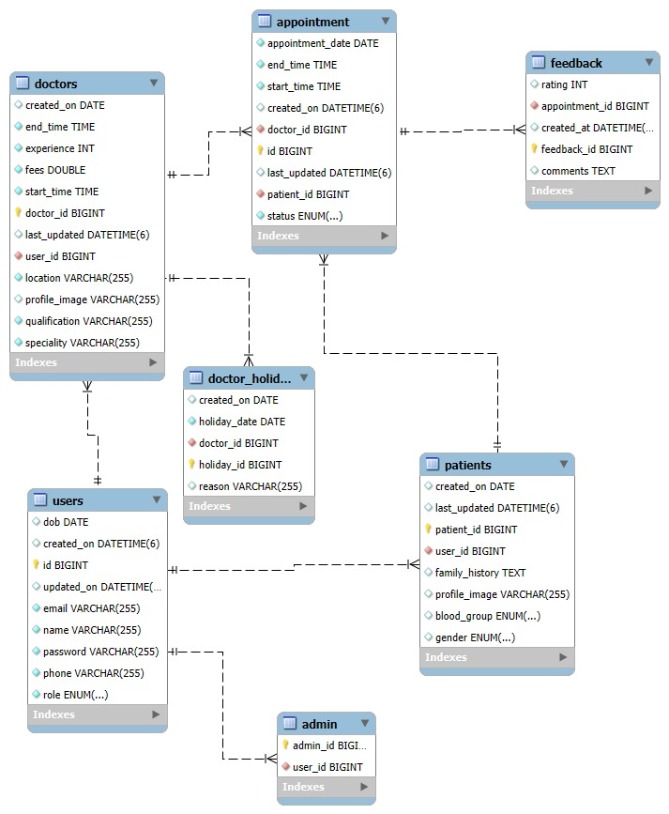

CLASS DIAGRAM

User
Attributes
- userId
- name
- email
- password
- role
Methods
- authenticate()
- getRole()

User
Attributes
- userId
- name
- email
- password
- role
Methods
- authenticate()
- getRole()

Patient
Attributes
- patientId
- userId
- bloodGroup
- gender
- familyHistory
- profileImage
Methods
- getPatientDetails()
- updateProfile()

Doctor
Attributes
- doctorId
- userId
- qualification
- speciality
- fees
- startTime
- endTime
- profileImage
Methods
- getDoctorDetails()
- updateAvailability()

Appointment
Attributes
- appointmentId
- appointmentDate
- startTime
- endTime
- status
- doctorId
- patientId
Methods
- bookAppointment()
- cancelAppointment()
- getAppointmentDetails()

DoctorHoliday
Attributes
- holidayId
- holidayDate
- reason
- doctorId
Methods
- addHoliday()
- removeHoliday()

Feedback
Attributes
- feedbackId
- rating
- comments
- appointmentId
- createdAt
Methods
- submitFeedback()
- viewFeedback()

Admin
Attributes
- adminId
- userId
Methods
- manageUsers()
- manageDoctors()

5 Test Report

SR-NO | TEST CASE | EXPECTED RESULT
1 | Login Page | User is redirected to the respective dashboard
2 | Login Page / Reset Button | All input fields are cleared
3 | Admin Login | Admin dashboard is displayed
4 | Add Doctor (Admin) | Doctor details are saved successfully
5 | View Doctor List | Newly added doctor is visible
6 | Patient Registration Page | All mandatory fields must be filled
7 | Patient Login | Patient login is successful
8 | Doctor Login | Doctor login is successful
9 | Book Appointment (Patient) | Appointment is booked successfully
10 | View Appointments | Appointment details are displayed correctly
11 | Logout | User is logged out and redirected to login page

SR-NO | DEVIATION | PROGRAM
1 | Code commenting not followed uniformly | Backend Services
2 | Minor UI alignment issues | Frontend Application

Appendix B

