**Assignment-06.**

**Name.- Ghansham A. Kamble.**

**S.No.- 47.**

**Que.01-** Wap to convert Fahrenheit to Celsius in Java using formula given below  
  °C = (°F – 32) / (9/5)

**Ans.-**

**package Lab06;**

**public class Question01 {**

**public static void main(String[] args) {**

**float f = -40;**

**float c = (((f-32)*5)/9);**

**if(c==f) System.out.println("Temprature in celcius = "+c+" and in**

**Fahrenheit = "+f+" are EQUAL");**

**else System.out.println("Temprature in celcius is = " +c);**

**}**

**}**

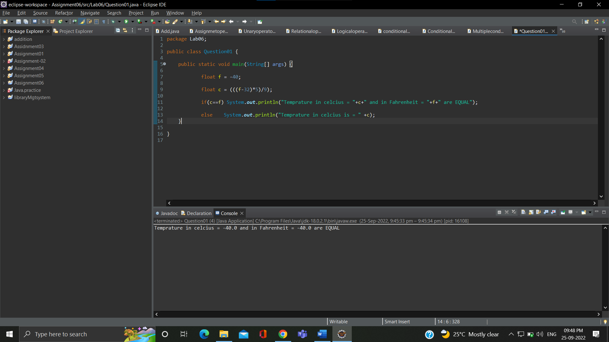

**Que.02-** wap to check a given number is armstrong or not  i.e. 153 = 1*1*1  + 5*5*5+3*3*3

**Ans.-**

**package Lab06;**

**public class Question02 {**

**public static void main(String[] args) {**

**int number = 371, originalNumber, remainder, result = 0, n = 0;**

**originalNumber = number;**

**for (;originalNumber != 0; originalNumber /= 10, ++n);**

**originalNumber = number;**

**for (;originalNumber != 0; originalNumber /= 10)**

**{**

**remainder = originalNumber % 10;**

**result += Math.pow(remainder, n);**

**}**

**if(result == number)**

**System.out.println(number + " is an Armstrong number.");**

**else**

**System.out.println(number + " is not an Armstrong number.");**

**}**

**}**

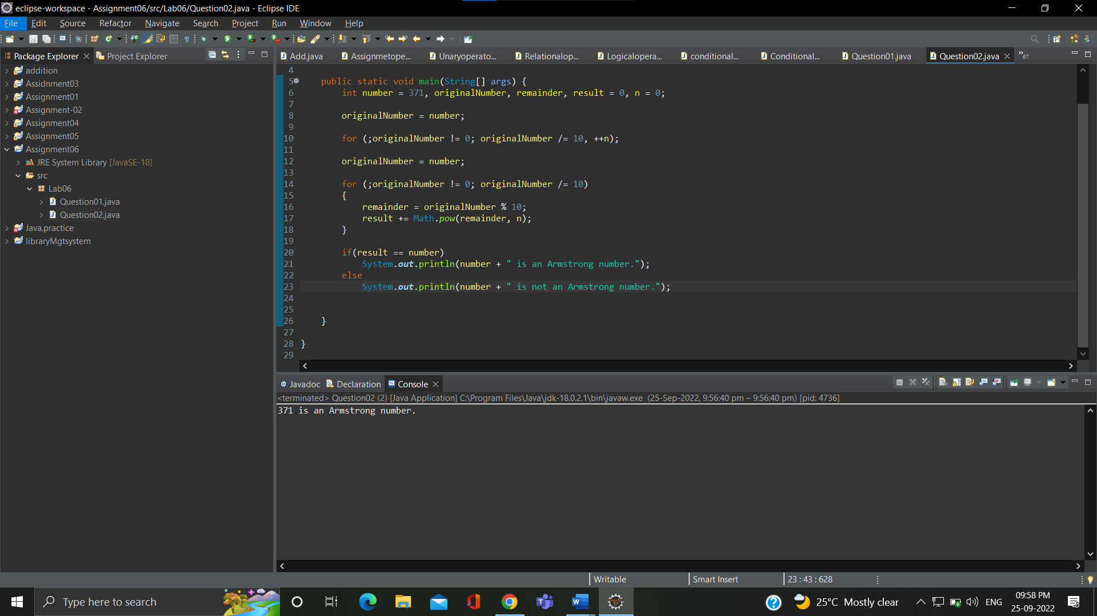

**Que.03-** Rajan  went to a movie with his friends in a multiplex theatre and during  break time he bought pizzas, puffs and cool drinks. Consider   the following prices :  
  
Rs.100/pizza  
Rs.20/puffs  
Rs.10/cooldrink  
Generate a bill for What Rajan  has bought.

**Ans.-**

**package Lab06;**

**import java.util.*;**

**public class Question03 {**

**public static void main(String[] args) {**

**Scanner s = new Scanner(System.in);**

**int pizza;**

**int puff;**

**int drink;**

**System.out.println("No. of pizza buy = ");**

**pizza = s.nextInt();**

**System.out.println("No. of puff buy = ");**

**puff = s.nextInt();**

**System.out.println("No. of drink buy = ");**

**drink = s.nextInt();**

**int bpizza = pizza * 100;**

**int bpuff = puff * 20;**

**int bdrink = drink * 10;**

**System.out.println("Bill of pizza is = " + bpizza );**

**System.out.println("Bill of puff is = " + bpuff );**

**System.out.println("Bill of drink is = " + bdrink );**

**int total = bpizza+bpuff+bdrink;**

**System.out.println("Total bill is = " + total );**

**}**

**}**

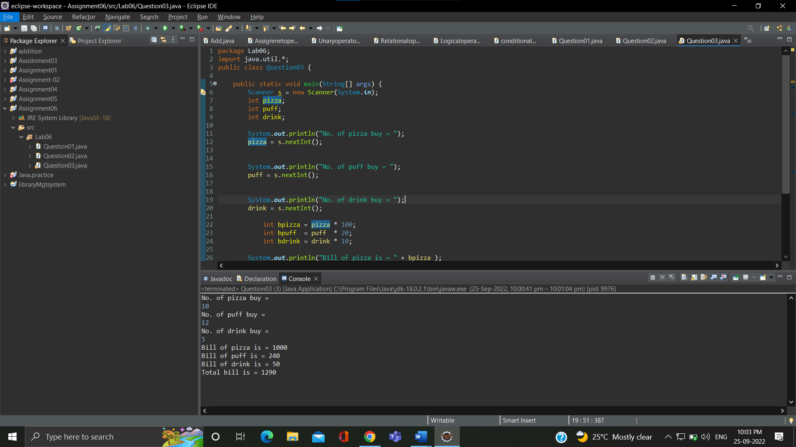

**Que.04-** Given an integer U denoting the amount of KWh units of electricity consumed, the task is to calculate the electricity bill with the help of the below charges:  
   
  
1 to 100 units – Rs. 10/unit  
100 to 200 units – Rs. 15/unit  
200 to 300 units – Rs. 20/unit  
above 300 units – Rs. 25/unit

**Ans.-**

**package Lab06;**

**import java.util.*;**

**public class Question04 {**

**public static void main(String[] args) {**

**Scanner s =new Scanner(System.in);**

**int unit;**

**int charges=0;**

**System.out.print("Enter unit1 consumed = ");**

**unit = s.nextInt();**

**if(unit<=100)**

**charges = 10*unit;**

**else if(unit>100 && unit<=200)**

**charges = 15*unit;**

**else if(unit>200 && unit<=300)**

**charges = 15*unit;**

**else if(unit>300 && unit<=400)**

**charges = 15*unit;**

**System.out.println("Total bill is = " +charges+" Rs.");**

**}**

**}**

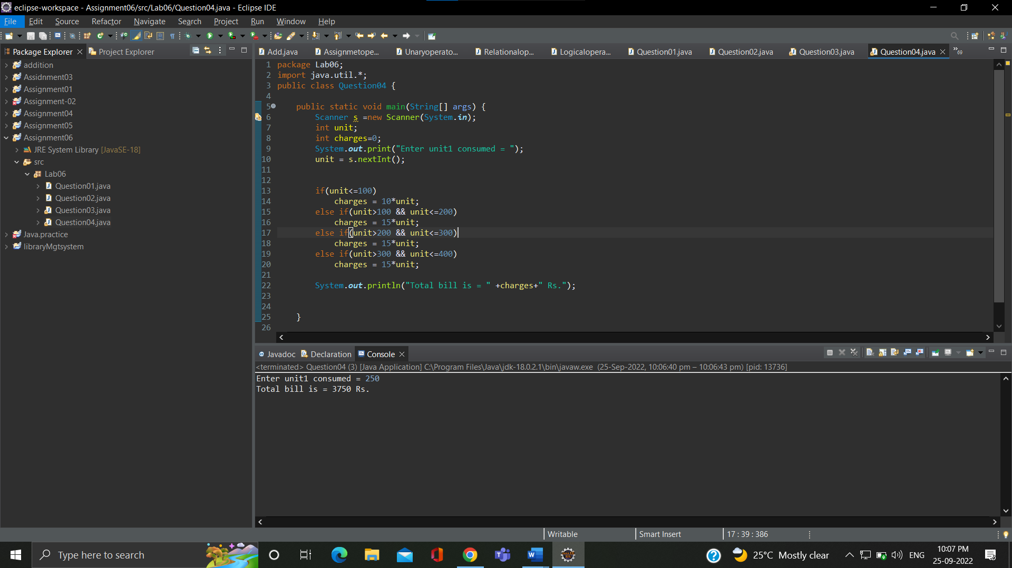

**Que.05-** Write a java program that  define a sorted array of size N and an integer K, find the position at which K is  
present in the array using binary search.  
Example 1:  
Input:  
N = 5  
arr[] = {1 2 3 4 5}  
K = 4  
Output: 3  
Explanation: 4 appears at index 3.

**Ans.-**

**package Lab06;**

**import java.util.*;**

**public class Question05 {**

**public static void main(String[] args) {**

**int u[] = {1,2,3,4,5};**

**int key = 4;**

**int index= 0;**

**for(int i=0; i<u.length; i++)**

**{**

**if(key == u[i])**

**{**

**index=i;**

**break;**

**}**

**}**

**System.out.println(key+ " Appears at index " + index);**

**}**

**}**

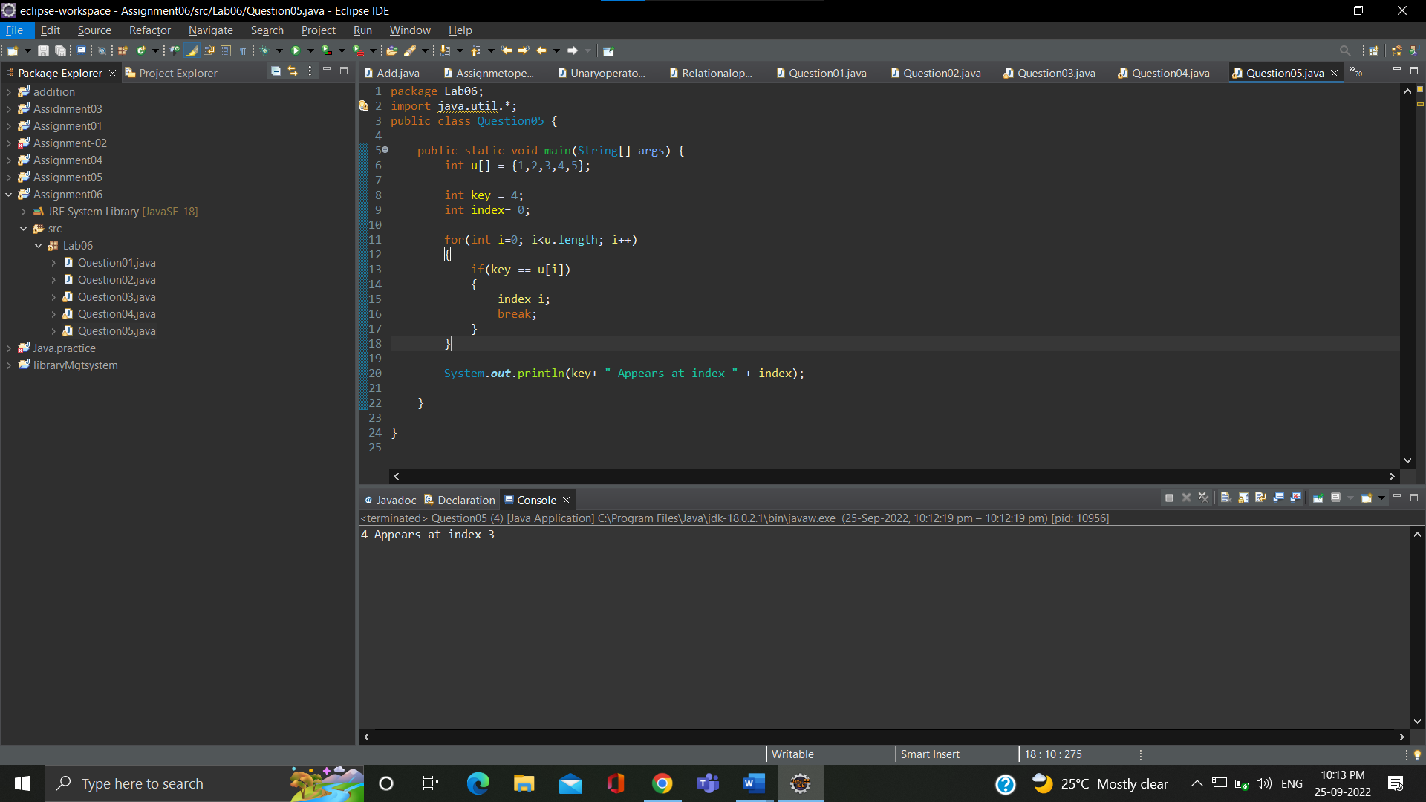

**Que.06-** write a java program and define  an array, print all the elements which are leaders. A Leader is an element that is greater than all of the elements on its right side in the array.  
Examples:  
Example 1:  
Input:  
 arr = [4, 7, 1, 0]  
Output:  
 7 1 0  
Explanation:  
 Rightmost element is always a leader. 7 and 1 are greater than the elements in their right side.

**Ans.-**

**package Lab06;**

**public class Question06 {**

**public static void main(String[] args) {**

**int array[]= {151,80,90,35,61,2,3};**

**System.out.println("The leaders of the array are");**

**int max=Integer.MIN_VALUE;**

**for(int i=array.length-1;i>=0;i--) {**

**if (array[i] > max) {**

**System.out.print(array[i] + " ");**

**max = array[i];**

**}**

**}**

**}**

**}**

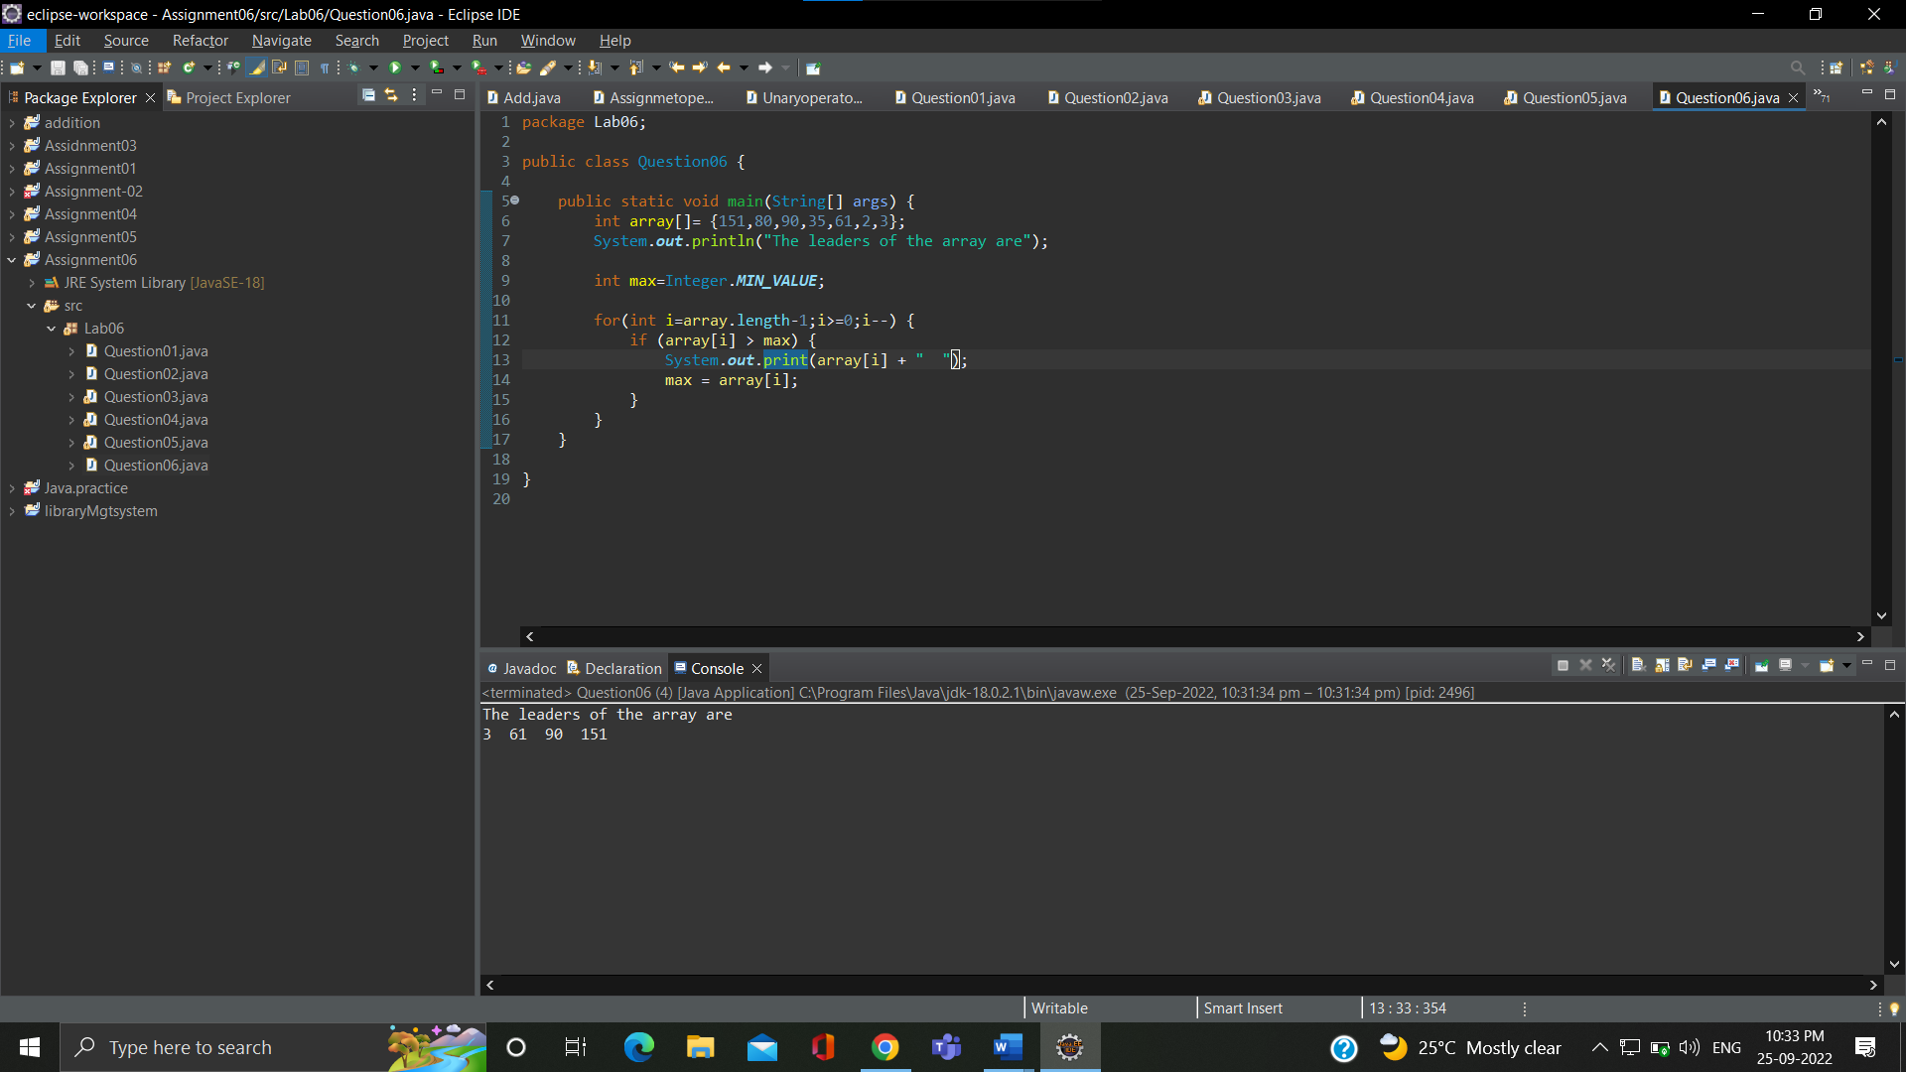

**Que.07-** Given two strings a and b consisting of lowercase characters. The task is to check whether two given strings are an anagram of each other or not. An anagram of a string is another string that contains the same characters, only the order of characters can be different. For example,  abc  and  bca are an anagram of each other.  
  
Example 1:  
  
Input:a = cdacnoida, b = ciddacnoa  
Output: YES  
Explanation: Both the string have same characters with  
        same frequency. So, both are anagrams.

**Ans.-**

**package Lab06;**

**import java.util.Arrays;**

**public class Question07 {**

**public static void main(String[] args) {**

**String a = "cdacnoida";**

**String b = "noidacdac";**

**if(a.length() == b.length())**

**{**

**char[] charu = a.toCharArray();**

**char[] charv = b.toCharArray();**

**Arrays.sort(charu);**

**Arrays.sort(charv);**

**boolean result = Arrays.equals(charu, charv);**

**if(result) {**

**System.out.println(a + " and " + b + " are anagram.");**

**}**

**else {**

**System.out.println(a + " and " + b + " are not anagram.");**

**}**

**}**

**else {**

**System.out.println(a + " and " + b + " are not anagram.");**

**}**

**}**

**}**

