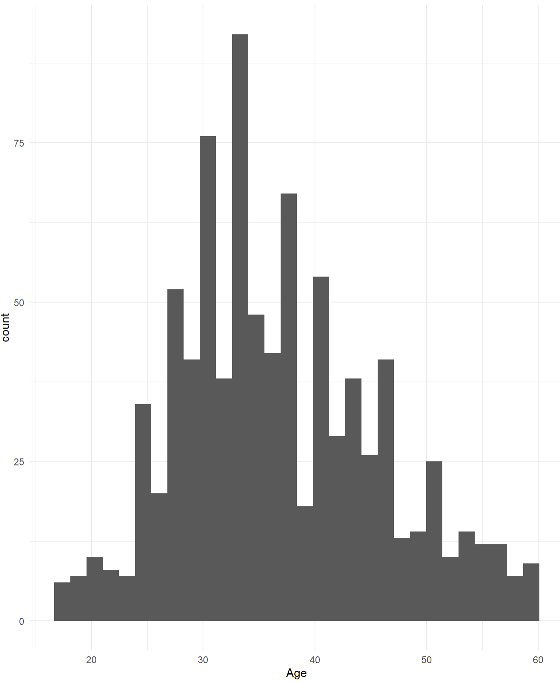

A histogram of age vs attrition


