First, have the following programs installed in your ‘Applications’ directory:   
Bowtie2, SAMtools, BEDTools, and QUAST.

---------------------------

To edit your PATH (.bash_profile) on a MAC:

Open the terminal

Type cd <ENTER> to go to the HOME directory

Type ls -alF to view all files in the HOME directory

If a .bash_profile has NOT previously been created, Type touch .bash_profile

If you have a .bash_profile already, continue to the next step.

Type nano .bash_profile to open the text editor.

Below are the paths to the executable files for each program. Type the following:

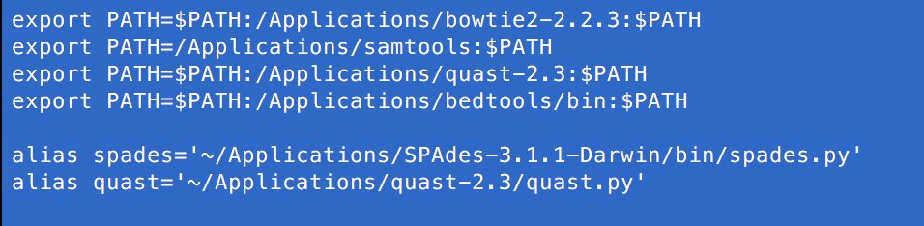

Hold <CONTROL> Type ‘o’ to save

Hit <ENTER>

Hold <CONTROL> Type ‘x’ to exit

Type source .bash_profile

Open a new terminal window and cd to the directory that holds the contig and reference files.

Type sh U50_Terminal_SUBMISSION_SCRIPT.sh <reference.fasta> <contig.fasta>

Example:

sh U50_Terminal_SUBMISSION_SCRIPT.sh KT995530.fasta KT995530_spades_ctg.fasta

---------------------------

If you have WINDOWS, please see: <https://www.java.com/en/download/help/path.xml>